DSA Stage 1 — Study Guide
Foundations: Complexity • Arrays • Strings • Hashing • Math/Bit • Recursion

Python edition • Simple explanations • Diagrams • Solved exercises

How to use this guide: This document covers all 6 topics of Stage 1 from your study plan. Each topic is explained in plain language with a Python angle, includes diagrams to visualize the concept, shows runnable code examples, and ends with practice questions that already have answers — so you can attempt first, then check your work without leaving the doc.

Reading order
Read the topics in the order they appear. Each one builds on the last:
- Topic 1 — Time & Space Complexity (the language of DSA)
- Topic 2 — Arrays (the most fundamental data structure)
- Topic 3 — Strings (basically arrays of characters)
- Topic 4 — Hash Tables (Python dicts and sets)
- Topic 5 — Math & Bit Manipulation
- Topic 6 — Recursion (the foundation for trees, graphs, and DP)

How to actually study with this
- Read the explanation. Don't just skim — read carefully and look at every diagram.
- Type out every code example by hand. Don't copy-paste. Typing builds muscle memory.
- When you reach the practice questions, attempt EACH one before reading the answer. Even if you fail — failing first is what makes the answer stick.
- If you got it wrong, close the doc, wait an hour, and re-attempt the same problem from scratch.

Topic 1 — Time & Space Complexity
Why this matters
Before we learn any data structure, we need a way to talk about how fast or slow code is. We can't just say "this is fast" — fast on what computer? With what input size? Big-O notation gives us a universal way to describe how an algorithm scales when the input gets bigger.
Plain English: Big-O answers: "If my input doubles in size, how many MORE steps will my code take?" It ignores small details (like exact CPU speed) and focuses on the big picture.

The 6 complexity classes you must know
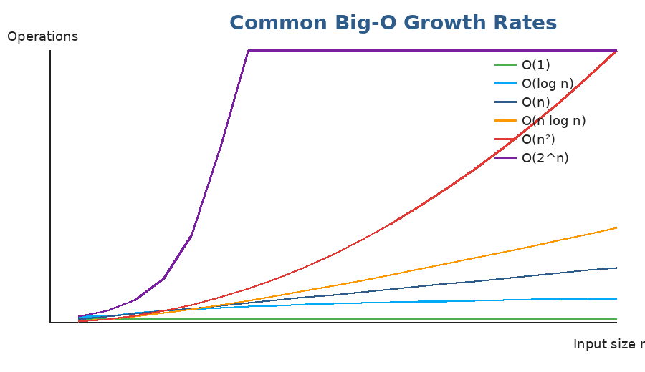
Y-axis = number of operations. As n grows, the curves separate dramatically.
Operation | Time complexity
O(1) — Constant | Same time no matter how big n is
O(log n) — Logarithmic | Time grows very slowly. Doubling n adds 1 step.
O(n) — Linear | Time grows in proportion to n
O(n log n) — Linearithmic | Slightly worse than linear (good sorting algos)
O(n²) — Quadratic | Doubling n quadruples the time. Nested loops over the same data.
O(2^n) — Exponential | Disaster. Doubles in time for every +1 to n.

How to read code and figure out its Big-O
Three rules cover 95% of cases:

Rule 1 — A simple loop over n elements is O(n).
def print_all(arr): # arr has n elements
for x in arr: # loop runs n times
print(x) # one operation
# Total: n × 1 = O(n)

Rule 2 — Nested loops multiply.
def all_pairs(arr):
for i in arr: # n iterations
for j in arr: # n iterations
print(i, j) # 1 operation
# Total: n × n = O(n²)

Rule 3 — Sequential code adds, but we keep the LARGEST term.
def mixed(arr):
for x in arr: print(x) # O(n)
for x in arr: # O(n²)
for y in arr: print(x, y)
# Total: O(n) + O(n²) = O(n²) (the bigger one wins)

O(log n) — the magical one
O(log n) appears when each step CUTS THE PROBLEM IN HALF. Binary search is the classic example. If you have 1,000,000 items and you halve them each step, you reach 1 in only ~20 steps! log₂(1,000,000) ≈ 20.
def binary_search(arr, target):
lo, hi = 0, len(arr) - 1
while lo <= hi:
mid = (lo + hi) // 2
if arr[mid] == target: return mid
elif arr[mid] < target: lo = mid + 1
else: hi = mid - 1
return -1
# Each iteration halves the range → O(log n)

Space complexity
Same idea but for memory. We ask: "How much extra memory does this algorithm use, beyond the input?"
def make_doubled(arr):
result = [] # new list of size n
for x in arr:
result.append(x * 2)
return result
# Extra space used: O(n) for the result list

An in-place algorithm uses only O(1) extra space — meaning, no matter how big n is, the extra memory used stays constant. Reversing a list with two pointers is O(1) space. Sorting with merge sort is O(n) space because of the temp arrays.
Common gotcha: Recursion uses stack space! A recursive function that goes n levels deep uses O(n) space, even if it doesn't allocate any explicit data structures.

Quick reference: Python operations and their Big-O
Memorize these — they come up in every interview answer.
Operation | Time complexity
list[i] (index access) | O(1)
list.append(x) | O(1) amortized
list.pop() (from end) | O(1)
list.pop(0) (from start) | O(n) ← slow!
list.insert(0, x) | O(n) ← slow!
x in list (search) | O(n)
x in set / x in dict | O(1) average
dict[key] / set lookup | O(1) average
len(list / dict / set) | O(1)
sorted(list) / list.sort() | O(n log n)

Practice questions — Topic 1
Q1. What is the time complexity of this function?
def find_max(arr):
best = arr[0]
for x in arr:
if x > best: best = x
return best

Answer:
It's O(n). The loop runs n times. Each iteration does a constant amount of work (one comparison, possibly one assignment).
Q2. What about this one?
def has_duplicate(arr):
n = len(arr)
for i in range(n):
for j in range(i+1, n):
if arr[i] == arr[j]: return True
return False

Answer:
It's O(n²). The outer loop runs n times. For each i, the inner loop also runs n times. Total work = n × n = n². Even though the inner loop body is tiny, what matters is HOW MANY TIMES it runs.
Q3. And this one — be careful, the input is one number, not a list!
def count_halvings(n):
count = 0
while n > 0:
n = n // 2
count += 1
return count

Answer:
It's O(log n). Each iteration divides n by 2. To go from n down to 0, you halve about log₂(n) times. If n = 1024, this loop runs only 10 times.
Q4. Which is faster for large n: O(n²) or O(n log n)?
Answer:
O(n log n) is much faster. For n = 1,000,000:
• n² = 1,000,000,000,000 (one trillion operations)
• n log n ≈ 20,000,000 (twenty million operations)
That's why merge sort and quicksort (n log n) crush bubble sort (n²) on big inputs.
Q5. What is the SPACE complexity of this function?
def squares(arr):
out = []
for x in arr:
out.append(x * x)
return out

Answer:
Space complexity is O(n) — we create a new list of size n. Time complexity is also O(n) because we loop through the input once.
Q6. If algorithm A is O(n) and algorithm B is O(1), which is faster?
Answer:
B is asymptotically faster (O(1) means constant time, regardless of input size). But for SMALL inputs, A might actually be faster — Big-O only tells us about behavior as n gets large. An O(1) algorithm with a huge constant (say, 10,000 operations) can be slower than an O(n) algorithm for small n. We almost always assume n is large when comparing Big-O.
Q7. Why is `if x in some_list` O(n) but `if x in some_dict` O(1)?
Answer:
A list has no internal structure to find x quickly — Python has to check each element one by one until it finds x or reaches the end. That's a linear scan: O(n).
A dict (hash table) computes a hash of x and jumps directly to the right bucket — no scanning. That's O(1) on average.
This is why we often convert a list to a set when we need to do many membership checks.

Topic 2 — Arrays (Python Lists)
What is an array?
An array is a sequence of values stored next to each other in memory. Each value gets an index (a number starting from 0), so you can jump directly to any value without scanning the whole thing.
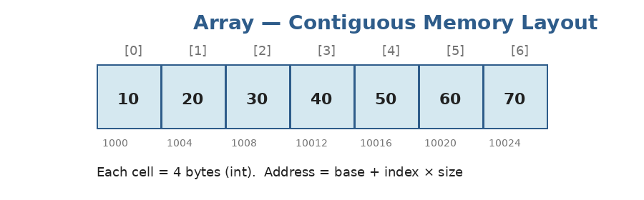
Each value sits at a predictable memory address. arr[3] is reached by computing base + 3 × cell_size — instant access, O(1).
Python note: Python's `list` is a dynamic array — it behaves like a C array but can grow when needed. Under the hood Python overallocates a little extra space so that .append() is O(1) most of the time.

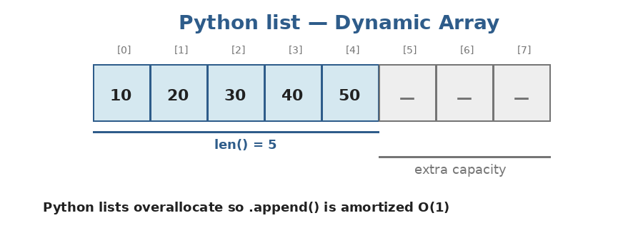
A Python list with 5 used cells and 3 spare slots. When the spares fill up, Python allocates a bigger buffer and copies everything over.
Creating and using lists in Python
# Create
arr = [10, 20, 30, 40, 50]
empty = []

# Index access (O(1))
arr[0] # → 10 (first element)
arr[-1] # → 50 (last element — negative indexing)

# Update (O(1))
arr[2] = 99 # arr is now [10, 20, 99, 40, 50]

# Length (O(1))
len(arr) # → 5

# Add to end (O(1) amortized)
arr.append(60)

# Add at start (O(n) — slow! everything shifts right)
arr.insert(0, 5)

# Remove from end (O(1))
arr.pop()

# Slice — copies a section (O(k) where k = slice length)
arr[1:4] # → [20, 99, 40]

Operation costs — memorize these
Operation | Time complexity
Access by index arr[i] | O(1)
Update by index arr[i] = x | O(1)
Append to end arr.append(x) | O(1) amortized
Pop from end arr.pop() | O(1)
Insert at start arr.insert(0, x) | O(n)
Pop from start arr.pop(0) | O(n)
Search x in arr | O(n)
Slice arr[a:b] | O(b - a)

Why is insert at start slow?: Because all the OTHER elements have to shift one position to the right to make room. That's n-1 moves — O(n). If you need a structure that's fast at both ends, use collections.deque (we'll see this with queues).

Pattern 1: Two Pointers
The two-pointer pattern uses two indices that move through the array — usually one from the left and one from the right, or one fast and one slow. It's used to AVOID nested loops, turning O(n²) into O(n).
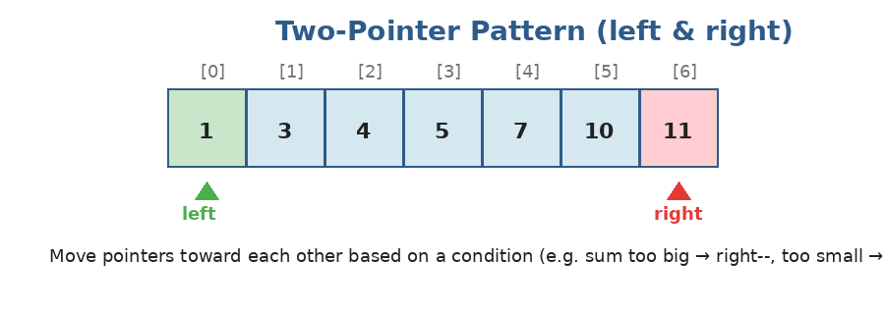
Two indices `left` and `right` move toward each other. Each step looks at one pair and then advances one (or both) pointers.
Classic example: check if a sorted array contains two numbers that sum to a target.
def two_sum_sorted(arr, target):
left, right = 0, len(arr) - 1
while left < right:
total = arr[left] + arr[right]
if total == target:
return (left, right)
elif total < target:
left += 1 # need a bigger sum → move left up
else:
right -= 1 # need a smaller sum → move right down
return None

two_sum_sorted([1, 3, 4, 5, 7, 11], 9) # → (1, 4) because 3 + 7 = 9

Time: O(n). Space: O(1). The two pointers each cross the array at most once.
Pattern 2: Sliding Window
A sliding window keeps track of a contiguous chunk of the array. When the window 'slides', we remove the element leaving the window and add the new one entering — instead of recomputing from scratch.
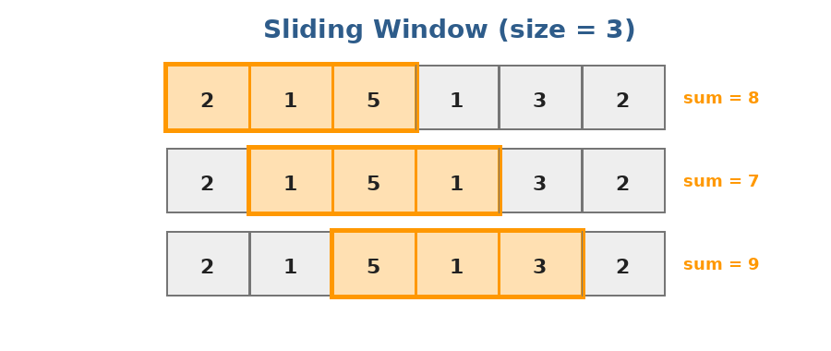
A window of size 3 slides across the array. Each step: subtract the leaving element, add the entering element — O(1) update.
Classic example: maximum sum of any 3 consecutive numbers.
def max_sum_window(arr, k):
window_sum = sum(arr[:k]) # initial window
best = window_sum
for i in range(k, len(arr)):
window_sum += arr[i] - arr[i-k] # add new, remove old
best = max(best, window_sum)
return best

max_sum_window([2, 1, 5, 1, 3, 2], 3) # → 9 (window [5,1,3])

Time: O(n). The naive approach recomputes each window's sum and is O(n·k).
Pattern 3: Prefix Sum
If you need to answer many "sum of arr[i..j]" queries, computing each one from scratch is slow. Instead, precompute a prefix array where prefix[i] = sum of the first i elements. Then any range sum is just one subtraction.
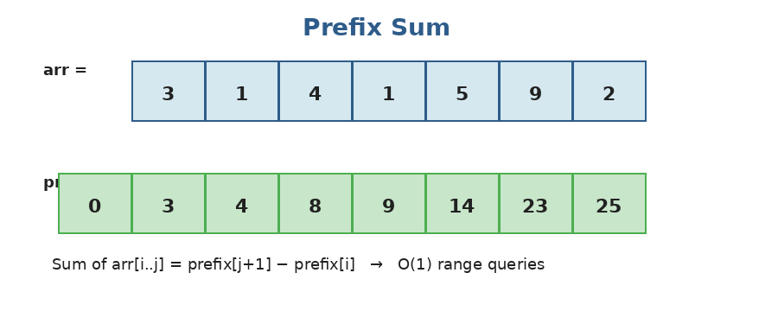
prefix[0] is always 0, then each cell accumulates. Sum of arr[2..4] = prefix[5] − prefix[2] = 19 − 4 = 15.
def build_prefix(arr):
prefix = [0] * (len(arr) + 1)
for i, v in enumerate(arr):
prefix[i+1] = prefix[i] + v
return prefix

def range_sum(prefix, i, j):
# returns sum of arr[i..j] inclusive
return prefix[j+1] - prefix[i]

arr = [3, 1, 4, 1, 5, 9, 2]
prefix = build_prefix(arr) # [0, 3, 4, 8, 9, 14, 23, 25]
range_sum(prefix, 2, 4) # → 4 + 1 + 5 = 10

When to use which pattern: • Two pointers → sorted arrays, palindromes, pair-sums • Sliding window → "longest/max/min subarray of length k" or "satisfying condition" • Prefix sum → many range-sum queries, or "subarray sum equals K" (with hashmap)

Practice questions — Topic 2
Q1. Two Sum (unsorted array). Given an unsorted list and a target, return the indices of the two numbers that add to the target. Example: nums = [2, 7, 11, 15], target = 9 → return [0, 1].
Answer:
Brute force is O(n²) — check every pair. The clever way is O(n) using a hashmap. As we walk through the list, for each number x we check if (target - x) is already in the map. If yes, we found the pair.
def two_sum(nums, target):
seen = {} # value → index
for i, x in enumerate(nums):
need = target - x
if need in seen:
return [seen[need], i]
seen[x] = i
return []

two_sum([2, 7, 11, 15], 9) # → [0, 1]
# Time: O(n), Space: O(n)

Q2. Reverse a list IN-PLACE. Don't create a new list. Example: [1,2,3,4,5] becomes [5,4,3,2,1].
Answer:
Use two pointers — left starts at 0, right at the end. Swap them, then move both inward.
def reverse(arr):
left, right = 0, len(arr) - 1
while left < right:
arr[left], arr[right] = arr[right], arr[left]
left += 1
right -= 1
return arr

reverse([1,2,3,4,5]) # → [5,4,3,2,1]
# Time: O(n), Space: O(1) — truly in-place

Q3. Move Zeroes. Move all zeros to the end while keeping the order of non-zero elements. Example: [0,1,0,3,12] → [1,3,12,0,0]. Do it in-place.
Answer:
Use a 'write pointer'. Walk through the array; whenever you see a non-zero, write it at the position of the write pointer and advance. After the loop, fill the rest with zeros.
def move_zeroes(arr):
write = 0
for x in arr:
if x != 0:
arr[write] = x
write += 1
for i in range(write, len(arr)):
arr[i] = 0
return arr

move_zeroes([0,1,0,3,12]) # → [1,3,12,0,0]
# Time: O(n), Space: O(1)

Q4. Maximum Subarray (Kadane's algorithm). Find the contiguous subarray with the largest sum. Example: [-2,1,-3,4,-1,2,1,-5,4] → 6 (from [4,-1,2,1]).
Answer:
Walk through the array tracking two things: current_sum (sum of the best subarray ending HERE) and best (best seen so far).
At each step: either extend the previous subarray (current_sum += x) or start fresh from x — whichever is bigger.
def max_subarray(arr):
current = best = arr[0]
for x in arr[1:]:
current = max(x, current + x) # extend or restart
best = max(best, current)
return best

max_subarray([-2,1,-3,4,-1,2,1,-5,4]) # → 6
# Time: O(n), Space: O(1)

Q5. Longest Substring Without Repeating Characters. Given a string, find the length of the longest substring with no repeated characters. Example: "abcabcbb" → 3 ("abc").
Answer:
Use a sliding window plus a set to track characters currently in the window. When we see a duplicate, shrink the window from the left until the duplicate is gone.
def longest_unique(s):
seen = set()
left = best = 0
for right, ch in enumerate(s):
while ch in seen:
seen.remove(s[left])
left += 1
seen.add(ch)
best = max(best, right - left + 1)
return best

longest_unique("abcabcbb") # → 3
# Time: O(n), Space: O(min(n, alphabet_size))

Q6. Subarray Sum Equals K. Count how many contiguous subarrays sum exactly to K. Example: arr=[1,1,1], K=2 → 2.
Answer:
Use a prefix sum + hashmap. As we walk through the array, we keep a running sum. For each running sum, we ask: 'how many earlier positions had a running sum of (current - K)?' Each such position gives one valid subarray.
Initialize the map with {0: 1} to handle subarrays that start at index 0.
def subarray_sum(nums, k):
count = 0
running = 0
counts = {0: 1} # prefix sum 0 seen once (empty prefix)
for x in nums:
running += x
count += counts.get(running - k, 0)
counts[running] = counts.get(running, 0) + 1
return count

subarray_sum([1, 1, 1], 2) # → 2
# Time: O(n), Space: O(n)

Q7. Product of Array Except Self. Return an array where output[i] = product of all numbers except nums[i]. NO division allowed. Example: [1,2,3,4] → [24,12,8,6].
Answer:
Two passes. First pass left-to-right: build prefix-products into the output. Second pass right-to-left: multiply by suffix-product as you go.
def product_except_self(nums):
n = len(nums)
out = [1] * n

prefix = 1 # prefix product
for i in range(n):
out[i] = prefix
prefix *= nums[i]

suffix = 1 # suffix product
for i in range(n-1, -1, -1):
out[i] *= suffix
suffix *= nums[i]

return out

product_except_self([1,2,3,4]) # → [24, 12, 8, 6]
# Time: O(n), Space: O(1) extra (output doesn't count)

Topic 3 — Strings
What is a string?
A string is just a sequence of characters. In Python, you can think of it like a list of characters — you can index it with [i], you can slice it, you can loop through it. The big difference: strings are IMMUTABLE.
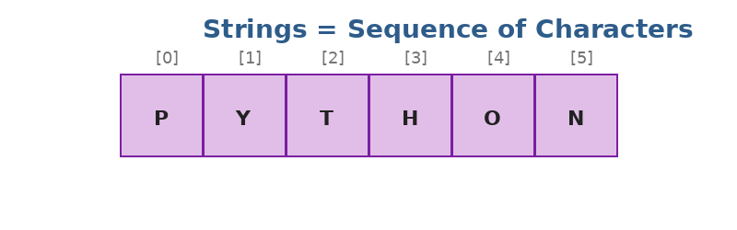
"PYTHON" — six characters at indices 0 through 5. Just like an array.
Immutable means "can't change": You cannot do `s[0] = 'X'`. Python will throw a TypeError. To 'modify' a string, you have to build a new one. This is why we often convert strings to a list of characters first when we need to mutate them.

Common string operations in Python
s = "hello world"

len(s) # 11
s[0] # 'h'
s[-1] # 'd'
s[0:5] # 'hello' (slice)
s[::-1] # 'dlrow olleh' (reversed!)
s.upper() # 'HELLO WORLD'
s.lower() # 'hello world'
s.split() # ['hello', 'world'] (split on whitespace)
s.replace('l','L')# 'heLLo worLd'
'world' in s # True

# Iterate
for ch in s:
print(ch)

# Build a new string from chars (the right way)
chars = ['h', 'e', 'l', 'l', 'o']
''.join(chars) # 'hello'

Don't do this: Building a string with `result = result + ch` in a loop is O(n²) — every concatenation creates a new string and copies everything. Always collect characters in a list, then ''.join(list) at the end. That's O(n).

ASCII tricks
Sometimes you need to convert characters to numbers (and back). Python has two built-ins:
ord('a') # → 97 (ASCII code for 'a')
ord('A') # → 65
ord('0') # → 48

chr(97) # → 'a' (character for code 97)

# Useful trick: turn a lowercase letter into 0–25
'b' → ord('b') - ord('a') # → 1
'z' → ord('z') - ord('a') # → 25

Pattern: Two Pointers on Strings — Palindromes
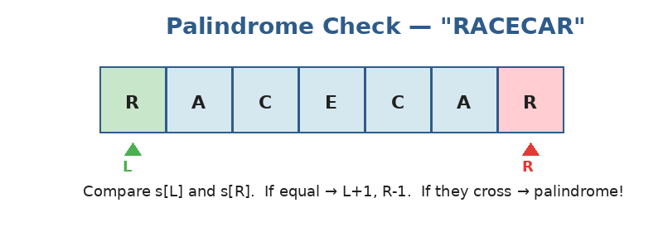
Compare s[L] vs s[R]. If equal, move both inward. If they ever disagree, it's not a palindrome.
def is_palindrome(s):
left, right = 0, len(s) - 1
while left < right:
if s[left] != s[right]:
return False
left += 1
right -= 1
return True

is_palindrome("racecar") # True
is_palindrome("hello") # False

Pattern: Sliding Window with a Frequency Map
Many string problems boil down to: "find the longest/shortest window that satisfies some character-count condition." Use a sliding window plus a dictionary of character counts.
# Example: longest substring with at most 2 distinct characters
def longest_2_distinct(s):
counts = {}
left = best = 0
for right, ch in enumerate(s):
counts[ch] = counts.get(ch, 0) + 1
while len(counts) > 2:
counts[s[left]] -= 1
if counts[s[left]] == 0:
del counts[s[left]]
left += 1
best = max(best, right - left + 1)
return best

longest_2_distinct("eceba") # → 3 ("ece")

Practice questions — Topic 3
Q1. Reverse a String. Reverse the input string in place. The input is given as a list of characters. Example: ['h','e','l','l','o'] → ['o','l','l','e','h'].
Answer:
Two pointers: left at 0, right at the end. Swap and move both inward.
def reverse_string(s):
left, right = 0, len(s) - 1
while left < right:
s[left], s[right] = s[right], s[left]
left += 1
right -= 1

# Or just: s.reverse() in Python (but they want you to show the algorithm)

Q2. Valid Anagram. Given two strings s and t, return True if t is an anagram of s. Example: s="anagram", t="nagaram" → True.
Answer:
Two simple ways. Way 1: sort both strings and compare — O(n log n). Way 2 (better): count characters in s, then subtract counts using t — if anything ends non-zero, not an anagram. O(n).
def is_anagram(s, t):
if len(s) != len(t):
return False
counts = {}
for ch in s:
counts[ch] = counts.get(ch, 0) + 1
for ch in t:
if ch not in counts or counts[ch] == 0:
return False
counts[ch] -= 1
return True

# Pythonic one-liner:
# from collections import Counter
# return Counter(s) == Counter(t)

Q3. Valid Palindrome (ignoring non-alphanumeric and case). Example: "A man, a plan, a canal: Panama" → True.
Answer:
Use two pointers and skip any non-alphanumeric character. Compare lower-cased letters.
def is_palindrome(s):
left, right = 0, len(s) - 1
while left < right:
while left < right and not s[left].isalnum():
left += 1
while left < right and not s[right].isalnum():
right -= 1
if s[left].lower() != s[right].lower():
return False
left += 1
right -= 1
return True

is_palindrome("A man, a plan, a canal: Panama") # True

Q4. First Unique Character. Find the index of the first non-repeating character in a string, or -1 if none. Example: "leetcode" → 0 (l appears once, first).
Answer:
Two passes. First pass: count every character. Second pass: return the index of the first character with count 1.
def first_uniq_char(s):
counts = {}
for ch in s:
counts[ch] = counts.get(ch, 0) + 1
for i, ch in enumerate(s):
if counts[ch] == 1:
return i
return -1

first_uniq_char("leetcode") # → 0
first_uniq_char("loveleetcode") # → 2

Q5. Group Anagrams. Group strings that are anagrams of each other. Example: ["eat","tea","tan","ate","nat","bat"] → [["eat","tea","ate"],["tan","nat"],["bat"]].
Answer:
Trick: anagrams have the same characters when sorted. Use the sorted string as a hashmap key.
def group_anagrams(strs):
groups = {}
for s in strs:
key = ''.join(sorted(s)) # 'eat', 'tea', 'ate' all → 'aet'
groups.setdefault(key, []).append(s)
return list(groups.values())

group_anagrams(["eat","tea","tan","ate","nat","bat"])
# → [['eat','tea','ate'], ['tan','nat'], ['bat']]
# Time: O(n · k log k), Space: O(n · k) where k = max string length

Q6. Longest Repeating Character Replacement. Given a string and an integer k, you can change at most k characters. Find the length of the longest substring with all the same character after the changes. Example: "AABABBA", k=1 → 4 ("AABA" or "ABBA" with one swap).
Answer:
Sliding window. Track the count of the MOST FREQUENT character in the current window. If (window_size - max_count) > k, we'd need too many changes — shrink from the left.
def character_replacement(s, k):
counts = {}
left = best = max_count = 0
for right, ch in enumerate(s):
counts[ch] = counts.get(ch, 0) + 1
max_count = max(max_count, counts[ch])
# window size - count of dominant char = number of swaps needed
if (right - left + 1) - max_count > k:
counts[s[left]] -= 1
left += 1
best = max(best, right - left + 1)
return best

character_replacement("AABABBA", 1) # → 4

Q7. Is Subsequence. Given two strings s and t, return True if s is a subsequence of t (you can delete characters from t but not reorder). Example: s="abc", t="ahbgdc" → True.
Answer:
Two pointers: i walks through s, j walks through t. Whenever t[j] matches s[i], advance i. At the end, if i reached the end of s, every character was found in order.
def is_subsequence(s, t):
i = 0
for ch in t:
if i < len(s) and s[i] == ch:
i += 1
return i == len(s)

is_subsequence("abc", "ahbgdc") # → True
is_subsequence("axc", "ahbgdc") # → False
# Time: O(len(t)), Space: O(1)

Topic 4 — Hash Tables (Python dict & set)
What is a hash table?
A hash table is a data structure that stores key→value pairs with magical lookup speed: O(1) on average. Behind the scenes, it uses a HASH FUNCTION that converts each key into a number (an index into an internal array). Whenever you ask 'is this key here?', it just hashes the key and jumps to the right slot — no scanning needed.
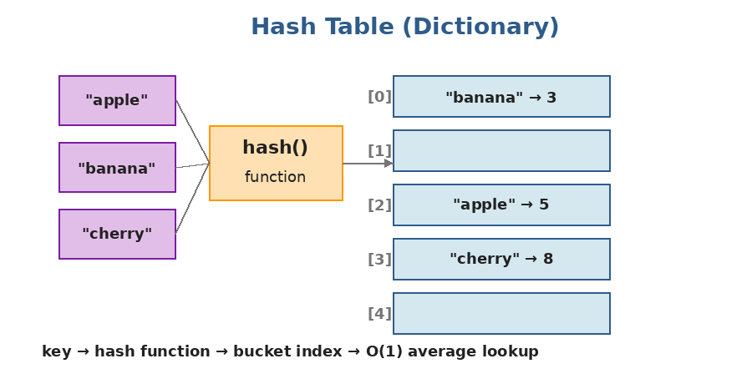
The key is hashed to a bucket index. Different keys can collide on the same bucket — Python handles this internally with open addressing.
In Python this is just dict and set: `dict` is a hash MAP (key → value). `set` is a hash SET (just the keys, no values). Both have O(1) average insert / lookup / delete.

Using dict and set in Python
# DICT — key → value
counts = {}
counts['apple'] = 5
counts['banana'] = 3
counts['apple'] # → 5
'apple' in counts # → True
del counts['banana']
len(counts) # → 1

# Iterate
for key, value in counts.items():
print(key, value)

# Common pattern: counting
text = "hello world"
freq = {}
for ch in text:
freq[ch] = freq.get(ch, 0) + 1
# Or even simpler:
from collections import Counter
freq = Counter(text) # → Counter({'l': 3, 'o': 2, ...})

# SET — just keys, no values
seen = set()
seen.add(5)
seen.add(7)
5 in seen # → True
seen.remove(5)

Why hash tables matter so much in interviews
Hash tables are the single most powerful trick in interview DSA. They convert dozens of O(n²) brute-force solutions into O(n). Whenever you see a problem that asks 'have I seen this before?' or 'how many times has X appeared?' — reach for a dict or set.
Pattern 1: Frequency Counting
# Most common word in a list
def most_common(words):
counts = {}
for w in words:
counts[w] = counts.get(w, 0) + 1
return max(counts, key=counts.get)

most_common(['a','b','a','c','b','a']) # → 'a'

Pattern 2: Seen-So-Far Set
# Has any duplicate?
def contains_duplicate(arr):
seen = set()
for x in arr:
if x in seen:
return True
seen.add(x)
return False

# Brute force is O(n²). With a set, it's O(n).

Pattern 3: Look-up the Complement (Two Sum trick)
As you walk through the array, ask: 'has the number I NEED already appeared?' Store every number you've seen so far in a hashmap.
def two_sum(nums, target):
seen = {} # value → index
for i, x in enumerate(nums):
complement = target - x
if complement in seen:
return [seen[complement], i]
seen[x] = i

Pattern 4: Group-By with a Hashmap
# Group strings by length
from collections import defaultdict
groups = defaultdict(list)
for s in ["hi", "bye", "yo", "food"]:
groups[len(s)].append(s)
# → {2: ['hi', 'yo'], 3: ['bye'], 4: ['food']}

defaultdict tip: `defaultdict(list)` automatically creates an empty list for any missing key, so you don't need .setdefault() everywhere. Common defaults: defaultdict(int) for counters, defaultdict(set) for grouping unique values.

What can go wrong with hash tables?
- Keys must be HASHABLE — meaning, immutable. You can use strings, numbers, tuples as keys, but NOT lists or other dicts.
- Worst-case lookup is O(n) (if every key collides into the same bucket), but in practice this never happens with random data.
- Sets and dicts use more memory than lists — about 2-3x. Worth it for the speed.
Practice questions — Topic 4
Q1. Contains Duplicate. Return True if any value appears at least twice in the array. Example: [1,2,3,1] → True.
Answer:
Walk through the list, keep seen values in a set, return True if you see a value already in the set.
def contains_duplicate(nums):
seen = set()
for x in nums:
if x in seen: return True
seen.add(x)
return False

# One-liner: return len(set(nums)) != len(nums)

Q2. Top K Frequent Elements. Return the k most frequent elements. Example: nums=[1,1,1,2,2,3], k=2 → [1,2].
Answer:
Step 1: count frequencies with a dict. Step 2: sort items by frequency and take the top k. More efficient: use a min-heap of size k (we'll cover heaps later — for now, sorting is fine).
def top_k_frequent(nums, k):
counts = {}
for x in nums:
counts[x] = counts.get(x, 0) + 1
# Sort by count, descending
sorted_items = sorted(counts.items(), key=lambda kv: -kv[1])
return [item[0] for item in sorted_items[:k]]

top_k_frequent([1,1,1,2,2,3], 2) # → [1, 2]

Q3. Intersection of Two Arrays. Return the intersection (each element appears once). Example: [1,2,2,1], [2,2] → [2].
Answer:
Convert both to sets, intersect.
def intersection(nums1, nums2):
return list(set(nums1) & set(nums2))

intersection([1,2,2,1], [2,2]) # → [2]

Q4. Longest Consecutive Sequence. Find the length of the longest run of consecutive integers. Example: [100,4,200,1,3,2] → 4 (the run 1,2,3,4). Must run in O(n) (no sorting).
Answer:
Put all numbers in a set. For each number that is the START of a run (i.e., n-1 is NOT in the set), count how long the run goes by checking n+1, n+2, ... in the set.
Each number is visited at most twice, so it's O(n).
def longest_consecutive(nums):
s = set(nums)
best = 0
for x in s:
if x - 1 not in s: # x is the start of a run
length = 1
while x + length in s:
length += 1
best = max(best, length)
return best

longest_consecutive([100,4,200,1,3,2]) # → 4

Q5. Group Anagrams (revisited with hashmap focus). Group strings that are anagrams. Example: ["eat","tea","tan","ate","nat","bat"] → [["eat","tea","ate"],["tan","nat"],["bat"]].
Answer:
Same key idea: anagrams sort to the same string. Group by the sorted-string key in a dict.
from collections import defaultdict

def group_anagrams(strs):
groups = defaultdict(list)
for s in strs:
groups[''.join(sorted(s))].append(s)
return list(groups.values())

Q6. Valid Sudoku. Given a 9x9 board (some cells filled, some '.'), determine if the current placement is valid (no duplicates in any row, column, or 3x3 box). Don't need to solve it — just check.
Answer:
Use three sets: one for each row, column, and box. As you scan the board, build a unique key per row/col/box and add the (key, digit) pair to a single set. If you ever try to add a duplicate, return False.
def is_valid_sudoku(board):
seen = set()
for r in range(9):
for c in range(9):
ch = board[r][c]
if ch == '.': continue
box = (r // 3, c // 3)
keys = [('row', r, ch), ('col', c, ch), ('box', box, ch)]
for k in keys:
if k in seen: return False
seen.add(k)
return True

Q7. Ransom Note. Given a ransom note string and a magazine string, return True if you can construct the note from letters in the magazine (each magazine letter used at most once).
Answer:
Count letters in the magazine. Walk through the note; decrement the count for each letter. If any letter's count goes below 0 (or doesn't exist), return False.
from collections import Counter

def can_construct(note, magazine):
available = Counter(magazine)
for ch in note:
if available[ch] == 0: return False
available[ch] -= 1
return True

can_construct("aa", "aab") # → True
can_construct("aa", "ab") # → False

Topic 5 — Math & Bit Manipulation
Why this topic
These don't appear as often as arrays or hashing, but every interview season SOME problem uses them. Skipping math/bit means losing easy interview points.
Part A: Math basics
GCD — Greatest Common Divisor
The largest number that divides both a and b. Use Euclid's algorithm — beautifully short:
def gcd(a, b):
while b:
a, b = b, a % b
return a

gcd(48, 18) # → 6
gcd(100, 75) # → 25

# Python has it built-in too:
from math import gcd

Time: O(log(min(a, b))). Surprisingly fast.
Prime checking and the Sieve of Eratosthenes
# Check if n is prime — O(√n)
def is_prime(n):
if n < 2: return False
if n < 4: return True
if n % 2 == 0: return False
i = 3
while i * i <= n:
if n % i == 0: return False
i += 2
return True

# Find all primes up to N — Sieve of Eratosthenes — O(N log log N)
def sieve(N):
is_p = [True] * (N + 1)
is_p[0] = is_p[1] = False
for i in range(2, int(N**0.5) + 1):
if is_p[i]:
for j in range(i*i, N+1, i):
is_p[j] = False
return [i for i in range(N+1) if is_p[i]]

sieve(20) # → [2, 3, 5, 7, 11, 13, 17, 19]

Part B: Bit manipulation
Computers store everything in binary — sequences of 0s and 1s. Bit operations let us manipulate those directly, which is sometimes much faster (and shorter) than arithmetic.
The 4 basic bit operations
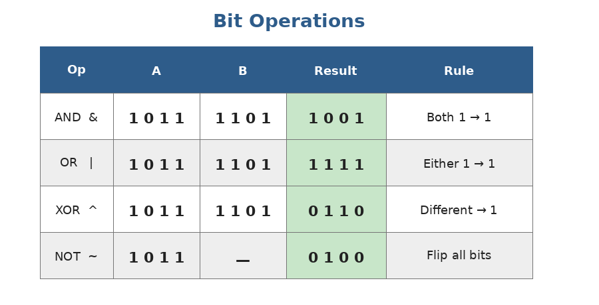
AND, OR, XOR work on each pair of bits independently. NOT flips every bit.
# In Python:
a = 0b1011 # = 11
b = 0b1101 # = 13

a & b # 0b1001 = 9 (AND)
a | b # 0b1111 = 15 (OR)
a ^ b # 0b0110 = 6 (XOR)
~a # ...1...0100 (NOT — flips ALL bits, gives -12 in Python)

# Shifts
a << 1 # 0b10110 = 22 (shift left = multiply by 2)
a >> 1 # 0b101 = 5 (shift right = divide by 2)

XOR — the magical one
XOR (^) has properties that make it perfect for many tricks:
- x ^ x = 0 (any number XOR'd with itself is 0)
- x ^ 0 = x (XOR with 0 is identity)
- XOR is commutative and associative — order doesn't matter
Classic XOR trick — Single Number: Given an array where every number appears twice EXCEPT ONE, find the unique one. XOR all numbers — pairs cancel to 0, only the lonely one survives.

def single_number(nums):
result = 0
for x in nums:
result ^= x
return result

single_number([2, 3, 4, 3, 2]) # → 4
# Time: O(n), Space: O(1) (no hashmap needed!)

Useful bit tricks to memorize
# Check if i-th bit is set
n & (1 << i) # nonzero if bit i is set

# Set the i-th bit
n |= (1 << i)

# Clear the i-th bit
n &= ~(1 << i)

# Toggle the i-th bit
n ^= (1 << i)

# Count set bits (number of 1s in binary)
bin(n).count('1') # easy Python way
# Or Brian Kernighan's trick:
def count_bits(n):
count = 0
while n:
n &= n - 1 # clears the LOWEST set bit each iteration
count += 1
return count

# Check if n is a power of 2 (exactly one bit set)
n > 0 and (n & (n - 1)) == 0

Practice questions — Topic 5
Q1. Number of 1 Bits. Count the number of 1s in the binary representation of n. Example: n=11 → 3 (binary 1011 has three 1s).
Answer:
Use Brian Kernighan's trick: each iteration n &= n-1 clears one set bit. Count how many times you can do that.
def count_ones(n):
count = 0
while n:
n &= n - 1
count += 1
return count

count_ones(11) # → 3
# In Python: bin(n).count('1') works too

Q2. Single Number. Every element appears twice except one. Find the unique one. Example: [4,1,2,1,2] → 4.
Answer:
XOR everything. Pairs cancel out, leaving the lonely number.
def single_number(nums):
result = 0
for x in nums:
result ^= x
return result

Q3. Power of Two. Determine if n is a power of 2. Example: 16 → True, 18 → False.
Answer:
Powers of 2 in binary look like 10000... — exactly one bit set. Trick: n & (n-1) clears the lowest set bit. If the result is 0, there was only one bit. (Also need n > 0 to handle 0.)
def is_power_of_two(n):
return n > 0 and (n & (n - 1)) == 0

is_power_of_two(16) # → True
is_power_of_two(18) # → False

Q4. Reverse Integer. Reverse the digits of a 32-bit signed integer. If the result overflows, return 0. Example: 123 → 321, -123 → -321.
Answer:
Use modulo and integer division. Pop the last digit (n % 10), build the reversed number, and check overflow at the end.
def reverse(x):
sign = -1 if x < 0 else 1
x = abs(x)
result = 0
while x:
result = result * 10 + x % 10
x //= 10
result *= sign
if result < -2**31 or result > 2**31 - 1:
return 0
return result

reverse(123) # → 321
reverse(-123) # → -321

Q5. Sqrt(x). Compute the integer square root (truncated). Example: sqrt(8) → 2 (since 2² ≤ 8 < 3²). No using ** or math.sqrt.
Answer:
Binary search on the answer. The square root of x is between 0 and x. Find the largest m such that m² ≤ x.
def my_sqrt(x):
if x < 2: return x
lo, hi = 1, x // 2
while lo <= hi:
mid = (lo + hi) // 2
if mid * mid == x:
return mid
elif mid * mid < x:
lo = mid + 1
else:
hi = mid - 1
return hi # largest m with m² <= x

my_sqrt(8) # → 2
my_sqrt(16) # → 4

Q6. Counting Bits. For every i in [0..n], return the number of 1 bits in i. Example: n=5 → [0,1,1,2,1,2].
Answer:
DP trick: count[i] = count[i >> 1] + (i & 1). The number of bits in i equals the number of bits in i//2 plus 1 if i is odd.
def count_bits(n):
dp = [0] * (n + 1)
for i in range(1, n + 1):
dp[i] = dp[i >> 1] + (i & 1)
return dp

count_bits(5) # → [0,1,1,2,1,2]

Q7. Missing Number. Given an array of n distinct numbers in [0..n], find the missing one. Example: [3,0,1] → 2.
Answer:
Two clean ways. Way 1 (math): expected sum = n(n+1)/2; subtract actual sum. Way 2 (XOR): XOR all indices and all values; pairs cancel, the missing one survives.
# Math approach
def missing_number(nums):
n = len(nums)
return n * (n + 1) // 2 - sum(nums)

# XOR approach (no overflow risk)
def missing_number_xor(nums):
result = len(nums)
for i, x in enumerate(nums):
result ^= i ^ x
return result

missing_number([3, 0, 1]) # → 2

Topic 6 — Recursion
What is recursion?
A recursive function is a function that calls ITSELF on a smaller version of the problem. Recursion is how we naturally describe many problems: "to solve N, first solve N-1, then combine."
Two ingredients of every recursive function: 1) BASE CASE — the simplest input where we know the answer directly (e.g., "if n == 0, return 1"). 2) RECURSIVE CASE — call the function on a smaller subproblem and use that result. Without a base case, the recursion never ends — that's a stack overflow.

Example: factorial
def factorial(n):
if n <= 1: # base case
return 1
return n * factorial(n - 1) # recursive case

factorial(4) # → 24

To understand what's happening, look at how Python tracks each call on the stack:
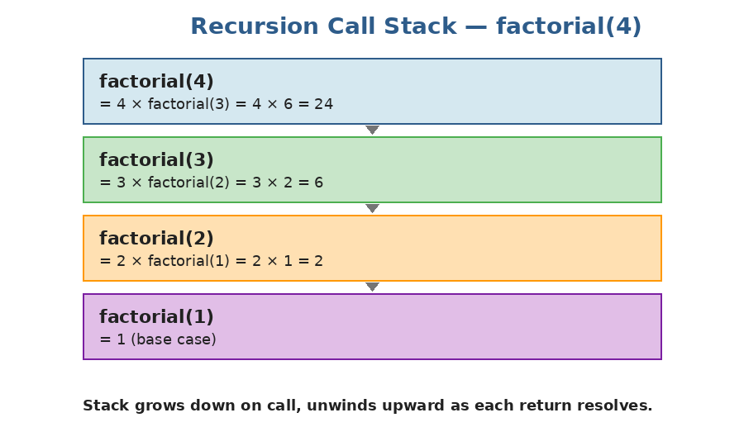
Each call sits on the stack until its child returns. Then we resolve upward, multiplying as we go: 1 → 2 → 6 → 24.
Example: Fibonacci (and why naive recursion is slow)
def fib(n):
if n < 2:
return n
return fib(n-1) + fib(n-2)

fib(10) # → 55

This is correct, but it recomputes the same values exponentially many times. fib(30) takes a noticeable pause; fib(40) takes seconds. We'll fix this with MEMOIZATION later (in the DP topic), but for now, just remember: plain recursion of overlapping subproblems is slow.
Example: power(x, n) — fast exponentiation
How do we compute x^n quickly? Naive: multiply x by itself n times — O(n). Smart: x^n = (x^(n/2))² — recursing halves n each step → O(log n).
def power(x, n):
if n == 0:
return 1
if n < 0:
return 1 / power(x, -n)
half = power(x, n // 2)
if n % 2 == 0:
return half * half
else:
return half * half * x

power(2, 10) # → 1024
power(3, 5) # → 243
# Time: O(log n)

How to think recursively (the trick)
Don't trace every call by hand — that way lies madness. Instead:
- Identify the smallest input where the answer is obvious — that's your base case.
- Assume your function ALREADY WORKS on smaller inputs (a 'recursive leap of faith').
- Use that smaller result to build the answer for the current input.
Example: "reverse a string". Smallest case: a 1-character string is already reversed. For longer strings, assume reverse("ello") works (returns "olle"). Then reverse("hello") = reverse("ello") + "h" = "olleh".
def reverse(s):
if len(s) <= 1:
return s
return reverse(s[1:]) + s[0]

reverse("hello") # → "olleh"

Recursion limits in Python
Python's default recursion limit is 1000: If you exceed it, you get RecursionError. You can raise it with `import sys; sys.setrecursionlimit(10000)`, but if your recursion is going that deep, you should probably convert to iteration. Tail call optimization is NOT a thing in Python.

Practice questions — Topic 6
Q1. Sum of digits. Compute the sum of digits of n recursively. Example: 1234 → 1+2+3+4 = 10.
Answer:
Base case: a single digit returns itself. Recursive: take the last digit (n % 10) and add to the sum of the rest (n // 10).
def sum_digits(n):
if n < 10:
return n
return n % 10 + sum_digits(n // 10)

sum_digits(1234) # → 10

Q2. Power of three. Determine if n is a power of 3, recursively. Example: 27 → True, 45 → False.
Answer:
Base cases: 1 is true (3^0), anything ≤ 0 or not divisible by 3 is false. Otherwise recurse on n//3.
def is_power_of_three(n):
if n < 1: return False
if n == 1: return True
if n % 3 != 0: return False
return is_power_of_three(n // 3)

Q3. Reverse a string recursively. Example: "hello" → "olleh".
Answer:
Base case: empty or 1-char string. Recursive: reverse the tail, then append the first char.
def reverse(s):
if len(s) <= 1:
return s
return reverse(s[1:]) + s[0]

Q4. Climbing Stairs (recursive). You can climb 1 or 2 steps at a time. How many distinct ways to climb n stairs? Example: n=3 → 3 (1+1+1, 1+2, 2+1).
Answer:
Base cases: 1 way to climb 0 or 1 stair. Recursive: ways(n) = ways(n-1) + ways(n-2). (Sound familiar? It's Fibonacci!)
This is exponential as written — we'll add memoization in the DP topic. For now, it's correct but only fast for small n.
def climb_stairs(n):
if n <= 1:
return 1
return climb_stairs(n - 1) + climb_stairs(n - 2)

climb_stairs(3) # → 3

Q5. Print all subsets of a list (preview of backtracking). Example: [1,2,3] → [[],[1],[2],[1,2],[3],[1,3],[2,3],[1,2,3]].
Answer:
For each element, two choices: include it or skip it. Recursion explores both branches.
def subsets(nums):
result = []
def helper(i, current):
if i == len(nums):
result.append(current[:]) # copy!
return
# skip
helper(i + 1, current)
# include
current.append(nums[i])
helper(i + 1, current)
current.pop() # undo
helper(0, [])
return result

subsets([1, 2, 3])
# → [[], [3], [2], [2,3], [1], [1,3], [1,2], [1,2,3]] (order varies)

Q6. Pow(x, n) with negative exponents. Implement x^n in O(log n).
Answer:
Negative exponent: x^(-n) = 1 / x^n. Otherwise use the half-and-square trick.
def my_pow(x, n):
if n == 0:
return 1.0
if n < 0:
return 1 / my_pow(x, -n)
half = my_pow(x, n // 2)
if n % 2 == 0:
return half * half
else:
return half * half * x

my_pow(2.0, 10) # → 1024.0
my_pow(2.0, -2) # → 0.25

Q7. Fibonacci with a counter (to feel the slowness). Compute fib(n) and count how many calls were made.
Answer:
fib(n) makes about 2^n calls — exponential. fib(20) → 13,529 calls. fib(30) → 1,664,079. This is what 'overlapping subproblems' looks like in practice.
def fib_counted(n, counter):
counter[0] += 1
if n < 2:
return n
return fib_counted(n-1, counter) + fib_counted(n-2, counter)

counter = [0]
fib_counted(10, counter)
print(counter[0]) # → 177 calls just to compute fib(10)!

# Try n=20: 13,529 calls. n=30: 1,664,079.
# This is why memoization will be crucial in the DP topic.

You've finished Stage 1!
If you've worked through all 6 topics — reading explanations, typing every code example, and solving the practice questions — you now have the foundation needed for everything that follows.
What you should now be comfortable with
- Saying the Big-O of a piece of code without thinking too hard about it.
- Recognizing when to use two pointers, sliding window, or prefix sum on an array problem.
- Reaching for a dict or set whenever you need fast "have I seen this?" lookups.
- Writing a recursive function with a clean base case + recursive case.
- Using XOR and basic bit tricks for the cases where they're the right tool.
Before moving on to Stage 2
Take one rest day, then test yourself:
- Re-implement two_sum, max_subarray, is_palindrome, single_number, and factorial — all from scratch, without looking. Time yourself: each should take under 5 minutes.
- Re-read your handwritten cheatsheet from Stage 1. If you don't have one, make one now — one page per topic.
- Pick any 3 problems from this guide that you found hardest and re-solve them.
- Only when those feel comfortable should you move to Stage 2 (Linked Lists, Stacks, Queues).

Good luck. The next stage is built on what you just learned — so don't move on until this is solid.

