DSA Stage 2 — Study Guide
Linear DS, Sorting & Searching

Linked Lists • Stacks • Queues • Sorting Algorithms • Binary Search

How to use this guide: This document covers all 5 topics of Stage 2 from your study plan. Each topic uses Python throughout, with diagrams to visualize what's happening, code you can type and run, and practice questions with full answers. Same format as Stage 1 — read, type, attempt, then check.

What you should already know (from Stage 1)
- Comfortable with Big-O — O(1), O(n), O(log n), O(n log n), O(n²).
- Python lists (arrays) and their operation costs.
- Hash maps (dicts) for O(1) lookup.
- Recursion with a base case + recursive case.
If any of those feel shaky, go back to Stage 1 first. Stage 2 will assume them.

Reading order
- Topic 7 — Linked Lists (the first "pointer-heavy" data structure)
- Topic 8 — Stacks (LIFO; the monotonic stack pattern)
- Topic 9 — Queues & Deques (FIFO; sliding window max)
- Topic 10 — Sorting Algorithms (bubble, insertion, merge, quick, counting)
- Topic 11 — Binary Search (and the "search on the answer" twist)

Topic 7 — Linked Lists
What is a linked list?
A linked list is a sequence of NODES, where each node holds a value and a POINTER to the next node. Unlike an array, the nodes don't sit next to each other in memory — they're scattered around, connected only by pointers.
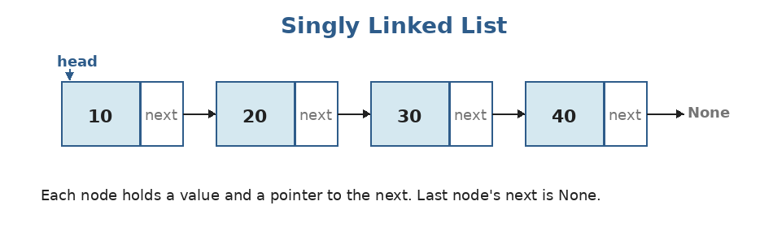
Each node has two parts: the value, and `next` (a reference to the next node). The last node points to None.
Linked list vs array — what's the trade-off?
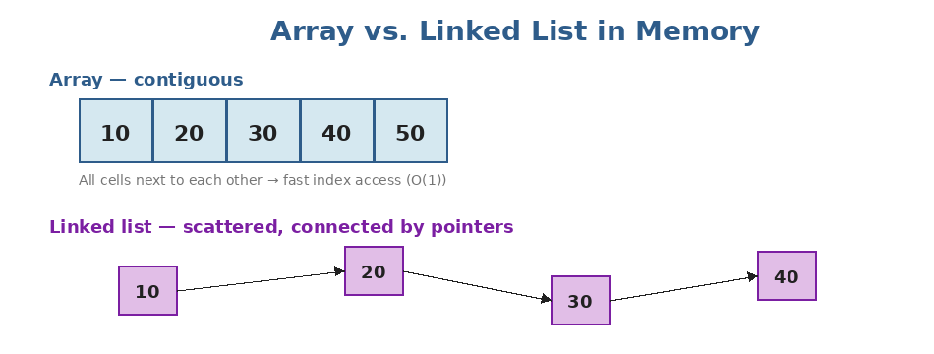
Arrays store elements in one contiguous block. Linked lists scatter them across memory and connect with pointers.
Operation | Time complexity
Access by index arr[i] | Array: O(1) • LL: O(n)
Insert at start | Array: O(n) • LL: O(1)
Insert at end | Array: O(1)* • LL: O(1) if you have a tail pointer
Delete a known node | Array: O(n) (shift) • LL: O(1) (just rewire)
Search for a value | Array: O(n) • LL: O(n)
Memory overhead | Array: low • LL: extra pointer per node

When to use a linked list: Use a linked list when you do lots of inserts and deletes in the middle, and rarely need random access. In real Python code, you usually just use a list — but linked lists are essential for understanding pointer-based structures (trees, graphs) and they appear constantly in interviews.

Building a linked list in Python
class ListNode:
def __init__(self, val=0, next=None):
self.val = val
self.next = next

# Build the list 10 → 20 → 30 → None
node3 = ListNode(30)
node2 = ListNode(20, node3)
node1 = ListNode(10, node2)
head = node1

# Walk through and print
curr = head
while curr:
print(curr.val)
curr = curr.next
# 10
# 20
# 30

Helper to convert a Python list to a linked list (and back) — handy for testing:
def build(values):
dummy = ListNode()
curr = dummy
for v in values:
curr.next = ListNode(v)
curr = curr.next
return dummy.next

def to_list(head):
out = []
while head:
out.append(head.val)
head = head.next
return out

head = build([1, 2, 3, 4])
to_list(head) # → [1, 2, 3, 4]

The dummy node trick: Notice how `build` uses a `dummy` node? This is a CLASSIC pattern. It avoids the special case of "what if the list is empty?" — you always have a node to attach to. At the end, return `dummy.next`. Use this in any function that builds or modifies a linked list from the front.

Pattern 1: Reversing a linked list
This is THE most-asked linked list problem. You should be able to write it from memory in under 2 minutes by the end of this topic. The trick is using THREE pointers: prev, curr, and a temporary next.
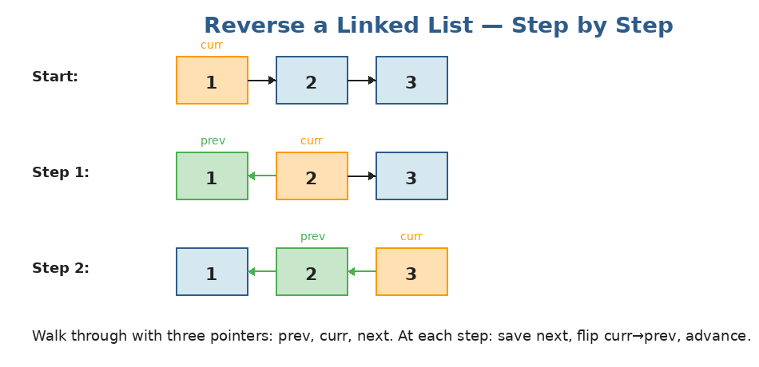
At each step, we save curr.next, flip curr.next to point to prev, then advance prev and curr.
def reverse_list(head):
prev = None
curr = head
while curr:
next_node = curr.next # 1. save next
curr.next = prev # 2. flip pointer
prev = curr # 3. advance prev
curr = next_node # 4. advance curr
return prev # prev is the new head

# Time: O(n), Space: O(1)

Pattern 2: Fast and Slow pointers
Two pointers, but instead of moving from opposite ends, both start at the head. The 'slow' pointer moves 1 step at a time. The 'fast' pointer moves 2 steps. This unlocks several classic problems.
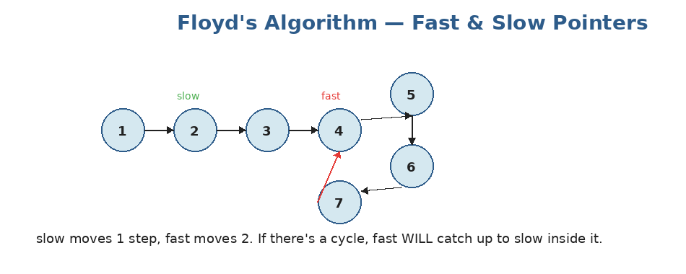
If there's a cycle, the fast pointer will eventually lap the slow one and they'll collide. If fast hits None, no cycle.
Use 1 — find the middle of a list:
def find_middle(head):
slow = fast = head
while fast and fast.next:
slow = slow.next
fast = fast.next.next
return slow
# When fast reaches the end, slow is at the middle. O(n) time, O(1) space.

Use 2 — detect a cycle:
def has_cycle(head):
slow = fast = head
while fast and fast.next:
slow = slow.next
fast = fast.next.next
if slow == fast:
return True
return False

Use 3 — find the Nth node from the end (one pass):
def remove_nth_from_end(head, n):
dummy = ListNode(0, head)
fast = slow = dummy
# Move fast n steps ahead first
for _ in range(n):
fast = fast.next
# Now move both until fast hits the last node
while fast.next:
fast = fast.next
slow = slow.next
# slow is now just before the node to remove
slow.next = slow.next.next
return dummy.next

Doubly linked list (briefly)
A doubly linked list adds a `prev` pointer to each node, so you can walk in both directions. It's the foundation for LRU caches and Python's collections.deque. We'll see it again later.
class DListNode:
def __init__(self, val=0):
self.val = val
self.prev = None
self.next = None

Practice questions — Topic 7
Note: All problems below assume the ListNode class defined above. Test inputs use the build() helper.
Q1. Reverse Linked List. Given the head of a singly linked list, reverse it and return the new head. Example: 1→2→3→4→5 becomes 5→4→3→2→1.
Answer:
Use the three-pointer pattern: prev, curr, next. At each step, save next, flip curr's pointer, advance prev and curr.
def reverse_list(head):
prev = None
curr = head
while curr:
nxt = curr.next
curr.next = prev
prev = curr
curr = nxt
return prev

# Time: O(n), Space: O(1)

Q2. Middle of the Linked List. Return the middle node. If even number of nodes, return the second middle. Example: 1→2→3→4→5 → returns the node with value 3.
Answer:
Fast/slow pointers. Slow moves 1 step, fast moves 2. When fast can't move forward anymore, slow is at the middle.
def middle_node(head):
slow = fast = head
while fast and fast.next:
slow = slow.next
fast = fast.next.next
return slow

# Time: O(n), Space: O(1)

Q3. Linked List Cycle. Detect if a linked list has a cycle. Return True if there's a cycle, False otherwise.
Answer:
Floyd's Tortoise and Hare. If there's a cycle, the fast pointer (moving 2x) will eventually meet the slow pointer (moving 1x).
If fast reaches None, no cycle — done.
def has_cycle(head):
slow = fast = head
while fast and fast.next:
slow = slow.next
fast = fast.next.next
if slow == fast:
return True
return False

# Time: O(n), Space: O(1)

Q4. Merge Two Sorted Lists. Merge two sorted linked lists into one sorted list. Example: 1→3→5 and 2→4→6 → 1→2→3→4→5→6.
Answer:
Use a dummy node. Walk both lists in parallel; at each step, attach the smaller node to the result and advance that pointer. After the loop, attach whatever is left from either list.
def merge_two_lists(l1, l2):
dummy = ListNode()
tail = dummy
while l1 and l2:
if l1.val <= l2.val:
tail.next = l1
l1 = l1.next
else:
tail.next = l2
l2 = l2.next
tail = tail.next
tail.next = l1 if l1 else l2 # attach remainder
return dummy.next

# Time: O(n + m), Space: O(1)

Q5. Remove Nth Node From End. Remove the n-th node from the end of the list. Example: head=1→2→3→4→5, n=2 → 1→2→3→5.
Answer:
Two pointers. Move 'fast' n steps ahead first. Then advance both until fast reaches the last node — slow will be right BEFORE the node to remove.
Use a dummy node so removing the first node is no special case.
def remove_nth_from_end(head, n):
dummy = ListNode(0, head)
fast = slow = dummy
for _ in range(n):
fast = fast.next
while fast.next:
fast = fast.next
slow = slow.next
slow.next = slow.next.next
return dummy.next

# Time: O(n), Space: O(1) — single pass

Q6. Palindrome Linked List. Check if a singly linked list is a palindrome. Example: 1→2→2→1 → True.
Answer:
Step 1: find the middle with fast/slow.
Step 2: reverse the second half.
Step 3: walk the first half and reversed-second half in parallel, comparing values.
def is_palindrome(head):
# 1. Find middle
slow = fast = head
while fast and fast.next:
slow = slow.next
fast = fast.next.next

# 2. Reverse second half
prev = None
while slow:
nxt = slow.next
slow.next = prev
prev = slow
slow = nxt

# 3. Compare
left, right = head, prev
while right:
if left.val != right.val: return False
left = left.next
right = right.next
return True

# Time: O(n), Space: O(1)

Q7. Intersection of Two Linked Lists. Two lists may share a tail (Y-shape). Return the node where they intersect, or None if they don't.
Answer:
Beautiful trick: walk pointer A through list A, then through list B. Walk pointer B through list B, then through list A. Both pointers travel the same total distance, so they meet at the intersection (or both reach None if no intersection).
def get_intersection(headA, headB):
a, b = headA, headB
while a is not b:
a = a.next if a else headB
b = b.next if b else headA
return a # either the intersection node, or None

# Time: O(n + m), Space: O(1)

Topic 8 — Stacks
What is a stack?
A stack is a Last-In-First-Out (LIFO) data structure. You can only add or remove from the TOP. Think of a stack of plates — the last one you put on is the first one you take off.
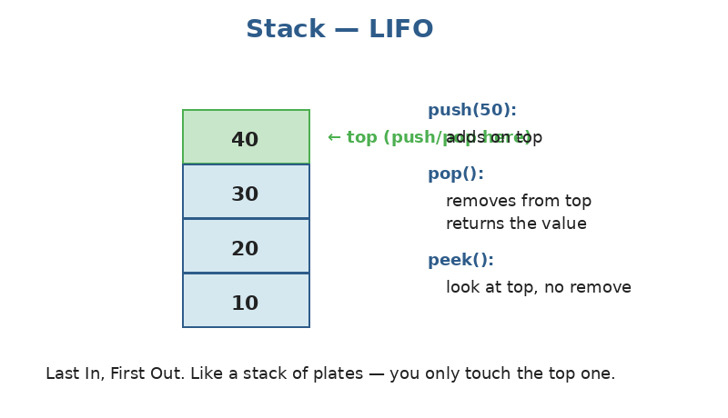
The three operations of a stack. Each is O(1).
Stacks in Python
In Python, you don't need a special class — a regular list IS a stack. `append()` is push, `pop()` is pop:
stack = []

stack.append(10) # push
stack.append(20)
stack.append(30)
print(stack) # [10, 20, 30]

top = stack.pop() # → 30 (the last in)
print(stack) # [10, 20]

# Peek (look at top without removing)
top = stack[-1] # → 20

# Check if empty
not stack # True if empty

Why use a list?: Python's list does push/pop at the end in O(1) amortized — that's exactly what a stack needs. Don't use list.pop(0) or list.insert(0, x) for stack operations — those are O(n) because they shift everything.

Where stacks show up — function calls
Every time you call a function, Python pushes a new frame onto an internal CALL STACK. When the function returns, that frame is popped. This is also why deep recursion can blow up: too many frames stack up.
Pattern 1: Matching pairs / valid parentheses
When you see opening and closing characters that need to match in the right order, a stack is almost always the answer. Push openers; when you see a closer, pop and check it matches.
def is_valid(s):
pairs = {')': '(', ']': '[', '}': '{'}
stack = []
for ch in s:
if ch in '([{':
stack.append(ch)
else: # ch is a closer
if not stack or stack.pop() != pairs[ch]:
return False
return not stack # all openers matched

is_valid("()[]{}") # → True
is_valid("([)]") # → False (mismatched order)
is_valid("{[]}") # → True

Pattern 2: Monotonic stack (next greater element)
A monotonic stack is one where the values inside are always in sorted order (either always increasing or always decreasing). Whenever a new value would break the order, you pop until it doesn't. This is the secret to solving 'next greater element' style problems in O(n) instead of O(n²).
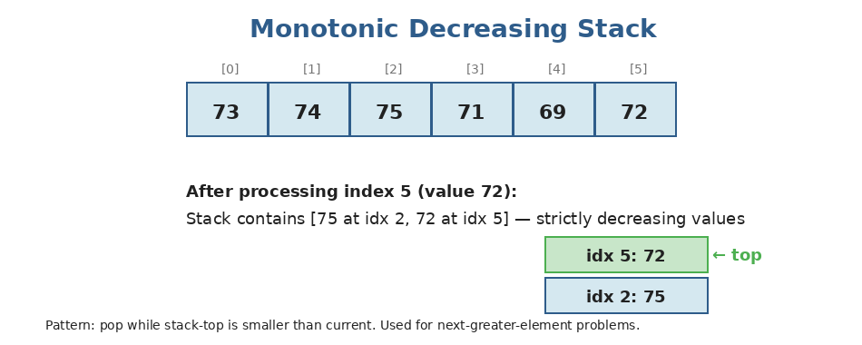
Decreasing monotonic stack: each new value pops everything smaller. The popped element's 'next greater' is exactly the value that pushed it out.
Classic example — Daily Temperatures: for each day, how many days until a warmer day?
def daily_temperatures(temps):
n = len(temps)
answer = [0] * n
stack = [] # stack of indices, temps decreasing
for i, t in enumerate(temps):
while stack and temps[stack[-1]] < t:
j = stack.pop()
answer[j] = i - j # j's next-warmer is at i
stack.append(i)
return answer

daily_temperatures([73, 74, 75, 71, 69, 72, 76, 73])
# → [1, 1, 4, 2, 1, 1, 0, 0]
# Time: O(n) — each index pushed and popped at most once

Why is this O(n)?: Each element is pushed once and popped at most once. Even though there's a while loop inside the for loop, across the WHOLE run the inner while-loop body runs at most n times total. This is called amortized analysis.

Practice questions — Topic 8
Q1. Valid Parentheses. Given a string of only '()[]{}', return True if every opener has a matching closer in the right order. Example: "({[]})" → True.
Answer:
Stack of openers. Push when you see '(' '[' '{'. When you see a closer, pop and check it matches.
def is_valid(s):
pairs = {')': '(', ']': '[', '}': '{'}
stack = []
for ch in s:
if ch in '([{':
stack.append(ch)
else:
if not stack or stack.pop() != pairs[ch]:
return False
return not stack

Q2. Min Stack. Design a stack that, in addition to push/pop/top, also returns the minimum element in O(1).
Answer:
Use a SECOND stack that stores the running minimum. Each time we push, also push min(new_val, current_min) onto the min-stack. Pop them together.
class MinStack:
def __init__(self):
self.stack = []
self.min_stack = []

def push(self, val):
self.stack.append(val)
if not self.min_stack:
self.min_stack.append(val)
else:
self.min_stack.append(min(val, self.min_stack[-1]))

def pop(self):
self.stack.pop()
self.min_stack.pop()

def top(self):
return self.stack[-1]

def get_min(self):
return self.min_stack[-1]

# All ops O(1) time, O(n) space

Q3. Daily Temperatures. For each day's temperature, return the number of days until a warmer day (0 if no warmer day comes). Example: [73,74,75,71,69,72,76,73] → [1,1,4,2,1,1,0,0].
Answer:
Monotonic decreasing stack of indices. When today is warmer than the index on top, pop and record the gap.
def daily_temperatures(temps):
n = len(temps)
answer = [0] * n
stack = []
for i, t in enumerate(temps):
while stack and temps[stack[-1]] < t:
j = stack.pop()
answer[j] = i - j
stack.append(i)
return answer

# Time: O(n), Space: O(n)

Q4. Evaluate Reverse Polish Notation. Evaluate an expression in postfix notation. Example: ["2","1","+","3","*"] → 9, because (2+1)*3.
Answer:
Walk through tokens. If it's a number, push. If it's an operator, pop two numbers, apply the op, push the result.
Watch out: the order of popping matters for - and / (b is popped first, then a, and you compute a OP b).
def eval_rpn(tokens):
stack = []
for t in tokens:
if t in {'+', '-', '*', '/'}:
b = stack.pop()
a = stack.pop()
if t == '+': stack.append(a + b)
elif t == '-': stack.append(a - b)
elif t == '*': stack.append(a * b)
else: stack.append(int(a / b)) # truncate toward zero
else:
stack.append(int(t))
return stack[0]

eval_rpn(["2","1","+","3","*"]) # → 9

Q5. Generate Parentheses. Given n, generate all valid combinations of n pairs of parentheses. Example: n=3 → ["((()))","(()())","(())()","()(())","()()()"].
Answer:
Use recursion (which is implicitly stack-based). Track how many '(' and ')' we've used. Add '(' if we haven't used n yet. Add ')' only if we've placed more '(' than ')' so far.
def generate_parentheses(n):
result = []
def backtrack(s, open_count, close_count):
if len(s) == 2 * n:
result.append(s)
return
if open_count < n:
backtrack(s + '(', open_count + 1, close_count)
if close_count < open_count:
backtrack(s + ')', open_count, close_count + 1)
backtrack('', 0, 0)
return result

generate_parentheses(3)
# → ['((()))', '(()())', '(())()', '()(())', '()()()']

Q6. Next Greater Element. For each element in nums, find the next greater element to its right (or -1 if none). Example: [2,1,2,4,3] → [4,2,4,-1,-1].
Answer:
Monotonic decreasing stack — same pattern as Daily Temperatures, but we record the VALUE not the gap.
def next_greater(nums):
n = len(nums)
answer = [-1] * n
stack = [] # indices
for i, x in enumerate(nums):
while stack and nums[stack[-1]] < x:
j = stack.pop()
answer[j] = x
stack.append(i)
return answer

next_greater([2, 1, 2, 4, 3]) # → [4, 2, 4, -1, -1]

Q7. Largest Rectangle in Histogram. Given an array of bar heights, find the area of the largest rectangle. Example: [2,1,5,6,2,3] → 10 (5 and 6, width 2).
Answer:
Hard problem — uses a monotonic INCREASING stack of indices. When we see a shorter bar, we pop and compute the area for the popped height (its width spans from after the new top of stack to the current index).
Trick: append a 0 at the end so the stack drains naturally.
def largest_rectangle(heights):
stack = [] # indices, heights at these indices increasing
heights = heights + [0] # sentinel
best = 0
for i, h in enumerate(heights):
while stack and heights[stack[-1]] > h:
top = stack.pop()
width = i if not stack else i - stack[-1] - 1
best = max(best, heights[top] * width)
stack.append(i)
return best

largest_rectangle([2, 1, 5, 6, 2, 3]) # → 10
# Time: O(n), Space: O(n)

Topic 9 — Queues & Deques
What is a queue?
A queue is a First-In-First-Out (FIFO) structure. You add to one end (the BACK) and remove from the other end (the FRONT). Think of a line at a coffee shop — first to arrive is first to be served.
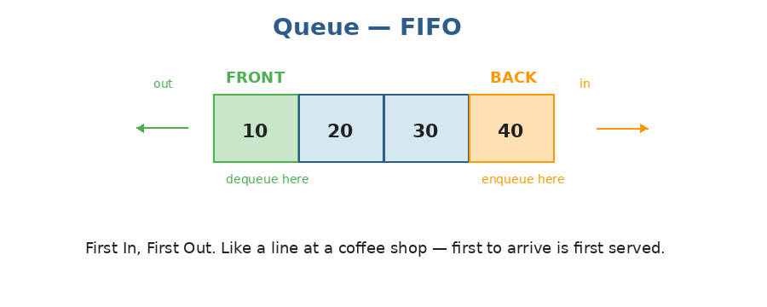
Items enter at the back, leave from the front. Both operations are O(1) with the right structure.
Don't use a Python list as a queue
Important Python detail: A Python list makes a TERRIBLE queue. Removing from the front (list.pop(0)) is O(n) because every other element has to shift left. For queues, ALWAYS use collections.deque — its popleft() is O(1).

from collections import deque

q = deque()

q.append(10) # enqueue (add to back) — O(1)
q.append(20)
q.append(30)
print(q) # deque([10, 20, 30])

x = q.popleft() # dequeue (remove from front) — O(1)
print(x) # 10
print(q) # deque([20, 30])

# Peek at front
front = q[0] # → 20

# Check if empty
not q # True if empty

Where queues show up — BFS
The most common use of a queue in interviews is Breadth-First Search (BFS) on trees and graphs. We process nodes level by level: pop a node, add its neighbors to the queue, repeat. We'll cover this in detail when we get to trees and graphs.
Deque — the queue's bigger sibling
A deque ("deck", short for double-ended queue) lets you push and pop from BOTH ends in O(1). Python's collections.deque is actually a deque, not just a queue. Same import, more powerful.
from collections import deque

dq = deque([1, 2, 3])

dq.append(4) # add to right (back) — O(1)
dq.appendleft(0) # add to left (front) — O(1)
print(dq) # deque([0, 1, 2, 3, 4])

dq.pop() # remove from right (back) → 4
dq.popleft() # remove from left (front) → 0

Pattern: Monotonic deque — Sliding Window Maximum
Famous problem: given an array and a window size k, return the max of every window of size k. Naive solution is O(n·k). With a monotonic deque, it's O(n).
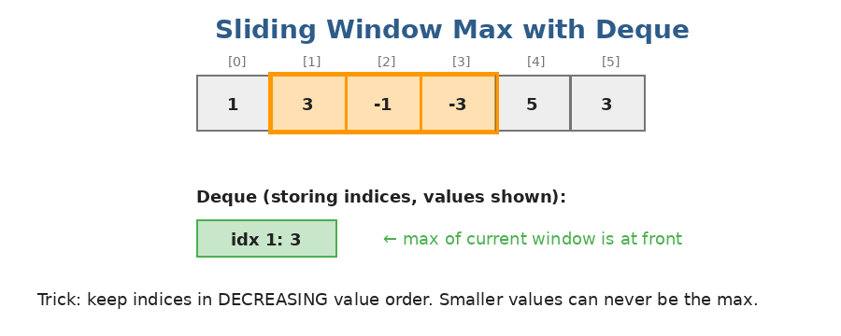
The deque stores INDICES whose values are decreasing. The front is always the max of the current window.
The trick:
- Before adding a new index to the back, pop from the back any indices whose values are smaller (they can never be the max).
- If the front index has fallen out of the window, pop it from the front.
- After both cleanups, the front is the current window's max.
from collections import deque

def sliding_window_max(nums, k):
dq = deque() # stores indices
result = []
for i, x in enumerate(nums):
# Remove smaller values from the back
while dq and nums[dq[-1]] < x:
dq.pop()
dq.append(i)
# Remove the front if it's out of the window
if dq[0] <= i - k:
dq.popleft()
# Once we have a full window, record the max
if i >= k - 1:
result.append(nums[dq[0]])
return result

sliding_window_max([1, 3, -1, -3, 5, 3, 6, 7], 3)
# → [3, 3, 5, 5, 6, 7]
# Time: O(n) — each index added and removed at most once

Practice questions — Topic 9
Q1. Implement Queue using Stacks. Implement a queue using only stacks (push, pop, peek, empty).
Answer:
Two stacks. push() adds to the input stack. pop() and peek() use the output stack — if it's empty, transfer everything from input to output (which reverses the order, putting the oldest on top).
Each element is pushed and popped at most twice → amortized O(1) per operation.
class MyQueue:
def __init__(self):
self.in_stack = []
self.out_stack = []

def push(self, x):
self.in_stack.append(x)

def _move(self):
if not self.out_stack:
while self.in_stack:
self.out_stack.append(self.in_stack.pop())

def pop(self):
self._move()
return self.out_stack.pop()

def peek(self):
self._move()
return self.out_stack[-1]

def empty(self):
return not self.in_stack and not self.out_stack

Q2. Sliding Window Maximum. Given nums and k, return the max of every window of size k. Example: nums=[1,3,-1,-3,5,3,6,7], k=3 → [3,3,5,5,6,7].
Answer:
Monotonic decreasing deque of indices. Each step: pop smaller indices from the back, append current, drop the front if it's out of the window.
from collections import deque

def max_sliding_window(nums, k):
dq = deque()
result = []
for i, x in enumerate(nums):
while dq and nums[dq[-1]] < x:
dq.pop()
dq.append(i)
if dq[0] <= i - k:
dq.popleft()
if i >= k - 1:
result.append(nums[dq[0]])
return result

# Time: O(n), Space: O(k)

Q3. Number of Recent Calls. Build a counter that, on each ping(t), returns the number of pings within the last 3000 ms (inclusive). Pings come in non-decreasing time order.
Answer:
Use a deque. On each ping(t): append t, pop from the front while front < t - 3000, return len(deque).
from collections import deque

class RecentCounter:
def __init__(self):
self.q = deque()

def ping(self, t):
self.q.append(t)
while self.q[0] < t - 3000:
self.q.popleft()
return len(self.q)

# Each ping is amortized O(1)

Q4. Design Circular Queue. Implement a fixed-size circular queue with enQueue, deQueue, Front, Rear, isEmpty, isFull.
Answer:
Use a fixed-size list and two pointers (head and tail) with modular arithmetic. Track size separately to distinguish empty from full.
class MyCircularQueue:
def __init__(self, k):
self.q = [0] * k
self.capacity = k
self.head = 0
self.size = 0

def enQueue(self, value):
if self.size == self.capacity: return False
tail = (self.head + self.size) % self.capacity
self.q[tail] = value
self.size += 1
return True

def deQueue(self):
if self.size == 0: return False
self.head = (self.head + 1) % self.capacity
self.size -= 1
return True

def Front(self):
return -1 if self.size == 0 else self.q[self.head]

def Rear(self):
if self.size == 0: return -1
return self.q[(self.head + self.size - 1) % self.capacity]

def isEmpty(self): return self.size == 0
def isFull(self): return self.size == self.capacity

Q5. First Negative in Every Window of Size K. Given an array and k, find the first negative number in every window of size k. Example: [12,-1,-7,8,-15,30,16,28], k=3 → [-1,-1,-7,-15,-15,0].
Answer:
Deque of indices of NEGATIVE values. For each i: append if nums[i] < 0, drop the front if out of window. Front of deque (if any) is the first negative in the current window.
from collections import deque

def first_negative(nums, k):
dq = deque()
result = []
for i, x in enumerate(nums):
if x < 0:
dq.append(i)
if dq and dq[0] <= i - k:
dq.popleft()
if i >= k - 1:
result.append(nums[dq[0]] if dq else 0)
return result

# Time: O(n), Space: O(k)

Q6. Implement Stack using Queues. Implement a LIFO stack using only queue operations (enqueue at back, dequeue from front).
Answer:
Easiest version: use ONE queue. On push, enqueue the new element, then rotate the queue so the new element ends up at the front.
from collections import deque

class MyStack:
def __init__(self):
self.q = deque()

def push(self, x):
self.q.append(x)
# Rotate so x is at the front
for _ in range(len(self.q) - 1):
self.q.append(self.q.popleft())

def pop(self):
return self.q.popleft()

def top(self):
return self.q[0]

def empty(self):
return not self.q

# push is O(n), all others O(1)

Q7. Reveal Cards in Increasing Order. Given a deck, return an arrangement so that revealing cards using "reveal top, then move new top to bottom" gives them in increasing order.
Answer:
Simulate backwards. Sort the deck. Use a deque of EMPTY POSITIONS (0..n-1). For each card (smallest first), put it at deque.popleft(), then rotate by moving the next position to the back.
from collections import deque

def deck_revealed_increasing(deck):
n = len(deck)
deck.sort()
positions = deque(range(n))
result = [0] * n
for card in deck:
result[positions.popleft()] = card
if positions:
positions.append(positions.popleft())
return result

deck_revealed_increasing([17,13,11,2,3,5,7])
# → [2,13,3,11,5,17,7]

Topic 10 — Sorting Algorithms
Why learn sorting?
Python gives you sorted() and list.sort() for free — both are O(n log n) and very fast. So why study sorts? Three reasons: (1) interviewers ask you to implement them; (2) the partition logic in quicksort shows up in OTHER algorithms (like quickselect); (3) understanding when sorting beats brute-force is a core skill.
We'll cover 5 sorts: bubble, selection, insertion, merge, quicksort. Plus counting sort for special cases.
1. Bubble Sort — O(n²)
The simplest (and slowest) sort. Walk through the list, compare adjacent pairs, swap if out of order. Each pass 'bubbles' the largest remaining element to the end. After n-1 passes, sorted.
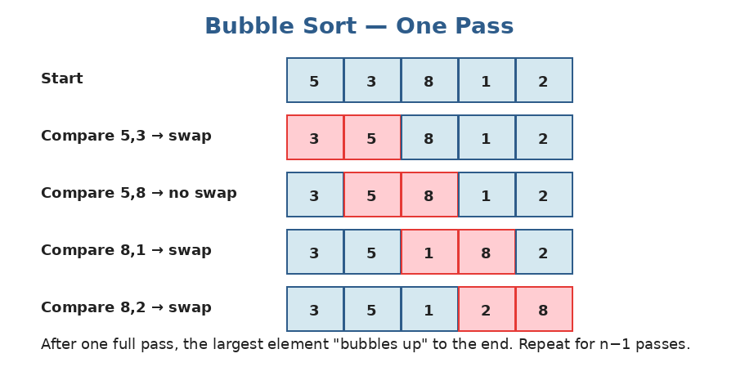
One pass of bubble sort. Red cells are being compared. The largest value reaches the end after each full pass.
def bubble_sort(arr):
n = len(arr)
for i in range(n - 1):
swapped = False
for j in range(n - 1 - i):
if arr[j] > arr[j+1]:
arr[j], arr[j+1] = arr[j+1], arr[j]
swapped = True
if not swapped: # already sorted, early exit
return arr
return arr

# Time: O(n²) worst, O(n) best (already sorted with early-exit). Space: O(1)

2. Insertion Sort — O(n²) but fast on small/almost-sorted data
Imagine sorting a hand of playing cards. You pick up cards one at a time and insert each into its correct spot among the cards already in your hand. That's insertion sort.
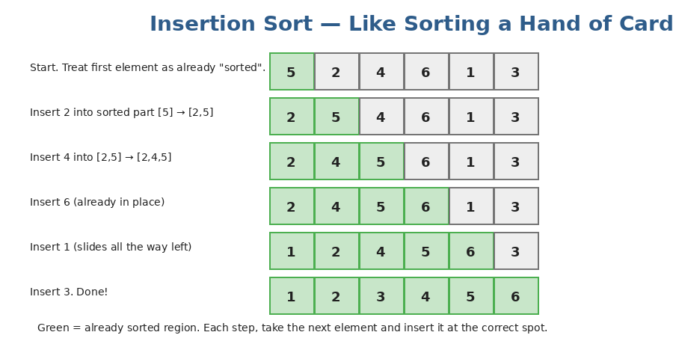
Green cells are already sorted. Each step picks the next element and slides it left to its right place.
def insertion_sort(arr):
for i in range(1, len(arr)):
key = arr[i]
j = i - 1
# Slide larger elements one step to the right
while j >= 0 and arr[j] > key:
arr[j+1] = arr[j]
j -= 1
arr[j+1] = key
return arr

# Time: O(n²) worst. O(n) best (already sorted). Space: O(1)
# Sweet spot: insertion sort is fast for small n (< 50) or nearly-sorted data.

Why insertion sort matters: Real production sorts (Python's Timsort, Java's Dual-Pivot Quicksort) actually fall back to insertion sort for small subarrays because it has lower constant overhead. Don't dismiss it as "just" an O(n²) sort.

3. Selection Sort — O(n²)
Each pass, FIND the minimum of the unsorted region and SWAP it to the front of the unsorted region. Simple but does the same n² work even on already-sorted data.
def selection_sort(arr):
n = len(arr)
for i in range(n - 1):
min_idx = i
for j in range(i + 1, n):
if arr[j] < arr[min_idx]:
min_idx = j
arr[i], arr[min_idx] = arr[min_idx], arr[i]
return arr

# Time: O(n²) always (no early exit). Space: O(1)

4. Merge Sort — O(n log n)
The first 'fast' sort. The idea: split the array in half, recursively sort each half, then MERGE the two sorted halves into one sorted whole. Splitting takes log n levels; each level does O(n) merging. Total: O(n log n).
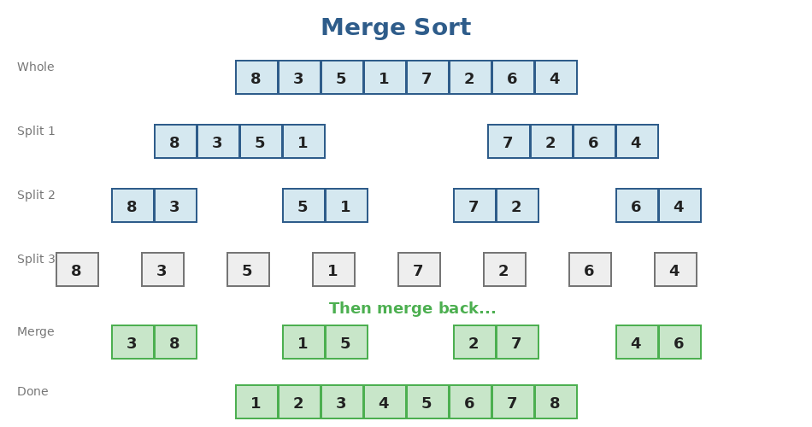
Top-down: keep splitting until each piece has 1 element. Bottom-up: merge sorted pieces back together.
def merge_sort(arr):
if len(arr) <= 1:
return arr
mid = len(arr) // 2
left = merge_sort(arr[:mid])
right = merge_sort(arr[mid:])
return merge(left, right)

def merge(left, right):
result = []
i = j = 0
while i < len(left) and j < len(right):
if left[i] <= right[j]:
result.append(left[i])
i += 1
else:
result.append(right[j])
j += 1
result.extend(left[i:])
result.extend(right[j:])
return result

merge_sort([8, 3, 5, 1, 7, 2, 6, 4])
# → [1, 2, 3, 4, 5, 6, 7, 8]
# Time: O(n log n) ALWAYS. Space: O(n) for the merge buffers.
# STABLE: equal elements keep their relative order.

5. Quicksort — O(n log n) average, O(n²) worst
Quicksort picks a PIVOT, then partitions the array so all smaller elements are on its left and all larger elements are on its right. The pivot is now in its final sorted position. Recurse on the two sides.
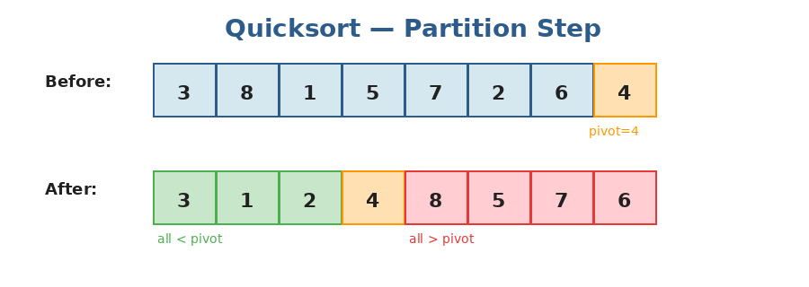
One partition step around pivot=4. The orange pivot lands in its final position; everything left is smaller, everything right is larger.
def quicksort(arr, lo=0, hi=None):
if hi is None: hi = len(arr) - 1
if lo < hi:
p = partition(arr, lo, hi)
quicksort(arr, lo, p - 1)
quicksort(arr, p + 1, hi)
return arr

def partition(arr, lo, hi):
pivot = arr[hi] # use last element as pivot
i = lo - 1 # boundary of "smaller" region
for j in range(lo, hi):
if arr[j] <= pivot:
i += 1
arr[i], arr[j] = arr[j], arr[i]
arr[i+1], arr[hi] = arr[hi], arr[i+1]
return i + 1 # final pivot position

quicksort([3, 8, 1, 5, 7, 2, 6, 4])
# → [1, 2, 3, 4, 5, 6, 7, 8]
# Time: O(n log n) average. O(n²) if pivots are bad (e.g. always picking smallest).
# Space: O(log n) average for the recursion stack.

Quicksort vs Merge sort: Same Big-O on average, but quicksort is usually FASTER in practice (better cache behavior, in-place). Merge sort is preferred when (a) you need stability or (b) you care about worst-case guarantees.

6. Counting Sort — O(n + k) when input range is small
If you know the values are integers in a small range (say, 0..1000), you can sort in O(n) by COUNTING how many of each value exist, then writing them out in order. Not a comparison sort — beats the O(n log n) lower bound.
def counting_sort(arr):
if not arr: return arr
max_val = max(arr)
counts = [0] * (max_val + 1)
for x in arr:
counts[x] += 1
out = []
for v, c in enumerate(counts):
out.extend([v] * c)
return out

counting_sort([4, 2, 2, 8, 3, 3, 1]) # → [1, 2, 2, 3, 3, 4, 8]
# Time: O(n + k) where k = max value. Space: O(k).
# Great when k is small. Useless when k is huge (e.g. 64-bit integers).

Comparison summary
Operation | Time complexity
Bubble sort | Avg O(n²), Best O(n) — always learn it, never use it
Selection sort | O(n²) always — minimal swaps, otherwise just slow
Insertion sort | Avg O(n²), Best O(n) — fastest for small/almost-sorted
Merge sort | O(n log n) always, stable, O(n) extra space
Quicksort | Avg O(n log n), worst O(n²), in-place
Counting sort | O(n + k), only for integers in small range
Python's sorted | O(n log n) — Timsort (merge + insertion hybrid). Stable.

Practice questions — Topic 10
Q1. Sort an Array. Implement merge sort from scratch. Example: [5,2,3,1] → [1,2,3,5].
Answer:
Standard merge sort — recursively split into halves, then merge the sorted halves.
def sort_array(nums):
if len(nums) <= 1: return nums
mid = len(nums) // 2
left = sort_array(nums[:mid])
right = sort_array(nums[mid:])
# merge
result = []
i = j = 0
while i < len(left) and j < len(right):
if left[i] <= right[j]:
result.append(left[i]); i += 1
else:
result.append(right[j]); j += 1
result.extend(left[i:]); result.extend(right[j:])
return result

Q2. Kth Largest Element in an Array. Find the kth largest element. Example: nums=[3,2,1,5,6,4], k=2 → 5.
Answer:
Easiest: sort and return nums[-k] — O(n log n).
Faster: quickselect (partition like quicksort, but only recurse on the side containing the answer) — O(n) average.
# Simple version
def find_kth_largest(nums, k):
nums.sort()
return nums[-k]

# Quickselect (O(n) average)
import random
def find_kth_largest_qs(nums, k):
target = len(nums) - k # index of kth largest in sorted order
def quickselect(lo, hi):
pivot = nums[random.randint(lo, hi)]
# 3-way partition: < pivot, == pivot, > pivot
lt, gt = lo, hi
i = lo
while i <= gt:
if nums[i] < pivot:
nums[lt], nums[i] = nums[i], nums[lt]
lt += 1; i += 1
elif nums[i] > pivot:
nums[gt], nums[i] = nums[i], nums[gt]
gt -= 1
else:
i += 1
if target < lt: return quickselect(lo, lt-1)
elif target > gt: return quickselect(gt+1, hi)
else: return nums[target]
return quickselect(0, len(nums)-1)

Q3. Sort Colors (Dutch National Flag). Sort an array containing only 0s, 1s, and 2s in-place. Example: [2,0,2,1,1,0] → [0,0,1,1,2,2].
Answer:
Three pointers: low (next slot for 0), mid (current), high (next slot for 2). Walk mid forward.
If arr[mid]==0: swap with low, advance both. If 1: just advance mid. If 2: swap with high, decrement high (don't advance mid — could be a 0 or 2 we just swapped in).
def sort_colors(nums):
low, mid, high = 0, 0, len(nums) - 1
while mid <= high:
if nums[mid] == 0:
nums[low], nums[mid] = nums[mid], nums[low]
low += 1
mid += 1
elif nums[mid] == 1:
mid += 1
else: # 2
nums[mid], nums[high] = nums[high], nums[mid]
high -= 1
return nums

# Time: O(n), Space: O(1) — single pass!

Q4. Merge Intervals. Given a list of intervals, merge overlapping ones. Example: [[1,3],[2,6],[8,10],[15,18]] → [[1,6],[8,10],[15,18]].
Answer:
Sort intervals by start time. Walk through; merge each interval into the previous one if they overlap.
def merge(intervals):
intervals.sort(key=lambda x: x[0])
merged = []
for start, end in intervals:
if merged and start <= merged[-1][1]:
merged[-1][1] = max(merged[-1][1], end)
else:
merged.append([start, end])
return merged

merge([[1,3],[2,6],[8,10],[15,18]])
# → [[1,6],[8,10],[15,18]]
# Time: O(n log n) for the sort

Q5. Insert Interval. Given a sorted list of non-overlapping intervals and a new interval, insert it and merge if needed. Example: [[1,3],[6,9]], new=[2,5] → [[1,5],[6,9]].
Answer:
Three phases: (1) add all intervals that end BEFORE the new one starts, (2) merge all overlapping intervals into a single new interval, (3) add the merged one + remaining.
def insert(intervals, new_interval):
result = []
i, n = 0, len(intervals)
# Phase 1: skip intervals before new
while i < n and intervals[i][1] < new_interval[0]:
result.append(intervals[i])
i += 1
# Phase 2: merge overlapping
while i < n and intervals[i][0] <= new_interval[1]:
new_interval[0] = min(new_interval[0], intervals[i][0])
new_interval[1] = max(new_interval[1], intervals[i][1])
i += 1
result.append(new_interval)
# Phase 3: add remaining
while i < n:
result.append(intervals[i])
i += 1
return result

Q6. Meeting Rooms II. Given meeting time intervals, find the MINIMUM number of conference rooms needed. Example: [[0,30],[5,10],[15,20]] → 2.
Answer:
Sort starts and ends separately. Walk through them like a merge: each start needs a room, each end frees one. Track the running count and its max.
def min_meeting_rooms(intervals):
starts = sorted(i[0] for i in intervals)
ends = sorted(i[1] for i in intervals)
rooms = 0
best = 0
s = e = 0
while s < len(starts):
if starts[s] < ends[e]:
rooms += 1
best = max(best, rooms)
s += 1
else:
rooms -= 1
e += 1
return best

min_meeting_rooms([[0,30],[5,10],[15,20]]) # → 2

Q7. Wiggle Sort. Reorder so that nums[0] <= nums[1] >= nums[2] <= nums[3]... Example: [3,5,2,1,6,4] → [1,5,2,6,3,4] (one valid answer).
Answer:
Clever O(n) trick: walk through. At even index, if next is smaller, swap. At odd index, if next is larger, swap. After this single pass, the pattern holds.
def wiggle_sort(nums):
for i in range(len(nums) - 1):
if (i % 2 == 0 and nums[i] > nums[i+1]) or \
(i % 2 == 1 and nums[i] < nums[i+1]):
nums[i], nums[i+1] = nums[i+1], nums[i]
return nums

wiggle_sort([3,5,2,1,6,4]) # e.g. → [3,5,1,6,2,4]
# Time: O(n), Space: O(1)

Topic 11 — Binary Search
What is binary search?
Binary search finds a target in a SORTED array in O(log n) time. The trick: look at the middle. If the middle is the target, done. If the middle is too small, the answer must be on the right. If too big, on the left. Each step CUTS the search range in half.
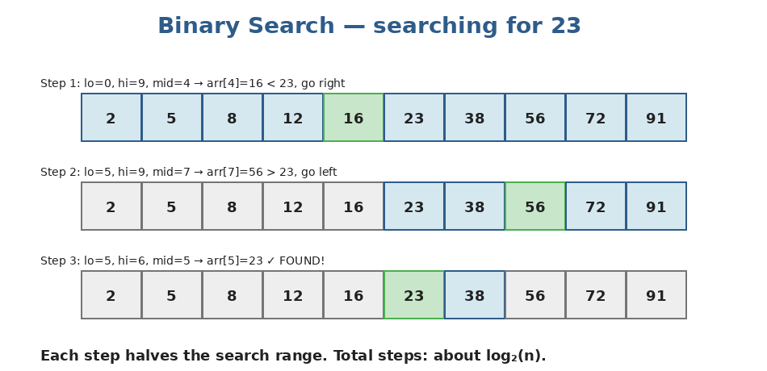
Three steps to find 23 in a 10-element array. Each step halves the range.
Why O(log n) is amazing: n=10 → at most 4 steps. n=1000 → at most 10 steps. n=1,000,000 → at most 20 steps. n=4,000,000,000 (4 billion) → at most 32 steps. Logarithmic growth is the difference between feasible and infeasible.

The classic binary search
def binary_search(nums, target):
lo, hi = 0, len(nums) - 1 # inclusive range
while lo <= hi:
mid = (lo + hi) // 2
if nums[mid] == target:
return mid
elif nums[mid] < target:
lo = mid + 1 # look right
else:
hi = mid - 1 # look left
return -1 # not found

binary_search([1, 3, 5, 7, 9, 11], 7) # → 3
binary_search([1, 3, 5, 7, 9, 11], 4) # → -1

The off-by-one trap: Three things must agree: (1) is your range [lo, hi] inclusive or [lo, hi) half-open? (2) does your while condition match (lo <= hi vs lo < hi)? (3) do you update with mid+1, mid-1, or mid? Pick ONE convention and stick with it. I recommend [lo, hi] inclusive, while lo <= hi, update with mid+1/mid-1.

Python has bisect for free:
from bisect import bisect_left, bisect_right

arr = [1, 3, 3, 3, 5, 7]
bisect_left(arr, 3) # → 1 (leftmost position where 3 can be inserted)
bisect_right(arr, 3) # → 4 (rightmost position)

# To check if x is in arr in O(log n):
i = bisect_left(arr, x)
found = i < len(arr) and arr[i] == x

The big idea: Binary Search on the ANSWER
Most beginners think binary search is only for sorted arrays. WRONG. The deeper idea is: if you can phrase the problem as "is X a feasible answer?" with the property that small X is feasible and big X isn't (or vice versa), you can binary-search the SPACE OF ANSWERS — not just an array.
The pattern: Define a function feasible(x) that returns True/False. Find the smallest (or largest) x for which feasible(x) is True. If feasibility is MONOTONIC (False, False, ..., False, True, True, ..., True), you can binary search.

Classic example — Koko Eating Bananas:
Koko has piles of bananas and h hours to eat them all. Each hour she picks a pile and eats up to k bananas (the rest of that pile waits). Find the minimum k that lets her finish in h hours.
import math

def min_eating_speed(piles, h):
def can_finish(k):
# at speed k, total hours needed:
return sum(math.ceil(p / k) for p in piles) <= h

lo, hi = 1, max(piles)
while lo < hi:
mid = (lo + hi) // 2
if can_finish(mid):
hi = mid # try slower
else:
lo = mid + 1 # need faster
return lo

min_eating_speed([3, 6, 7, 11], 8) # → 4
# Time: O(n log m) where m = max pile size

Binary search on rotated sorted arrays
A rotated sorted array (like [4,5,6,7,0,1,2]) isn't fully sorted, but at any midpoint, ONE half IS sorted. We can still use binary search by figuring out which half is sorted and whether the target lies in it.
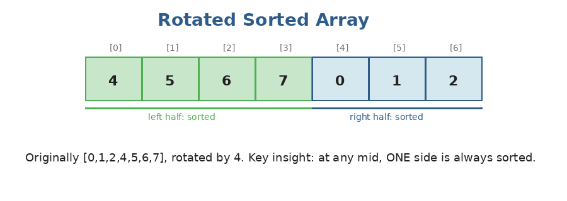
Originally [0,1,2,4,5,6,7], rotated by 4. The left half [4,5,6,7] is sorted; the right half [0,1,2] is sorted. The two halves are stitched at the rotation point.
def search_rotated(nums, target):
lo, hi = 0, len(nums) - 1
while lo <= hi:
mid = (lo + hi) // 2
if nums[mid] == target:
return mid
# Is the left half sorted?
if nums[lo] <= nums[mid]:
if nums[lo] <= target < nums[mid]:
hi = mid - 1
else:
lo = mid + 1
else: # right half is sorted
if nums[mid] < target <= nums[hi]:
lo = mid + 1
else:
hi = mid - 1
return -1

search_rotated([4,5,6,7,0,1,2], 0) # → 4

Practice questions — Topic 11
Q1. Binary Search. Given a sorted array and a target, return the index of target or -1 if not found.
Answer:
The textbook implementation. Pick [lo, hi] inclusive, update with mid+1/mid-1.
def search(nums, target):
lo, hi = 0, len(nums) - 1
while lo <= hi:
mid = (lo + hi) // 2
if nums[mid] == target: return mid
elif nums[mid] < target: lo = mid + 1
else: hi = mid - 1
return -1

Q2. Search Insert Position. Given a sorted array and target, return the index where target IS or where it would be inserted to keep the array sorted. Example: [1,3,5,6], target=2 → 1.
Answer:
Same binary search, but if not found, return lo (where the search settled).
def search_insert(nums, target):
lo, hi = 0, len(nums) - 1
while lo <= hi:
mid = (lo + hi) // 2
if nums[mid] == target: return mid
elif nums[mid] < target: lo = mid + 1
else: hi = mid - 1
return lo

Q3. First Bad Version. Given an API isBadVersion(v) that returns True if v is bad, find the FIRST bad version. All versions after the first bad one are also bad.
Answer:
Binary search for the boundary between False and True. Use lo < hi (no equals) and update hi = mid (not mid - 1) to converge correctly to the first True.
def first_bad_version(n):
lo, hi = 1, n
while lo < hi:
mid = (lo + hi) // 2
if isBadVersion(mid):
hi = mid # mid is bad, but maybe earlier is too
else:
lo = mid + 1 # mid is good, look right
return lo

Q4. Find First and Last Position of Element in Sorted Array. Example: nums=[5,7,7,8,8,10], target=8 → [3,4].
Answer:
Two binary searches: one for the leftmost occurrence, one for the rightmost. Or use Python's bisect_left and bisect_right.
from bisect import bisect_left, bisect_right

def search_range(nums, target):
left = bisect_left(nums, target)
right = bisect_right(nums, target) - 1
if left <= right and right < len(nums) and nums[left] == target:
return [left, right]
return [-1, -1]

Q5. Search in Rotated Sorted Array. The array was originally sorted but rotated. Find the target's index, or -1. Example: [4,5,6,7,0,1,2], target=0 → 4.
Answer:
Binary search with a twist: at each mid, figure out which half is sorted. Then check if target lies within that sorted half — if yes, search there; otherwise the other half.
def search(nums, target):
lo, hi = 0, len(nums) - 1
while lo <= hi:
mid = (lo + hi) // 2
if nums[mid] == target:
return mid
if nums[lo] <= nums[mid]: # left half sorted
if nums[lo] <= target < nums[mid]:
hi = mid - 1
else:
lo = mid + 1
else: # right half sorted
if nums[mid] < target <= nums[hi]:
lo = mid + 1
else:
hi = mid - 1
return -1

Q6. Find Minimum in Rotated Sorted Array. The array is sorted then rotated. Find the minimum. Example: [3,4,5,1,2] → 1.
Answer:
Binary search for the rotation point. Compare nums[mid] with nums[hi]: if mid > hi, the min is to the RIGHT of mid; otherwise, mid could be the min, so search left including mid.
def find_min(nums):
lo, hi = 0, len(nums) - 1
while lo < hi:
mid = (lo + hi) // 2
if nums[mid] > nums[hi]:
lo = mid + 1
else:
hi = mid
return nums[lo]

find_min([3,4,5,1,2]) # → 1

Q7. Koko Eating Bananas. piles[i] bananas in pile i. Koko has h hours. Each hour she picks one pile and eats up to k bananas. Find the smallest k that lets her finish in h hours.
Answer:
Binary search on the answer (k). Range: 1 to max(piles). For each candidate k, compute total hours = sum(ceil(p/k) for p in piles) and compare to h. Find the smallest k where total <= h.
import math

def min_eating_speed(piles, h):
def can_finish(k):
return sum(math.ceil(p / k) for p in piles) <= h
lo, hi = 1, max(piles)
while lo < hi:
mid = (lo + hi) // 2
if can_finish(mid):
hi = mid
else:
lo = mid + 1
return lo

min_eating_speed([3,6,7,11], 8) # → 4
# Time: O(n log m) where m = max(piles)

You've finished Stage 2!
Stage 2 added five major weapons to your toolkit: linked list manipulation, stacks (especially the monotonic stack pattern), queues and deques (especially the monotonic deque), the major sorting algorithms, and binary search (both classic and on the answer space).
What you should now be comfortable with
- Writing reverseList, hasCycle, and findMiddle on a linked list from memory.
- Recognizing when a problem needs a monotonic stack (next-greater-element-style problems).
- Always reaching for collections.deque when you need a queue or sliding-window-max.
- Implementing merge sort and quicksort from scratch in under 5 minutes each.
- Writing binary search without off-by-one errors, and recognizing when a problem can be solved by binary-searching the answer space.
Before moving on to Stage 3 (Trees, Heaps, Tries)
Self-test:
- Re-implement reverseList, hasCycle, and merge_two_lists from scratch — without looking at this guide.
- Solve Daily Temperatures and Sliding Window Maximum from scratch.
- Implement merge sort AND quicksort on a blank file. Time yourself: under 5 min each.
- Implement binary search three different ways: classic, leftmost (bisect_left), and on-the-answer (Koko).

Stage 3 brings TREES — and trees are where recursion truly pays off. The fast/slow pointer pattern from linked lists, the stack pattern from this stage, and recursion all converge into tree problems. Don't move on until linked lists feel automatic — trees are basically linked lists with two next-pointers per node.

