DSA Stage 3 — Study Guide
Trees, Heaps, and Tries

Binary Trees & Traversals • BSTs • Heaps / Priority Queues • Tries

How to use this guide: This document covers all 4 topics of Stage 3 from your study plan. Trees are where everything from Stages 1 and 2 comes together — recursion (Stage 1) + pointers (Stage 2) + traversal patterns. Same format as before: read, type, attempt, then check.

What you should already know
- Stage 1: recursion — base case + recursive case + the recursive leap of faith.
- Stage 2: linked lists — building nodes, walking with pointers, the dummy node trick.
- Stage 2: queues — using collections.deque, popleft() in O(1).
- Stage 2: stacks — push and pop on a Python list.
Trees are basically linked lists where each node has TWO next-pointers (left and right). If recursion still feels uncomfortable, take one day to redo Topic 6 from Stage 1 first.

Reading order
- Topic 12 — Binary Trees & Traversals (the foundation — most important topic in Stage 3)
- Topic 13 — Binary Search Trees (BST property, validation, kth-smallest)
- Topic 14 — Heaps / Priority Queues (top-K pattern is everywhere in interviews)
- Topic 15 — Tries (niche but FAANG-favorite for autocomplete-style problems)

Topic 12 — Binary Trees & Traversals
What is a binary tree?
A binary tree is a data structure where each node has at most TWO children: a left child and a right child. It's like a linked list, except each node has two next-pointers instead of one. There's a single ROOT at the top and the tree branches downward.
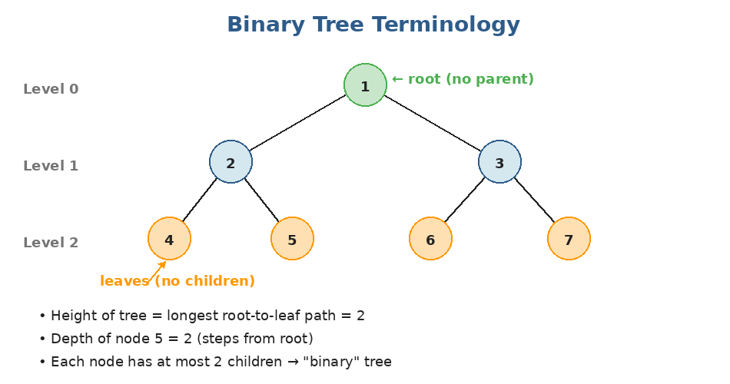
Standard tree vocabulary. Notice that the root sits at the TOP — trees in CS grow downward.
Important terms to memorize
- Root — the topmost node; the only node without a parent.
- Leaf — a node with NO children (both left and right are None).
- Parent / Child / Sibling — same as in a family tree.
- Depth of a node — number of edges from the root to that node.
- Height of a tree — depth of the deepest leaf. A single node has height 0.
- Subtree — every node IS the root of its own subtree.
Defining a tree node in Python
class TreeNode:
def __init__(self, val=0, left=None, right=None):
self.val = val
self.left = left
self.right = right

# Build the tree:
# 1
# / \
# 2 3
# / \
# 4 5
root = TreeNode(1,
TreeNode(2, TreeNode(4), TreeNode(5)),
TreeNode(3))

The mental model: A tree node knows about itself and its two children — it doesn't know who its parent is or where it sits in the larger tree. This locality is what makes recursion so natural for trees: you write a function that handles ONE node, and trust it to handle the children.

Traversals — visiting every node
There are 4 standard ways to walk through a tree. Three are DFS (depth-first), one is BFS (breadth-first). Memorize all four — they're the building blocks of every tree problem.
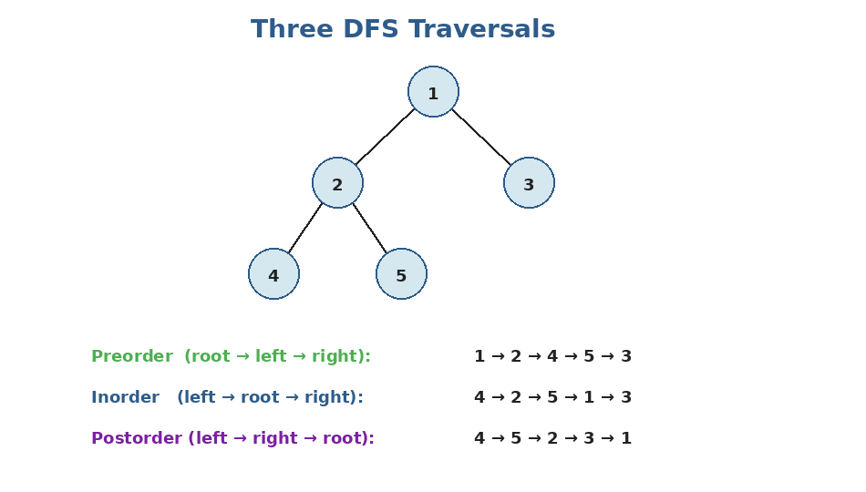
The three DFS traversals differ ONLY in WHEN they visit the current node, relative to the children.
Preorder — root, left, right
def preorder(node, result):
if node is None:
return
result.append(node.val) # visit ROOT first
preorder(node.left, result)
preorder(node.right, result)

result = []
preorder(root, result)
# → [1, 2, 4, 5, 3]

Inorder — left, root, right
def inorder(node, result):
if node is None:
return
inorder(node.left, result)
result.append(node.val) # visit ROOT in the middle
inorder(node.right, result)

result = []
inorder(root, result)
# → [4, 2, 5, 1, 3]

Inorder + BST = sorted!: Inorder traversal of a Binary Search Tree visits values in ASCENDING order. This is one of the most useful properties in DSA — we'll use it heavily in the next topic.

Postorder — left, right, root
def postorder(node, result):
if node is None:
return
postorder(node.left, result)
postorder(node.right, result)
result.append(node.val) # visit ROOT last

result = []
postorder(root, result)
# → [4, 5, 2, 3, 1]

Postorder is useful when computing something about a node that DEPENDS on its children — like tree height, or subtree sums.
Level Order — BFS using a queue
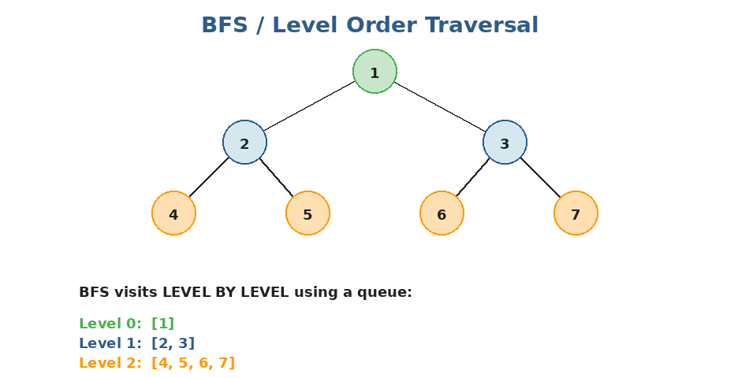
BFS visits all nodes at depth 0 first, then all at depth 1, etc. This needs a queue, not recursion.
from collections import deque

def level_order(root):
if not root:
return []
result = []
queue = deque([root])
while queue:
level_size = len(queue)
level = []
for _ in range(level_size):
node = queue.popleft()
level.append(node.val)
if node.left: queue.append(node.left)
if node.right: queue.append(node.right)
result.append(level)
return result

# Returns [[1], [2, 3], [4, 5, 6, 7]]

The level_size trick: Notice how we capture len(queue) at the start of each loop iteration? That's how we know how many nodes belong to the CURRENT level before we add the next level's nodes. This is the standard BFS-by-level template — memorize it.

The 'trust recursion' template
Most tree problems follow the same recursive template. Write a function that:
- Has a base case for None (return some neutral value).
- Recursively gets the answer from the LEFT subtree.
- Recursively gets the answer from the RIGHT subtree.
- Combines the two subtree answers (and possibly the current node) into the answer for THIS subtree.
# Example: maximum depth of a tree
def max_depth(node):
if node is None:
return 0
left = max_depth(node.left)
right = max_depth(node.right)
return 1 + max(left, right)

# Example: count all nodes
def count_nodes(node):
if node is None:
return 0
return 1 + count_nodes(node.left) + count_nodes(node.right)

Common operations and their costs
Operation | Time complexity
Visit every node (any traversal) | O(n) time, O(h) space (recursion stack)
Search for a value (general tree) | O(n) — must check every node
Compute height / depth | O(n)
Insert / delete (no special structure) | Depends — usually O(n) without BST property
Level order traversal | O(n) time, O(w) space (w = max width)

h = height of tree. For a balanced tree, h = log n. For a degenerate tree (every node has one child), h = n.
Practice questions — Topic 12
Q1. Maximum Depth of Binary Tree. Find the depth of the deepest leaf. Example: tree [3,9,20,null,null,15,7] → 3.
Answer:
Classic recursion. A null node has depth 0. Otherwise, depth = 1 + max(left_depth, right_depth).
def max_depth(root):
if root is None:
return 0
return 1 + max(max_depth(root.left), max_depth(root.right))

# Time: O(n), Space: O(h) for recursion stack

Q2. Invert Binary Tree. Mirror the tree — left becomes right at every node. Example: [4,2,7,1,3,6,9] → [4,7,2,9,6,3,1].
Answer:
At each node, swap its left and right children, then recurse into both.
def invert_tree(root):
if root is None:
return None
root.left, root.right = invert_tree(root.right), invert_tree(root.left)
return root

# Time: O(n), Space: O(h)

Q3. Same Tree. Given two trees, return True if they're structurally identical with the same values.
Answer:
Recurse on both at once. Both None → equal. One None → not equal. Otherwise, values must match AND both subtrees must match.
def is_same_tree(p, q):
if p is None and q is None: return True
if p is None or q is None: return False
if p.val != q.val: return False
return is_same_tree(p.left, q.left) and is_same_tree(p.right, q.right)

# Time: O(n), Space: O(h)

Q4. Diameter of Binary Tree. Length of the longest path between ANY two nodes (path is measured in edges, doesn't have to go through the root).
Answer:
For each node, the longest path THROUGH it = left_depth + right_depth. Track the max as we recurse.
Trick: helper returns the depth, but updates a shared `best` for the diameter.
def diameter(root):
best = [0]
def depth(node):
if node is None: return 0
L = depth(node.left)
R = depth(node.right)
best[0] = max(best[0], L + R)
return 1 + max(L, R)
depth(root)
return best[0]

# Time: O(n), Space: O(h)

Q5. Binary Tree Level Order Traversal. Return the values level by level. Example: [3,9,20,null,null,15,7] → [[3],[9,20],[15,7]].
Answer:
BFS with a queue. At each iteration, capture the current level size and process exactly that many nodes.
from collections import deque

def level_order(root):
if not root: return []
result = []
queue = deque([root])
while queue:
level_size = len(queue)
level = []
for _ in range(level_size):
node = queue.popleft()
level.append(node.val)
if node.left: queue.append(node.left)
if node.right: queue.append(node.right)
result.append(level)
return result

Q6. Path Sum. Given a tree and a target, return True if there's a ROOT-TO-LEAF path that sums to target.
Answer:
Recurse. At each node, subtract its value from the target. At a leaf, check if the remaining target equals the leaf's value.
def has_path_sum(root, target):
if root is None:
return False
if root.left is None and root.right is None: # leaf
return root.val == target
remaining = target - root.val
return has_path_sum(root.left, remaining) or has_path_sum(root.right, remaining)

# Time: O(n), Space: O(h)

Visualizing Path Sum:
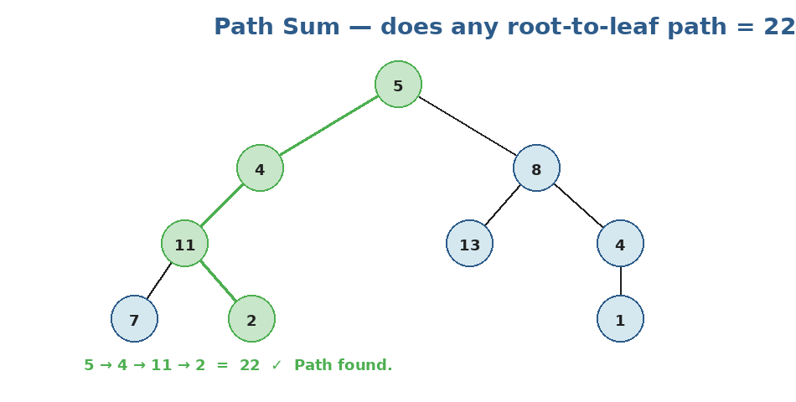
Target = 22. Path 5 → 4 → 11 → 2 sums to 22. Recursion checks each path subtracting as it descends.
Q7. Lowest Common Ancestor of a Binary Tree. Given two nodes p and q, return their lowest common ancestor.
Answer:
Recursion: if the current node IS p or q, return it. Otherwise, recurse into both children.
If both sides return non-None, the current node is the LCA. If only one side does, propagate that up.
def lowest_common_ancestor(root, p, q):
if root is None or root is p or root is q:
return root
left = lowest_common_ancestor(root.left, p, q)
right = lowest_common_ancestor(root.right, p, q)
if left and right: # p and q split here → root is LCA
return root
return left if left else right # both on one side

# Time: O(n), Space: O(h)

Visualizing LCA:
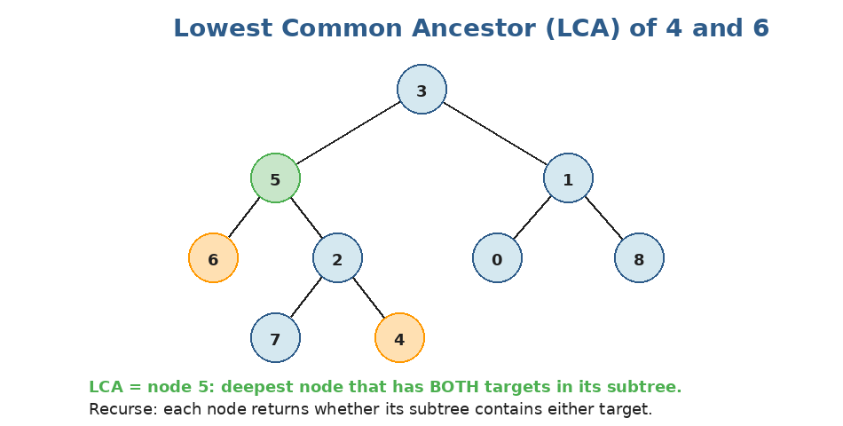
Targets are 4 and 6 (orange). Their LCA is node 5 (green) — the deepest node containing both in its subtree.

Topic 13 — Binary Search Trees
What makes a tree a BST?
A Binary Search Tree (BST) is a binary tree with one extra rule: for EVERY node, all values in the left subtree are SMALLER, and all values in the right subtree are LARGER. This single rule turns search/insert/delete from O(n) into O(log n) on average.
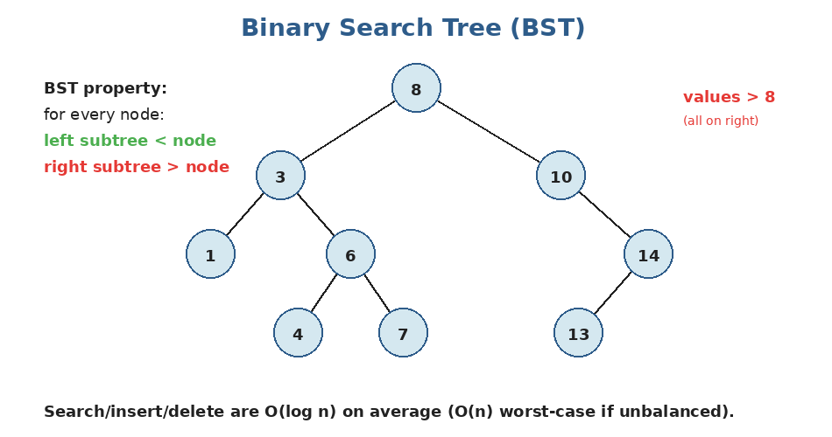
Notice how 8 sits at the root: everything to its left (3, 1, 6, 4, 7) is < 8; everything to its right (10, 14, 13) is > 8. The same rule holds at every node, recursively.
BST property is RECURSIVE: It's not enough that left.val < root.val < right.val for direct children. The property must hold for ALL descendants, not just the immediate children. This is the #1 mistake beginners make when validating a BST.

Searching in a BST
Just like binary search on an array — at each step, you go left or right based on comparison.
def search_bst(root, target):
while root:
if root.val == target:
return root
elif target < root.val:
root = root.left
else:
root = root.right
return None

# Time: O(h). Balanced: O(log n). Worst case: O(n).

Inserting into a BST
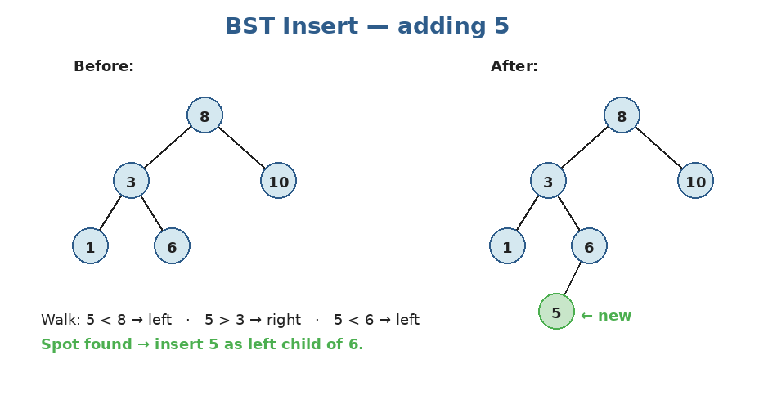
Inserting 5: walk down comparing at each step, then attach as a leaf at the empty spot found.
def insert_bst(root, val):
if root is None:
return TreeNode(val)
if val < root.val:
root.left = insert_bst(root.left, val)
else:
root.right = insert_bst(root.right, val)
return root

# Time: O(h)

Deleting from a BST (the tricky one)
Three cases when removing a node:
- Case 1: node is a LEAF → just remove it.
- Case 2: node has ONE child → replace the node with its child.
- Case 3: node has TWO children → find the IN-ORDER SUCCESSOR (smallest in right subtree), copy its value into the node, then delete the successor.
def delete_bst(root, key):
if root is None:
return None
if key < root.val:
root.left = delete_bst(root.left, key)
elif key > root.val:
root.right = delete_bst(root.right, key)
else: # found the node
if root.left is None: return root.right # cases 1 & 2
if root.right is None: return root.left

# Case 3: find smallest in right subtree
succ = root.right
while succ.left:
succ = succ.left
root.val = succ.val
root.right = delete_bst(root.right, succ.val)
return root

Validation — the classic interview question
Given a binary tree, is it a valid BST? The naive 'check left < root < right at each node' is WRONG (only checks direct children). Correct way: pass MIN and MAX bounds down through recursion.
def is_valid_bst(root, low=float('-inf'), high=float('inf')):
if root is None:
return True
if not (low < root.val < high):
return False
return (is_valid_bst(root.left, low, root.val)
and is_valid_bst(root.right, root.val, high))

# When recursing left, max becomes root.val. When recursing right, min becomes root.val.
# Time: O(n), Space: O(h)

Alternative way to validate: Inorder traversal of a BST should produce a STRICTLY INCREASING sequence. So you can do an inorder walk, tracking the previous value, and check that each new value is larger.

Practice questions — Topic 13
Q1. Search in a BST. Given the root of a BST and a value, return the subtree rooted at the matching node, or None.
Answer:
Walk down using BST property: smaller → left, larger → right.
def search_bst(root, val):
while root and root.val != val:
root = root.left if val < root.val else root.right
return root

Q2. Insert into a BST. Insert val into the BST and return the new root.
Answer:
Recurse to find the empty spot, attach a new node there.
def insert_into_bst(root, val):
if root is None:
return TreeNode(val)
if val < root.val:
root.left = insert_into_bst(root.left, val)
else:
root.right = insert_into_bst(root.right, val)
return root

Q3. Validate Binary Search Tree. Return True if the given tree is a valid BST.
Answer:
Recurse with a (low, high) range. At every node, val must lie strictly between them. Recurse left with high updated to val; recurse right with low updated to val.
def is_valid_bst(root):
def helper(node, low, high):
if node is None: return True
if not (low < node.val < high): return False
return helper(node.left, low, node.val) and helper(node.right, node.val, high)
return helper(root, float('-inf'), float('inf'))

Q4. Kth Smallest Element in a BST. Find the kth smallest element. Example: BST [3,1,4,null,2], k=1 → 1.
Answer:
Inorder traversal of a BST visits values in ascending order. Stop at the kth visit.
def kth_smallest(root, k):
stack = []
curr = root
while stack or curr:
# Go left as far as possible
while curr:
stack.append(curr)
curr = curr.left
curr = stack.pop()
k -= 1
if k == 0:
return curr.val
curr = curr.right

# Time: O(h + k), Space: O(h)

Q5. Lowest Common Ancestor of a BST. Find the LCA of two nodes in a BST. (Easier than the general tree version!)
Answer:
Use the BST property. If both p.val and q.val are < root.val, LCA is in the left subtree. If both are >, LCA is in the right subtree. Otherwise, root IS the LCA (the values split here).
def lowest_common_ancestor(root, p, q):
while root:
if p.val < root.val and q.val < root.val:
root = root.left
elif p.val > root.val and q.val > root.val:
root = root.right
else:
return root # split point

# Time: O(h), Space: O(1) — iterative version

Q6. Delete Node in a BST. Remove the node with the given key from the BST.
Answer:
Three cases: leaf (just remove); one child (replace with child); two children (replace value with inorder successor's value, then delete the successor).
def delete_node(root, key):
if root is None: return None
if key < root.val:
root.left = delete_node(root.left, key)
elif key > root.val:
root.right = delete_node(root.right, key)
else:
if root.left is None: return root.right
if root.right is None: return root.left
succ = root.right
while succ.left: succ = succ.left
root.val = succ.val
root.right = delete_node(root.right, succ.val)
return root

Q7. Convert Sorted Array to BST. Given a sorted array, build a HEIGHT-BALANCED BST.
Answer:
Recursion: pick the middle element as the root, recursively build the left subtree from the left half, and the right subtree from the right half.
def sorted_array_to_bst(nums):
def build(lo, hi):
if lo > hi: return None
mid = (lo + hi) // 2
node = TreeNode(nums[mid])
node.left = build(lo, mid - 1)
node.right = build(mid + 1, hi)
return node
return build(0, len(nums) - 1)

# Time: O(n), Space: O(log n) recursion stack (balanced!)

Topic 14 — Heaps / Priority Queues
What is a heap?
A heap is a SPECIAL kind of binary tree with one job: give you the smallest (or largest) element FAST. It's a complete binary tree (filled top-to-bottom, left-to-right) where every parent is ≤ its children (min-heap) or ≥ its children (max-heap).
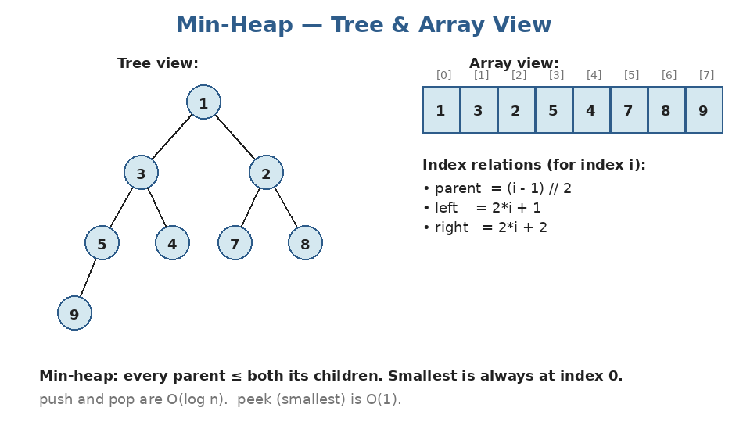
A heap is conceptually a tree but STORED as an array. The index relations let us walk parent/child without explicit pointers.
Why a heap, not a BST?: A heap is much SIMPLER than a BST. It only guarantees the smallest (or largest) is at the root. It doesn't keep elements sorted. But that's exactly what we need for problems like "give me the top K" or "find the median of a stream".

Heaps in Python — the heapq module
Python ships with heapq, which operates on regular lists. By default it's a MIN-HEAP.
import heapq

heap = []

heapq.heappush(heap, 5) # O(log n)
heapq.heappush(heap, 1)
heapq.heappush(heap, 8)
heapq.heappush(heap, 3)

print(heap[0]) # → 1 (smallest, peek is O(1))

smallest = heapq.heappop(heap) # → 1 (and removes it), O(log n)
print(heap) # heap order, e.g. [3, 5, 8]

# heapify an existing list — O(n)
arr = [9, 4, 7, 1, 6]
heapq.heapify(arr) # turns arr into a min-heap in-place

# Pop AND push together (slightly faster than separate calls)
heapq.heappushpop(heap, 4)

Need a max-heap? Negate the values
Python only ships a min-heap: There is no max-heap in heapq. The standard trick is to push -x instead of x, then negate again on pop. For tuples, negate the priority field.

# Max-heap simulation
heap = []
for x in [3, 1, 5, 2]:
heapq.heappush(heap, -x) # push negative

largest = -heapq.heappop(heap) # → 5

How push works inside (sift-up)
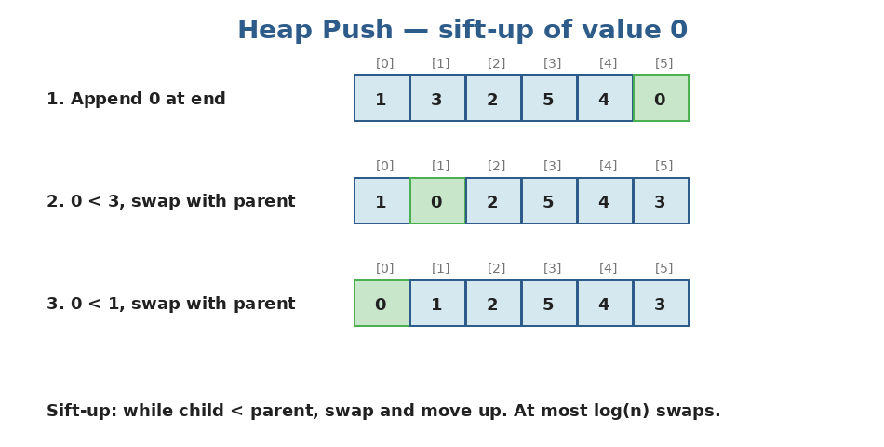
When you push, the new element goes at the end, then 'sifts up' by swapping with its parent until the heap property is restored.
Pop is similar but in reverse: replace the root with the last element, then 'sift down' by swapping with the smaller child until the property is restored. Both operations: O(log n).
Pattern 1: Top K (most common pattern)
Given an array of n elements, find the K largest (or K smallest). Naive: sort and take last K → O(n log n). With a heap: O(n log K) — much better when K is small.
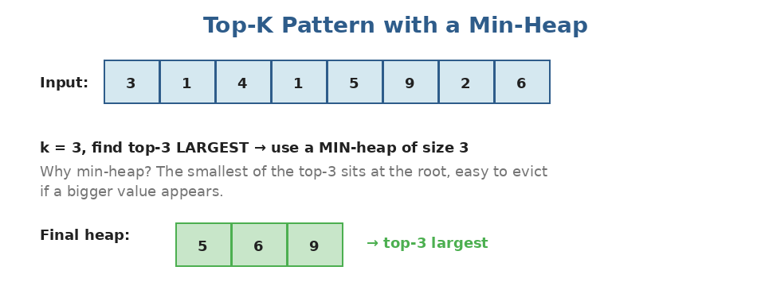
Counter-intuitive trick: to find the top-K LARGEST, use a MIN-heap of size K. The smallest of the top-K sits at the root, ready to be evicted if we find anything bigger.
import heapq

def top_k_largest(nums, k):
heap = []
for x in nums:
heapq.heappush(heap, x)
if len(heap) > k:
heapq.heappop(heap) # kick out smallest
return list(heap) # any order

top_k_largest([3, 1, 4, 1, 5, 9, 2, 6], 3)
# → [5, 6, 9] (some order)
# Time: O(n log k), Space: O(k)

Pattern 2: Two Heaps (median of a stream)
Sometimes you need to track BOTH ends of your data — typically the median. The trick: use TWO heaps. A max-heap for the smaller half and a min-heap for the larger half. Keep them roughly balanced. The median is either the top of one heap (odd count) or the average of both tops (even count).
import heapq

class MedianFinder:
def __init__(self):
self.lo = [] # max-heap (use negation): smaller half
self.hi = [] # min-heap: larger half

def add_num(self, num):
# Push to the smaller half first (use negation for max-heap)
heapq.heappush(self.lo, -num)
# Move the largest of lo into hi (rebalance step)
heapq.heappush(self.hi, -heapq.heappop(self.lo))
# If hi grew bigger, give one back to lo
if len(self.hi) > len(self.lo):
heapq.heappush(self.lo, -heapq.heappop(self.hi))

def find_median(self):
if len(self.lo) > len(self.hi):
return -self.lo[0]
return (-self.lo[0] + self.hi[0]) / 2

# Each add_num: O(log n). find_median: O(1).

Pattern 3: Merging K sorted things
If you need to merge K sorted lists/arrays/streams, a min-heap of (current_value, source_id) is the standard trick.
import heapq

def merge_k_sorted_lists(lists):
# min-heap of (value, list_index, item_index)
heap = []
for i, lst in enumerate(lists):
if lst:
heapq.heappush(heap, (lst[0], i, 0))

result = []
while heap:
val, list_idx, item_idx = heapq.heappop(heap)
result.append(val)
if item_idx + 1 < len(lists[list_idx]):
next_val = lists[list_idx][item_idx + 1]
heapq.heappush(heap, (next_val, list_idx, item_idx + 1))
return result

# Time: O(N log k) where N = total elements, k = number of lists

Practice questions — Topic 14
Q1. Kth Largest Element in an Array. Find the kth largest element. Example: nums=[3,2,1,5,6,4], k=2 → 5.
Answer:
Maintain a min-heap of size k. After processing all numbers, the smallest in the heap IS the kth largest overall.
import heapq

def find_kth_largest(nums, k):
heap = []
for x in nums:
heapq.heappush(heap, x)
if len(heap) > k:
heapq.heappop(heap)
return heap[0]

# Time: O(n log k), Space: O(k)

Q2. Top K Frequent Elements. Return the k most frequent elements. Example: nums=[1,1,1,2,2,3], k=2 → [1,2].
Answer:
Step 1: count frequencies with a Counter. Step 2: maintain a min-heap of size k by frequency. The k items left at the end are the answer.
import heapq
from collections import Counter

def top_k_frequent(nums, k):
counts = Counter(nums)
heap = []
for num, freq in counts.items():
heapq.heappush(heap, (freq, num))
if len(heap) > k:
heapq.heappop(heap)
return [num for _, num in heap]

# Time: O(n log k), Space: O(n)

Q3. K Closest Points to Origin. Given points on a 2D plane, return the k points closest to (0,0). Example: [[1,3],[-2,2]], k=1 → [[-2,2]].
Answer:
Same top-K pattern, but with squared distance as the key. Use a MAX-heap (negate distances) of size k. After processing, the k items left are closest.
import heapq

def k_closest(points, k):
heap = []
for x, y in points:
d = x*x + y*y # squared distance, no sqrt needed
heapq.heappush(heap, (-d, x, y))
if len(heap) > k:
heapq.heappop(heap)
return [[x, y] for _, x, y in heap]

# Time: O(n log k)

Q4. Last Stone Weight. Stones smash pairwise: take the two heaviest, smash them. If equal, both destroyed; else the difference goes back. Return the last remaining stone's weight (or 0).
Answer:
Always need the two largest — that's a max-heap (negate values in Python).
import heapq

def last_stone_weight(stones):
heap = [-s for s in stones]
heapq.heapify(heap)
while len(heap) > 1:
a = -heapq.heappop(heap) # largest
b = -heapq.heappop(heap) # second largest
if a != b:
heapq.heappush(heap, -(a - b))
return -heap[0] if heap else 0

# Time: O(n log n)

Q5. Find Median from Data Stream. Design a class that supports addNum(x) and findMedian(). Both must be efficient under streaming.
Answer:
Two heaps: max-heap for the smaller half (lo), min-heap for the larger half (hi). Balance so |lo|=|hi| or |lo|=|hi|+1.
Median = top of lo (odd total) or average of both tops (even).
import heapq

class MedianFinder:
def __init__(self):
self.lo, self.hi = [], [] # max-heap (negated), min-heap

def addNum(self, num):
heapq.heappush(self.lo, -num)
heapq.heappush(self.hi, -heapq.heappop(self.lo))
if len(self.hi) > len(self.lo):
heapq.heappush(self.lo, -heapq.heappop(self.hi))

def findMedian(self):
if len(self.lo) > len(self.hi):
return -self.lo[0]
return (-self.lo[0] + self.hi[0]) / 2

Q6. Merge K Sorted Lists. Given an array of k sorted linked lists, merge them all into one sorted linked list.
Answer:
Min-heap of nodes by value. Push the heads of all k lists. Pop the smallest, add to result, push that node's next (if any).
Note: ListNode objects need a tiebreaker for the heap, since two nodes with the same val can't be compared. Use (val, unique_id, node).
import heapq

def merge_k_lists(lists):
heap = []
for i, head in enumerate(lists):
if head:
heapq.heappush(heap, (head.val, i, head))

dummy = ListNode()
tail = dummy
counter = len(lists)
while heap:
val, i, node = heapq.heappop(heap)
tail.next = node
tail = node
if node.next:
heapq.heappush(heap, (node.next.val, counter, node.next))
counter += 1
return dummy.next

# Time: O(N log k), Space: O(k)

Q7. Task Scheduler. Given tasks with cooldown n (same task can't run within n steps), find the minimum total time. Example: tasks=['A','A','A','B','B','B'], n=2 → 8 (A→B→idle→A→B→idle→A→B).
Answer:
Always schedule the most-frequent available task. Use a max-heap of remaining counts. Each cycle of n+1 slots, pop up to n+1 most frequent, decrement, push back what's still positive.
import heapq
from collections import Counter

def least_interval(tasks, n):
counts = list(Counter(tasks).values())
heap = [-c for c in counts] # max-heap
heapq.heapify(heap)

time = 0
while heap:
temp = []
# try to fill a window of n+1 slots
for _ in range(n + 1):
if heap:
temp.append(heapq.heappop(heap) + 1) # used once (less negative)
time += 1
if not heap and not any(t < 0 for t in temp):
break
for t in temp:
if t < 0:
heapq.heappush(heap, t)
return time

Topic 15 — Tries (Prefix Trees)
What is a trie?
A trie (pronounced "try") is a tree where each EDGE represents a character. Walking from the root spells out a word. It's the perfect structure for storing a dictionary of strings when you need to do prefix-based queries like "does any word start with 'ca'?" or autocomplete.
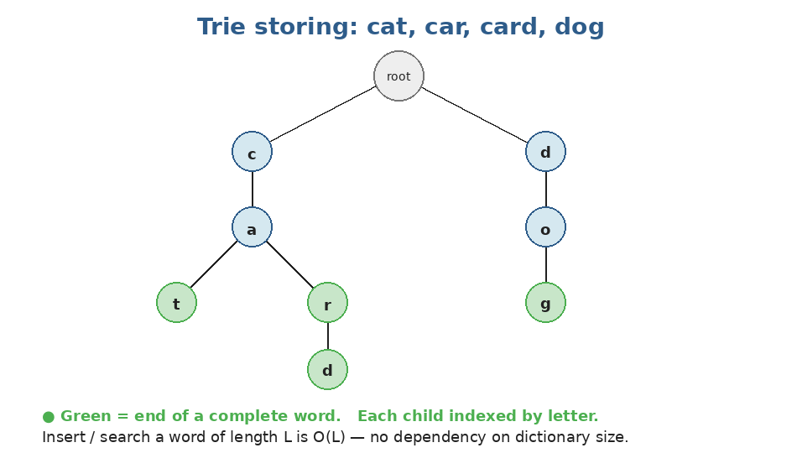
Same prefix = shared path. Words 'cat', 'car', and 'card' all share the c→a path. Green nodes mark the END of a complete word.
Why use a trie?
Operation | Time complexity
Insert a word of length L | O(L)
Search for a word of length L | O(L)
Search for any word with prefix P | O(|P|)
Compare with hashmap | Hashmap: same O(L) for full-word search, but BAD at prefix queries

When to use a trie: Reach for a trie when: (1) you need autocomplete or prefix matching, (2) you're doing many word lookups against a fixed dictionary, (3) you need to find all words sharing a prefix. Otherwise, a regular set is simpler.

Building a trie in Python
class TrieNode:
def __init__(self):
self.children = {} # char → TrieNode
self.is_end = False # marks end of a word

class Trie:
def __init__(self):
self.root = TrieNode()

def insert(self, word):
node = self.root
for ch in word:
if ch not in node.children:
node.children[ch] = TrieNode()
node = node.children[ch]
node.is_end = True

def search(self, word):
node = self._walk(word)
return node is not None and node.is_end

def starts_with(self, prefix):
return self._walk(prefix) is not None

def _walk(self, s):
node = self.root
for ch in s:
if ch not in node.children:
return None
node = node.children[ch]
return node

Usage:
trie = Trie()
trie.insert("cat")
trie.insert("car")
trie.insert("card")
trie.insert("dog")

trie.search("cat") # True
trie.search("ca") # False — 'ca' is a prefix, not a complete word
trie.starts_with("ca") # True — 'ca' IS a valid prefix

trie.search("cab") # False — 'cab' was never inserted

The is_end flag is critical
Don't forget is_end!: Without is_end, you can't distinguish "this is just a prefix" from "this is a complete word". The trie storing 'cat' contains a path for 'ca' too — but only the 't' node has is_end=True.

Practice questions — Topic 15
Q1. Implement Trie (Prefix Tree). Implement insert(word), search(word) returning True/False, and startsWith(prefix) returning True/False.
Answer:
Standard implementation. Node has children dict + is_end flag. Walk character by character.
class Trie:
def __init__(self):
self.root = {}

def insert(self, word):
node = self.root
for ch in word:
if ch not in node:
node[ch] = {}
node = node[ch]
node['#'] = True # marker for end

def search(self, word):
node = self._walk(word)
return node is not None and '#' in node

def startsWith(self, prefix):
return self._walk(prefix) is not None

def _walk(self, s):
node = self.root
for ch in s:
if ch not in node: return None
node = node[ch]
return node

Q2. Design Add and Search Words Data Structure. Like a trie, but search supports '.' as a wildcard matching any single letter. Example: add 'bad', 'dad', 'mad'; search 'b..' → True.
Answer:
Insert as normal. Search recursively: at each step, if the current char is '.', try ALL children. Otherwise, walk the matching child only.
class WordDictionary:
def __init__(self):
self.root = {}

def addWord(self, word):
node = self.root
for ch in word:
if ch not in node: node[ch] = {}
node = node[ch]
node['#'] = True

def search(self, word):
def dfs(node, i):
if i == len(word):
return '#' in node
ch = word[i]
if ch == '.':
# try every child
for k, child in node.items():
if k != '#' and dfs(child, i + 1):
return True
return False
else:
if ch not in node: return False
return dfs(node[ch], i + 1)
return dfs(self.root, 0)

Q3. Longest Common Prefix. Given an array of strings, return the longest common prefix. Example: ["flower","flow","flight"] → "fl".
Answer:
You don't actually need a trie for this — character-by-character comparison is simpler. Compare each character across all strings until they disagree.
(A trie solution would build a trie of all words and walk down while there's only ONE child and no is_end.)
def longest_common_prefix(strs):
if not strs: return ""
for i, ch in enumerate(strs[0]):
for s in strs[1:]:
if i >= len(s) or s[i] != ch:
return strs[0][:i]
return strs[0]

# Time: O(total characters across all strings)

Q4. Replace Words. Given a list of roots and a sentence, replace every word in the sentence with its shortest matching root if any exists. Example: roots=["cat","bat","rat"], sentence="the cattle was rattled by the battery" → "the cat was rat by the bat".
Answer:
Build a trie from the roots. For each word in the sentence, walk the trie character by character — return as soon as you hit a node where is_end=True.
def replace_words(roots, sentence):
trie = {}
for root in roots:
node = trie
for ch in root:
if ch not in node: node[ch] = {}
node = node[ch]
node['#'] = True

def shortest_root(word):
node = trie
for i, ch in enumerate(word):
if ch not in node: break
node = node[ch]
if '#' in node: return word[:i+1]
return word

return ' '.join(shortest_root(w) for w in sentence.split())

Q5. Word Search II (HARD). Given a 2D grid of letters and a list of words, find all words that exist in the grid (formed by adjacent cells, no reuse). Use a trie + DFS for efficiency.
Answer:
Build a trie of the words. DFS from each cell, walking the trie in parallel with the grid. When you reach a node with is_end=True, record the word. Mark cells visited (e.g. set to '#') and restore on backtrack.
This is genuinely hard — don't worry if it doesn't click first time.
def find_words(board, words):
# Build trie
trie = {}
for w in words:
node = trie
for ch in w:
if ch not in node: node[ch] = {}
node = node[ch]
node['$'] = w # store the full word at the leaf

rows, cols = len(board), len(board[0])
found = set()

def dfs(r, c, node):
ch = board[r][c]
if ch not in node: return
nxt = node[ch]
if '$' in nxt:
found.add(nxt['$'])
board[r][c] = '#' # mark visited
for dr, dc in [(-1,0),(1,0),(0,-1),(0,1)]:
nr, nc = r + dr, c + dc
if 0 <= nr < rows and 0 <= nc < cols and board[nr][nc] != '#':
dfs(nr, nc, nxt)
board[r][c] = ch # restore

for r in range(rows):
for c in range(cols):
dfs(r, c, trie)
return list(found)

You've finished Stage 3!
Stage 3 was where the recursion you learned in Stage 1 really paid off. Trees are everywhere in software (file systems, DOM, parse trees, search indexes) and they show up in roughly half of all interview problems. You now have all the tools to handle them.
What you should now be comfortable with
- Writing all 4 traversals (preorder, inorder, postorder, BFS) from memory.
- Using the 'trust recursion' template: base case + recurse left + recurse right + combine.
- Recognizing BST patterns (kth smallest, validation, LCA) and using inorder = sorted to your advantage.
- Reaching for a min-heap whenever you see 'top K' or 'merge K sorted'.
- Reaching for two heaps when you need to track BOTH ends (median of stream).
- Building a trie and recognizing prefix-query problems.
Before moving on to Stage 4 (Graphs)
Self-test:
- Re-implement maxDepth, invertTree, and levelOrder from scratch.
- Re-implement isValidBST and kthSmallest in a BST.
- Implement a min-heap manually (no heapq) — push and pop with sift-up/sift-down.
- Build a Trie class from scratch with insert, search, and startsWith.
- Solve Path Sum II (return ALL root-to-leaf paths summing to target) — combines traversal + path tracking.

Stage 4 brings GRAPHS — and graphs are basically generalized trees: a node can have ANY number of neighbors, and there can be cycles. The BFS template you learned for level-order traversal becomes graph BFS. Recursive tree DFS becomes graph DFS (with a visited set). Don't move on until trees feel automatic.

