DSA Stage 4 — Study Guide
Graphs

Representation • BFS/DFS • Topological Sort • Dijkstra • Union-Find • MST

How to use this guide: Stage 4 covers all 5 graph topics. Graphs are arguably the highest-leverage topic in interview DSA — they appear in roughly 30% of FAANG interviews. The good news: BFS and DFS on graphs are simple extensions of what you did on trees in Stage 3.

What you should already know
- Stage 3: BFS and DFS on trees — graphs are very similar.
- Stage 2: collections.deque for queue operations.
- Stage 3: heapq for Dijkstra's min-heap.
- Stage 1: recursion for DFS-style traversals.
If any feel shaky, revisit those stages first. Graphs combine ALL of these.

Reading order
- Topic 16 — Graph representation, BFS, DFS (the foundation)
- Topic 17 — Cycle detection & Topological sort
- Topic 18 — Shortest path (BFS for unweighted, Dijkstra for weighted)
- Topic 19 — Union-Find / Disjoint Set Union (DSU)
- Topic 20 — Minimum Spanning Tree (Kruskal & Prim)

Topic 16 — Graph Representation & Traversal
What is a graph?
A graph is a collection of NODES (also called vertices) connected by EDGES. Unlike a tree, a graph can have cycles, can be disconnected, and a node can have any number of neighbors.
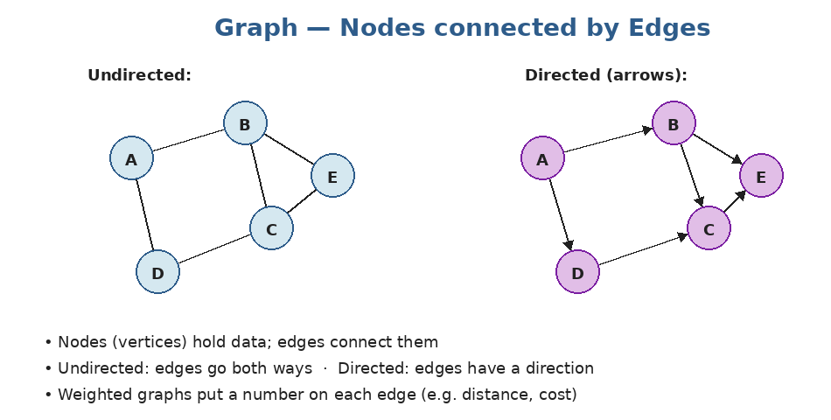
Two flavors: undirected (edges go both ways) and directed (edges have an arrow). Edges may also have weights (a cost or distance).
Where graphs show up everywhere
- Social networks — users are nodes, friendships are edges.
- Maps and routing — intersections are nodes, roads are weighted edges.
- Web pages — pages are nodes, hyperlinks are directed edges.
- File systems and dependencies — folders, packages, build steps.
- Grid problems — every cell is a node, neighbors are edges (very common in interviews).
How to represent a graph in Python
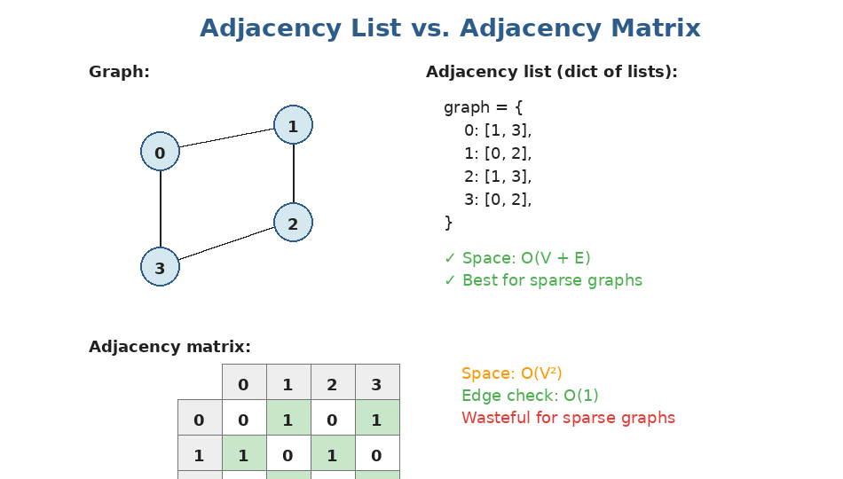
Two ways to store a graph. Adjacency list (left) is the default for interviews — flexible and uses O(V+E) space. Adjacency matrix (right) is only worth it for dense graphs.
In Python, an adjacency list is just a dict:
# Undirected graph
graph = {
0: [1, 3],
1: [0, 2],
2: [1, 3],
3: [0, 2],
}

# Directed graph (only one direction per edge)
directed = {
'A': ['B', 'C'],
'B': ['D'],
'C': ['D'],
'D': []
}

# Weighted graph: store (neighbor, weight) tuples
weighted = {
'A': [('B', 4), ('C', 2)],
'B': [('C', 1), ('D', 5)],
'C': [('D', 8)],
'D': []
}

Build from edge list: Interviewers often give you edges as a list like [[0,1],[1,2],[2,3]]. To convert into an adjacency list, use a defaultdict(list) and append both directions if undirected.

from collections import defaultdict

def build_graph(edges, directed=False):
graph = defaultdict(list)
for u, v in edges:
graph[u].append(v)
if not directed:
graph[v].append(u)
return graph

build_graph([[0,1],[1,2],[2,3]])
# → {0: [1], 1: [0, 2], 2: [1, 3], 3: [2]}

BFS — Breadth First Search
BFS explores the graph LEVEL BY LEVEL, visiting all neighbors before going deeper. Use a QUEUE (collections.deque) and a VISITED set.
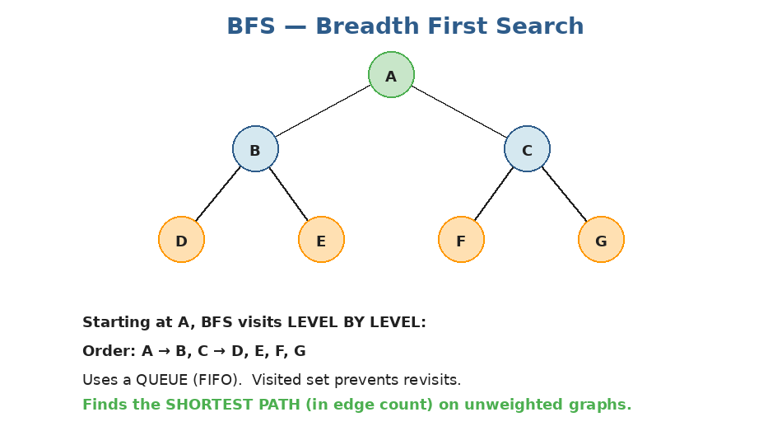
Starting at A, BFS visits all distance-1 neighbors before any distance-2 ones. Same template you used for tree level-order.
from collections import deque

def bfs(graph, start):
visited = {start}
queue = deque([start])
order = []
while queue:
node = queue.popleft()
order.append(node)
for neighbor in graph[node]:
if neighbor not in visited:
visited.add(neighbor) # mark BEFORE pushing!
queue.append(neighbor)
return order

# Time: O(V + E), Space: O(V) for visited + queue

Mark visited at PUSH time: Always add to visited when you ENQUEUE a node, not when you dequeue. Otherwise the same node can get pushed many times, blowing up the queue. This is the #1 BFS bug.

Step-by-step trace of how the queue evolves:
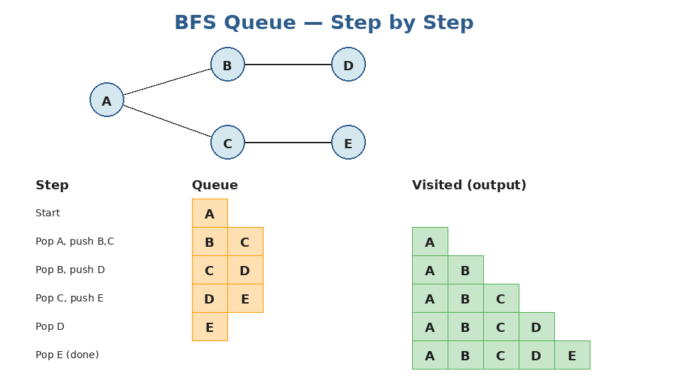
After each pop, neighbors are pushed (and marked visited). Notice how the queue stays a sliding window of "frontier" nodes.
DFS — Depth First Search
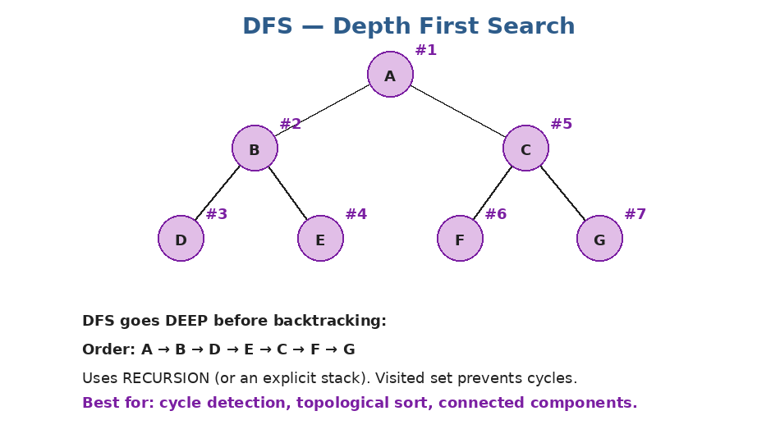
DFS goes as deep as possible before backtracking. The visited numbers (#1, #2, ...) show the order. Compare to BFS — totally different traversal order.
# Recursive DFS
def dfs_recursive(graph, node, visited=None, order=None):
if visited is None: visited = set()
if order is None: order = []
visited.add(node)
order.append(node)
for neighbor in graph[node]:
if neighbor not in visited:
dfs_recursive(graph, neighbor, visited, order)
return order

# Iterative DFS using an explicit stack
def dfs_iterative(graph, start):
visited = {start}
stack = [start]
order = []
while stack:
node = stack.pop()
order.append(node)
for neighbor in graph[node]:
if neighbor not in visited:
visited.add(neighbor)
stack.append(neighbor)
return order

# Time: O(V + E), Space: O(V)

BFS vs DFS — when to use which
Operation | Time complexity
BFS — find shortest path (unweighted) | Yes, BFS finds it
DFS — find shortest path | No (may overshoot)
BFS — minimum-steps problems | Best fit
DFS — cycle detection | Best fit
DFS — topological sort | Natural
DFS — connected components | Either works
BFS — level / layer traversal | Best fit

Grid problems = graph problems in disguise
A huge fraction of interview questions describe a 2D grid (e.g. a map of land/water cells). These are graph problems where each cell is a node and edges go to the 4 neighbors (up/down/left/right). The DIRECTIONS array is the standard idiom.
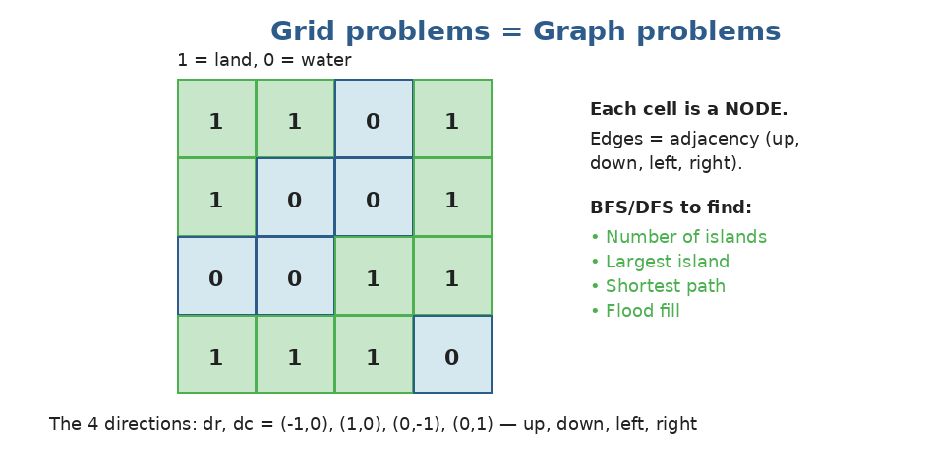
Same BFS/DFS templates, just with grid coordinates instead of node names.
def num_islands(grid):
if not grid: return 0
rows, cols = len(grid), len(grid[0])
visited = set()
count = 0
DIRS = [(-1,0),(1,0),(0,-1),(0,1)]

def dfs(r, c):
if (r,c) in visited: return
if not (0 <= r < rows and 0 <= c < cols): return
if grid[r][c] != '1': return
visited.add((r,c))
for dr, dc in DIRS:
dfs(r+dr, c+dc)

for r in range(rows):
for c in range(cols):
if grid[r][c] == '1' and (r,c) not in visited:
count += 1
dfs(r, c)
return count

# Time: O(rows × cols), Space: O(rows × cols) for visited

Practice questions — Topic 16
Q1. Number of Islands. Given a 2D grid of '1' (land) and '0' (water), count how many distinct islands exist (connected horizontally/vertically). Example: grid with 3 separate land regions → 3.
Answer:
Walk every cell. When you find unvisited land, increment count and DFS/BFS to mark all connected land. Each DFS/BFS call covers one entire island.
def num_islands(grid):
if not grid: return 0
rows, cols = len(grid), len(grid[0])
count = 0

def dfs(r, c):
if not (0 <= r < rows and 0 <= c < cols): return
if grid[r][c] != '1': return
grid[r][c] = '0' # mark as visited (in-place)
for dr, dc in [(-1,0),(1,0),(0,-1),(0,1)]:
dfs(r+dr, c+dc)

for r in range(rows):
for c in range(cols):
if grid[r][c] == '1':
count += 1
dfs(r, c)
return count

# Time: O(rows × cols), Space: O(rows × cols) recursion

Q2. Max Area of Island. Same grid setup, but return the area (number of cells) of the LARGEST island.
Answer:
DFS that returns the size of the island it explores. Track the max across all starts.
def max_area_of_island(grid):
rows, cols = len(grid), len(grid[0])

def dfs(r, c):
if not (0 <= r < rows and 0 <= c < cols): return 0
if grid[r][c] != 1: return 0
grid[r][c] = 0
return 1 + dfs(r+1,c) + dfs(r-1,c) + dfs(r,c+1) + dfs(r,c-1)

best = 0
for r in range(rows):
for c in range(cols):
if grid[r][c] == 1:
best = max(best, dfs(r, c))
return best

Q3. Flood Fill. Given an image (2D grid of colors), starting cell (sr, sc), and new color, change the start cell and all 4-connected cells of the SAME original color. Example: classic paint-bucket tool.
Answer:
Standard DFS or BFS. Just remember the original color before recursing — and skip if it equals the new color (avoids infinite loop).
def flood_fill(image, sr, sc, new_color):
original = image[sr][sc]
if original == new_color:
return image # no work needed

rows, cols = len(image), len(image[0])

def dfs(r, c):
if not (0 <= r < rows and 0 <= c < cols): return
if image[r][c] != original: return
image[r][c] = new_color
for dr, dc in [(-1,0),(1,0),(0,-1),(0,1)]:
dfs(r+dr, c+dc)

dfs(sr, sc)
return image

Q4. Rotting Oranges. A grid where 0=empty, 1=fresh orange, 2=rotten. Each minute, every fresh orange adjacent to a rotten one rots too. Return the minutes until ALL oranges rot, or -1 if impossible.
Answer:
Multi-source BFS. Start with ALL rotten oranges in the queue, BFS layer by layer. Each layer = one minute. After BFS, if any fresh orange remains, return -1.
from collections import deque

def oranges_rotting(grid):
rows, cols = len(grid), len(grid[0])
queue = deque()
fresh = 0

for r in range(rows):
for c in range(cols):
if grid[r][c] == 2:
queue.append((r, c, 0)) # (row, col, minute)
elif grid[r][c] == 1:
fresh += 1

minutes = 0
while queue:
r, c, t = queue.popleft()
minutes = t
for dr, dc in [(-1,0),(1,0),(0,-1),(0,1)]:
nr, nc = r+dr, c+dc
if 0 <= nr < rows and 0 <= nc < cols and grid[nr][nc] == 1:
grid[nr][nc] = 2
fresh -= 1
queue.append((nr, nc, t + 1))

return minutes if fresh == 0 else -1

Q5. Clone Graph. Given a reference to a node in a connected undirected graph, return a DEEP COPY of the entire graph.
Answer:
DFS with a hashmap from old-node to new-node. When you encounter an already-cloned node, return its clone. Otherwise, create a new node and recurse on its neighbors.
def clone_graph(node):
if not node: return None
cloned = {} # original_node -> cloned_node

def dfs(n):
if n in cloned:
return cloned[n]
copy = Node(n.val)
cloned[n] = copy
for nei in n.neighbors:
copy.neighbors.append(dfs(nei))
return copy

return dfs(node)

Q6. Pacific Atlantic Water Flow. Given a matrix of heights, find all cells whose water can flow to BOTH the Pacific (top/left edges) and the Atlantic (bottom/right edges). Water flows to neighbors of EQUAL OR LOWER height.
Answer:
Trick: instead of asking 'can THIS cell reach the ocean', start from the OCEAN and walk uphill. Two BFS/DFS — one from Pacific cells, one from Atlantic cells. The intersection is the answer.
def pacific_atlantic(heights):
if not heights: return []
rows, cols = len(heights), len(heights[0])
pacific = set()
atlantic = set()

def dfs(r, c, visited):
visited.add((r, c))
for dr, dc in [(-1,0),(1,0),(0,-1),(0,1)]:
nr, nc = r+dr, c+dc
if (0 <= nr < rows and 0 <= nc < cols
and (nr, nc) not in visited
and heights[nr][nc] >= heights[r][c]): # water flows UP from ocean
dfs(nr, nc, visited)

for c in range(cols):
dfs(0, c, pacific); dfs(rows-1, c, atlantic)
for r in range(rows):
dfs(r, 0, pacific); dfs(r, cols-1, atlantic)

return [list(p) for p in pacific & atlantic]

Q7. Walls and Gates. A 2D grid where -1=wall, 0=gate, INF=empty room. Fill each empty room with the distance to its NEAREST gate. Update in-place.
Answer:
Multi-source BFS starting from ALL gates simultaneously. Each step, fill empty cells with current distance.
from collections import deque

def walls_and_gates(rooms):
INF = 2147483647
if not rooms: return
rows, cols = len(rooms), len(rooms[0])
queue = deque()

for r in range(rows):
for c in range(cols):
if rooms[r][c] == 0:
queue.append((r, c))

while queue:
r, c = queue.popleft()
for dr, dc in [(-1,0),(1,0),(0,-1),(0,1)]:
nr, nc = r+dr, c+dc
if 0 <= nr < rows and 0 <= nc < cols and rooms[nr][nc] == INF:
rooms[nr][nc] = rooms[r][c] + 1
queue.append((nr, nc))

Topic 17 — Cycle Detection & Topological Sort
Cycles in graphs
A cycle is a path that starts and ends at the same node. Cycles matter because they break many algorithms (you'd loop forever). The visited set in BFS/DFS already prevents infinite loops, but DETECTING whether a cycle exists is a separate skill.
Cycle in undirected graph
DFS with parent-tracking. A cycle exists if you find an already-visited neighbor that ISN'T your parent.
def has_cycle_undirected(graph):
visited = set()
def dfs(node, parent):
visited.add(node)
for nei in graph[node]:
if nei not in visited:
if dfs(nei, node): return True
elif nei != parent: # visited AND not the one we came from → cycle
return True
return False

for node in graph:
if node not in visited:
if dfs(node, None): return True
return False

Cycle in directed graph — 3-color DFS
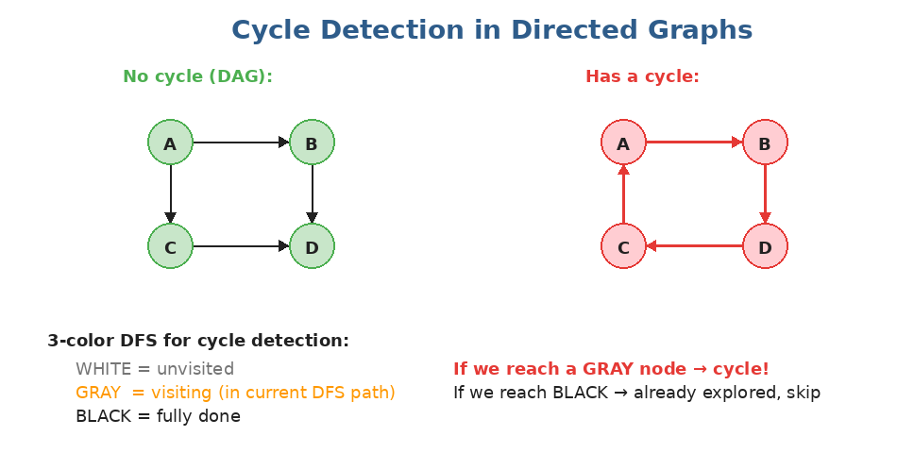
In a directed graph, a cycle exists if DFS reaches a node that is currently 'in progress' on the recursion stack.
def has_cycle_directed(graph):
WHITE, GRAY, BLACK = 0, 1, 2
color = {node: WHITE for node in graph}

def dfs(node):
color[node] = GRAY # actively exploring
for nei in graph[node]:
if color[nei] == GRAY: # back-edge → cycle!
return True
if color[nei] == WHITE and dfs(nei):
return True
color[node] = BLACK # done with this subtree
return False

for node in graph:
if color[node] == WHITE:
if dfs(node): return True
return False

Why 3 colors?: Two colors (visited / not) aren't enough for directed graphs. We need to know whether a visited node is STILL on the current DFS path (gray) or already FULLY explored (black). Hitting gray = cycle; hitting black = OK.

Topological Sort
Topological sort orders the nodes of a DAG (Directed Acyclic Graph) such that for every edge u → v, u comes BEFORE v in the order. Classic example: scheduling courses with prerequisites.
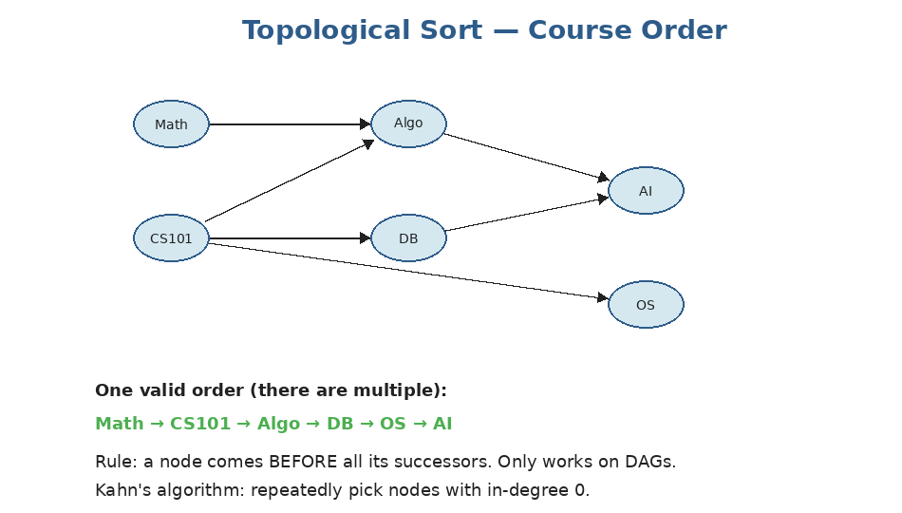
Each arrow means "must finish A before B". Topological sort gives a valid order to take all courses.
When does it work?: Only on DAGs. If the graph has a cycle, no valid topological order exists. So topo-sort algorithms also serve as cycle detectors.

Method 1: Kahn's algorithm (BFS-based)
Idea: repeatedly take a node with in-degree 0, then 'remove' it (decrementing the in-degrees of its neighbors).
from collections import deque

def topo_sort_kahn(graph, num_nodes):
in_degree = [0] * num_nodes
for u in graph:
for v in graph[u]:
in_degree[v] += 1

queue = deque(i for i in range(num_nodes) if in_degree[i] == 0)
order = []
while queue:
node = queue.popleft()
order.append(node)
for nei in graph[node]:
in_degree[nei] -= 1
if in_degree[nei] == 0:
queue.append(nei)

return order if len(order) == num_nodes else [] # cycle if not all included

# Time: O(V + E), Space: O(V + E)

Method 2: DFS-based topological sort
Idea: do a DFS; when a node finishes (post-order), prepend it to the result. Reverse at the end.
def topo_sort_dfs(graph, num_nodes):
visited = set()
order = []

def dfs(node):
visited.add(node)
for nei in graph[node]:
if nei not in visited:
dfs(nei)
order.append(node) # add AFTER all descendants

for node in range(num_nodes):
if node not in visited:
dfs(node)
return order[::-1] # reverse for correct order

Practice questions — Topic 17
Q1. Course Schedule. Given numCourses and prerequisites [[a,b]] (must take b before a), return True if you can finish all courses.
Answer:
This is a cycle-detection problem in disguise. Build the directed graph and check for a cycle. Equivalently: try to topologically sort; if all courses appear, no cycle.
from collections import defaultdict, deque

def can_finish(num_courses, prerequisites):
graph = defaultdict(list)
in_degree = [0] * num_courses
for a, b in prerequisites: # b → a
graph[b].append(a)
in_degree[a] += 1

queue = deque(i for i in range(num_courses) if in_degree[i] == 0)
taken = 0
while queue:
node = queue.popleft()
taken += 1
for nei in graph[node]:
in_degree[nei] -= 1
if in_degree[nei] == 0:
queue.append(nei)
return taken == num_courses

Q2. Course Schedule II. Same setup, but RETURN a valid order to finish all courses (or empty list if impossible).
Answer:
Same Kahn's algorithm — just save the order this time.
from collections import defaultdict, deque

def find_order(num_courses, prerequisites):
graph = defaultdict(list)
in_degree = [0] * num_courses
for a, b in prerequisites:
graph[b].append(a)
in_degree[a] += 1

queue = deque(i for i in range(num_courses) if in_degree[i] == 0)
order = []
while queue:
node = queue.popleft()
order.append(node)
for nei in graph[node]:
in_degree[nei] -= 1
if in_degree[nei] == 0:
queue.append(nei)
return order if len(order) == num_courses else []

Q3. Find Eventual Safe States. A node is SAFE if every path from it leads to a terminal node (no outgoing edges). Return all safe nodes in sorted order.
Answer:
A node is safe iff it's NOT on any cycle and has no path leading to a cycle. Use 3-color DFS — a node is safe if DFS finishes without ever visiting a gray node.
def eventual_safe_nodes(graph):
n = len(graph)
color = [0] * n # 0=white, 1=gray, 2=black

def dfs(node):
if color[node] != 0:
return color[node] == 2 # black = safe
color[node] = 1 # gray
for nei in graph[node]:
if color[nei] == 1 or not dfs(nei):
return False
color[node] = 2 # black
return True

return sorted(i for i in range(n) if dfs(i))

Q4. Graph Valid Tree. Given n nodes and a list of undirected edges, return True if they form a valid tree (connected + no cycles).
Answer:
A tree has exactly n-1 edges, is connected, and has no cycles. With n-1 edges, just one of (connected, no cycles) implies the other — so simply BFS/DFS from node 0 and check that all n nodes are visited.
from collections import defaultdict

def valid_tree(n, edges):
if len(edges) != n - 1:
return False
graph = defaultdict(list)
for a, b in edges:
graph[a].append(b)
graph[b].append(a)

visited = set()
def dfs(node):
visited.add(node)
for nei in graph[node]:
if nei not in visited:
dfs(nei)
dfs(0)
return len(visited) == n

Q5. Alien Dictionary (HARD). Given a sorted list of words from an alien language, derive the order of letters. Example: ["wrt","wrf","er","ett","rftt"] → "wertf".
Answer:
Compare each adjacent pair of words to find the FIRST differing letter — that gives an ordering edge. Build a directed graph of letters, then topo-sort.
Edge case: if word1 is a prefix of word2 but word1 comes AFTER word2 (e.g. "abc" then "ab"), it's invalid.
from collections import defaultdict, deque

def alien_order(words):
graph = defaultdict(set)
in_degree = {c: 0 for w in words for c in w}

for w1, w2 in zip(words, words[1:]):
if len(w1) > len(w2) and w1.startswith(w2):
return "" # invalid
for a, b in zip(w1, w2):
if a != b:
if b not in graph[a]:
graph[a].add(b)
in_degree[b] += 1
break

queue = deque(c for c in in_degree if in_degree[c] == 0)
order = []
while queue:
c = queue.popleft()
order.append(c)
for nei in graph[c]:
in_degree[nei] -= 1
if in_degree[nei] == 0:
queue.append(nei)
return ''.join(order) if len(order) == len(in_degree) else ""

Q6. Number of Connected Components in an Undirected Graph. Given n nodes and edges, count how many separate connected groups exist.
Answer:
DFS or BFS from each unvisited node. Each new start = a new component.
from collections import defaultdict

def count_components(n, edges):
graph = defaultdict(list)
for a, b in edges:
graph[a].append(b)
graph[b].append(a)

visited = set()
def dfs(node):
if node in visited: return
visited.add(node)
for nei in graph[node]:
dfs(nei)

count = 0
for i in range(n):
if i not in visited:
count += 1
dfs(i)
return count

Topic 18 — Shortest Path
Two flavors
There are two completely different shortest-path algorithms depending on whether the graph has weights:
- Unweighted graph → BFS finds shortest path (in terms of edge count).
- Weighted graph (non-negative weights) → Dijkstra's algorithm.
- Weighted graph WITH negative weights → Bellman-Ford (rarely asked).
BFS for unweighted shortest path
Why does plain BFS work? Because BFS visits nodes in order of distance from the start. The first time we reach a node, we've reached it via the shortest path.
from collections import deque

def shortest_path_unweighted(graph, start, end):
if start == end: return 0
visited = {start}
queue = deque([(start, 0)]) # (node, distance)
while queue:
node, dist = queue.popleft()
for nei in graph[node]:
if nei == end:
return dist + 1
if nei not in visited:
visited.add(nei)
queue.append((nei, dist + 1))
return -1 # unreachable

# Time: O(V + E)

Dijkstra's algorithm
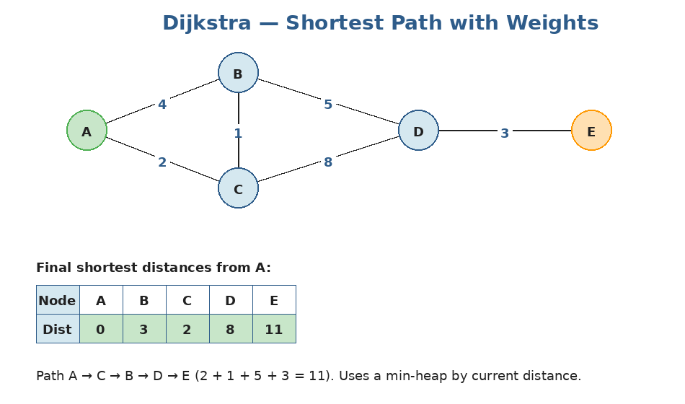
Each edge has a weight (cost). Dijkstra finds the cheapest total route from A to every other node using a min-heap.
The algorithm:
- Keep a min-heap of (current_distance, node), starting with (0, start).
- Pop the node with the smallest distance.
- If we already finalized it, skip.
- Otherwise, finalize and try to relax each neighbor: if going via this node gives a shorter distance, push the new (distance, neighbor) onto the heap.
import heapq

def dijkstra(graph, start):
# graph[u] = list of (v, weight)
dist = {start: 0}
heap = [(0, start)]
while heap:
d, node = heapq.heappop(heap)
if d > dist.get(node, float('inf')):
continue # stale entry, skip
for nei, weight in graph[node]:
new_dist = d + weight
if new_dist < dist.get(nei, float('inf')):
dist[nei] = new_dist
heapq.heappush(heap, (new_dist, nei))
return dist

# Time: O((V + E) log V), Space: O(V)

Dijkstra fails on negative edges: Dijkstra assumes that once you finalize a node's distance, no shorter path exists. A negative-weight edge could break that — you might find a shorter path later. For graphs with negative weights, use Bellman-Ford.

Practice questions — Topic 18
Q1. Shortest Path in Binary Matrix. Given an n×n grid (0=open, 1=blocked), find the shortest path from (0,0) to (n-1,n-1). You can move in 8 directions. Return path length, or -1 if blocked.
Answer:
BFS from (0,0). Note: 8 directions, not 4. The path LENGTH counts the cells, so the start counts as 1.
from collections import deque

def shortest_path_grid(grid):
n = len(grid)
if grid[0][0] or grid[n-1][n-1]: return -1
DIRS = [(-1,-1),(-1,0),(-1,1),(0,-1),(0,1),(1,-1),(1,0),(1,1)]
queue = deque([(0, 0, 1)]) # (r, c, length so far)
visited = {(0,0)}
while queue:
r, c, length = queue.popleft()
if (r, c) == (n-1, n-1):
return length
for dr, dc in DIRS:
nr, nc = r+dr, c+dc
if (0 <= nr < n and 0 <= nc < n
and grid[nr][nc] == 0
and (nr, nc) not in visited):
visited.add((nr, nc))
queue.append((nr, nc, length + 1))
return -1

Q2. Network Delay Time. A directed weighted graph. Sending a signal from node k, return the time for ALL nodes to receive it (the maximum shortest-path distance), or -1 if some node can't be reached.
Answer:
Dijkstra from k. The answer is max(dist.values()). If anything is missing or infinity, return -1.
import heapq
from collections import defaultdict

def network_delay_time(times, n, k):
graph = defaultdict(list)
for u, v, w in times:
graph[u].append((v, w))

dist = {k: 0}
heap = [(0, k)]
while heap:
d, node = heapq.heappop(heap)
if d > dist.get(node, float('inf')): continue
for nei, w in graph[node]:
nd = d + w
if nd < dist.get(nei, float('inf')):
dist[nei] = nd
heapq.heappush(heap, (nd, nei))

if len(dist) < n: return -1
return max(dist.values())

Q3. Cheapest Flights Within K Stops. Given flights [(from, to, price)], find the cheapest price from src to dst with at most k STOPS (so at most k+1 flights). Return -1 if impossible.
Answer:
Modified Dijkstra: state = (cost, node, stops_used). Only push if stops_used <= k. Note: standard Dijkstra's 'finalize once' trick may skip a longer-but-cheaper path here, so we keep exploring with the stops limit.
import heapq
from collections import defaultdict

def find_cheapest_price(n, flights, src, dst, k):
graph = defaultdict(list)
for u, v, w in flights:
graph[u].append((v, w))

# heap: (cost, node, stops_used)
heap = [(0, src, 0)]
best = {} # (node, stops) -> min cost
while heap:
cost, node, stops = heapq.heappop(heap)
if node == dst: return cost
if stops > k: continue
for nei, w in graph[node]:
new_cost = cost + w
if new_cost < best.get((nei, stops+1), float('inf')):
best[(nei, stops+1)] = new_cost
heapq.heappush(heap, (new_cost, nei, stops + 1))
return -1

Q4. Path with Minimum Effort. A grid of heights; you start at top-left and want to reach bottom-right (4 directions). The 'effort' of a path is the MAXIMUM absolute height difference between adjacent cells along the path. Return the minimum effort.
Answer:
Dijkstra variant where 'distance' = max edge weight along path (not sum). Heap entries are (max_effort_so_far, r, c). Relaxation uses max(current_effort, |height_diff|).
import heapq

def minimum_effort_path(heights):
rows, cols = len(heights), len(heights[0])
effort = [[float('inf')] * cols for _ in range(rows)]
effort[0][0] = 0
heap = [(0, 0, 0)]
while heap:
e, r, c = heapq.heappop(heap)
if (r, c) == (rows-1, cols-1):
return e
if e > effort[r][c]: continue
for dr, dc in [(-1,0),(1,0),(0,-1),(0,1)]:
nr, nc = r+dr, c+dc
if 0 <= nr < rows and 0 <= nc < cols:
ne = max(e, abs(heights[nr][nc] - heights[r][c]))
if ne < effort[nr][nc]:
effort[nr][nc] = ne
heapq.heappush(heap, (ne, nr, nc))
return 0

Q5. Word Ladder. Given beginWord, endWord, and a wordList, return the length of the shortest transformation sequence where each step changes one letter and the new word must be in the list.
Answer:
BFS on words. Two words are 'neighbors' if they differ by exactly one letter. To find neighbors fast, generate patterns like 'h*t' and group words by pattern.
from collections import defaultdict, deque

def ladder_length(begin, end, word_list):
if end not in word_list: return 0
word_set = set(word_list)

# Build pattern → words
patterns = defaultdict(list)
for w in word_set:
for i in range(len(w)):
patterns[w[:i] + '*' + w[i+1:]].append(w)

queue = deque([(begin, 1)])
visited = {begin}
while queue:
word, length = queue.popleft()
if word == end: return length
for i in range(len(word)):
pattern = word[:i] + '*' + word[i+1:]
for nei in patterns[pattern]:
if nei not in visited:
visited.add(nei)
queue.append((nei, length + 1))
patterns[pattern] = [] # avoid revisits
return 0

Topic 19 — Union-Find / Disjoint Set Union
What is Union-Find?
Union-Find (also called DSU — Disjoint Set Union) is a data structure that tracks a collection of disjoint sets. It supports two operations: find(x) returns which set x belongs to, and union(x, y) merges the sets containing x and y.
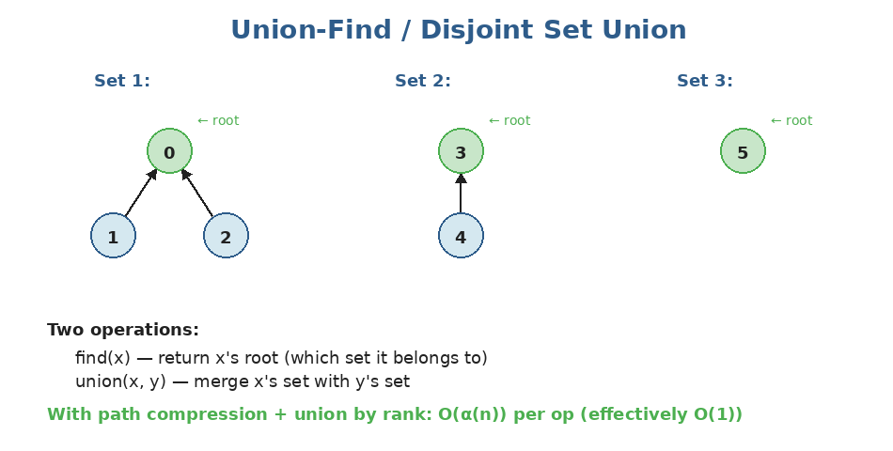
Each element points to its 'parent'. The root of the tree represents the set's identity. Two elements are in the same set iff they share a root.
Basic implementation
class UnionFind:
def __init__(self, n):
self.parent = list(range(n)) # each node is its own parent (own set)

def find(self, x):
# Walk up to the root
while self.parent[x] != x:
x = self.parent[x]
return x

def union(self, x, y):
rx, ry = self.find(x), self.find(y)
if rx != ry:
self.parent[rx] = ry # attach one root under the other

Two crucial optimizations
1. Path compression
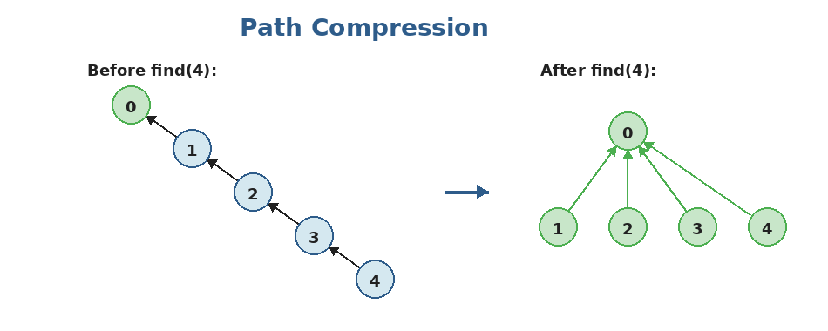
During find, point every node we visit DIRECTLY to the root. Future finds for those nodes are O(1).
2. Union by rank
When merging, attach the SHORTER tree under the TALLER one. This keeps trees shallow.
With both optimizations, the amortized cost of each operation is O(α(n)) where α is the inverse Ackermann function — effectively constant for any practical n.
class UnionFind:
def __init__(self, n):
self.parent = list(range(n))
self.rank = [0] * n
self.count = n # number of disjoint sets

def find(self, x):
# Path compression
if self.parent[x] != x:
self.parent[x] = self.find(self.parent[x])
return self.parent[x]

def union(self, x, y):
rx, ry = self.find(x), self.find(y)
if rx == ry:
return False # already in same set
# Union by rank
if self.rank[rx] < self.rank[ry]:
self.parent[rx] = ry
elif self.rank[rx] > self.rank[ry]:
self.parent[ry] = rx
else:
self.parent[ry] = rx
self.rank[rx] += 1
self.count -= 1
return True

When to reach for Union-Find: Use Union-Find when you need to: (1) check if two things are connected, (2) count connected components, (3) detect cycles in an undirected graph as edges arrive, (4) build a Minimum Spanning Tree (Kruskal's algorithm uses DSU).

Practice questions — Topic 19
Q1. Number of Connected Components in an Undirected Graph (DSU version). Given n nodes and edges, count connected components using Union-Find.
Answer:
Initialize DSU with n nodes (count = n). For each edge, union the two endpoints. Each successful union decrements count by 1. Return count.
def count_components(n, edges):
uf = UnionFind(n)
for a, b in edges:
uf.union(a, b)
return uf.count

Q2. Redundant Connection. A graph started as a tree (n nodes, n-1 edges, no cycles), then ONE extra edge was added. Find that redundant edge.
Answer:
Process edges in order. For each edge (u, v): if u and v are already in the same set, this edge creates the cycle — return it. Otherwise, union them.
def find_redundant_connection(edges):
n = len(edges)
uf = UnionFind(n + 1)
for a, b in edges:
if not uf.union(a, b): # already connected → this edge is redundant
return [a, b]

Q3. Number of Provinces. Given an n×n adjacency matrix (1 = directly connected), return the number of 'provinces' (groups of directly or transitively connected cities).
Answer:
Same as connected components. Walk the upper triangle of the matrix; for each (i, j) with isConnected[i][j] == 1, union them. Answer = uf.count.
def find_circle_num(is_connected):
n = len(is_connected)
uf = UnionFind(n)
for i in range(n):
for j in range(i + 1, n):
if is_connected[i][j]:
uf.union(i, j)
return uf.count

Q4. Accounts Merge. Given a list of accounts, where each account is [name, email1, email2, ...], merge accounts that share any email. Return merged accounts with emails sorted.
Answer:
Treat each unique email as a node. Within each account, union all its emails together. Then group emails by their root, attach the name from the original account.
from collections import defaultdict

def accounts_merge(accounts):
uf = UnionFind(10000) # enough capacity
email_to_id = {}
email_to_name = {}
next_id = 0

for acc in accounts:
name = acc[0]
for email in acc[1:]:
if email not in email_to_id:
email_to_id[email] = next_id
next_id += 1
email_to_name[email] = name
uf.union(email_to_id[acc[1]], email_to_id[email])

groups = defaultdict(list)
for email, eid in email_to_id.items():
groups[uf.find(eid)].append(email)

return [[email_to_name[g[0]]] + sorted(g) for g in groups.values()]

Q5. Graph Valid Tree (DSU version). Same problem as before, now using Union-Find.
Answer:
Tree iff exactly n-1 edges AND no cycle. Process each edge; if union returns False (already connected), there's a cycle → invalid. After all edges, check that count == 1 (one component).
def valid_tree(n, edges):
if len(edges) != n - 1:
return False
uf = UnionFind(n)
for a, b in edges:
if not uf.union(a, b): # cycle
return False
return True

Q6. Most Stones Removed with Same Row or Column. n stones on a 2D grid. A stone can be removed if it shares a row OR column with another remaining stone. Return the maximum number that can be removed.
Answer:
Each connected component (stones connected by row/col sharing) lets us remove all but one. Answer = n - number_of_components. Union stones sharing a row or column.
def remove_stones(stones):
n = len(stones)
uf = UnionFind(n)
for i in range(n):
for j in range(i + 1, n):
if stones[i][0] == stones[j][0] or stones[i][1] == stones[j][1]:
uf.union(i, j)
return n - uf.count

Topic 20 — Minimum Spanning Tree (MST)
What is an MST?
Given a connected, weighted, undirected graph, a SPANNING TREE is a subset of edges that connects all nodes with no cycles. The MINIMUM spanning tree is the spanning tree with the smallest total edge weight.
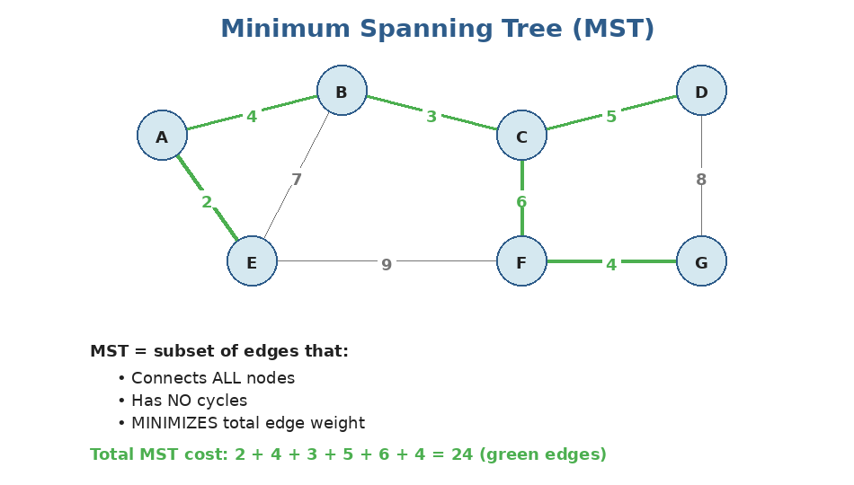
Same graph; the green edges form one valid MST. Note: there can be multiple MSTs if some edge weights tie.
Real-world examples
- Connecting cities with the cheapest set of roads.
- Wiring up a circuit board with minimum copper.
- Building a network with minimum cable cost.
Method 1: Kruskal's algorithm (with Union-Find)
Sort all edges by weight. Greedily add the cheapest edge that doesn't create a cycle. Use Union-Find to detect cycles.
def kruskal(n, edges):
# edges: list of (u, v, weight)
edges.sort(key=lambda e: e[2])
uf = UnionFind(n)
total = 0
used = []
for u, v, w in edges:
if uf.union(u, v):
total += w
used.append((u, v, w))
if len(used) == n - 1:
break
return total, used

# Time: O(E log E) for sorting (Union-Find is effectively O(α))

Method 2: Prim's algorithm (with min-heap)
Start from any node. Greedily extend the tree by adding the cheapest edge connecting the tree to an OUTSIDE node. Uses a min-heap, like a 'Dijkstra for MST'.
import heapq

def prim(graph, start, n):
# graph[u] = list of (v, weight)
visited = {start}
heap = [(w, start, v) for v, w in graph[start]]
heapq.heapify(heap)
total = 0
used = []

while heap and len(visited) < n:
w, u, v = heapq.heappop(heap)
if v in visited:
continue
visited.add(v)
total += w
used.append((u, v, w))
for nei, nw in graph[v]:
if nei not in visited:
heapq.heappush(heap, (nw, v, nei))
return total, used

# Time: O(E log V)

Kruskal vs Prim — when to use which
Operation | Time complexity
Kruskal — sparse graphs | O(E log E) — nice when E ≪ V²
Prim — dense graphs | O(E log V) with heap; can be O(V²) without
Kruskal — easy to code | Just sort edges + DSU
Prim — incremental builds | Better if you grow the MST one node at a time

In practice, Kruskal is the more common interview answer because Union-Find is such a generally useful tool.
Practice questions — Topic 20
Q1. Min Cost to Connect All Points. Given n points on a 2D plane, return the minimum cost to connect all points where the cost between two points is their Manhattan distance.
Answer:
Build all pairwise edges with Manhattan-distance weights. Then run Kruskal's algorithm.
def min_cost_connect_points(points):
n = len(points)
edges = []
for i in range(n):
for j in range(i + 1, n):
d = abs(points[i][0] - points[j][0]) + abs(points[i][1] - points[j][1])
edges.append((d, i, j))

edges.sort()
uf = UnionFind(n)
total = 0
used = 0
for w, u, v in edges:
if uf.union(u, v):
total += w
used += 1
if used == n - 1:
break
return total

# Time: O(n² log n)

Q2. Connecting Cities With Minimum Cost. Given n cities and a list of [city1, city2, cost] connections, return the min cost to connect all cities, or -1 if impossible.
Answer:
Standard Kruskal. After processing, check if exactly n-1 edges were used (otherwise, the graph is disconnected → return -1).
def minimum_cost(n, connections):
connections.sort(key=lambda c: c[2])
uf = UnionFind(n + 1) # 1-indexed cities
total = 0
used = 0
for a, b, cost in connections:
if uf.union(a, b):
total += cost
used += 1
return total if used == n - 1 else -1

Q3. Optimize Water Distribution in a Village. n houses; you can either build a well at house i (cost wells[i-1]) or lay a pipe between two houses (pipes[i] = [a, b, cost]). Minimize total cost so every house has water.
Answer:
Trick: model wells as edges from a virtual node 0 to each house. Then it's a standard MST on n+1 nodes.
def min_cost_to_supply_water(n, wells, pipes):
edges = []
for i, w in enumerate(wells, start=1):
edges.append((w, 0, i)) # virtual node 0 → house i, cost = well cost
for a, b, cost in pipes:
edges.append((cost, a, b))

edges.sort()
uf = UnionFind(n + 1)
total = 0
used = 0
for w, u, v in edges:
if uf.union(u, v):
total += w
used += 1
if used == n: break
return total

You've finished Stage 4!
Stage 4 was the most algorithmically dense stage so far. Graphs unify everything: the BFS/DFS templates from Stage 3 trees, the heap from Stage 3, the recursion from Stage 1. With graphs covered, you have the toolkit for ~half of medium and hard interview problems.
What you should now be comfortable with
- Building an adjacency list from a list of edges (with defaultdict).
- Writing BFS and DFS templates from memory — both for graphs and 4-directional grids.
- Recognizing and solving topo-sort problems (course schedule family).
- Implementing Dijkstra with a min-heap from scratch.
- Implementing Union-Find with path compression and union by rank.
- Recognizing when a problem maps to MST and reaching for Kruskal + DSU.
Before moving on to Stage 5 (Advanced Algorithms)
Self-test:
- Re-implement BFS, DFS (recursive AND iterative) on an adjacency list — from a blank file.
- Solve Number of Islands (BFS), Course Schedule (topo sort), Network Delay Time (Dijkstra) without notes.
- Implement Union-Find with both optimizations from scratch.
- Solve Min Cost to Connect All Points using Kruskal's from a blank file.

Stage 5 covers the ADVANCED ALGORITHMS — backtracking, dynamic programming (the most-feared interview topic), greedy, divide and conquer, and bitmask DP. Most of those build directly on recursion and on the patterns you've learned. Don't move on until graphs feel automatic — DP problems on graphs (and trees) are common.

