DSA Stage 5 — Study Guide
Advanced Algorithms

Backtracking • Dynamic Programming • Greedy • Divide & Conquer • Bitmasks

How to use this guide: Stage 5 is the final stage before the FAANG phase. It covers the highest-leverage advanced topics: Dynamic Programming (the most-feared interview topic), backtracking, greedy, divide and conquer, and bitmask DP. DP gets the most space because it's where most candidates struggle. Don't rush it — type every example.

What you should already know
- Stage 1: recursion fluency — base case + recursive case + the recursive leap of faith.
- Stage 2: stacks (used in iterative backtracking) and binary search.
- Stage 3: trees and recursion — DP on trees is just tree recursion + memoization.
- Stage 4: graphs — some DP problems are shortest-path on DAGs in disguise.

Reading order
- Topic 21 — Backtracking (the foundation for permutations, combinations, constraint problems)
- Topic 22 — DP — 1D (Climbing Stairs, House Robber, Word Break)
- Topic 23 — DP — 2D (Unique Paths, LCS, Edit Distance)
- Topic 24 — DP — Knapsack & Stocks (Coin Change, Buy/Sell Stock variants)
- Topic 25 — Greedy (interval scheduling, jump games)
- Topic 26 — Divide and Conquer
- Topic 27 — Bit Manipulation Deep Dive (Bitmask DP intro)

Topic 21 — Backtracking
What is backtracking?
Backtracking is a way of solving "try every possibility" problems. We make a CHOICE, recurse to extend it, and if it doesn't work, we UNDO the choice and try the next option. It's exhaustive search with an organized way to avoid revisiting the same path.
The template: Three steps repeat at every level: CHOOSE (add an option to the current path), EXPLORE (recurse), UN-CHOOSE (remove the option to try the next one). Memorize this — it solves dozens of problems.

The classic example: subsets of [1, 2, 3]
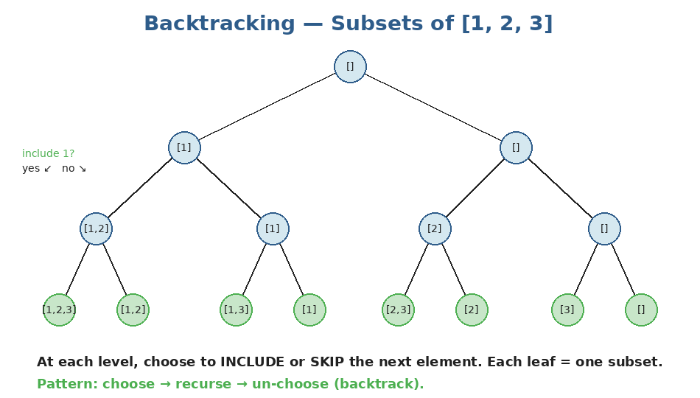
At each step we have two choices: include the next element, or skip it. The leaves are all 2³ = 8 subsets.
def subsets(nums):
result = []
current = []

def backtrack(i):
if i == len(nums):
result.append(current[:]) # IMPORTANT: copy!
return
# Choice 1: SKIP nums[i]
backtrack(i + 1)
# Choice 2: INCLUDE nums[i]
current.append(nums[i])
backtrack(i + 1)
current.pop() # UNDO

backtrack(0)
return result

subsets([1, 2, 3])
# → [[], [3], [2], [2,3], [1], [1,3], [1,2], [1,2,3]]

Why current[:] and not just current?: current is a single list that gets modified in place. If we appended current itself, every entry in result would be the SAME LIST — and by the end, all of them would be empty. current[:] makes a snapshot copy.

Pattern: Pruning to make backtracking feasible
Backtracking is exhaustive, so without pruning it's exponential. Pruning means: stop exploring a branch as soon as you can prove it can't yield a valid answer. Pruning is what separates a slow but correct solution from a fast one.
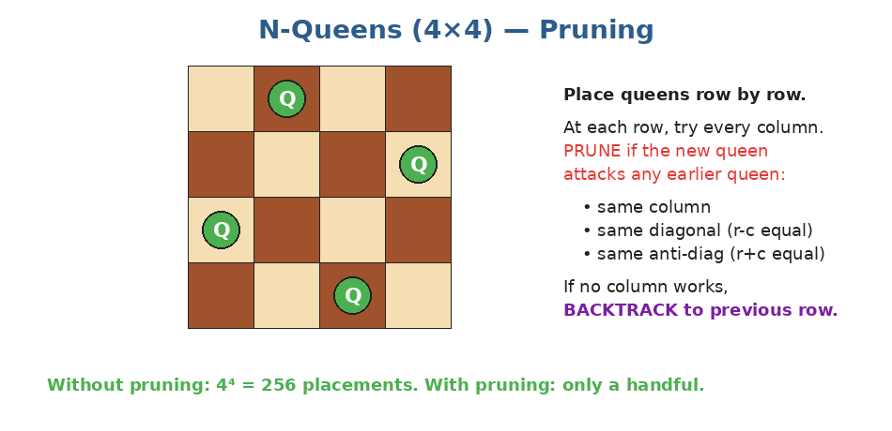
N-Queens: try each row's column. The moment a placement attacks an existing queen, prune that branch and try the next column.
def solve_n_queens(n):
result = []
cols = set()
diag1 = set() # r - c
diag2 = set() # r + c
placement = []

def backtrack(r):
if r == n:
result.append(placement[:])
return
for c in range(n):
if c in cols or (r - c) in diag1 or (r + c) in diag2:
continue # PRUNE: this column attacks an earlier queen
cols.add(c); diag1.add(r - c); diag2.add(r + c)
placement.append(c)
backtrack(r + 1)
cols.remove(c); diag1.remove(r - c); diag2.remove(r + c)
placement.pop()

backtrack(0)
return result

Pattern: Permutations
Same template, but we track which elements are 'used' so we don't repeat:
def permutations(nums):
result = []
current = []
used = [False] * len(nums)

def backtrack():
if len(current) == len(nums):
result.append(current[:])
return
for i in range(len(nums)):
if used[i]: continue
used[i] = True
current.append(nums[i])
backtrack()
current.pop()
used[i] = False

backtrack()
return result

permutations([1, 2, 3])
# → all 6 permutations

When to use backtracking
- Subsets / power sets
- Permutations
- Combinations (especially with constraints like "sum to target")
- Word search / pathfinding on grids without revisits
- Constraint problems: N-Queens, Sudoku
- Generating valid configurations: parentheses, IP addresses
Practice questions — Topic 21
Q1. Subsets. Given a list of distinct integers, return ALL possible subsets. Example: [1,2,3] → [[],[1],[2],[1,2],[3],[1,3],[2,3],[1,2,3]].
Answer:
Backtrack with include/skip choices at each index. Append a copy of current at every recursion (each path generates a unique subset).
def subsets(nums):
result = []
def backtrack(i, current):
if i == len(nums):
result.append(current[:])
return
backtrack(i + 1, current) # skip
current.append(nums[i])
backtrack(i + 1, current) # include
current.pop()
backtrack(0, [])
return result

Q2. Permutations. Return all permutations of a list of distinct integers. Example: [1,2,3] → 6 permutations.
Answer:
Use a `used` array to track which elements are in the current permutation. At each level, pick any unused element.
def permute(nums):
result = []
used = [False] * len(nums)
current = []
def backtrack():
if len(current) == len(nums):
result.append(current[:])
return
for i in range(len(nums)):
if used[i]: continue
used[i] = True
current.append(nums[i])
backtrack()
current.pop()
used[i] = False
backtrack()
return result

Q3. Combination Sum. Given an array of distinct candidates and a target, return all unique combinations where the chosen numbers sum to target. The same number MAY be chosen unlimited times. Example: candidates=[2,3,6,7], target=7 → [[2,2,3],[7]].
Answer:
Backtrack passing target down. At each step, either pick the current candidate (without advancing i, since reuse is allowed) or skip to the next.
def combination_sum(candidates, target):
result = []
current = []
def backtrack(i, remaining):
if remaining == 0:
result.append(current[:])
return
if i == len(candidates) or remaining < 0:
return
# pick candidates[i] (and stay at i for reuse)
current.append(candidates[i])
backtrack(i, remaining - candidates[i])
current.pop()
# skip to next
backtrack(i + 1, remaining)
backtrack(0, target)
return result

Q4. Letter Combinations of a Phone Number. Given a digit string like "23", return all letter combos. 2→abc, 3→def, etc. Example: "23" → ["ad","ae","af","bd","be","bf","cd","ce","cf"].
Answer:
For each digit, try every letter. Recurse to the next digit. Standard backtracking on string positions.
def letter_combinations(digits):
if not digits: return []
mapping = {'2':'abc','3':'def','4':'ghi','5':'jkl',
'6':'mno','7':'pqrs','8':'tuv','9':'wxyz'}
result = []
current = []
def backtrack(i):
if i == len(digits):
result.append(''.join(current))
return
for ch in mapping[digits[i]]:
current.append(ch)
backtrack(i + 1)
current.pop()
backtrack(0)
return result

Q5. Generate Parentheses. Given n, generate all combinations of n pairs of well-formed parentheses. Example: n=3 → ["((()))","(()())","(())()","()(())","()()()"].
Answer:
Track open and close counts. Add '(' if open < n. Add ')' only if close < open. Stop when length = 2n.
def generate_parenthesis(n):
result = []
def backtrack(s, open_count, close_count):
if len(s) == 2 * n:
result.append(s)
return
if open_count < n:
backtrack(s + '(', open_count + 1, close_count)
if close_count < open_count:
backtrack(s + ')', open_count, close_count + 1)
backtrack('', 0, 0)
return result

Q6. Word Search. Given a 2D board of letters and a word, return True if the word can be formed by adjacent (up/down/left/right) cells, with each cell used at most once.
Answer:
DFS from every cell. At each step, mark the cell visited (e.g. set to '#'), recurse to 4 neighbors, then RESTORE on backtrack.
def exist(board, word):
rows, cols = len(board), len(board[0])

def dfs(r, c, i):
if i == len(word): return True
if not (0 <= r < rows and 0 <= c < cols): return False
if board[r][c] != word[i]: return False
saved = board[r][c]
board[r][c] = '#' # mark visited
found = (dfs(r+1, c, i+1) or dfs(r-1, c, i+1)
or dfs(r, c+1, i+1) or dfs(r, c-1, i+1))
board[r][c] = saved # backtrack
return found

for r in range(rows):
for c in range(cols):
if dfs(r, c, 0):
return True
return False

Q7. N-Queens. Given n, return ALL distinct placements of n queens on an n×n board such that no two attack each other.
Answer:
Place row by row. Track sets of used columns and diagonals (r-c, r+c) for O(1) attack checks.
def solve_n_queens(n):
result = []
cols, d1, d2 = set(), set(), set()
placement = []

def backtrack(r):
if r == n:
board = ['.' * c + 'Q' + '.' * (n - c - 1) for c in placement]
result.append(board)
return
for c in range(n):
if c in cols or (r-c) in d1 or (r+c) in d2:
continue
cols.add(c); d1.add(r-c); d2.add(r+c)
placement.append(c)
backtrack(r + 1)
cols.remove(c); d1.remove(r-c); d2.remove(r+c)
placement.pop()
backtrack(0)
return result

Topic 22 — Dynamic Programming (1D)
What is dynamic programming?
Dynamic programming (DP) is the art of solving a problem by breaking it into OVERLAPPING SUBPROBLEMS and remembering the answers. The two pillars: (1) optimal substructure — the answer can be built from answers to smaller versions; (2) overlapping subproblems — the same subproblem appears many times.
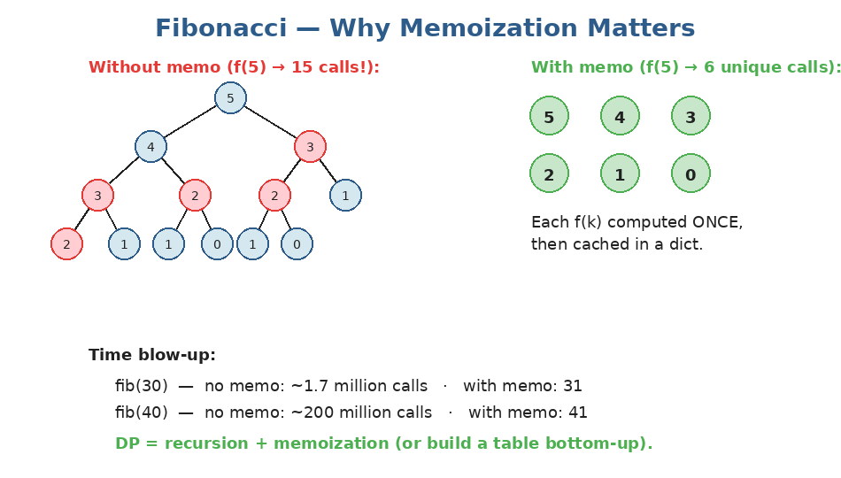
The naive Fibonacci recursion recomputes f(3) twice and f(2) three times — and it gets exponentially worse. Memoization caches each result.
Two flavors of DP
EVERY DP problem can be written two ways. Both are correct; they're just different shapes:
1. Top-down (memoization)
Write the natural recursion, then add a cache so we don't recompute.
from functools import lru_cache

@lru_cache(maxsize=None)
def fib(n):
if n < 2: return n
return fib(n - 1) + fib(n - 2)

# Or do it manually:
def fib_manual(n, memo=None):
if memo is None: memo = {}
if n < 2: return n
if n in memo: return memo[n]
memo[n] = fib_manual(n-1, memo) + fib_manual(n-2, memo)
return memo[n]

# Time: O(n), Space: O(n) for the cache + recursion stack

2. Bottom-up (tabulation)
Build a table from smallest subproblem to biggest. No recursion. Often faster (no function call overhead).
def fib(n):
if n < 2: return n
dp = [0] * (n + 1)
dp[1] = 1
for i in range(2, n + 1):
dp[i] = dp[i-1] + dp[i-2]
return dp[n]

# Often we can drop the table entirely if we only need the last 2 values:
def fib_optimized(n):
if n < 2: return n
a, b = 0, 1
for _ in range(2, n + 1):
a, b = b, a + b
return b

# Time: O(n), Space: O(1)

Climbing Stairs — the canonical 1D DP
You can climb 1 or 2 steps at a time. How many ways to climb n stairs? To reach step n, the previous move was either +1 (from n-1) or +2 (from n-2). So ways(n) = ways(n-1) + ways(n-2). Same shape as Fibonacci.
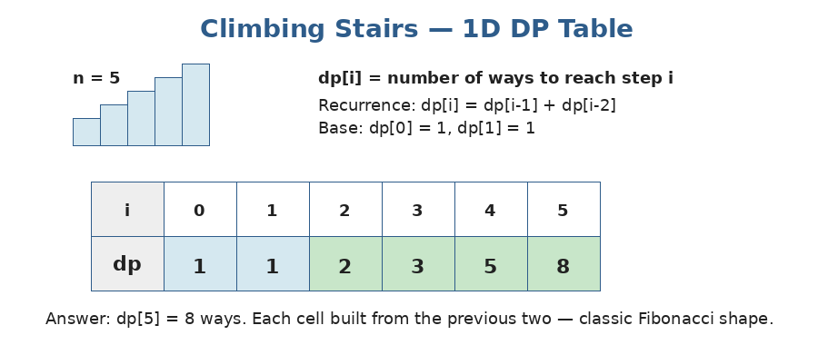
dp[i] = number of ways to reach step i. Each cell is the sum of the previous two.
def climb_stairs(n):
if n <= 2: return n
a, b = 1, 2
for _ in range(3, n + 1):
a, b = b, a + b
return b

How to attack any DP problem — 3 questions
Memorize these. Apply them to EVERY DP problem you see:
- 1. STATE: what does dp[i] (or dp[i][j]) represent? Answer this in plain English.
- 2. RECURRENCE: how does dp[i] depend on smaller subproblems?
- 3. BASE CASE: what are the smallest dp values you can fill in directly?
Worked example: House Robber: STATE: dp[i] = max money you can rob from houses 0..i. RECURRENCE: at house i, either skip it (carry dp[i-1]) or rob it (dp[i-2] + nums[i]). BASE: dp[0] = nums[0]; dp[1] = max(nums[0], nums[1]).

def rob(nums):
if not nums: return 0
if len(nums) == 1: return nums[0]
prev2, prev1 = nums[0], max(nums[0], nums[1])
for i in range(2, len(nums)):
curr = max(prev1, prev2 + nums[i])
prev2, prev1 = prev1, curr
return prev1

# Time: O(n), Space: O(1)

Practice questions — Topic 22
Q1. Climbing Stairs. n stairs; you can climb 1 or 2 at a time. How many distinct ways? Example: n=3 → 3.
Answer:
dp[i] = dp[i-1] + dp[i-2]. Optimize to two variables.
def climb_stairs(n):
if n <= 2: return n
a, b = 1, 2
for _ in range(3, n + 1):
a, b = b, a + b
return b

Q2. House Robber. You can't rob two adjacent houses. Max total. Example: [2,7,9,3,1] → 12 (rob houses 0,2,4).
Answer:
dp[i] = max(skip → dp[i-1], rob → dp[i-2] + nums[i]).
def rob(nums):
if not nums: return 0
if len(nums) == 1: return nums[0]
prev2, prev1 = nums[0], max(nums[0], nums[1])
for i in range(2, len(nums)):
prev2, prev1 = prev1, max(prev1, prev2 + nums[i])
return prev1

Q3. House Robber II. Same as House Robber, but houses are arranged in a CIRCLE — first and last are now adjacent.
Answer:
Trick: the optimal solution either INCLUDES the first house OR includes the last, but not both. So compute House Robber on nums[0:-1] and nums[1:], take the max.
def rob(nums):
if len(nums) == 1: return nums[0]
def rob_linear(arr):
prev2 = prev1 = 0
for x in arr:
prev2, prev1 = prev1, max(prev1, prev2 + x)
return prev1
return max(rob_linear(nums[:-1]), rob_linear(nums[1:]))

Q4. Decode Ways. "A"→1, "B"→2, ..., "Z"→26. Given a digit string, how many ways to decode it? Example: "12" → 2 ("AB" or "L").
Answer:
dp[i] = ways to decode the first i characters. Single-digit decode: if s[i-1] in '1'..'9' add dp[i-1]. Two-digit decode: if s[i-2:i] is in '10'..'26' add dp[i-2].
def num_decodings(s):
if not s or s[0] == '0': return 0
n = len(s)
dp = [0] * (n + 1)
dp[0] = dp[1] = 1
for i in range(2, n + 1):
if s[i-1] != '0':
dp[i] += dp[i-1]
two = int(s[i-2:i])
if 10 <= two <= 26:
dp[i] += dp[i-2]
return dp[n]

Q5. Word Break. Given a string and a dictionary, return True if the string can be split into a sequence of dictionary words. Example: s="leetcode", words=["leet","code"] → True.
Answer:
dp[i] = True if s[0:i] is breakable. dp[i] = True iff there exists some j < i where dp[j] is True AND s[j:i] is in the dictionary.
def word_break(s, word_dict):
word_set = set(word_dict)
n = len(s)
dp = [False] * (n + 1)
dp[0] = True
for i in range(1, n + 1):
for j in range(i):
if dp[j] and s[j:i] in word_set:
dp[i] = True
break
return dp[n]

# Time: O(n²) average, Space: O(n)

Q6. Longest Increasing Subsequence. Find the length of the longest strictly increasing subsequence. Example: [10,9,2,5,3,7,101,18] → 4 (e.g. [2,3,7,101]).
Answer:
O(n²) DP: dp[i] = length of LIS ending at index i. For each i, look at all j < i with nums[j] < nums[i] and take dp[j]+1. Answer is max(dp).
(Faster O(n log n) via binary search exists but the DP version is the one to know first.)
def length_of_lis(nums):
if not nums: return 0
n = len(nums)
dp = [1] * n
for i in range(1, n):
for j in range(i):
if nums[j] < nums[i]:
dp[i] = max(dp[i], dp[j] + 1)
return max(dp)

Q7. Maximum Subarray (Kadane's algorithm). Find the contiguous subarray with the largest sum. Example: [-2,1,-3,4,-1,2,1,-5,4] → 6.
Answer:
DP variant: at each i, either extend the previous subarray (current + x) or start fresh from x. Track the best.
def max_subarray(nums):
current = best = nums[0]
for x in nums[1:]:
current = max(x, current + x)
best = max(best, current)
return best

Topic 23 — Dynamic Programming (2D)
Why 2D?
Many problems need TWO indices to fully describe a state. Examples: position in a grid (row + column), or position in two strings simultaneously. The state becomes dp[i][j] instead of dp[i].
Pattern 1: Grid path DP
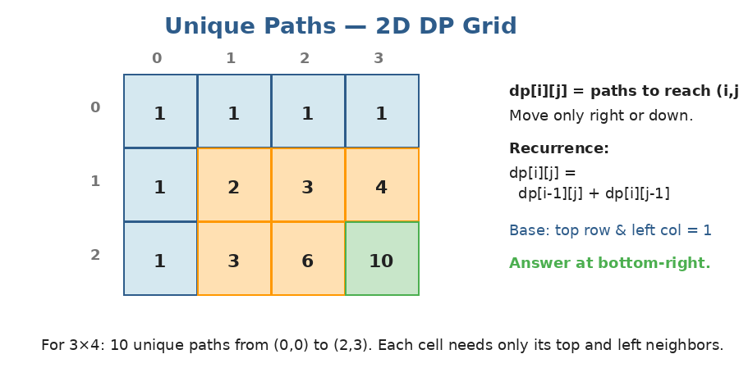
Unique Paths: from (0,0) to (m-1,n-1), moving only right or down. Each cell = paths from top + paths from left.
def unique_paths(m, n):
dp = [[1] * n for _ in range(m)]
for i in range(1, m):
for j in range(1, n):
dp[i][j] = dp[i-1][j] + dp[i][j-1]
return dp[m-1][n-1]

# Time: O(m × n), Space: O(m × n)
# Can be optimized to O(n) since each row only needs the previous row.

Variant: Min Path Sum — find the minimum sum from top-left to bottom-right.
def min_path_sum(grid):
m, n = len(grid), len(grid[0])
dp = [[0]*n for _ in range(m)]
dp[0][0] = grid[0][0]
for j in range(1, n):
dp[0][j] = dp[0][j-1] + grid[0][j]
for i in range(1, m):
dp[i][0] = dp[i-1][0] + grid[i][0]
for i in range(1, m):
for j in range(1, n):
dp[i][j] = min(dp[i-1][j], dp[i][j-1]) + grid[i][j]
return dp[m-1][n-1]

Pattern 2: Two-string DP
When comparing two strings (or sequences), the natural state is dp[i][j] = answer for s1[:i] and s2[:j]. The recurrence usually has two cases: characters match, or characters don't match.
Longest Common Subsequence (LCS)
Given two strings, find the length of the longest sequence appearing in both (not necessarily contiguous).
def lcs(s1, s2):
m, n = len(s1), len(s2)
dp = [[0]*(n+1) for _ in range(m+1)]
for i in range(1, m+1):
for j in range(1, n+1):
if s1[i-1] == s2[j-1]:
dp[i][j] = dp[i-1][j-1] + 1 # match: extend diagonal
else:
dp[i][j] = max(dp[i-1][j], dp[i][j-1]) # skip one char
return dp[m][n]

lcs("abcde", "ace") # → 3 ("ace")

The match-or-skip recurrence: Most two-string DPs follow this pattern: if chars match, base on dp[i-1][j-1] (consume both). If they don't, take max/min of dp[i-1][j] (skip s1's char) and dp[i][j-1] (skip s2's char). Memorize this shape.

Edit Distance (Levenshtein)
Minimum number of edits (insert, delete, replace) to convert s1 into s2.
def edit_distance(s1, s2):
m, n = len(s1), len(s2)
dp = [[0]*(n+1) for _ in range(m+1)]
for i in range(m+1): dp[i][0] = i # delete all of s1
for j in range(n+1): dp[0][j] = j # insert all of s2

for i in range(1, m+1):
for j in range(1, n+1):
if s1[i-1] == s2[j-1]:
dp[i][j] = dp[i-1][j-1]
else:
dp[i][j] = 1 + min(
dp[i-1][j], # delete from s1
dp[i][j-1], # insert into s1
dp[i-1][j-1], # replace
)
return dp[m][n]

edit_distance("horse", "ros") # → 3

Practice questions — Topic 23
Q1. Unique Paths. m×n grid. From (0,0) to (m-1,n-1), moving only right or down. Count distinct paths. Example: 3×7 → 28.
Answer:
dp[i][j] = dp[i-1][j] + dp[i][j-1]. Top row and left column are all 1.
def unique_paths(m, n):
dp = [[1] * n for _ in range(m)]
for i in range(1, m):
for j in range(1, n):
dp[i][j] = dp[i-1][j] + dp[i][j-1]
return dp[m-1][n-1]

Q2. Minimum Path Sum. m×n grid filled with non-negative numbers. Find a top-left to bottom-right path that MINIMIZES the sum.
Answer:
dp[i][j] = grid[i][j] + min(dp[i-1][j], dp[i][j-1]). Initialize first row/column as cumulative sums.
def min_path_sum(grid):
m, n = len(grid), len(grid[0])
for i in range(m):
for j in range(n):
if i == 0 and j == 0: continue
up = grid[i-1][j] if i > 0 else float('inf')
left = grid[i][j-1] if j > 0 else float('inf')
grid[i][j] += min(up, left)
return grid[m-1][n-1]

Q3. Longest Common Subsequence. Length of the longest subsequence common to s1 and s2. Example: "abcde", "ace" → 3.
Answer:
Match-or-skip recurrence on dp[i][j] for prefixes s1[:i] and s2[:j].
def lcs(s1, s2):
m, n = len(s1), len(s2)
dp = [[0]*(n+1) for _ in range(m+1)]
for i in range(1, m+1):
for j in range(1, n+1):
if s1[i-1] == s2[j-1]:
dp[i][j] = dp[i-1][j-1] + 1
else:
dp[i][j] = max(dp[i-1][j], dp[i][j-1])
return dp[m][n]

Q4. Edit Distance. Min number of insert/delete/replace operations to convert s1 to s2.
Answer:
Match → carry dp[i-1][j-1]. Mismatch → 1 + min of three: delete (dp[i-1][j]), insert (dp[i][j-1]), replace (dp[i-1][j-1]).
def min_distance(s1, s2):
m, n = len(s1), len(s2)
dp = [[0]*(n+1) for _ in range(m+1)]
for i in range(m+1): dp[i][0] = i
for j in range(n+1): dp[0][j] = j
for i in range(1, m+1):
for j in range(1, n+1):
if s1[i-1] == s2[j-1]:
dp[i][j] = dp[i-1][j-1]
else:
dp[i][j] = 1 + min(dp[i-1][j], dp[i][j-1], dp[i-1][j-1])
return dp[m][n]

Q5. Maximal Square. In a 2D matrix of '0's and '1's, find the area of the largest SQUARE of 1's. Example: side 2 → area 4.
Answer:
dp[i][j] = side length of the largest square with bottom-right corner at (i,j). If grid[i][j] == '1', dp[i][j] = 1 + min(top, left, top-left).
def maximal_square(matrix):
if not matrix: return 0
m, n = len(matrix), len(matrix[0])
dp = [[0]*n for _ in range(m)]
best = 0
for i in range(m):
for j in range(n):
if matrix[i][j] == '1':
if i == 0 or j == 0:
dp[i][j] = 1
else:
dp[i][j] = 1 + min(dp[i-1][j], dp[i][j-1], dp[i-1][j-1])
best = max(best, dp[i][j])
return best * best

Q6. Longest Palindromic Substring. Find the longest substring that's a palindrome. Example: "babad" → "bab" or "aba".
Answer:
dp[i][j] = True iff s[i:j+1] is a palindrome. Base: single chars are palindromes; pairs are palindromes iff equal. Otherwise dp[i][j] = (s[i]==s[j]) AND dp[i+1][j-1].
Fill diagonals from short to long substrings. Track the longest seen.
def longest_palindrome(s):
n = len(s)
if n == 0: return ""
dp = [[False]*n for _ in range(n)]
start, max_len = 0, 1
for i in range(n):
dp[i][i] = True
for length in range(2, n+1):
for i in range(n - length + 1):
j = i + length - 1
if s[i] == s[j] and (length == 2 or dp[i+1][j-1]):
dp[i][j] = True
if length > max_len:
start, max_len = i, length
return s[start:start+max_len]

Q7. Distinct Subsequences (HARD). Given s and t, count how many distinct subsequences of s equal t. Example: s="rabbbit", t="rabbit" → 3.
Answer:
dp[i][j] = number of ways s[:i] forms t[:j]. If s[i-1]==t[j-1], we can either match (dp[i-1][j-1]) or skip s's char (dp[i-1][j]). Otherwise skip only.
def num_distinct(s, t):
m, n = len(s), len(t)
dp = [[0]*(n+1) for _ in range(m+1)]
for i in range(m+1): dp[i][0] = 1 # empty t matches in 1 way (delete all of s)
for i in range(1, m+1):
for j in range(1, n+1):
if s[i-1] == t[j-1]:
dp[i][j] = dp[i-1][j-1] + dp[i-1][j]
else:
dp[i][j] = dp[i-1][j]
return dp[m][n]

Topic 24 — DP — Knapsack & Stocks
0/1 Knapsack — the classic
You have items with weights and values, and a knapsack of limited capacity. You can EITHER take an item (once) OR skip it. Maximize total value without exceeding capacity. The state captures "first i items, capacity w".
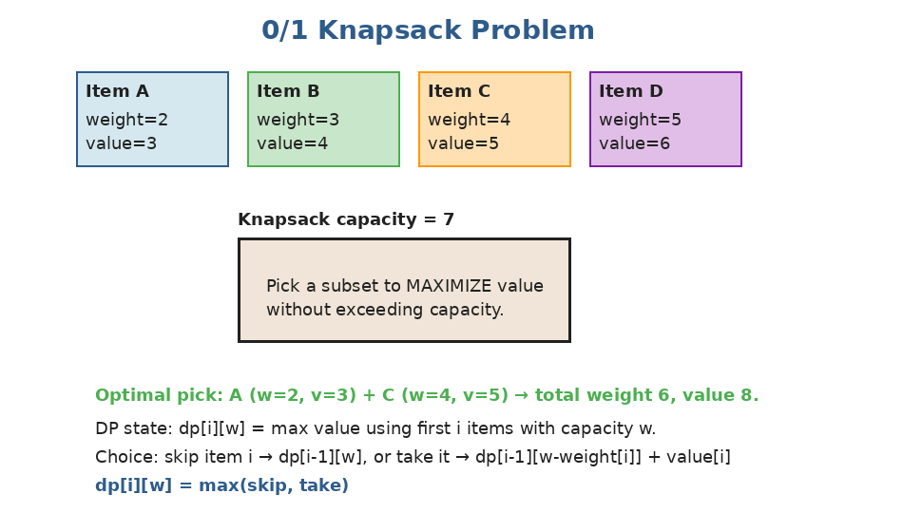
At each item, choose: skip (carry dp[i-1][w]) or take (dp[i-1][w - weight[i]] + value[i]) — if it fits.
def knapsack(weights, values, capacity):
n = len(weights)
dp = [[0]*(capacity+1) for _ in range(n+1)]
for i in range(1, n+1):
w_i, v_i = weights[i-1], values[i-1]
for w in range(capacity+1):
dp[i][w] = dp[i-1][w] # skip
if w >= w_i:
dp[i][w] = max(dp[i][w], dp[i-1][w-w_i] + v_i) # take
return dp[n][capacity]

# Time: O(n × capacity), Space: O(n × capacity)
# Can be optimized to O(capacity) with a 1D array (iterate w backwards).

Common 0/1 knapsack disguises
- Partition Equal Subset Sum: split into 2 subsets of equal sum → subset-sum problem.
- Target Sum: assign +/- to each number to reach a target → equivalent to subset-sum.
- Last Stone Weight II: minimize difference between two piles → also subset-sum.
Unbounded Knapsack — pick any item any times
Same idea, but if you 'take' item i, you can take it again. Coin Change is the canonical example.
# Coin Change: minimum number of coins to make amount
def coin_change(coins, amount):
dp = [float('inf')] * (amount + 1)
dp[0] = 0
for w in range(1, amount + 1):
for coin in coins:
if w >= coin:
dp[w] = min(dp[w], dp[w - coin] + 1)
return dp[amount] if dp[amount] != float('inf') else -1

# Coin Change 2: number of ways to make amount (combinations, not permutations)
def coin_change_ways(amount, coins):
dp = [0] * (amount + 1)
dp[0] = 1
for coin in coins: # outer loop over coins (combinations)
for w in range(coin, amount + 1):
dp[w] += dp[w - coin]
return dp[amount]

Loop order matters!: For Coin Change (min coins) the answer is the same either loop order. But for Coin Change 2 (count of ways), you MUST loop coins in the outer loop. Otherwise you count permutations (e.g. 1+2 and 2+1) as different.

Stock-trading DP — state machine
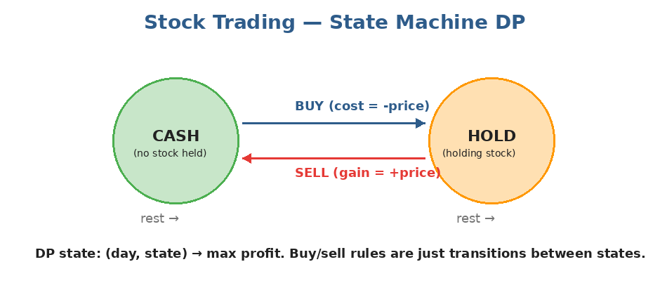
Two states: CASH (no shares) and HOLD (one share). On each day you can transition (buy/sell) or rest. DP over (day, state).
Best Time to Buy and Sell Stock II — unlimited transactions:
def max_profit(prices):
cash, hold = 0, -prices[0]
for p in prices[1:]:
cash = max(cash, hold + p) # sell today (or rest in cash)
hold = max(hold, cash - p) # buy today (or rest in hold)
return cash

# Equivalent: sum up every positive day-to-day gain

With cooldown — after selling, must wait one day before buying:
def max_profit_cooldown(prices):
if not prices: return 0
cash, hold, cooldown = 0, -prices[0], 0
for p in prices[1:]:
new_cash = max(cash, cooldown)
new_hold = max(hold, cash - p)
new_cooldown = hold + p # we must have just sold
cash, hold, cooldown = new_cash, new_hold, new_cooldown
return max(cash, cooldown)

Practice questions — Topic 24
Q1. Coin Change. Coins of given denominations and a target amount. Return the FEWEST coins needed, or -1 if impossible. Example: coins=[1,2,5], amount=11 → 3 (5+5+1).
Answer:
dp[w] = min coins for amount w. For each w, try each coin: dp[w] = min over coins of dp[w-coin] + 1.
def coin_change(coins, amount):
dp = [float('inf')] * (amount + 1)
dp[0] = 0
for w in range(1, amount + 1):
for c in coins:
if w >= c:
dp[w] = min(dp[w], dp[w-c] + 1)
return dp[amount] if dp[amount] != float('inf') else -1

Q2. Coin Change 2. Number of distinct combinations to make amount. Example: amount=5, coins=[1,2,5] → 4 (5; 2+2+1; 2+1+1+1; 1+1+1+1+1).
Answer:
dp[w] = number of ways to make w. Outer loop over coins (gives combinations, not permutations).
def change(amount, coins):
dp = [0] * (amount + 1)
dp[0] = 1
for c in coins:
for w in range(c, amount + 1):
dp[w] += dp[w - c]
return dp[amount]

Q3. Partition Equal Subset Sum. Determine if the array can be split into 2 subsets with equal sums. Example: [1,5,11,5] → True (11 vs 5+5+1).
Answer:
If total sum is odd, impossible. Else: find subset summing to total/2. Standard 0/1 knapsack with a boolean dp.
def can_partition(nums):
total = sum(nums)
if total % 2: return False
target = total // 2
dp = [False] * (target + 1)
dp[0] = True
for x in nums:
for w in range(target, x - 1, -1): # iterate backwards (0/1 knapsack)
dp[w] = dp[w] or dp[w - x]
return dp[target]

Q4. Target Sum. Given nums and target, count assignments of +/- to each number so the sum equals target. Example: nums=[1,1,1,1,1], target=3 → 5.
Answer:
Math trick: let P = sum of positives, N = sum of negatives. P + N = total, P - N = target. So P = (total + target) / 2. The problem becomes: count subsets that sum to P. Standard subset-sum count DP.
def find_target_sum_ways(nums, target):
total = sum(nums)
if abs(target) > total or (total + target) % 2: return 0
p = (total + target) // 2
dp = [0] * (p + 1)
dp[0] = 1
for x in nums:
for w in range(p, x - 1, -1):
dp[w] += dp[w - x]
return dp[p]

Q5. Best Time to Buy and Sell Stock. ONE buy and one sell. Max profit, or 0 if no profit. Example: [7,1,5,3,6,4] → 5.
Answer:
Track the minimum price seen so far. At each day, profit = price - min_so_far.
def max_profit(prices):
min_price = float('inf')
best = 0
for p in prices:
min_price = min(min_price, p)
best = max(best, p - min_price)
return best

Q6. Best Time to Buy and Sell Stock II. Unlimited transactions allowed. Example: [7,1,5,3,6,4] → 7.
Answer:
State machine DP: cash and hold. Or simpler: sum every positive day-to-day gain.
def max_profit(prices):
profit = 0
for i in range(1, len(prices)):
if prices[i] > prices[i-1]:
profit += prices[i] - prices[i-1]
return profit

Q7. Best Time to Buy and Sell Stock with Cooldown. After selling, must wait one day before buying. Example: [1,2,3,0,2] → 3.
Answer:
Three states: cash (no stock, can buy), hold (have stock), cooldown (just sold). Transition daily.
def max_profit(prices):
if not prices: return 0
cash, hold, cooldown = 0, -prices[0], 0
for p in prices[1:]:
cash, hold, cooldown = (
max(cash, cooldown),
max(hold, cash - p),
hold + p,
)
return max(cash, cooldown)

Topic 25 — Greedy Algorithms
What makes an algorithm greedy?
A greedy algorithm makes the LOCALLY OPTIMAL choice at each step, never reconsidering. When greedy works, it gives the GLOBAL optimum — and it's usually faster than DP for the same problem. The catch: greedy doesn't always work. Knowing WHEN to use it is the skill.
The greedy choice property: A problem has the greedy choice property if there's a 'safe' choice you can make at each step that NEVER excludes the optimal answer. Proving greedy correct usually involves an EXCHANGE argument: "if the optimal solution doesn't make this choice, we can swap and it still works".

Pattern: Interval Scheduling
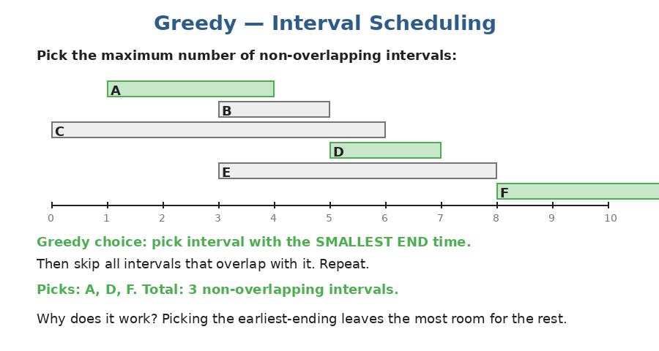
To pick the maximum number of non-overlapping intervals, sort by END time and greedily take each compatible one. Picking the earliest ending leaves the most room for the rest.
def max_intervals(intervals):
intervals.sort(key=lambda x: x[1]) # sort by END
count = 0
end = float('-inf')
for s, e in intervals:
if s >= end:
count += 1
end = e
return count

Pattern: Sweep + Greedy
For interval-merging problems, sort by start, then walk through extending or starting a new interval.
def merge(intervals):
intervals.sort(key=lambda x: x[0])
merged = []
for s, e in intervals:
if merged and s <= merged[-1][1]:
merged[-1][1] = max(merged[-1][1], e)
else:
merged.append([s, e])
return merged

Pattern: Jump Game family
Jump Game: from index 0, can you reach the end? At each index, jump up to nums[i] forward. Greedy: track the FARTHEST reachable index. If at any i > farthest, you're stuck. Otherwise the answer is yes.
def can_jump(nums):
farthest = 0
for i, x in enumerate(nums):
if i > farthest:
return False
farthest = max(farthest, i + x)
return True

Greedy vs DP — when to use which?
Operation | Time complexity
Greedy works | When the locally best choice is always globally safe (interval scheduling, Huffman codes, MST)
Greedy fails | When future depends on past combos (knapsack, longest path)
Coin Change with [1, 5, 10, 25] | Greedy works (US coins)
Coin Change with [1, 3, 4] | Greedy FAILS — for amount 6, greedy picks 4+1+1=3 coins; optimal is 3+3=2

Practice questions — Topic 25
Q1. Jump Game. From index 0, each index lets you jump up to nums[i] forward. Can you reach the last index? Example: [2,3,1,1,4] → True; [3,2,1,0,4] → False.
Answer:
Track farthest reachable index. If you ever stand at i > farthest, return False.
def can_jump(nums):
farthest = 0
for i, x in enumerate(nums):
if i > farthest: return False
farthest = max(farthest, i + x)
return True

Q2. Jump Game II. Same setup, but minimize the number of jumps to reach the end. Example: [2,3,1,1,4] → 2.
Answer:
BFS-on-array: maintain the current jump's range [start, end]. Explore the range, find the FARTHEST index reachable. When you reach end, you've used one jump — start the next from there.
def jump(nums):
jumps = 0
end = farthest = 0
for i in range(len(nums) - 1):
farthest = max(farthest, i + nums[i])
if i == end: # reached current jump's edge
jumps += 1
end = farthest
return jumps

Q3. Merge Intervals. Merge overlapping intervals. Example: [[1,3],[2,6],[8,10],[15,18]] → [[1,6],[8,10],[15,18]].
Answer:
Sort by start. Walk through; merge into the previous interval if overlapping, else start a new one.
def merge(intervals):
intervals.sort(key=lambda x: x[0])
merged = []
for s, e in intervals:
if merged and s <= merged[-1][1]:
merged[-1][1] = max(merged[-1][1], e)
else:
merged.append([s, e])
return merged

Q4. Non-overlapping Intervals. Min number of intervals to REMOVE so the rest are non-overlapping. Example: [[1,2],[2,3],[3,4],[1,3]] → 1 (remove [1,3]).
Answer:
Sort by END time. Greedily keep each interval whose start ≥ last kept end. Removed = total - kept.
def erase_overlap(intervals):
intervals.sort(key=lambda x: x[1])
kept = 0
end = float('-inf')
for s, e in intervals:
if s >= end:
kept += 1
end = e
return len(intervals) - kept

Q5. Gas Station. n stations on a circle. gas[i] is gas you gain at station i; cost[i] is gas needed to reach the next. Return the starting index that lets you complete the loop, or -1.
Answer:
If total gas < total cost, impossible. Else, walk the array tracking running tank. If tank dips below 0, no station between the previous start and i can be the answer — try i+1 as the new start.
def can_complete_circuit(gas, cost):
if sum(gas) < sum(cost): return -1
start = 0
tank = 0
for i in range(len(gas)):
tank += gas[i] - cost[i]
if tank < 0:
start = i + 1
tank = 0
return start

Q6. Task Scheduler. Given task counts and cooldown n, return min total time. Same task can't run within n steps. Example: ["A","A","A","B","B","B"], n=2 → 8.
Answer:
Greedy / formula: let M = max frequency, c = number of tasks tied at M. Min time = max(len(tasks), (M-1)*(n+1) + c). Build (M-1) blocks of length n+1, then add c tasks in the final block.
from collections import Counter

def least_interval(tasks, n):
counts = Counter(tasks)
max_count = max(counts.values())
tied = sum(1 for v in counts.values() if v == max_count)
return max(len(tasks), (max_count - 1) * (n + 1) + tied)

Q7. Partition Labels. Partition a string into as many parts as possible such that each letter appears in at most one part. Return part lengths. Example: "ababcbacadefegdehijhklij" → [9,7,8].
Answer:
First pass: record each letter's LAST index. Second pass: keep extending the current partition's end to the max last-index seen so far. When i reaches that end, close the partition.
def partition_labels(s):
last = {ch: i for i, ch in enumerate(s)}
result = []
start = end = 0
for i, ch in enumerate(s):
end = max(end, last[ch])
if i == end:
result.append(end - start + 1)
start = i + 1
return result

Topic 26 — Divide and Conquer
The 3-step recipe
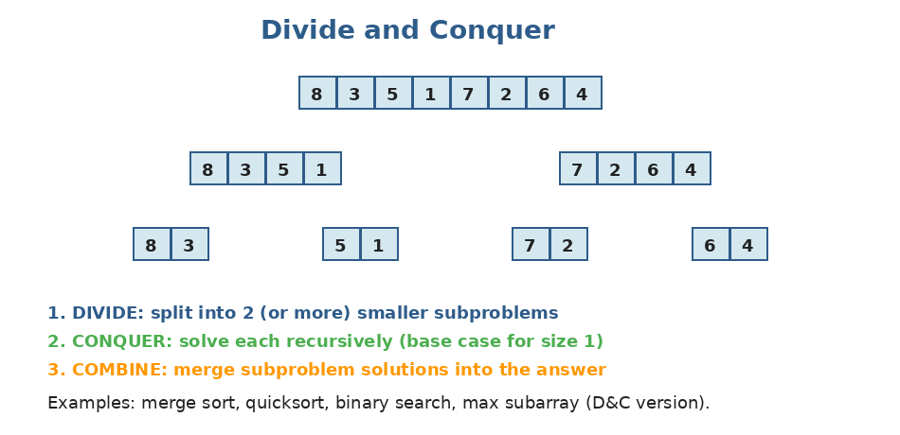
The same idea behind merge sort: divide the array, recursively conquer each half, then combine the answers.
Three steps for any D&C algorithm:
- DIVIDE: split the problem into smaller subproblems (usually halves).
- CONQUER: recursively solve each subproblem (base case for the smallest size).
- COMBINE: merge subproblem solutions into the final answer.
Examples you've already seen
- Merge sort (Stage 2) — divide array, sort halves, merge.
- Quicksort (Stage 2) — partition, recurse on each side.
- Binary search (Stage 2) — divide range in half, recurse on the relevant side.
Where D&C beats DP
When subproblems DON'T overlap (each smaller problem is solved exactly once), D&C is the right tool — no need for a memoization table. When they DO overlap, DP wins.
Worked example: Maximum Subarray (D&C version)
We already saw Kadane's O(n) DP solution. Here's the D&C version: split in half, the answer is one of three: (a) the max subarray entirely in the left half, (b) entirely in the right half, or (c) crossing the midpoint.
def max_subarray_dnc(nums):
def helper(lo, hi):
if lo == hi: return nums[lo]
mid = (lo + hi) // 2
left_max = helper(lo, mid)
right_max = helper(mid + 1, hi)

# max subarray crossing mid
left_cross = float('-inf')
s = 0
for i in range(mid, lo - 1, -1):
s += nums[i]
left_cross = max(left_cross, s)
right_cross = float('-inf')
s = 0
for i in range(mid + 1, hi + 1):
s += nums[i]
right_cross = max(right_cross, s)

return max(left_max, right_max, left_cross + right_cross)

return helper(0, len(nums) - 1)

# Time: O(n log n)

Note: Kadane's O(n) DP version is faster — but the D&C version is what generalizes to harder problems.
Practice questions — Topic 26
Q1. Maximum Subarray (D&C version). Same as Kadane's but using divide and conquer.
Answer:
Recurse left half, right half. Compute the max subarray crossing the midpoint by sweeping outward from mid. Answer = max of the three.
def max_subarray(nums):
def helper(lo, hi):
if lo == hi: return nums[lo]
mid = (lo + hi) // 2
L = helper(lo, mid)
R = helper(mid+1, hi)
# crossing
s = 0; left_cross = float('-inf')
for i in range(mid, lo-1, -1):
s += nums[i]; left_cross = max(left_cross, s)
s = 0; right_cross = float('-inf')
for i in range(mid+1, hi+1):
s += nums[i]; right_cross = max(right_cross, s)
return max(L, R, left_cross + right_cross)
return helper(0, len(nums)-1)

Q2. Different Ways to Add Parentheses. Given an expression like "2-1-1", return ALL possible results from grouping with parentheses. Example: "2-1-1" → [0, 2].
Answer:
Recurse: for each operator, split the expression there. Compute all values for the left side and right side. Combine each pair using the operator.
def diff_ways(expression):
if expression.isdigit():
return [int(expression)]
result = []
for i, ch in enumerate(expression):
if ch in '+-*':
lefts = diff_ways(expression[:i])
rights = diff_ways(expression[i+1:])
for L in lefts:
for R in rights:
if ch == '+': result.append(L + R)
elif ch == '-': result.append(L - R)
else: result.append(L * R)
return result

Q3. Median of Two Sorted Arrays (HARD). Given two sorted arrays of total length n, find the median in O(log(min(m, n))).
Answer:
Binary search on the smaller array. Imagine partitioning each array so 'left side' and 'right side' have equal counts. Adjust until max(left side) ≤ min(right side). Median is at the boundary.
This is genuinely hard — it's a classic Google question. Don't worry if it doesn't click on first attempt.
def find_median(nums1, nums2):
if len(nums1) > len(nums2):
nums1, nums2 = nums2, nums1
m, n = len(nums1), len(nums2)
lo, hi = 0, m
half = (m + n + 1) // 2

while lo <= hi:
i = (lo + hi) // 2 # cut in nums1
j = half - i # cut in nums2
L1 = float('-inf') if i == 0 else nums1[i-1]
R1 = float('inf') if i == m else nums1[i]
L2 = float('-inf') if j == 0 else nums2[j-1]
R2 = float('inf') if j == n else nums2[j]
if L1 <= R2 and L2 <= R1:
if (m + n) % 2:
return max(L1, L2)
return (max(L1, L2) + min(R1, R2)) / 2
elif L1 > R2:
hi = i - 1
else:
lo = i + 1

Topic 27 — Bit Manipulation Deep Dive
Quick recap from Stage 1
You already saw the basics in Stage 1: AND, OR, XOR, NOT, shifts. Tricks like XOR-cancellation, n & (n-1) clears the lowest set bit, etc. This topic builds on that with a more powerful idea: BITMASKS.
Bitmasks — using bits to represent subsets
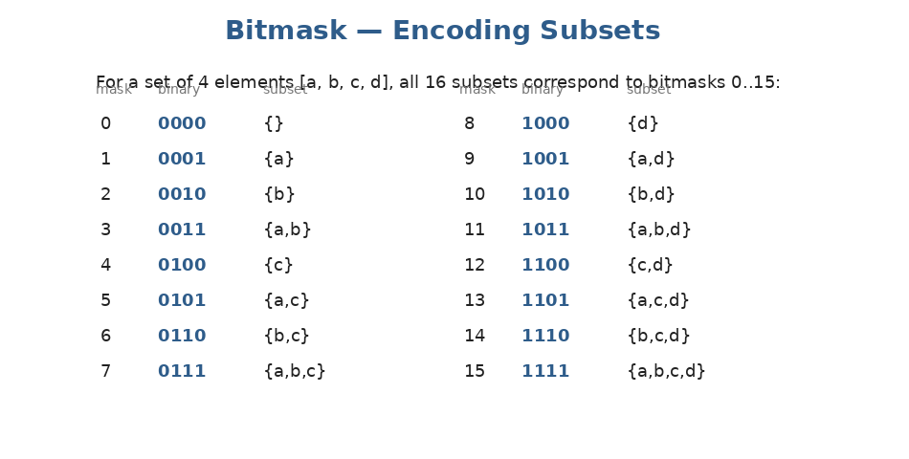
An n-bit integer encodes a subset of n elements. Bit i set means element i is included.
Three operations on bitmasks you should memorize:
# Test if bit i is set
(mask >> i) & 1 # 1 if set, 0 otherwise

# Set bit i
mask | (1 << i)

# Clear bit i
mask & ~(1 << i)

# Toggle bit i
mask ^ (1 << i)

# Count set bits
bin(mask).count('1')

Iterating all subsets of n elements
# All 2^n subsets of [0, 1, ..., n-1]
n = 4
for mask in range(1 << n): # 0 to 15
subset = [i for i in range(n) if (mask >> i) & 1]
print(subset)

Bitmask DP — intro
When the state of a problem can be described as 'which elements have we used so far,' and the number of elements is small (n ≤ ~20), encoding that as a bitmask gives clean DP states. Classic example: Traveling Salesman has state = (current city, set of visited cities) — bitmask captures the set.
When to consider bitmask DP: If you see a problem with up to ~20 items and you need to track which subset has been chosen, bitmask DP is often the right tool. 2^20 ≈ 1 million states, which is fast enough.

Worked example — Partition to K Equal Sum Subsets:
def can_partition_k_subsets(nums, k):
total = sum(nums)
if total % k: return False
target = total // k
n = len(nums)
if max(nums) > target: return False

nums.sort(reverse=True) # try big numbers first (helps pruning)
used = [False] * n

def backtrack(group_idx, current_sum, start):
if group_idx == k - 1: return True
if current_sum == target:
return backtrack(group_idx + 1, 0, 0)
for i in range(start, n):
if used[i] or current_sum + nums[i] > target: continue
used[i] = True
if backtrack(group_idx, current_sum + nums[i], i + 1):
return True
used[i] = False
return False

return backtrack(0, 0, 0)

(The pure bitmask DP version stores dp[mask] = is it possible to fill complete groups using exactly the elements in mask. We're showing the cleaner backtracking version above for clarity.)
Practice questions — Topic 27
Q1. Subsets (using bitmasks). Generate all subsets of nums using bitmask iteration instead of backtracking.
Answer:
Loop mask from 0 to 2^n - 1. For each mask, build the subset by including index i if (mask >> i) & 1.
def subsets(nums):
n = len(nums)
result = []
for mask in range(1 << n):
subset = [nums[i] for i in range(n) if (mask >> i) & 1]
result.append(subset)
return result

Q2. Single Number II. Every element appears EXACTLY THREE times except one. Find the unique. Example: [2,2,3,2] → 3.
Answer:
Count each bit position modulo 3. The result has bit i set iff the unique number has bit i set.
(There's a slicker O(1)-space solution using two bitmasks ones/twos, but the bit-counting approach is easy to code.)
def single_number(nums):
result = 0
for i in range(32):
bit_count = sum((x >> i) & 1 for x in nums)
if bit_count % 3:
result |= (1 << i)
# handle negative values in 32-bit interpretation
if result >= 2**31:
result -= 2**32
return result

Q3. Single Number III. Two elements appear once, the rest twice. Find both unique. Example: [1,2,1,3,2,5] → [3, 5].
Answer:
XOR all numbers → result = a ^ b (the two uniques). Find any set bit in result (use rightmost: result & -result). That bit DIFFERS between a and b. Partition the array by that bit; XOR each partition separately.
def single_number(nums):
xor_all = 0
for x in nums:
xor_all ^= x
diff_bit = xor_all & -xor_all # rightmost set bit
a = b = 0
for x in nums:
if x & diff_bit:
a ^= x
else:
b ^= x
return [a, b]

Q4. Counting Bits. For every i in [0..n], return the number of set bits in i. Example: n=5 → [0,1,1,2,1,2].
Answer:
DP: dp[i] = dp[i >> 1] + (i & 1). The bits in i equal the bits in i//2 plus 1 if i is odd.
def count_bits(n):
dp = [0] * (n + 1)
for i in range(1, n + 1):
dp[i] = dp[i >> 1] + (i & 1)
return dp

Q5. Maximum XOR of Two Numbers in an Array. Find max XOR of any pair. Example: [3,10,5,25,2,8] → 28 (5 ^ 25).
Answer:
Greedy bit-by-bit construction with a Trie of binary representations. Insert each number's bits into the trie; for each number, walk the trie greedily picking the OPPOSITE bit when possible (maximizes XOR).
(A simpler O(n × 32) hash-set version also exists — see code below.)
def find_max_xor(nums):
max_xor = 0
mask = 0
for i in range(31, -1, -1):
mask |= (1 << i)
prefixes = {x & mask for x in nums}
candidate = max_xor | (1 << i)
# Can we achieve `candidate`? Need two prefixes p, q with p ^ q == candidate.
for p in prefixes:
if (candidate ^ p) in prefixes:
max_xor = candidate
break
return max_xor

You've finished Stage 5 — and Stage 1 of the study plan!
If you've completed all 27 topics, you now have the full DSA toolkit. There's no algorithmic concept in a typical FAANG interview that isn't covered in these 5 stages. You're ready for the FAANG phase.
Quick reference: DP patterns
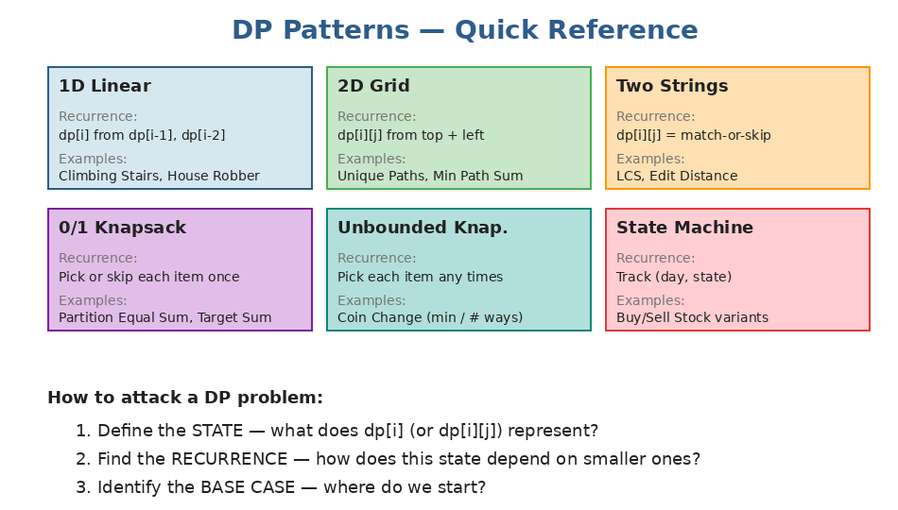
Six core DP shapes. Most DP problems are variations on these.
What you should now be comfortable with
- Writing the backtracking template (choose / explore / un-choose) on autopilot.
- Identifying the STATE, RECURRENCE, and BASE CASE for any DP problem you face.
- Choosing top-down (memoization) vs bottom-up (tabulation) — and converting between them.
- Recognizing the six DP patterns: 1D, 2D grid, two-string, 0/1 knapsack, unbounded knapsack, state machine.
- Spotting greedy opportunities (sort + sweep, interval problems, jump games).
- Using bitmasks to encode subsets when n is small.
Self-test before the FAANG phase
Re-implement these from a blank file, all without notes:
- Subsets, Permutations, Combination Sum (backtracking).
- Climbing Stairs, House Robber, Coin Change (1D DP).
- Unique Paths, Longest Common Subsequence (2D DP).
- Best Time to Buy/Sell Stock with Cooldown (state-machine DP).
- Merge Intervals, Jump Game (greedy).
- Single Number, Counting Bits (bit tricks).
Each should take under 10 minutes. If something takes longer, redo that topic.
Your final study plan
Stage 1 of the study plan is now COMPLETE. The plan moves into Stage 2 (FAANG phase):
- F1–F9: most-asked FAANG problems by topic with mock days.
- F10: 5 full mock interviews and final polish.
That phase doesn't need new theory — it's about building speed and pattern recognition under pressure. The cheatsheets you've built across all 5 stages are your reference. Good luck.

