THE COMPLETE GUIDE TO
P-VALUES
Simple Language | Real Examples | Visual Explanations

From "What is a p-value?" to "How do I use it?" — everything explained clearly

1. What Exactly IS a P-Value?
The p-value is: The probability of getting results as extreme as yours (or more extreme), ASSUMING the null hypothesis is true.
Think of it as: "How surprising is my result IF nothing unusual is happening?"

In plain English, when you do an experiment, you always ask yourself: "Could this result just be a coincidence?" The p-value answers exactly that question. A small p-value says "NO — this is very unlikely to be a coincidence." A large p-value says "YES — this could easily happen by chance."

The Courtroom Analogy — The Best Way to Understand It
Imagine you are a judge in a courtroom. The defendant is "innocent until proven guilty." The p-value is exactly like the evidence in a trial:

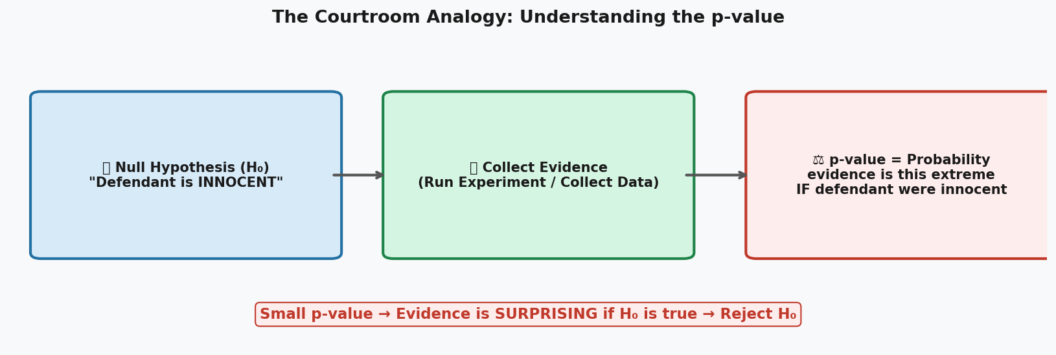

H0 (Null Hypothesis) = "INNOCENT"  This is your starting assumption — that nothing special is happening. Examples:  - "The drug has NO effect"  - "The coin is fair (not biased)"  - "There is NO difference between groups"  - "Students taught method A and B score the SAME" | Low p-value = "Strong Evidence of Guilt"  Small p-value means:  - "If H0 were true, seeing this result is VERY unlikely"  - Therefore, maybe H0 is NOT true  - We "reject" H0 — like a "guilty" verdict  - Our finding is called "statistically significant"

2. How to Read the p-value Number
The p-value is always a number between 0 and 1. Here is how to interpret it:

p-value | What it means in plain English | Decision | Real-life analogy
p = 0.90 | If H0 were true, this result happens 90% of the time — very normal! | Fail to reject H0 | Like drawing a red card from a deck — totally expected
p = 0.50 | This result happens 50% of the time under H0 — quite common | Fail to reject H0 | Like a coin landing heads — nothing unusual
p = 0.20 | Happens 20% of the time — possible but less common | Fail to reject H0 | Like rolling a 5 or 6 on a die — not rare
p = 0.05 | Only 5% of the time under H0 — starting to look suspicious | Borderline! | Like flipping heads 4 times in a row
p = 0.01 | Only 1% of the time — very suspicious! | Reject H0 | Like flipping heads 7 times in a row
p = 0.001 | Only 0.1% of the time — almost impossible if H0 is true! | Strongly Reject H0 | Like flipping heads 10 times in a row

The Magic Threshold: Alpha (alpha = 0.05)
By convention, scientists use alpha = 0.05 as the decision line.
If p < 0.05 --> Result is "statistically significant" --> Reject the null hypothesis
If p >= 0.05 --> Result is "not significant" --> Fail to reject the null hypothesis

Why 0.05? It means we accept a 5% chance of being wrong (a "false alarm"). This is a widely accepted trade-off in science, though it is somewhat arbitrary.

3. Example 1: Is This Coin Biased? (Coin Flip Test)
This is the simplest possible experiment. Let's walk through it step by step.

The Story
Your friend claims he has a MAGIC coin that lands on heads more often than tails. You decide to test it. You flip the coin 10 times and get 9 heads.

Step-by-Step Analysis
- State the Null Hypothesis (H0): "The coin is fair. p(heads) = 0.5"
- State the Alternative Hypothesis (H1): "The coin is biased. p(heads) > 0.5"
- Collect data: You flip 10 times, get 9 heads.
- Calculate p-value: What is the probability of getting 9 or 10 heads if the coin were fair?
- Make a decision based on the p-value.

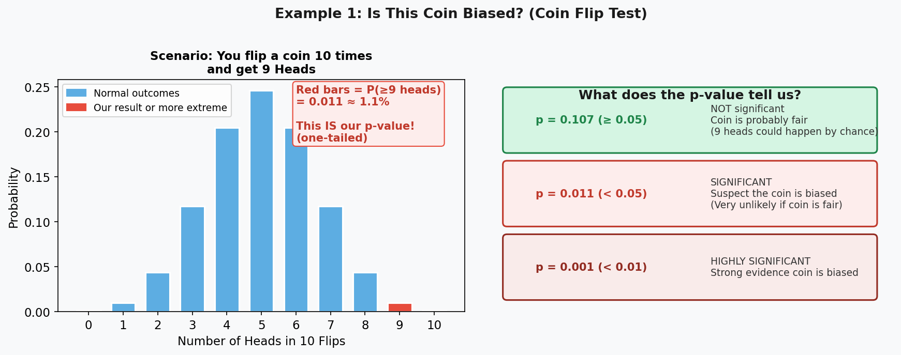

The Calculation (what the computer does for you):
P(exactly 9 heads in 10 flips, fair coin) = 0.0098
P(exactly 10 heads in 10 flips, fair coin) = 0.0010
p-value = 0.0098 + 0.0010 = 0.0107

Since p = 0.0107 < 0.05: We REJECT the null hypothesis. The coin is probably biased!

4. Example 2: Does the New Drug Lower Blood Pressure?
This is the most common type of p-value test in medicine — comparing two groups.

The Story
A pharmaceutical company develops a new blood pressure drug. They test it on 100 patients: 50 get the real drug, 50 get a sugar pill (placebo). After 3 months, they measure everyone's blood pressure.

The Setup  - Group 1 (Drug): 50 patients, average BP = 108  - Group 2 (Placebo): 50 patients, average BP = 100  - Difference: 8 points  The Question:  Is this 8-point difference REAL, or could it just be random variation between the two groups? | What H0 says  H0: "The drug has NO real effect. Any difference is just random."  H1: "The drug has a REAL effect on blood pressure."  The p-value answers: "If H0 were true (drug has no effect), how often would we see a difference THIS big just by random chance?"

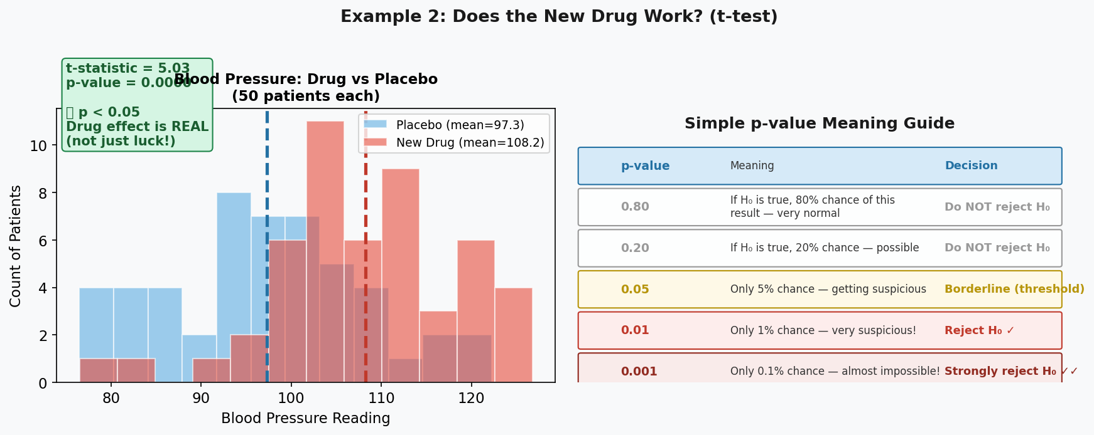

Reading the Result:
p-value = 0.0023

This means: If the drug had NO effect, you would only see a difference this big 0.23% of the time (less than 1 in 400 trials).
Since 0.0023 < 0.05, we REJECT H0. The drug does appear to lower blood pressure. This result is statistically significant!

5. Example 3: Do Students Learn Better with Video Lessons?
A school tests two teaching methods. Let's see if there's a real difference.

Aspect | Group A (Traditional) | Group B (Video Lessons) | Result
Teaching method | Blackboard lectures | Animated video lessons | Different methods tested
Sample size | 30 students | 30 students | 60 students total
Average score | 72 / 100 | 79 / 100 | 7-point difference
Score variation | Some variation | Some variation | Not all same score
p-value | — | p = 0.038 | Significant! p < 0.05
Conclusion | — | — | Video lessons appear to improve scores

What p = 0.038 means here:
"If BOTH teaching methods were equally effective (H0), you would only see a 7-point difference this large by RANDOM CHANCE about 3.8% of the time. Since that is less than 5%, we conclude video lessons probably ARE better."

6. The Bell Curve: Where Does the p-value Come From?
Every statistical test produces a "test statistic" — a number. The p-value is the area in the tail of the bell curve beyond your test statistic.

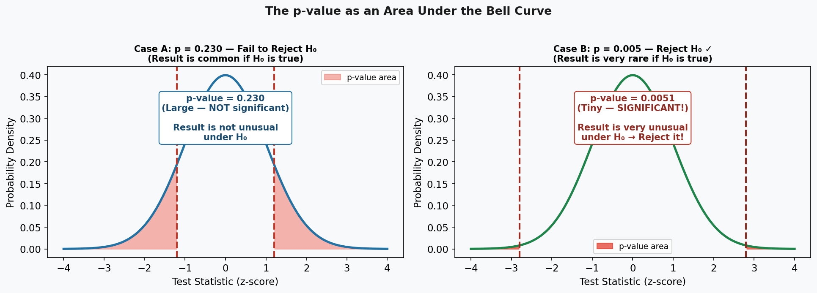

Case A (p = 0.230): Your result falls in the middle — not unusual. Big red area. Cannot reject H0.

Case B (p = 0.005): Your result falls in the extreme tail — very unusual. Tiny red area. Reject H0!

KEY INSIGHT: The p-value IS the size of that shaded area. Smaller area = more surprising result = stronger evidence against H0.

7. One-Tailed vs Two-Tailed Tests
When you calculate a p-value, you need to decide: are you looking for an effect in ONE direction, or EITHER direction?

Type | When to use it | H1 looks like... | Example | p-value area
One-tailed test | When you care only about one direction | Mean > X or Mean < X | "Does the drug LOWER BP?" (not raise it) | One tail of bell curve
Two-tailed test | When you care about either direction (most common) | Mean ≠ X (different, either way) | "Is the coin BIASED?" (heads or tails) | Both tails of bell curve

Simple Rule: When in doubt, USE TWO-TAILED. It is more conservative (harder to get significance) and is the default in most software and research.

Practical tip: A two-tailed p-value is exactly double the one-tailed p-value. So if your one-tailed p = 0.03, your two-tailed p = 0.06.

8. Myths and Misconceptions — What p-value Does NOT Mean
The p-value is one of the most misunderstood concepts in all of science. Here are the most common mistakes:

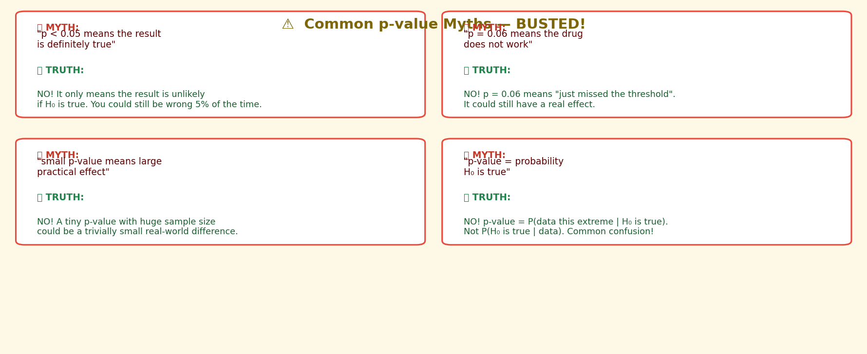

Most Common Misunderstanding #1
WRONG belief: "p = 0.03 means there is a 97% chance the drug works."
CORRECT: "p = 0.03 means: IF the drug had no effect, we would only see results this extreme 3% of the time. The drug might still not work — we're just saying the data looks suspicious."

Most Common Misunderstanding #2
WRONG belief: "p = 0.001 means the drug has a HUGE effect."
CORRECT: "p = 0.001 only says the result is statistically significant — not that the effect is large or practically important. With 1 million patients, even a 0.01 mmHg difference in blood pressure can get p < 0.001. Always look at EFFECT SIZE too."

Most Common Misunderstanding #3
WRONG belief: "p = 0.06 means the drug doesn't work."
CORRECT: "p = 0.06 means we lack sufficient evidence to rule out chance. The drug MIGHT work but we can't say for certain with this data. This is a fail to reject H0, NOT proof H0 is true."

9. How to Use a p-value: Step-by-Step
Whenever you run any statistical test, follow these steps in order:

Step | What you do | Example (Drug Test)
Step 1 | Define H0 (the boring, default assumption) | "Drug has NO effect on blood pressure"
Step 2 | Define H1 (what you hope to prove) | "Drug DOES reduce blood pressure"
Step 3 | Choose your alpha level (usually 0.05) | alpha = 0.05 (5% false alarm rate)
Step 4 | Collect data and run the appropriate test | 50 patients per group, run t-test
Step 5 | Read the p-value from the output | Software reports p = 0.023
Step 6 | Compare p to alpha | 0.023 < 0.05
Step 7 | Make your decision and state it clearly | "We reject H0. Drug significantly reduces BP (p=0.023)"

10. Which Statistical Test to Use?
Different situations require different tests — but they all produce a p-value the same way:

Situation | Test to Use | Example
Compare average of ONE group vs a known value | One-sample t-test | "Is our class average (72) different from national average (70)?"
Compare averages of TWO groups | Two-sample t-test (Independent) | "Does the drug lower BP more than placebo?"
Same people measured TWICE | Paired t-test | "Did students improve after the training?"
Compare 3 or more groups | ANOVA (F-test) | "Are test scores different across 3 teaching methods?"
Check relationship between two numbers | Pearson Correlation | "Does more study time correlate with higher scores?"
Check if two categories are related | Chi-Square Test | "Is gender related to voting preference?"
Predict one thing from others | Regression | "Does height + weight predict blood pressure?"

11. Quick Reference Summary

p-value range | Common label | In plain English | Action
p > 0.10 | Not significant | Very likely just random variation | Cannot reject H0
0.05 < p <= 0.10 | Marginally significant / Trend | Somewhat surprising — watch this | Cannot reject H0 (but worth noting)
0.01 < p <= 0.05 | Significant * | Unlikely to be random — real effect possible | Reject H0
0.001 < p <= 0.01 | Very significant ** | Very unlikely to be random | Reject H0 confidently
p <= 0.001 | Highly significant *** | Extremely unlikely if H0 is true | Strongly reject H0

Remember the 3 Golden Rules:

1. p-value is NOT a probability that H0 is true. It is the probability of your DATA, given H0 is true.
2. Statistical significance ≠ Practical importance. Always look at effect size (how big is the actual difference?)
3. Failing to reject H0 is NOT proof that H0 is true. It just means not enough evidence to rule it out.

The One-Sentence Summary
"The p-value tells you how often you would get results THIS surprising (or more surprising) purely by chance, if nothing special was actually happening."
Small p = big surprise = something is probably really happening. Large p = not surprised = could just be luck.

