DATA DISTRIBUTIONS
A Practical Field Guide for Data Science

What to check before you process data — how to check it in Python,
what to do in each case, and which algorithms to use (or avoid).
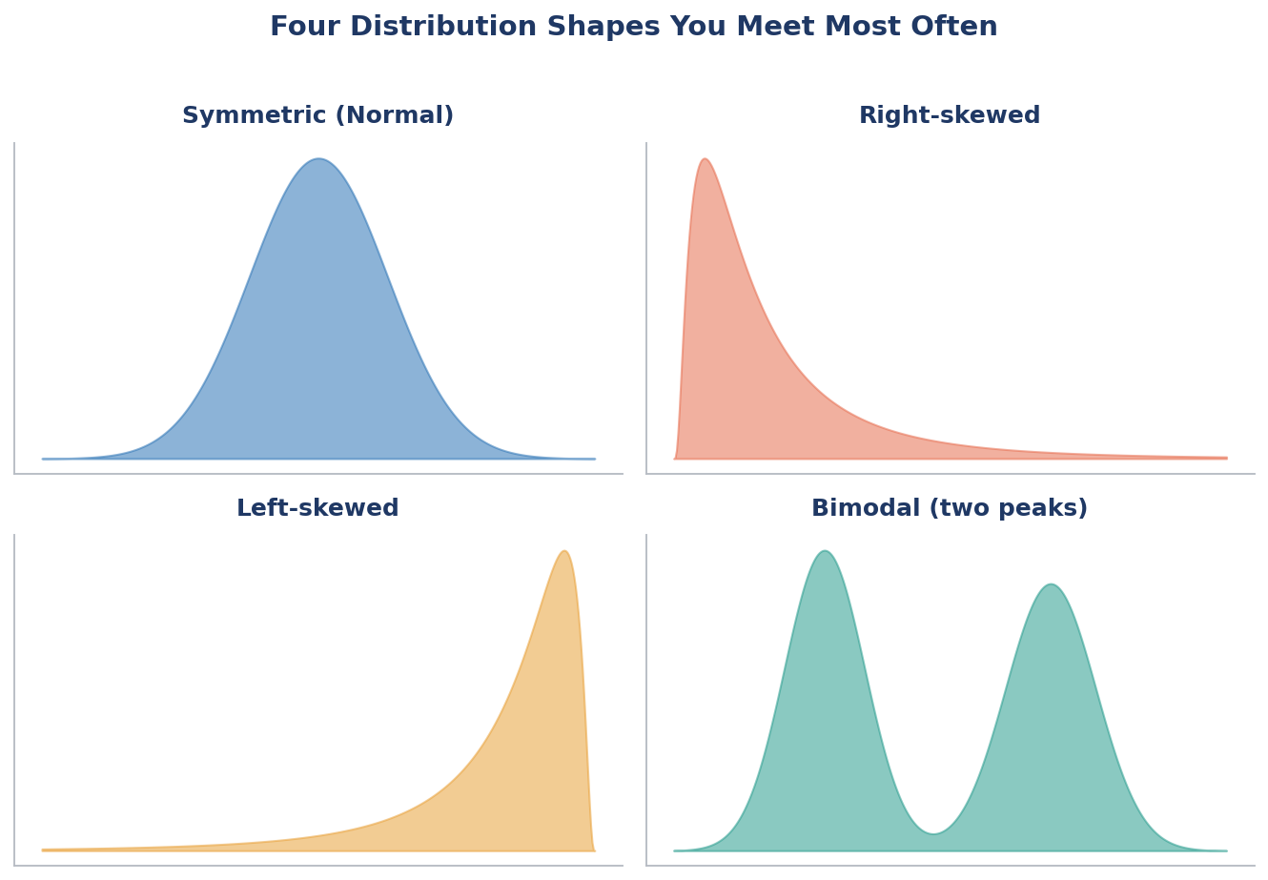

Table of Contents

1. Why Check Distributions First?
Before you build a single model, you should know the shape of your data. A distribution simply describes how often each value shows up. Picture a bar chart of your numbers: where do most pile up, where are the gaps, and are there a few extreme values way out on the side?
The shape matters because of three big reasons:
- It changes your cleaning steps. Skewed data and outliers often need transforming or capping before anything else.
- It changes which algorithm fits. Some models quietly assume a bell shape; feed them a lopsided one and the results suffer.
- It changes how you read results. The average income of a town is misleading if one billionaire lives there — the shape tells you to use the median instead.
ℹ The one-line idea
Check the shape → decide what to fix → then pick an algorithm that gets along with that shape. This document walks through every common shape in that exact order.

2. Your Distribution-Checking Toolkit
You only need a handful of tools to diagnose almost any distribution. Learn these four and you can read any column of numbers.

2.1 The Histogram and KDE — your first look
A histogram chops the range into bins and counts how many values land in each. A KDE (kernel density estimate) draws a smooth curve over it so the shape is easier to see. This is always your first move.
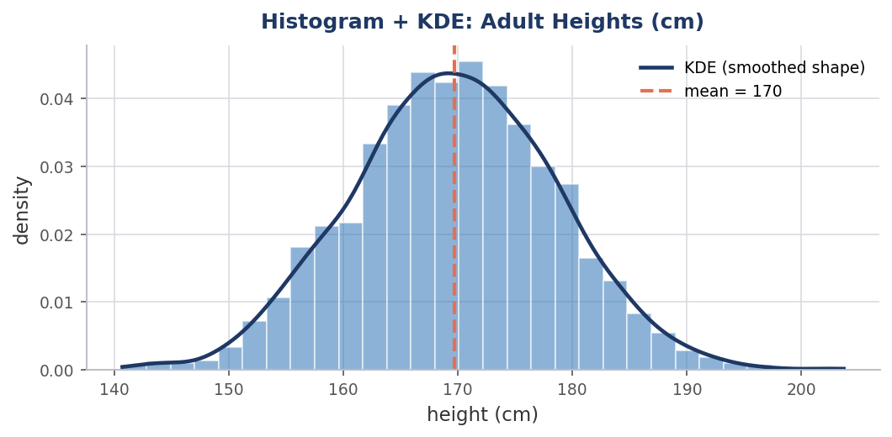
Figure 2.1 — A histogram with a smooth KDE curve. The dashed line marks the mean.
import numpy as np, matplotlib.pyplot as plt, seaborn as sns

# any numeric column, e.g. df["height"]
sns.histplot(df["height"], kde=True, bins=30)
plt.axvline(df["height"].mean(), color="red", ls="--", label="mean")
plt.legend(); plt.show()

2.2 The Q-Q Plot — is it really normal?
A Q-Q (quantile-quantile) plot compares your data to a perfect bell curve. If the points sit on the straight line, your data is close to normal. If they bend away at the ends, it is skewed or heavy-tailed. It is the quickest visual normality check.
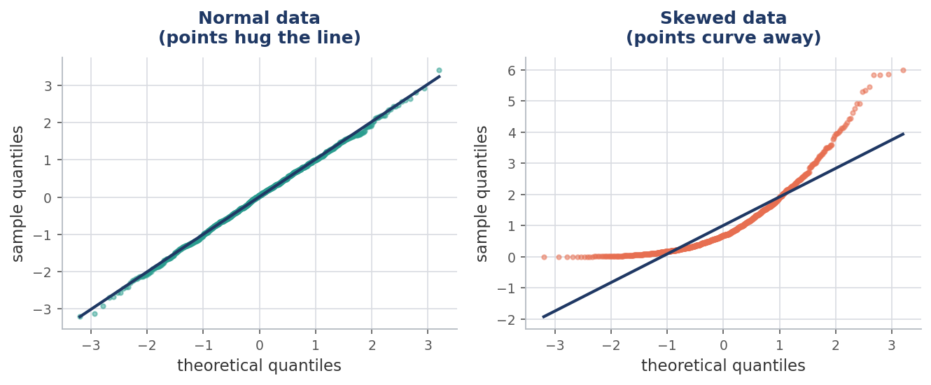
Figure 2.2 — Left: normal data hugs the line. Right: skewed data curves away at the ends.
from scipy import stats
import matplotlib.pyplot as plt

stats.probplot(df["height"], dist="norm", plot=plt)
plt.show() # points on the line -> roughly normal

2.3 Skewness and Kurtosis — two numbers that summarize shape
Skewness measures lopsidedness. Positive = a long tail to the right; negative = a long tail to the left; near zero = symmetric. Kurtosis measures how heavy the tails are — high kurtosis means more extreme outliers than a bell curve would have.
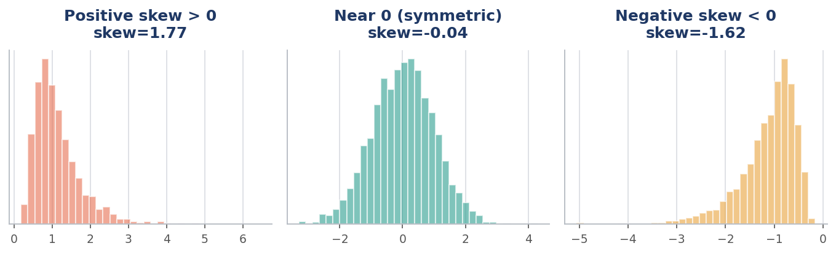
Figure 2.3 — The same idea seen three ways: right-skewed, symmetric, and left-skewed.
from scipy.stats import skew, kurtosis

print("skew:", skew(df["income"])) # 0.8 -> right-skewed
print("kurtosis:", kurtosis(df["income"])) # >0 -> heavier tails than normal
Skewness value | What it means | Typical action
about -0.5 to 0.5 | Fairly symmetric | Usually fine as-is
0.5 to 1 (or -0.5 to -1) | Moderately skewed | Consider a transform
above 1 (or below -1) | Highly skewed | Transform recommended

2.4 Normality Tests — putting a number on it
Sometimes you want a formal yes/no. These tests return a p-value: a small p-value (typically below 0.05) means “probably not normal.” Here are the common ones and when to reach for each.
Test | Best for | scipy function
Shapiro-Wilk | Small to medium samples (< ~5,000) | stats.shapiro(x)
D'Agostino K² | Medium samples; uses skew + kurtosis | stats.normaltest(x)
Anderson-Darling | Sensitive to the tails | stats.anderson(x)
Kolmogorov-Smirnov | Comparing to any reference shape | stats.kstest(x, 'norm')
from scipy import stats

stat, p = stats.shapiro(df["height"])
print(f"p-value = {p:.4f}")
print("Looks normal" if p > 0.05 else "Not normal")
⚠ The big caveat: large datasets break normality tests
On large samples (tens of thousands of rows), these tests almost always say “not normal” — even when the data is normal enough for practical purposes. Tiny, harmless wiggles get flagged because the test has so much data to nitpick.
Rule of thumb: trust the histogram and Q-Q plot over the p-value once you pass a few thousand rows. Statistical significance is not the same as practical significance.

2.5 A reusable profile() function
Rather than retyping these checks, keep a small helper you can drop on any column. This is the kind of cheat-sheet utility worth saving.
import numpy as np
from scipy import stats

def profile(series, name="column"):
s = series.dropna()
print(f"--- {name} ---")
print(f"count : {len(s):,}")
print(f"mean : {s.mean():.2f}")
print(f"median : {s.median():.2f}")
print(f"std : {s.std():.2f}")
print(f"skew : {stats.skew(s):.2f}")
print(f"kurtosis: {stats.kurtosis(s):.2f}")
# normality flag (use plots to confirm on big data)
if len(s) < 5000:
_, p = stats.shapiro(s)
print(f"shapiro p: {p:.4f} ->", "normal-ish" if p>0.05 else "not normal")
# quick outlier count via IQR
q1, q3 = s.quantile([0.25, 0.75]); iqr = q3 - q1
out = ((s < q1 - 1.5*iqr) | (s > q3 + 1.5*iqr)).sum()
print(f"outliers (IQR rule): {out:,}")

profile(df["income"], "income")

3. The Normal (Bell-Shaped) Distribution
The famous bell curve. Most values cluster around the average, and they thin out symmetrically on both sides. It is the shape many classic statistics quietly assume.

What it looks like in the wild
- Simple: repeated measurements of the same object — weigh a 100 g block 5,000 times and the tiny errors form a bell.
- Medium: adult heights within one gender, or shoe sizes in a population.
- Data-science: the residuals (errors) of a good linear regression should be roughly normal — checking this validates the model.
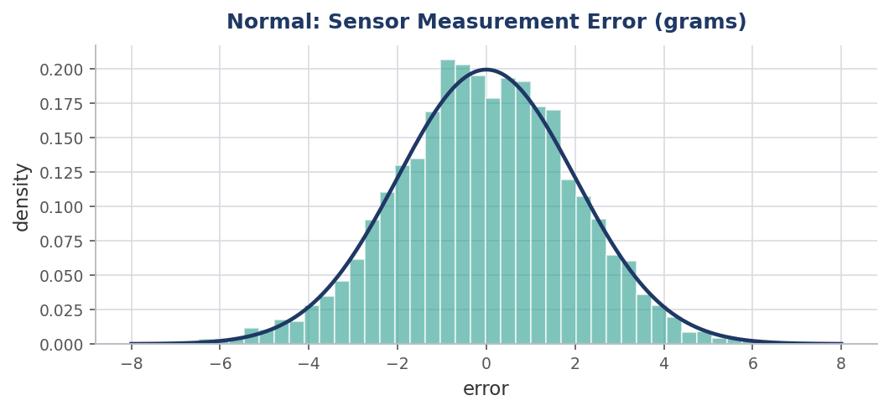
Figure 3.1 — Sensor measurement error: a clean, symmetric bell centered on zero.

How to check
from scipy import stats
stats.probplot(df["error"], dist="norm", plot=plt); plt.show()
print("skew:", round(stats.skew(df["error"]), 2)) # near 0 = symmetric

What to do
- If it is already normal, you are in luck: most algorithms are happy. No transform needed.
- Still scale it (e.g. StandardScaler) before distance-based or gradient-based models so all features share a range.
✓ Algorithms that LOVE normal data
Linear & Logistic Regression (assume normal residuals), Linear Discriminant Analysis, Gaussian Naive Bayes, and anything relying on z-scores or the mean ± standard deviation rule.

4. Skewed Distributions (Right and Left)
A skewed distribution leans to one side with a long tail trailing off the other way. This is probably the most common shape in real business data, and the one that causes the most trouble if ignored.

What it looks like in the wild
- Right-skewed (long tail to the right): income, house prices, website visits per user, customer lifetime value. A few huge values pull the mean above the median.
- Left-skewed (long tail to the left): scores on an easy exam, age at retirement, percentage of a battery's life used before charging. Most values bunch near the top.
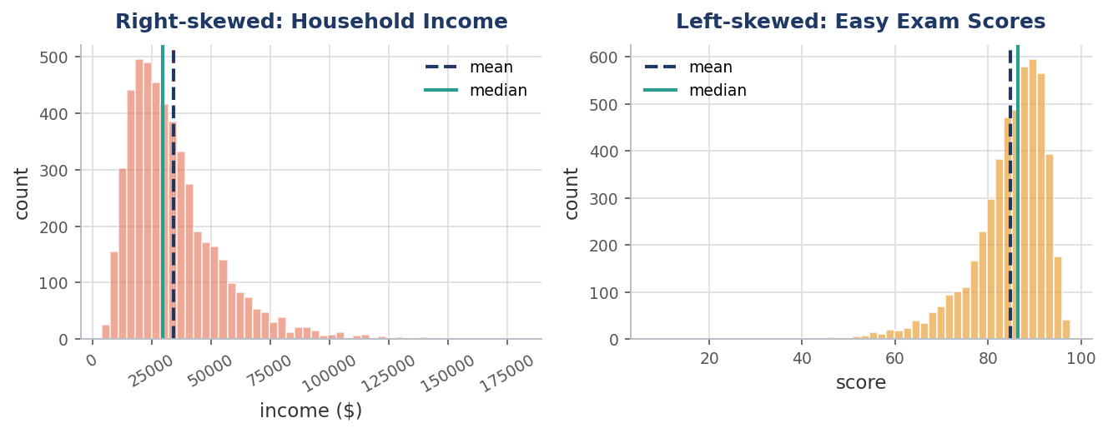
Figure 4.1 — Left: right-skewed income (mean > median). Right: left-skewed exam scores (mean < median).
ℹ A quick tell without any plot
Compare mean and median. Mean far above median → right-skewed. Mean far below median → left-skewed. When they are close, the data is roughly symmetric.

How to check
from scipy.stats import skew
print("skew:", round(skew(df["income"]), 2)) # +1.5 strongly right-skewed
print("mean :", df["income"].mean())
print("median:", df["income"].median()) # much smaller -> right skew

What to do: transform it
The fix is a transformation that squeezes the long tail and pulls the shape toward symmetric. Pick based on your data:
Transform | Use when | Note
log(x) | Right-skewed, all values > 0 | Most common; handles big tails
log1p(x) = log(1+x) | Right-skewed with zeros | Safe when data contains 0
sqrt(x) | Mild right skew, counts | Gentler than log
Box-Cox | Right-skewed, strictly positive | Finds the best power for you
Yeo-Johnson | Skewed data with zeros / negatives | Works where Box-Cox can't
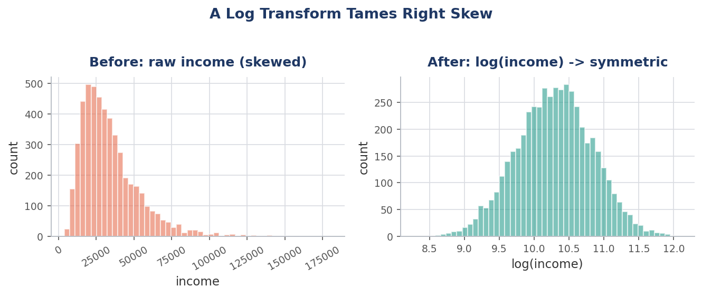
Figure 4.2 — Raw income is lopsided; after a log transform it becomes nicely symmetric.
import numpy as np
from sklearn.preprocessing import PowerTransformer

# simplest: log (for strictly positive data)
df["income_log"] = np.log1p(df["income"])

# automatic best-power transform that allows zeros/negatives
pt = PowerTransformer(method="yeo-johnson")
df["income_yj"] = pt.fit_transform(df[["income"]])
✕ Why skew hurts certain models
Distance-based models (KNN, K-Means, SVM) and gradient-based ones (linear/logistic regression, neural nets) get dominated by the giant tail values. Untransformed skew makes them weight the outliers far too heavily.
✓ Models that don't care about skew
Tree-based models — Decision Trees, Random Forest, Gradient Boosting / XGBoost / LightGBM — split on order, not magnitude, so they handle skew without transforming. Convenient, but transforming can still help interpretability.

5. The Uniform Distribution
In a uniform distribution every value is equally likely — the histogram looks flat, like a table top. There is no clear peak.

What it looks like in the wild
- Simple: numbers drawn in a fair lottery, or rolling a fair die many times.
- Medium: a well-shuffled ID column, or random timestamps spread evenly across a day.
- Data-science: a feature that turns out uniform often carries little signal (e.g. a random user ID) — a hint it may be safe to drop.
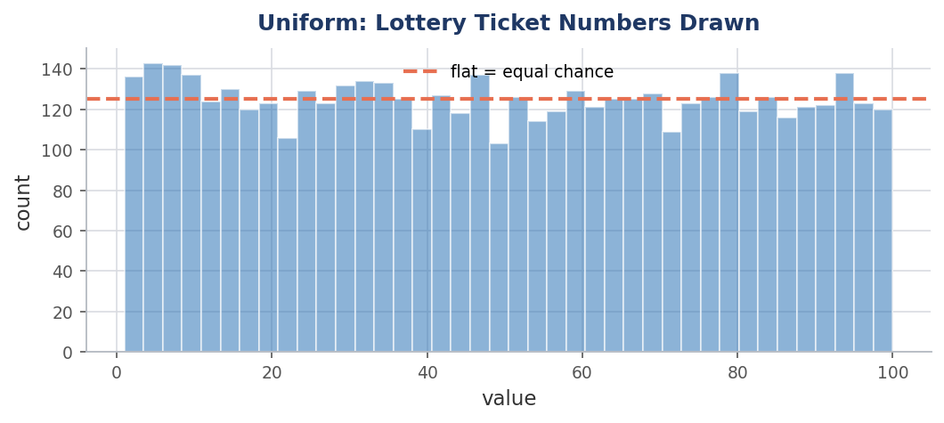
Figure 5.1 — Uniform data: roughly equal counts across the whole range.

How to check
from scipy import stats
# compare against a uniform reference using KS test
stat, p = stats.kstest(df["ticket"],
"uniform",
args=(df["ticket"].min(),
df["ticket"].max() - df["ticket"].min()))
print("looks uniform" if p > 0.05 else "not uniform")

What to do
- If a feature is uniform and unrelated to the target, consider dropping it — it may just be an identifier.
- If it is meaningful, min-max scaling fits naturally because the range is well defined.
- Uniform features rarely need transforming; there is no tail to fix.

6. Bimodal and Multimodal Distributions
Two (or more) peaks. This is a flashing sign that your data is really a mix of two different groups stacked together.

What it looks like in the wild
- Simple: heights of a mixed adult crowd — one peak for women, one for men.
- Medium: daily commute times where some people walk and others drive — two clusters of duration.
- Data-science: restaurant visit times peaking at lunch and dinner, or sensor readings from two machine models pooled together.
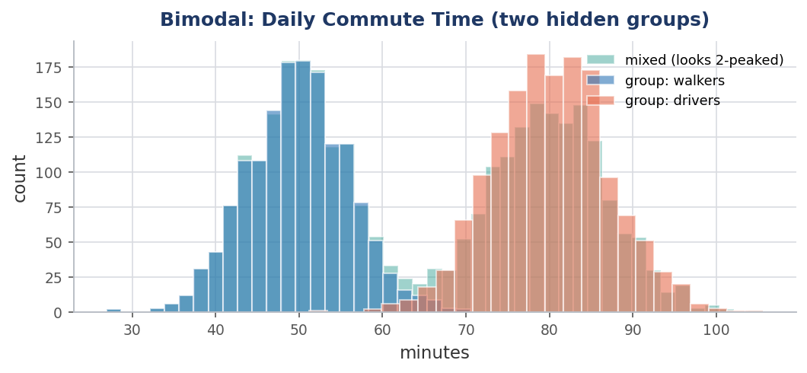
Figure 6.1 — The combined data (teal) shows two peaks because it hides two groups (blue and orange).

How to check
import seaborn as sns
sns.histplot(df["commute"], kde=True, bins=40) # eye the peaks
# confirm clusters with KMeans
from sklearn.cluster import KMeans
labels = KMeans(n_clusters=2, n_init=10).fit_predict(df[["commute"]])

What to do
- Find the hidden variable. Add the group as a feature (e.g. a “travel_mode” column). One peak per group often explains everything.
- Split or segment. Sometimes it is cleaner to model each group separately.
✕ What NOT to do with bimodal data
Do not report a single mean — the average commute might land in the empty valley between the peaks, describing nobody. Also avoid Gaussian Naive Bayes and z-score outlier rules here; both assume one peak.

7. The Exponential Distribution
A steep start that decays quickly: many small values, fewer and fewer large ones. It famously describes the waiting time between random events.

What it looks like in the wild
- Simple: time between buses arriving, or between raindrops hitting a window.
- Medium: minutes between new sign-ups on a website, or time until a part fails.
- Data-science: session durations and “time to next purchase” features in churn and survival models.
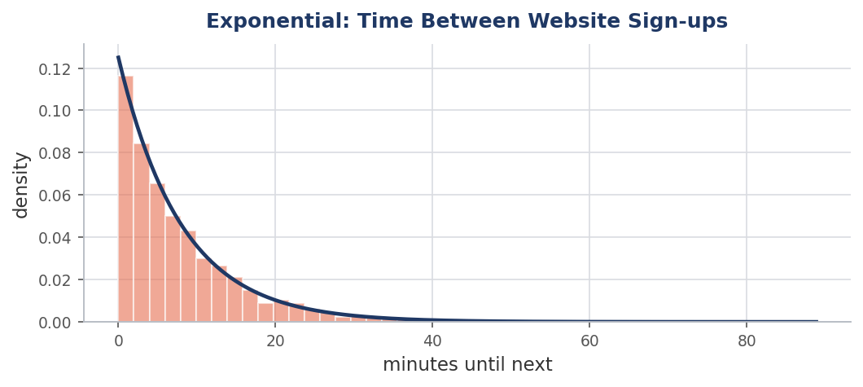
Figure 7.1 — Exponential waiting times: a tall start that fades to a long thin tail.

How to check & what to do
from scipy import stats
# fit and compare
loc, scale = stats.expon.fit(df["wait"])
stat, p = stats.kstest(df["wait"], "expon", args=(loc, scale))

# exponential is heavily right-skewed -> a log transform helps
import numpy as np
df["wait_log"] = np.log1p(df["wait"])
- Treat it like strong right-skew: a log transform makes it usable by linear and distance-based models.
- For time-to-event problems, consider survival models (e.g. Cox regression) designed for this shape.

8. Poisson and Count Distributions
Count data: whole numbers that can't go below zero (0, 1, 2, 3 …). The Poisson shape describes how many times a rare-ish event happens in a fixed window.

What it looks like in the wild
- Simple: number of emails you get per hour, or cars passing a corner each minute.
- Medium: support tickets opened per hour, or goals scored in a match.
- Data-science: “number of purchases per customer” or “clicks per session” — classic count targets.
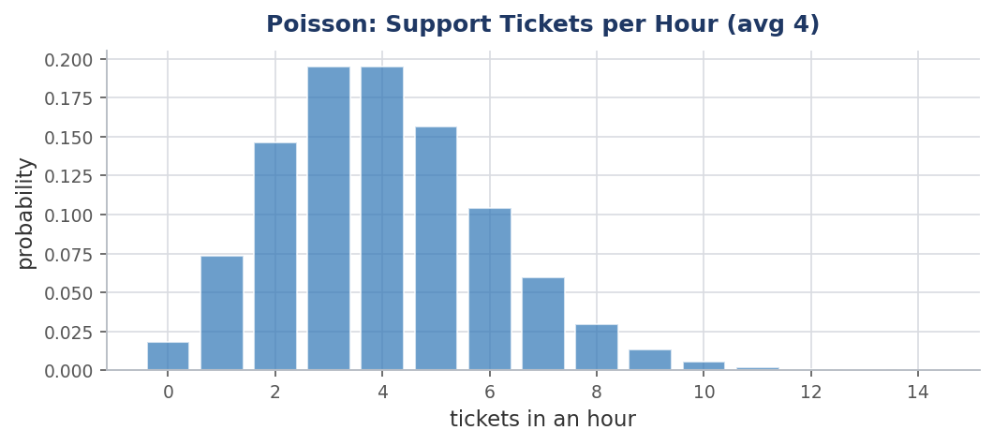
Figure 8.1 — Poisson counts: discrete bars, right-leaning, never negative.

How to check & what to do
# Poisson clue: mean is roughly equal to variance
print("mean:", df["tickets"].mean())
print("var :", df["tickets"].var())

# if var >> mean the data is "overdispersed" -> use Negative Binomial
⚠ Don't use plain linear regression on counts
Linear regression can predict negative or fractional counts, which is nonsense for “2.5 tickets.” Use Poisson regression instead, or Negative Binomial regression when the variance is much bigger than the mean (overdispersion).

9. Power-Law and Heavy-Tailed Distributions
A tiny number of values are enormous while the vast majority are small — the classic “80/20” pattern. The tail is so heavy that ordinary outlier rules fall apart.

What it looks like in the wild
- Simple: city populations — a few mega-cities, countless small towns.
- Medium: words in a book (a handful appear constantly), or wealth across people.
- Data-science: product sales (a few blockbusters), social-media followers, or website traffic by page.
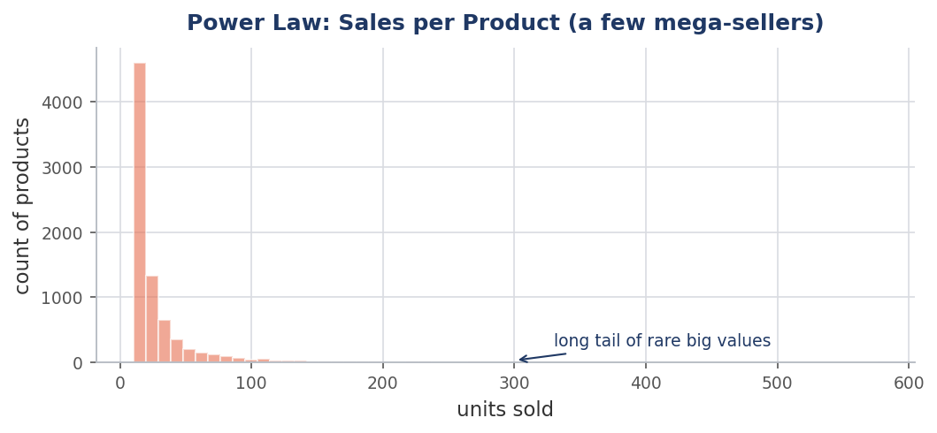
Figure 9.1 — A power law: most products sell little, a rare few sell enormously.

How to check & what to do
import numpy as np
# heavy tails reveal themselves on a log scale
sns.histplot(np.log1p(df["sales"]), bins=50)

# a log transform is almost always the right first step
df["sales_log"] = np.log1p(df["sales"])
- Use a log transform — it compresses the giant tail dramatically and is the standard remedy.
- Be careful with the mean and standard deviation; they are dominated by the few huge values. Prefer median and percentiles to describe the data.
✕ The IQR / z-score outlier trap
Standard outlier rules will flag the entire tail as “outliers” — but here those big values are real and important, not errors. Don't blindly delete them; transform instead, or model the tail explicitly.

10. Class Imbalance (the Target Variable)
This is a distribution of a different kind — the spread of your labels, not a numeric feature. When one class hugely outnumbers another, models get lazy and just predict the majority.

What it looks like in the wild
- Fraud detection: perhaps 1–2% of transactions are fraud, the rest legitimate.
- Medical screening: most patients don't have the rare disease being tested for.
- Manufacturing: defective units are a small fraction of all units produced.
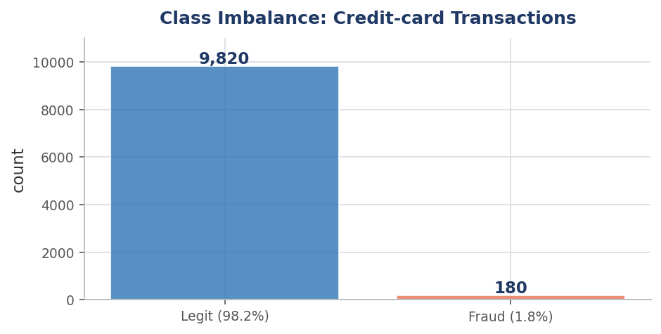
Figure 10.1 — A 98 / 2 split. A model that always says “legit” would be 98% accurate yet useless.
✕ Why accuracy lies here
With a 98/2 split, a model that predicts “not fraud” every single time scores 98% accuracy — and catches zero fraud. Judge these models with precision, recall, F1, or AUC instead of accuracy.

How to check & what to do
print(df["is_fraud"].value_counts(normalize=True)) # see the split

from imblearn.over_sampling import SMOTE
X_res, y_res = SMOTE(random_state=42).fit_resample(X, y) # synthesize minority

# or tell the model to weight the rare class more
from sklearn.ensemble import RandomForestClassifier
model = RandomForestClassifier(class_weight="balanced")
Fix | How it works | When to use
class_weight='balanced' | Penalizes mistakes on rare class more | First, simplest thing to try
SMOTE (oversample) | Creates synthetic minority examples | Small minority, enough features
Random undersample | Drops some majority rows | Huge datasets you can trim
Better metrics | Track recall / F1 / AUC, not accuracy | Always

11. Algorithm Sensitivity Cheat Sheet
Which models care about your distribution, and which shrug it off? Keep this table close.
Algorithm | Cares about shape / scale? | Notes
Linear / Logistic Regression | Yes — a lot | Assumes normal-ish residuals; scale & transform skew
KNN | Yes — distance-based | Scale features; skew distorts distances
K-Means | Yes — distance-based | Scale first; struggles with skew & outliers
SVM | Yes — distance-based | Scaling is essential; transform heavy skew
Gaussian Naive Bayes | Yes — assumes normal | Avoid on bimodal / heavily skewed features
Neural Networks | Yes — gradient-based | Scale inputs; helps training stability
PCA | Yes — variance-based | Standardize first or big-scale features dominate
Decision Tree | No | Splits on order, not magnitude
Random Forest | No | Robust to skew, scale, outliers
Gradient Boosting / XGBoost | No | Same — no scaling or transform needed
✓ The shortcut
If you must transform/scale: it matters for distance-based and gradient-based models. If you want to skip it: tree-based models (Random Forest, XGBoost) are forgiving and a great baseline on messy real-world data.

12. The Decision Workflow
Putting it all together: a simple loop of check → find → do, for every numeric column.
- Plot it. Histogram + KDE first, then a Q-Q plot if you suspect normal.
- Measure it. Compute skewness, and compare mean vs median.
- Name the shape. Normal, skewed, uniform, bimodal, exponential, count, or heavy-tailed?
- Act on it. Transform skew (log / Box-Cox / Yeo-Johnson), scale for distance models, segment bimodal data, rebalance imbalanced labels.
- Pick a friendly algorithm. Match the model to the shape using the cheat sheet above.

What you see | What it likely is | What to do next
One symmetric peak | Normal | Scale; linear/Bayes models OK
Long tail to the right | Right-skewed / power law | log or Yeo-Johnson transform
Long tail to the left | Left-skewed | Reflect then transform, or Yeo-Johnson
Flat, no peak | Uniform | Maybe an ID — consider dropping
Two or more peaks | Bimodal / mixed groups | Find hidden group; segment
Steep decay from zero | Exponential | Log transform; survival models
Whole-number counts | Poisson / count | Poisson or Neg-Binomial regression
One class dominates | Class imbalance | SMOTE / class weights; better metrics
ℹ Final thought
There is no “bad” distribution — only a mismatch between the data's shape and the tool you chose. Look first, decide second, model third, and most data problems become straightforward.

