NLP — COMPLETE NOTES
From Text Basics to Transformers
Cleaned up, corrected, re-ordered & explained simply

What's inside
Part 1 — Text Preprocessing & Classical Representation
Part 2 — Word Embeddings (Word2Vec, GloVe, FastText, WordNet)
Part 3 — Sequence Models (RNN, LSTM, GRU, Seq2Seq)
Part 4 — Attention & Transformers ★ most important
Part 5 — Transformer Models (BERT, GPT, BART)
Part 6 — Evaluation & Other Concepts (BLEU, CRF, Markov…)
+ Confusing interview questions after each major topic
+ Quick-revision cheat sheet at the end

Table of Contents

How to read these notes
These are your original notes — re-organised into a proper learning order, with mistakes fixed, missing bits filled in, and everything re-explained in plain language with small examples. Every image you had is kept and placed next to the right topic.
Transformers (Part 4) got the most attention — that's the part interviewers dig into the hardest.

Part 1 — Text Preprocessing & Classical Representation

1.1 Cleaning raw text — the first steps
Before a computer can do anything smart with text, we break it down and tidy it up. These are the very first tools you learn.
Step | What it does | Tiny example
Tokenization | Breaks raw text into small chunks (usually words). | “I love NLP” → [“I”, “love”, “NLP”]
Stemming | Chops a word down to a rough root. Fast, but the root may not be a real word. | “studies” → “studi”
Lemmatization | Converts a word to its real dictionary base form. Slower, but always a valid word. | “studies” → “study”
Parsing | Breaks a sentence apart according to grammar (who is the subject, verb, object). | Finds that “dog” is the subject of “runs”
Semantic analysis | Pulls out the actual meaning of the text, not just the words. | “It’s raining cats and dogs” → heavy rain
Stemming vs Lemmatization (people mix these up)
Stemming just cuts letters off the end using rules — quick and dumb. “caring” → “car” (wrong meaning!).
Lemmatization uses a dictionary + the word’s grammar role, so “caring” → “care”. Use lemmatization when meaning matters; use stemming when you just need speed.

1.2 Bag of Words (BoW)
Bag of Words is the simplest way to turn text into numbers. You just count how many times each word appears and throw away the order completely — that's why it's a “bag” (a bag has no order).
- We only care whether known words appear and how often, not where they appear.
- Problem it ignores: word order and grammar. “Dog bites man” and “Man bites dog” look identical to BoW.
In code, CountVectorizer builds this word-count table for you. Each sentence becomes a row of counts (a sparse matrix — mostly zeros).
Example: 3 reviews turned into a word-count table. Each column is a word, each number is how many times it appeared in that review.
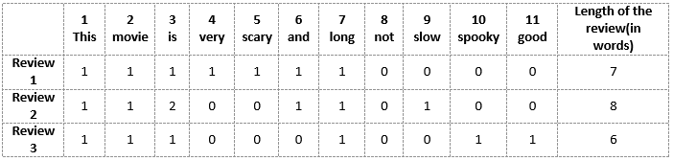
Bag of Words / CountVectorizer: each review becomes a row of word counts
CountVectorizer — handy parameters
lowercase — by default it lowercases everything and tokenizes by word.
stop_words — removes very common words like “the”, “is”.
max_df — ignore words that appear in too many documents (too common to be useful).
min_df — ignore words that appear too rarely (probably noise/typos).

1.3 TF-IDF
BoW treats every word as equally important. But the word “the” appearing 50 times tells you nothing. TF-IDF fixes this by asking: “is this word special to THIS document, or does it appear everywhere?”
TF-IDF = TF × IDF
TF(term) = (times the term appears in the document)
/ (total terms in that document)

IDF(term) = log( total number of documents
/ number of documents containing the term )

TF-IDF = TF * IDF
- High TF-IDF → word is frequent in this doc but rare overall → important / unique (a good keyword).
- Low / zero TF-IDF → word appears in almost every document → not useful (like “the”, “and”).
Why the log in IDF?
With a big corpus (say 10,000 documents), a rare word's raw IDF ratio explodes to a huge number and dominates everything. Taking the log squashes that range so the values stay sensible. log is just a “volume knob” that stops rare words from screaming.

1.4 N-grams
An n-gram is just n words taken together in a row. It's the cheapest way to bring back a little bit of word-order that BoW threw away.
Sentence: “I reside in Bengaluru”
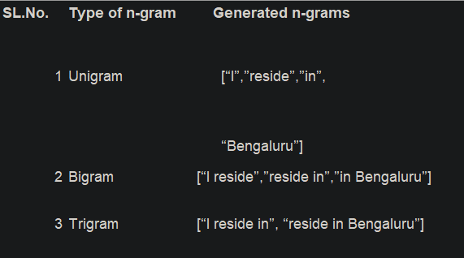
Unigrams (1 word), Bigrams (2 words), Trigrams (3 words) for the sentence
- Unigram (n=1): “I”, “reside”, “in”, “Bengaluru”
- Bigram (n=2): “I reside”, “reside in”, “in Bengaluru”
- Trigram (n=3): “I reside in”, “reside in Bengaluru”
Bigrams/trigrams help the model see phrases like “new york” or “not good” as units. Downside: the bigger n gets, the more combinations explode.

1.5 Padding & Masking
Neural networks want every input to be the same length. But sentences are different lengths. So we pad short ones and then tell the model to ignore the padding.
- Padding — adds filler values (usually 0) so every sequence in a batch has the same length.
pad_sequences(arr, padding='pre', maxlen=9, truncating='pre', value=0)
- Masking — once everything is padded, masking is the signal that says “these padded spots are fake, don’t learn from them.” Without it the model would waste effort on the zeros.
Important order: convert your padded NumPy array into a tensor first, then apply the masking layer.
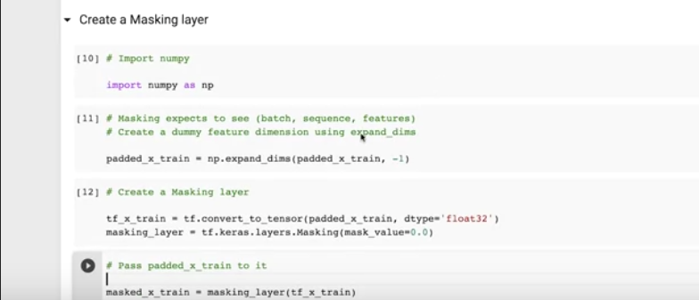
Creating a Masking layer in Keras (convert to tensor → mask padded values)

Q. Bag of Words vs TF-IDF — when would you pick one over the other?
BoW = raw counts; every word weighted equally; good when you just need a quick, simple baseline and the vocabulary is small.
TF-IDF = counts re-weighted so common words shrink and distinctive words stand out; almost always better for search, document similarity, and classic classifiers. Both still ignore word order and meaning — that's what embeddings (Part 2) fix.

Part 2 — Word Embeddings

2.1 What is a word embedding?
BoW and TF-IDF give each word a slot in a giant sparse vector — and “king” and “queen” end up completely unrelated. A word embedding instead represents each word as a short, dense vector of real numbers (like [0.2, -0.7, 0.5]) where words with similar meaning get similar vectors.
- “King” and “queen” land close together; “king” and “banana” land far apart.
- These vectors are learned from data, so they capture meaning and relationships.
Popular methods: Word2Vec (Skip-gram, CBOW), GloVe, FastText, and contextual ones like ELMo and BERT.

Keras Embedding layer
Keras can learn embeddings for you with one layer:
embedding = Embedding(input_dim=vocab_size,
output_dim=embedding_dim,
input_length=max_len)
Argument | Meaning | Plain words
input_dim | Vocabulary size | How many unique words exist in total
output_dim | Embedding vector size | How many numbers represent ONE word
input_length | Sequence length | How many words per input sentence
These weights are learned, not fixed
The embedding values start random. During training, the network nudges them so that words used in similar ways drift toward similar vectors. That training is exactly what lets the model “understand” word relationships.

How an embedding feeds a neural network (the matrix shapes)
Say each word becomes a 3-number vector and a sentence's vector is the average of its words. Five sentences give five 1×3 vectors. When this hits a hidden layer:
For any layer: W shape = (neurons in layer) x (inputs to layer)

Z = W . X + b # W = weights, X = input matrix, b = bias

If the layer has 4 neurons and each input vector is length 3,
then W is (4 x 3): each of the 4 neurons holds 3 weights,
one weight to multiply against each of the 3 input numbers.
Batch size just means how many sentences you push through at once (e.g. batch size = 2 → two sentences at a time).

2.2 Word2Vec
Word2Vec is a famous, shallow (one hidden layer) neural network that learns embeddings. The trick: it learns word meaning purely from which words appear near each other. It comes in two flavours:
 | CBOW | Skip-gram
Idea | Use the surrounding context words to predict the missing middle word. | Use the middle word to predict its surrounding context words.
Direction | context → target | target → context
Faster? | Faster to train | Slower
Best at | Frequent words, smaller data | Rare words, larger data

CBOW (Continuous Bag of Words)
Looks like a simple feed-forward network. It takes the context words around a blank and tries to predict the word that fills the blank.
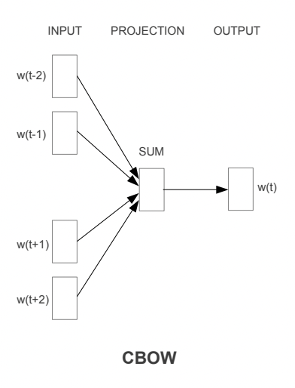
CBOW: context words w(t-2)…w(t+2) are summed to predict the target word w(t)

Skip-gram
The opposite of CBOW. You give it ONE word and it tries to predict the words likely to appear around it.
Window size is a setting that says how many neighbours count. Sentence: “I will have orange juice and eggs for breakfast.” With window = 2 and target = “juice”, the neighbours are (have, orange, and, eggs).
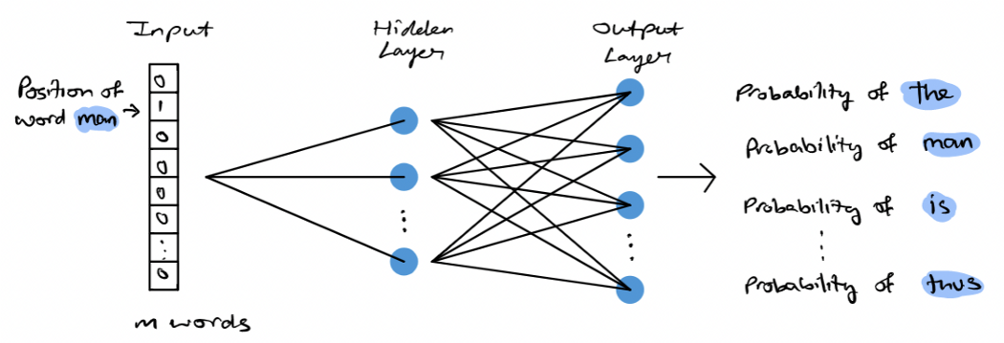
Skip-gram: one input word → predicts probability of each context word
How the in/out actually look
Input is a one-hot vector of size V (V = vocabulary size) — all zeros except a 1 at the current word. Output is also size V, where each number is the probability of that word being a neighbour. Training keeps updating the weights, and those hidden-layer weights ARE the final word vectors.

2.3 GloVe & FastText (the other two you listed)
Your notes mention these but don't explain them — here's the short version so the list isn't a mystery.
- GloVe (Global Vectors): instead of sliding a window like Word2Vec, it looks at global co-occurrence counts (how often word A appears with word B across the whole corpus) and learns vectors from those statistics.
- FastText: an upgrade of Word2Vec that breaks words into character chunks (sub-words). Because of this it can build a vector for a word it never saw before (e.g. “playing” from “play” + “ing”), and it handles spelling mistakes better.

2.4 WordNet
WordNet is a big hand-built dictionary/thesaurus of English. It groups words into synsets — sets of synonyms that share one meaning — and links them by relationships.
- Nouns, verbs, adjectives, adverbs are grouped into synsets, each expressing one distinct concept.
- Links include hyponymy (“dog” is a kind of “animal”) and antonymy (opposites).
- You can get meanings, definitions, examples, synonyms and antonyms from it.
path_similarity() measures how related two words are by counting steps between them in the WordNet graph. Score is between 0 and 1, where 1 means basically the same word.

Q. Word2Vec embeddings vs BERT embeddings — what's the real difference?
Word2Vec/GloVe give ONE fixed vector per word, no matter the sentence. So “bank” in “river bank” and “bank account” gets the exact same vector — that's the problem.
BERT gives contextual vectors: the same word gets a different vector depending on the sentence around it. That's why BERT understands “bank” correctly in both cases. (More in Part 5.)

Part 3 — Sequence Models (RNN → LSTM → GRU → Seq2Seq)

3.1 Recurrent Neural Network (RNN)
A normal neural network treats every input independently. But language is a sequence — to guess the next word you must remember the previous ones. An RNN handles this by feeding the output of the previous step back in as an extra input to the current step. So at every step the RNN sees two things: the present word and a memory of the recent past.
- Great for sequence data (time series, translation), but it suffers from short-term memory — it forgets things from far back.
- A 4-word sentence “unfolds” into a 4-step chain; words first become number vectors, then are processed one by one.
- Key difference from a normal network: an RNN reuses the SAME weights at every time step. A normal deep network uses different weights per layer.
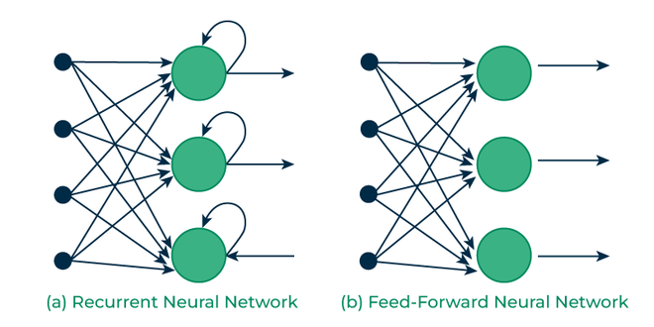
Recurrent network (loops back on itself) vs a plain feed-forward network

How many hidden layers does a simple RNN have?
A simple RNN = ONE hidden layer, reused over time. Repeating the cell across time steps does NOT make it many layers — it's the same layer applied again and again. You only get a “deep RNN” when you stack multiple RNN layers on top of each other.

Working of a simple RNN
At each time step the cell computes:
h_t = tanh( W . x_t + U . h_{t-1} + b )

x_t = current word vector (the new input)
h_{t-1}= previous step's output (the memory)
h_t = this step's output
W = weights for the new word
U = weights for the previous memory
b = bias
This recurrent connection is what gives the RNN its internal memory — each step's output is fed forward to help the next step.
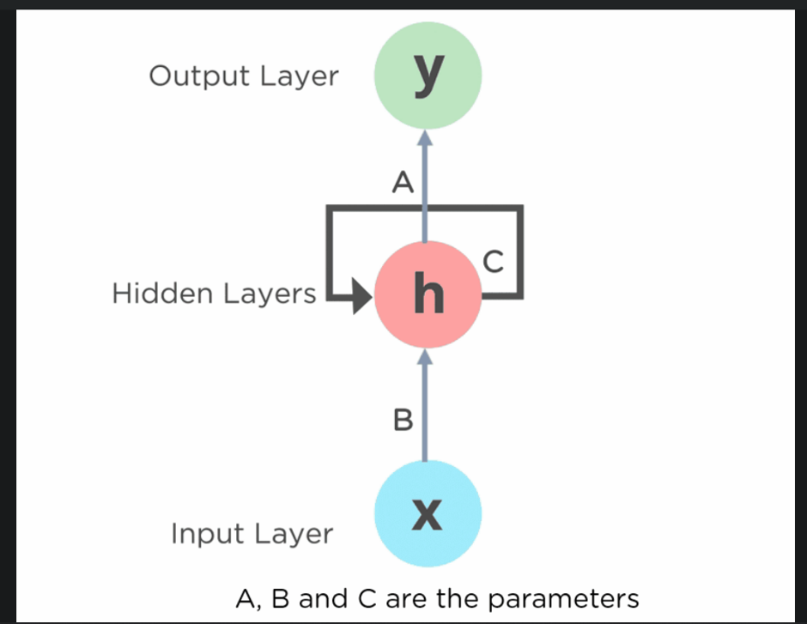
RNN cell: input x → hidden h (loops with weight C) → output y. A, B, C are the weight sets
Two ways the same weights are named (don't get confused)
Some diagrams label the weights A, B, C: B = input→hidden (new word), C = hidden→hidden (the memory loop), A = hidden→output. The formula above calls them W (new), U (memory). Same idea, different letters.
These weights stay the same during a forward pass and only change during backpropagation.
Quick correction on outputs
softmax outputs values between 0 and 1 that add up to 1 (probabilities). tanh, used inside the cell, outputs between -1 and 1. Don't mix the two ranges up.

3.2 Types of RNN
RNNs are grouped by how many inputs go in and how many outputs come out.
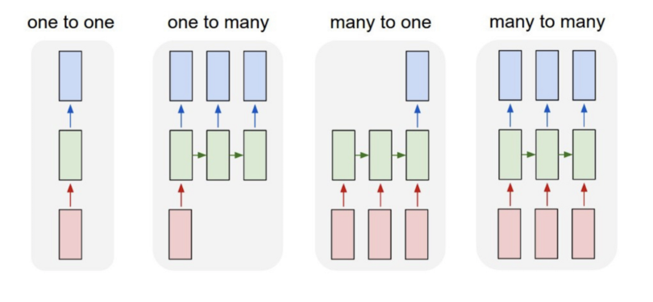
The four input–output shapes of RNNs
Type | Inputs → Outputs | Example
One to One | 1 → 1 | Plain network (“Vanilla”); normal classification
One to Many | 1 → many | Image → caption (a sentence)
Many to One | many → 1 | Sentence → sentiment (positive/negative)
Many to Many | many → many | Translation (English sentence → French sentence)

3.3 Backpropagation Through Time (BPTT)
To train an RNN we unroll it across all time steps and send the error backwards through every step — this is BPTT. In a many-to-many setup, the losses at each step are added up, and then the gradient flows all the way back from the last step to the first.

The big problem with RNNs: vanishing & exploding gradients
Because the gradient travels back through many steps, it gets multiplied by the same weights again and again:
- Vanishing gradient: if those numbers are less than 1, multiplying many of them makes the gradient shrink toward zero → early words get almost no learning signal → the network can't remember long-range info.
- Exploding gradient: if the weights are large, the repeated multiplication blows the gradient up to huge values → unstable training.
This is exactly why plain RNNs struggle with long sentences — and why LSTM/GRU were invented.

3.4 Bidirectional RNN
A normal RNN only knows the past. But sometimes the meaning of a word depends on what comes AFTER it too. A bidirectional RNN runs two RNNs: one reads the sentence left-to-right, the other right-to-left, and their outputs are joined (usually concatenated) at each step.
Result: at any position, the output depends on both the words before AND the words after it. Great for tasks where full context helps (like NER).
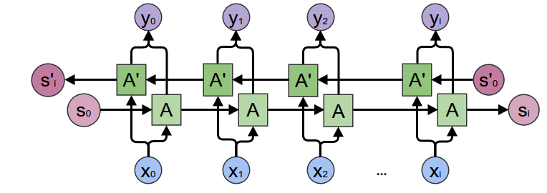
Bidirectional RNN: a forward chain and a backward chain combined at each step

3.5 LSTM (Long Short-Term Memory)
LSTM is a smarter RNN cell built to fix the forgetting/vanishing-gradient problem. Its secret weapon is the cell state — a separate “memory conveyor belt” running along the top that information can ride along almost unchanged. Three gates decide what to add or remove from it.
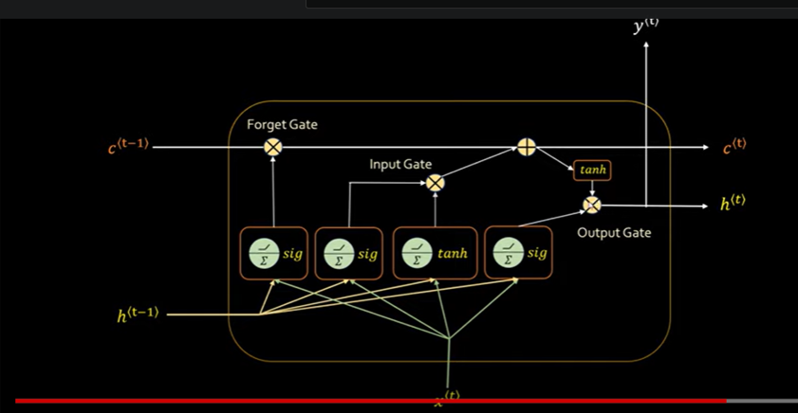
LSTM cell: forget gate, input gate, output gate controlling the cell state
Gate | Job | How it works (simple)
Forget gate | Decides what old info to throw away from memory. | Looks at h_{t-1} and x_t, applies sigmoid → values 0–1 (0 = forget, 1 = keep).
Input gate | Decides what new info to add to memory. | h_{t-1} and x_t go through sigmoid AND tanh separately; their outputs multiply, then add to the cell state.
Output gate | Decides what to output right now. | Combines current input + cell state to produce h_t (the visible output).
Cell state vs hidden state (commonly confused)
Cell state C_t = the long-term memory belt along the top; changes slowly, carries info across many steps. This is what fixes short-term memory.
Hidden state h_t = the short-term/working output at each step (same idea as a plain RNN's h_t).
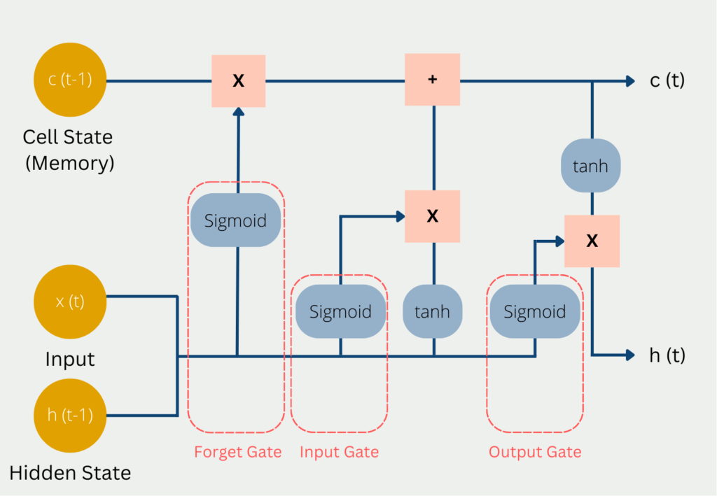
Full LSTM cell: sigmoid + tanh gates updating cell state C and hidden state h

Backpropagation through time in LSTM
Same idea as normal BPTT, with one extra: at each step you must also update the forget, input and output gate weights. Because the cell state mostly adds information (instead of repeatedly multiplying), the gradient flows back much more cleanly — that's the real reason LSTM beats plain RNN on long sequences.

Truncated BPTT (TBPTT) and ARTBP
Running BPTT across a very long sequence is slow and memory-hungry. TBPTT splits the sequence into chunks and backpropagates only a fixed number of steps at a time, then updates weights and moves on.
- Trade-off: too-short truncation → it won't converge; too-long → converges slowly. Choosing the length is tricky.
ARTBP (Anticipated Reweighted Truncated BPTT): uses random, variable chunk lengths plus correction factors in the equations to reduce the bias TBPTT introduces. In theory it's nicer; in practice it often performs about the same as TBPTT.
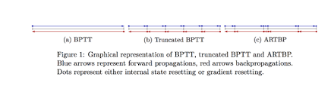
BPTT vs Truncated BPTT vs ARTBP (blue = forward, red = backward arrows)

3.6 Bidirectional LSTM
Same idea as bidirectional RNN, but with LSTM cells: one LSTM reads forward, one reads backward, outputs combined. You get long-memory AND full past+future context.
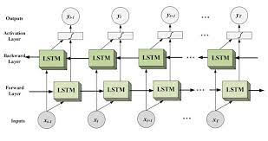
Bidirectional LSTM: forward layer + backward layer of LSTM cells

3.7 GRU (Gated Recurrent Unit)
GRU is a lighter, faster cousin of LSTM. It does a similar job with only TWO gates and no separate cell state (the hidden state does both jobs). Fewer gates = fewer parameters = faster training, often with similar accuracy.
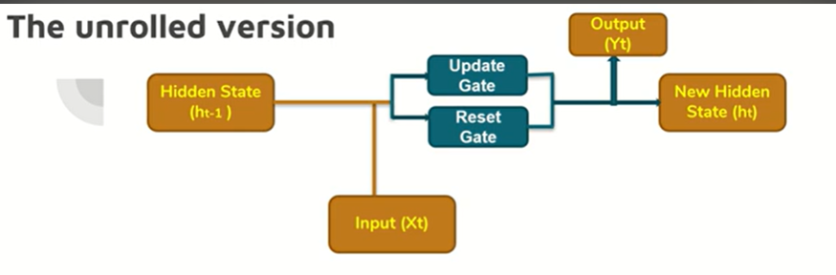
GRU unrolled: update gate + reset gate, no separate cell state
Gate | What it controls
Update gate | How much of the OLD hidden state to keep vs replace with new info.
Reset gate | How much of the PAST to forget when computing the new candidate state.
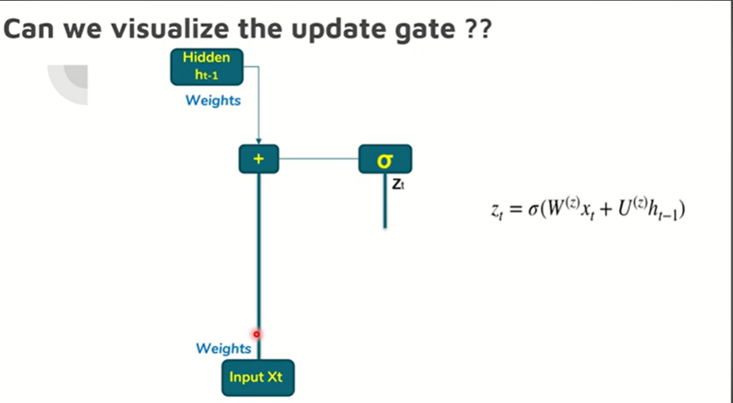
Update gate: z_t = σ( Wᵣ x_t + Uᵣ h_{t-1} )
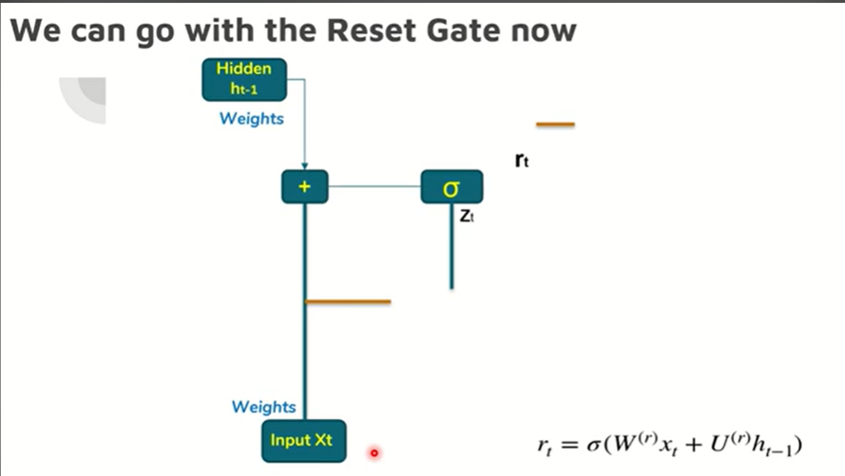
Reset gate: r_t = σ( Wᵣ x_t + Uᵣ h_{t-1} )

3.8 Sequence-to-Sequence (Encoder–Decoder)
How do you translate “India is a beautiful country” into Hindi when input and output lengths differ? Seq2Seq: one network (encoder) reads the whole input and squeezes it into a summary vector; another network (decoder) reads that summary and produces the output sequence word by word.
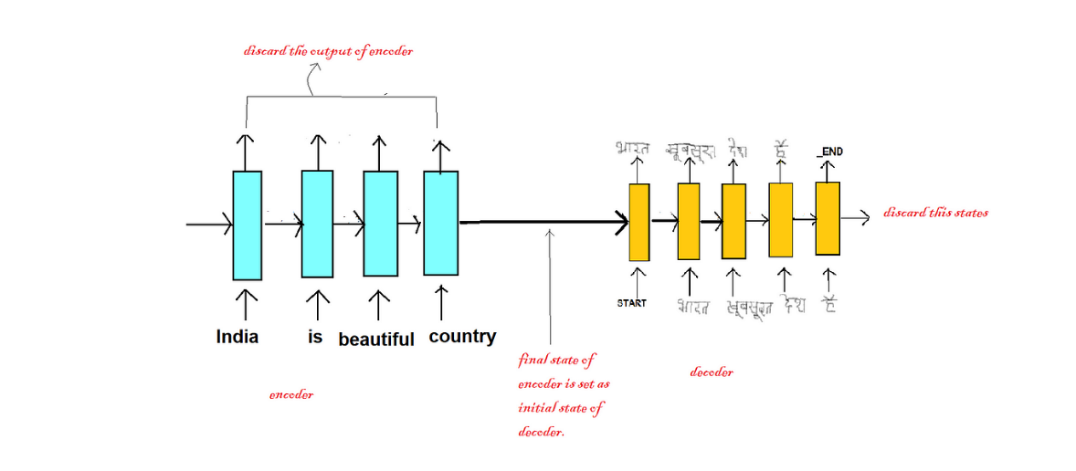
Seq2Seq: encoder reads the English sentence, decoder generates the Hindi translation
Part | Role
Encoder | An LSTM/GRU that reads the input. We throw away its outputs and keep only its final internal states.
Intermediate (context) vector | The encoder's final state — a single vector meant to hold the meaning of the whole input.
Decoder | Another LSTM/GRU. Its starting state = the encoder's final state. It generates the output one word at a time.
Teacher forcing (training trick)
During training, instead of feeding the decoder its own (possibly wrong) previous guess, we feed it the ACTUAL correct previous word. This makes training faster and more stable. The loss is computed on each predicted word and backpropagated through time.
Drawback of plain Encoder–Decoder → why Attention was born
Cramming an entire sentence into ONE fixed vector is a bottleneck. For long sentences the encoder “forgets” early words, so translations get worse and BLEU scores drop. The fix is Attention (Part 4): let the decoder look back at ALL encoder words, not just one summary.

Q. Why does LSTM fix the vanishing gradient but a plain RNN doesn't?
In a plain RNN the gradient is repeatedly multiplied by the same weight as it travels back — many numbers < 1 multiplied together vanish to ~0.
In an LSTM the cell state is mostly updated by addition (the gates add/remove info rather than re-multiplying everything). Addition keeps the gradient roughly intact across many steps, so information from far back still gets a learning signal.
Q. LSTM vs GRU — which one should I use?
GRU: fewer gates, fewer parameters, trains faster, needs less data — a good default, especially on smaller datasets.
LSTM: the separate cell state gives it slightly more control, which can help on very long or complex sequences. In practice their accuracy is often close, so people try both. Rule of thumb: start with GRU; switch to LSTM if you need more capacity.

Part 4 — Attention & Transformers ★
Read this part slowly — it's the heart of modern NLP
Everything before this (RNN, LSTM, GRU) reads text one word at a time. Transformers read the WHOLE sentence at once and use Attention to let every word look at every other word directly. This is why they're faster (parallel) and far better at long-range meaning. BERT, GPT and ChatGPT are all Transformers.

4.1 What is Attention?
Attention is a mechanism (not a full model) that lets the network decide which other words to focus on when processing a given word. A Transformer is a model architecture that uses attention very heavily and cleverly.
- Attention gives Transformers extremely long-term memory — they can use the whole context while generating text.
- Example: in “The animal didn’t cross the street because it was tired,” attention helps the word “it” look back and figure out it means “animal,” not “street.”

4.2 The Transformer at a glance
At its core a Transformer is a stack of Encoder layers and a stack of Decoder layers. No RNN, no LSTM — all words are processed together. Self-attention relates every word in the sequence to every other word.
Overall flow: Embedding → add Positional Encoding → Encoder stack → Decoder stack → Linear → Softmax → output word.
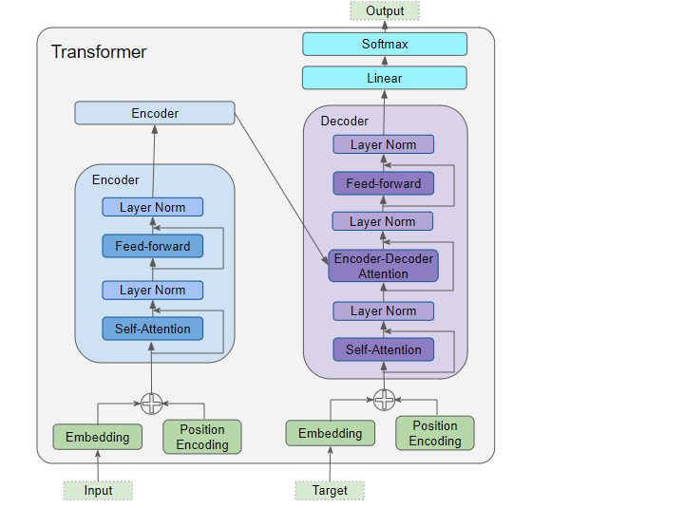
Full Transformer: Encoder stack (left) and Decoder stack (right) with attention, feed-forward, layer-norm
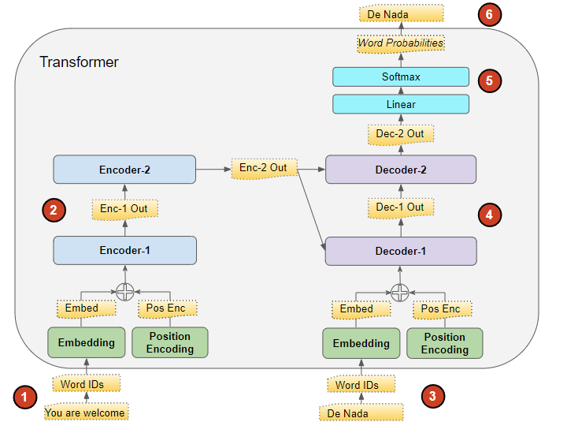
End-to-end flow with numbered steps: “You are welcome” → encoders → decoders → “De Nada”

4.3 Inputs: Embedding + Positional Encoding
Both the encoder and decoder turn their input through two layers before any attention happens:
- Embedding layer: each word is mapped to a word ID, then to a rich meaning vector (just like Part 2).
- Positional Encoding: because all words enter at once, the model has no built-in sense of order. So we ADD a position signal to each word's embedding to tell it “I’m word #1, I’m word #2…”.
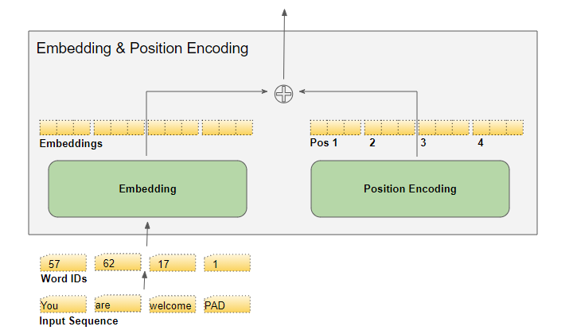
Word IDs → Embedding, plus Position Encoding, added together
The positional encoding is computed independently of the actual words — it only depends on the position and the embedding dimension, using sine and cosine waves:
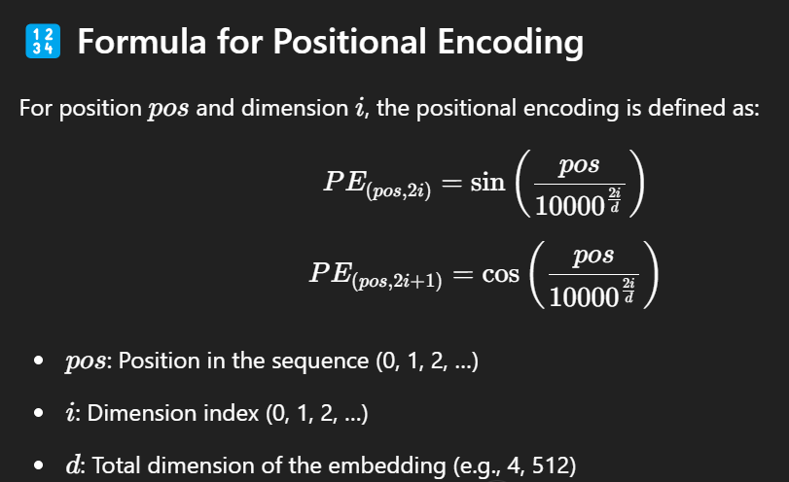
Positional encoding formula: even dimensions use sine, odd dimensions use cosine
Q. Why does positional encoding use sine and cosine?
1) Stable range. sin and cos always stay between -1 and 1, so positions never blow up to huge numbers no matter how long the sentence.
2) Relative positions are easy to learn. Because of how sine/cosine waves work, the model can express “position 5 is 2 steps after position 3” through simple combinations — so it captures distance between words, not just absolute slots.
Q. If positional encoding is ADDED to the word embeddings, doesn't it corrupt them and ruin training?
No. The embedding dimensions are large (e.g. 512). The position signal is spread across those dimensions in a smooth, predictable pattern, and the network simply LEARNS to separate “meaning” from “position” during training. The two pieces of information coexist instead of overwriting each other.

4.4 The Encoder
The encoder stack is usually 6 identical encoders stacked in a line. Each encoder has two main sub-layers:
- Multi-Head Self-Attention layer — lets each word look at all other words in the input.
- Feed-Forward layer — a small neural network applied to each position.
Around BOTH sub-layers there is a residual skip-connection followed by a Layer-Normalization step (“Add & Normalize”).

How data flows through the encoder stack
- The first encoder gets its input from Embedding + Positional Encoding.
- That goes into Multi-Head Self-Attention.
- The attention output goes into the Feed-Forward layer.
- Its output flows up to the next encoder — and so on through all 6.
- Each sub-layer is wrapped with a residual connection + Layer-Norm.
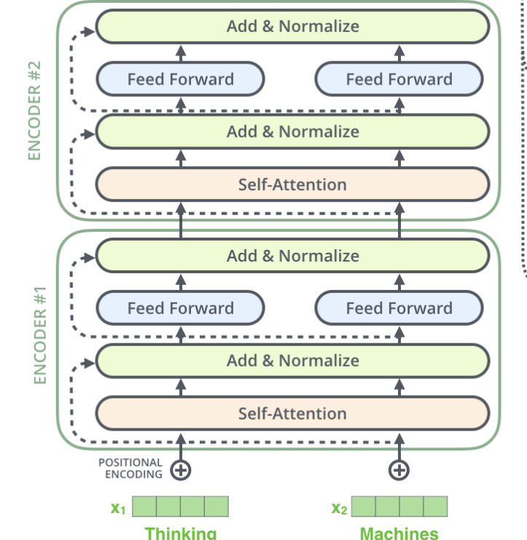
Two stacked encoders: Self-Attention → Add&Normalize → Feed Forward → Add&Normalize

4.5 Self-Attention: the Q, K, V mechanism
This is THE core idea. For every word we create three vectors by multiplying its embedding X by three learned weight matrices:
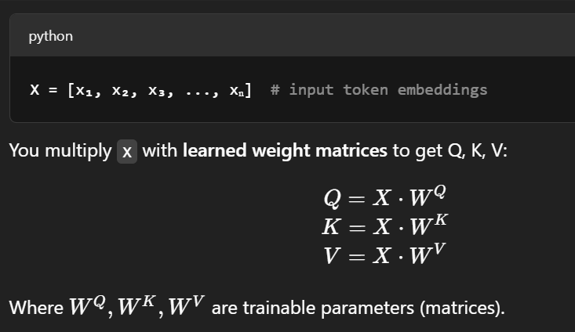
Q = X·Wᵠ, K = X·Wᵏ, V = X·Wᵛ (Wᵠ, Wᵏ, Wᵛ are learned)
Vector | Name | Easy intuition (like a search engine)
Q | Query | “What am I looking for?” — the current word's question.
K | Key | “What do I contain?” — each word's label/advertisement.
V | Value | “What I actually pass on” — the word's real content.
To find how much word A should pay attention to word B, you take the dot product of A's Query with B's Key. Big dot product = strong match = high attention. Then softmax turns these scores into weights that sum to 1, and you use them to take a weighted sum of the Value vectors.
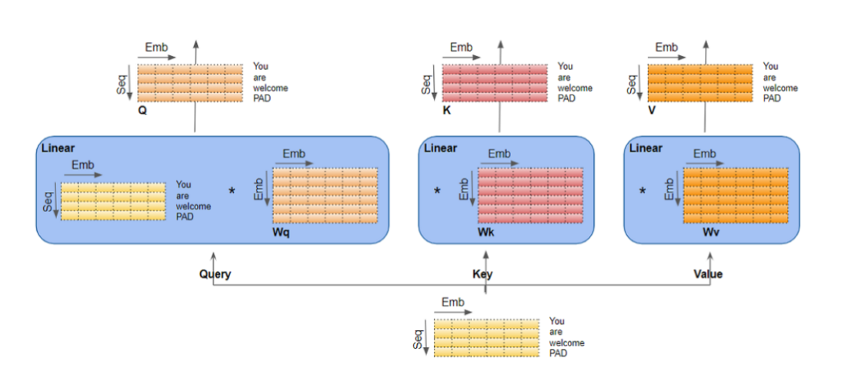
Each word's embedding X is multiplied by Wᵠ/Wᵏ/Wᵛ to produce Query, Key, Value matrices
The full self-attention formula:
Attention(Q, K, V) = softmax( (Q . Kᵀ) / √d_k ) . V

Q . Kᵀ → raw attention scores (every word vs every word)
√d_k → scaling factor (d_k = key dimension)
softmax → turns scores into weights that add up to 1
× V → weighted blend of all words' Values = the output
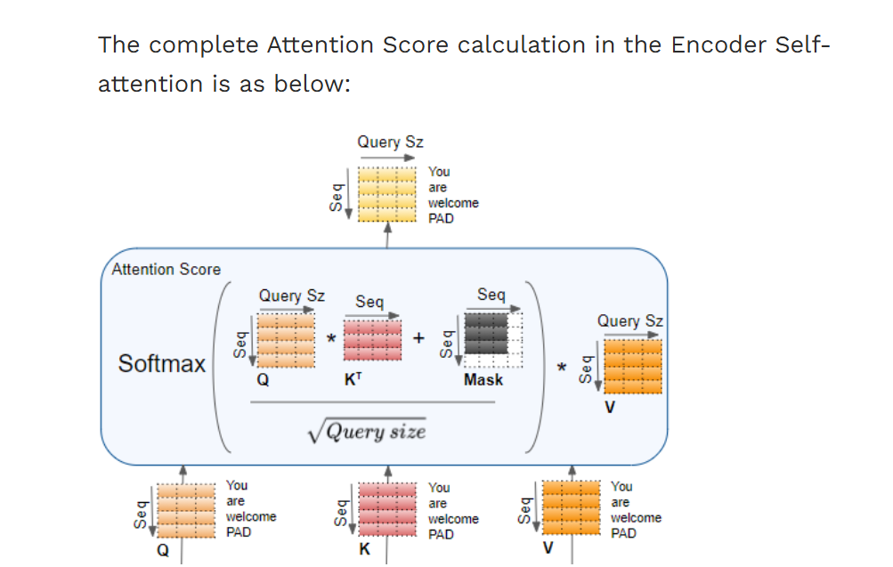
Full attention-score calculation: softmax( (Q·Kᵀ)/√(size) + Mask ) · V
Q. Softmax already normalises the scores — so why divide by √d_k first?
It's not to normalise the output — it's to keep softmax stable. When d_k is large, the dot products Q·Kᵀ become very big numbers.
Softmax of very large values becomes “peaky”: almost all attention collapses onto a single word, and the gradients get tiny and unstable, so learning slows or breaks.
Dividing by √d_k shrinks the scores back into a reasonable range, keeping softmax smooth and the gradients healthy.

4.6 Multi-Head Attention
Instead of doing self-attention once, the Transformer does it several times in parallel (e.g. 8 “heads”), each with its OWN Wᵠ/Wᵏ/Wᵛ weight matrices. Each head can focus on a different kind of relationship — one head might track grammar, another might track who-did-what.
- Multiply X by each head's Wᵠ/Wᵏ/Wᵛ → 8 different sets of Q/K/V.
- Run the same attention math 8 times → get 8 output matrices (Z₀…Z₇).
- The feed-forward layer wants ONE matrix, not 8. So concatenate the 8 outputs…
- …then multiply by one more learned weight matrix Wₒ to blend them into a single matrix that holds info from every head.
Why bother with multiple heads?
One attention head can only capture one type of relationship at a time. Multiple heads let the model capture many relationships simultaneously — that's what makes multi-head attention more powerful than a single attention layer. Each head's projections are different because each has its own weights.

4.7 Residual connections & Layer-Norm
In a normal deep network, data flows strictly layer → layer. A residual (skip) connection adds a shortcut: it lets the original input jump over a sub-layer and get added back to its output. This keeps gradients flowing and stops deep stacks from degrading.
- Every encoder sub-layer (and decoder sub-layer) has a residual connection around it, then a Layer-Normalization step.
- The Feed-Forward network is not just a pass-through — it has real weights that get updated during backpropagation.

4.8 The Decoder
The decoder looks like the encoder but with one extra attention layer and one important twist (masking). Each decoder has THREE sub-layers:
- Masked Multi-Head Self-Attention — target words attend to each other, but each word can only look at itself and earlier words (never future ones).
- Encoder–Decoder Attention — here the Queries come from the decoder, but the Keys and Values come from the ENCODER's output. This is how the decoder “looks at” the input sentence to decide what to generate next.
- Feed-Forward — same as in the encoder.
As always, each sub-layer has a residual connection + Layer-Norm. The first decoder gets Output-Embedding + Positional Encoding; later decoders get the previous decoder's output.
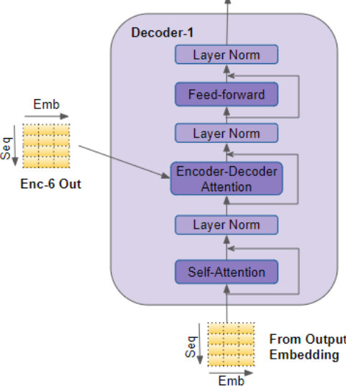
Decoder block: Masked Self-Attention → Encoder-Decoder Attention → Feed-forward (with Add&Norm)

Why masking in the decoder?
When generating word #4, the model must NOT be allowed to peek at words #5, #6… (they don't exist yet at test time). So before softmax, future positions in the attention matrix are set to negative infinity. After softmax those become ~0, so future words are effectively ignored. Each word can only attend to itself and the words before it.
Q. There are THREE attention layers in a Transformer — what's the difference?
1) Encoder self-attention: the input sentence attends to itself (every input word looks at every other input word). Not masked.
2) Decoder masked self-attention: the output sentence attends to itself, but masked so each word only sees earlier output words.
3) Encoder–Decoder attention: Queries from the decoder, Keys/Values from the encoder — lets the output focus on the right parts of the input. This is the bridge between the two stacks.
Q. Are the 6 encoder layers the same layer reused (like RNN shares weights over time)?
No — common trap. An RNN reuses ONE set of weights across time steps. A Transformer's 6 encoders are 6 SEPARATE layers, each with its own independent weights. They're identical in structure but learn different things.

4.9 Final Linear + Softmax layer
The decoder stack outputs a vector of floats. How do we turn that into an actual word?
- Linear layer: a fully-connected layer projects that vector into a very long “logits” vector — one score per word in the vocabulary. If the model knows 10,000 words, this vector is 10,000 numbers wide.
- Softmax: turns those 10,000 scores into probabilities (all positive, summing to 1).
- Pick: the word with the highest probability is chosen as the output for this step.
Training: we compare this predicted probability distribution against the correct word using cross-entropy loss, and backpropagate to improve the weights.

4.10 Transfer Learning & Fine-Tuning
Term | What it means | Everyday analogy
Transfer Learning | Take a model already trained on a huge dataset (e.g. BERT) and reuse it for a new but related task; usually you only swap out the last few layers. | A trained chef learning a new cuisine — they keep all their core skills.
Fine-Tuning | Continue training that pre-trained model a bit more on YOUR specific, smaller dataset so it adapts to your task. | That chef practising your restaurant's exact recipes for a week.
Both are lifesavers when you have limited data — you stand on the shoulders of a model that already learned language from billions of words.
Q. Why can't BERT generate text well, while GPT can?
BERT is an encoder — it reads the whole sentence in both directions to UNDERSTAND it, but it's not built to produce words one-by-one.
GPT is a decoder with masked self-attention — it's trained to predict the next word given previous words, which is exactly what generation needs. (Full comparison in Part 5.)
Q. Transformers process all words in parallel — so what's the catch?
Self-attention compares every word with every other word, so cost grows with the square of the sequence length (n²). Double the sentence length → ~4× the compute and memory. That's why very long inputs are expensive and why context-length limits exist.

Part 5 — Transformer-Based Models (BERT, GPT, BART)
Once the Transformer existed, people built famous models from its pieces. The trick is which half they use:
Model | Uses | Reads direction | Best at
BERT | Encoder only | Both directions | Understanding (classify, answer, tag)
GPT | Decoder only | Left → right only | Generating text
BART | Encoder + Decoder | Both, then generates | Text-to-text (summarise, translate)

5.1 BERT — Bidirectional Encoder Representations from Transformers
BERT (Google, 2018) reads a sentence in BOTH directions at once, so it understands each word using the words on its left AND right. Older models read only one direction. Because it understands context so well, it boosted many tasks: sentiment analysis, question answering, named-entity recognition, text classification.
BERT uses only the encoder half of the Transformer, because its goal is to understand language, not generate it.

How BERT prepares its input
BERT uses WordPiece tokenization — it splits rare words into smaller known pieces (e.g. “running” → “run” + “##ning”), so it never gets totally stuck on an unfamiliar word. It also adds special tokens and three embeddings per token:
- [CLS] token at the very start (used for classification); [SEP] token between/after sentences.
- Token embeddings: the word-piece meaning vectors.
- Segment embeddings: a marker saying “this belongs to Sentence A vs Sentence B” so BERT can tell two sentences apart.
- Positional embeddings: the position of each token in the sentence.

BERT's two training tasks
BERT is pre-trained on two clever self-supervised tasks (no human labels needed):
Task | What happens | Why it helps
1. Masked LM (MLM) | Randomly hide ~15% of words with a [MASK] token, run the sentence through, and make BERT predict the hidden words from the surrounding context. | Forces BERT to deeply understand context from both sides.
2. Next Sentence Prediction (NSP) | Give BERT two sentences and ask: “does sentence B really follow sentence A?” | Teaches relationships between sentences — useful for Q&A and inference.

5.2 GPT — Generative Pre-trained Transformer
GPT (OpenAI) is the generation specialist — it's the engine behind ChatGPT. It's autoregressive: it produces text one word at a time, and each new word is fed back in as context for the next.
- GPT uses the Transformer DECODER (the opposite of BERT, which uses the encoder).
- It's built from layers of masked self-attention + feed-forward networks.
- The mask ensures GPT only attends to PREVIOUS tokens, never future ones — so it's strictly left-to-right. (Makes sense: when writing, you don't know the next word yet.)
Autoregressive, in plain words
An autoregressive model predicts the next value from its own past values. GPT writing a sentence is like predicting the next word from all the words it has written so far, then repeating.

5.3 BART — Bidirectional and Auto-Regressive Transformers
BART is a hybrid: it glues BERT's understanding power to GPT's generating power.
- Encoder (BERT-like): reads and understands the input in both directions.
- Decoder (GPT-like): generates the output one word at a time.
Its architecture is basically a standard Transformer encoder–decoder (like the original Transformer or T5). It shines at text-to-text jobs: summarization, question answering, translation, dialogue generation, and text correction/filling.

Q. BERT vs GPT — the one comparison interviewers love.
Architecture: BERT = encoder; GPT = decoder.
Reading: BERT is bidirectional (sees both sides at once); GPT is left-to-right only.
Training goal: BERT fills in masked words (MLM); GPT predicts the next word.
Use it for: BERT → understanding tasks (classification, NER, extractive Q&A). GPT → generation tasks (writing, chat, completion).

Part 6 — Evaluation & Other Important Concepts

6.1 BLEU Score (evaluating translations / generated text)
When a model outputs a whole sentence (translation, summary), how do we score it? Exact-match is too harsh — “The ball is blue” and “The ball has a blue color” both fine. BLEU (Bilingual Evaluation Understudy) measures how much the machine output overlaps with a human reference.
- BLEU ranges from 0 to 1. In practice even good systems top out around 0.6–0.7 — so don't expect 1.0.
BLEU = Brevity Penalty × Geometric Average of n-gram precisions

Clipped precision (the cheat-blocker)
Without a limit, a model could spam one correct word to fake a perfect score. If the candidate repeats “the cat” 3 times but the reference only has it twice, BLEU counts it only twice. This “clipping” stops inflated scores.

Brevity Penalty (don't reward too-short outputs)
A super-short output could score high precision by only emitting words it's sure about. The brevity penalty punishes outputs shorter than the reference.
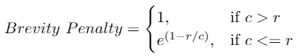
Brevity Penalty: 1 if candidate longer than reference, else e^(1 - r/c)
where c = candidate length, r = reference length.

Geometric average precision
BLEU checks 1-gram, 2-gram, 3-gram, 4-gram overlaps (how many of the machine's n-grams appear in the reference) and combines them with a geometric mean.
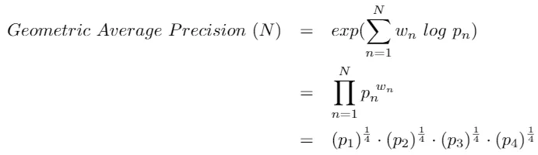
Geometric Average Precision over n-gram precisions p₁…pₙ

6.2 Batch Normalization vs Layer Normalization in NLP
Normalization keeps the numbers flowing through a network in a healthy range so training is stable and faster. There are two flavours, and which one you use matters a lot in NLP.
- Batch Norm normalizes across the batch (compares the same feature across many samples). It struggles when batch sizes are small or sequence lengths vary — both common in NLP.
- Layer Norm normalizes across the features of a single sample. It doesn't care about batch size, so it's the standard choice inside RNNs, LSTMs and Transformers.
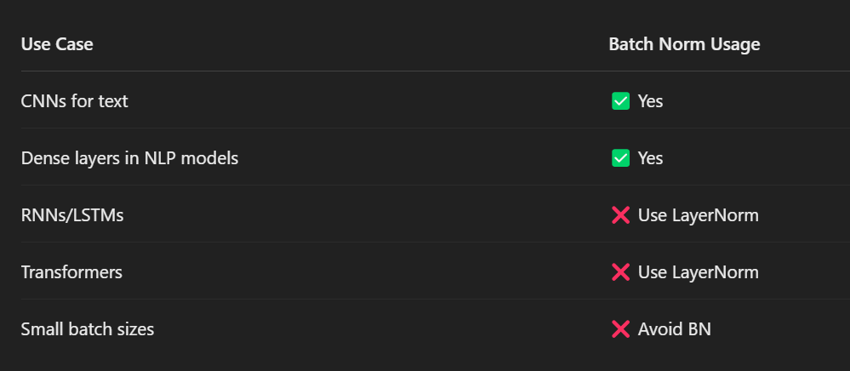
When to use Batch Norm vs Layer Norm — RNNs/LSTMs/Transformers prefer LayerNorm
Tie-back to Part 4
This is exactly why every “Add & Normalize” step inside a Transformer uses Layer Normalization, not Batch Normalization.

6.3 Markov Chain
A Markov chain is a model of a sequence of events where the next state depends ONLY on the current state — not on the full history. It has “no memory” beyond the present.
- Example: predicting tomorrow's weather only from today's weather (ignoring last week). Today sunny → 70% sunny tomorrow, 30% rainy.
This “the future depends only on the present” rule is called the Markov property.

6.4 CRF (Conditional Random Field)
A CRF is a model used for labeling sequences (like tagging each word) that considers how labels connect to each other, not just each label on its own.
Why it beats a plain softmax tagger: a softmax predicts each word's tag independently. A CRF looks at the whole label sequence and learns which label transitions are legal.
Example (Named Entity Recognition)
A tag sequence like ['B-PER', 'I-PER', 'O'] makes sense (Begin-Person, Inside-Person, Outside). But ['B-PER', 'O', 'I-PER'] is nonsense — you can't be “inside a person” right after “outside.” A CRF learns to avoid such illegal jumps; an independent softmax can't.

6.5 TimeDistributed
TimeDistributed is a Keras wrapper that applies the same layer separately to every time step of a sequence. If you have 10 words and want to run the SAME dense layer on each word's output, you wrap it in TimeDistributed instead of writing the loop yourself.
- Use case: sequence labeling — e.g. predict a part-of-speech tag for every word in a sentence, one independent prediction per time step.

Quick-Revision Cheat Sheet

The evolution in one line
BoW/TF-IDF (counts, no meaning) → Word2Vec/GloVe (meaning, fixed) → RNN (memory, slow, forgets) → LSTM/GRU (better memory) → Seq2Seq (in→out, bottleneck) → Attention/Transformer (look at everything, parallel) → BERT/GPT/BART.

Must-remember facts
Topic | One-liner to remember
Stemming vs Lemma | Stemming = fast chop, may be non-word. Lemma = dictionary base, always real word.
TF-IDF | Rare-but-here words score high; everywhere-words score low. log tames big corpora.
CBOW vs Skip-gram | CBOW: context→word (fast). Skip-gram: word→context (better for rare words).
RNN problem | Vanishing/exploding gradient from repeated multiplication → forgets long range.
LSTM fix | Cell state + gates use ADDITION, so gradients survive. C_t = long memory, h_t = output.
GRU | 2 gates (update, reset), no cell state, faster than LSTM.
Seq2Seq flaw | One fixed context vector = bottleneck on long sentences → Attention fixes it.
Self-attention | softmax(Q·Kᵀ / √d_k)·V. Q=question, K=label, V=content.
√d_k scaling | Stops softmax going peaky + keeps gradients stable; NOT for normalising output.
Multi-head | Several attentions in parallel, own weights each, capture different relationships.
Positional encoding | sin/cos added to embeddings so the model knows word order.
3 attentions | Encoder self / Decoder masked self / Encoder-decoder (Q from decoder, K,V from encoder).
Decoder mask | Hide future words (set to -∞ before softmax) so it can't cheat.
LayerNorm not BatchNorm | Transformers/RNNs use LayerNorm (batch-size independent).
BERT vs GPT | BERT = encoder, bidirectional, understands (MLM+NSP). GPT = decoder, left-to-right, generates.
BART | BERT encoder + GPT decoder = understand then generate (summarise, translate).
BLEU | Brevity Penalty × geometric mean of clipped n-gram precision; 0–1, ~0.6–0.7 is great.

Final word
If you can confidently explain Q/K/V self-attention, why we scale by √d_k, the three attention types, decoder masking, and BERT-vs-GPT — you're covering exactly what most NLP interviews push hardest on. Revisit Part 4 until those feel easy.

