COMPLETE STATISTICS MASTER GUIDE
z-Tests · t-Tests · Chi-Square Tests

Simple Language | Multiple Real Examples | Step-by-Step Walkthroughs | How p-Values Work
Every concept explained plainly — with real scenarios from business, healthcare, education and everyday life

What this guide covers:
PART 1 — z-Tests  - What a z-test is and how it works  - One-sample z-test (4 scenarios)  - Two-sample z-test (3 scenarios)  - One-proportion z-test (3 scenarios)  - Two-proportion z-test (2 scenarios)  - How z-scores connect to p-values | PART 2 — t-Tests  - What a t-test is and why it differs from z  - One-sample t-test (3 scenarios)  - Two-sample t-test (3 scenarios)  - Paired t-test (3 scenarios)  - How the t-distribution generates p-values  - z vs t complete comparison

PART 3 — Chi-Square Tests
- What chi-square is and when to use it  - Goodness-of-Fit test (4 scenarios)  - Test of Independence (4 scenarios) | - Test of Homogeneity (3 scenarios)  - Fisher's Exact Test (2 scenarios)  - Misconceptions, assumptions and effect size

PART 1
z-Tests

Chapter 1: What Is a z-Test?

1.1 The Simple Idea
A z-test is a statistical test that answers one question: "Is the difference I see in my data real, or could it just be random chance?" It does this by converting your result into a z-score — a number that tells you how many standard deviations your result sits away from what you would expect if nothing special were happening.

Simple analogy: Think of every experiment result as a test score. The z-test converts that score into a percentile rank. If your result is in the top 2.5%, it is so unusual that you conclude something real is happening — not just luck.

z-score = (Your observed value − What you expected) / Standard Error

Small z (near 0): Result is normal — could easily happen by chance.
Large |z| (far from 0): Result is unusual — strong evidence something real is happening.

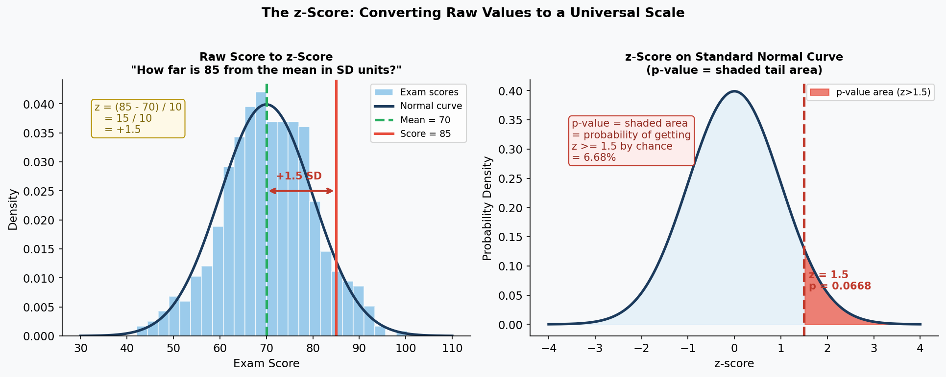

From the chart: A student scored 85 where the average is 70 and SD is 10. Their z-score = (85−70)/10 = +1.5. On the right chart, the red shaded area is the p-value — the probability of scoring this high or higher purely by chance.

1.2 Three Requirements for a z-Test
Requirement | What it means | Example
Large sample (n ≥ 30) | The Central Limit Theorem ensures the sampling distribution is normal | Surveying 200 customers about satisfaction
Known population SD (σ) | You know — or can reliably use — the true population standard deviation | Government data gives national SD of exam scores = 15
Quantitative or proportion data | Testing a mean (average) or a proportion (percentage) | Average delivery time; percentage of customers who bought

1.3 How the p-Value Is Generated From a z-Score
Once you have the z-score, the p-value is simply the area under the standard normal curve beyond your z-score. Bigger z-score → further into the tail → smaller area → smaller p-value.

p-value | What it means | Conclusion
p = 0.30 | 30% chance of seeing this if H0 is true | Very normal — no evidence against H0
p = 0.10 | 10% chance | Borderline — not convincing
p = 0.05 | 5% chance | Standard threshold — barely significant
p = 0.01 | 1% chance | Strong evidence — reject H0
p = 0.001 | 0.1% chance — very rare | Very strong evidence — definitely reject H0

1.4 Common Misconceptions

MYTH | TRUTH
z-test can be used for any sample size. | z-test is designed for large samples (n ≥ 30) where the population SD is known. For small samples, the t-test is more appropriate. Using z with small samples gives falsely narrow confidence intervals — you will reject H0 too often.

MYTH | TRUTH
A large z-score means the effect is large and important in real life. | A large z-score only means statistical significance — not practical importance. With 10,000 people, a salary difference of $50 (completely trivial!) can produce z = 5.0. Always ask whether the actual difference is meaningful alongside the z-score.

Chapter 2: Types of z-Tests

2.1 Type 1 — One-Sample z-Test
Purpose: Compare ONE group's mean against a known or claimed population value.

Formula: z = (x̄ − μ₀) / (σ / √n)
Where: x̄ = sample mean | μ₀ = claimed population mean | σ = population SD | n = sample size

Scenario 1A — Employee Salary Audit
Real-World Scenario: HR Department Salary Investigation
A company claims average employee salary is $52,000. An auditor surveys 64 employees and finds a sample mean of $53,500. The national SD for this job category is $4,900.
H0: Mean salary = $52,000 | H1: Mean salary > $52,000 | alpha = 0.05
z = (53,500 − 52,000) / (4,900 / √64) = 1,500 / 612.5 = 2.45
p = 0.0071 < 0.05 → REJECT H0. Strong evidence salaries exceed $52,000.

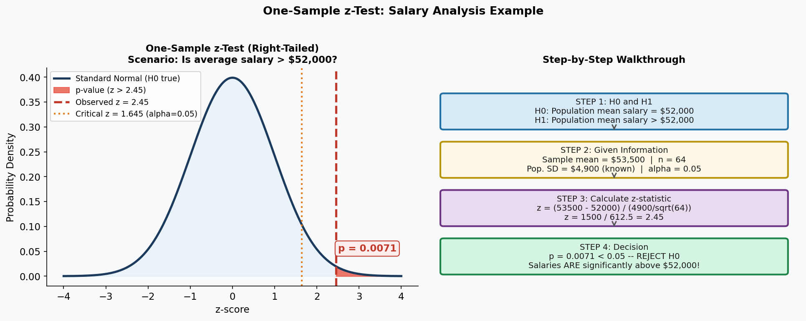

Scenario 1B — Hospital Wait Time
Real-World Scenario: Emergency Room Efficiency Study
A hospital claims average ER wait time is 45 minutes. A patient group samples 100 visits and finds a mean of 51 minutes. Historical population SD = 18 minutes.
H0: Mean wait = 45 min | H1: Mean wait > 45 min | alpha = 0.05
z = (51 − 45) / (18 / √100) = 6 / 1.8 = 3.33
p = 0.0004 → REJECT H0. ER wait times are significantly longer than claimed.

Scenario 1C — Cereal Box Weight
Real-World Scenario: Food Manufacturing Quality Control
Boxes are labelled 500g. An inspector tests 50 boxes. Sample mean = 496g. Known production SD = 8g.
H0: Mean weight = 500g | H1: Mean weight ≠ 500g | Two-tailed
z = (496 − 500) / (8 / √50) = −4 / 1.13 = −3.54
p = 0.0004 → REJECT H0. Boxes are being underfilled. Production line must stop.

2.2 Type 2 — Two-Sample z-Test
Purpose: Compare the means of TWO separate groups.

Formula: z = (x̄₁ − x̄₂) / √(σ₁²/n₁ + σ₂²/n₂)

Scenario 2A — Commute Times: Two Cities
Real-World Scenario: Urban Transport Study
City A: n=80, sample mean=68 min, σ=14 min. City B: n=80, sample mean=72 min, σ=16 min.
H0: Means are equal | H1: They differ | Two-tailed
z = (68 − 72) / √(14²/80 + 16²/80) = −4 / 2.38 = −1.68
p = 0.093 > 0.05 → Fail to reject H0. No significant difference in commute times.

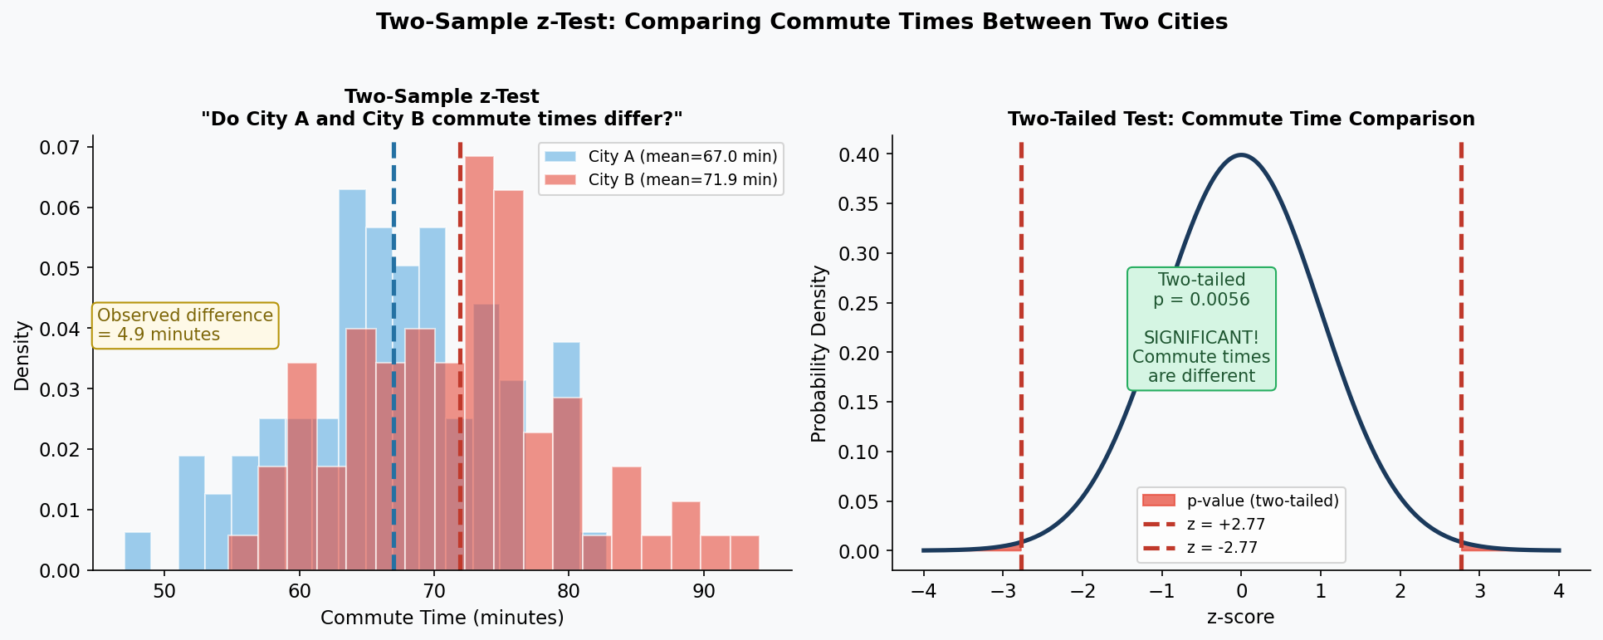

Scenario 2B — Sales Training ROI
Real-World Scenario: Corporate Training Effectiveness
Trained reps (n=60): mean monthly revenue = $18,500, σ=$3,200. Untrained (n=60): mean = $16,200, σ=$3,500.
H0: Both groups generate the same revenue | H1: Trained group generates more
z = (18,500 − 16,200) / √(3200²/60 + 3500²/60) = 2,300 / 612.3 = 3.76
p = 0.00008 → REJECT H0. Training significantly increases revenue by ~$2,300/month.

Scenario 2C — Online vs In-Person Learning
Real-World Scenario: Education Research
Online class (n=120): mean score=74.3, σ=11.2. In-person (n=120): mean score=77.1, σ=10.8.
H0: Scores are equal | H1: They differ | Two-tailed
z = (74.3 − 77.1) / √(11.2²/120 + 10.8²/120) = −2.8 / 1.42 = −1.97
p = 0.049 → Barely reject H0. In-person slightly better — but very borderline!

2.3 Type 3 — One-Proportion z-Test
Purpose: Test whether a proportion is significantly different from a claimed value.

Formula: z = (p̂ − p₀) / √(p₀(1−p₀) / n)
Where: p̂ = observed proportion | p₀ = claimed proportion | n = sample size

Scenario 3A — Website Conversion Rate
Real-World Scenario: E-Commerce Product Redesign
Website normally converts 5% of visitors. After a redesign, 80 out of 1,000 visitors buy (8%).
H0: Click rate = 5% | H1: Click rate > 5% | Right-tailed
z = (0.08 − 0.05) / √(0.05 × 0.95 / 1000) = 0.03 / 0.00689 = 4.35
p = 0.000007 → REJECT H0. Redesign genuinely increased conversion rate.

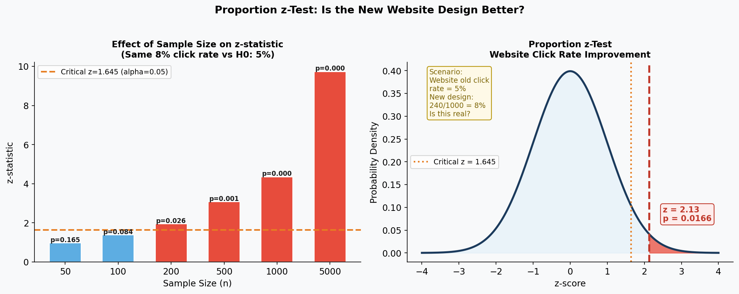

Scenario 3B — Customer Satisfaction
Real-World Scenario: Retail Monthly Performance Review
Benchmark: 78% of customers should rate service "satisfactory or better." This month: 380/500 = 76%.
H0: p = 0.78 | H1: p < 0.78 | Left-tailed
z = (0.76 − 0.78) / √(0.78 × 0.22 / 500) = −0.02 / 0.01852 = −1.08
p = 0.14 → Fail to reject H0. Drop is within normal variation. No emergency action needed.

Scenario 3C — Pharmaceutical Defect Rate
Real-World Scenario: Regulatory Inspection
Manufacturer claims defect rate is under 2%. Inspector tests 800 pills and finds 22 defective (2.75%).
H0: Defect rate = 2% | H1: Defect rate > 2% | Right-tailed
z = (0.0275 − 0.02) / √(0.02 × 0.98 / 800) = 0.0075 / 0.004975 = 1.508
p = 0.066 → Borderline. Not significant at 0.05 but regulators request a larger sample.

2.4 Type 4 — Two-Proportion z-Test
Purpose: Compare TWO proportions from two different groups.

Formula: z = (p̂₁ − p̂₂) / √(p̂(1−p̂)(1/n₁ + 1/n₂)) where p̂ = pooled proportion

Scenario 4A — Drug vs Placebo Recovery
Real-World Scenario: Clinical Drug Trial
Drug group: 87/100 recovered (87%). Placebo group: 61/100 recovered (61%).
H0: Recovery rates are equal | H1: Drug group recovers more | Right-tailed
Pooled p̂ = (87+61)/200 = 0.74. z = (0.87−0.61) / √(0.74×0.26×2/100) = 0.26 / 0.062 = 4.19
p = 0.000014 → REJECT H0. Drug significantly improves recovery rate.

Scenario 4B — Email Subject Line A/B Test
Real-World Scenario: Digital Marketing Campaign
Email A: 340/2,000 opened (17%). Email B: 410/2,000 opened (20.5%).
H0: Both open rates are equal | H1: They differ | Two-tailed
Pooled p̂ = 750/4000 = 0.1875. z = (0.205−0.17) / √(0.1875×0.8125×2/2000) = 2.84
p = 0.0045 → REJECT H0. Email B significantly outperforms Email A.

2.5 When to Use Each z-Test — Summary
z-Test Type | Question Asked | Key Condition
One-Sample (Mean) | Is our group's mean different from a known value? | n ≥ 30, σ known
Two-Sample (Means) | Are two groups' means different? | Both n ≥ 30, both σ known
One-Proportion | Is our proportion different from a claimed rate? | n×p ≥ 10 and n×(1−p) ≥ 10
Two-Proportion | Are two groups' proportions different? | Both groups satisfy proportion conditions

PART 2
t-Tests

Chapter 3: What Is a t-Test?

3.1 The Simple Idea
A t-test does the same job as a z-test — it asks "is this difference real or just chance?" — but for situations when:

- Your sample is SMALL (n < 30) — z-test becomes unreliable
- You do NOT know the population standard deviation — you estimate it from your sample instead

Because of this extra uncertainty, the t-test uses a wider curve — the t-distribution — which has heavier tails. This means you need more extreme results to claim significance, which is the honest approach with less data.

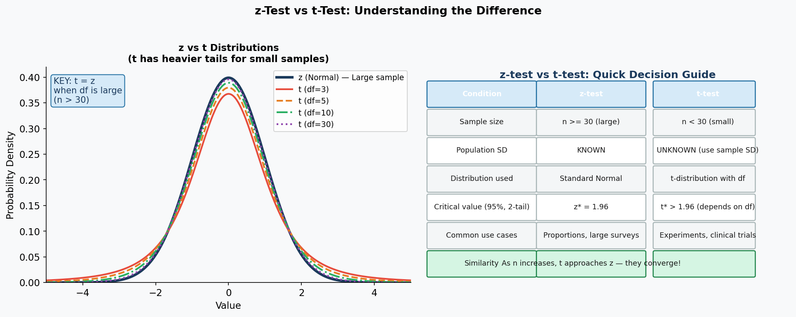

3.2 z-Test vs t-Test Side by Side
Characteristic | z-Test | t-Test
Sample size needed | Large (n ≥ 30) | Any size — especially for n < 30
Population SD | Must be KNOWN (σ) | Estimated from your sample (s)
Distribution used | Standard Normal | t-distribution (wider tails, depends on df)
Critical value (95%, two-tail) | Always 1.96 | Larger than 1.96 for small df; approaches 1.96 as n grows
When they converge | For large n, t → z | They give practically identical results for n > 100
Most common use | Population surveys, proportions | Lab experiments, clinical trials, small studies

3.3 How the t-Test Produces a p-Value
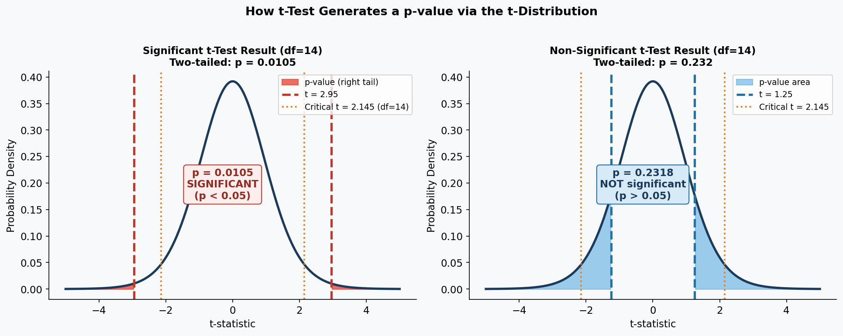

t = (Sample Mean − Hypothesised Mean) / (Sample SD / √n)

After calculating t, the p-value = the area in the tail(s) of the t-distribution beyond your t-value. Larger |t| → further into the tail → smaller area → smaller p-value → stronger evidence against H0.

Degrees of freedom: df = n−1 (one-sample) | df = n₁+n₂−2 (two-sample) | df = n−1 (paired, where n = number of pairs)

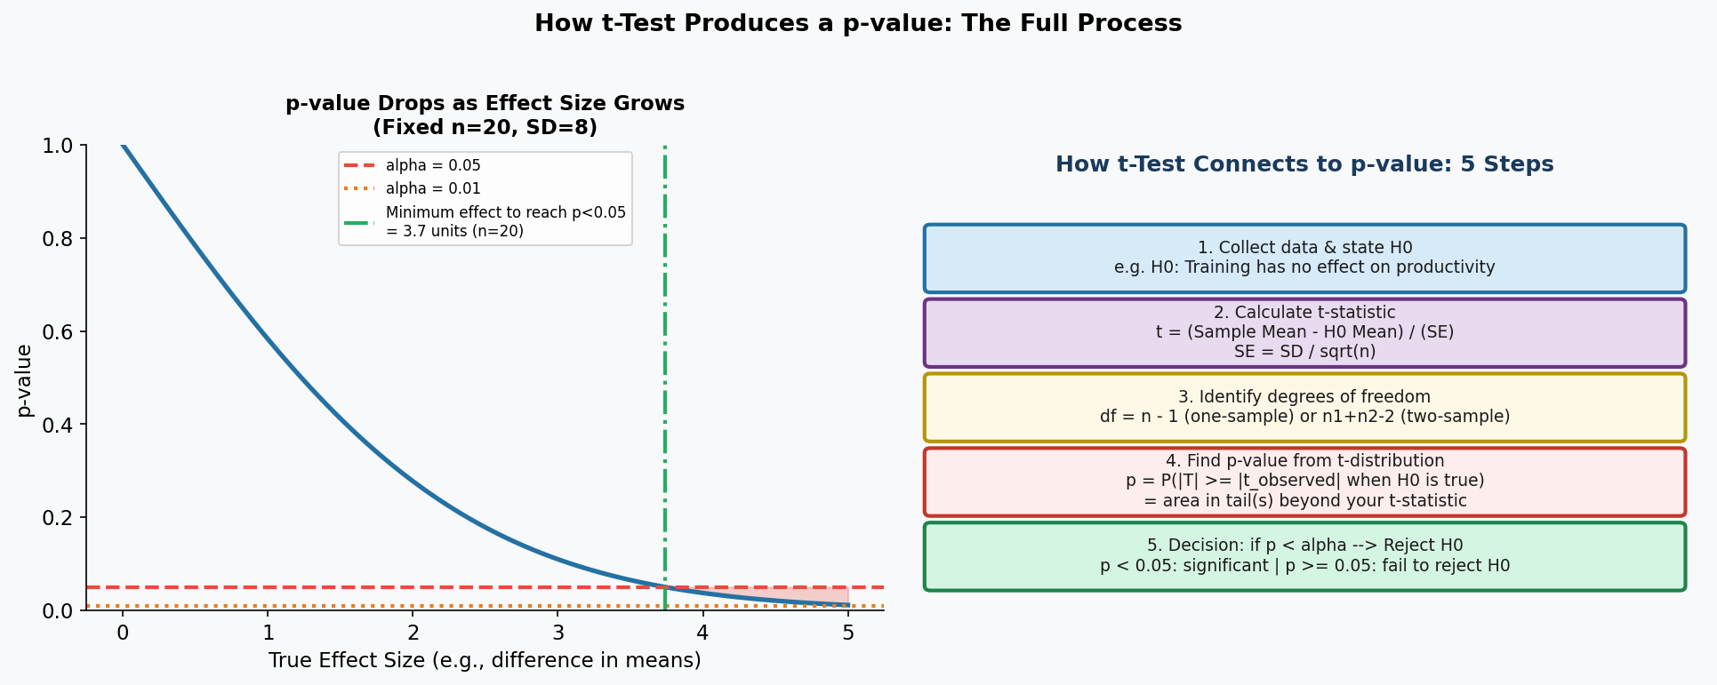

3.4 Common Misconceptions

MYTH | TRUTH
The t-test can only be used with normally distributed data. | Not entirely true. The t-test is robust to departures from normality — especially for n ≥ 15 or 20. The Central Limit Theorem ensures the sampling distribution of the mean becomes approximately normal even when raw data is skewed. Only for very small samples (n < 10) with clearly non-normal data should you consider non-parametric alternatives.

MYTH | TRUTH
If p > 0.05, the two groups are definitely the same. | "Fail to reject H0" does NOT mean H0 is true. It means you lack sufficient evidence to reject it. This could be because (1) there really is no difference, OR (2) your sample was too small to detect a real effect. Always check whether your study had adequate statistical power.

Chapter 4: Types of t-Tests

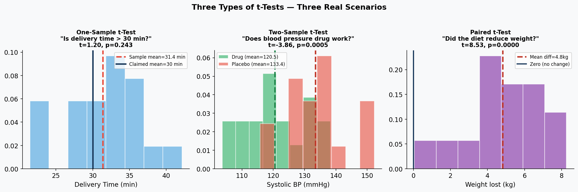

4.1 Type 1 — One-Sample t-Test
Purpose: Test whether your sample mean is significantly different from a specific claimed or target value. Population SD is UNKNOWN — you use your sample SD instead.

Formula: t = (x̄ − μ₀) / (s / √n) | df = n − 1

Scenario 1A — Food Delivery App
Real-World Scenario: Delivery Service Performance Audit
A food app advertises delivery in 30 minutes. A consumer group tracks 20 orders: mean = 34.2 min, sample SD = 6.8 min.
H0: Mean delivery = 30 min | H1: Mean > 30 min | df = 19 | alpha = 0.05
t = (34.2 − 30) / (6.8 / √20) = 4.2 / 1.52 = 2.76
Critical t (df=19, one-tail, alpha=0.05) = 1.729
2.76 > 1.729 and p = 0.006 < 0.05 → REJECT H0. Delivery time significantly exceeds 30 minutes.

Scenario 1B — Medical Device Battery Life
Real-World Scenario: Regulatory Compliance Check
A heart monitor claims 72-hour battery life. Quality control tests 15 units: mean = 69.3 hours, sample SD = 4.1 hours.
H0: Mean = 72 hrs | H1: Mean < 72 hrs | Left-tailed | df = 14
t = (69.3 − 72) / (4.1 / √15) = −2.7 / 1.059 = −2.55
p = 0.012 → REJECT H0. Battery life is significantly less than claimed. Submission halted.

Scenario 1C — School vs National Exam Average
Real-World Scenario: School Performance Comparison
National reading average = 75. School tests 25 students: mean = 78.4, sample SD = 9.2.
H0: Mean = 75 | H1: Mean ≠ 75 | Two-tailed | df = 24
t = (78.4 − 75) / (9.2 / √25) = 3.4 / 1.84 = 1.85
Critical t (df=24, two-tail, alpha=0.05) = 2.064
p = 0.077 → Fail to reject H0. School is slightly above average but not significantly so.

4.2 Type 2 — Two-Sample (Independent) t-Test
Purpose: Compare means of TWO completely separate, independent groups. People in Group 1 and Group 2 are different individuals.

Formula: t = (x̄₁ − x̄₂) / √(s₁²/n₁ + s₂²/n₂) | df ≈ Welch formula (software calculates this)

Scenario 2A — Blood Pressure Drug Pilot
Real-World Scenario: Pharmaceutical Clinical Trial
Drug group (n=18): mean BP = 122 mmHg, SD = 8.5. Placebo group (n=18): mean BP = 132 mmHg, SD = 9.2.
H0: Equal blood pressure | H1: Drug group lower | Left-tailed | df ≈ 33
t = (122 − 132) / √(8.5²/18 + 9.2²/18) = −10 / 2.952 = −3.39
p = 0.001 → REJECT H0. Drug significantly reduces blood pressure by ~10 mmHg.

Scenario 2B — Call Centre Training
Real-World Scenario: Business Operations Analysis
Team A (old process, n=22): mean handling = 8.7 min, SD = 1.9. Team B (after training, n=22): mean = 7.2 min, SD = 1.6.
H0: Equal handling time | H1: They differ | Two-tailed | df ≈ 41
t = (8.7 − 7.2) / √(1.9²/22 + 1.6²/22) = 1.5 / 0.529 = 2.84
p = 0.007 → REJECT H0. Team B is significantly faster. Saves 6,600 minutes per day.

Scenario 2C — Social Media Image vs Text Posts
Real-World Scenario: Content Marketing Strategy
Image posts (n=25): mean likes = 342, SD = 87. Text-only posts (n=25): mean likes = 298, SD = 94.
H0: Equal engagement | H1: Image posts get more | Right-tailed | df ≈ 48
t = (342 − 298) / √(87²/25 + 94²/25) = 44 / 25.6 = 1.72
p = 0.046 → Reject H0. Image posts significantly outperform — but only just. Worth monitoring.

4.3 Type 3 — Paired t-Test
Purpose: Compare TWO measurements from the SAME subjects — before/after, two conditions, or matched pairs.

Formula: t = d̄ / (s_d / √n) where d̄ = mean of differences, s_d = SD of differences, n = number of pairs

Why more powerful than two-sample: By looking only at the CHANGE within each person, you remove all variation due to individual differences. This reduces noise and detects smaller effects.

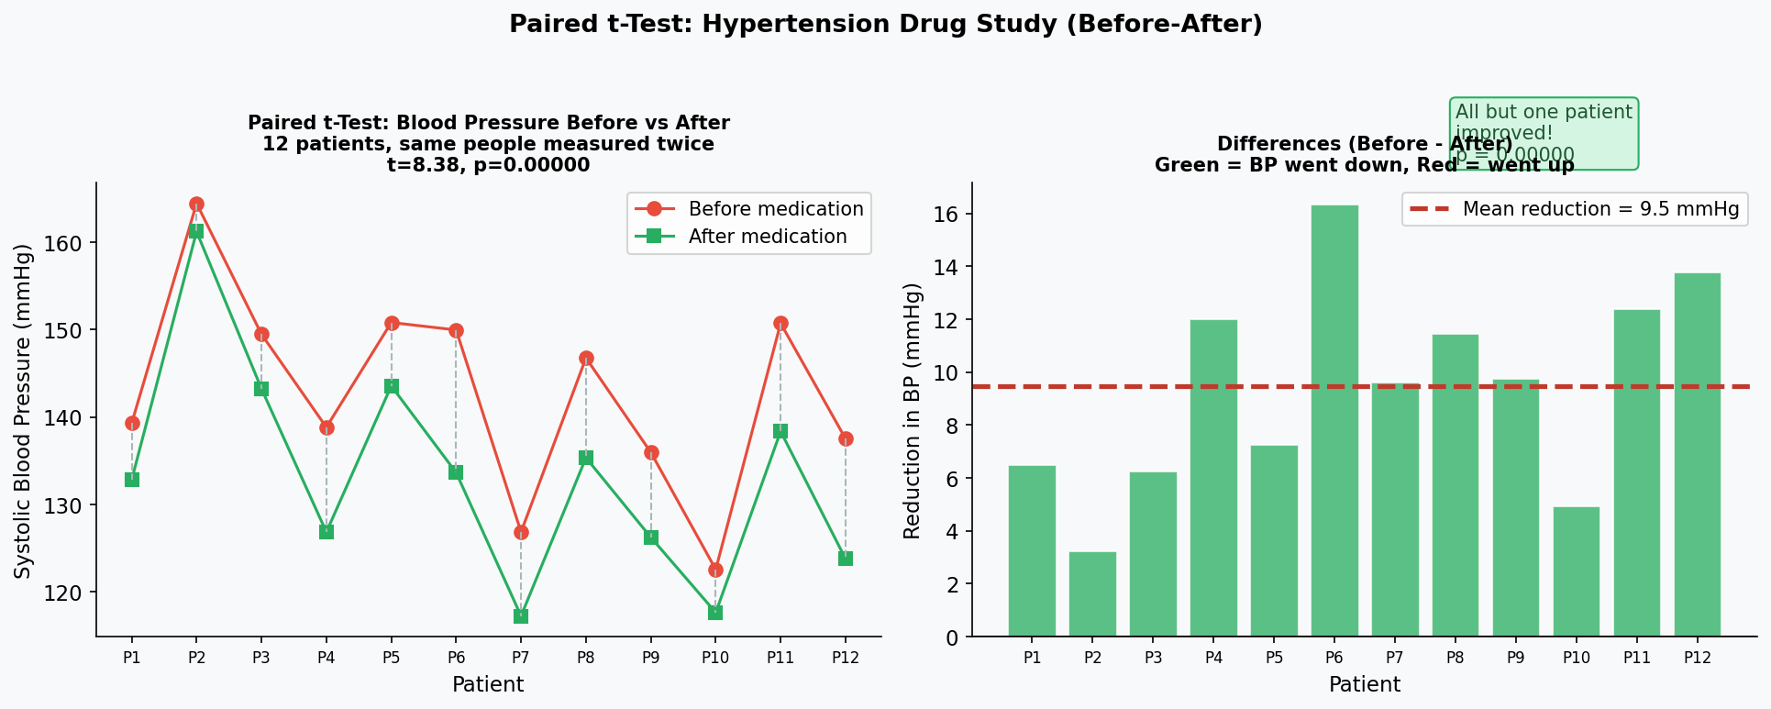

Scenario 3A — Blood Pressure Medication
Real-World Scenario: Hypertension Drug Study
12 patients measured BEFORE and AFTER 4 weeks of medication.
Mean difference (before − after) = 11 mmHg, SD of differences = 5.2, n = 12, df = 11.
H0: Mean difference = 0 | H1: Mean difference > 0 | Right-tailed
t = 11 / (5.2 / √12) = 11 / 1.501 = 7.33
p = 0.00001 → REJECT H0. Medication significantly reduces BP by ~11 mmHg.

Scenario 3B — Employee Productivity Training
Real-World Scenario: Corporate Training Effectiveness
10 employees measured BEFORE and AFTER a productivity workshop.
Before mean: 69.3% | After mean: 75.4% | Mean difference: 6.1%, SD of differences: 1.29, n=10, df=9
H0: Mean difference = 0 | H1: Mean difference > 0
t = 6.1 / (1.29 / √10) = 6.1 / 0.408 = 14.95
p < 0.000001 → REJECT H0. Training improved productivity by 6.1 percentage points.

Scenario 3C — Left vs Right Eye Vision
Real-World Scenario: Optometry Research
14 patients: both eyes tested. Right eye mean = 81.4, left eye mean = 79.8. Mean difference = 1.6, SD of differences = 3.8, n=14, df=13.
H0: Mean difference = 0 | H1: They differ | Two-tailed
t = 1.6 / (3.8 / √14) = 1.6 / 1.016 = 1.575
p = 0.14 → Fail to reject H0. No significant difference between eyes. Both equally healthy.

4.4 Master Decision: Which t-Test to Use?
Situation | Test Type | df | Real Example
One group compared to a known value | One-Sample t | n − 1 | Is delivery time > 30 min?
Two separate independent groups compared | Two-Sample t | n₁+n₂ − 2 (approx) | Drug group vs placebo — different patients
Same people measured twice (before/after) | Paired t | n − 1 (where n = pairs) | Weight before and after diet — same people

PART 3
Chi-Square Tests

Chapter 5: What Is the Chi-Square Test?

5.1 The Simple Idea — Counts vs Expectations
The chi-square test answers: "Are my observed counts different from what I would expect — or is the difference just random noise?"

It works entirely with COUNT data — things you tally into categories. Not heights or weights — but things like: how many people chose option A, how many patients recovered, how many products were defective.

Simple analogy: You stock 4 meal options equally at a canteen, expecting equal popularity. At the end of the week the counts are very unequal. Was that a random fluke — or do students genuinely prefer some meals? The chi-square test answers that.

Small p-value (< 0.05): Counts are too unequal to be random. Something real is happening.
Large p-value (≥ 0.05): Counts could easily happen by chance. No strong evidence of a real difference.

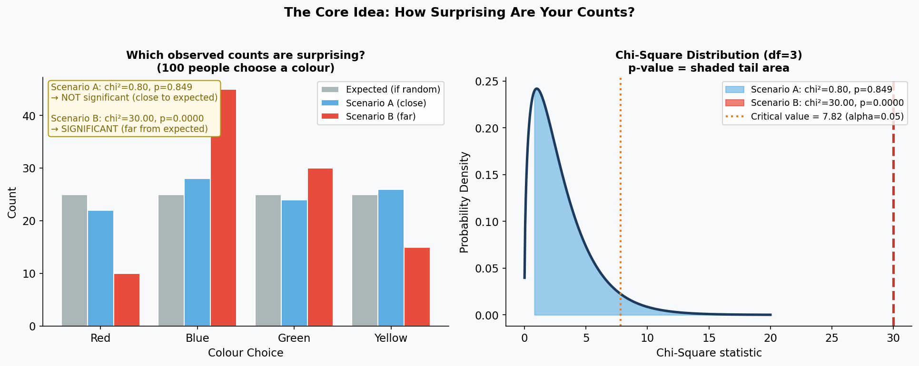

5.2 The Formula — Plain English
chi² = Σ (Observed − Expected)² / Expected across all categories

In plain English: For every category, compute how far your observed count is from the expected count. Square it (makes it positive and punishes bigger gaps more). Divide by expected (standardises it). Add them all up.

Large chi²: Observed is far from expected → evidence against H0.
Small chi²: Observed is close to expected → no evidence against H0.

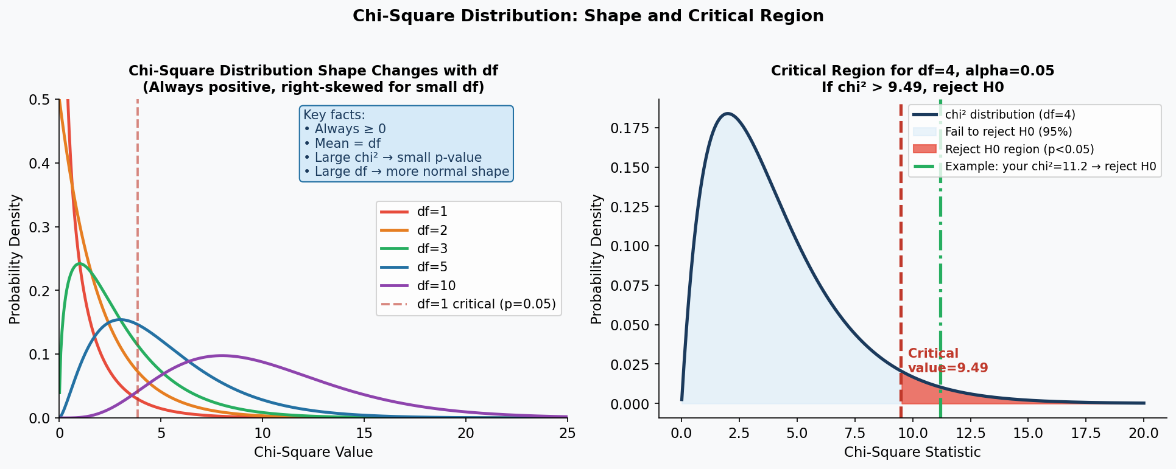

5.3 Use Chi-Square for Counts — NOT for Measurements
USE chi-square for:  - Categorical data — groups, labels, types  - Count data — how many fall into each category  - Number of people choosing Brand A, B or C  - Number of patients recovered vs not recovered  - Number of defective vs non-defective items | DO NOT use chi-square for:  - Heights, weights, temperatures, salaries  - Comparing group means → use t-test or ANOVA  - Very small expected counts (< 5) → use Fisher's  - Percentages without the raw counts behind them  - Continuous data of any kind

5.4 Misconceptions — Busted

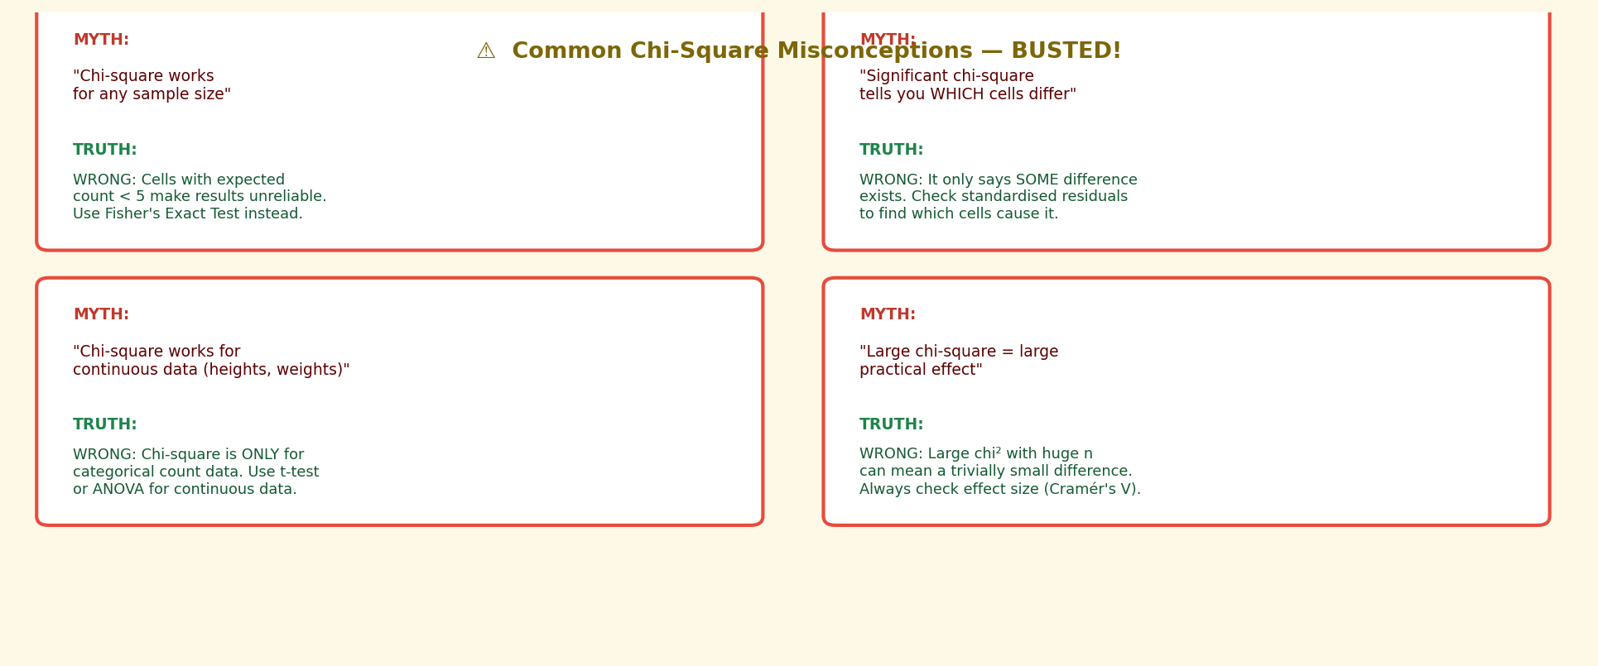

MYTH | TRUTH
Chi-square can be used on any data including averages and measurements. | Chi-square is ONLY for count/frequency data in categories. If you have heights, weights or salaries, use a t-test (two groups) or ANOVA (3+ groups). Putting continuous measurements into chi-square is mathematically wrong.

MYTH | TRUTH
A significant chi-square tells you which specific category caused the problem. | Chi-square gives ONE overall result. It tells you SOMETHING is different but not WHERE. To find which cells are most surprising, examine the standardised Pearson residual for each cell: residual = (O − E) / √E. Residuals above +2 or below −2 identify the problem cells.

MYTH | TRUTH
A large chi-square means a large, important real-world difference. | Chi-square grows with sample size. With 100,000 people, a trivial difference gives chi² = 500. Always report Cramér's V alongside: V = √(chi² / (n × (min(rows,cols)−1))). V near 0 = tiny effect, V near 0.3 = moderate, V near 0.5 = large.

Chapter 6: Type 1 — Goodness-of-Fit Test

6.1 What Does It Test?
The Goodness-of-Fit test answers: "Does my single categorical variable follow the expected distribution?"

You have ONE variable with multiple categories and want to know if the counts you observe match what you would expect. The "expected" could be equal counts, a known theory, or last year's proportions.

Always follow these steps:

- State H0 (the expected distribution) and H1 (that it differs)
- Collect observed counts for each category
- Calculate the expected count for each category
- Compute chi² = Σ (O−E)²/E across all categories
- df = number of categories − 1
- Find the p-value from the chi-square distribution
- If p < 0.05: reject H0 — distribution differs from expected

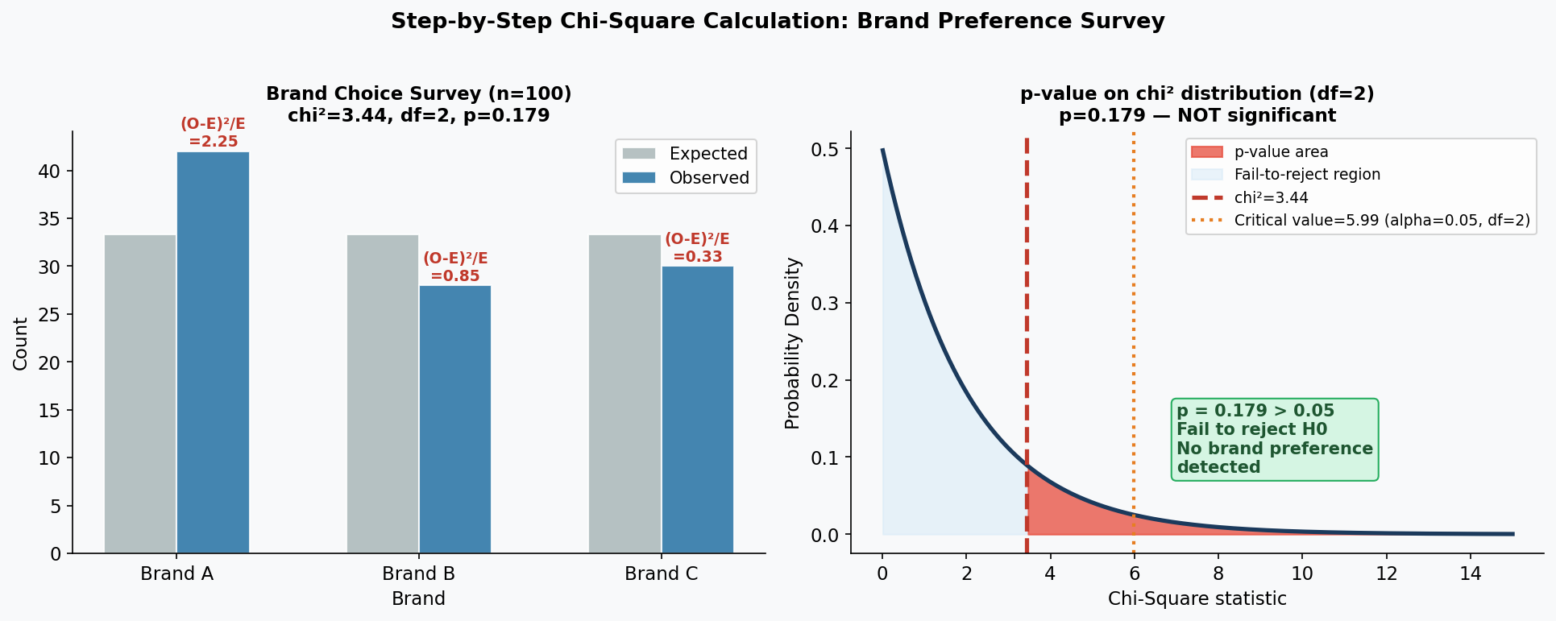

6.2 Scenario A — Office Snack Preference
Real-World Scenario: Company Canteen Planning
A company stocks 5 snack types equally — 60 of each per 300 sold. End-of-month counts:
Chips: 78 | Biscuits: 52 | Fruit: 41 | Nuts: 55 | Chocolate: 74
H0: All equally preferred | H1: Some are preferred more | df = 4
chi² = (78−60)²/60 + (52−60)²/60 + (41−60)²/60 + (55−60)²/60 + (74−60)²/60 = 16.17
Critical value (df=4, alpha=0.05) = 9.488
16.17 > 9.488 → REJECT H0. p = 0.0028. Staff prefer Chips and Chocolate. Order more!

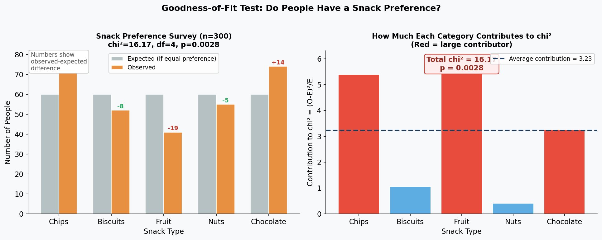

6.3 Scenario B — Casino Dice Fairness
Real-World Scenario: Casino Quality Control
A die is rolled 300 times. A fair die should show each face 50 times.
Fair die: Face 1:48, 2:53, 3:47, 4:51, 5:49, 6:52 → chi² = 0.56, p = 0.99
Fair die → Fail to reject H0. Die is fair. (p = 0.99 >> 0.05)
Biased die: Face 1:28, 2:46, 3:55, 4:63, 5:58, 6:50 → chi² = 25.8, p = 0.00009
Biased die → REJECT H0. Face 1 appears far less than expected — die is rigged.

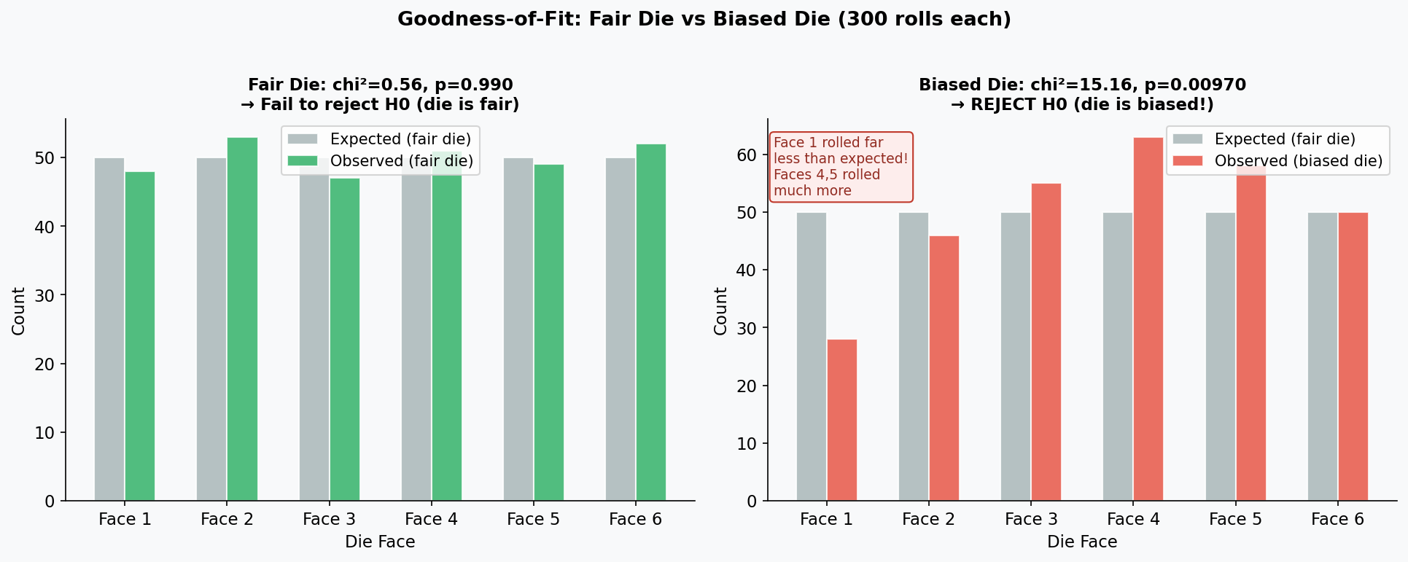

6.4 Scenario C — Website Traffic by Day
Real-World Scenario: E-Commerce Traffic Analysis
Expected: 2,000 visits per day. Observed over 4 weeks:
Mon: 2,450 | Tue: 2,100 | Wed: 1,980 | Thu: 1,870 | Fri: 2,200 | Sat: 1,600 | Sun: 1,800
H0: Traffic is equal across all days | df = 6
chi² = 234.9 (dominated by Monday spike and Saturday dip)
p ≈ 0 → REJECT H0. Traffic is very unequal. Run Monday/Friday ad campaigns; offer Saturday deals.

6.5 Scenario D — Monthly Birth Rate
Real-World Scenario: Hospital Administration Records
1,200 births over a year. If equal, expect 100 per month.
Peaks in Sep (118), Oct (124), Nov (115). Lows in Jan (78), Feb (82).
H0: Births equally distributed across 12 months | df = 11
chi² = 18.7 | Critical value (df=11, alpha=0.05) = 19.68
18.7 < 19.68 → Fail to reject H0. p = 0.066. Variation is within chance range — barely.
Lesson: Close results like p = 0.066 mean "not enough evidence yet" — not "definitely no difference."

Chapter 7: Type 2 — Test of Independence

7.1 What Does It Test?
The Test of Independence answers: "Are two categorical variables related to each other — or are they completely independent?"

You have TWO variables and want to know if knowing one helps predict the other. You collect counts in a table where rows are one variable and columns are the other.

H0: The two variables are INDEPENDENT — knowing one tells you nothing about the other.
H1: The two variables ARE related — there is an association between them.

Expected count formula: E = (Row Total × Column Total) / Grand Total
df = (rows − 1) × (columns − 1)

7.2 Scenario A — Gender vs Department
Real-World Scenario: HR Workforce Analysis
200 employees. Are men and women distributed differently across Engineering, Marketing and HR?
Engineering: Male=45, Female=20 | Marketing: Male=30, Female=40 | HR: Male=25, Female=40
H0: Gender and department are independent | df = 2
chi² = 16.46, p = 0.0003
REJECT H0: Gender distribution is significantly different across departments. Engineering is male-dominated; HR is female-heavy.

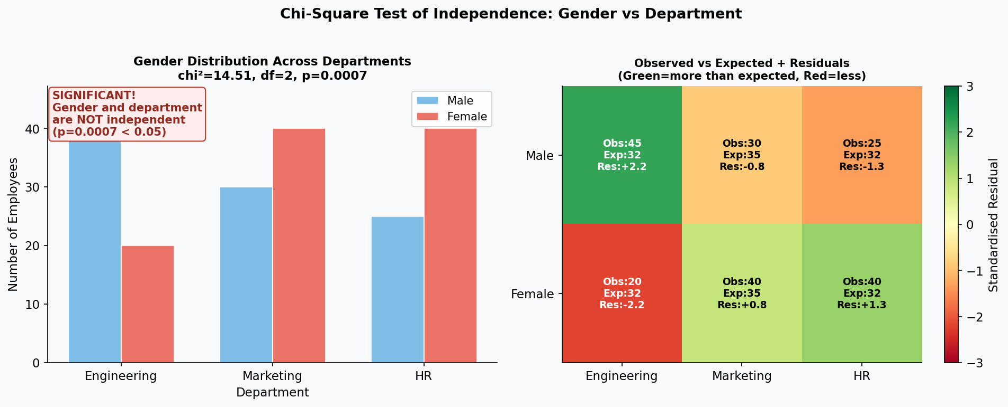

7.3 Scenario B — Smoking vs Lung Disease
Real-World Scenario: Public Health Research
200 patients: 100 smokers, 100 non-smokers. Checked for lung disease.
Smokers: 60 have disease, 40 don't. Non-smokers: 30 have disease, 70 don't.
H0: Smoking status and disease are independent | df = 1
Expected for "Smoker + Disease" = (100×90)/200 = 45. But observed = 60!
chi² = 18.18, p = 0.00002
REJECT H0: Smoking and lung disease are significantly related. Smokers show 60% disease rate vs 30% for non-smokers.

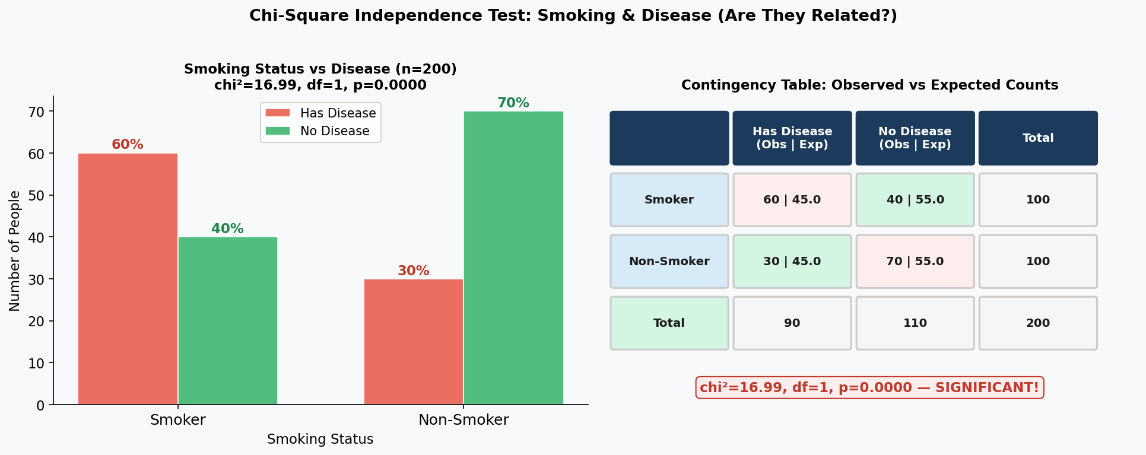

7.4 Scenario C — Age Group vs Product Choice
Real-World Scenario: Retail Marketing Analysis
500 customers: 3 age groups (Under 30, 30−50, Over 50) × 3 product categories (Electronics, Clothing, Food).
Under-30s: heavily Electronics. Over-50s: heavily Food. Middle: balanced.
H0: Age group and product preference are independent | df = 4
chi² = 31.8, p = 0.000002
REJECT H0: Age strongly predicts product preference. Target ads by age group.

7.5 Scenario D — Study Method vs Exam Result
Real-World Scenario: University Education Research
300 students across 3 study methods: Solo, Study Group, Online Tutorials. Outcome: Pass or Fail.
Solo: 60 passed, 40 failed (60%). Study Group: 80 passed, 20 failed (80%). Online: 70 passed, 30 failed (70%).
H0: Study method and exam result are independent | df = 2
chi² = 12.7, p = 0.0018
REJECT H0: Study method IS related to exam outcome. Group study has notably higher pass rates.
Note: chi-square shows a relationship exists — it does NOT prove study groups CAUSE better results.

Chapter 8: Type 3 — Test of Homogeneity

8.1 What Does It Test?
The Test of Homogeneity answers: "Do different groups have the same distribution of a categorical variable?"

Test of Independence  ONE sample, two variables on the same people.  Question: "Are these two things related?"  Example: Survey 200 employees. Record gender AND job satisfaction. Are these linked? | Test of Homogeneity  MULTIPLE separate samples, one variable measured in each.  Question: "Are the distributions the same?"  Example: Survey 100 employees from EACH of 3 companies. Same job satisfaction mix?

8.2 Scenario A — Product Mix Across Three Cities
Real-World Scenario: Retail Chain Sales Distribution
150 customers sampled from London, Manchester and Birmingham each.
London: Electronics=70, Clothing=50, Homeware=30. Manchester: 45, 65, 40. Birmingham: 50, 55, 45.
H0: Product mix is the same in all three cities | df = 4
chi² = 14.8, p = 0.005
REJECT H0: Product preferences differ significantly across cities. Stock each store differently.

8.3 Scenario B — Drug Response Across Three Hospitals
Real-World Scenario: Multi-Centre Clinical Trial
Three hospitals each test the same blood pressure drug on 200 patients.
Hospital A: 140 improved, 40 no change, 20 worse. B: 120/60/20. C: 130/45/25.
H0: Outcome distribution is the same across all hospitals | df = 4
chi² = 7.9, p = 0.096
Fail to reject H0: Treatment response is consistent across hospitals. Drug works uniformly.

8.4 Scenario C — Satisfaction Across Age Groups
Real-World Scenario: Telecom Customer Satisfaction Survey
200 customers per age group (Under 30, 30−55, Over 55). Rating: Good, Neutral, Poor.
Under-30: 110 Good, 60 Neutral, 30 Poor. 30−55: 90/75/35. Over-55: 70/80/50.
H0: Satisfaction distribution is the same across age groups | df = 4
chi² = 22.4, p = 0.0002
REJECT H0: Older customers are significantly less satisfied. Improve phone support and simplified interfaces for over-55s.

Chapter 9: Fisher's Exact Test — When Chi-Square Fails

9.1 When to Use Fisher's Exact Test
Chi-square becomes unreliable when sample sizes are small. The rule: if ANY cell has an expected count below 5, use Fisher's Exact Test instead.

Why chi-square fails with small counts: Chi-square uses a mathematical approximation that only works well when expected counts are large enough. With tiny counts, the approximation breaks down and gives untrustworthy p-values.

Fisher's Exact Test: Calculates the EXACT probability of your table (and all more extreme tables) under H0 — no approximation needed. Works for any sample size, but is mainly designed for 2×2 tables.

Use Fisher's when:
- Any cell in your 2×2 table has an expected count < 5
- Your total sample size is very small (n < 20)
- You are studying a rare event or rare subgroup

9.2 Scenario A — Rare Drug Side Effect
Real-World Scenario: Small Pilot Drug Study
A pilot study tests a new antibiotic on 20 patients (10 per group). Tracking one rare side effect.
Drug group: 4 had side effect, 6 did not. Placebo: 1 had side effect, 9 did not.
Expected count for "Drug + Side effect" = (10×5)/20 = 2.5 → below 5, so chi-square is unreliable.
Use Fisher's Exact Test. p-value (one-tailed) = 0.143
Fail to reject H0: No significant evidence of higher side effect rate. Sample is too small to conclude.
Action: Run a much larger study (n = 100+) before drawing any conclusions about side effects.

9.3 Scenario B — Hiring Discrimination Audit
Real-World Scenario: Equal Opportunity Employment Review
A small company reviewed 12 recent job applications: 7 men and 5 women. Only 3 people were hired.
Hired: 3 men, 0 women. Not hired: 4 men, 5 women.
Expected "Women + Hired" = (5×3)/12 = 1.25 → below 5, so use Fisher's.
H0: Gender and hiring decision are independent
Fisher's Exact Test p-value = 0.242
Fail to reject H0: No statistically significant gender bias detected — but only because the sample is tiny.
Important: This does NOT prove fairness. Monitor ongoing hiring data over time to build statistical power.

Chapter 10: The Big Picture — All Three Tests Together

10.1 Master Decision Guide
Your Situation | Data Type | Test to Use | Distribution
Test one group mean against a known value, large n, σ known | Continuous | One-Sample z-test | Standard Normal
Compare two group means, large n, both σ known | Continuous | Two-Sample z-test | Standard Normal
Test one proportion against a known rate | Binary counts | One-Proportion z-test | Standard Normal
Compare two proportions from two groups | Binary counts | Two-Proportion z-test | Standard Normal
Test one group mean, small n OR σ unknown | Continuous | One-Sample t-test | t-distribution (df=n−1)
Compare two independent groups, small n or σ unknown | Continuous | Two-Sample t-test | t-distribution
Same subjects measured twice (before/after) | Continuous | Paired t-test | t-distribution (df=n−1)
One categorical variable vs expected distribution | Counts/categories | Chi-Square Goodness-of-Fit | Chi-square (df=k−1)
Two categorical variables — are they related? | Counts/categories | Chi-Square Independence | Chi-square (df=(r−1)(c−1))
Same variable across multiple separate groups | Counts/categories | Chi-Square Homogeneity | Chi-square (df=(r−1)(c−1))
2×2 table with expected count < 5 in any cell | Small counts | Fisher's Exact Test | Exact (hypergeometric)

10.2 "Test Yourself" — Pick the Right Test
Four situations — which test applies?

Situation A: You survey 500 people about annual income. National SD = $25,000. Is average income different from $65,000?
Answer: One-Sample z-Test — large n, known σ, comparing to a value

Situation B: 12 patients have cholesterol measured BEFORE and AFTER a 6-week diet. Population SD unknown.
Answer: Paired t-Test — same people measured twice, small n, unknown σ

Situation C: You want to know if men and women apply for promotions at different rates. 400 women (32% applied), 400 men (28% applied).
Answer: Two-Proportion z-Test — comparing two proportions, large samples

Situation D: You check whether customer satisfaction (Good/Neutral/Poor) is the same across 3 store branches. Data: counts in each category.
Answer: Chi-Square Test of Homogeneity — same categorical variable across multiple groups

10.3 How All Three Tests Connect to p-Values
Test | What you calculate | Reference distribution | p-value = ...
z-test | z-statistic | Standard Normal (z) | Area beyond z in the normal tail
t-test | t-statistic | t-distribution (df) | Area beyond t in the t-distribution tail
Chi-square test | chi² statistic | Chi-square distribution (df) | Area beyond chi² in the right tail only

The unifying idea behind all three:

Step 1: Assume H0 is true (nothing special is happening).
Step 2: Calculate a test statistic from your data (z, t, or chi²).
Step 3: Ask: how often would you get a test statistic this extreme — or more extreme — if H0 really were true?
Step 4: That probability IS the p-value. Small p-value → result is surprising → reject H0.

10.4 Five Rules That Apply to Every Test
Rule | What it means | Example
Always pre-specify your hypothesis | Decide H0 and H1 BEFORE collecting data — never after seeing results | Write your hypothesis on Day 1; collect data on Day 2
Statistical ≠ Practical significance | A tiny trivial difference can be statistically significant with a huge sample | $2 salary difference significant at n=100,000 — who cares?
Failing to reject ≠ Proving H0 | p > 0.05 means "not enough evidence" — not "H0 is definitely true" | Small study found no drug effect — may need larger sample
Check your assumptions | Each test has requirements — if violated, results are unreliable | Chi-square with expected count < 5 → use Fisher's instead
Report effect size alongside p | The p-value alone is incomplete — add Cohen's d, Cramér's V etc. | p = 0.001 tells you it's real; Cohen's d tells you how big

One Sentence for Every Test
z-Test: "Is this difference real — when my sample is large and I know the population SD?" The z-score tells me how many standard deviations away from expected I am; the tail area gives the p-value.

t-Test: "Is this difference real — when my sample is small or the population SD is unknown?" The t-statistic does the same job as z, but uses a wider t-distribution that honestly reflects the extra uncertainty.

Chi-Square: "Are my observed counts close enough to expected — or too different to be random chance?" Large chi² means the counts are surprising; the p-value tells me how surprising.

