Chapter 2. Large Language Models
As we saw in Chapter 1, the LLM powers agents to go from observations to actions. In Figure 2-1, we can see this general workflow. Here, we color-code the areas where the agent interacts with the user (on the left) and where the agent interacts with the environment (on the right).
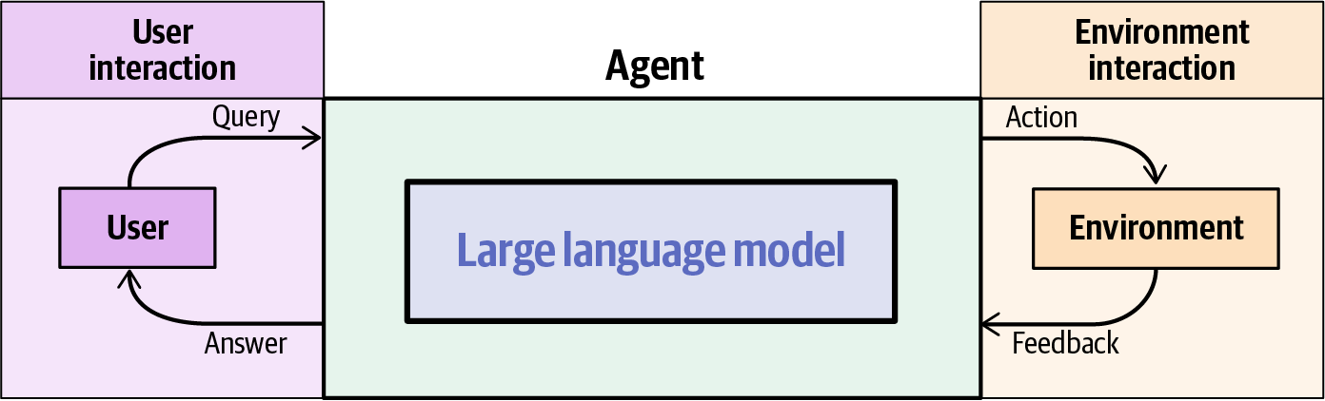
Figure 2-1. The agent acts as a bridge between user and environment
Let’s take a simple example to unroll the loop we see in the figure. The example is a simple information-seeking agent trying to answer a question for a user using a web search tool.
In Figure 2-2, we can see that interaction:
- The user asks the agent a question.
- The agent uses a web search tool, effectively pulling in information from the environment.
- The retrieved information is presented to the agent, which decides that it now has enough information to answer the user’s question.
- The agent prints out its answer to the user.
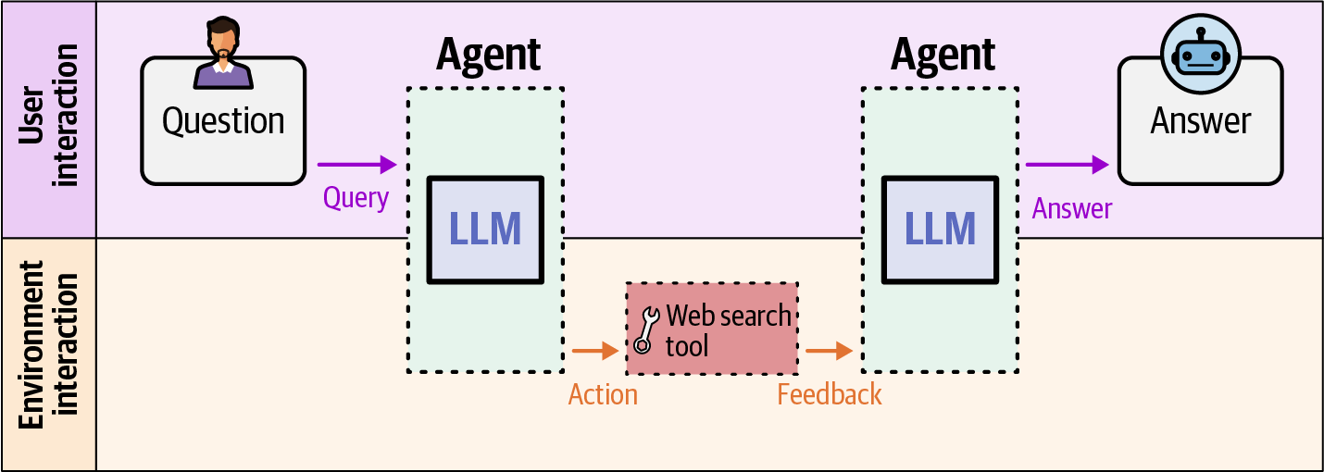
Figure 2-2. The agent receives a user’s question (left), calls a web search tool to retrieve information from the environment, then uses the retrieved information to generate and return an answer (right)
In LLM-backed agents, the LLM is tasked with processing the user query, choosing the right action, processing the feedback or observation resulting from the action, and communicating back to the user.
In this chapter, you’ll learn how LLMs work and how they’re created. We’ve structured the chapter in two parts with intentionally different audiences in mind.
Part 1 offers a high-level overview of LLMs aimed at agent developers: the core intuitions, capabilities, and limitations you need to build and reason about agent systems—without requiring a deep understanding of the underlying machinery.
Part 2 takes a significantly deeper dive into model internals and training techniques. This section assumes more comfort with machine learning concepts and is intended for readers who want to understand why LLMs behave the way they do, not just how to use them. This understanding can be valuable when diagnosing agent failures, selecting models, or pushing the boundaries of what agents can do.
If you’re primarily focused on building agents, feel free to proceed to the next chapter after reading Part 1—you’ll have everything you need. You can return to Part 2 when you’re ready to go deeper.
Part 1: What You Should Know About Large Language Models
Language models are systems trained to predict and generate text sequences. Their inputs and outputs are best understood initially as sequences of words, or more precisely, tokens—which can be words, parts of words, numbers, or punctuation.
Input and Output Tokens
We can see the perspective of an LLM’s inputs and outputs in Figure 2-3. The input text (which can be a query from the user or feedback from the environment) is first broken down into tokens, then presented to the language model. The language model generates the first token, then the next one, then the next, until its response is completed.
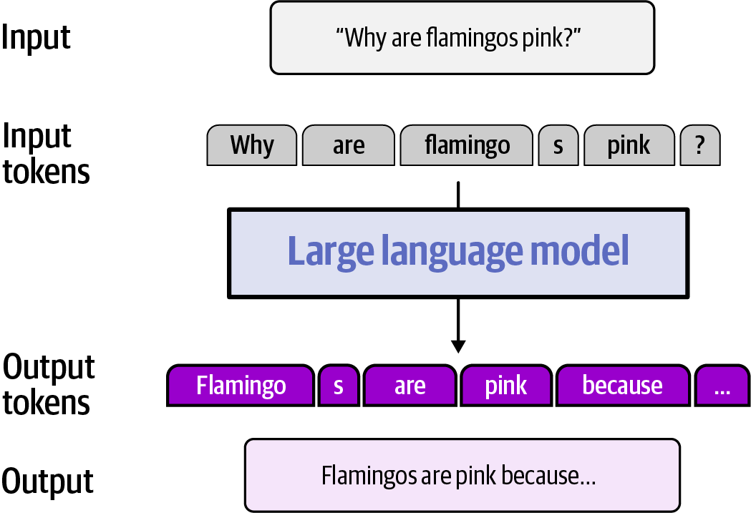
Figure 2-3. Input text is split into tokens—“flamingos” becomes two tokens (“flamingo” and “s”)—passed to the LLM, which generates output tokens sequentially to form the final response
This one step of generating this output text is actually a loop where the model generates a token, adds it to the input, and then processes this new input again to generate the next token. We can see the first of these steps in Figure 2-4. Models that operate like this, consuming their own output from one step as inputs in a following step, are called autoregressive models.
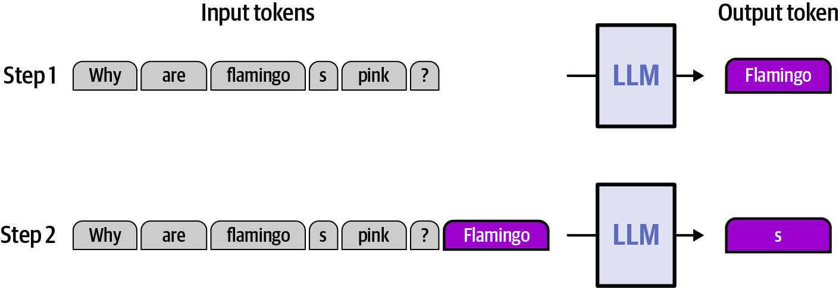
Figure 2-4. The model generates “Flamingo” from the input tokens (step 1); that output token is appended to the input and the model generates the next token, “s” (step 2)
From Language Modeling to Powering Agents
The LLMs that power agents start out as general language models, as previously discussed. This is done in the first training phase of a language model and creates what’s called a base language model. But for an LLM to be able to power an agent, it needs an additional set of capabilities to fit the expected role. LLM creators train LLMs in the subsequent phase of training, called post-training, to be able to parse inputs and generate outputs in a format that supports these expected capabilities.
System prompt
Language models are most often deployed by one entity, say a company, to serve a set of users, say the employees of the company. The party that deploys the model needs a way to describe the expected behavior of the model in a way that takes precedence over what the end users ask of the model.
This is the role of the system prompt: a privileged input that shapes model behavior before the model sees a single token from the user. Because it’s baked into how the model is used rather than how it’s trained, system prompts let deployers customize behavior without touching the underlying model.
In Figure 2-5, we see how a system prompt is added to the beginning of a user message. We also see a simple example of a formatting style that identifies the various parts of the input and output. Shown here is a simplified format that looks like the OpenAI Harmony format used for models such as OpenAI’s GPT-OSS, released in 2025.
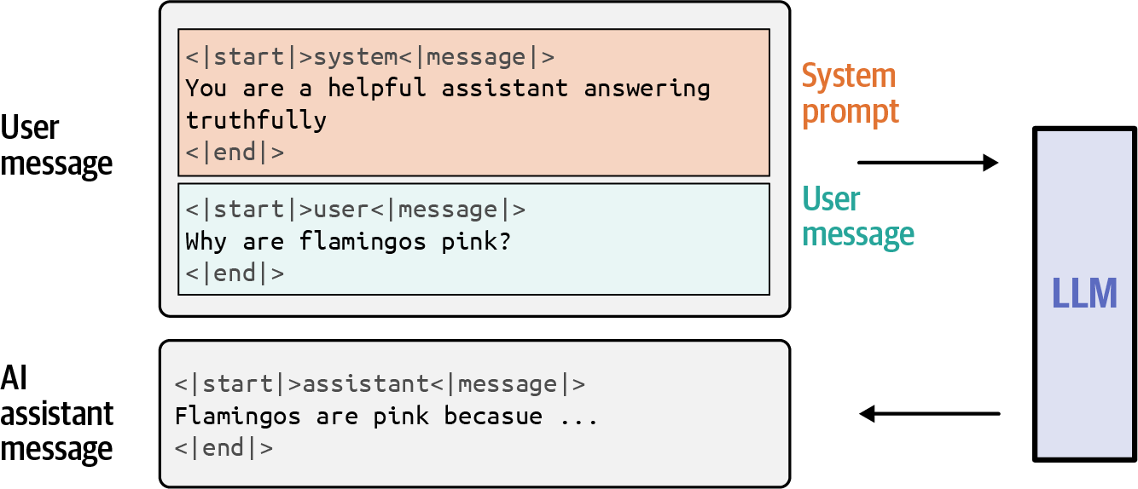
Figure 2-5. A system prompt prepended to the user message shapes how the model will respond—here instructing it to “answer truthfully”—before the full input is passed to the LLM
Multi-turn conversations
Popular LLM systems like ChatGPT are modeled as a conversation between a user and an AI chatbot. This way, the LLM can keep track of a longer conversation and identify who said what in the history of the conversation. In Chapter 4, we’ll touch on this as being one way we give an LLM some form of memory to be able to recollect earlier messages in the conversation.
Tool use
The conversation formats define a specific way for a language model to take an action. The LLM outputs a specific format, choosing a software function to invoke. The agentic software wrapper around the language model looks for these patterns and calls the functions that the LLM is trying to invoke. These functions are usually listed in the system prompt telling the LLM what actions are available to it.
Chapter 5 is dedicated to tools, their definitions, invocations, and processing their outputs. We touch on them here for an early example of the types of text that flow into and out of language models, enabling them to power agents.
In Figure 2-6, we can see an example message passed to an LLM. It has a system prompt, multiple turns in the chat history, and a final question asked by the user. The LLM responds by choosing to call a web search tool to retrieve the information required to answer the question.
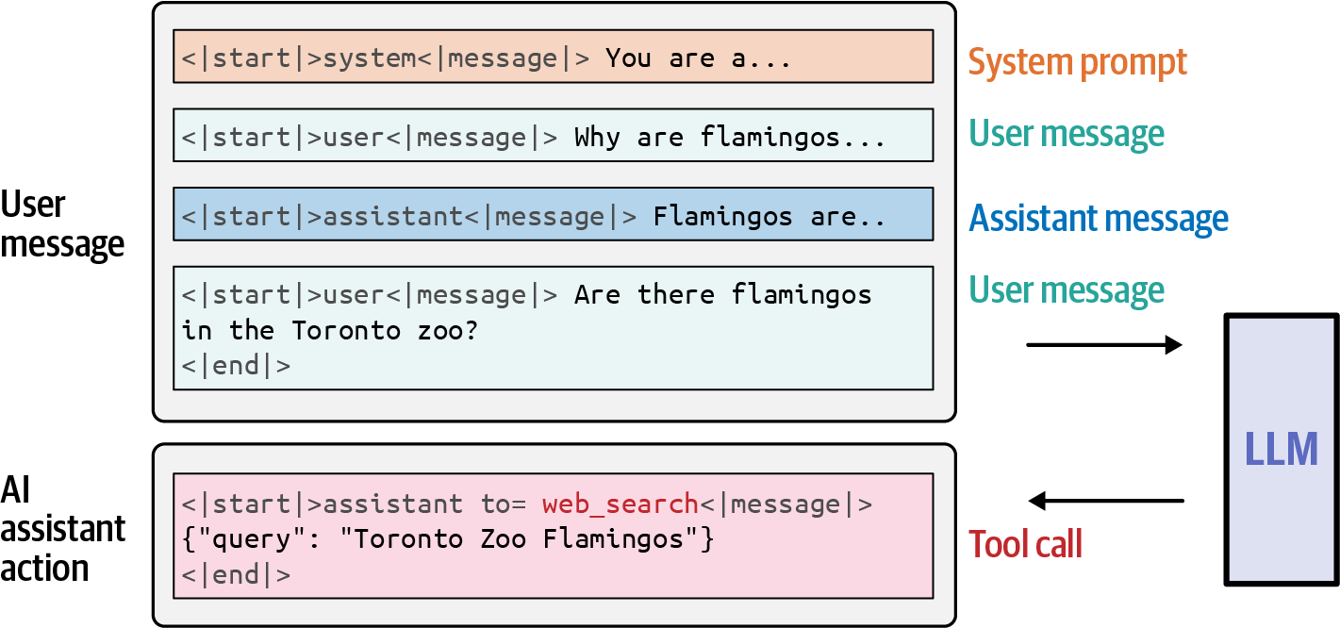
Figure 2-6. The LLM responds to a user question by emitting a tool call (web_search with a structured query) and executing it before the conversation continues
All of the input text we see in this figure is an example of the text that gets tokenized and sent to the LLM. And the output text is what the LLM generates one token at a time.
The TinyAgent
The LLM is the agent’s brain, and it’s the first thing we want to implement in your TinyAgent. To do so, we will need to consider which LLM to use, as there are hundreds of options depending on your hardware, use case, and the LLM’s capabilities. Newer models such as Gemma 4 have been trained to perform native reasoning and tool calling and have various options for different hardware. However, rather than only showing an LLM that “just does” reasoning and tool calling, we also want to show you what it’s like to build the tool calling and reasoning behavior yourself.
We decided to show you both! Throughout the book, we will demonstrate these capabilities both from a prompt-driven and model-driven perspective. By doing it yourself through various prompting techniques, you’ll gain insight into how these newer models have learned to perform reasoning and tool calling natively.
As such, we choose two models to use throughout this book: one that cannot natively perform any reasoning or tool calling whatsoever (Gemma 3) and one that has been trained specifically to perform agentic tasks through reasoning and tool calling (Gemma 4). They both have various sizes, where bigger models tend to be stronger than smaller models. For Gemma 3, we opt for the 12-billion-parameter model (Gemma 3 12B), and for Gemma 4, we opt for the smaller model that has effectively 4 billion parameters (Gemma 4 E4B).
The large language model
Before we start creating the main class for the brain, the LLM, we first explore a common way of interacting with LLMs, namely through the OpenAI-endpoint. It is a standardization of LLM inference that includes set fields, parameters, and responses so that you always get the same standardized format back. OpenAI, with the release of GPT 3.5 in 2022, set this standard for parsing an LLM’s response.
This endpoint generally contains the following pieces of information:
base_url
The URL of your hosted LLM
api_key
The key for accessing your hosted LLM
model
The name of your LLM
messages
The query to send to your LLM
Before you can use the LLM, you will first have to spin up a server that hosts your LLM. Don’t worry, this is much easier than it sounds. There are many different ways to download and host your LLM on your device. Popular options include Ollama, LMStudio, and llama.cpp. Ollama and LMStudio work well for both developers and non-developers, whereas llama.cpp is ideal for developers. Throughout this book, we’ll assume you use Ollama, which hosts its LLMs locally on http://localhost:11434/v1/. However, you can use any inference engine, both locally and hosted, as long as it is OpenAI-compatible (which most are).
After installing Ollama, you can download the models like so:
ollama pull gemma4:e4b
ollama pull gemma3:12b
As we covered previously, all LLMs have a specific prompt template that decides how to format the text that passes through the LLM. Instead of having to look up what this template is for each model, most inference engines (like Ollama) do this for you with the messages structure. These messages are a common format for structuring multiple turns of questions and responses between you (user) and the LLM (assistant). You can then use the messages structure to talk to the LLM, which will automatically convert it to the prompt template of the LLM.
We’ll use this structure to call the OpenAI-endpoint, which, in turn, will return a response. This response can contain multiple answers in parallel but is generally a single answer. As such, we focus on inspecting its one answer, namely result["choices"][0]:
import json
import urllib.request

# Prepare request
data = json.dumps(
{
"model": "gemma4:e4b",
"messages": [{"role": "user", "content": "Hi! How's life?"}]
}
).encode("utf-8")

# Post request
req = urllib.request.Request(
url="http://localhost:11434/v1/chat/completions",
data=data,
headers={"Content-Type": "application/json"}
)

# Parse response
with urllib.request.urlopen(req) as response:
result = json.loads(response.read())

# Print response
print(result["choices"][0])
This will give the following output:
{
'index': 0,
'message': {
'role': 'assistant',
'content': "I\'m doing really well, thank you for asking! \n\n
How about you? What\'s going on with you today?",
'reasoning': 'Thinking Process:\n\n1.
**Analyze the Request:** The user said, "Hi! How\'s life?" This is a
casual, conversational greeting seeking an update or general positive
interaction.\n2.
**Determine the Persona/Role:** I am an AI assistant...'
},
'finish_reason': 'stop'
}
Note that we truncated the reasoning a bit to prevent it from being too long for this book. As we cover in Chapter 3, reasoning significantly improves the response of an LLM.
Depending on the capabilities of the underlying LLM, it might output more fields than just the content and reasoning. Some models are capable of returning tool calls, which get a field of their own. As discussed before, we are not going to use the tool and reasoning fields immediately. The reason is two-fold and is important for the philosophy behind understanding what is happening under the hood:
- Using the reasoning and tool_calls fields is a bit “magical” and does not teach you how these are actually created and used. Instead, we’re going to show you how to do this explicitly through prompting techniques.
- Some models actually do not support reasoning and tool_calls, but with proper prompting, can still be used as agents. So instead of blindly relying on these fields, we want to show you how to nudge the model to do explicit reasoning and tool calling with prompting.
In Chapter 3 (reasoning) and Chapter 5 (tool calling), we will show you first how to use these capabilities by leveraging prompting techniques before exploring how a model does this natively.
After we get the output, we are going to create a Response dataclass where we will track the content, reasoning, tool_call, and other metadata the model may provide:
from dataclasses import dataclass

@dataclass
class Response:
"""Structured response from LLM calls."""

content: str = ""
reasoning: str | None = None
tool_call: dict | None = None
metadata: dict | None = None
For now, we are only interested in using the content of the model, as we want to show you how to have a non-reasoning model that still shows reasoning behavior. To do that, we are adding a parameter to the LLM class we’ll be building that can disable thinking. Lastly, we also track metadata that the backend might provide, such as the model’s name ("model"), the number of tokens in the prompt ("prompt_tokens"), and the number of tokens that were generated ("completion_tokens").
In this LLM class, we’re going to query the OpenAI-compatible endpoint directly as we did before. However, we add a few functionalities to prepare you for later chapters, such as adding tools/reasoning and extracting them:
import json
import urllib.request

class LLM:
def __init__(
self,
model: str,
base_url: str = "http://localhost:11434/v1",
api_key: str = "no_key",
think: bool = False,
):
"""Initialize the LLM with the given model."""
self.model = model
self.base_url = base_url
self.api_key = api_key
self.think = think

def generate(
self, messages: list[dict], tools: list | None = None
) -> Response:
"""Generate a response from the LLM given a list of messages."""
# Build the request body
body = {
"model": self.model,
"messages": messages,
}

# Tools and Reasoning
if tools:
body["tools"] = tools
if not self.think:
body["reasoning_effort"] = "none"

# POST to the OpenAI-compatible /chat/completions endpoint
request = urllib.request.Request(
f"{self.base_url}/chat/completions",
data=json.dumps(body).encode(),
headers={
"Content-Type": "application/json",
"Authorization": f"Bearer {self.api_key}",
},
)
with urllib.request.urlopen(request) as response:
data = json.loads(response.read())

# Extract message, tool_call, and metadata
message = data["choices"][0]["message"]
tool_calls = message.get("tool_calls")
tool_call = tool_calls[0] if tool_calls else None
metadata = {
"model": data["model"],
"prompt_tokens": data["usage"]["prompt_tokens"],
"completion_tokens": data["usage"]["completion_tokens"],
}

# Format as Response dataclass
return Response(
content=message.get("content"),
reasoning=message.get("reasoning"),
tool_call=tool_call,
metadata=metadata,
)
We also added the option to add tools to your LLM and extract a tool call if it exists. These options are explored in more detail in Chapter 5. We make sure to have this now so we do not need to update this class later.
Finally, you can call the LLM with our updated class and extract the response only:
# Re-initialize the LLM with the updated class
llm = LLM(model="gemma4:e4b")

# Generate a `Response` dataclass
response = llm.generate([{"role": "user", "content": "Hi! How's life?"}])
print(response)
This gives you:
Response(
content="Life is going well, thank you for asking!
I'm busy processing information and helping users like you, which is always
interesting. How about I ask you? How's life on your end? ",
reasoning=None,
tool_call=None,
metadata={
"model": "gemma4:e4b",
"prompt_tokens": 16,
"completion_tokens": 43,
},
)
The Response object is going to be used throughout the TinyAgent so that we can easily access the output of the LLM. Before integrating it into the agent, let’s first explore how we can track the state of an agent.
A step and trajectory
Remember that we are creating an agentic harness and a vital component of any harness, is that you can easily debug what is happening during inference. An agent might run for several turns at a time and run into an incorrect tool usage. To easily debug that, we want to keep track of everything the model has done so far. To do so, we track each Step the agent has taken (including observation from the output of a tool):
from dataclasses import dataclass

@dataclass
class Step:
"""A single step in an agent's trajectory."""

thought: str = ""
action: dict | None = None
observation: str | None = None
answer: str | None = None
metadata: dict | None = None
The Step is very much like the Response object with one major difference, the answer and observation fields. The answer is the final answer of the model and represents that the agent has reached the end of its turn. The observation is the output of tool usage. They are consequences of any processing or results we get from the TinyAgent. Finally, we use the term action to describe a tool call because in Chapter 6 we will explore loops of thought → action → observation that allow for autonomous behavior.
To reach its final answer, an agent might need various steps and use different actions. This sequence of steps is called the agent’s trajectory. We likewise track this information as it allows for easily debugging this sequence of steps to identify where and why an agent might have failed.
The Trajectory that you are going to create is where each Step will be created and filled with information related to the TinyAgent:
class Trajectory:
"""Records agent execution as a sequence of runs."""
def __init__(self) -> None:
self.runs: list[dict] = []

def initialize(self, query: str) -> None:
"""Register a new run with the given query."""
self.runs.append({"query": query, "steps": []})

def add(self, response: Response, observation: str | None = None) -> None:
"""Record a step from a Response, optionally with an observation."""
# Add THOUGHT
step = Step(
thought=response.reasoning or "",
metadata=response.metadata,
)

# Add ACTION/OBSERVATION or ANSWER
if observation is not None:
step.action = response.tool_call
step.observation = observation
else:
step.answer = response.content

self.runs[-1]["steps"].append(step)
Updating your TinyAgent
Finally, you need to update the TinyAgent with only a few lines of code to add this brain (the LLM) to your agent. Note that we focus on only single-step agents for now, without any autonomy. This is behavior that will be added and explored in-depth in Chapter 6:
class TinyAgent:
"""A minimal, modular, and educational agent framework."""

def __init__(self, llm: LLM):
self.llm = llm
self.memory = None # Chapter 4: Add Memory
self.tools = None # Chapter 5: Add Tools
self.planner = None # Chapter 6: Add Planning

self.trajectory = Trajectory()

def run(self, task: str) -> str:
"""Run the agent on a task."""
self.trajectory.initialize(task)
return self._step(task)

def _step(self, task: str) -> str:
"""Perform a single step."""
messages = [{"role": "user", "content": task}]
response = self.llm.generate(messages)
self.trajectory.add(response)
return response.content

def _execute_action(self, action: str) -> str | None:
"""Execute a tool action."""
# Placeholder - will be implemented in later chapters
return f"Executed action: {action}"
Helper Functions
As you progress through the chapters, you might add just a single line of code to TinyAgent. That becomes difficult to spot as the number of lines of code in TinyAgent grows. We prepared a number of helper functions in the illustrated-agents package that will help you quickly see what (small) changes were made between two versions of, for example, TinyAgent. These are all added to the notebooks in the associated GitHub repository and are generally used like so:
from illustrated_agents.chapters.ch2 import tinyagents_diff
tinyagents_diff
Or you can use them to inspect how a given class has changed between two chapters, even if the chapters are far apart:
from illustrated_agents.chapters import ch1, ch6
from illustrated_agents.utils import DiffViewer

tinyagents_diff = DiffViewer(
ch1.TinyAgent, ch6.TinyAgent,
"Chapter 1 - TinyAgent", "Chapter 6 - TinyAgent"
)
To test if it works, initialize the TinyAgent again with the updated LLM and ask it a question:
agent = TinyAgent(llm=llm)
response = agent.run("What is 2 + 2?")
print(response)
This gives you:
"2 + 2 is 4."
A straightforward answer—great!
Throughout these chapters we also will be looking at the trajectory quite often to debug and see if the TinyAgent performed as expected. You can access the full trajectory with:
print(agent.trajectory.runs)
This gives:
[
{
'query': 'What is 2 + 2?',
'steps': [
Step(
thought='',
action=None,
observation=None,
answer='2 + 2 is 4.',
metadata={
'model': 'gemma4:e4b', 'prompt_tokens': 17, 'completion_tokens': 9
}
)
]
}
]
Your “Agent” is still nothing more than the LLM and has no additional behavior/capabilities that we can showcase yet. For that, we need to add more modules, such as reasoning (Chapter 3), memory (Chapter 4), tools (Chapter 5), and planning (Chapter 6).
Note
Trajectories can get unwieldy quickly when you have dozens of steps, tool calls, long reasoning, and more. We created a small helper utility that visualizes these components without seeming unwieldy. As always, these can be found in the notebook on the associated GitHub repository. The utility is called the TrajectoryViewer and is used at the end of each notebook:
from illustrated_agents.utils import TrajectoryViewer
TrajectoryViewer(agent.trajectory)
There was a lot of code to explore but it was vital for creating this foundation of LLM, Response, Step, and Trajectory. These are things that are going to be used quite often to standardize behavior in your TinyAgent.
What We Built
TinyAgent/
├── agent.py ← Updated (Integrated the `LLM` into your `TinyAgent`)
├── llm.py ← New (An LLM wrapper for local or cloud models)
└── trajectory.py ← New (Step and Trajectory tracking)
Now that you have a working LLM and added it to your TinyAgent, let’s explore how these models are actually trained!
Training a Large Language Model
LLMs go through two major phases of training: pre-training and post-training (Figure 2-7). Pre-training is where they get their name from, because they are trained on a language processing task called language modeling.
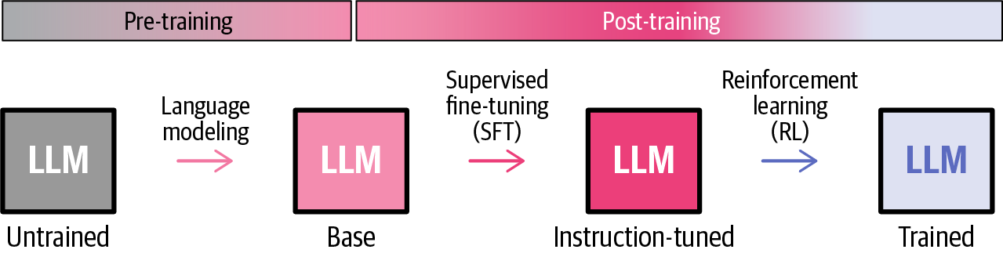
Figure 2-7. The two phases of LLM training: pre-training produces a base model, and post-training applies supervised fine-tuning (SFT) and reinforcement learning (RL) to produce the final model
Pre-training: language modeling
Language modeling is the task of presenting a model with a sequence of words (or more precisely, tokens) and asking it to predict the next word that is most likely to appear. This phase requires vast amounts of data and it takes a major part of the computing done during the training process.
Pre-training data is drawn from curated mixtures of sources including web text, books, and code, each filtered to satisfy quality criteria. From this text data, we can extract different spans of text and use each one as a training example. Say, for example, we handsomely pay O’Reilly Media to license the data on its website describing our earlier book, Hands-On Large Language Models. As we can see in Figure 2-8, we can take one span of that text and present it to the model. We hide the last token, give the model all the previous tokens, and ask it to predict the next word in the sequence.
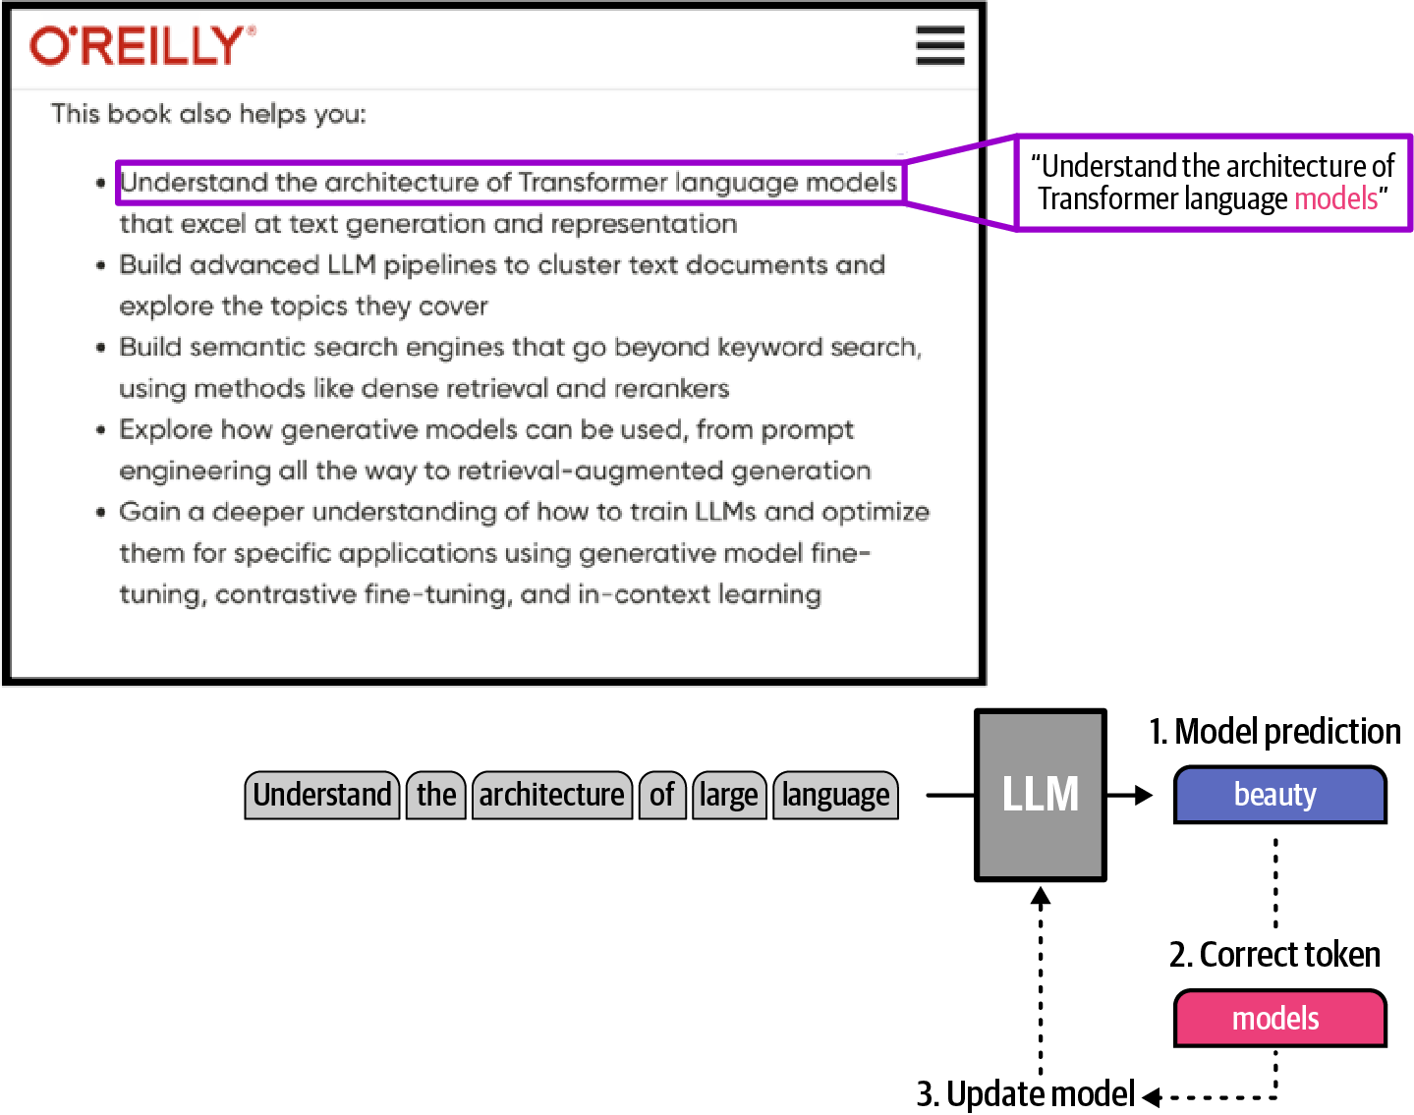
Figure 2-8. Pre-training as next-token prediction, where the model attempts to predict the next word in a sentence and updates its weights based on errors
At the start, the model under training would almost always guess incorrectly, which is part of the process. Now that we have its wrong prediction and the correct word, we plug them both in our loss calculation and update the weights of the model so that next time it has a better chance of making the right prediction. This is done billions of times and in the end results in a base model. The most famous and transformational of these is OpenAI’s GPT3, released in 2020. Since then, the later steps in the training process were widely adopted to lead to a model that requires less prompt engineering and behaves more in line with how people (and agent scaffolds) expect it to behave.
Post-training: supervised fine-tuning
Base models have strong latent capabilities, including reasoning, summarization, translation, and code generation, that often require heavy prompt engineering to unlock. Post-training helps polish these model behaviors using a much smaller set of training examples.
The first step of post-training is called supervised fine-tuning (SFT). It is also sometimes referred to as instruction-tuning because it’s where a model is trained to follow instructions we give it in prompts.
As we can see in Figure 2-9, an SFT training example is composed of a prompt and a completion that shows how we want the model to behave if it sees such a prompt. The update rule is almost identical to that of pre-training. The key difference is that while prompt tokens are included in the input context, they are excluded from the loss computation so the model is trained on only the response tokens. This is why we’ve assigned these tokens different colors and borders in the figure.
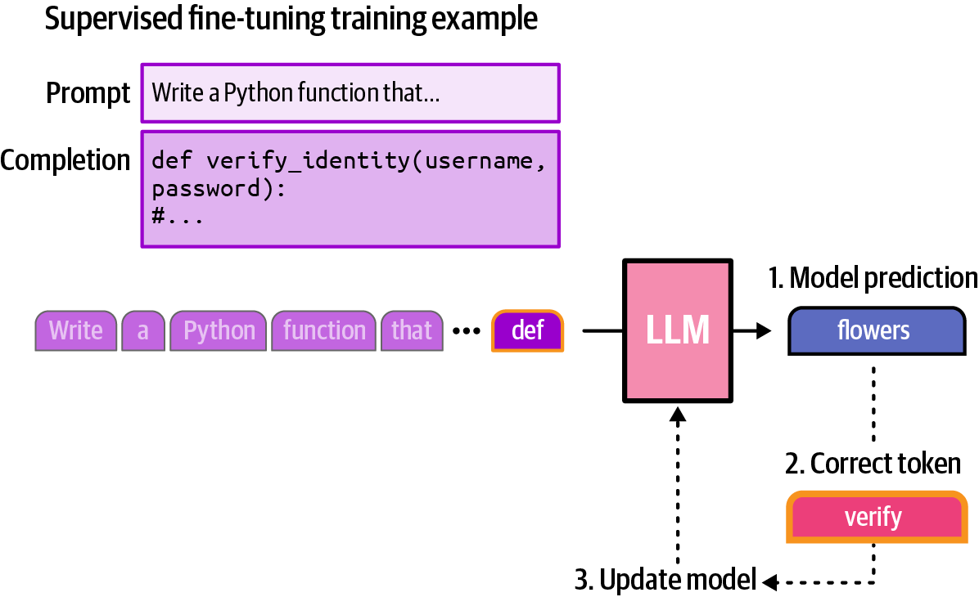
Figure 2-9. SFT trains the model on prompt-completion pairs. The prompt tokens (light purple) are fed as context but excluded from the loss; only the completion tokens (dark purple) are trained on—here, the model predicts “flowers” where “verify” is correct, and the weights are updated accordingly.
The SFT training phase is essential, yet not enough to produce a cutting-edge model. It teaches the model to follow instructions, but it cannot fully capture human preferences about what makes a response genuinely helpful, accurate, or well-reasoned. The reinforcement learning step that follows is what pushes the model in that direction.
Post-training: reinforcement learning
Notice how in SFT, we show the model what the desired output looks like. Reinforcement learning (RL) is a different training methodology that doesn’t require having a complete targeted response. Instead, we use methods that evaluate the quality of a model-generated response and update the model’s weights based on that quality score, called a reward.
One of the most commonly used RL methods in training LLMs is Reinforcement Learning from Human Feedback (RLHF), which relies on preference scores collected from humans or specialized models called reward models, themselves often being LLMs as well.
A single training example in an RLHF step, as shown in Figure 2-10, can be a prompt and two completions for it: one that is preferred, and another that is rejected.
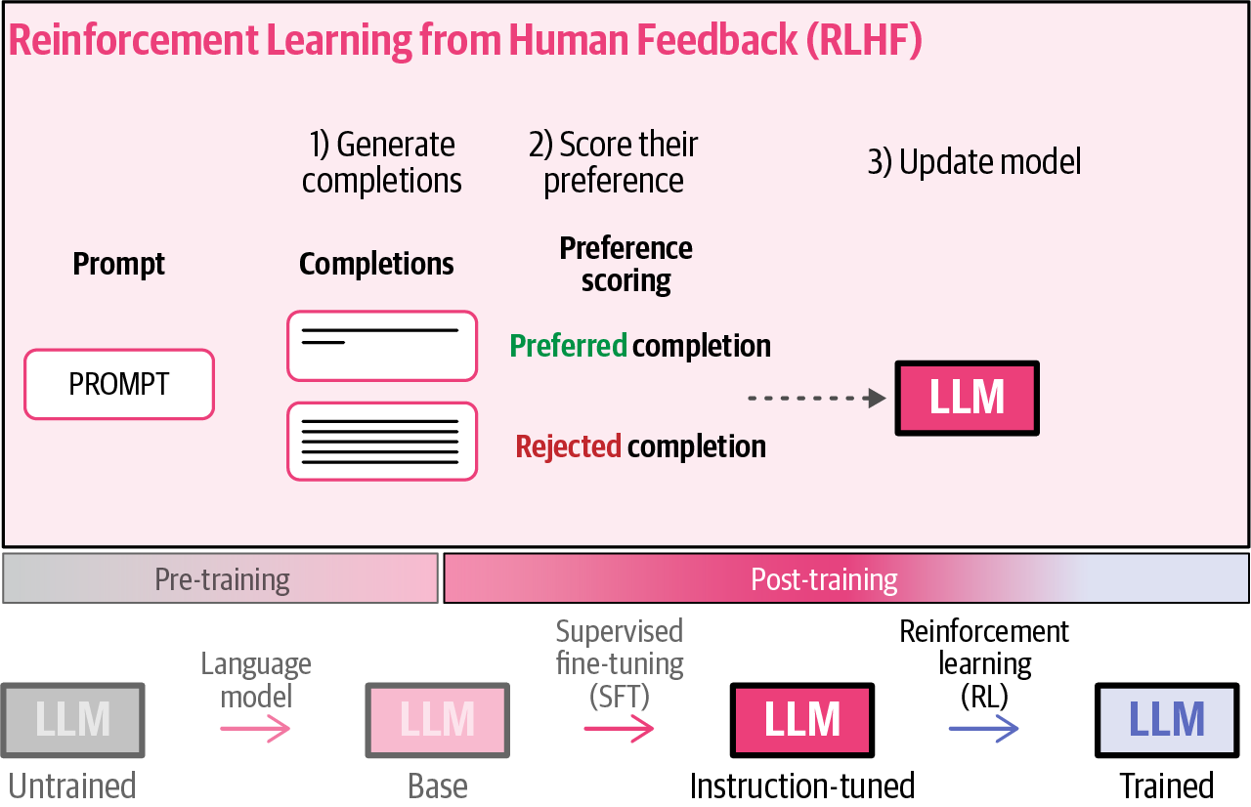
Figure 2-10. The model generates multiple completions, which are scored by human raters or a reward model trained on human preferences, and the model is updated toward producing higher-scoring responses
The RLHF training objective is to update the model to increase the likelihood of generating output like the preferred response and decrease the likelihood of generating output like the rejected response. This can be used to polish model behaviors such as response length, type of language the model uses, safe type of completions to generate or to avoid, and many other types of behaviors.
The other major RL method widely used in post-training today’s leading LLMs is Reinforcement Learning with Verifiable Rewards (RLVR). Similar to RLHF, it updates the model based on a reward score. The difference here is that the rewards can be obtained from automated ways of verifying the output; for example, if it follows a certain format, or the final answer it results in is equal to the correct answer (that we knew beforehand, in the case of math problems, for example). We see a couple of very basic verifiers in Figure 2-11 that hint at the actual verifiers used in RLVR methods.
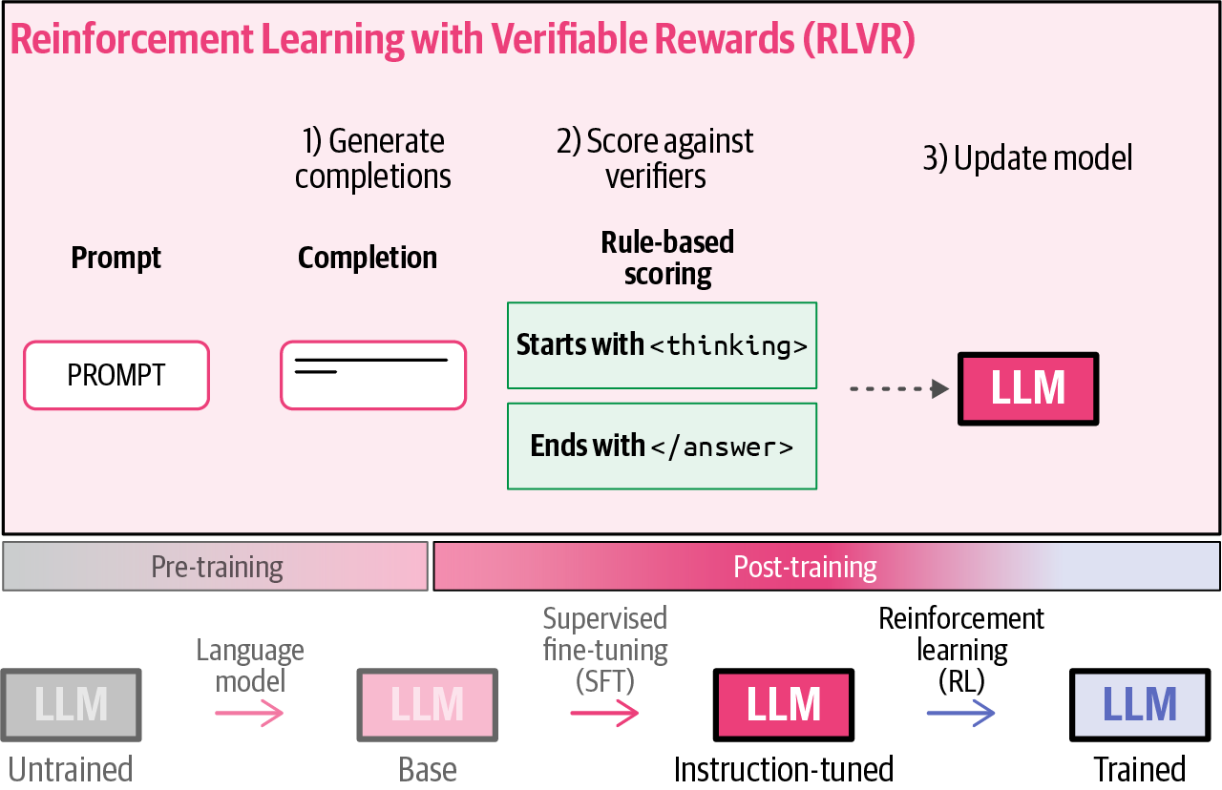
Figure 2-11. With RLVR, correctness is determined automatically by verifiers rather than relying on human preference
We’ll dig deeper into RLVR and various types of verifiers at multiple points in the book.
The Group Relative Policy Optimization reinforcement learning algorithm
To better grasp the intuitions behind RLVR, we can look at a more specific example for a model that solves math problems. Let’s say we have a set of math problems and the final correct answer for each of them. We want to train the model to solve them correctly and to print the answer in the format <answer>42</answer>, if 42 was the answer to a specific problem, for example.
In Figure 2-12, we can see an example showing an RL training dataset made up of math word problems and their answers. In an RLVR training step, we take one of the problems and pass it to the model with instructions about the format that we want. Once the model generates its output, we can automatically verify whether it followed the requested format and if it arrived at the correct solution of the problem. The model’s response is then scored on two verifiable dimensions: format (did it use the correct tags?) and accuracy (was the answer right?). The combined reward signal is used to update the model weights.
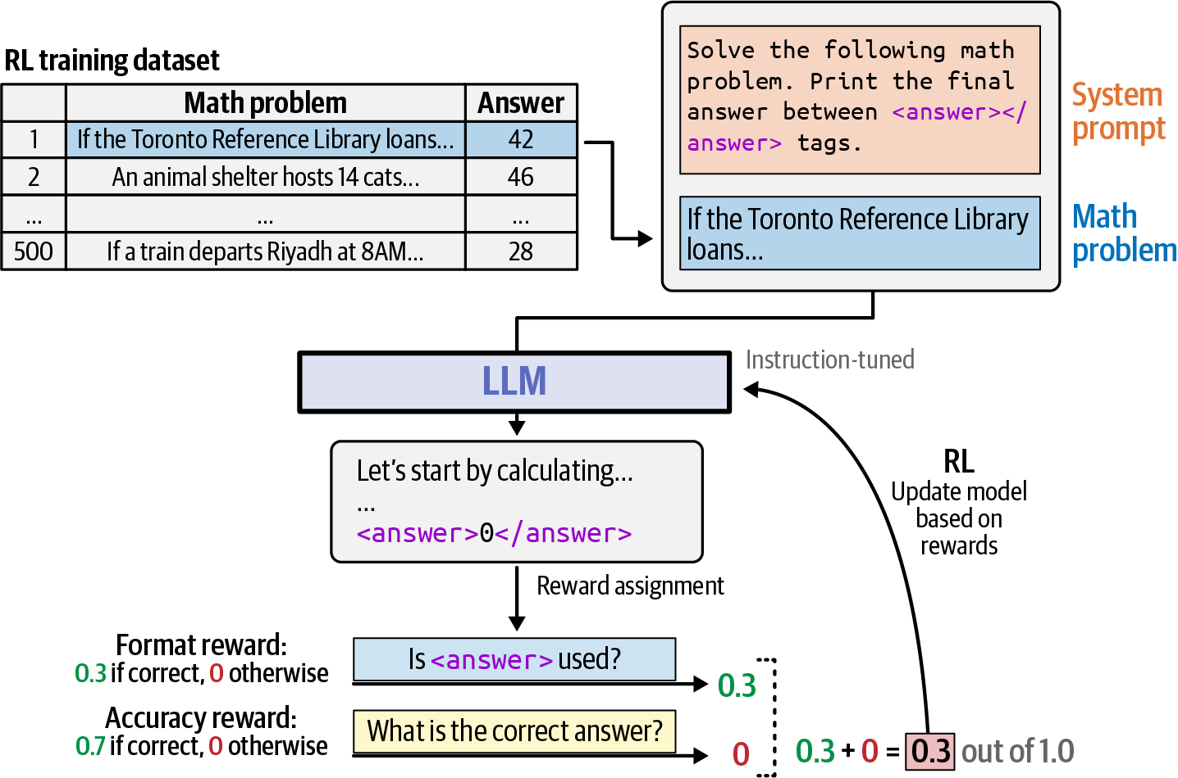
Figure 2-12. RLVR training on math problems
In this example we had two kinds of rewards, a format reward scoring whether the model uses the correct format for the output and assigning a reward of 0.3 if correct or 0 if incorrect. Then there’s an accuracy reward that compares the final result to the actual result and assigns a reward of 0.7 if correct and 0 if incorrect. In Chapter 3, we’ll see how this method was used to train DeepSeek-R1, one of the first open-weight reasoning LLMs.
The Group Relative Policy Optimization (GRPO) algorithm has another key ingredient beyond reward assignment. Rather than scoring a single response, at each training step GRPO generates a group of responses for the same prompt using a temperature setting that ensures diversity among them. Rewards are then computed relative to this group, reinforcing responses that score higher than the others. This comparative approach is what the word “group” in the name refers to.
In Figure 2-13, we can see this intuition for a group size of five. We generate five answers from the model, assign a reward to each one, and use those scores to update the model.
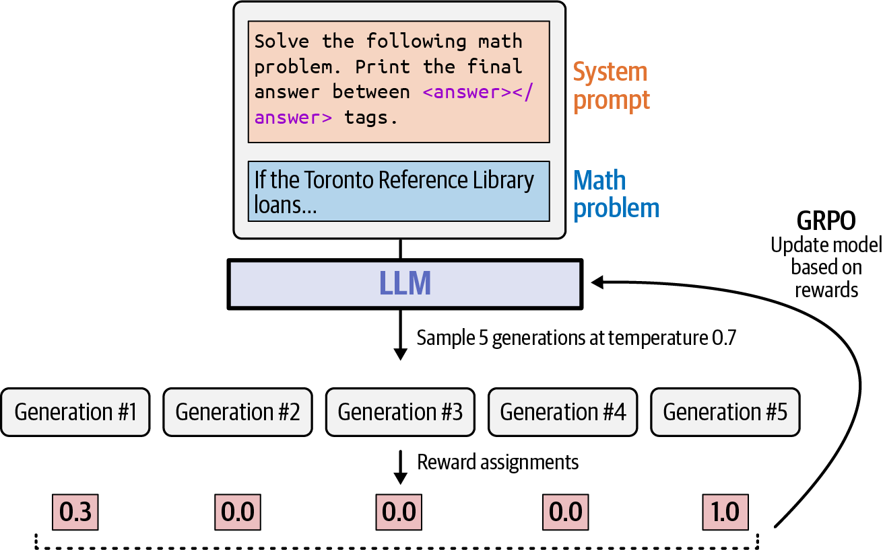
Figure 2-13. GRPO generates multiple responses to a single prompt, assigns rewards, and updates the model based on relative scores
This concludes the main intuitions for model training we think are useful for builders of AI agents to know about how LLMs are trained. Next, we’ll take a closer look at the architecture of the neural network that this process trains.
The Transformer Architecture
Now that we’ve seen the inputs and outputs of the model and covered how the model gets trained, it’s time to look inside the trained model and get a sense of the inner workings. LLMs have predominantly been neural networks built in the Transformer decoder architecture since around 2020.
The tokenizer, Transformer blocks, and language modeling head
A Transformer decoder has three major components: a tokenizer, a stack of Transformer blocks, and a language modeling head (LM head). We see these components in Figure 2-14.
The tokenizer is the piece of software responsible for breaking the text input into tokens. It is carefully optimized earlier in the training process of the LLM to help bring out the capabilities we need in the trained LLM. The vast majority of agent developers will work with a ready-made tokenizer prepared by the model provider.
For an LLM intended to power agents, careful tuning for a tokenizer includes support for generating software code, the various languages intended for use, and adding special tokens (like <|start|>) that are used in the specified data format.
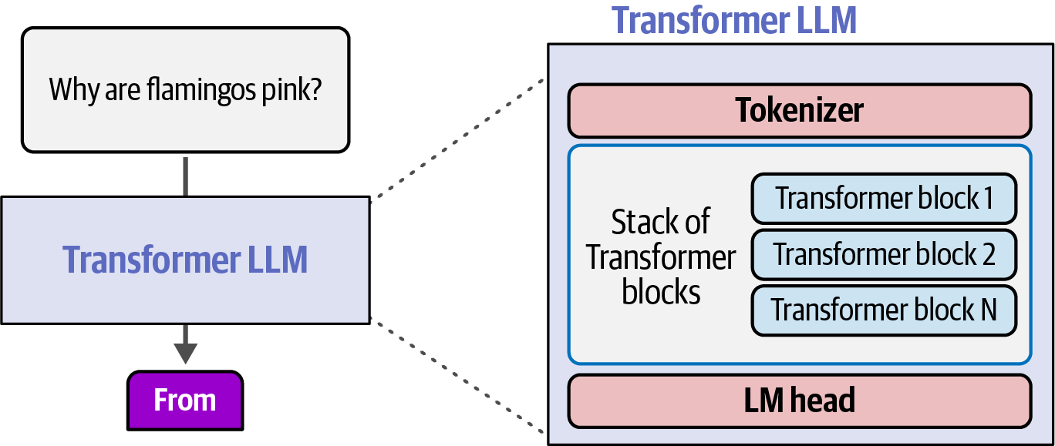
Figure 2-14. The three main components of a Transformer LLM: a tokenizer, a stack of Transformer blocks, and an LM head
A tokenizer has a set number of tokens in its vocabulary, say 50,000. We see an example of these in Figure 2-15.
We can also see in the figure that the model has an equal number of vector embeddings—one per token in our vocabulary. These embeddings vectors are numeric representations of each token and they are what the model uses to calculate language and how it processes its inputs.
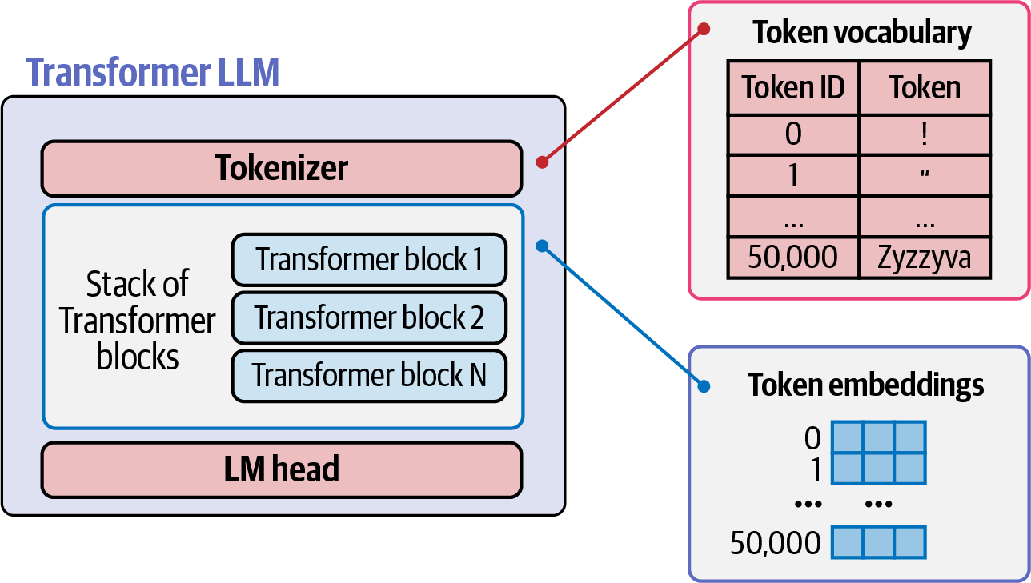
Figure 2-15. The tokenizer maps input text to token IDs drawn from a fixed vocabulary (here, 50,000 tokens), each of which is then looked up in an embeddings table to retrieve a numeric vector before being passed to the Transformer blocks
Almost the entirety of the processing done inside a language model is conducted inside the stack of Transformer blocks, which we cover in more detail in the next section. But what results from that process is a single vector containing information on what the next token should be.
That vector is passed to the LM head to interpret. It makes a simple calculation, which results in a probability score for each token in its vocabulary. That score is informed by everything the model learned in its training phases, and tokens with high probabilities are the ones most likely to appear as a completion in response to the input tokens. In Figure 2-16, we can see an example of such a scoring of probabilities.
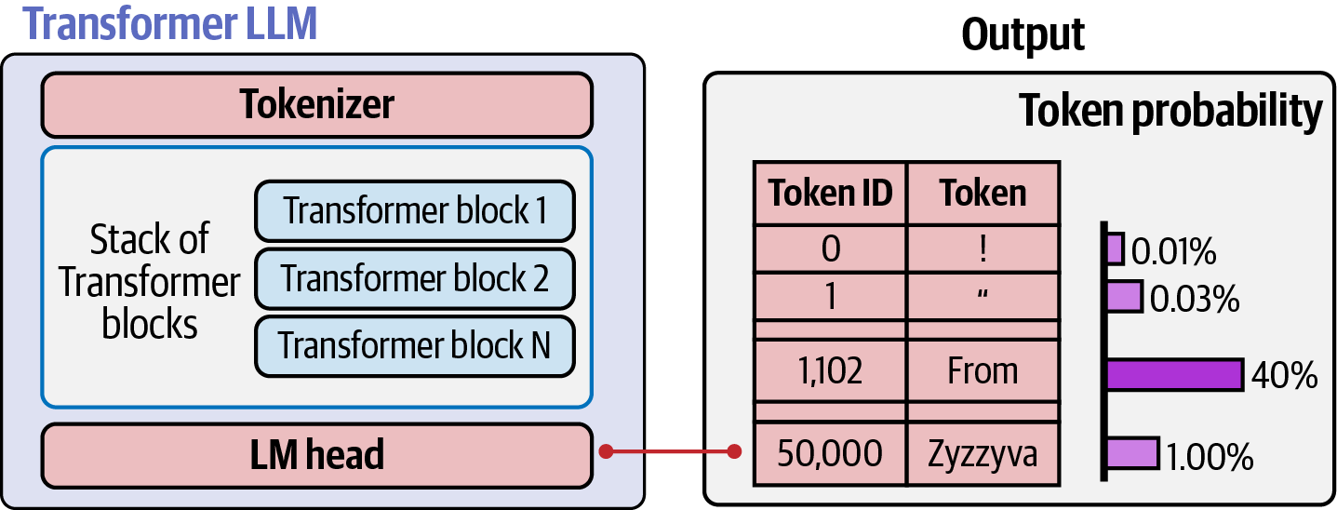
Figure 2-16. The LM head converts final representations into a probability distribution over the entire vocabulary
The next natural step would be to actually pick the output token as informed by these probabilities. We may choose the highest probability token, but there are often good reasons for picking other tokens. The method to pick tokens from the probability distribution is called a decoding strategy.
If you’ve played with the temperature setting of an LLM, then you have interacted with these probabilities. A temperature value of zero leads to always choosing the single token with the highest probability. Increasing that temperature allows sampling, which means choosing from the distribution in a way where higher-probability tokens have a higher chance of being picked (Figure 2-17).
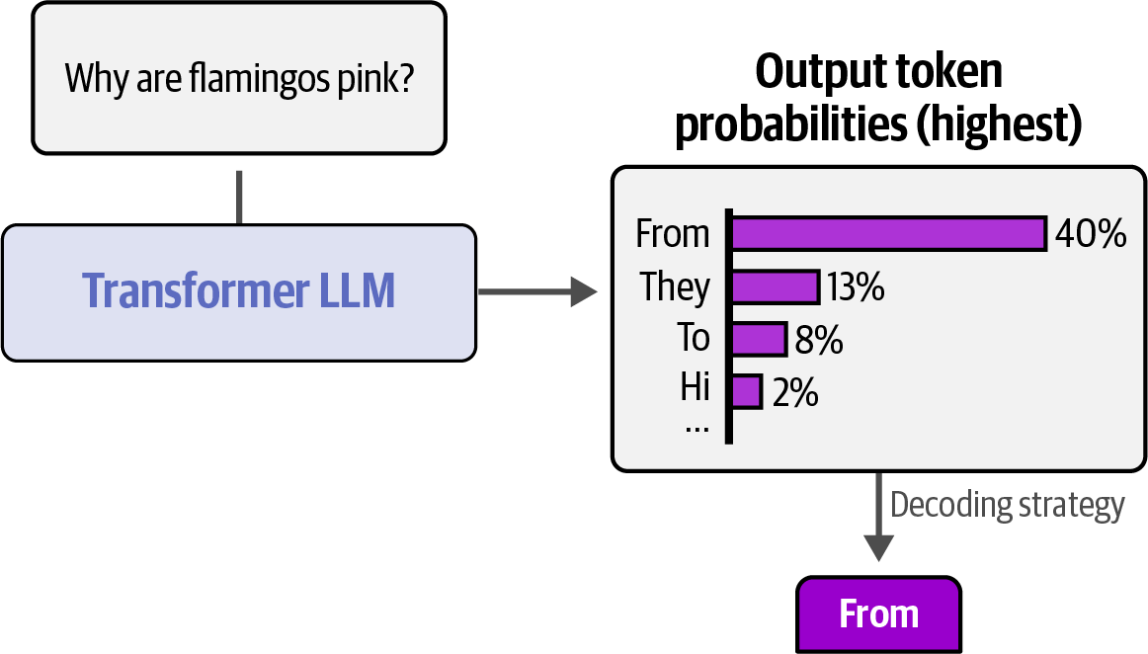
Figure 2-17. The decoding strategy selects a token from the probability distribution, where higher temperatures increase the chance of lower-probability tokens
Processing through the Transformer blocks
A neural network processes inputs and produces an output in a forward pass. This means that the calculation flows sequentially through the various layers. This is exactly what happens with the Transformer blocks. First the first block starts processing, then it passes its results of processing to the next block, and so on. The final block passes its result to the LM head, and we proceed to decoding as we saw in the previous section.
Figure 2-18 shows this flow through the stack of Transformer blocks. It also shows how each token can be seen flowing through its own track.
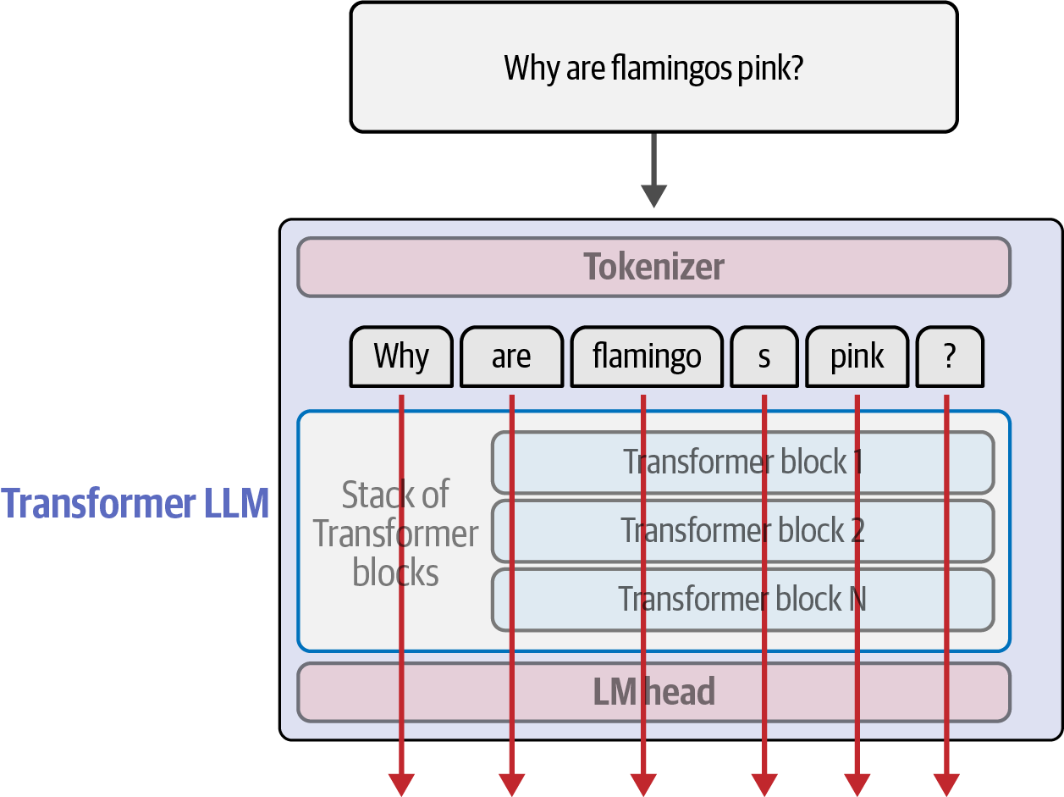
Figure 2-18. Each input token is processed through the full stack of Transformer blocks in parallel, with every token position producing its own output vector passed to the LM head—though only the final token’s output is used to predict the next token
The number of tracks that a model supports is commonly known as its context size. So, a model that has a context length of 100,000 can have only that number of tokens flowing through it simultaneously, which generally limits its input and output capacity to text of that size.
For text generation, the processing flow of the last token is what’s used to generate the next token, as we can see in Figure 2-19. That calculation is informed, however, by all the processing conducted on the previous tokens, as we’ll see next when looking closer at the insides of a Transformer block.
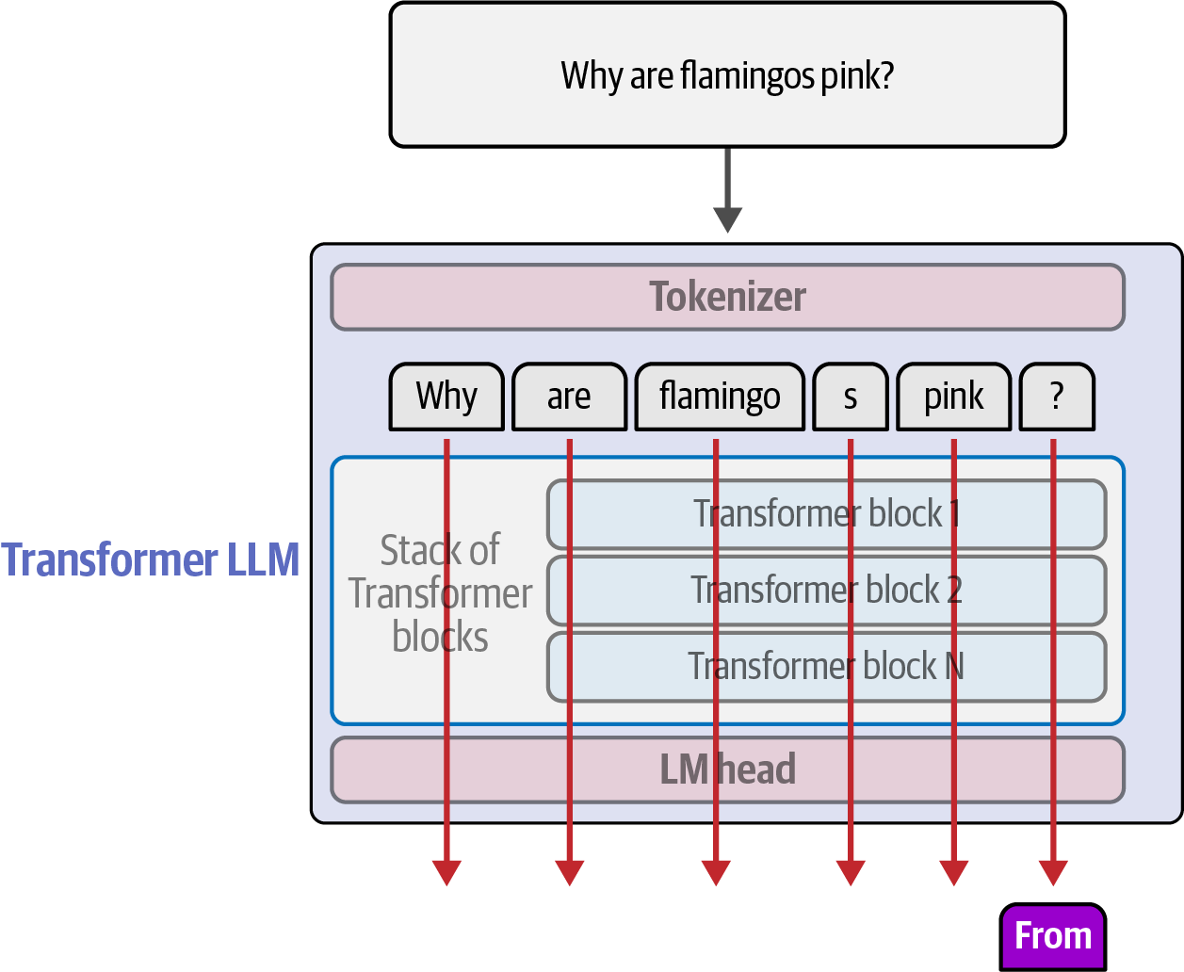
Figure 2-19. Each token flows through its own track in the stack, with only the final token’s track passed to the LM head to predict the next token
For agent developers, context length is a key property for selecting the best model to build an agent around. It sets a limit on how much information we can pack in the input of the model. This limitation gives rise to a whole discipline of context engineering that we’ll revisit repeatedly in this book. This is the discipline of choosing the most relevant information for the model to fit within this architectural limitation of the Transformer model.
Another key concept for agent developers is to realize that after that first pass where all the input tokens are processed, it’s common to cache the results so that in the next forward pass, we process the information along only the one track associated with the new token we’re generating. This is referred to as prompt-caching, prefix-caching, or more technically, kv-caching.
In Figure 2-20, we can see how only one track is active and information from previous tracks is cached and used for that one active calculation. This leads to dramatically increased speed and reduces the amount of processing required.
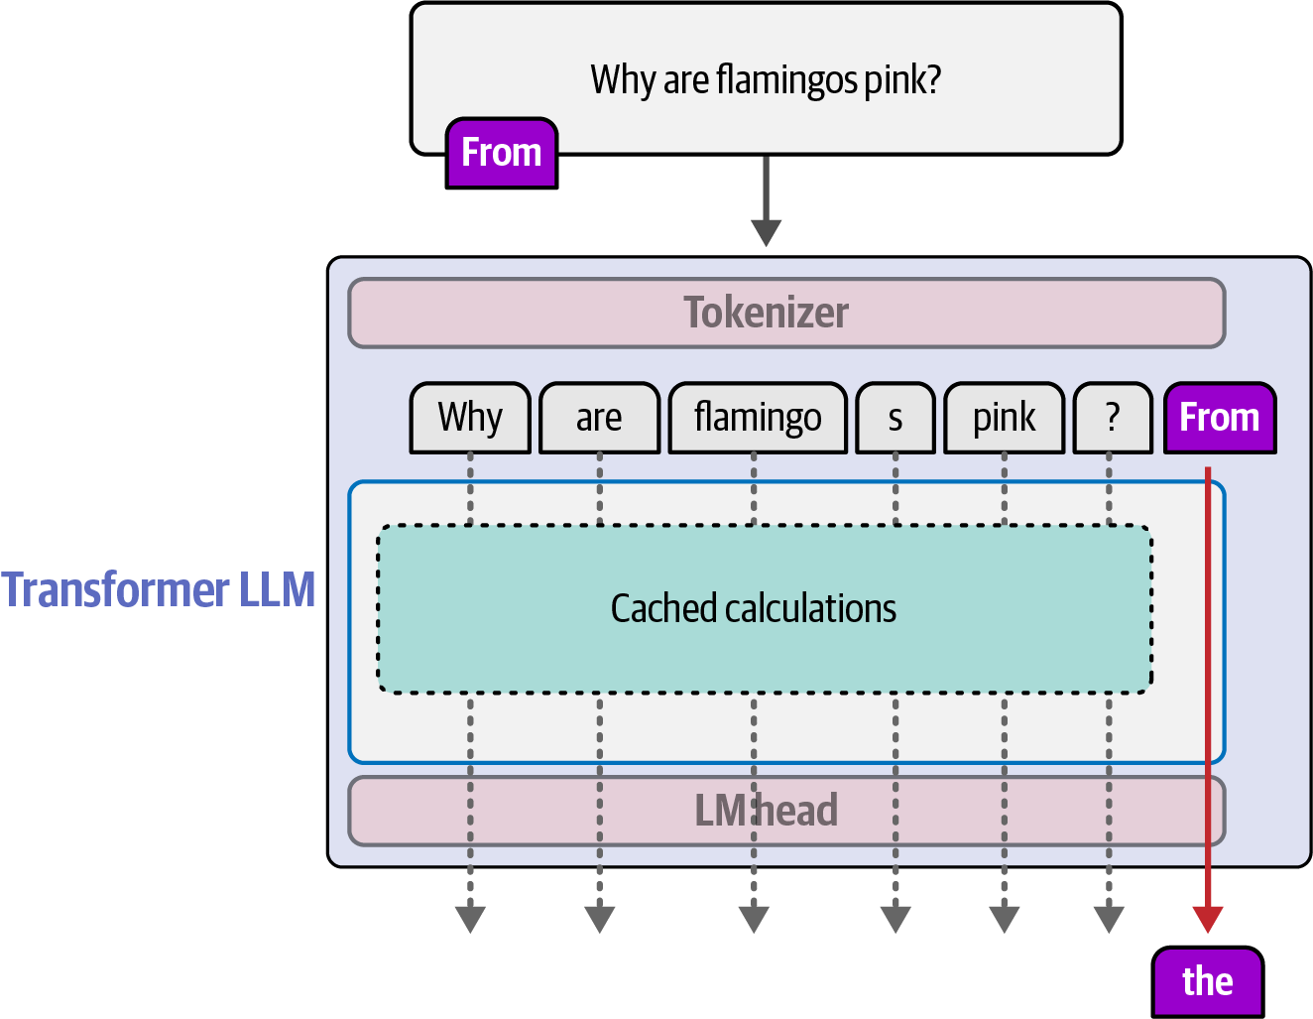
Figure 2-20. Previous token calculations are cached so each subsequent generation step processes only the single new token’s track
Optimizing for the kv-cache is a key responsibility for agent developers to increase the speed and reduce the cost of the agents they build. In Chapter 10, we cover some strategies used by developers of software engineering agents to optimize for this cache, reducing the latency and improving the economics of their agents.
Inside the Transformer block
We’ve seen how the input text is broken down into tokens. And we’ve also seen that each token has an associated static embedding vector in the model. The Transformer operates on these embedding vectors. The first Transformer block is presented with the embedding vectors associated with the tokens in the input text.
As we can see in Figure 2-21, the first block does a bit of processing on these input vectors and hands off the results of its processing (as the same number and size of vectors) to the next Transformer block. This goes on block by block until the last block in the stack.
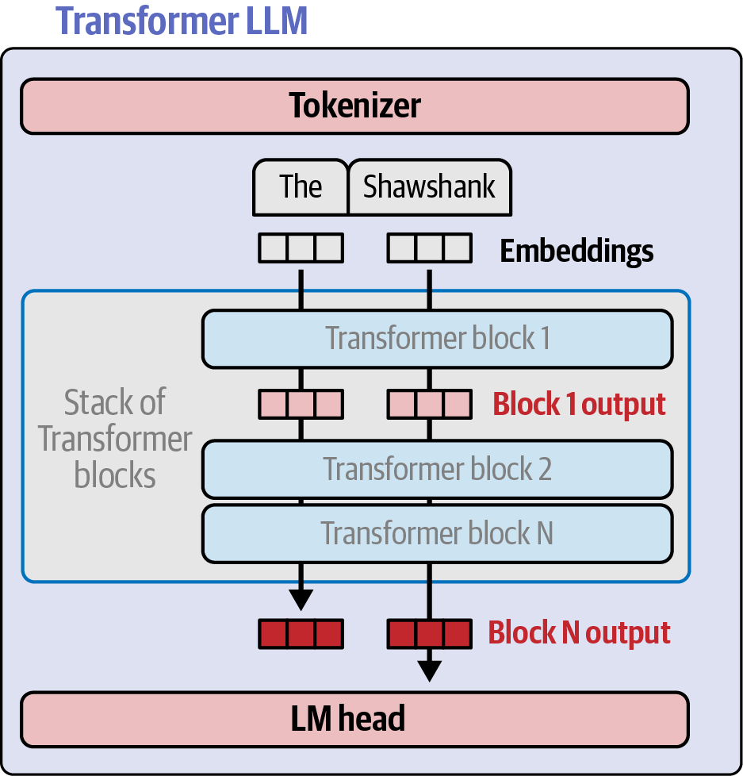
Figure 2-21. Token embeddings flow through the stack as fixed-size vectors, with each Transformer block progressively refining representations while keeping size constant
But what processing actually happens inside a Transformer block?
There are two major components inside a Transformer block: a self-attention layer and a feed-forward neural network layer (Figure 2-22). Without going into too much detail, in the next section we explain the intuition for each of these two components, starting with feed-forward neural networks and then coming back to self-attention.
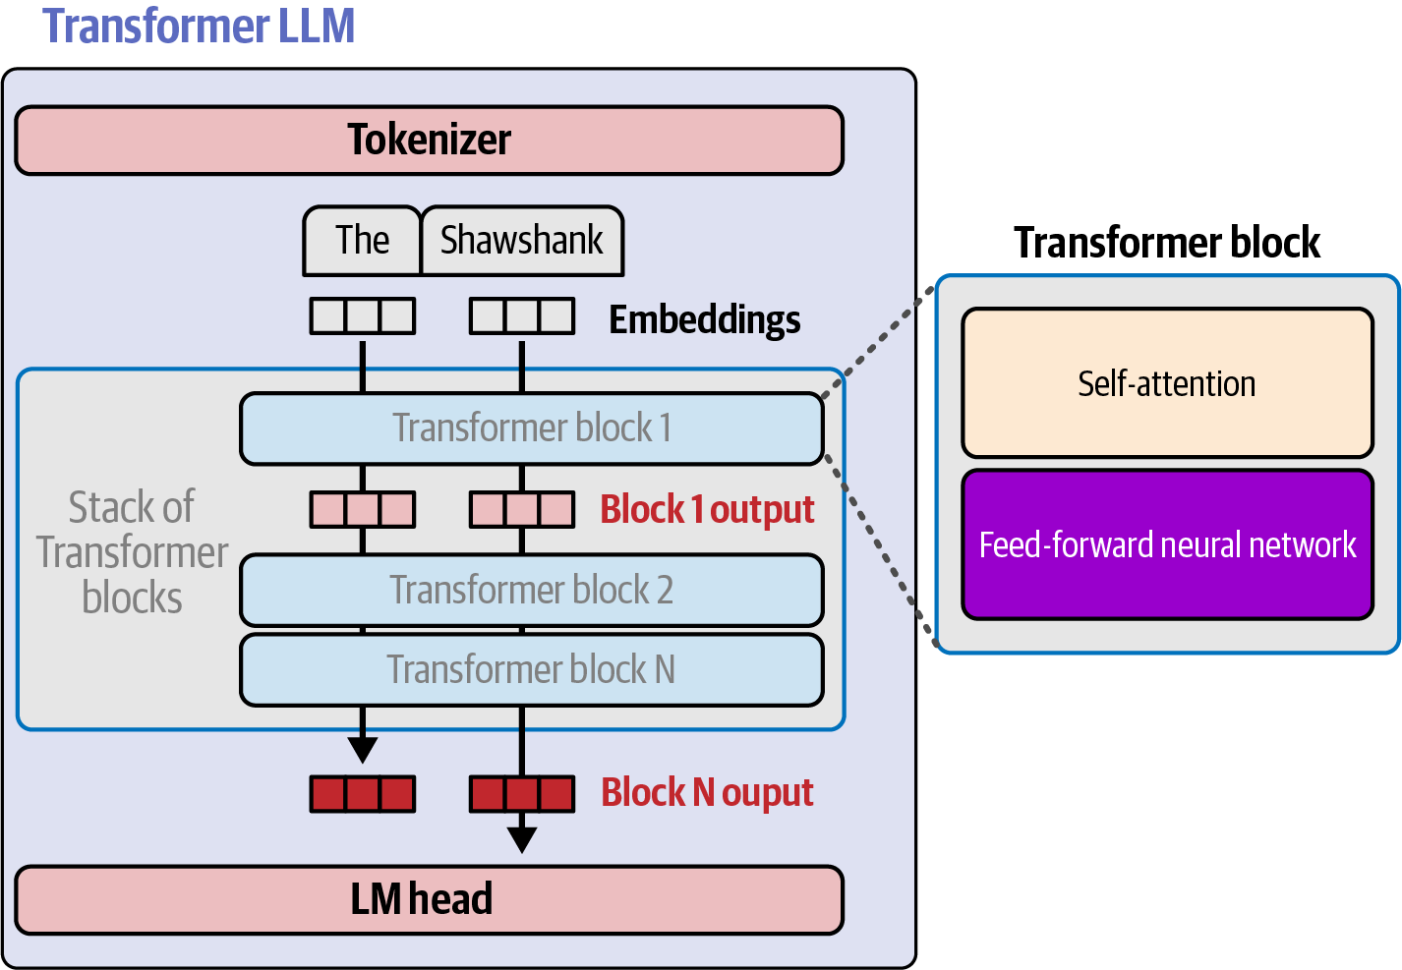
Figure 2-22. Inside each Transformer block are a self-attention layer for gathering context and a feed-forward neural network for processing representations
The Transformer block: the feed-forward neural network
Let’s first talk about the feed-forward neural network because it’s simpler, even though in the architecture it comes after self-attention. This layer does the heavy lifting in predicting the next token because the training process shapes its ability to predict the patterns encoded in the training dataset.
If we train a feed-forward neural network on vast amounts of web data, when we give it the words “The Shawshank,” it would be able to predict that the next word would be “Redemption,” because the 1994 film with that name is the most common occurrence of this sequence of tokens. Figure 2-23 shows this oversimplified example, which suggests the feed-forward layers store factual associations learned during training.
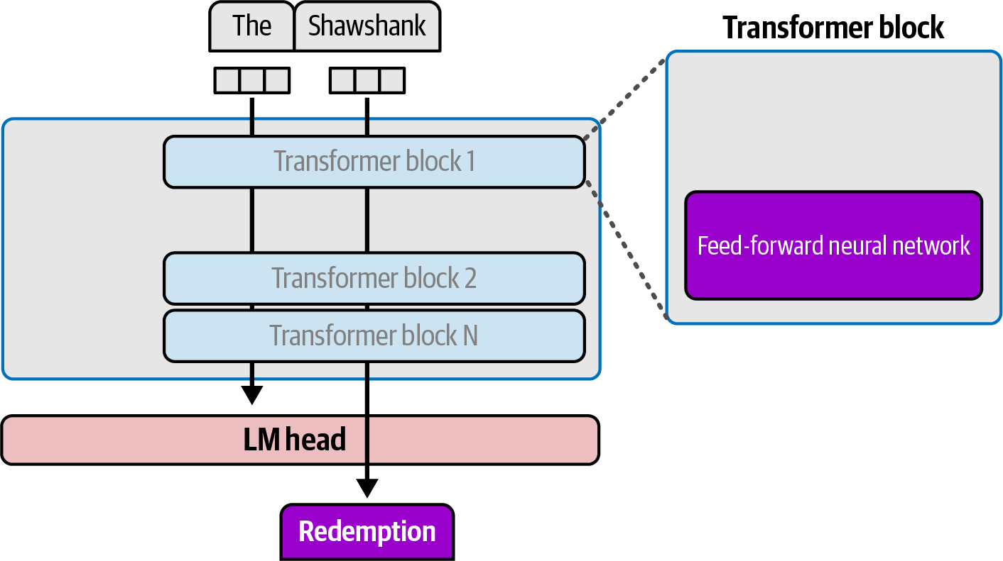
Figure 2-23. The feed-forward neural network layer highlighted within the Transformer block
In the original Transformer as well as in the majority of LLMs at the time of writing, the feed-forward neural network layer is one big neural network, as we can see in Figure 2-24. The training process prunes and adapts its connections in a way that encodes the patterns in language. Recall that by now, we’re no longer talking about a specific human language, we’re talking about a model that supports multiple human languages, multiple programming languages, as well as the patterns we need to define tool calling, multi-turn conversations, and, as we’ll see in Chapter 3, reasoning patterns.
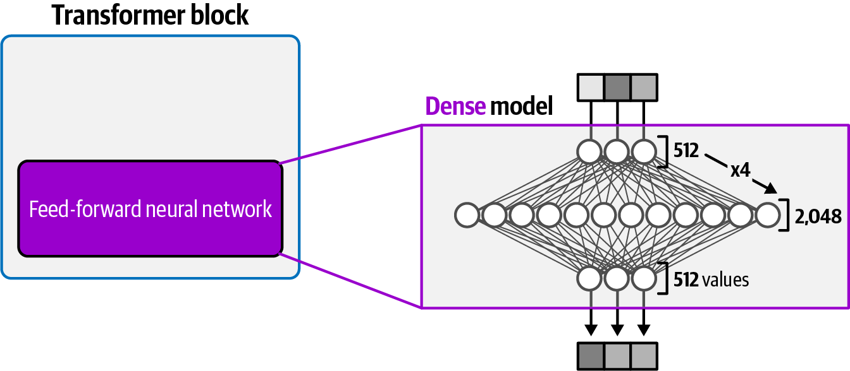
Figure 2-24. The feed-forward neural network in a dense model expands the token representation to a larger hidden dimension before compressing it back down
In recent years, there has been a trend away from having a single large network, and replacing it with a large number of smaller, more specialized networks. This architecture is called a mixture-of-experts (MoE), and we talk about it more in the second part of this chapter. We mention this here because as you select a model to power your agent, you may come across a choice of a dense model and an MoE model, especially if you’re looking at open source models.
In Figure 2-25, we see a basic MoE feed-forward layer that contains four sublayers; each is called an expert. These are preceded by a router that looks at the input token and decides which expert (or set of experts) is best suited to process this particular token.
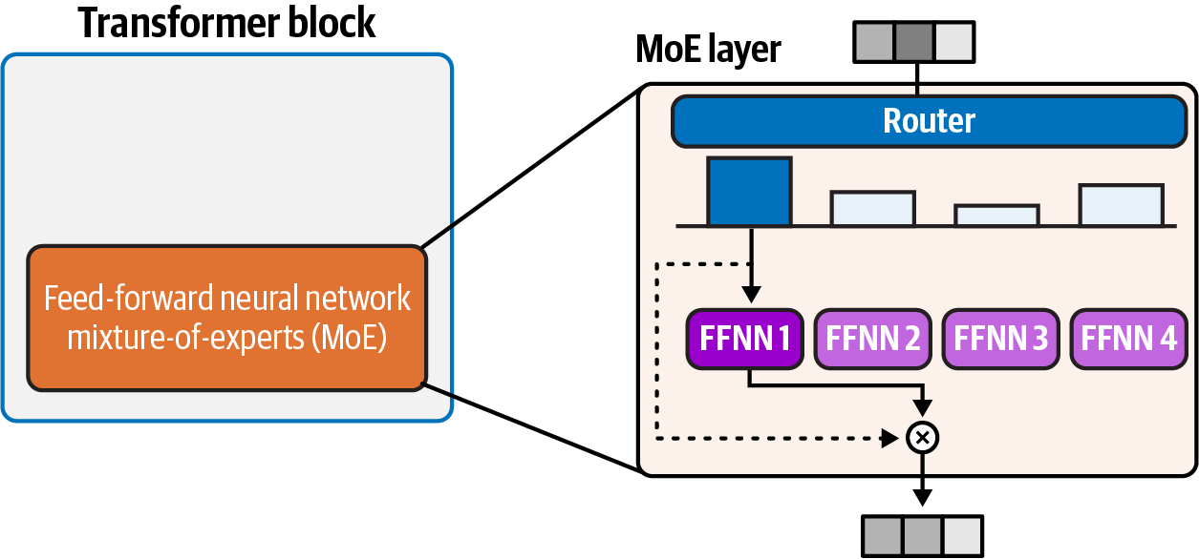
Figure 2-25. A mixture-of-experts feed-forward layer replaces a single large neural network with multiple smaller expert neural networks, routed per token to save capacity
Let’s now turn to the other major component of the Transformer block.
The Transformer block: an overview of self-attention
Language encodes a lot of information in the order of words in a sequence and the context that a word is used in. A word such as bank can mean a financial institution or can mean a riverbank. We would only know which is meant by looking at the context where the word is used. The self-attention layer allows the Transformer to make these distinctions.
As we can see in Figure 2-26, a model is presented with an input sentence that is, “The dog chased the llama because it.” When processing the word it in its own processing track, the model needs to know whether it refers to the dog or the llama. Self-attention is tuned to resolve this kind of problem.
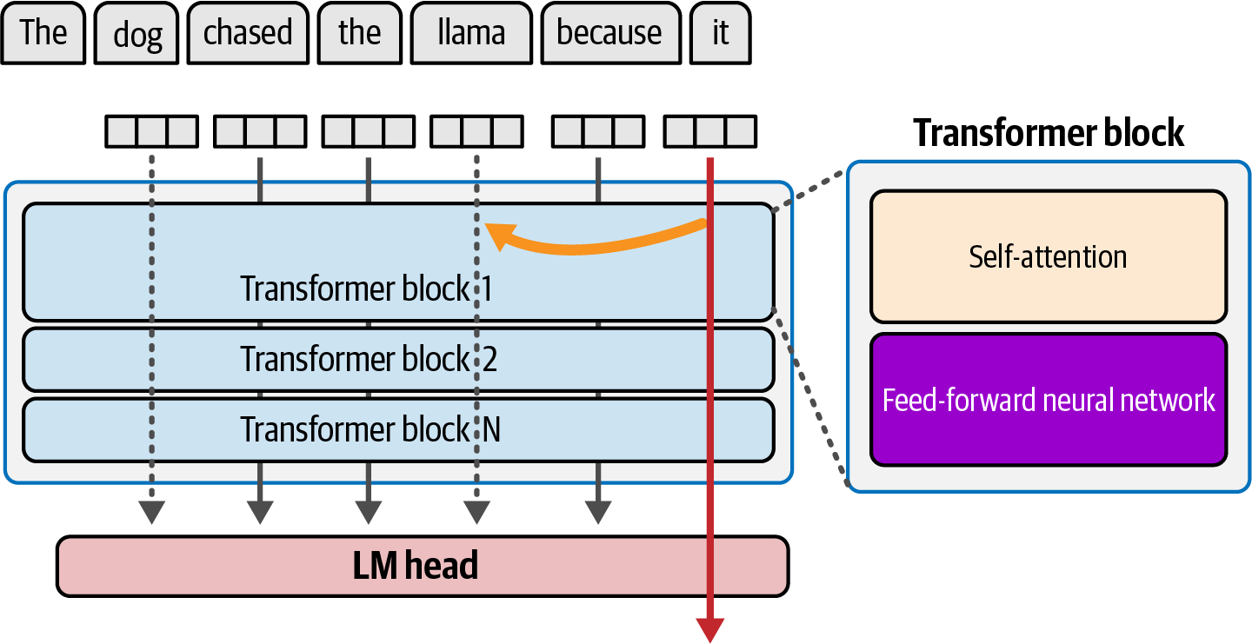
Figure 2-26. Self-attention allows each token to draw on context from other positions in the sequence. Here, when processing “it” (red track), the model attends back to “lama” (orange arc) to resolve the ambiguity of what “it” refers to—a distinction the feed-forward layer alone could not make.
Part 2 of this chapter goes into how self-attention is calculated, but the high-level intuition is that it attends to the most relevant previous tokens in the sequence. It learns that relevance from the training process. Figure 2-27 shows this function in its most basic form: we have the token we’re currently processing (in red), and four previous tokens. Self-attention enriches the information encoded in the input vector with information from the most relevant previous tokens in the sequence.
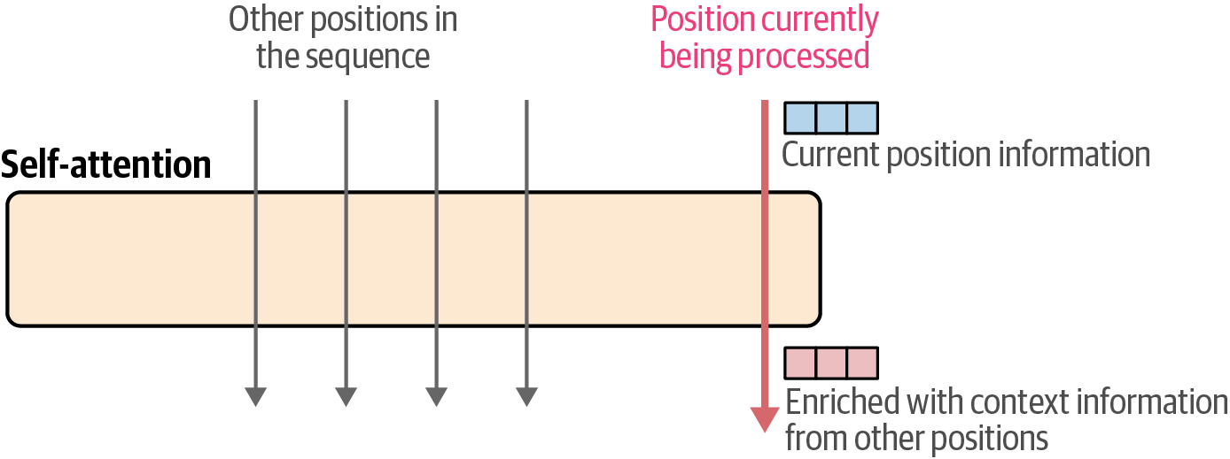
Figure 2-27. Self-attention enriches the current token’s representation by drawing in information from the most relevant preceding positions
Self-attention does this by taking two steps: first, it scores the relevance of the previous tokens and then proceeds to a step of combining the relevant information into the token we’re processing, as we can see in Figure 2-28.
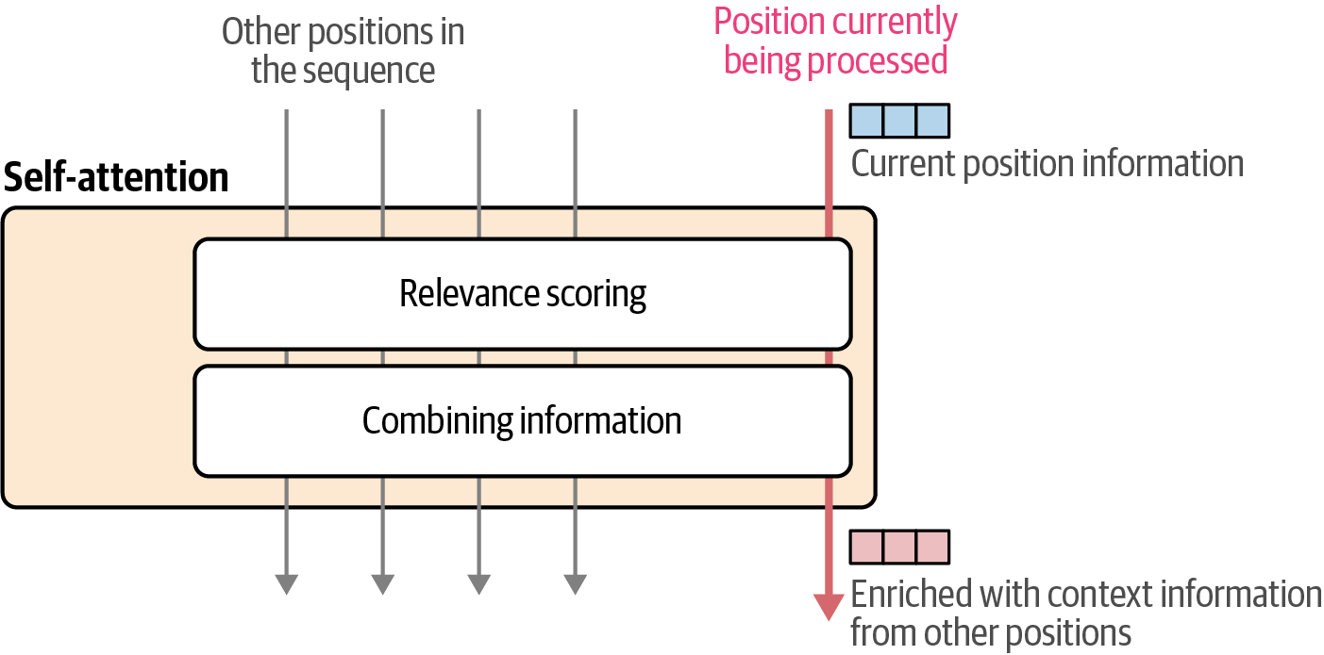
Figure 2-28. Self-attention operates in two steps: relevance scoring determines how much attention to pay to each preceding position, and combining information blends those positions’ representations into the current token’s output vector in proportion to their relevance scores
Self-attention is one of the most resource-intensive operations in the Transformer. That’s why it’s commonly one of the areas most targeted for improvement. Now we’ll turn to the second half of this chapter, where we look at how self-attention is calculated and newer and more efficient forms of self-attention.
Part 2: A Deeper Dive Into Large Language Models
We’ll now switch gears and move into a collection of LLM-related concepts in more depth. Namely, we’ll build on what we’ve learned in the first half of the chapter on LLM architectures and training and take a closer look at self-attention, some of its more efficient variants, and MoE models.
How Self-Attention Works
Earlier in the chapter, we saw how self-attention allows the model to attend to previous tokens, thus enriching the representation of the token we’re currently processing, as shown in Figure 2-29.
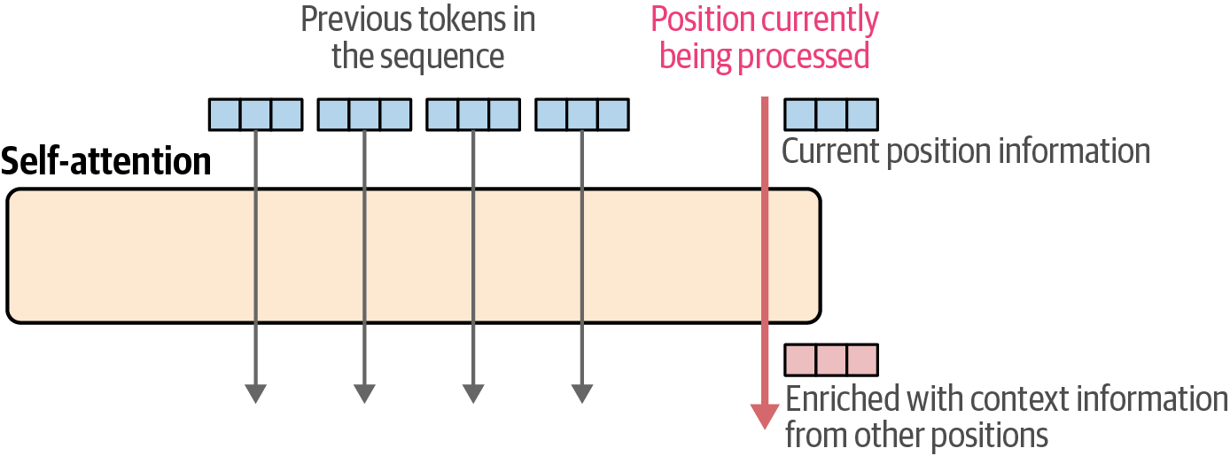
Figure 2-29. Self-attention takes the current token’s vector (pink) along with those of preceding tokens and produces an enriched output vector for the current position that incorporates context from the rest of the sequence
Going into the attention calculation are a collection of vectors: the vector for the current position and the vectors for the previous positions.
A trained model is able to attend properly by utilizing three projection matrices that resulted from the training process. We multiply the input vectors by each of these projection matrices, resulting in matrices we call the queries, keys, and values matrices (Figure 2-30).
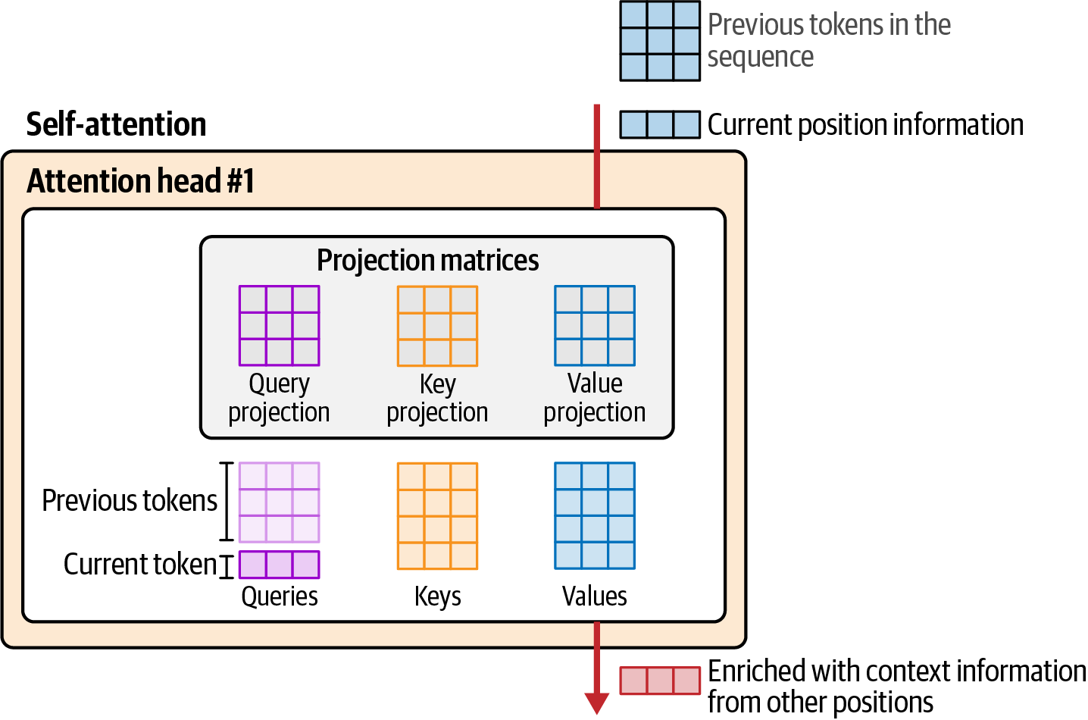
Figure 2-30. Inside an attention head, the input vectors for the current and preceding positions are multiplied by three learned projection matrices to produce the queries, keys, and values used in the attention calculation
The first step of self-attention, relevance scoring, involves multiplying the query for the token we’re currently processing by the key vectors associated with all the input tokens. This results in a relevance score for each vector, as Figure 2-31 shows.
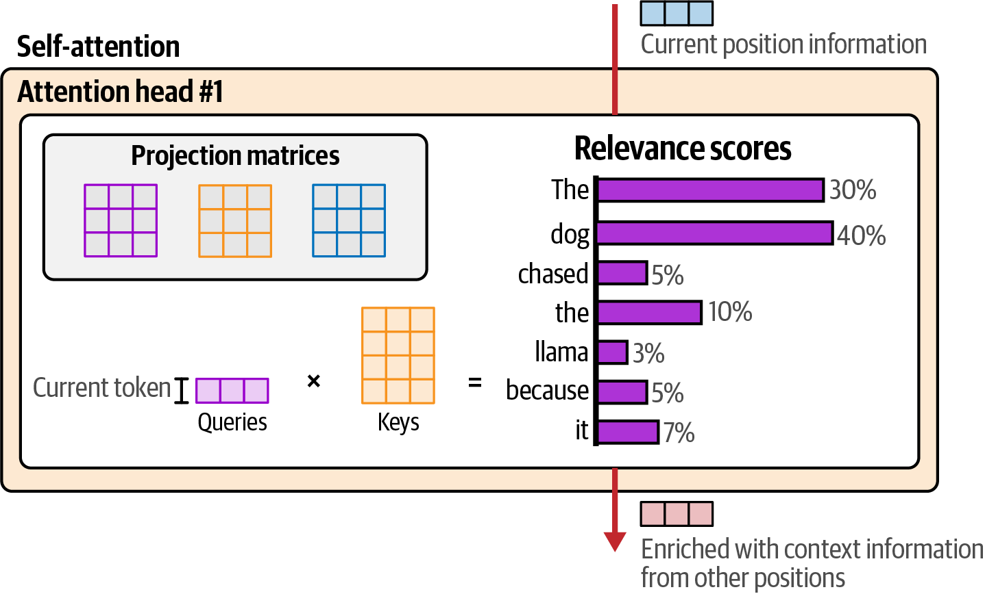
Figure 2-31. Relevance scoring multiplies the current token’s query vector by key vectors of all input tokens to produce relevance scores
After deciding the relevance values, self-attention then proceeds to combine information from these tokens, weighted by how relevant they are, and merge them into the vector of the current token we’re processing. We see that weighted summation calculation in Figure 2-32.
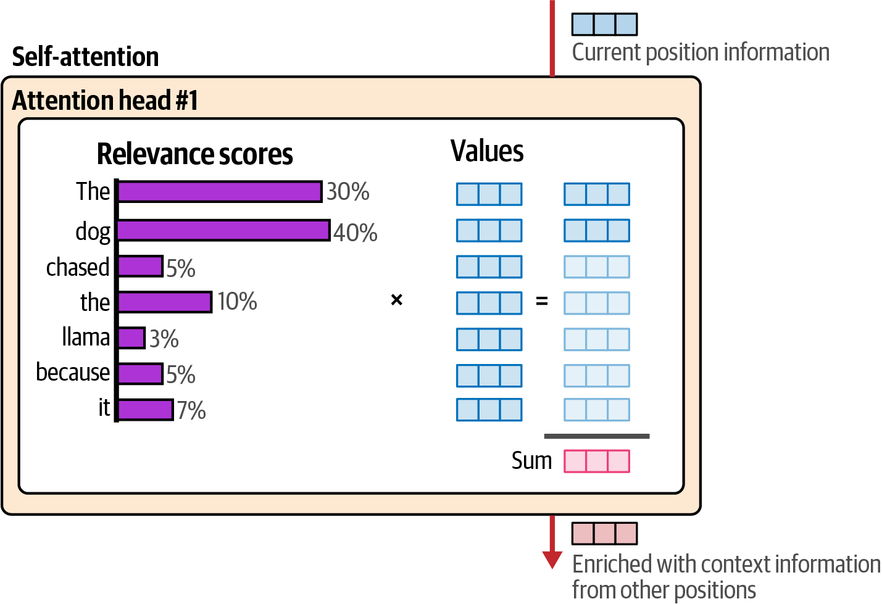
Figure 2-32. Information-combining multiplies each token’s value vector by its relevance score and sums the results, producing the enriched output vector for the current position
This vector becomes the output of the self-attention layer. Figure 2-33 presents this in another way, closer to the mathematical formula you’ll often see in LLM literature. The current and previous tokens are projected into queries, keys, and values; the query-key product (scaled by √d_{k} and passed through softmax) produces the relevance scores, which are then multiplied by the values to produce the attention output for the current position.
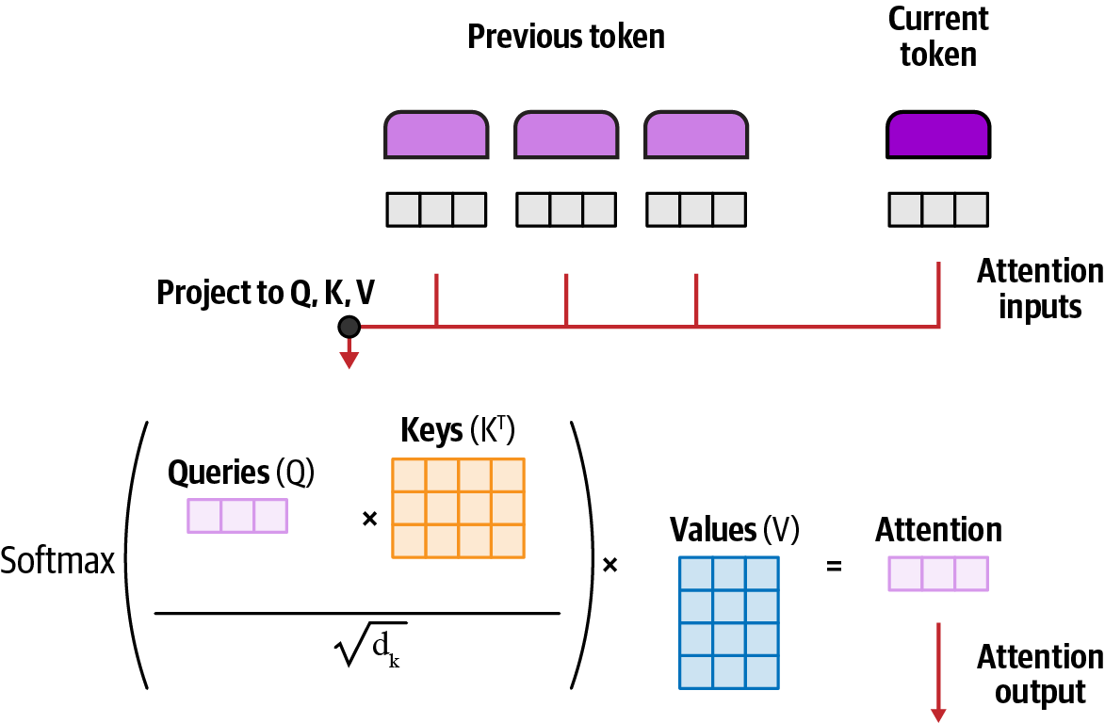
Figure 2-33. The same self-attention calculation expressed in the form commonly seen in the literature: projecting tokens into queries, keys, and values to calculate attention
As we’ll see in the next section, there is one final operation after calculating attention this way.
KV-Caching Revisited
What we’ve described so far are major components of self-attention as described in the Transformer paper, which is often called “vanilla attention.” This early form of self-attention, however, does a lot of redundant calculations of the K and V weights for each generated attention score if we apply it naively to text generation. Specifically, at each step, attention is recalculated for the entire sequence despite having calculated the K and V vectors of the previously seen tokens before. Imagine that a model is processing the attention scores for the tokens “My” and “name.” As shown in Figure 2-34, regular attention would recalculate the K and V vectors at each subsequent step despite having calculated them before.
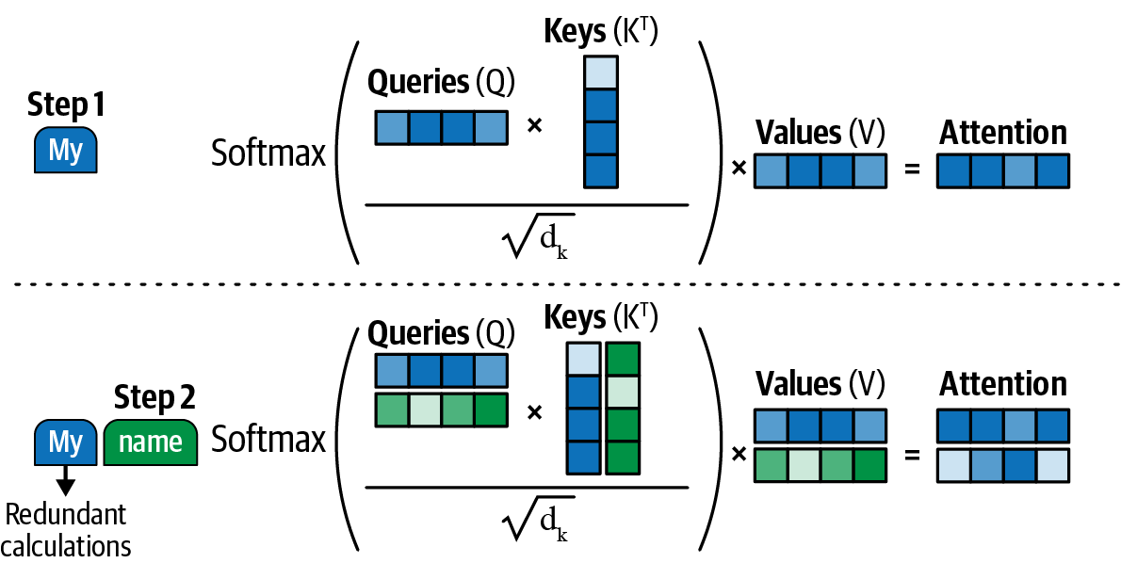
Figure 2-34. Vanilla attention recomputes the keys and values for every previous token at each generation step, causing redundant calculations
This is where the KV cache comes in. Instead of having to recalculate those vectors, we can simply cache and reuse them for subsequent decoding steps. This makes inference much faster by reducing the redundant computation. A basic KV cache is shown in Figure 2-35 and demonstrates how the K and V vectors are reused from previous steps instead. Also note that the query (Q) vectors do not need to be cached because they become unnecessary in subsequent iterations. Specifically, we need only the query vector of the latest token to compute the self-attention.
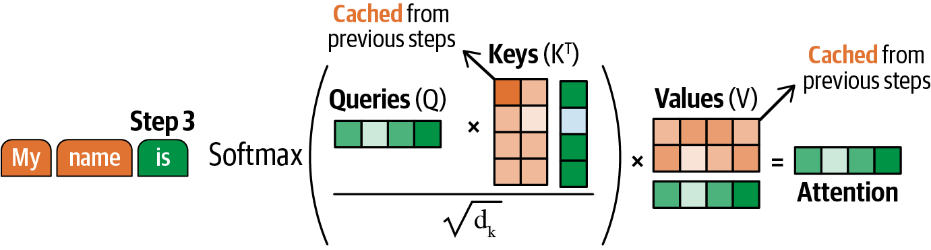
Figure 2-35. The KV cache stores keys and values from previous steps to avoid recomputation, processing only the new token’s query
Although such a KV cache can make inference much faster, it does require significantly more memory if all KV values are cached. For that, there are many different forms of attention created that attempt to reduce the calculations needed, which should therefore also reduce the KV cache that needs to be maintained.
More Efficient Self-Attention
Variants of attention mechanisms have since been developed to alleviate the memory issue of the KV cache and optimize the attention calculations. Popular techniques include Grouped-Query Attention and FlashAttention.1 More recently, however, DeepSeek introduced two attention mechanisms that showed tremendous improvements in the efficiency of attention calculations, namely Multi-head Latent Attention (MLA) and DeepSeek Sparse Attention (DSA).
Multi-head Latent Attention
A major step in making the KV-cache more memory efficient is through MLA, first used in DeepSeek-V2 and popularized by DeepSeek-R1.2,3 MLA is a variant of Multi-head Attention, which maintains separate Q, K, and V projection matrices for each attention head, producing a different Q, K, and V matrix per head. MLA uses low-rank joint compression of the keys and values to reduce the KV cache during inference. At its core, it compresses the keys and values into a smaller latent representation that is cached in place of the full K and V. In practice, this compressed cache is often combined with quantization (reducing the numerical precision of stored values) for additional memory savings.
MLA first compresses the input embeddings into lower-dimensional representations called the latent Q and latent KV. These representations are significantly smaller than the full Q and KV, which allows us to cache the latent KV instead of the full K and V. Positional information via Rotary Position Embedding (RoPE) is applied to a decoupled component of the latent Q, since the latent Q is recomputed at every step. RoPE is not applied to the latent K itself, because the cached K would then need to be recomputed at every step, breaking the benefit of caching. Therefore, positional information is carried by a separate small key instead. Note that at this step, the Q, K, and V representations are split across multiple attention heads, much like standard Multi-head Attention. Finally, the content and positional components are concatenated and passed through standard Multi-head Attention. The full procedure is shown in Figure 2-36.
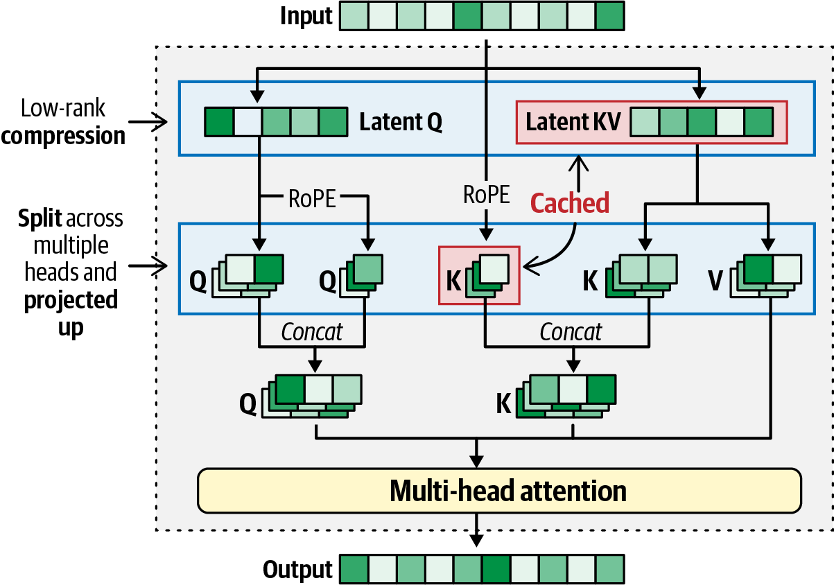
Figure 2-36. Multi-head Latent Attention compresses input into low-rank representations and caches the smaller latent KV to save memory
As such, MLA is essentially Multi-head Attention but with a compressed KV cache containing the previously mentioned Latent KV representation. This compression reduces the KV cache quite a bit and allows for much faster inference. It’s also more efficient than previous methods, such as Grouped-Query Attention. An overview of MLA versus other common attention mechanisms can be found in Figure 2-37. Note that Grouped-Query Attention and Multi-Query Attention share K and V across query heads to reduce the memory necessary for the KV cache but tend to be less accurate.
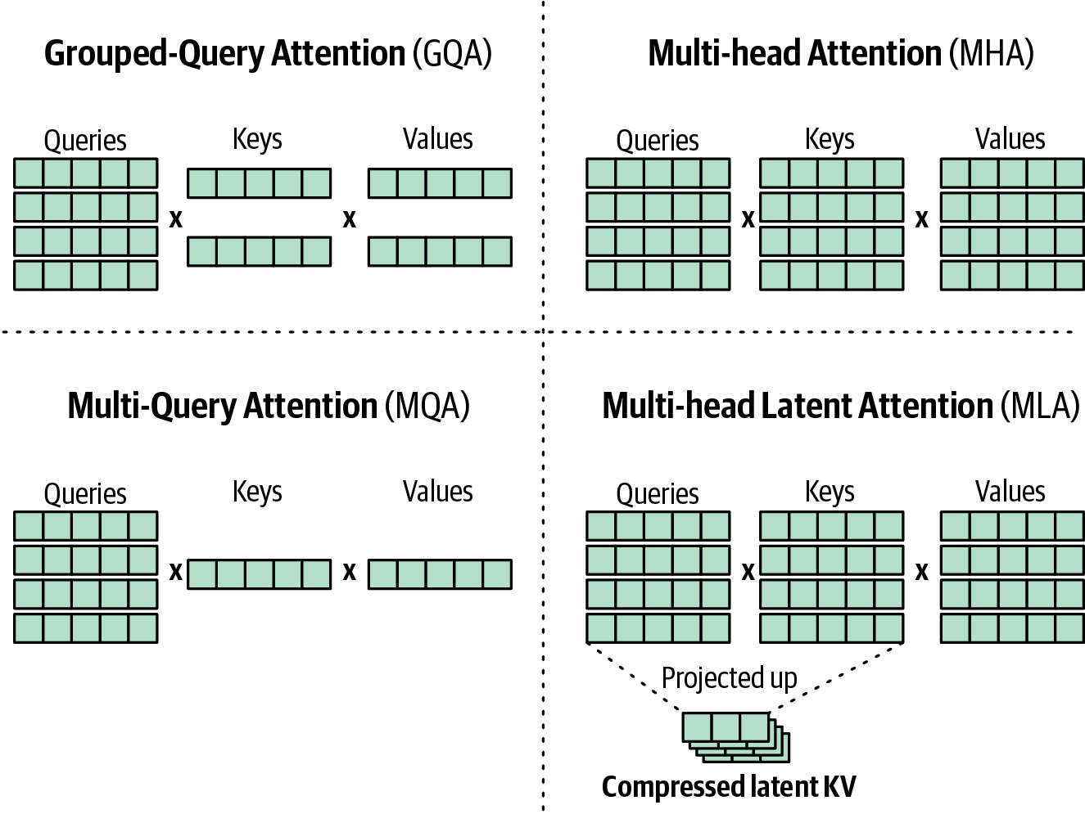
Figure 2-37. Four approaches to attention: MHA uses full K and V; GQA and MQA reduce K and V directly; MLA caches compressed latent KV
DeepSeek Sparse Attention
The next step in making MLA more efficient was first introduced in DeepSeek-V3.2. This new attention mechanism, called DeepSeek Sparse Attention (DSA), is instantiated under MLA and is an additional module to more efficiently select the tokens to attend to.4 It has two main components, a lightning indexer and a Top-K Selector. The lightning indexer determines how relevant each preceding token is to the current query. For that, it uses the Q/K values that both have RoPE applied to them. Likewise, it takes in a scalar weight parameter w that helps the lightning indexer make better decisions about which tokens to select for the full attention mechanism. The output of the lightning indexer is scores fed to the Top-K Selector, which in turn retrieves only the KV entries that correspond to the Top-K index scores. As a result, the attention output is computed through the query token and a subset of KV entries. This full procedure is shown in Figure 2-38.
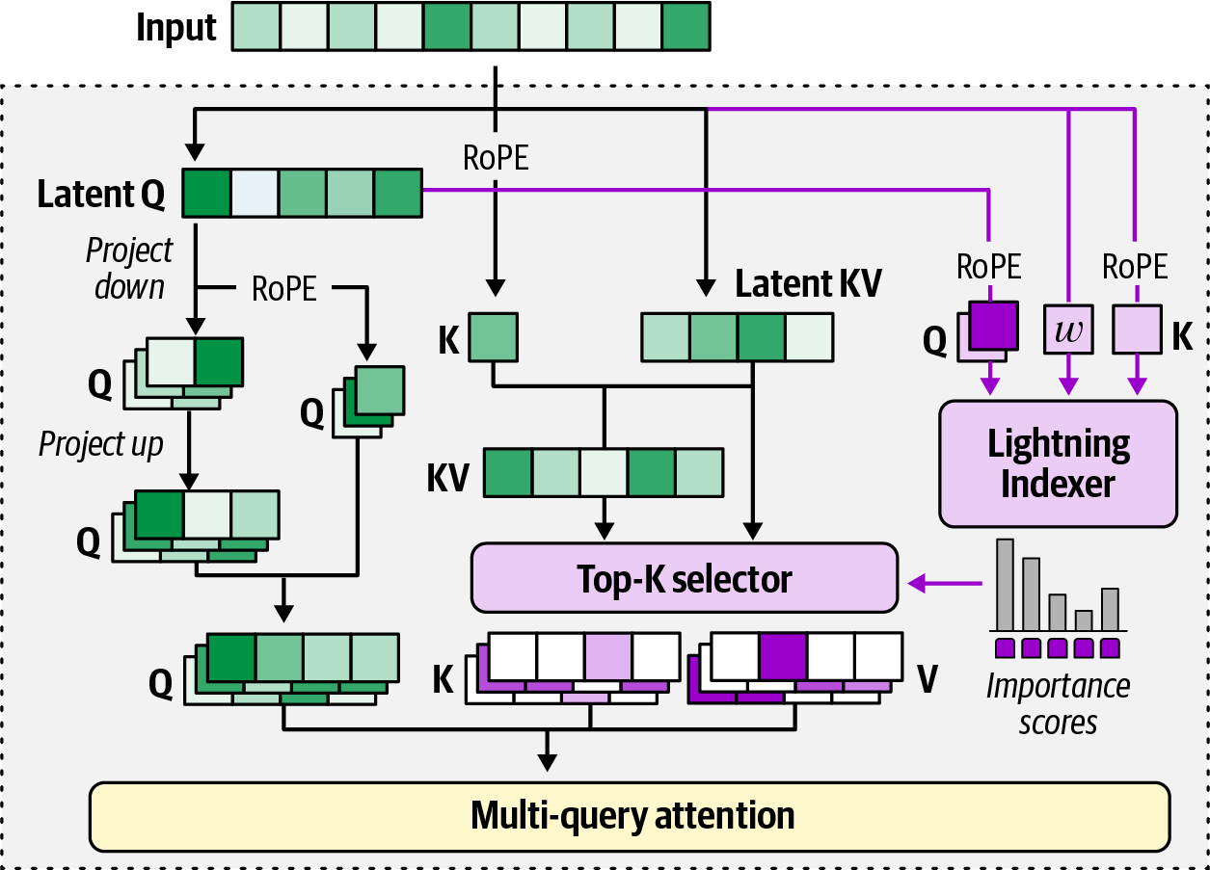
Figure 2-38. DeepSeek Sparse Attention (DSA) adds a Lightning Indexer and a Top-K Selector to compute attention over a sparse subset
Together, the Lightning Indexer and Top-K Selector reduce the number of tokens to attend to K. In the paper referenced, the authors selected 2,048 tokens to attend to, which drastically reduces the computation necessary for the attention computations.
Note that since MLA is used, there is already a significant memory benefit due to the compression of the KV-cache. In their construction of MLA, instead of using MHA as the core attention mechanism, MQA was used. The authors mentioned optimizing for computational efficiency, which is true for MQA, considering it uses fewer keys and values than MHA.
Mixture of Experts
MoE is a technique that is becoming more mainstream to create more efficient LLMs. MoE uses several submodels or “experts” to improve the quality and efficiency of LLMs. There are two main components of an MoE:
Experts
Each feed-forward neural network in an LLM is replaced by a set of “experts.”
Router or gate network
Determines which tokens are sent to which experts.
Let’s first explore experts. Remember that a typical Transformer-based LLM uses self-attention followed by a feed-forward neural network. As shown in Figure 2-39, we call this a dense model because everything is activated.
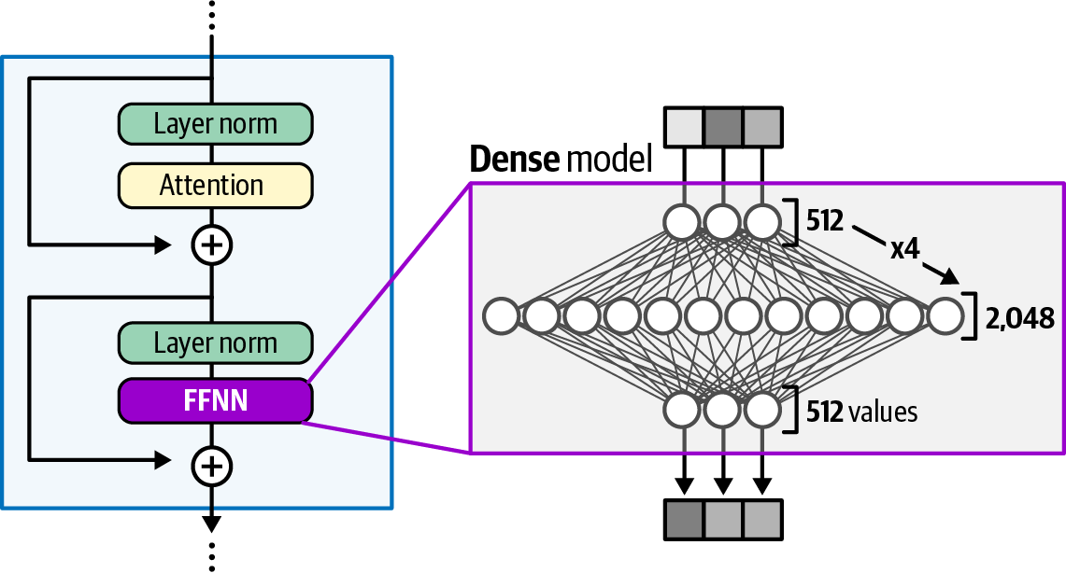
Figure 2-39. In a dense Transformer block, the feed-forward neural network (FFNN) is active for every single token passing through
A sparse model, in contrast, may deploy several feed-forward neural networks instead. These are typically smaller than a regular network, but together they tend to be bigger. Each feed-forward neural network in a sparse model is typically referred to as an “expert” because, during training, each “expert” learns different information and may specialize in the processing of certain tokens (Figure 2-40). For instance, one expert might be used for processing numbers, whereas another processes verbs. It’s still a bit unclear what these experts actually learn, but there has been some research suggesting that they specialize in fine-grained information such as verbs versus numbers rather than each learning an entirely different domain.5
Note that in this example, all experts are used, which does not allow for any efficiency gains. To choose a subset of experts during inference, we make use of the router (also called a gate network). This is a small feed-forward neural network that is trained to choose an expert for a given token. The router, together with the experts, makes up the MoE layer as shown in Figure 2-41.
The router is arguably the most important component because the experts are nothing more than just small feed-forward neural networks. So, how exactly does the router then choose which expert to use for each token? Let’s go through a minimal example step-by-step.
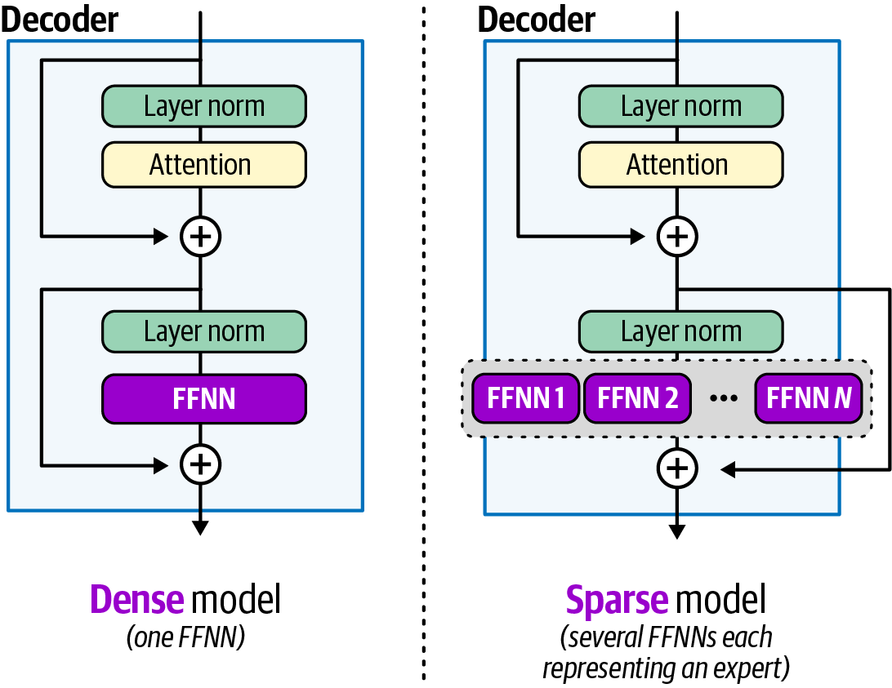
Figure 2-40. A dense block (left) applies a single network to all tokens, while a sparse block (right) routes different tokens to different experts
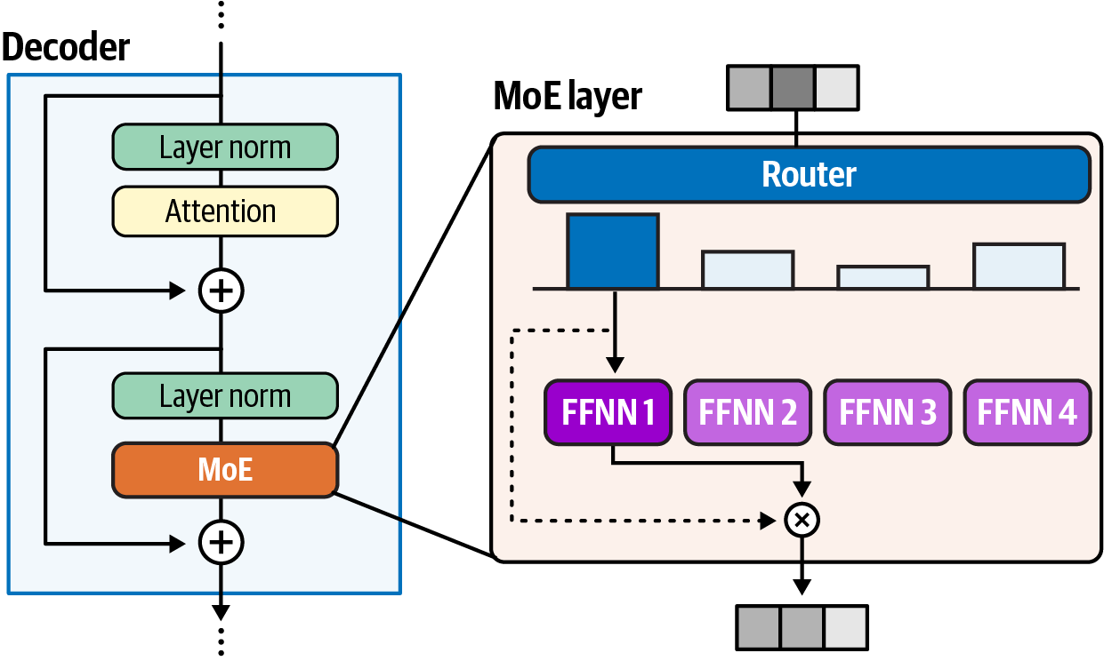
Figure 2-41. An MoE layer uses a router to score experts and direct each token to a small active subset, leaving others inactive
The router, as a neural network, will have its own weight matrix, which is used to multiply the input token embeddings. Applying a softmax on the output will result in a probability distribution per expert. This probability distribution provides the likelihood that an expert will be chosen given an input token. Figure 2-42 shows everything put together, demonstrating how the input flows through the router and experts.
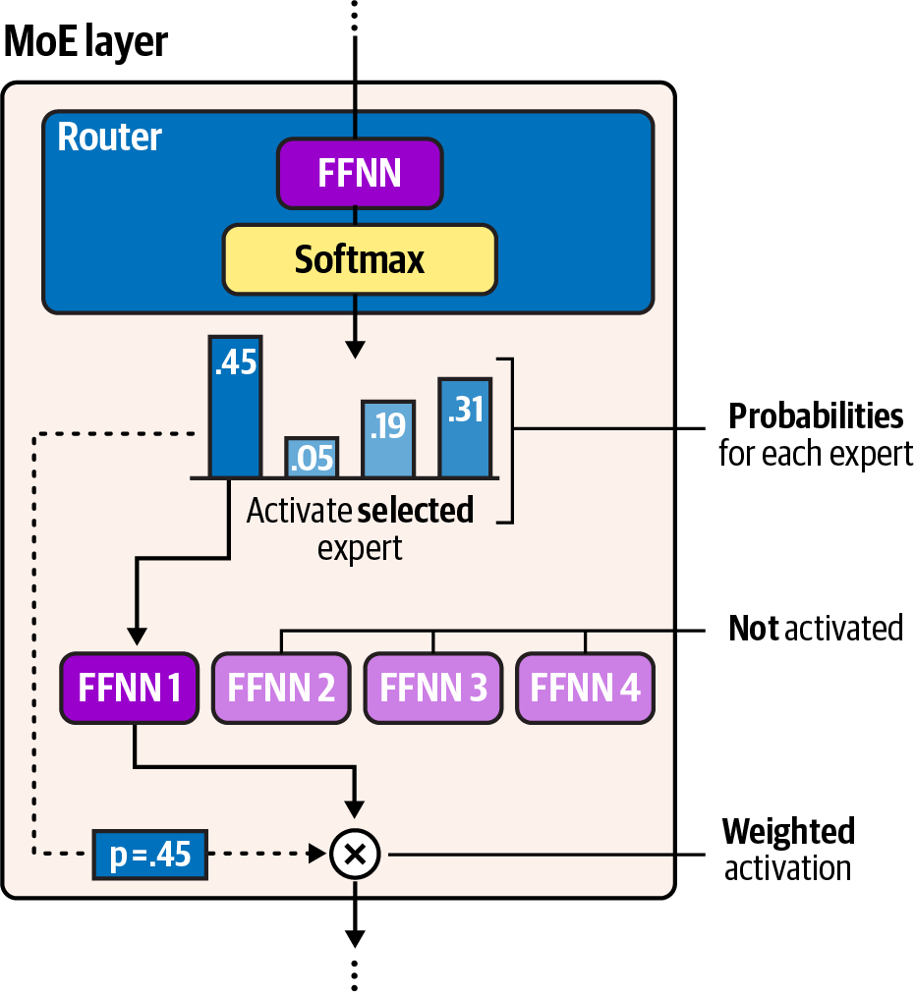
Figure 2-42. Inside the router, the token representation is mapped to a probability distribution over experts using a small network and softmax
Note that any number of experts can be selected, but generally a fixed number are selected for training and inference. When selecting multiple experts, there is a need to balance how much each expert is trained. If the same set of experts is always chosen during training and inference, then all other experts are undertrained.
To balance the distribution of training among experts, the router will have to dynamically balance which expert to choose and when. This is referred to as load balancing. To prevent one expert from dominating the training time, there are two main techniques that are often employed in one way or another, namely expert capacity and auxiliary loss.
Expert capacity gives each expert in the MoE layer a limit to how many tokens it can process.6 Instead of having a single expert do all the work, the tokens are somewhat more equally distributed. For instance, by the time an expert has reached capacity, each subsequent token routed to it will be sent to the next-highest scoring expert, as shown in Figure 2-43.
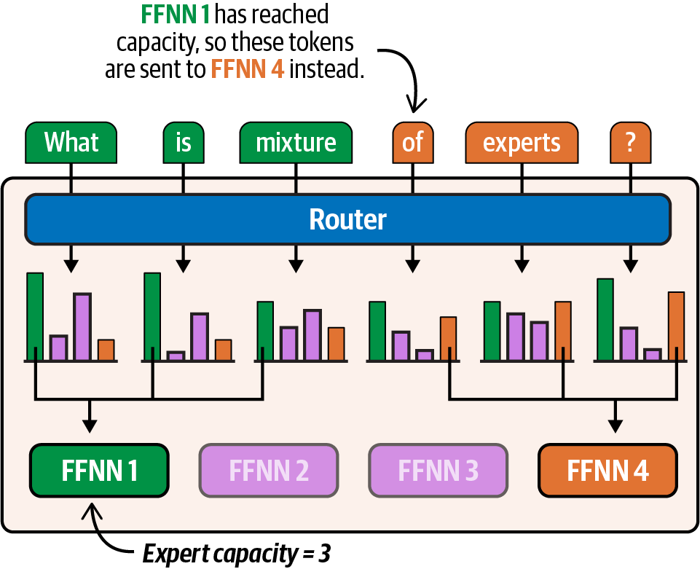
Figure 2-43. Expert capacity caps how many tokens each expert can process per batch, routing excess tokens to the next-highest expert
In contrast, instead of limiting the experts, the router can also be adjusted to account for this probability imbalance. A straightforward technique is to add Gaussian noise just before the router produces its probabilities. By introducing noise, the distributions will slightly change, and by (slight) chance, sometimes choose different experts to use. A more advanced technique to balance how the router selects experts is called auxiliary loss.7 These are loss functions that can be added to the router to reward it for equally distributing the experts during training or punish it when the same expert is chosen.
The main benefit of MoE is its computational requirements. Although using MoE does not make the resulting model smaller, it runs much faster because only a few experts are activated at a given time. As Figure 2-44 shows, all parameters that a MoE model has need to be loaded into memory and are called sparse parameters. The active parameters, in contrast, are those that are activated only during inference.
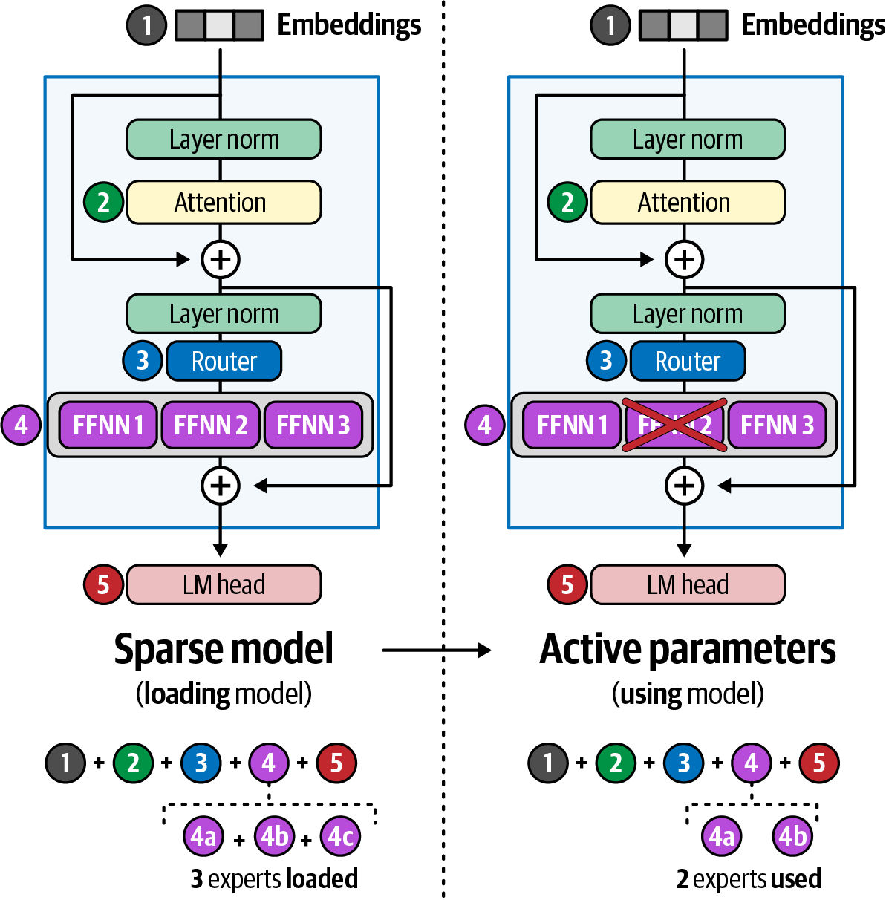
Figure 2-44. In an MoE model, all experts must be loaded into memory, but only an active subset is used per forward pass
Most recent models tend to use MoE layers, such as OpenAI’s GPT-OSS and NVIDIA’s Nemotron 3. Often, you’ll see models like Qwen3-30B-A3B that put the number of sparse parameters (30 billion) and active parameters (3 billion) in their name.8 As such, even though 30 billion parameters need to be loaded in memory, only 3 billion are used, which makes it much faster for inference.
Another example of MoE is the previously discussed DeepSeek-R1. As Figure 2-45 shows, DeepSeek-R1 has 256 experts, of which 8 are always chosen. Note that there is also a shared expert bypassing the router. This expert is always chosen, which often helps the model divert all general knowledge to that expert and more specialized knowledge to all others.
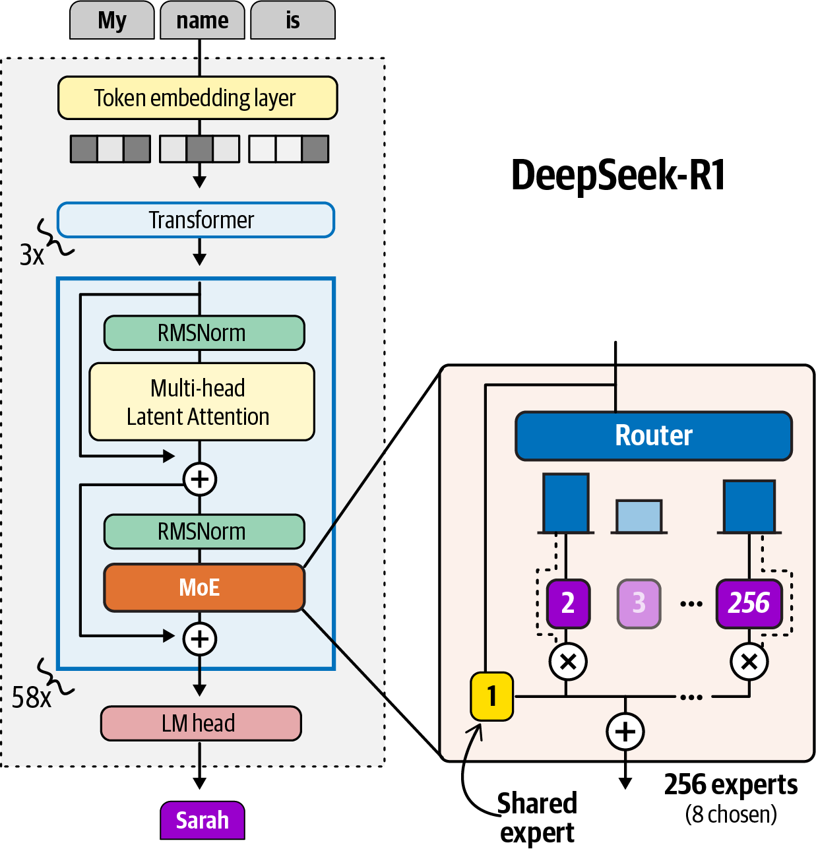
Figure 2-45. DeepSeek-R1 uses MoE layers with 256 experts per layer, of which 8 are selected by the router for each token. A shared expert bypasses the router and is always active
In practice, there are many different choices for the number of experts chosen for a given LLM and the sizes of each expert compared to the overall size of the LLM. Table 2-1 demonstrates various open-weight LLMs and their implementations of MoE.
Model | Sparse parameters (billion) | Active parameters (billion) | Number of experts | Experts activated | Shared experts
Mistral 7x8B | 46.7 | 12.8 | 8 | 4 | 0
DeepSeek-R1 | 671 | 37 | 256 | 8 | 1
Llama 4 Maverick | 400 | 17 | 128 | 1 | 1
Qwen3 235B-A22B | 235 | 22 | 128 | 8 | 0
Kimi-K2 | 1,000 | 32 | 384 | 8 | 1
GPT-OSS 120B | 120 | 5.1 | 128 | 4 | 0
GPT-OSS 20B | 20 | 3.6 | 32 | 4 | 0
GLM 4.5 | 335 | 12 | 160 | 8 | 1
Qwen3 Next | 80 | 3 | 512 | 10 | 1
Mistral Large 3 | 671 | 41 | 128 | 4 | 1
Nemotron-3-Nano-30B-A3B | 31.6 | 3.6 | 128 | 6 | 2
Table 2-1. Open-weight LLMs and their MoE
Summary
This chapter covered the engine that powers every agent in this book: the LLM. We structured the chapter in two parts because the depth of understanding needed depends on what you’re trying to do.
Part 1 looked at LLMs from the perspective of an agent developer. Language models consume and produce tokens, and the formats built on top of those tokens—system prompts, multi-turn conversations, and tool calls—are what let a language model serve as the reasoning core of an agent.
We then walked through how LLMs are created across two training phases. Pre-training via next-token prediction produces a base model. Post-training via SFT and RL shapes the base model into something that follows instructions and generates responses aligned with human preferences. We looked at how RLVR and the GRPO algorithm use verifiable signals such as format and correctness to push models toward reliable behavior.
We also opened up the Transformer itself, tracing how tokens flow through a stack of blocks, each containing a self-attention layer and a feed-forward neural network, before the LM head converts the final representation into a next-token probability distribution. For agent developers, the two architectural properties worth carrying into later chapters are context length, which limits how much information we can pack into a model’s input, and the KV cache, which shapes the economics and latency of every agent we build.
Part 2 went deeper into the internals. We saw how self-attention is actually computed through the queries, keys, and values produced by three projection matrices and how relevance scoring and information combining make up the two steps of the attention operation.
We then looked at how self-attention has evolved to address its memory and compute costs. The KV cache itself avoids redundant recomputation. Grouped-Query and Multi-query Attention shrink the cache by sharing K and V across heads. DeepSeek’s Multi-head Latent Attention takes a different approach, caching a low-rank compressed representation that gets projected back up when needed. DeepSeek Sparse Attention adds a Lightning Indexer and Top-K Selector to attend to only the most relevant tokens instead of the entire sequence.
We closed with MoE architectures, which replaced the dense feed-forward layer with a router and a set of smaller expert networks. This produces models where the total and active parameter counts can differ by an order of magnitude, a distinction that matters when selecting a model to deploy.
In the next chapter, we turn to reasoning LLMs, the class of models that has reshaped what agents can do by producing long chains of thought before committing to an answer.
1 Dao, Tri et al. 2022. “FlashAttention: Fast and Memory-efficient Exact Attention with IO-Awareness,” NIPS’22: Proceedings of the 36th International Conference on Neural Information Processing Systems, 1189: 16344-16359.
2 Shao, Zhihong et al. 2024. “DeepSeek-V2: A Strong, Economical, and Efficient Mixture-of-Experts Language Model.” arXiv, 2405.04434.
3 Guo, Daya et al. 2025. “DeepSeek-R1 Incentivizes Reasoning in LLMs Through Reinforcement Learning.” Nature 645: 633–638. https://doi.org/10.1038/s41586-025-09422-z.
4 Liu, Aixin et al. 2025. “DeepSeek-V3. 2: Pushing the Frontier of Open Large Language Models,” arXiv, 2512.02556.
5 Zoph, Barret et al. 2022. “ST-MoE: Designing Stable and Transferable Sparse Expert Models.” arXiv, 2202.08906.
6 Lepikhin, Dmitry et al. 2020. “Gshard: Scaling Giant Models with Conditional Computation and Automatic Sharding,” International Conference on Learning Representations, poster.
7 Shazeer, Noam et al. 2017. “Outrageously Large Neural Networks: The Sparsely-Gated Mixture-of-Experts Layer,” International Conference on Learning Representations, poster.
8 Yang, An et al. 2025. “Qwen3 Technical Report,” arXiv, 2505.09388.

