Normal Distribution
A Complete Data Science Field Guide
Version 4: Q-Q plots, transformations, p-values and z-tests
What's new in this version
- Section 3.3: removed Pearson, ANOVA, t-test, Linear Regression, Chi-Square and Mutual Information.
- Section 6.2: full Q-Q plot explanation: how the ideal normal is built, how it becomes a straight line, what each shape means.
- Section 7.1: why we transform data, and why the median alone is not enough.
- Section 9: p-value in simple words, with tail diagrams.
- Section 10: z-test: normality conditions, five types, two worked examples each, with p-values.
- Section 12: new interview questions Q7, Q8, Q9.
Corrections (shown red struck-through, then green)
- Height of 7'0" is about 4.7 SD, not "nearly 4".
- Skewness range row, Shapiro-Wilk range, and "three ways" to check normality.
- All diagrams are now on a black background; numbered lists restart correctly.

Tip: when Word asks to update fields on opening, click Yes so the table of contents fills in.

Table of Contents

Section 1: What Is Normal Distribution?

1.1 The Simple Explanation
Imagine you measure the height of 1,000 people. Most people are somewhere in the middle — average height. Very few people are extremely short, and very few are extremely tall. If you draw a bar chart of all these heights, you get a shape that looks like a bell. This is the Normal Distribution — also called the Bell Curve.

📘 Core Idea
A normal distribution is a symmetric, bell-shaped curve where:
- Most values cluster around the centre (the mean)
- Values become progressively rarer as you move away from the centre
- The left and right sides are mirror images of each other

1.2 The Three Magic Properties
A normal distribution has three measures of the "centre" that are all equal:
Measure | What It Is | How It Works
Mean | The mathematical average | Add all values, divide by count
Median | The middle value | Sort data and find the midpoint
Mode | The most frequent value | The peak of the bell curve

✅ Key Insight: Mean = Median = Mode
In a perfect normal distribution, these three values are identical. This symmetry is what makes normal distribution so mathematically beautiful and predictable.

1.3 The 68-95-99.7 Rule (Empirical Rule)
The most powerful property of a normal distribution is how predictable it is. If you know the mean (μ) and standard deviation (σ), you know exactly how data is spread:
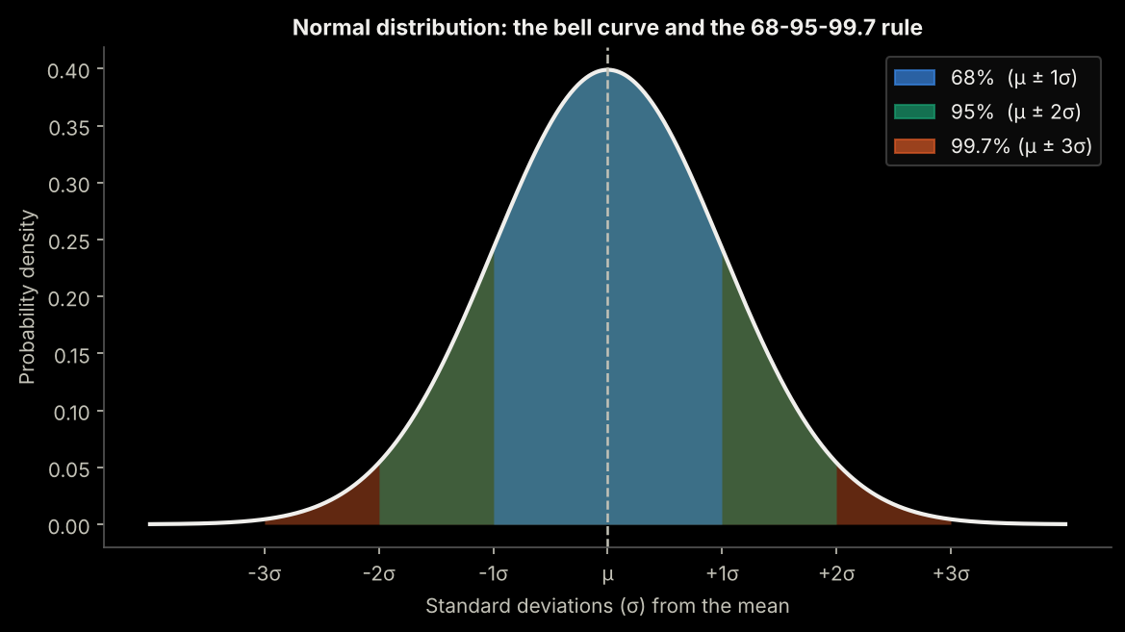
Range | Data Coverage | Real-World Meaning
±1 Standard Deviation | 68% of all data falls here | Out of 1,000 people, ~680 are in this range
±2 Standard Deviations | 95% of all data falls here | Out of 1,000 people, ~950 are in this range
±3 Standard Deviations | 99.7% of all data falls here | Only ~3 in 1,000 are outside this range

1.4 Simple Real-World Examples

Example 1: Human Heights
The average height of adult males in the US is about 5'10" (178 cm) with a standard deviation of about 3 inches.
- 68% of men are between 5'7" and 6'1"
- 95% of men are between 5'4" and 6'4"
- 99.7% of men are between 5'1" and 6'7"
- Being 7'0" tall is extremely rare — nearly 4 standard deviations from the mean ✔ Being 7'0" tall is extremely rare — about 4.7 standard deviations above the mean (84 in vs. the mean of 70 in, with σ = 3 in)

Example 2: Exam Scores
A professor gives an exam. Most students score around 70. Few students fail spectacularly (below 30), and few score perfectly (above 95). The distribution of scores naturally forms a bell curve.

Example 3: Manufacturing
A factory produces bolts that should be 10mm in diameter. Due to tiny variations in machines and materials, some bolts are 9.98mm, some are 10.02mm. These tiny variations follow a normal distribution centred at 10mm.

Section 2: Why Is Normal Distribution Special?

2.1 It Appears Everywhere in Nature
Normal distribution is not just a math concept — it is nature's favourite pattern. It appears in:
- Biology: Heights, weights, blood pressure, IQ scores
- Physics: Measurement errors, thermal noise
- Finance: Daily stock returns (approximately)
- Psychology: Test scores, reaction times
- Engineering: Manufacturing tolerances, signal noise

2.2 The Central Limit Theorem — The Real Magic
⭐ The Central Limit Theorem (CLT)
If you take many random samples from ANY population and calculate the average of each sample, those averages will follow a normal distribution — even if the original data is not normally distributed!
This works when sample size n ≥ 30.
The sample mean is an unbiased estimator of the population mean.
Standard Error of the Mean: SE = σ / √n (σ = population standard deviation, n = sample size)

Example: Imagine a dice (clearly not normal — each number 1-6 is equally likely). If you roll a dice 30 times and average the result, and repeat this experiment 1,000 times, the 1,000 averages will form a bell curve!
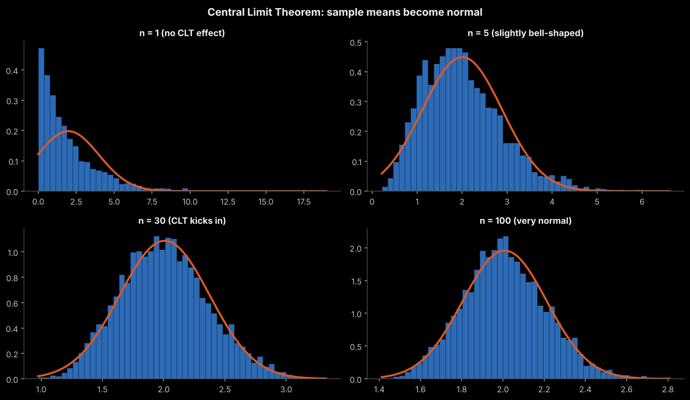
The charts above show this: as sample size increases from n=1 to n=100, the distribution of sample means transforms into a bell curve.

2.3 Mathematical Convenience
Normal distributions have incredibly well-understood mathematical properties:
- The sum of independent normal random variables is also normally distributed. The new mean is the sum of the individual means, and the new variance is the sum of the individual variances.
- The difference of independent normal random variables is also normally distributed. The new mean is obtained by subtracting the corresponding means, while the new variance is still the sum of the individual variances.
- Normal distributions are closed under linear combinations. This means that adding or subtracting normal random variables, and multiplying them by constants, produces another normal random variable.
- Normal distributions are NOT closed under nonlinear operations such as multiplication, division, powers, logarithms, or exponentials — the resulting distribution is generally not normal.
- Probabilities can be calculated precisely using Z-scores.
- It is completely described by just two numbers: mean and standard deviation.
- Most statistical tests (t-tests, ANOVA, linear regression) are built on the assumption of normality.

Section 3: Importance in Data Science & Machine Learning

3.1 How Normality Affects Data Cleaning
When data follows a normal distribution, cleaning becomes much more systematic and defensible.

Outlier Detection
With normal data, the 3-sigma rule works perfectly: any value more than 3 standard deviations from the mean is considered an outlier (~0.3% of data). You get a clear, mathematically justified cut-off.
🔍 Example: Detecting Fraudulent Transactions
Average transaction: $45 | Standard deviation: $20
- Normal range: $45 ± 3×$20 = between −$15 and $105
- A transaction of $500 is (500−45)/20 = 22.75 standard deviations away
- This is clearly an outlier → flag as potential fraud
With non-normal data (like income), this rule breaks down — you need robust methods like IQR.

Missing Value Imputation
- Normal data: Impute with mean (it is the most representative value)
- Skewed data: Impute with median (mean is pulled by the tail, misleading)

3.2 How Normality Affects Feature Engineering

Scaling and Standardization
StandardScaler (Z-score normalization) works best on approximately normal features. It centres data at 0 with standard deviation 1. On heavily skewed data, scaling spreads outliers further and distorts model training.

Creating New Features
- Log transforms on skewed features create more informative, balanced features
- Ratio features (e.g., income/expense) are often more normally distributed than raw values
- Interaction features between normal features are easier to interpret

3.3 How Normality Affects Feature Selection
Feature selection means choosing which columns (features) are worth giving to the model. Whether normality matters depends on how the selection method scores a feature:
- Methods that score a feature using averages and standard deviations assume the feature is roughly normal. On skewed data with outliers, a few extreme values can make a useless feature look important — or hide a useful one.
- Methods that use ranks or tree splits (for example, tree-based feature importance) do not care about the shape of the distribution.
- Practical rule: if the selection method is built on means and variances, check the distribution first and transform skewed features. If it is rank-based or tree-based, you can usually skip the transformation.

3.4 How Normality Affects Algorithm Choice
Very few algorithms require the input features themselves to be normally distributed.
Algorithms / methods that DO have a normality assumption:
- t-Test
- ANOVA
- MANOVA
- Hotelling's T²
- Linear Discriminant Analysis (LDA)
- Classical linear regression inference (normal residuals)

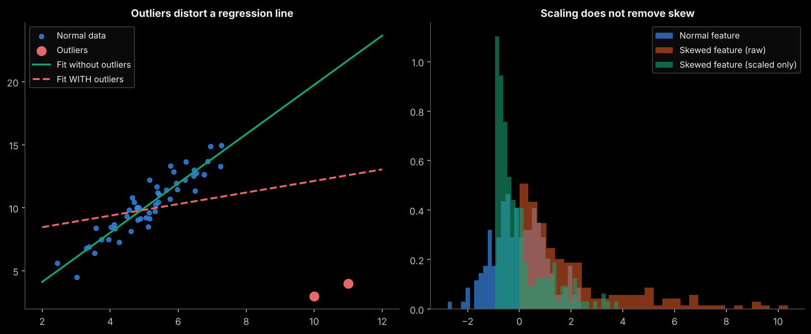
Algorithm | Normality Assumption | Effect if Data Is Not Normal
Linear / Logistic Regression | Assumes normal residuals (not features) | Coefficient estimates unreliable; CIs wrong
Naive Bayes (Gaussian) | Explicitly assumes Gaussian features | Severely wrong predictions if features are skewed
LDA | Assumes normally distributed classes | Poor class separation if violated
Decision Trees / Random Forests | No normality assumption | Works well on any distribution
SVM with RBF Kernel | Benefits from scaled near-normal features | Works but may train slower on very skewed data
Neural Networks | No assumption, but scaling helps | Benefits from normalized inputs
K-Means Clustering | Assumes spherical (normal-like) clusters | Clusters may be meaningless on skewed data
KNN | No assumption, but scaling required | Distance metrics distorted by skewed features

💡 Quick Decision Rule
- If algorithm assumes normality (linear models, LDA, Naive Bayes) → transform skewed features first
- If algorithm is distribution-free (trees, forests, boosting) → skewed data is fine, but scaling may still help
- Always check residuals after fitting, not just input features

Section 4: Skewness — What Is It and What Does It Tell You?

4.1 The Simple Explanation
Skewness measures how asymmetric your data is — how much does it lean to one side? A perfectly normal distribution has zero skewness. Think of skewness as measuring the "tail" of your data: which direction does the tail pull?
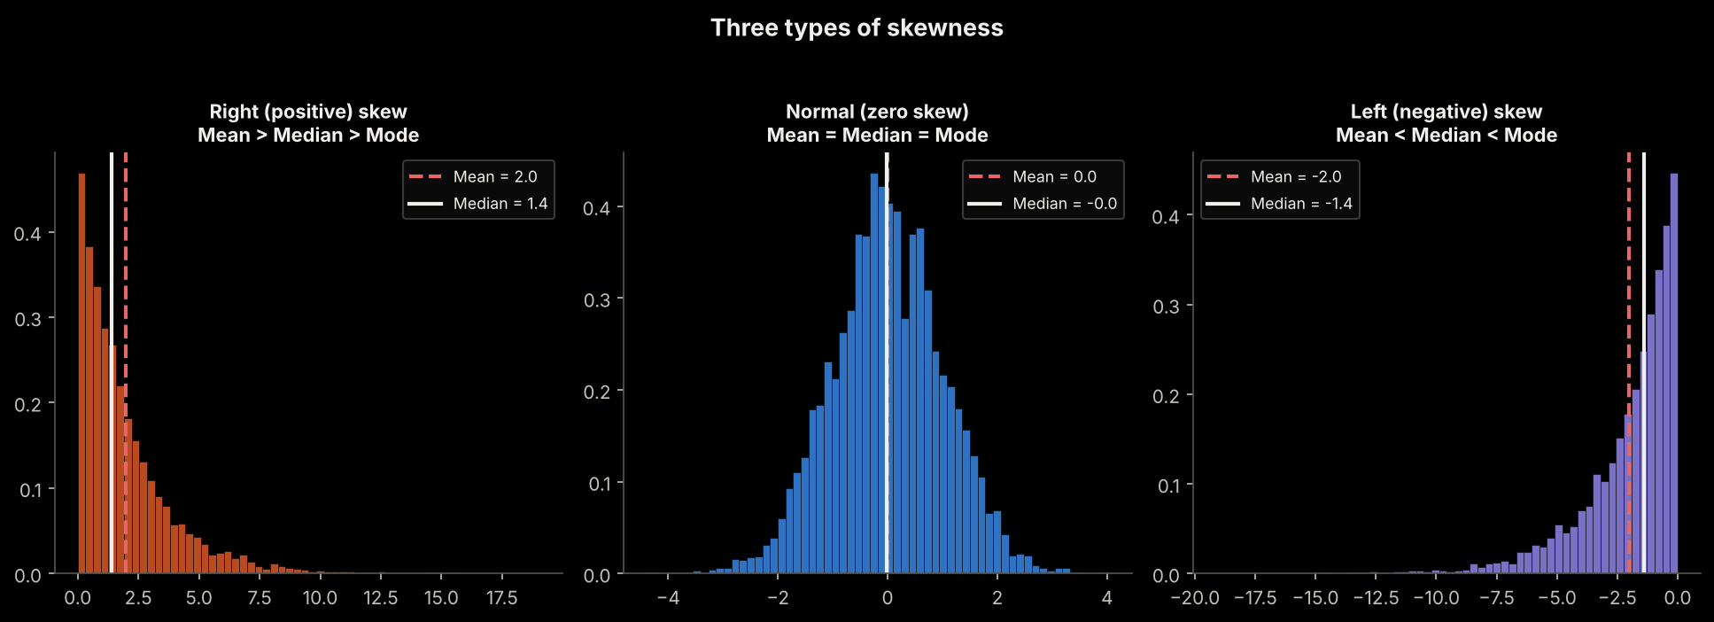

4.2 The Three Types of Skewness

Type 1: Zero Skew (Normal / Symmetric)
🔵 Zero Skewness (Skewness ≈ 0)
What it looks like: Perfectly balanced bell curve. No tail in either direction.
What it tells you: Data is symmetric. Mean = Median = Mode.
- Example: Heights of adult men in the same country
- Example: IQ scores across a large population
- Example: Error measurements in a calibrated instrument

Type 2: Positive Skew (Right Skew)
➡ Positive / Right Skewness (Skewness > 0)
What it looks like: The right tail is longer. Most values are on the left, but a few very high values stretch to the right.
What it tells you: Mean > Median > Mode. Outliers are pulling the mean to the right.
Example: Income in a country — most people earn moderate salaries, but a few billionaires pull the average WAY up.
- Median income (what the "typical person" earns): $55,000
- Mean income (pulled up by billionaires): $95,000
- The mean makes the average person look richer than most actually are!
Example: Property prices in a city with one ultra-luxury neighbourhood.
Example: Social media post shares — most posts get few shares, viral posts get millions.
Example: Medical expenses — most people spend little, but a few with chronic illness spend enormously.

Type 3: Negative Skew (Left Skew)
⬅ Negative / Left Skewness (Skewness < 0)
What it looks like: The left tail is longer. Most values are on the right (high side), but a few very low values stretch to the left.
What it tells you: Mean < Median < Mode. Outliers are pulling the mean to the left.
Example 1: Age at retirement — most people retire around 60-65 (clustered on the right), but some retire early (pulling the tail left).
Example 2: Exam scores in an easy test — most students score 80-100, but a few who did not study score very low.
- Mode: 90 (most common score)
- Median: 85
- Mean: 78 (pulled down by the handful who scored 10-20)
Example 3: Life expectancy in a developing country with high infant mortality — most who survive childhood live to 60-70+, but high infant deaths create a left tail.

4.3 Skewness Values — What the Number Means

⚠ ISSUE FOUND: Skewness table only had 2 rows: "Less than -1" and "Greater than +1". The 3 middle rows covering moderate and near-symmetric ranges were missing entirely.
✔ CORRECTED: All 5 rows restored. The 3 added rows are highlighted in green.

Skewness Value | Interpretation | Action Required
Less than −1 | Highly negatively skewed | Strong left tail — transform data
−1 to −0.5 | Moderately negatively skewed ✚ ADDED | Consider log or Yeo-Johnson transformation Consider square / cube, reflect + log, or Yeo-Johnson ✚ ADDED (plain log suits right skew only)
−0.5 to +0.5 | Approximately symmetric ✚ ADDED | Treat as approximately normal — no transform needed ✚ ADDED
+0.5 to +1 | Moderately positively skewed ✚ ADDED | Consider log or Box-Cox transformation ✚ ADDED
Greater than +1 | Highly positively skewed | Strong right tail — transform data

Section 5: Kurtosis — What Shape Is the Peak?

5.1 The Simple Explanation
If skewness tells you about the lean (left or right), kurtosis tells you about the shape of the peak and the thickness of the tails. Is the peak very sharp and thin? Or is it flat and wide? Are there many extreme values (fat tails) or few (thin tails)?
🏔 Easy Analogy for Kurtosis
Imagine a mountain:
- Leptokurtic = Mount Everest — very sharp, pointy peak with heavy foothills (fat tails)
- Mesokurtic = A normal rolling hill — standard bell shape
- Platykurtic = A plateau — flat top, thin tails

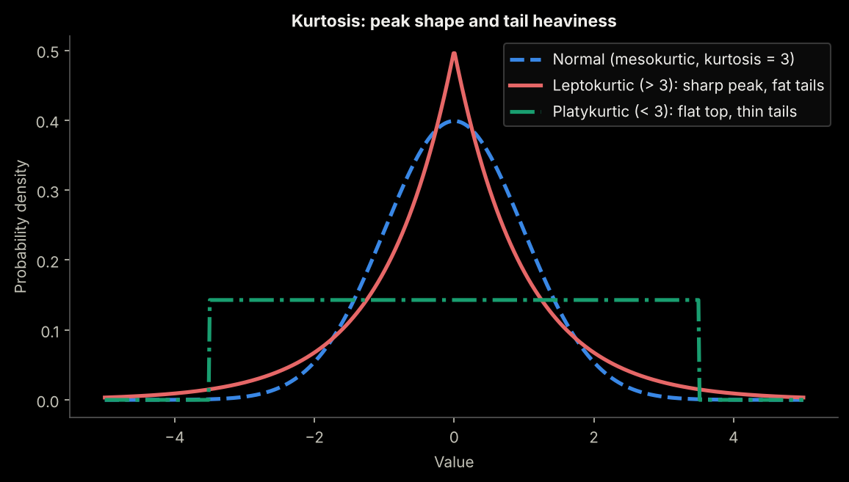

5.2 The Three Types of Kurtosis

Mesokurtic — The Baseline (Kurtosis = 3, Excess = 0)
This is the normal distribution itself. Used as the reference point. All other kurtosis values are compared to this.
- Example: Heights of adult men
- Example: IQ scores

Leptokurtic — Sharp Peak, Fat Tails (Kurtosis > 3, Excess > 0)

⚠ ISSUE FOUND: Leptokurtic callout was missing "Example 1: Daily stock market returns" entirely — the callout jumped straight to "Example 2: Insurance claims" with no Example 1 before it.
✔ CORRECTED: Example 1 (stock market / fat tails / 2008 crisis) fully restored in green below.

📈 Leptokurtic: "More extreme values than expected"
What it means: A sharper, taller peak AND heavier tails than normal distribution.
In plain English: Most values are extremely close to the average, BUT extreme outliers are more common.
Example 1: Daily stock market returns. ✚ RESTORED
- On 99% of days, stock prices barely move (sharp peak at zero return)
- But occasionally there are crashes (−30%) or surges (+20%) — the fat tails
- This is why the 2008 financial crisis was a "100-year event" that happened multiple times in 20 years
- Normal distribution models said these crashes are near-impossible — leptokurtic models predict them correctly
Example 2: Insurance claims.
- Most claims are small and predictable (the sharp peak)
- But catastrophic events (hurricanes, earthquakes) create extreme claims — fat tails
- If an insurer uses a normal distribution model, they will be UNDERPREPARED for disasters

Platykurtic — Flat Peak, Thin Tails (Kurtosis < 3, Excess < 0)

⚠ ISSUE FOUND: Platykurtic callout had "Example : Age of customers at a theme park" (missing number) then jumped to "Example 3: Grades..." with no Example 2. Numbering was inconsistent.
✔ CORRECTED: Corrected: dice = Example 1, theme park = Example 2, standardized test = Example 3. Consistent numbering throughout.

📉 Platykurtic: "Fewer extreme values than expected"
What it means: A flatter, shorter peak AND thinner tails than normal distribution.
In plain English: Values are more uniformly spread out. Extreme outliers are rare.
Example 1: Rolling a fair dice. ✚ ADDED
- All values (1-6) are equally likely — very flat distribution
- No sharp peak anywhere, and values cannot exceed 6 (thin tails)
Example 2: Age of customers at a theme park. ✚ RENUMBERED
- Customers spread fairly evenly from children (5) to adults (65)
- No single age dominates — flat distribution
Example 3: Grades on a standardized test where teachers teach to the test. ✚ RENUMBERED
- Most students cluster in a wide band of acceptable scores
- Few very high or very low extremes — the tails are compressed

5.3 Kurtosis Values — What the Number Means

⚠ ISSUE FOUND: Kurtosis table was missing the Mesokurtic row (Kurtosis = 3, Excess = 0) — the normal distribution baseline was absent from its own reference table.
✔ CORRECTED: Mesokurtic row added back (highlighted in green).

Kurtosis Value | Type | Practical Meaning
< 3 (Excess < 0) | Platykurtic | Flat peak, thin tails, fewer outliers than normal. Uniform-like distributions.
= 3 (Excess = 0) ✚ ADDED | Mesokurtic ✚ ADDED | Normal distribution. The baseline reference point. ✚ ADDED
> 3 (Excess > 0) | Leptokurtic | Sharp peak, fat tails, more outliers than expected. Common in finance.
> 10 (Excess > 7) | Extreme Leptokurtic | Extremely fat tails. Catastrophic outlier risk. Check for data errors or fraud.

⚠ Excess Kurtosis vs Raw Kurtosis
Most software (Python scipy, pandas) reports EXCESS kurtosis = Raw Kurtosis − 3.
- scipy.stats.kurtosis() → returns EXCESS kurtosis (normal distribution = 0)
- A value of 0 means perfectly normal
- Positive = leptokurtic | Negative = platykurtic

Section 6: How to Check if Data Is Normally Distributed
⚠ There are four levels of normality testing, from quick visual inspection to rigorous statistical tests. ✔ There are three main ways to check normality, from quick visual inspection to formal statistical tests.
Always use more than one method — no single test tells the whole story.

6.1 Method 1: Histogram with KDE
The simplest check: plot your data and see if it looks like a bell curve.
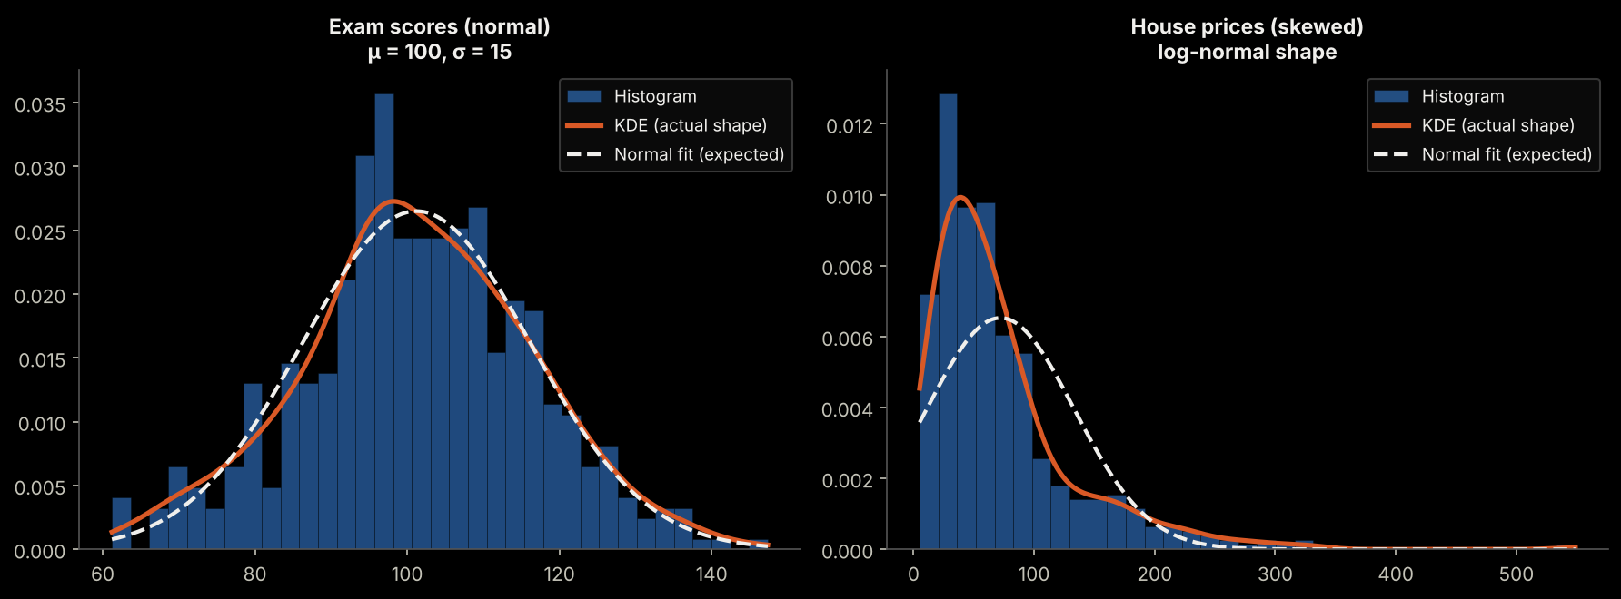
What to look for in a Histogram:
- ✅ Bell-shaped curve: symmetric, single peak in the middle → likely normal
- ❌ Multiple peaks: bimodal or multimodal → definitely not normal
- ❌ Long tail on one side: skewed distribution
- ❌ Flat shape: uniform or platykurtic distribution

6.2 Method 2: Q-Q Plot (Quantile-Quantile Plot)
A Q-Q plot is a picture that answers one question: "If my data were truly normal, where would each of my data points sit — and do they really sit there?" It compares your data against a perfect normal distribution, point by point. If every dot lands on a straight line, the data is normal.
The 5 steps in one glance
- Sort your data from smallest to largest.
- Give each value a percentile (its position in the sorted list, as a %).
- For each percentile, look up the z-value a perfect normal distribution would have there (the "theoretical quantile").
- Pair them: smallest data value with smallest z, 2nd smallest with 2nd smallest, and so on. Plot one dot per pair.
- Check whether the dots form a straight line. Straight = normal. Bent = not normal, and the way it bends tells you why.

Step 0: What is a quantile?
A quantile is a cut-off value that splits sorted data into parts. The median is the 50% quantile: half of the values are below it. The 25% quantile (Q1) has a quarter of the values below it. In a Q-Q plot every data point acts as its own quantile.
Example: if 10 students are sorted by marks, the 3rd lowest student sits at about the 25th percentile — 25% of the class scored lower or equal.

Step 1: Sort the data and give every value a percentile
Sort the n values from smallest to largest. The value with rank i gets the percentile (i − 0.5) ÷ n. The "− 0.5" simply puts each point in the middle of its own slice, so the smallest value is not 0% and the largest is not 100%.
- With n = 10 values: rank 1 → 5%, rank 2 → 15%, rank 3 → 25% ... rank 10 → 95%.
- With n = 100 values: rank 1 → 0.5%, rank 50 → 49.5%, rank 100 → 99.5%.
(Other tools use slightly different formulas, for example (i − 0.375) ÷ (n + 0.25). The picture they draw is almost identical.)

Step 2: Where does the "ideal normal" to compare with come from?
Nothing random is generated. The comparison distribution is the standard normal curve (mean 0, standard deviation 1), whose shape we already know exactly. We cut the area under this bell curve into n slices of equal area, each holding 1/n of the probability. With 10 data points that is ten slices of 10% each. Then, for every slice, we find the z-value that cuts that slice exactly in half. These z-values are called the theoretical quantiles: they are the values a perfectly normal sample of this size would be expected to have.
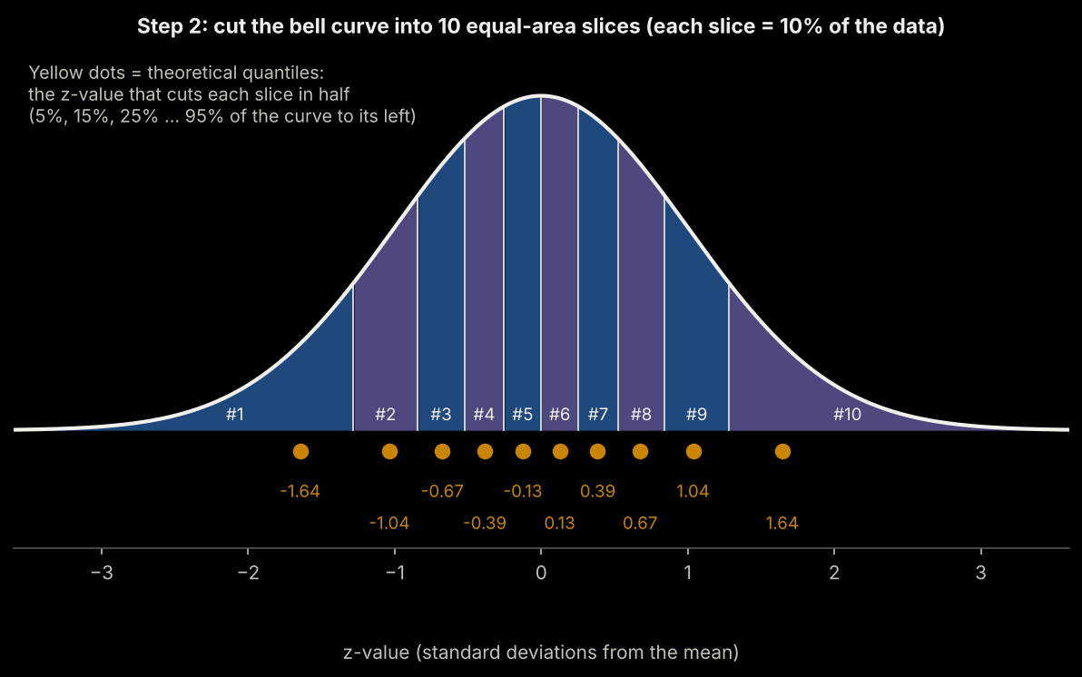
Notice that the z-values are bunched up near the centre and spread out at the ends. That is exactly how a normal distribution behaves: many values in the middle, few at the extremes.

Step 3: Pair them up and plot
The smallest data value is paired with the smallest z-value, the 2nd smallest with the 2nd smallest z, and so on. Each pair becomes one dot: x = the theoretical z-value (what a normal distribution would give), y = your actual value (what you really have).
Worked example: heights (in cm) of 10 students
Mean = 167.0 cm, standard deviation = 8.34 cm. The last column converts each height into its own z-score: (height − mean) ÷ SD.

Rank i | Sorted height (cm) | Percentile (i − 0.5) ÷ 10 | Theoretical z (normal) | Data's own z-score
1 | 154 | 5% | -1.64 | -1.56
2 | 158 | 15% | -1.04 | -1.08
3 | 161 | 25% | -0.67 | -0.72
4 | 163 | 35% | -0.39 | -0.48
5 | 166 | 45% | -0.13 | -0.12
6 | 168 | 55% | 0.13 | 0.12
7 | 170 | 65% | 0.39 | 0.36
8 | 173 | 75% | 0.67 | 0.72
9 | 176 | 85% | 1.04 | 1.08
10 | 181 | 95% | 1.64 | 1.68

Look at the last two columns: on every row the theoretical z and the data's own z-score are almost the same. The correlation between the two columns is 0.999 (1.000 would be perfect). That is exactly what "normal" looks like.

Step 4: Why normal data becomes a straight line
Any value from a normal distribution can be written as:
height = mean + SD × z
That is the equation of a straight line (y = intercept + slope × x), where the intercept is the mean and the slope is the standard deviation.
- If the data really is normal, plotting (z, value) MUST give a straight line.
- If the shape is not normal, the dots bend away from the line.
- We never ask "is it curved?" — we ask "is it straight?", which the human eye judges very well.

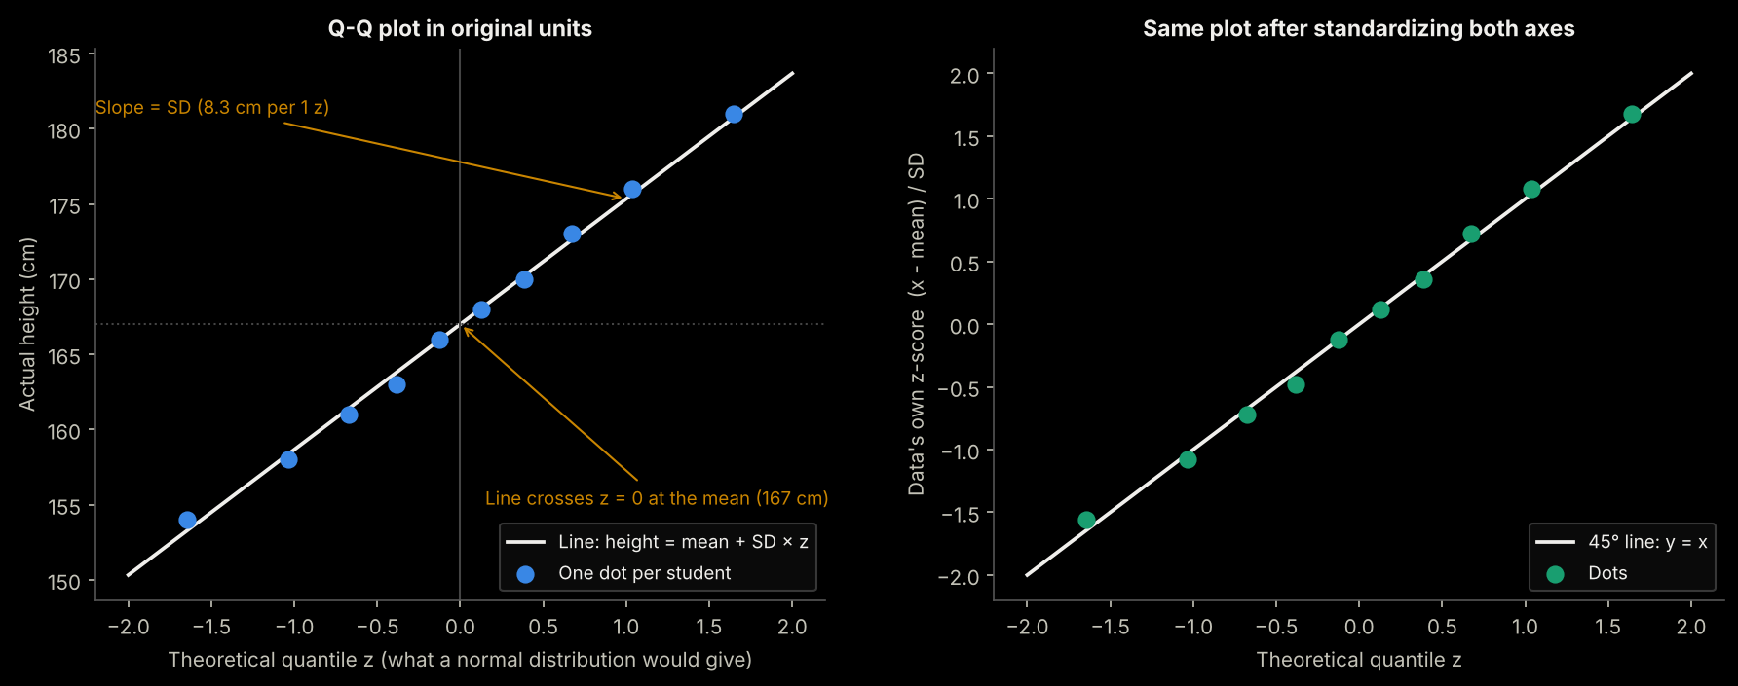
Left: original units (the line's intercept is the mean, its slope is the standard deviation). Right: both axes converted to z-scores, so the reference line becomes the 45° diagonal.
How the data is "converted into a straight line to compare": many tools standardize the data first (subtract the mean, divide by the SD). Then the ideal reference is simply the 45° diagonal y = x: dots on the diagonal mean normal. Both versions show the same picture; they differ only in the units on the y-axis.
About the reference line: some tools fit it through all the dots (regression); others draw it through the 25th and 75th percentile points, which ignores outliers. Either is fine for reading shapes.

Step 5: What do the different shapes mean?
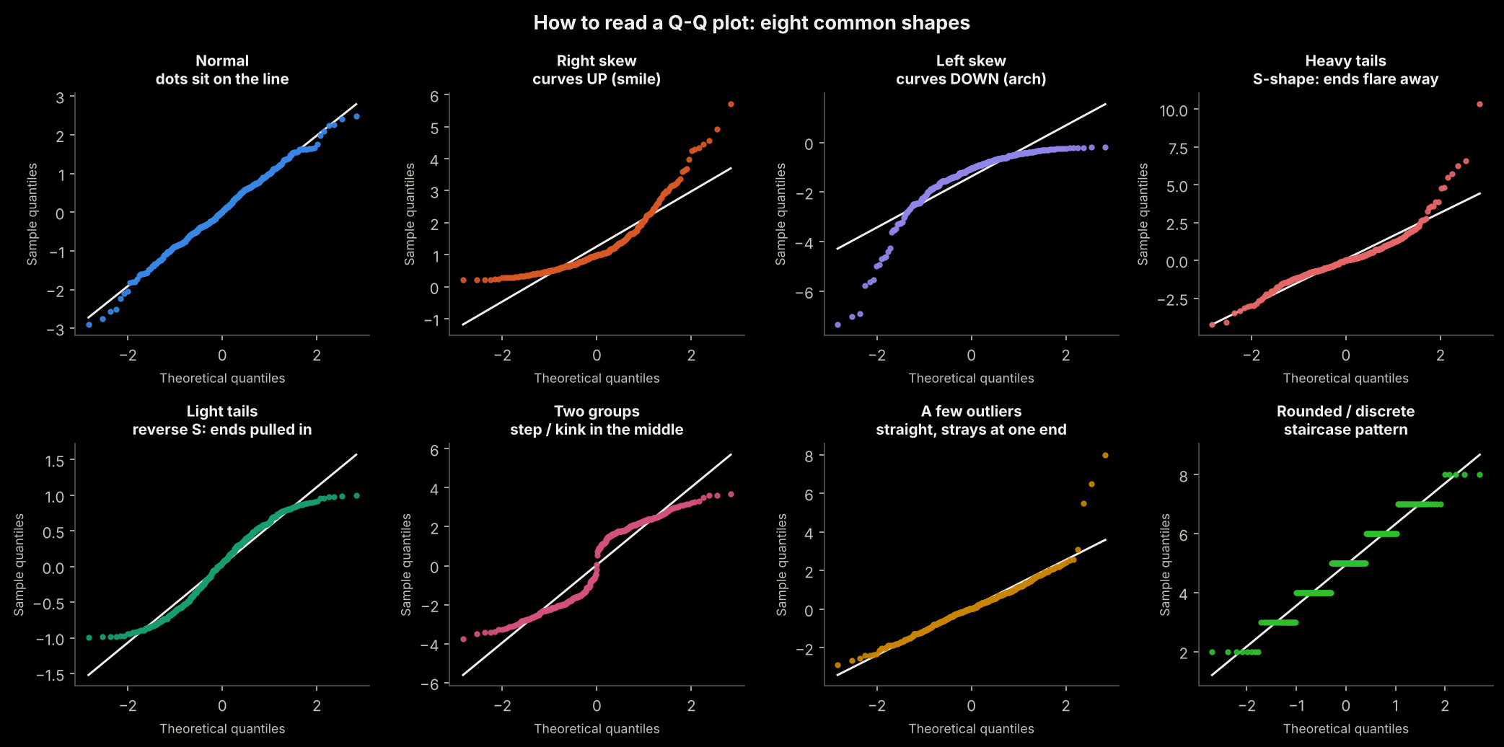
What you see | What it tells you about the data | Real-world example | What to do
Dots on the line | Approximately normal | Adult heights | Nothing — the normal assumption is fine
Curves UP like a smile (convex) | Right skew: long tail to the right | Salaries, house prices | Log, square root or Box-Cox
Curves DOWN like an arch (concave) | Left skew: long tail to the left | Marks in an easy exam | Square, cube, reflect + log, or Yeo-Johnson
S-shape: low end below the line, high end above it | Heavy tails: more extreme values than normal | Daily stock returns | Check outliers; use robust methods or the t-distribution
Reverse S: ends pulled in toward the middle | Light tails: fewer extremes than normal (flat-topped) | Dice rolls, uniform data | Usually harmless
Straight, but a few dots far away at one end | A few outliers | A data-entry error (999 instead of 99) | Investigate; fix errors before transforming
A step or kink in the middle | Two groups mixed together (bimodal) | Heights of men and women combined | Split into groups; no transform fixes this
Staircase of flat runs | Discrete or rounded values | Ratings 1-5, ages in whole years | A Q-Q plot is a poor fit; judge by other means

🧠 Memory trick
- Curve = skew. S-shape = tails. Straight with strays = outliers. Step = two groups.

Limits and tips
- With small samples (n < 30) dots wobble around the line even when the data is truly normal — do not over-read small wiggles.
- With huge samples even a tiny, harmless bend becomes visible — ask whether the bend is big enough to matter.
- Always read the Q-Q plot together with the histogram and the skewness / kurtosis numbers.
- For regression, draw the Q-Q plot of the residuals (prediction errors), not of the raw features.

6.3 Method 3: Statistical Tests for Normality
Test | Best Used When | How It Works
Shapiro-Wilk | Best for small samples (n < 5,000) Small to medium samples (up to about 5,000) | W statistic + p-value. p > 0.05 → cannot reject normality
D'Agostino-Pearson | Best for medium to large samples (n > 50) | Combines skewness + kurtosis tests into one
Kolmogorov-Smirnov | For large samples or comparing distributions | Compares empirical CDF to theoretical CDF
Anderson-Darling | Sensitive to tail behaviour | Better at detecting non-normality in tails
Jarque-Bera | Used heavily in finance/econometrics | Based on skewness and kurtosis combined

⚠ Important: What "p > 0.05" Means in Normality Tests
- p > 0.05: "We cannot reject normality" → data may be normal
- p ≤ 0.05: "We REJECT the null hypothesis of normality" → data is NOT normal
Warning: With very large samples (n > 1,000), these tests detect even tiny, meaningless deviations from normality. Always combine statistical tests with visual inspection! (p-values are explained in Section 9.)

Section 7: How to Convert Non-Normal Data to Normal
When your data is skewed or non-normal, you can apply mathematical transformations to make it more normal. This section first explains why we do it (and why simply using the median is not enough), then shows each transformation.

7.1 Why Do We Transform Data? Can't We Simply Use the Median?
A natural question: if outliers pull the mean around, why not report the median and move on? The honest answer: sometimes you can — but only for one specific job.

7.1.1 What the median is good at
The median answers: "What does a typical value look like?" It is not moved by extreme values, so for describing the centre of skewed data (salaries, house prices, waiting times) it is the right summary. If the top earner's salary changes from $2 million to $20 million, the median does not change at all.

7.1.2 Why the median is not enough
Job to be done | Can the median do it? | Why / example
Describe the typical value | Yes | The median salary of $47,500 describes the typical employee well.
Find a total (budget, payroll, revenue, claims) | No | Total = mean × count. The payroll of the 8 employees in Section 8.2 is $2,950,000. Median × 8 = $380,000 — an 87% underestimate.
Predict a value from other features (regression, ML) | No | A median is one fixed number. It cannot say that a bigger house costs more. A model must learn how the target changes with each feature.
Train algorithms that use every value (linear / logistic regression, neural networks, K-means, KNN) | No | These algorithms add up squared errors or distances, so they see every value. Extreme values get huge pull. A transformation tames them; one median cannot be plugged in.
Build confidence intervals and run standard tests | Only partly | The mean has a simple formula for its uncertainty (σ / √n) and becomes normal by the CLT. The median has no simple formula — you need bootstrapping.
Combine groups | No | The overall mean follows from group means and sizes. The overall median cannot be calculated from group medians.

🏥 Real-world example: why an insurer cannot price with the median
An insurance company pays out the TOTAL of all claims. Most claims are small, but a few are huge. If it set premiums using the median claim, it would collect far less than it pays out and lose money. The mean (which includes the huge claims) is the number that balances the books.
The lesson: the median tells you about the typical customer; the mean tells you about the total bill. Different questions need different numbers.

7.1.3 What a transformation actually gives you
A transformation keeps ALL your data but squeezes the long tail, so the numbers behave better. After a log transform, outliers no longer dominate, the shape is closer to a bell curve, and mean-based tools (regression, z-tests, t-tests, confidence intervals) become reliable. Relationships also often turn into straight lines.
💡 The median and the log transform get along very well
- The median of log(x) is exactly the log of the median of x. A monotonic transformation never moves the middle value.
- The average of the logged values, converted back with exp() (called the geometric mean), lands close to the median for skewed data such as salaries.
- So the log transform lets you use the powerful mean-based tools, while the answer you report still describes a "typical" value.

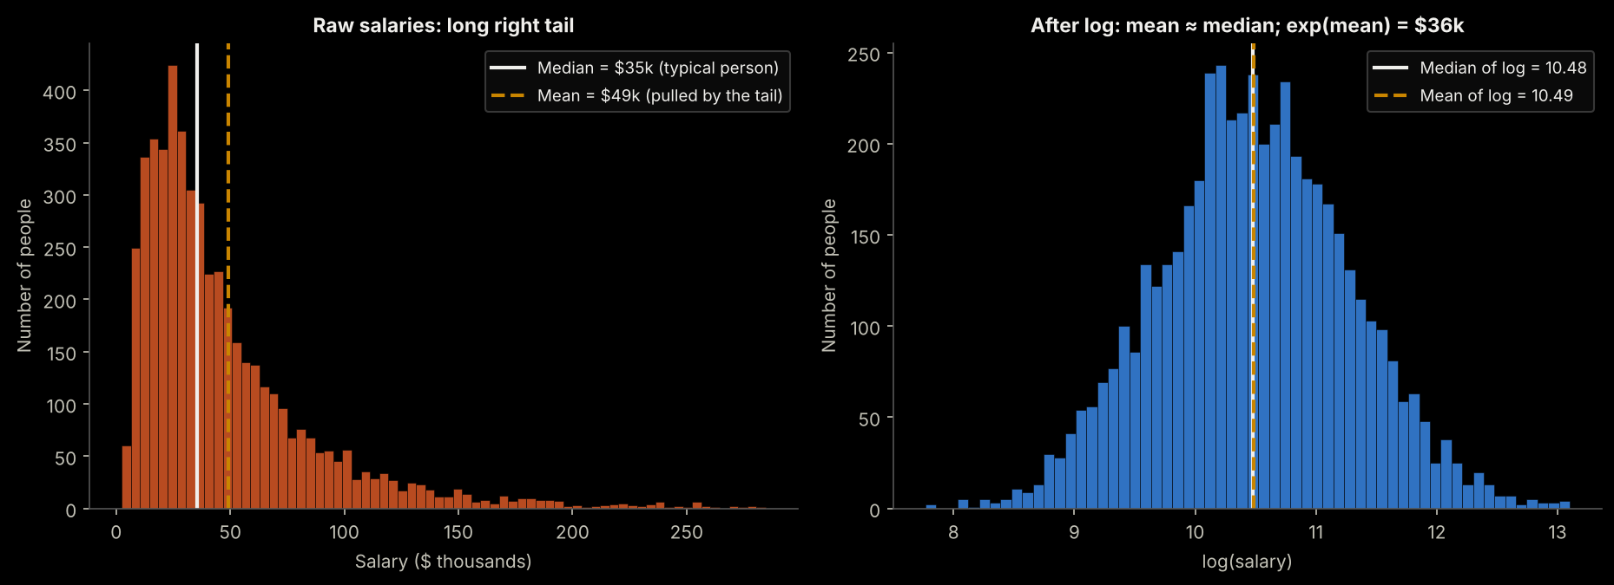
Simulated salaries. Raw data: mean $49k is pulled far above the median $35k. After the log, mean and median coincide, and exp(mean of log) = $36k is close to the median.
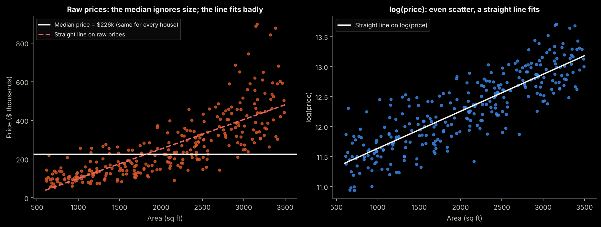
Left: the median is one flat number for every house, and a straight line on raw prices fits badly. Right: after the log, the scatter is even and a straight line fits well.

7.1.4 So which one should I use?
Situation | Best choice
Describing a typical value in a report | Median (add the IQR to show the spread)
Need totals, budgets or expected loss | Mean of the original data
Building a model or a test that assumes normality | Transform (log / Box-Cox / Yeo-Johnson), model, then back-transform
Outliers are mistakes | Fix or remove the errors first — do not transform them away
Outliers are real, and you do not want to transform | Robust methods: trimmed mean, winsorizing, median (quantile) regression, tree-based models
Not sure | Report mean AND median. A big gap between them is a warning sign of skew

7.1.5 The cost of transforming
- Results are on a different scale (for example log-dollars), so you must back-transform before reporting (see Section 8).
- A transformation cannot fix errors in the data, or two groups mixed together.
- Interpretation changes: effects become percentage (multiplicative) changes instead of fixed-amount changes.

7.2 The Transformation Toolbox at a Glance
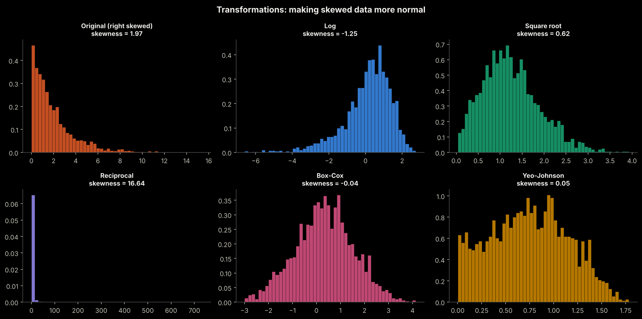

7.3 Log Transformation — Most Common
📐 Log Transformation: log(x)
Best for: Right-skewed data with large positive values.
Requirement: All values must be POSITIVE (> 0). If data has zeros, use log(x + 1).
Real-world use cases:
- Income / salary data
- House prices
- Population sizes
- Website traffic counts
- Any data that grows exponentially

7.4 Square Root Transformation
√ Square Root Transform: √x
Best for: Moderately right-skewed data. Gentler than log transform.
Requirement: All values must be NON-NEGATIVE (≥ 0).
- Count data (number of customer complaints)
- Poisson-distributed data
- Moderate skew that log over-corrects

7.5 Box-Cox Transformation
⚙ Box-Cox Transform
A powerful, flexible family of transforms that automatically finds the best power (λ).
Requirement: All values must be STRICTLY POSITIVE (> 0).
How it works: Tests many values of λ and picks the one that makes data most normal.
- λ = 0 → log transform
- λ = 0.5 → square root transform
- λ = 1 → no transformation (original data)
- λ = −1 → reciprocal (1/x) transform

7.6 Yeo-Johnson Transformation
🔧 Yeo-Johnson Transform
Works like Box-Cox but ALSO handles zero and negative values.
Requirement: Works on any real-valued data (positive, zero, or negative).
Use this instead of Box-Cox when your data contains zeros or negative numbers.
Implemented in sklearn's PowerTransformer.

7.7 Choosing the Right Transformation
Situation | Recommended Transform | Examples
Right skewed, all positive | Log transform: log(x) | Salary, prices, populations
Right skewed, has zeros | Log(x+1) or Square root | Count data, website visits
Moderate right skew | Square root: √x | Complaint counts, distances
Any skew, all positive | Box-Cox (auto-optimised) | General purpose for positive data
Any skew, zeros or negatives | Yeo-Johnson (auto-optimised) | Temperature change, financial returns
Left skewed | Square, cube, or reflect+log | Test scores in easy tests
Bimodal (two peaks) | Cannot fix with transform | Check if data has two subgroups

Section 8: Is Transforming Data "Cheating"? Does It Give Wrong Results?
🤔 This Is One of the Most Important Questions in Applied Statistics
The short answer: No, transformation is NOT cheating — IF done correctly and interpreted correctly.
The long answer: Read on. This is nuanced and critical to understand.

8.1 What Transformation Actually Does
A transformation does NOT change the data or make up fake information. It changes the SCALE on which you view the data. The actual ordering and relationships between data points remain intact.
🌡 Analogy: Changing Units Is Not Cheating
Imagine you measure temperature in Celsius. Converting to Fahrenheit does not change reality — you just view the same data on a different scale.
Similarly, when we take log(salary), we are not changing who earns more — we are just changing the scale to make differences more symmetric and visible.

8.2 Salary Example — Worked Through Step by Step
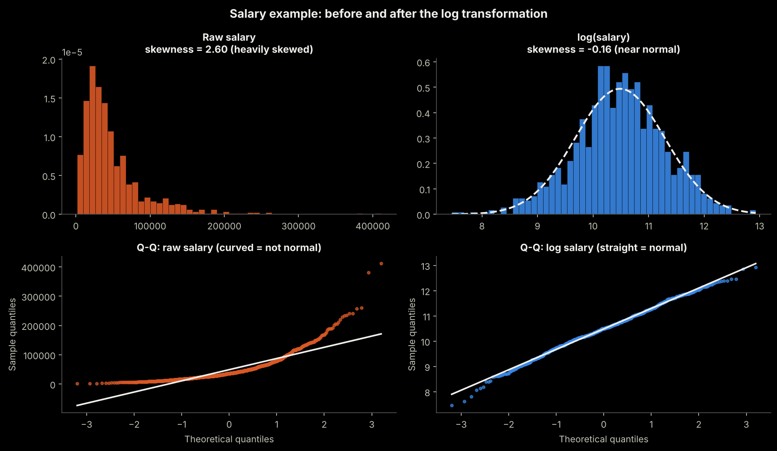

The Original Problem
Salary data: [30,000 35,000 40,000 45,000 50,000 250,000 500,000 2,000,000]
- Mean salary: $368,750 — pulled up by 3 high earners
- Median salary: $47,500 — what the "typical" person earns
- A linear regression on this data would have TERRIBLE residuals — outliers dominate the model

After Log Transformation
Log values: [10.3, 10.5, 10.6, 10.7, 10.8, 12.4, 13.1, 14.5]
- Now the distribution is much more symmetric
- Regression works far better
- The log scale means: $30k vs $300k is the same "distance" as $300k vs $3M
- This makes intuitive sense — we think of salary differences in percentages, not absolute dollars

💡 Key Insight: Transformation Reveals a Different Truth
- Raw scale: "$250,000 is 5 times better than $50,000" (absolute)
- Log scale: "$250,000 is a proportional step up from $50,000" (percentage)
Neither is wrong — they answer DIFFERENT questions. For most human decisions and many statistical models, the log (multiplicative) relationship is more meaningful.

8.3 House Price Prediction — A Complete Example
# BEFORE transformation — Problem
# Training data: mostly houses $200k-$500k, a few mansions at $5M-$10M
# Result WITHOUT transformation:
# - Model dominated by mansions (they have huge residuals)
# - For average $300k houses, predictions are terrible

# AFTER log transformation — Solution
import numpy as np
from sklearn.linear_model import LinearRegression

# Transform target variable
df["log_price"] = np.log(df["price"])

# Train model on log scale
model = LinearRegression()
model.fit(X_train, df["log_price"])

# Predict and convert BACK to original dollar scale
log_predictions = model.predict(X_test)
price_predictions = np.exp(log_predictions) # Reverse the log

# Now a $10k error on a $100k house = same proportional weight
# as a $100k error on a $1M house

8.4 When Does Transformation Give Wrong Information?
❌ Transformation CAN mislead if you:
- Forget to inverse-transform predictions before reporting them (reporting log($) instead of actual $)
- Apply the wrong transform (e.g., log on left-skewed data — makes it worse)
- Interpret a log-scale coefficient as linear (a coefficient of 0.5 in log-space means ~65% increase, not $0.50 more)
- Transform when skew is caused by data quality issues — fix the data error first
- Use log on count data with many zeros — log(0) is undefined; use count models instead

8.5 The Golden Rule of Transformations
✅ Golden Rule: Transform → Model → Inverse-Transform → Interpret
- Transform your skewed data (e.g., log(x))
- Build and evaluate your model in the transformed space
- Inverse-transform all predictions back to the original scale (e.g., exp(prediction))
- Communicate results in the original, interpretable scale
Example: Model predicts log(salary) = 11.2 → exp(11.2) = $73,130 — this is the actual predicted salary.
The transformation is a tool, not a final destination.

Section 9: The p-value in Simple Words

9.1 The Idea in One Sentence
The p-value answers one question:
"If nothing special is going on (the boring explanation is true), how often would I still see a result at least this extreme, just by luck?"
- Small p-value → "This would rarely happen by luck" → the boring explanation looks doubtful.
- Large p-value → "This happens by luck quite often" → no real evidence against the boring explanation.

9.2 A Real-World Story
🏭 Light-bulb maker
A factory claims its bulbs last 1,000 hours on average. A quality inspector tests 36 bulbs and finds an average of 1,015 hours. Is the factory telling the truth, or are the bulbs really better?
- Boring explanation (null hypothesis, H0): the true average is still 1,000 hours, and the extra 15 hours is just luck of which bulbs we picked.
- Interesting explanation (alternative, H1): the true average is NOT 1,000 hours.
- The p-value tells us how often luck alone would give an average this far from 1,000 (15 hours or more, in either direction). Here it is 0.0719, about 7.2%.
That is more than 5%, so luck explains it fairly easily. We have no solid evidence that the bulbs differ from the claim.

9.3 The p-value Is a Tail Area
After converting our result into a z-score, the p-value is simply the area under the bell curve beyond that z-value. The further out the z-score, the smaller the tail, and the smaller the p-value.
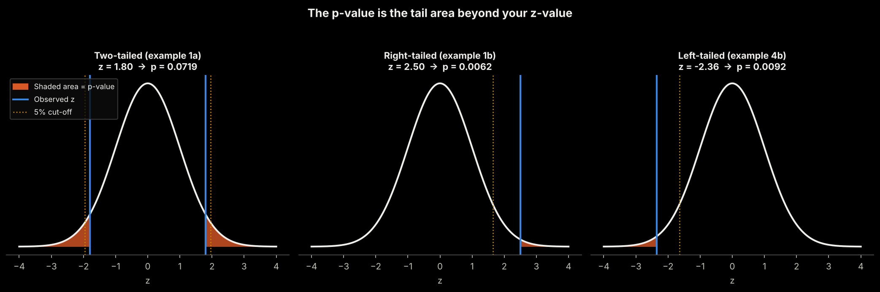
Orange area = p-value. Left: two-tailed (different in either direction). Middle: right-tailed (bigger). Right: left-tailed (smaller).

9.4 Significance Level α and the Decision Rule
Before looking at the data, choose a cut-off called α (alpha), usually 0.05 (5%). It is the amount of "false alarm" risk you accept.
Result | Decision | Plain meaning
p ≤ α (e.g. 0.01) | Reject H0 | Result is "statistically significant": hard to explain by luck alone
p > α (e.g. 0.20) | Fail to reject H0 | Luck could easily explain it: not enough evidence

Common α | Critical z (two-tailed) | Critical z (one-tailed) | Used when
0.10 | ±1.645 | 1.282 | Early exploration; cheap mistakes
0.05 | ±1.960 | 1.645 | The usual standard in business, education, marketing
0.01 | ±2.576 | 2.326 | Medicine, safety, expensive decisions

9.5 One-Tailed or Two-Tailed?
Type | Question you ask | p-value is | Example
Two-tailed | Is it DIFFERENT (higher or lower)? | 2 × tail area | Is the average bulb life different from 1,000 hours?
Right-tailed | Is it HIGHER? | area to the right | Did the new teaching method raise marks?
Left-tailed | Is it LOWER? | area to the left | Is customer satisfaction below the promised 90%?
Decide the direction BEFORE seeing the data. Choosing one-tailed after peeking, just to get a smaller p-value, is cheating.

9.6 Quick z → p Table
z-value (distance from H0) | Two-tailed p | One-tailed p
1.000 | 0.3173 | 0.1587
1.645 | 0.1000 | 0.0500
1.960 | 0.0500 | 0.0250
2.326 | 0.0200 | 0.0100
2.576 | 0.0100 | 0.0050
3.000 | 0.0027 | 0.0013

9.7 Myth vs Truth
Myth | Truth
"p = 0.03 means there is a 3% chance H0 is true." | It means: if H0 were true, results this extreme would appear about 3% of the time. It is not the chance that H0 is true.
"p > 0.05 proves H0 is true." | It only means we lack evidence against H0. Absence of evidence is not proof of absence.
"A tiny p-value means a big, important effect." | With millions of users even a trivial effect gets a tiny p. Always check the effect size (Q9 in Section 12).
"p = 0.049 is a win and p = 0.051 is a failure." | They are nearly identical evidence. 0.05 is a convention, not a law of nature.

Section 10: The z-Test

10.1 What Is a z-Test?
A z-test checks whether a sample result (an average or a percentage) is far enough from a claimed value, or from another group, to be more than luck. It works by converting the difference into a z-score, "how many standard errors away from the claim are we?", and then reading the p-value from the normal curve.
The universal z-test recipe
z = (what we observed − what H0 claims) ÷ standard error
- State H0 (nothing special) and H1 (what you suspect), and pick α.
- Compute the observed value (sample mean or proportion).
- Compute the standard error (SE): the typical amount the result wobbles by luck.
- Compute z = (observed − claimed) ÷ SE.
- Convert z to a p-value. Compare with α and decide.

10.2 Does the Data Need to Be Normally Distributed?
Short answer: the SAMPLE MEAN must be (about) normal. The raw data does not have to be.
The z-test uses the normal curve to judge the sample mean (or proportion). By the Central Limit Theorem (Section 2), sample means become normal as the sample grows, even when the raw data is skewed.

Situation | Is a z-test OK? | Why
Population is normal AND population σ is known | Yes, any n | The sample mean is exactly normal
Population shape unknown, n ≥ 30, σ known (or very well estimated) | Yes | CLT makes the sample mean approximately normal
Very skewed data (salaries, claims), n between 30 and about 100 | Yes Careful | CLT may need more data; check a histogram or Q-Q plot, consider a log transform or bootstrap
Small sample (n < 30), non-normal data | No | Use a nonparametric test, or a transformation, or the bootstrap
σ unknown and n small | No: use a t-test | Estimating σ adds extra uncertainty that the t-distribution accounts for
Proportions | Yes if n·p ≥ 10 and n·(1−p) ≥ 10 | Then the count of successes is approximately normal

Also required for every z-test: the observations are independent (one customer's answer does not influence another's), and the sample is random or representative.
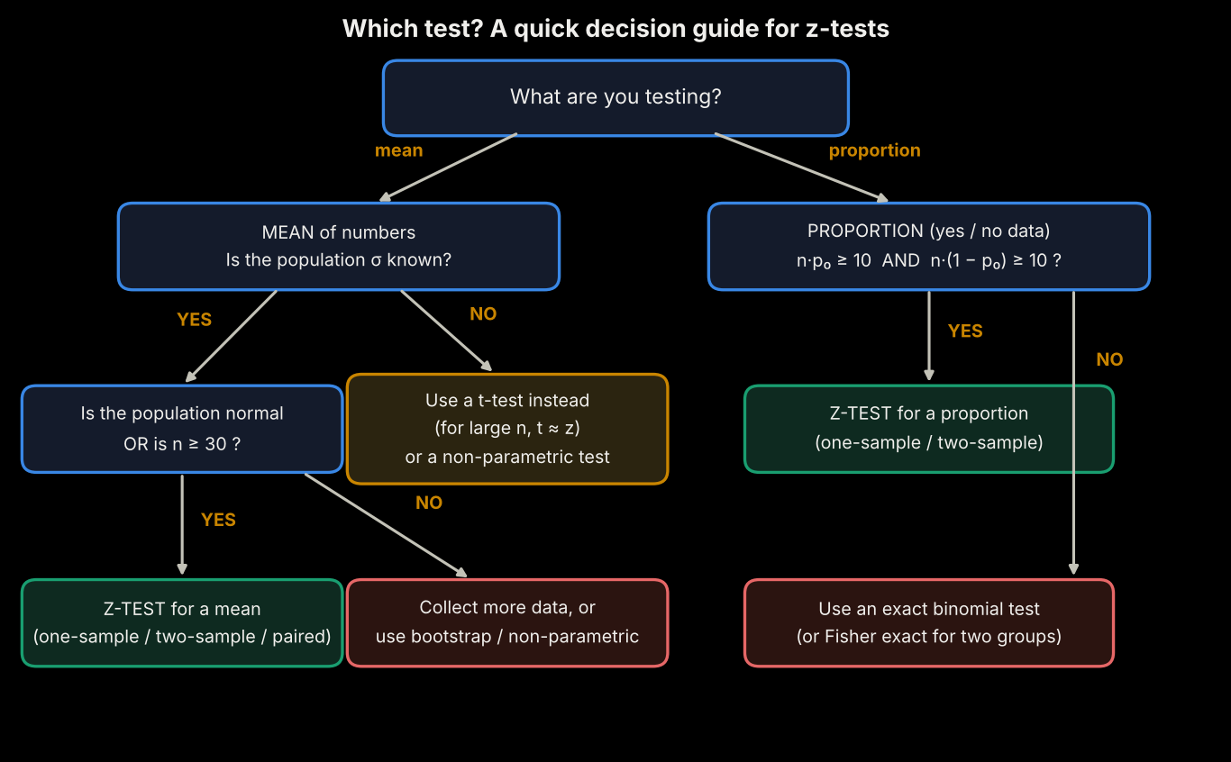
Decision guide: which z-test do I need?

10.3 The Five Types of z-Test at a Glance
# | Type | Question it answers | Formula (z = ...)
1 | One-sample (mean) | Is our average different from a claimed value? | (x-bar − μ0) ÷ (σ / √n)
2 | Two-sample (means) | Do two separate groups have different averages? | (x-bar1 − x-bar2) ÷ √(σ1²/n1 + σ2²/n2)
3 | Paired (means) | Did the SAME people change between before and after? | d-bar ÷ (σd / √n)
4 | One-proportion | Is our percentage different from a claimed percentage? | (p-hat − p0) ÷ √(p0(1−p0)/n)
5 | Two-proportion | Do two groups have different percentages? | (p-hat1 − p-hat2) ÷ √(p-pooled(1−p-pooled)(1/n1+1/n2))

Here x-bar means sample mean, μ0 the claimed mean, σ the standard deviation, n the sample size, d-bar the average of the before/after differences, p-hat a sample percentage (as a decimal), and p-pooled the combined percentage of both groups.

10.4 Type 1: One-Sample z-Test (Mean)
Use it when you have ONE group and a claimed average, and you want to know whether reality differs from the claim.
Example 1a: Light-bulb life (two-tailed)
Situation: A factory claims bulbs last 1,000 hours (known σ = 50). We test 36 bulbs: average 1,015 hours.
H0 / H1: μ = 1000 vs μ ≠ 1000. α = 0.05
SE: 50 ÷ √36 = 8.33
z: (1015 − 1000) ÷ 8.33 = 1.80
p-value: two-tailed = 0.0719
Decision: p > 0.05 → CANNOT reject H0 (not significant). The 15-hour gain could be luck.

Example 1b: New teaching method (right-tailed)
Situation: Past exam average is 70 (σ = 10). 100 students taught with a new method average 72.5. Did marks go UP?
H0 / H1: μ = 70 vs μ > 70. α = 0.05
SE: 10 ÷ √100 = 1.00
z: (72.5 − 70) ÷ 1.00 = 2.50
p-value: right tail = 0.0062
Decision: p ≤ 0.05 → REJECT H0 (significant). Strong evidence the new method works.

💡 Notice
Same-sized evidence looks different with different sample sizes: 15 hours out of 36 bulbs was not convincing, but 2.5 marks from 100 students was. A larger n shrinks the SE and makes small differences easier to detect.

10.5 Type 2: Two-Sample z-Test (Means of Two Independent Groups)
Use it to compare the averages of TWO different groups of people or items. The groups must be independent: nobody appears in both.
Example 2a: Two filling machines (two-tailed)
Situation: Machine A: 50 bottles, average 500.8 g (σ = 2). Machine B: 40 bottles, average 500.0 g (σ = 2.5). Do they fill differently?
H0 / H1: μA = μB vs μA ≠ μB. α = 0.05
SE: √(2²/50 + 2.5²/40) = 0.486
z: (500.8 − 500.0) ÷ 0.486 = 1.646
p-value: two-tailed = 0.0998
Decision: p > 0.05 → CANNOT reject H0 (not significant). The 0.8 g gap may be luck.

Example 2b: Web page load time (right-tailed)
Situation: Old page: 100 visitors, average load 3.2 s (σ = 0.8). New page: 100 different visitors, average 2.9 s (σ = 0.9). Is the OLD page slower?
H0 / H1: μold = μnew vs μold > μnew. α = 0.05
SE: √(0.8²/100 + 0.9²/100) = 0.1204
z: (3.2 − 2.9) ÷ 0.1204 = 2.491
p-value: right tail = 0.0064
Decision: p ≤ 0.05 → REJECT H0 (significant). The new page is genuinely faster.

10.6 Type 3: Paired z-Test (Before and After on the Same Subjects)
Use it when the SAME people or items are measured twice. Subtract first (after − before for each person), then run a one-sample z-test on the differences against 0. Pairing removes person-to-person variation, which makes it more powerful.
Example 3a: Weight-loss programme (right-tailed)
Situation: 49 people weighed before and after a programme. Average loss 1.5 kg, standard deviation of the losses 5 kg.
H0 / H1: average loss = 0 vs average loss > 0. α = 0.05
SE: 5 ÷ √49 = 0.714
z: 1.5 ÷ 0.714 = 2.10
p-value: right tail = 0.0179
Decision: p ≤ 0.05 → REJECT H0 (significant). The programme works on average.

Example 3b: Coaching class (right-tailed)
Situation: 64 students take a test before and after a coaching class. Average gain 3.2 marks, standard deviation of gains 10.
H0 / H1: average gain = 0 vs average gain > 0. α = 0.05
SE: 10 ÷ √64 = 1.25
z: 3.2 ÷ 1.25 = 2.56
p-value: right tail = 0.0052
Decision: p ≤ 0.05 → REJECT H0 (significant). Coaching helps.

10.7 Type 4: One-Proportion z-Test
Use it when the result is a YES/NO outcome and you compare a percentage with a claimed percentage. The SE uses the CLAIMED proportion p0, because we are asking "if H0 were true...". Check n·p0 ≥ 10 and n·(1−p0) ≥ 10.
Example 4a: Clinic appointment slots (two-tailed)
Situation: A clinic believes half of patients prefer morning appointments. In a survey of 100 patients, 60 chose mornings (60%).
H0 / H1: p = 0.50 vs p ≠ 0.50. α = 0.05
SE: √(0.5 × 0.5 ÷ 100) = 0.050
z: (0.60 − 0.50) ÷ 0.050 = 2.00
p-value: two-tailed = 0.0455
Decision: p ≤ 0.05 → REJECT H0 (significant). Mornings are genuinely more popular (a borderline result; collect more data if the decision is costly).

Example 4b: Customer satisfaction promise (left-tailed)
Situation: A retailer promises that 90% of customers are satisfied. A survey of 200 customers finds 170 satisfied (85%). Is satisfaction BELOW the promise?
H0 / H1: p = 0.90 vs p < 0.90. α = 0.05
SE: √(0.9 × 0.1 ÷ 200) = 0.0212
z: (0.85 − 0.90) ÷ 0.0212 = -2.357
p-value: left tail = 0.0092
Decision: p ≤ 0.05 → REJECT H0 (significant). The promise is not being met.

10.8 Type 5: Two-Proportion z-Test
Use it to compare the percentages of two independent groups, the standard A/B test. Under H0 both groups share the same true percentage, so we combine (pool) them to estimate it: p-pooled = total successes ÷ total people.
Example 5a: Email subject lines (two-tailed)
Situation: Subject A: 120 opens out of 1,000 emails (12%). Subject B: 150 opens out of 1,000 (15%). Different open rates?
H0 / H1: pA = pB vs pA ≠ pB. α = 0.05
Pooled: (120 + 150) ÷ 2000 = 0.135
SE: √(0.135 × 0.865 × (1/1000 + 1/1000)) = 0.01528
z: (0.15 − 0.12) ÷ 0.01528 = 1.963
p-value: two-tailed = 0.0496
Decision: p ≤ 0.05 → REJECT H0 (significant) (barely!). Subject B looks better; p is right on the edge, so confirm with a repeat test.

Example 5b: Two advertisements (two-tailed)
Situation: Ad A: 40 clicks from 400 viewers (10%). Ad B: 64 clicks from 400 viewers (16%). Is one ad better?
H0 / H1: pA = pB vs pA ≠ pB. α = 0.05
Pooled: (40 + 64) ÷ 800 = 0.130
SE: √(0.13 × 0.87 × (1/400 + 1/400)) = 0.02378
z: (0.16 − 0.10) ÷ 0.02378 = 2.523
p-value: two-tailed = 0.0116
Decision: p ≤ 0.05 → REJECT H0 (significant). Ad B performs better.

10.9 Summary of All Ten Examples
Ex. | Test | z | p-value | Tail | Decision at α = 0.05
1a | One-sample mean (bulbs) | 1.80 | 0.0719 | two | Not significant
1b | One-sample mean (teaching) | 2.50 | 0.0062 | right | Significant
2a | Two-sample mean (machines) | 1.65 | 0.0998 | two | Not significant
2b | Two-sample mean (web speed) | 2.49 | 0.0064 | right | Significant
3a | Paired (weight loss) | 2.10 | 0.0179 | right | Significant
3b | Paired (coaching) | 2.56 | 0.0052 | right | Significant
4a | One-proportion (clinic) | 2.00 | 0.0455 | two | Significant
4b | One-proportion (satisfaction) | -2.36 | 0.0092 | left | Significant
5a | Two-proportion (emails) | 1.96 | 0.0496 | two | Significant
5b | Two-proportion (ads) | 2.52 | 0.0116 | two | Significant

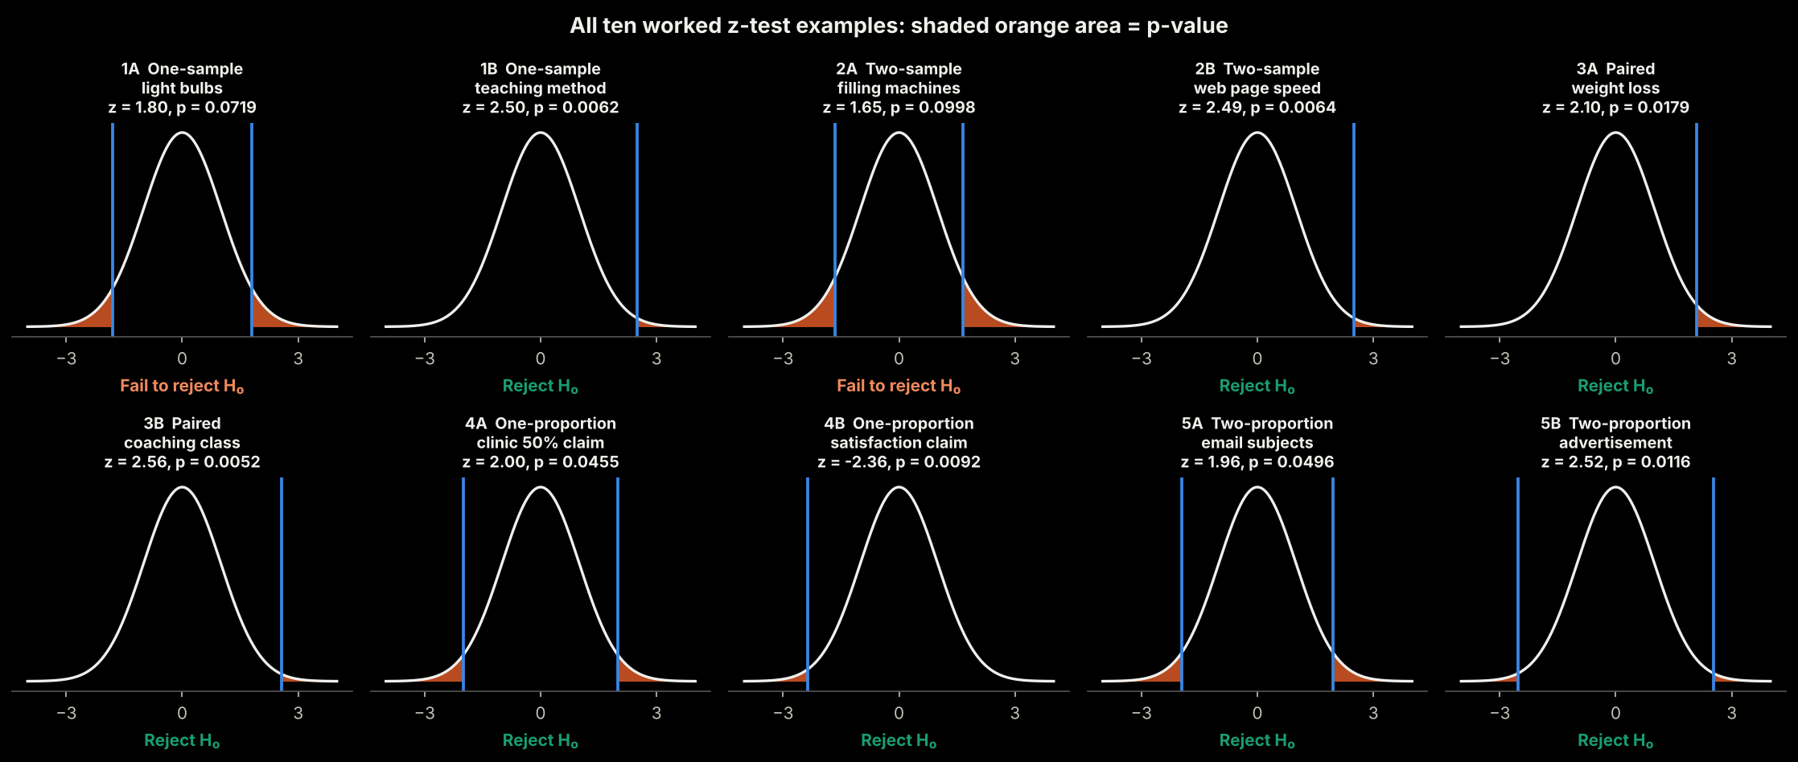

10.10 Common Mistakes
Mistake | Fix
Using a z-test with a tiny, skewed sample | Check the Q-Q plot; transform, use a nonparametric test or bootstrap
Using a z-test when σ is unknown and n is small | Use a t-test
Using a two-sample test on before/after data of the same people | Use the paired test
Choosing one-tailed after seeing the data | Fix the direction and α before collecting data
Using p-hat instead of p0 in the one-proportion SE | Use the claimed p0 under H0
Reading "not significant" as "no effect" | It only means not enough evidence; the sample may be too small

Section 11: Quick Reference Cheat Sheet

11.1 Summary of All Concepts
Concept | Definition / Property | Example / Context
Normal Distribution | Bell-shaped, symmetric curve. Mean = Median = Mode. | 68-95-99.7 rule; basis for most statistical tests
Right (Positive) Skew | Long tail on the right. Mean > Median > Mode. | Income, house prices, viral metrics
Left (Negative) Skew | Long tail on the left. Mean < Median < Mode. | Retirement ages, easy exam scores
Zero Skew | Symmetric. Mean = Median = Mode. | Heights, IQ scores, measurement errors
Leptokurtic | Sharp peak, fat tails. Excess kurtosis > 0. | Stock returns, insurance claims
Platykurtic | Flat peak, thin tails. Excess kurtosis < 0. | Dice rolls, uniform distributions
Mesokurtic | Normal kurtosis. Excess kurtosis = 0. | The baseline normal distribution
Log Transform | log(x). Great for right skew, all-positive data. | Salary, prices, populations
Box-Cox | Auto-finds best power transform. Positive data only. | General purpose positive data
Yeo-Johnson | Like Box-Cox but handles zeros + negatives. | Financial returns, temp changes
Shapiro-Wilk | Normality test. Works up to n = 5,000. | p > 0.05 → likely normal
Q-Q Plot | Sorted data vs normal quantiles. Straight line = normal; curve = skew; S = tails; step = two groups. | Always use alongside statistical tests
Median vs Transform | Median describes the typical value; it cannot give totals or feed models. Transform keeps all data. | Insurance claims, payroll, house prices
Central Limit Theorem | Sample means become normal for n ≥ 30. | SE = σ/√n; powers most hypothesis tests
p-value | Chance of a result at least this extreme if H0 is true (tail area beyond z). | p ≤ 0.05 → reject H0
z-test (means) | z = (observed − claimed) ÷ SE. Needs normal sample mean (n ≥ 30 or normal data, σ known). | Bulbs, teaching method, web speed
z-test (proportions) | Needs n·p ≥ 10 and n·(1−p) ≥ 10. Two-proportion uses the pooled p. | A/B tests, surveys, ads

11.2 Critical z-values
α | Two-tailed | One-tailed
0.10 | ±1.645 | 1.282
0.05 | ±1.960 | 1.645
0.01 | ±2.576 | 2.326

Section 12: Complex Interview Questions & Answers
These are real-world, conceptual questions that test deep understanding, not just memorisation.
⚠ ISSUE FOUND: Interview section had Q1 → Q3 → Q5 → Q6 only. Questions Q2 (Central Limit Theorem) and Q4 (2008 financial crisis / 25-sigma event) were completely missing from the document.
✔ CORRECTED: Q2 and Q4 are fully restored below. New questions Q7, Q8 and Q9 cover Q-Q plots, z-tests and p-values.

Q1: "Your feature has a skewness of 2.5. Should you always transform it before using it in a model?"
💬 Strong Answer:
Not necessarily — it depends on the algorithm and what the skewness represents.
Factors to consider:
- Algorithm choice: tree-based models (Random Forest, XGBoost) do not care about monotonic transformations, so no transformation is needed.
- Linear regression, logistic regression and Gaussian Naive Bayes are sensitive to skew and outliers. Transform.
- Is the skewness real or caused by data issues? Check for entry errors, wrong units, mixed populations.
- Does the skewness have meaning? Income IS skewed in reality; log(income) is often more meaningful than raw income.
- Sample size: with small samples, apparent skewness may just be sampling noise.
Conclusion: check the algorithm requirements first. If a transformation is needed, prefer Box-Cox or Yeo-Johnson as they auto-optimise.

Q2: "Explain how the Central Limit Theorem makes normal distribution practically useful even when data is not normally distributed." ✚ RESTORED
💬 Strong Answer: ✚ RESTORED
The CLT says the sampling distribution of the mean approaches normality as the sample size grows, regardless of the population shape.
Practical implications:
- Hypothesis testing: when we compare average revenue between groups, we compare SAMPLE MEANS. Even if revenue is heavily skewed, the means are approximately normal for large n.
- Confidence intervals: standard-error-based intervals rely on the CLT, so valid 95% intervals exist for skewed data with adequate sample size.
- A/B testing at scale: purchase amounts are extremely skewed (most spend $0, a few spend $500+), but with millions of users the means are normal, making standard z-tests valid.
- Limitation: heavily skewed or fat-tailed data may need n ≥ 200 or more. The standard error equals σ/√n.

Q3: "You log-transform your target variable. RMSE on the log scale is 0.15. How do you report accuracy in dollars to a stakeholder?"
💬 Strong Answer:
You cannot hand a business person an RMSE of 0.15; it means nothing to them.
Step 1: Understand the log-scale RMSE
- RMSE 0.15 on the log scale ≈ predictions are typically off by about 15-16% (e^0.15 ≈ 1.16).
Step 2: Convert predictions back to dollars
- predictions_dollars = exp(predicted log price); actual_dollars = exp(actual log price).
- Compute RMSE or MAE on these dollar values.
Step 3: Report in business language
- "Our model predicts house prices with an average error of about ±$24,000, roughly 8% of a typical house price."
Key warning: NEVER report the naive log-scale RMSE as a dollar figure. Always inverse-transform before computing business metrics.

Q4: "A financial risk model assumed normally distributed returns. In 2008, the model called the crash a 25-sigma event (basically impossible). What went wrong?" ✚ RESTORED
💬 Strong Answer: ✚ RESTORED
This is the classic "fat tails" failure of the normality assumption.
What went wrong:
- Financial returns are NOT normal. They are leptokurtic (fat tails): extreme events happen far more often than the normal curve predicts.
- A 25-sigma event under a normal distribution has essentially zero probability, yet crashes of that apparent size happen within decades.
- Correlations break down in crises. In 2008 everything fell together (tail dependence).
How to fix it:
- Use fat-tailed distributions: Student's t with low degrees of freedom, or stable distributions.
- Use Extreme Value Theory, which models tail events directly.
- Stress test with historical scenarios (2008, the dot-com crash, 1987).
- Model tail dependence with copulas.
- Report Expected Shortfall (CVaR), not just Value-at-Risk.

Q5: "You are asked to impute missing values in a right-skewed salary column. Your colleague suggests using the mean. Do you agree?"
💬 Strong Answer:
No. For right-skewed salary data the mean is a poor imputation value.
- Example: [30k, 35k, 40k, 45k, 50k, 500k, 2M] → mean = $385,714, yet 5 of 7 people earn $30k-$50k.
- Imputing $385k makes missing rows look like high earners and distorts downstream models.
Better alternatives:
- Median imputation ($45,000), which represents the typical employee.
- Conditional median within subgroups (job level, department).
- Model-based imputation (KNN, MICE) using other features.
- Log-scale mean: transform, impute, back-transform (gives the geometric mean).
Follow-up: check whether data is Missing At Random or Missing Not At Random. If high earners systematically hide salary, any simple imputation adds bias.
Note: imputing with the median is fine here because the goal is a typical value for a single missing cell. If the goal were a total payroll, the median would underestimate (Section 7.1).

Q6: "Shapiro-Wilk gives p = 0.03 on your 500,000-row dataset. Your histogram looks like a perfect bell curve. What is happening and what do you do?"
💬 Strong Answer:
Classic statistical vs. practical significance.
- With n = 500,000, the test has enormous power and detects trivial deviations (a skewness of 0.01).
- The p-value says "not a PERFECT normal", true for almost every real dataset.
What to do:
- Trust the histogram and Q-Q plot over the p-value for large samples.
- Check the actual skewness and kurtosis; skewness −0.05 and excess kurtosis 0.12 are practically irrelevant.
- Use effect size: skewness within ±0.5 and excess kurtosis within ±1 are practical thresholds.
- For model assumptions, check RESIDUALS for normality, not the input features.
(Note: Shapiro-Wilk is only reliable up to about 5,000 rows; for 500,000 rows use D'Agostino-Pearson or rely on plots.)

Q7: "Your Q-Q plot of regression residuals is S-shaped: the left end dips below the line and the right end rises above it. What does it mean and what do you do?"
💬 Strong Answer: ✚ NEW
An S-shape (low end below the line, high end above) means heavy tails: the residuals have more extreme errors than a normal distribution would give. The middle of the data is fine; the extremes are the problem.
What to do:
- Look at the extreme points: are they data errors or genuine rare events?
- Check the kurtosis of the residuals (expected > 0).
- Point predictions are usually still fine, but p-values and prediction intervals from the normal assumption become too optimistic.
- Switch to robust methods: Huber regression, quantile regression, t-distributed errors, or bootstrap confidence intervals.
- If the curve was a smile or arch instead of an S, that would signal skew, and a log or Box-Cox transform of the target could help.

Q8: "You run a z-test on customer order values (very right-skewed) with n = 200. A colleague says the test is invalid because the data is not normal. Who is right?"
💬 Strong Answer: ✚ NEW
The colleague is mostly wrong. The z-test needs the SAMPLE MEAN to be approximately normal, not the raw data. With n = 200, the CLT usually delivers that, even for skewed data.
Caveats to mention:
- For extremely skewed data (a few huge orders), n = 200 may still be borderline. Check the bootstrap distribution of the mean.
- If σ is unknown, use the sample SD (with n = 200 the z and t answers are almost identical).
- Orders must be independent (not repeat purchases by one customer).
- A log transform plus a test on the log scale is an alternative, but it tests the geometric mean, not the arithmetic mean.

Q9: "An A/B test gives 10.0% conversion for A and 10.1% for B, with 1,000,000 users in each group, p ≈ 0.019. Do you ship B?"
💬 Strong Answer: ✚ NEW
Statistically significant (z = 2.35, p = 0.019 < 0.05), but that is not the same as practically important.
- The lift is 0.1 percentage points (a 1% relative improvement). With millions of users, even trivial effects get small p-values.
- Compute a confidence interval for the difference and translate it into money: extra conversions × value per conversion, minus the cost of the change.
- Check for novelty effects, segment differences and guardrail metrics (revenue per user, latency).
- Decide with the effect size and business cost, not the p-value alone. If the gain is worth more than the cost, ship it; otherwise don't.
The same logic explains Q6: very large samples make everything "significant".

End of Document — Normal Distribution: A Complete Data Science Field Guide

