myQ Smart Delivery Intelligence
Application Walkthrough
AI-powered package delivery monitoring for your garage — powered by Couchbase

Architecture Overview
SmartDelivery demonstrates Couchbase's full-stack capabilities in a single application:
1. Go Event Generator — Streams 5,000+ delivery events/sec using collection.Do() bulk API with 50 parallel goroutines
2. Couchbase Eventing — Server-side functions automatically enrich raw deliveries: PII redaction, knowledge narrative generation, risk assessment
3. Vector Embedding Pipeline — Second eventing function calls OpenAI to generate 1,536-dim embeddings for semantic search
4. Streamlit Dashboard — Three views (Homeowner, Operations, AI Search) powered by N1QL queries with GSI indexes, KV lookups, and vector search
5. RAG AI Copilot — Conversational Q&A using Couchbase Vector Search for context retrieval and GPT-4o-mini for response generation

1. My myQ — Homeowner View
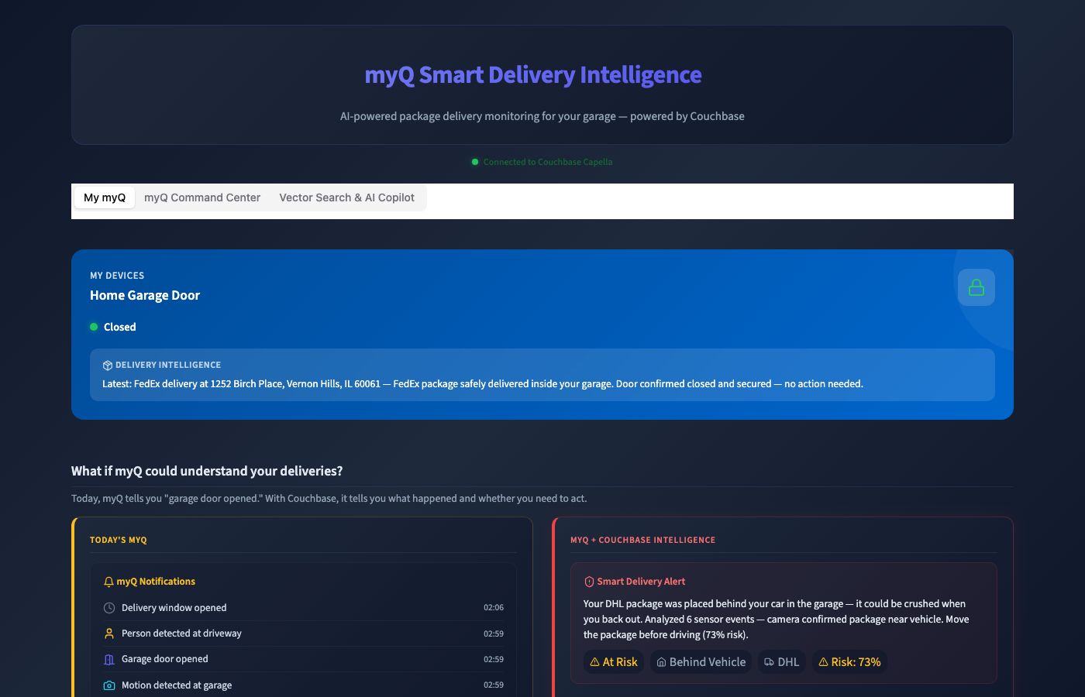

The My myQ tab is the homeowner-facing view. It displays the garage door status, the latest delivery intelligence alert, and a before-vs-after comparison showing the difference between raw myQ sensor events (left) and Couchbase-powered smart delivery alerts (right).
Key features:
- Real-time garage door status (Open/Closed)
- Delivery Intelligence banner with scenario-aware messaging
- Before vs After comparison: raw events vs AI-enriched alerts
- Risk-aware color coding: red for at-risk deliveries, green for safe

2. My myQ — Active Alerts & Recent Activity


Scrolling down on the My myQ tab reveals active alerts and recent delivery activity. Each notification card shows a scenario-aware smart summary generated automatically by Couchbase Eventing — no application code needed.
Key features:
- Active Alerts with risk scores and actionable recommendations
- Recent Delivery Activity cards with per-delivery smart summaries
- 7 scenario types: happy path, package behind car, front door misdelivery, door stuck open, no package placed, delivery timeout, theft/suspicious
- Expandable 'View Couchbase Eventing Pipeline' showing the 3-step enrichment process

3. myQ Command Center — Fleet Overview
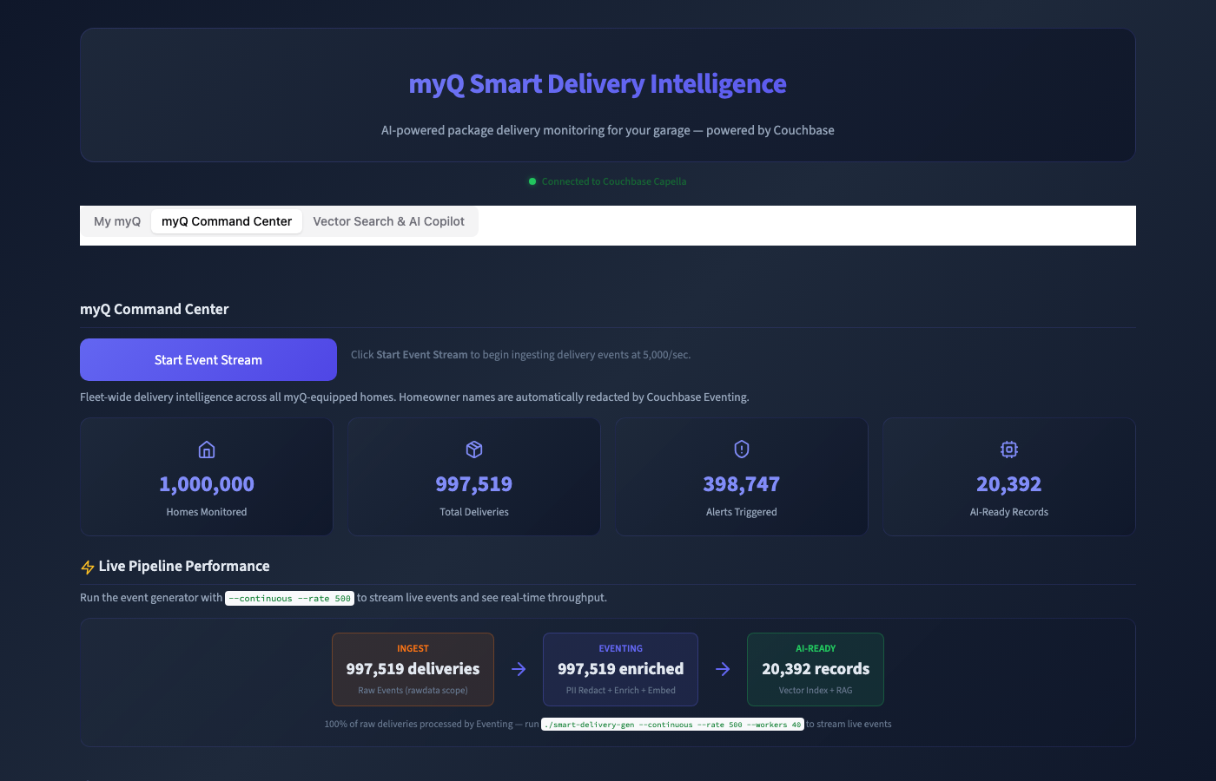

The Command Center is the fleet operations view. It shows aggregate statistics across all monitored homes and provides controls for the event generator.
Key features:
- 1,000,000 Homes Monitored, Total Deliveries, Alerts Triggered, AI-Ready Records
- Start/Stop Event Stream button launching the Go event generator at 5,000 ops/sec
- Auto-stop after 1 million deliveries per session
- Live pipeline performance metrics with real-time ops/sec counter

4. Command Center — Pipeline Performance & PII Redaction


The pipeline performance section shows the real-time data flow from ingestion through Couchbase Eventing to AI-ready records. Below it, the PII Redaction showcase demonstrates automatic name masking by Couchbase Eventing.
Key features:
- Live pipeline flow: Ingest -> Eventing -> Vector Embedding -> AI-Ready
- Automatic PII redaction: 'John Smith' -> 'J*** S***' (server-side, zero app code)
- Raw data vs Processed data side-by-side comparison
- Addresses preserved for operations; only names are redacted

5. Command Center — Alert Feed


The Alert Feed provides a filterable view of all delivery alerts across the fleet. Operators can filter by severity level to triage incidents.
Key features:
- Severity filter: All, Critical, High, Medium, Low
- Color-coded alert cards with severity indicators
- Alert types: theft risk, door stuck, package at risk, misdelivery, etc.
- Address and timestamp for each alert

6. Vector Search & AI Copilot
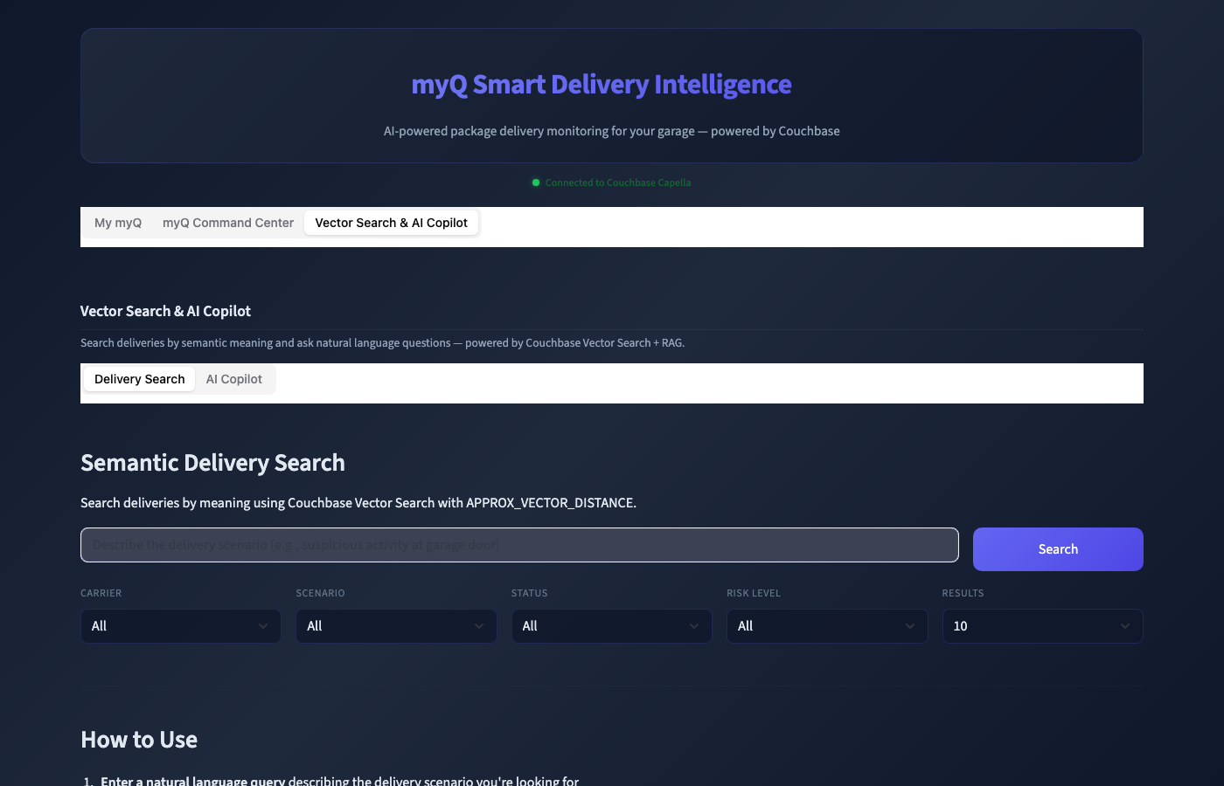

The Vector Search & AI Copilot tab combines semantic delivery search with a RAG-powered conversational AI assistant.
Delivery Search features:
- Natural language queries (e.g., 'suspicious activity at garage door')
- Filters: Carrier, Scenario, Status, Risk Level, Result Limit
- Couchbase Vector Search with APPROX_VECTOR_DISTANCE (1,536-dim embeddings)
- Expandable 'View Couchbase Query' showing the actual SQL++ vector query
AI Copilot features:
- Conversational RAG Q&A over delivery data
- Streaming LLM responses (GPT-4o-mini) with cited delivery IDs
- 5-step RAG pipeline: Embed Query -> Vector Search -> Build Context -> Feed to LLM -> Stream Response
- Cached embeddings for repeat questions (1-hour TTL)

Technology Stack
Component | Technology
Database | Couchbase Capella (Cloud)
Event Generator | Go 1.21+ with gocb/v2 SDK, 50 goroutines, collection.Do() bulk API
Server-Side Logic | Couchbase Eventing (JavaScript, automatic on mutation)
Embeddings | OpenAI text-embedding-3-small (1,536 dimensions)
Vector Search | Couchbase Vector Index with APPROX_VECTOR_DISTANCE
LLM | OpenAI GPT-4o-mini (streaming, RAG)
Frontend | Streamlit 1.53+ with streamlit-shadcn-ui components

