ACADEMIC TASK-2 INT332
(DEVOPS VIRTUALIZATION AND CONFIGURATION MANAGEMENT)

COMPUTER SCIENCE AND ENGINEERING
Submitted by:
Name: Abhijeet Kumar
Registration number: 12303503
Roll No. :- 01
Section: 40M59

Submitted to:
Divya Thakur



LOVELY PROFESSIONAL UNIVERSITY

A Project Report on
AI Resume Analyzer
An AI-Powered ATS Resume Analysis Tool
Built with Python · Flask · Groq AI · Docker · GitHub Actions
GitHub: github.com/abhijeetkumar51
Repository: github.com/abhijeetkumar51/ai-resume-analyzer
Table of Contents
Chapter 1 — Introduction
1.1 Project Overview
1.2 Problem Statement
1.3 Objectives
1.4 Scope
Chapter 2 — System Requirements
2.1 Hardware Requirements
2.2 Software Requirements
Chapter 3 — Workflow
Step-by-step process flow
Chapter 4 — Implementation
4.1 Project Setup Steps
4.2 Project Structure
4.3 Configuration Files
4.4 Application Code (app.py)
4.5 Dockerfile
4.6 GitHub Actions CI/CD (main.yml)
4.7 Docker Commands
4.8 GitHub Repository
Chapter 5 — Results and Output
5.1 Application Home Page
5.2 Resume Upload & Analysis
5.3 ATS Score Display
5.4 Detailed Analysis Results
5.5 CI/CD Build Success
5.6 Docker Image Creation
5.7 Running Container
5.8 Deployed Application
Chapter 6 — Future Scope
Chapter 7 — Conclusion
7.1 Objective Achieved
7.2 Technologies Learned
7.3 Final Outcome

Chapter 1 — Introduction

1.1 Project Overview
The AI Resume Analyzer is an intelligent, AI-powered web application that helps job seekers optimize their resumes for Applicant Tracking Systems (ATS). The application allows users to upload their resume in PDF format and paste a target job description. It then leverages the Groq AI API with the LLaMA 3.3 70B large language model to perform a comprehensive analysis.
The application generates the following outputs:
- ATS Compatibility Score (0–100)
- Matching Skills — skills the candidate already possesses
- Missing Skills — skills the candidate needs to add
- Strengths — strong points of the resume
- Weaknesses — areas that need improvement
- Improvement Suggestions — actionable recommendations
- Overall Summary — a concise 2–3 sentence assessment
The project is fully containerized with Docker, automated with GitHub Actions CI/CD, and deployed on Render for live access.

1.2 Problem Statement
In today's competitive job market, over 75% of resumes are rejected by Applicant Tracking Systems before they ever reach a human recruiter. Job seekers face several critical challenges:
- Lack of ATS awareness — Most candidates are unaware that their resumes are first screened by automated software, not humans.
- Keyword mismatch — Resumes often fail to include the specific keywords and skills mentioned in job descriptions.
- No feedback loop — Candidates submit resumes without knowing why they are being rejected, receiving no actionable feedback.
- Expensive professional review — Professional resume review services cost ₹2,000–₹10,000+ per session, making them inaccessible to many.
- Generic resume tools — Existing free tools provide only basic formatting checks without AI-driven content analysis.
There is a clear need for a free, instant, and intelligent resume analysis tool that can compare a resume against a specific job description and provide detailed, actionable feedback.

1.3 Objectives
The primary objectives of this project are:
- Build an AI-powered resume analyzer using a large language model (LLaMA 3.3 70B via Groq API) to evaluate resume-job description compatibility.
- Extract text from PDF resumes automatically using the PyPDF2 library.
- Generate a quantitative ATS score (0–100) that indicates how well a resume matches a job description.
- Provide qualitative feedback including matching skills, missing skills, strengths, weaknesses, and suggestions.
- Create a modern, responsive web interface using HTML, CSS, and JavaScript with a premium dark-mode design.
- Containerize the application using Docker for consistent, reproducible deployments.
- Automate the build and deployment pipeline using GitHub Actions CI/CD to push Docker images to Docker Hub.
- Deploy the application on Render for public access.

1.4 Scope
In Scope:
- PDF resume upload and text extraction
- Job description text input
- AI-powered analysis using Groq API (LLaMA 3.3 70B model)
- ATS score generation with skill gap analysis
- Responsive, animated web UI with glassmorphism design
- Docker containerization
- CI/CD pipeline with GitHub Actions
- Cloud deployment on Render
Out of Scope:
- Support for non-PDF formats (DOCX, TXT, images)
- OCR for scanned/image-based PDFs
- User accounts, login, and history tracking
- Resume editing or rewriting
- Multi-language support (currently English only)
- Mobile native application
Chapter 2 — System Requirements

2.1 Hardware Requirements
Component | Minimum Requirement | Recommended
Processor | Intel Core i3 / AMD Ryzen 3 | Intel Core i5 / AMD Ryzen 5 or higher
RAM | 4 GB | 8 GB or more
Storage | 2 GB free disk space | 5 GB (including Docker images)
Network | Active internet connection | Broadband connection
Display | 1024 × 768 resolution | 1920 × 1080 or higher

Note: Since the heavy AI computation is performed server-side by the Groq cloud API, the local hardware requirements are minimal. Docker Desktop, if used, benefits from at least 8 GB RAM.

2.2 Software Requirements
Software | Version | Purpose
Python | 3.11+ | Backend runtime
pip | Latest | Python package manager
Flask | 3.0.3 | Web framework
Groq Python SDK | 0.13.0 | AI model API client
PyPDF2 | 3.0.1 | PDF text extraction
Werkzeug | 3.0.3 | WSGI utility (Flask dependency)
python-dotenv | Latest | Environment variable loading
flask-cors | Latest | Cross-Origin Resource Sharing
Docker | 20.10+ | Containerization
Docker Desktop | Latest (optional) | Docker GUI for Windows/Mac
Git | 2.30+ | Version control
VS Code | Latest (optional) | Code editor / IDE
Web Browser | Chrome / Edge / Firefox | Frontend access
Groq API Key | Free tier | AI model access
GitHub Account | Free | Repository hosting and CI/CD
Docker Hub Account | Free | Docker image registry
Render Account | Free tier | Cloud deployment

Operating System: Windows 10/11, macOS, or Linux (Ubuntu 20.04+)
Chapter 3 — Workflow
The AI Resume Analyzer follows a clear step-by-step workflow from user interaction to AI-generated results. The complete process flow is described below:
Step 1 — User Interface Loading
The user navigates to http://localhost:5000. Flask serves the index.html template, which renders a premium dark-mode interface with animated background orbs, floating particles, and a glassmorphism card layout.
Step 2 — Resume Upload
The user drags and drops or clicks to upload a PDF resume file. The frontend validates that only .pdf files are accepted. The file name is displayed in a green confirmation badge.
Step 3 — Job Description Input
The user pastes the full job description text (including required skills, responsibilities, and qualifications) into the textarea.
Step 4 — Submit for Analysis
When the user clicks "Analyze My Resume," the frontend disables the button, shows an animated loader with step-by-step progress indicators, and sends a POST request with FormData to the /analyze endpoint.
Step 5 — Backend Validation
Flask validates that a PDF file is present, the filename is not empty, the file extension is .pdf, and the job description is not blank. If any validation fails, a 400 error is returned.
Step 6 — PDF Text Extraction
The uploaded PDF is saved to the uploads/ directory. PyPDF2 reads each page and extracts the text content. If the PDF is a scanned image with no extractable text, an error is returned.
Step 7 — AI Analysis via Groq
The extracted resume text and job description are embedded into a carefully crafted prompt. The prompt instructs the LLaMA 3.3 70B model to return a structured JSON object with exactly 7 fields: ats_score, matching_skills, missing_skills, strengths, weaknesses, suggestions, and summary.
Step 8 — Response Parsing
The raw AI response is cleaned (markdown code fences stripped if present) and parsed as JSON. The structured result is sent back to the frontend as a JSON response.
Step 9 — Results Rendering
The frontend renders the results with smooth animations: an animated ring chart for the ATS score, color-coded skill tags (green for matching, red for missing), and ordered lists for strengths, weaknesses, and suggestions.

Workflow Diagram:
User Opens App → Uploads Resume PDF → Pastes Job Description → Clicks Analyze → Frontend sends POST /analyze → Flask Validates Input → Saves PDF → PyPDF2 Extracts Text → Groq AI Analyzes → JSON Response → Frontend Renders Results

Chapter 4 — Implementation

4.1 Project Setup Steps
Step 1: Clone the Repository
git clone https://github.com/abhijeetkumar51/ai-resume-analyzer.git
cd ai-resume-analyzer
Step 2: Create a Virtual Environment
python -m venv venv
Step 3: Activate the Virtual Environment
# Windows (PowerShell)
.\venv\Scripts\Activate
# Mac/Linux
source venv/bin/activate
Step 4: Install Dependencies
pip install -r requirements.txt
Step 5: Configure Environment Variables
Create a .env file in the project root:
GROQ_API_KEY=gsk_your_api_key_here
Get a free API key from: https://console.groq.com/keys
Step 6: Run the Application
python app.py
Open http://localhost:5000 in your browser.

4.2 Project Structure
ai-resume-analyser/
├── app.py # Flask backend + Groq AI integration
├── requirements.txt # Python dependencies
├── Dockerfile # Docker container configuration
├── .dockerignore # Files excluded from Docker builds
├── .env # Environment variables (API key)
├── .env.example # Template for .env file
├── .gitignore # Files excluded from Git
├── README.md # Project documentation
├── templates/
│ └── index.html # Frontend UI (HTML + CSS + JS)
├── static/
│ └── .gitkeep # Keeps empty static folder in Git
├── uploads/ # Temporary PDF storage (runtime)
└── .github/
└── workflows/
└── main.yml # GitHub Actions CI/CD pipeline

4.3 Configuration Files
requirements.txt:
flask==3.0.3
groq==0.13.0
PyPDF2==3.0.1
Werkzeug==3.0.3

4.4 Application Code — app.py
The main application file (app.py) is the Flask backend that handles all server-side logic. Key components include:
- Environment loading — Reads the GROQ_API_KEY from the .env file using python-dotenv.
- Flask app initialization — Configures CORS, upload folder, and max file size (16 MB).
- get_api_key() — Reads the API key from environment variables at request time.
- extract_text_from_pdf() — Uses PyPDF2 to read each page of the uploaded PDF and extract text.
- analyze_resume_with_groq() — Constructs a detailed prompt, sends it to Groq's LLaMA 3.3 70B model, and parses the structured JSON response.
- Route "/" (GET) — Serves the frontend HTML page.
- Route "/analyze" (POST) — Handles resume upload, validation, text extraction, AI analysis, and returns JSON results.

Complete app.py source code:
import os
import json
import re
from dotenv import load_dotenv
from flask import Flask, request, render_template, jsonify
from flask_cors import CORS
from groq import Groq
import PyPDF2
load_dotenv()
app = Flask(__name__)
CORS(app, origins=['http://localhost:5173', 'http://127.0.0.1:5173'])
app.config['UPLOAD_FOLDER'] = 'uploads'
app.config['MAX_CONTENT_LENGTH'] = 16 * 1024 * 1024
os.makedirs(app.config['UPLOAD_FOLDER'], exist_ok=True)
def get_api_key():
return os.environ.get('GROQ_API_KEY', '').strip()
def extract_text_from_pdf(pdf_path):
text = ""
with open(pdf_path, 'rb') as file:
pdf_reader = PyPDF2.PdfReader(file)
for page in pdf_reader.pages:
extracted = page.extract_text()
if extracted:
text += extracted + "\n"
return text.strip()
def analyze_resume_with_groq(resume_text, job_description):
api_key = get_api_key()
if not api_key:
raise Exception("GROQ_API_KEY is not set.")
client = Groq(api_key=api_key)
prompt = f"""You are an expert ATS and HR specialist.
Analyze the resume against the job description.
Return ONLY a valid JSON object with: ats_score, matching_skills,
missing_skills, strengths, weaknesses, suggestions, summary.
RESUME: {resume_text}
JOB DESCRIPTION: {job_description}"""
chat_completion = client.chat.completions.create(
messages=[
{"role": "system", "content": "You are an expert ATS resume analyzer."},
{"role": "user", "content": prompt}
],
model="llama-3.3-70b-versatile",
temperature=0.3,
max_tokens=2048,
)
raw = chat_completion.choices[0].message.content.strip()
raw = re.sub(r'^```(?:json)?\s*', '', raw)
raw = re.sub(r'\s*```$', '', raw)
return json.loads(raw)
@app.route('/', methods=['GET'])
def index():
return render_template('index.html')
@app.route('/analyze', methods=['POST'])
def analyze():
if 'resume' not in request.files:
return jsonify({'error': 'No resume file uploaded.'}), 400
file = request.files['resume']
job_description = request.form.get('job_description', '').strip()
if not file.filename.lower().endswith('.pdf'):
return jsonify({'error': 'Only PDF files are supported.'}), 400
pdf_path = os.path.join(app.config['UPLOAD_FOLDER'], 'resume.pdf')
file.save(pdf_path)
resume_text = extract_text_from_pdf(pdf_path)
if not resume_text:
return jsonify({'error': 'Could not extract text.'}), 400
try:
result = analyze_resume_with_groq(resume_text, job_description)
return jsonify(result)
except Exception as e:
return jsonify({'error': str(e)}), 500
if __name__ == '__main__':
app.run(host='0.0.0.0', port=5000, debug=True)

4.5 Dockerfile
# Use latest patched Python slim image
FROM python:3.13-slim
# Patch OS-level vulnerabilities in base image
RUN apt-get update && apt-get upgrade -y && apt-get clean && rm -rf /var/lib/apt/lists/*
# Set working directory inside container
WORKDIR /app
# Copy requirements first (layer caching - faster rebuilds)
COPY requirements.txt .
# Install Python dependencies
RUN pip install --no-cache-dir -r requirements.txt
# Copy all project files
COPY . .
# Create uploads directory inside container
RUN mkdir -p uploads
# Expose port 5000 to the host
EXPOSE 5000
# Run the Flask app
CMD ["python", "app.py"]

Dockerfile Instruction Explanation:
Instruction | Purpose
FROM python:3.13-slim | Uses a minimal Python 3.13 base image
RUN apt-get update && upgrade | Patches OS-level security vulnerabilities
WORKDIR /app | Sets /app as the working directory inside the container
COPY requirements.txt . | Copies dependencies file first for Docker layer caching
RUN pip install ... | Installs Python packages without caching to save space
COPY . . | Copies all project files into the container
RUN mkdir -p uploads | Creates the uploads directory for temporary PDF storage
EXPOSE 5000 | Documents that the container listens on port 5000
CMD ["python", "app.py"] | Starts the Flask application when the container runs

4.6 GitHub Actions CI/CD — main.yml
name: CI/CD - Build & Push Docker Image
on:
push:
branches: [ "main" ]
pull_request:
branches: [ "main" ]
jobs:
build-and-push:
runs-on: ubuntu-latest
steps:
- name: Checkout code
uses: actions/checkout@v4
- name: Set up Python 3.11
uses: actions/setup-python@v5
with:
python-version: '3.11'
- name: Install dependencies
run: |
python -m pip install --upgrade pip
pip install -r requirements.txt
- name: Log in to Docker Hub
if: github.event_name == 'push'
uses: docker/login-action@v3
with:
username: abhijeetchy51
password: ${{ secrets.DOCKER_PASSWORD }}
- name: Build Docker image
run: docker build -t abhijeetchy51/ai-resume-analyser:latest .
- name: Push to Docker Hub
if: github.event_name == 'push'
run: docker push abhijeetchy51/ai-resume-analyser:latest

CI/CD Pipeline Steps:
Step | Description
Trigger | Runs on every push or pull_request to the main branch
Checkout | Clones the repository code using actions/checkout@v4
Python Setup | Installs Python 3.11 for dependency validation
Install Dependencies | Upgrades pip and installs all packages from requirements.txt
Docker Login | Authenticates with Docker Hub using stored secrets (only on push)
Build Image | Builds the Docker image tagged as abhijeetchy51/ai-resume-analyser:latest
Push Image | Pushes the built image to Docker Hub for deployment (only on push)

4.7 Docker Commands
# Build the Docker image locally
docker build -t abhijeetchy51/ai-resume-analyser:latest .
# Run the container with API key
docker run -p 5000:5000 -e GROQ_API_KEY="gsk_your_key_here" abhijeetchy51/ai-resume-analyser:latest
# Pull the pre-built image from Docker Hub
docker pull abhijeetchy51/ai-resume-analyser:latest
# List running containers
docker ps
# Stop a running container
docker stop <container_id>

4.8 GitHub Repository
- Repository URL: https://github.com/abhijeetkumar51/ai-resume-analyzer
- Docker Hub: https://hub.docker.com/r/abhijeetchy51/ai-resume-analyser
- License: MIT
Chapter 5 — Results and Output

5.1 Application Home Page
When the user opens http://localhost:5000, they are greeted with a premium dark-mode interface featuring:
- Animated gradient background with floating orbs and particles
- A glassmorphism card with a 3D animated document icon for PDF upload
- A job description textarea
- An "Analyze My Resume" button with a shimmer hover effect
- Statistics bar showing analysis count, speed (<5s), metrics (7), and price (100% Free)

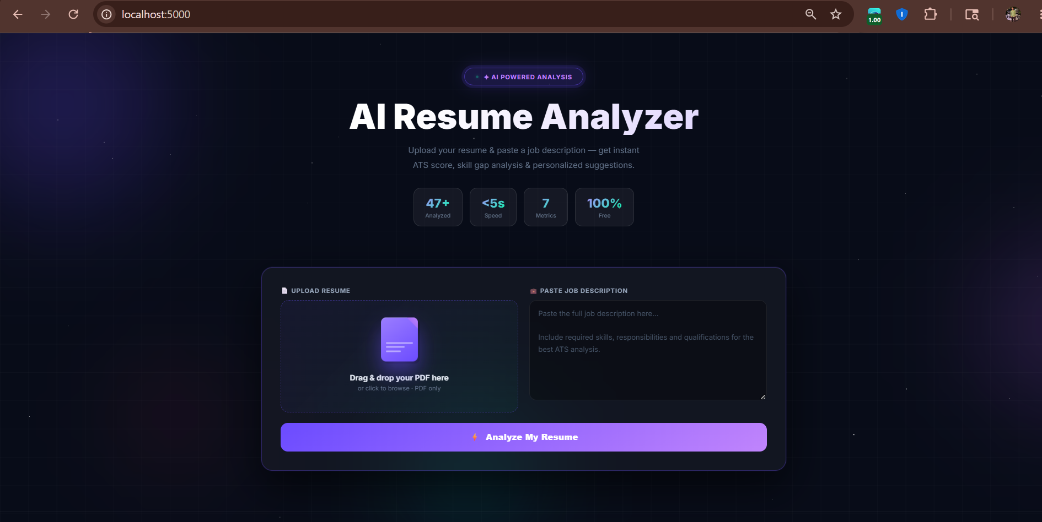
[Application Home Page]

5.2 Resume Upload & Analysis
After the user uploads a PDF and pastes a job description:
- The submit button changes to "Analyzing…" and becomes disabled.
- A multi-step loader appears with animated progress steps: Extracting resume content → Matching with job requirements → Calculating ATS score → Building improvement plan.
- The analysis completes in under 5 seconds.

5.3 ATS Score Display
The result section shows a large animated ring chart with the ATS score:
- 70–100 (Green): "Excellent Match!" — strong alignment with the job
- 45–69 (Yellow): "Room to Improve" — partial match with gaps
- 0–44 (Red): "Needs Work" — significant skill gaps
The score number animates from 0 to the final value with a smooth counter effect.
[ATS Scoring Chart] 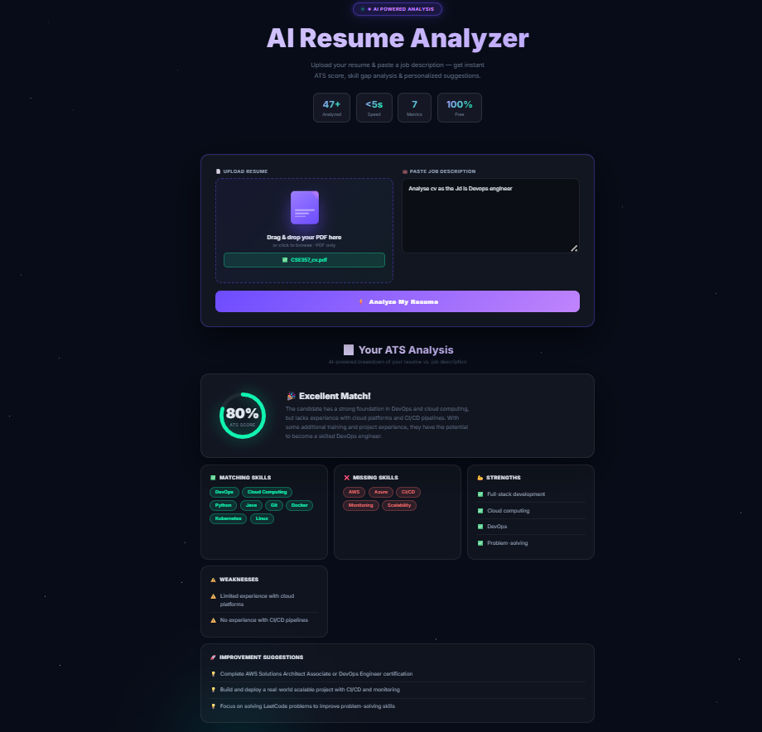

5.4 Detailed Analysis Results
The results section displays six cards in a responsive grid:
Card | Content | Visual Style
ATS Score | Ring chart + score + summary text | Animated SVG ring with glow
Matching Skills | Skills the candidate has | Green tags with hover effect
Missing Skills | Skills to add to resume | Red tags with hover effect
Strengths | Resume strong points | Green bullet list
Weaknesses | Areas needing improvement | Warning bullet list
Suggestions | Actionable improvement tips | Lightbulb bullet list

5.5 Successful GitHub Actions CI/CD Build
When code is pushed to the main branch, the GitHub Actions pipeline executes:
- Checks out the code — ✅ Success
- Sets up Python 3.11 — ✅ Success
- Installs all dependencies — ✅ Success
- Logs into Docker Hub — ✅ Success
- Builds the Docker image — ✅ Success
- Pushes the image to Docker Hub — ✅ Success
[GitHub Actions Successful Build (Green Checkmark)]
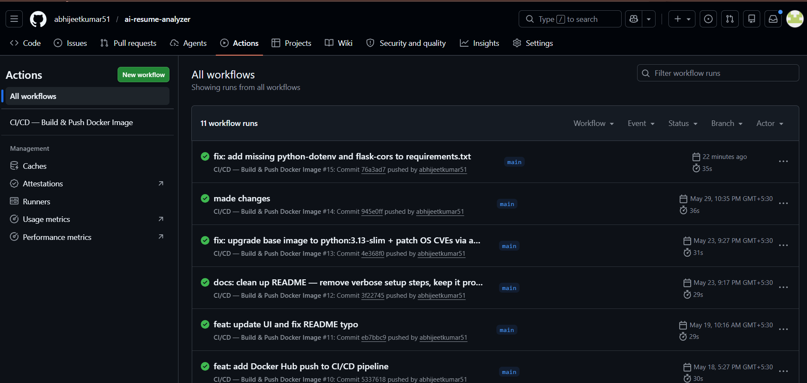

5.6 Docker Image Creation
Property | Value
Image Name | abhijeetchy51/ai-resume-analyser:latest
Base Image | python:3.13-slim
Exposed Port | 5000
Registry | Docker Hub
[Docker Hub showing the pushed image]
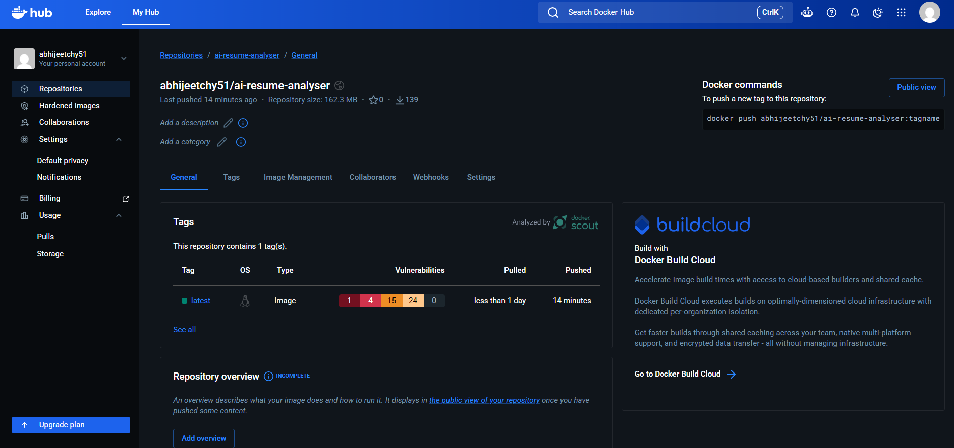

5.7 Running Container
When the Docker container runs, the following output is displayed:
* Serving Flask app 'app'
* Debug mode: on
* Running on all addresses (0.0.0.0)
* Running on http://127.0.0.1:5000
* Running on http://172.x.x.x:5000

5.8 Deployed Application
The application is deployed on Render and is publicly accessible. The deployment process:
- GitHub Actions builds and pushes the Docker image to Docker Hub.
- Render pulls the latest Docker image from Docker Hub.
- The container starts with the GROQ_API_KEY injected as a runtime environment variable.
- The application is live and accessible via the Render URL.
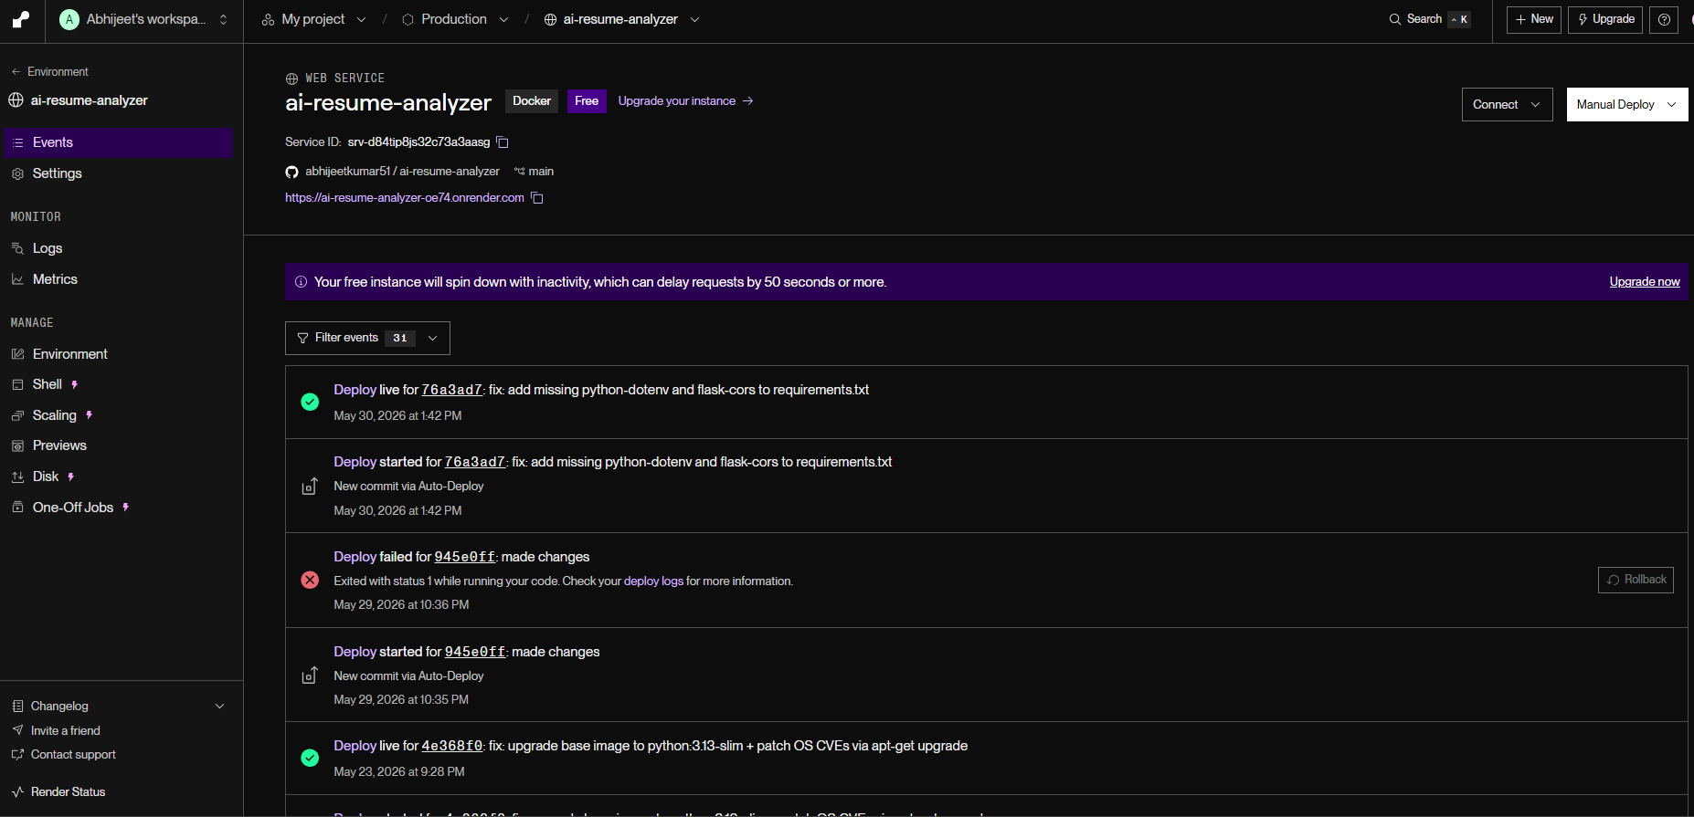

Chapter 6 — Future Scope
The AI Resume Analyzer has significant potential for future enhancements:
6.1 Multi-Format Support
- Support for DOCX, TXT, and RTF file formats using python-docx and similar libraries.
- OCR integration (Tesseract) for scanned/image-based PDFs.
6.2 User Accounts & History
- User registration and login system.
- Resume analysis history dashboard.
- Progress tracking across multiple job applications.
6.3 AI-Powered Resume Rewriting
- Automatically suggest rewritten bullet points optimized for ATS.
- Generate tailored cover letters based on the resume and job description.
- Keyword injection tool that naturally weaves missing keywords into the resume.
6.4 Multi-Language Support
- Support for resume analysis in Hindi, Spanish, French, German, and other languages.
- Multilingual job description matching.

6.5 Advanced Analytics
- Industry benchmarking — compare scores against industry averages.
- Trend analysis — track how resume quality improves over time.
- Skill demand heatmaps — visualize in-demand skills by industry and region.

6.6 Integration & APIs
- LinkedIn profile import for direct analysis.
- Chrome browser extension for one-click analysis from job portals.
- Public REST API for third-party integrations.
6.7 Mobile Application
- Native Android and iOS apps using React Native or Flutter.
- Camera-based resume scanning with real-time analysis.

6.8 Enhanced Deployment
- Kubernetes orchestration for horizontal scaling.
- Redis caching to reduce redundant API calls.
- Rate limiting and API key management for public deployment.

Chapter 7 — Conclusion

7.1 Objective Achieved
The AI Resume Analyzer project has successfully achieved all of its primary objectives:
- ✅ Built an AI-powered resume analyzer — The application uses the Groq API with the LLaMA 3.3 70B model to perform intelligent, context-aware resume analysis.
- ✅ PDF text extraction — PyPDF2 reliably extracts text from uploaded PDF resumes.
- ✅ ATS score generation — The system generates a quantitative compatibility score (0–100) along with seven detailed metrics.
- ✅ Modern web interface — A premium, responsive UI with dark mode, glassmorphism, animations, and a polished user experience.
- ✅ Docker containerization — The application is fully containerized with a production-ready Dockerfile.
- ✅ CI/CD automation — GitHub Actions automatically builds and pushes Docker images on every push to main.
- ✅ Cloud deployment — The application is deployed and publicly accessible on Render.

7.2 Technologies Learned
Through this project, the following technologies and concepts were learned and applied:
Technology | Skill Acquired
Python & Flask | Building REST APIs, handling file uploads, serving templates
Groq API & LLMs | Prompt engineering, structured JSON output, AI integration
PyPDF2 | Programmatic PDF text extraction
HTML/CSS/JS | Modern UI design, CSS animations, glassmorphism, responsive layouts
Docker | Writing Dockerfiles, building images, running containers, layer caching
GitHub Actions | CI/CD pipelines, automated builds, Docker Hub integration
Render | Cloud deployment of containerized applications
Environment Variables | Secure API key management with .env files
Git & GitHub | Version control, branching, .gitignore, repository management

7.3 Final Outcome
The AI Resume Analyzer is a fully functional, production-ready web application that demonstrates the practical integration of modern AI capabilities with web development, containerization, and DevOps practices. It solves a real-world problem by providing job seekers with instant, free, and actionable feedback on their resumes — helping them improve their chances of clearing ATS filters and landing interviews.
The project showcases end-to-end software development skills: from designing a premium user interface to building a robust backend, containerizing with Docker, automating deployments with CI/CD, and deploying to the cloud.

— End of Report —

