Group 1A
Name, IC
- Matondkar Abhijeet Suresh, G5372862L

Task 1: Create Sample Flask App
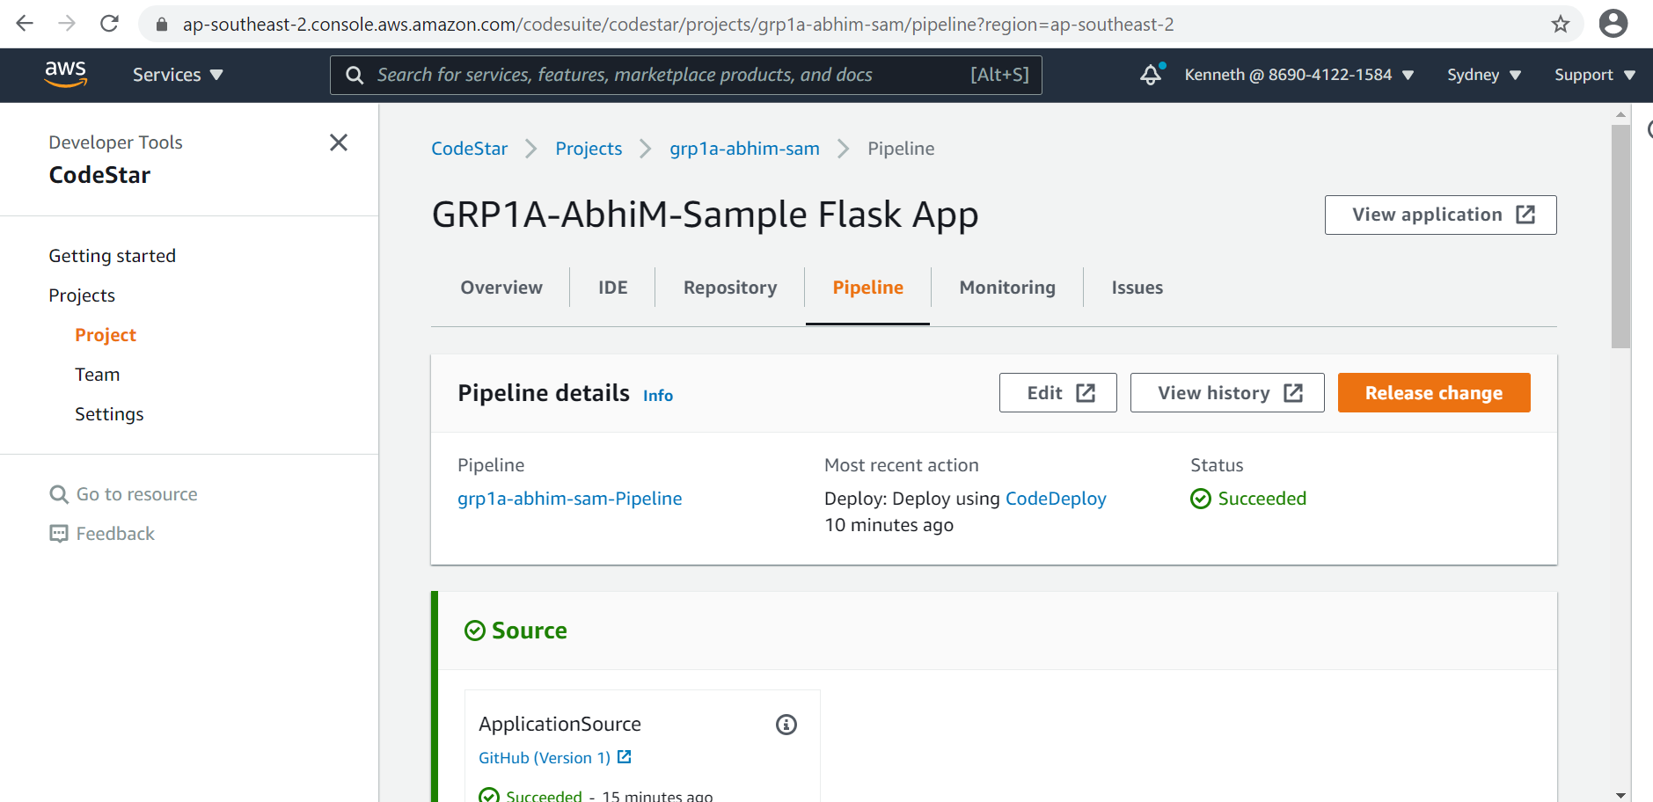

Task 2: Fail the Sample Flask App
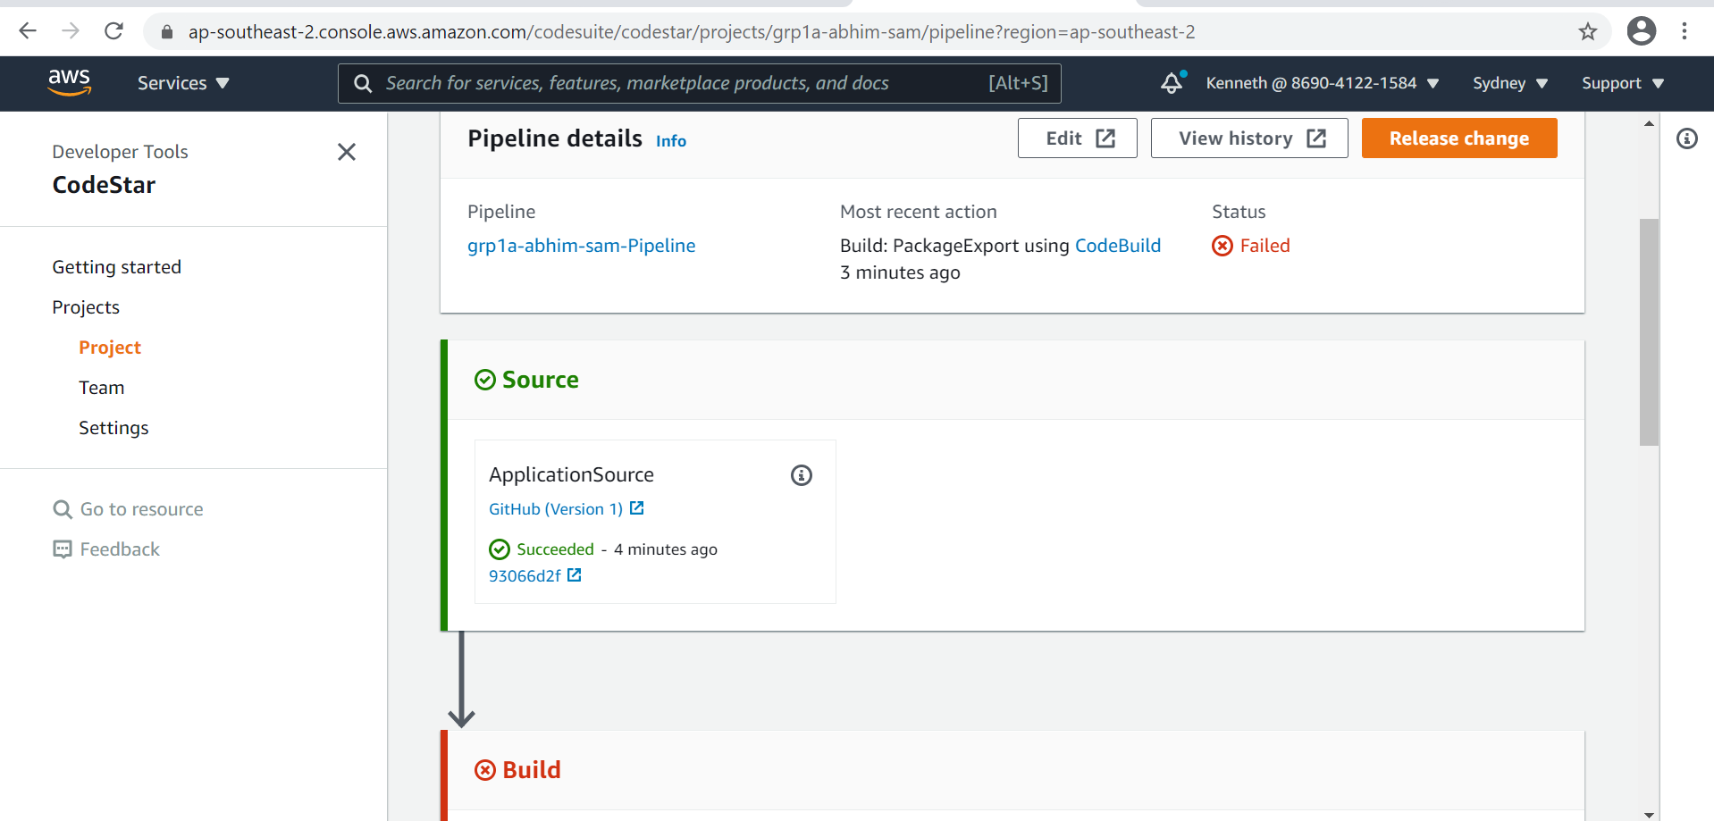

Task 3: Create ASP .Net App
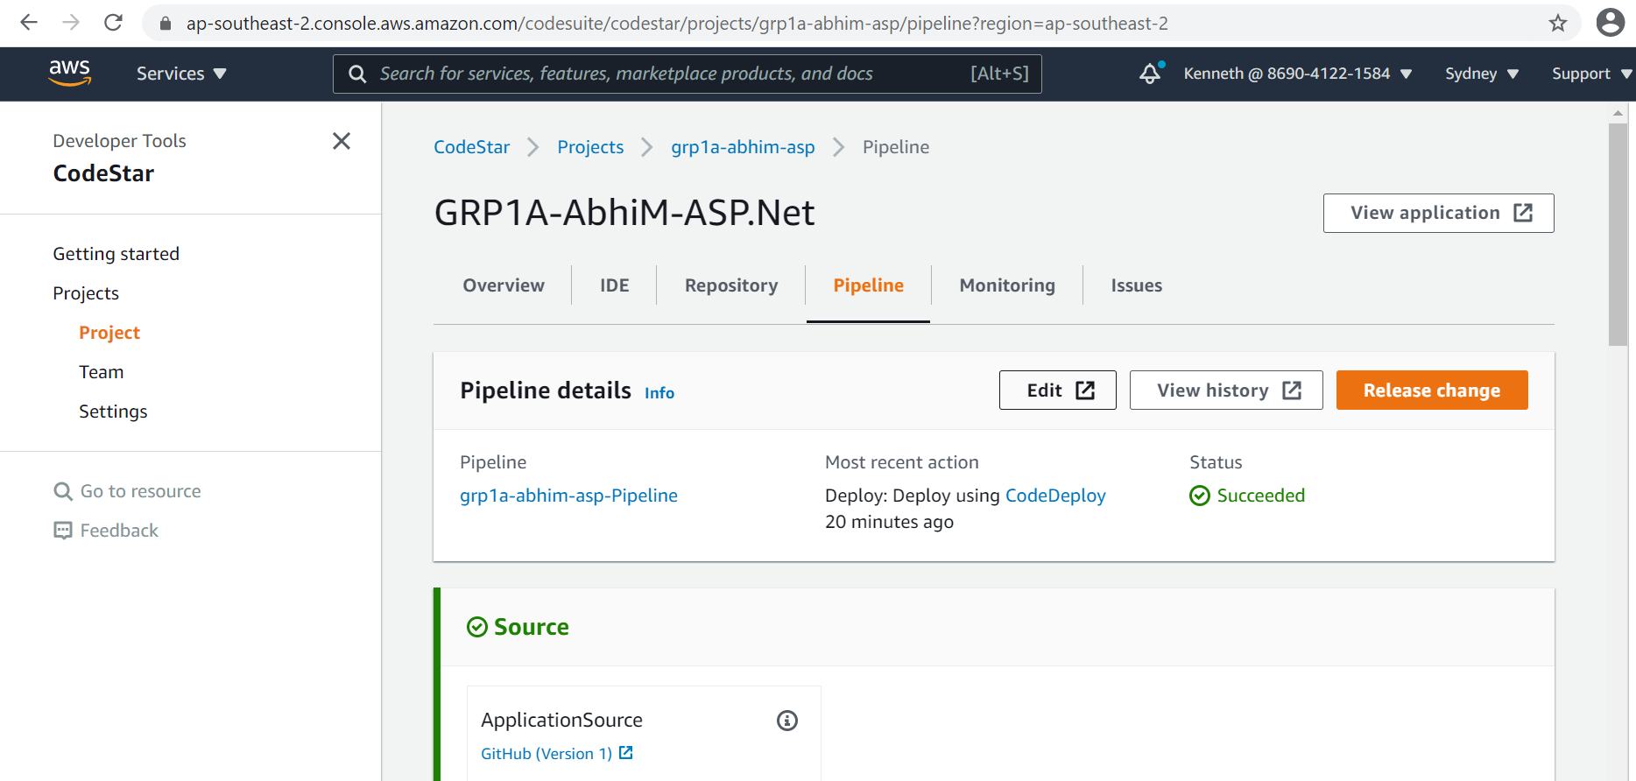

Task 4: Jenkins Successful Build
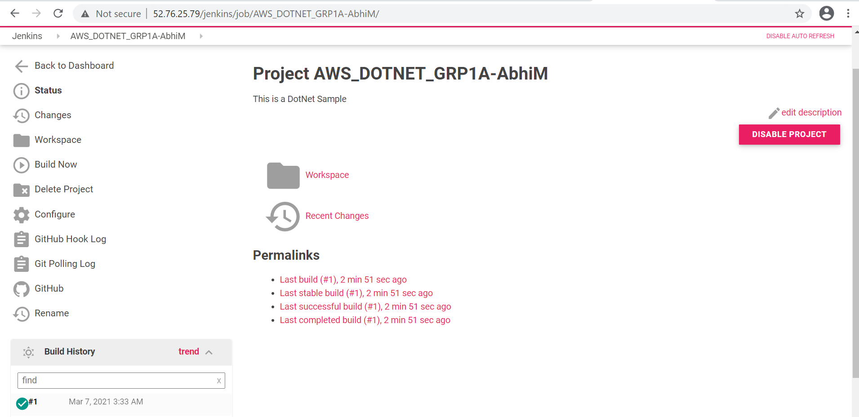

Task 5: Jenkins Failed Build
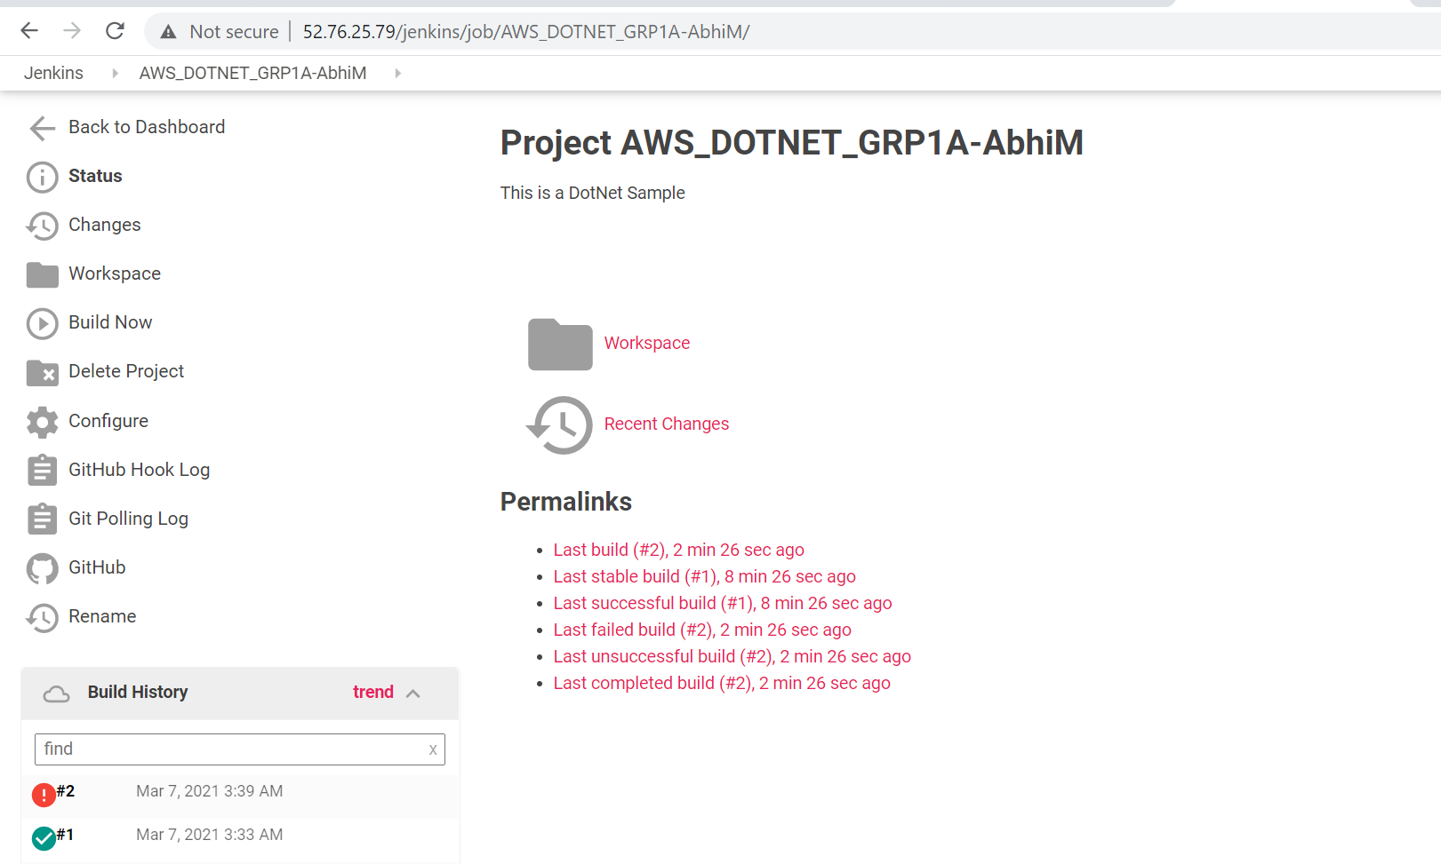

Task 6: Docker Image Creation Success
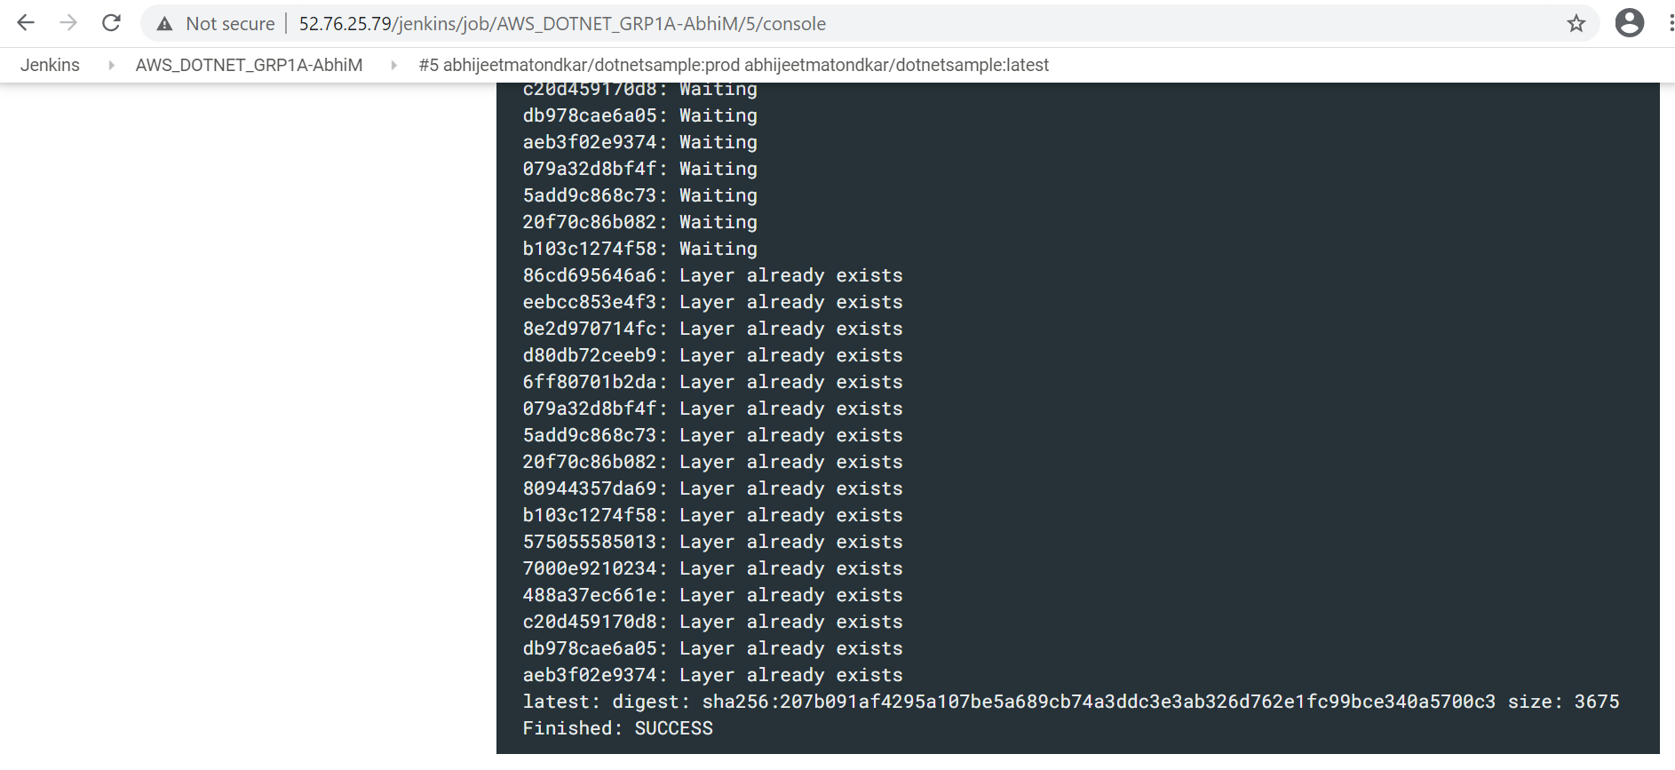

Task 7: DockerHub Upload Success
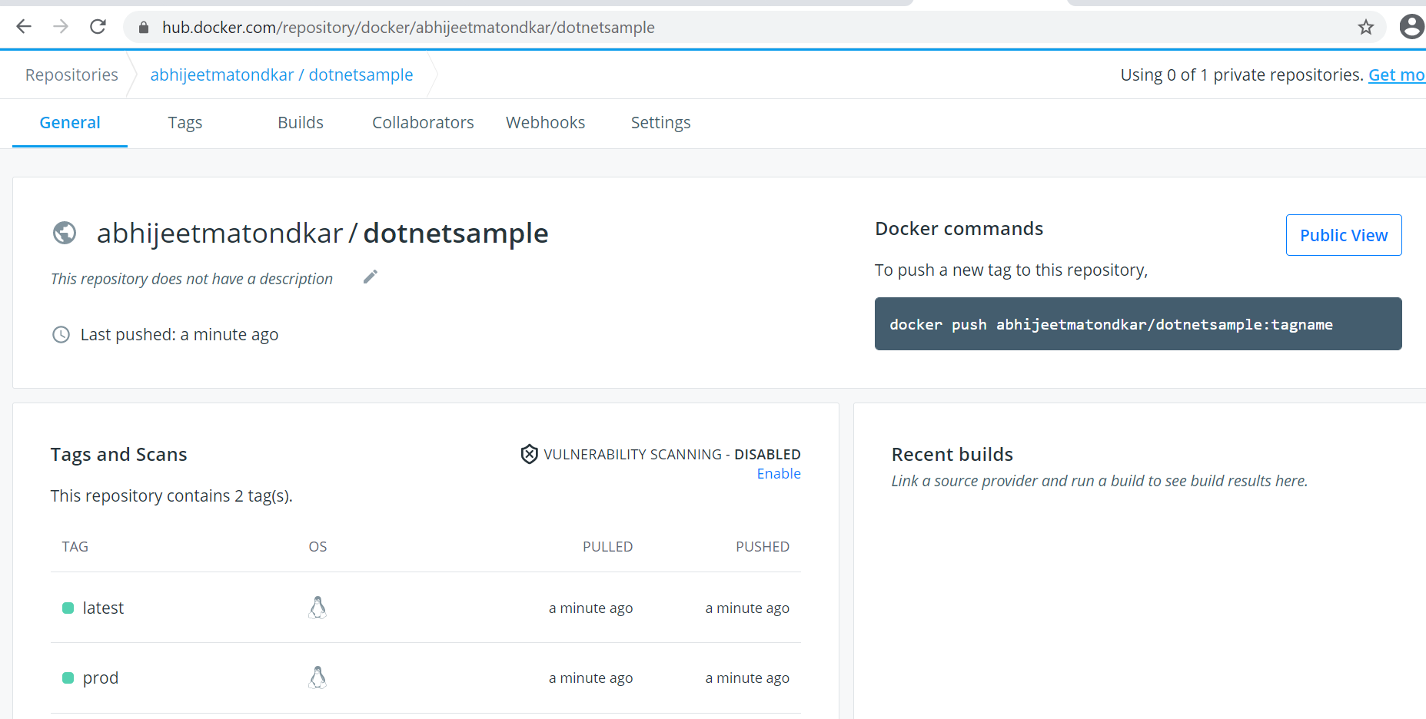

In the below diagram
- Client refers to the mobile device
- Sensor refers to the IOT sensor deployed across the block that will be used to pump raw data to the back-end system
- API Gateway to receive updates from TraceTogether component as well as receive data from the IOT sensorIt will subsequently broadcast the messages to client
- Feedback component will receive data from the sensors deployed via the Public API Gateway
  - Feedback will have
    - Long Term Storage to retain data
    - A Database to save raw data that will be processed by the back-end system
  - Feedback will subsequently feed to the Processing unit
- Processing Block will comprise of
  - An API Gateway that receives raw data from the Feedback component
  - A set of AWS Lambda functions that will process the raw data
  - A Database to save the processed data
  - (Optional) We can also include a Long Term Storage to save data older than a certain duration
  - Processing will subsequently feed to Notification
- Notification component of the design will comprise of
  - A series of AWS setup functions that accept the processed data and feed to Lambda functions
  - The Lambda function will than perform the task of broadcasting updates on the SNS topic
  - The SNS function will be used to send individual updates to TraceTogether Component
  - (Optional) Database to hold any failed notification details or details of notification sent
- TraceTogether component will comprise of
  - API Gateway to receive inputs from Notification component
  - A series of Lambda function to further process the information before syncing it with the Public API Gateway

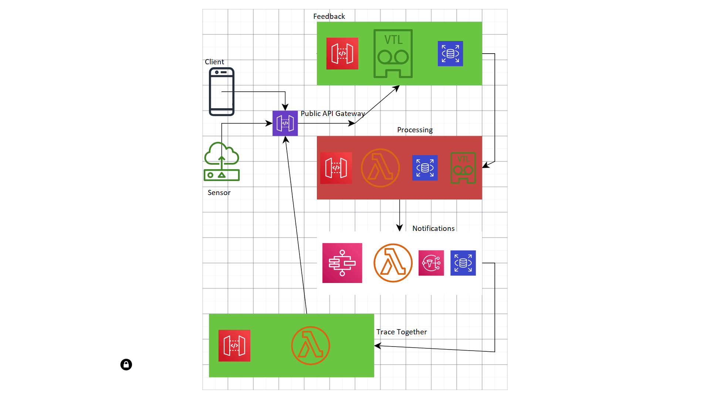
We subsequently need two CI-CD pipelines to cater to two components both of which will deploy the changes to the Public API Gateway
- The Front End App component
- The Sensor component
The CI-CD pipeline to comprise of
- Github to host two projects one for Front End and one to have Firmware updates
- Two Build projects setup in Jenkins to
  - Build code
  - Run unit and integration tests
  - Create Container image for the JS code
  - Create installers for sensor code
- The Docker images created to be deployed on ECS cluster using Cloud Formation templates onto the Public API Gteway
- Puppet to be used to deploy firmware updates across sensors via the Public API Gateway acting also as Puppet Master
- We then need two sets of Monitoring Tools to
  - Collect data from sensors to feed to Feedback component
  - Monitor system performance and health checks

