ProcessGenius AI — Product Roadmap
Axiom Solutions | From 4-Month Compliance Pilot to Multi-Vertical AI Compliance Platform | Owner: Product Management
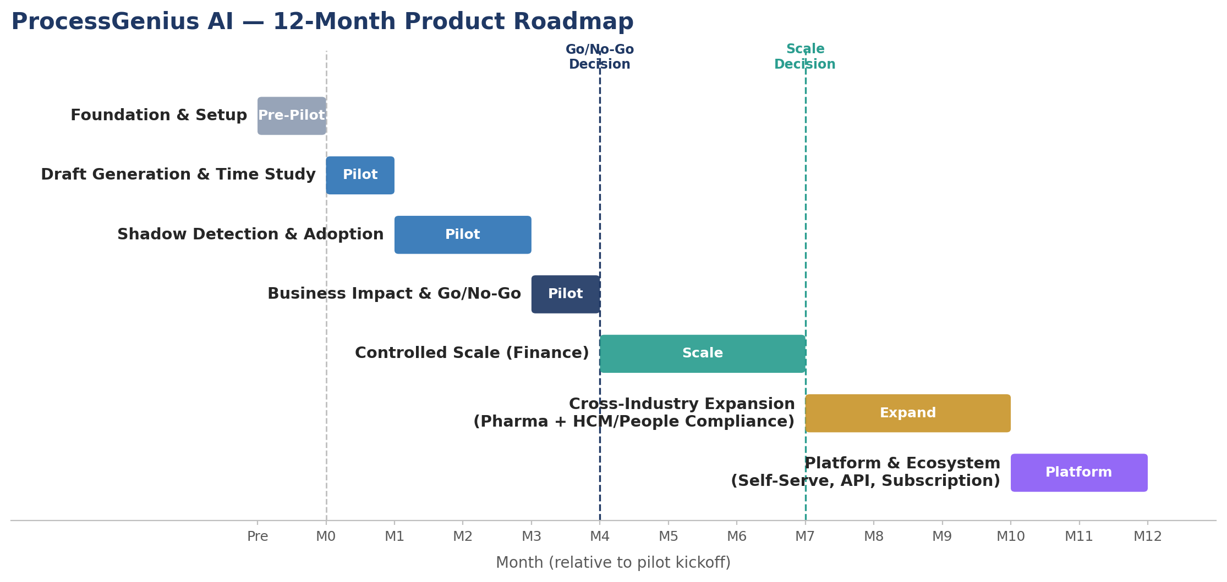
Roadmap Narrative
The roadmap sequences from a tightly-scoped, guardrail-first pilot in finance to a multi-vertical AI compliance platform. Each phase gate is deliberately conservative: we do not expand scope, client volume, or automation level until accuracy and detection guardrails are proven at the current stage. The Phase 5 expansion intentionally pairs a new industry (pharma) with a new domain (HCM/People compliance — labor law and HR policy documentation), reusing the same human-in-the-loop architecture validated in the pilot rather than building a parallel stack.
12-Month Phase Plan
Phase | Timeframe | Objectives & Key Deliverables | Exit / Success Gate
Phase 0 — Foundation  & Setup | Pre-Pilot  (Wk -4–0) | Stand up guardrail framework (SME review workflow, confidence thresholds); assemble regulatory corpus for 3 finance clients; select pilot cohort; baseline current KPIs. | Guardrails, tooling, and baselines signed off by Compliance & pilot clients.
Phase 1 — Draft  Generation & Time Study | Month 1 | Run BA-only vs. BA+AI draft A/B test; SME-score outputs against regulatory checklist; capture drafting time baseline. | ≥90% draft accuracy vs. source regulation; time-to-document data captured.
Phase 2 — Shadow  Detection & Adoption | Months 2–3 | Run regulatory-change detection in shadow mode alongside manual monitoring; track BA/client override & trust via telemetry and interviews. | ≥95% change-detection recall; override-rate and adoption signal collected.
Phase 3 — Business  Impact & Go/No-Go | Month 4 | Compare pilot vs. matched non-pilot clients on audit prep time & documentation accuracy; run client retainer-intent survey; executive readout. | Go/No-Go decision: guardrail metrics met AND ≥2 of 3 clients signal willingness to pay.
Phase 4 — Controlled  Scale (Finance) | Months 5–7 | Expand to 5–8 additional finance clients; introduce confidence-tiered automation; launch client-facing audit-trail dashboard; formalize "AI Compliance Maintenance" retainer. | Retainer live with paying clients; accuracy/recall guardrails hold at scale.
Phase 5 — Cross-  Industry Expansion | Months 8–10 | Extend to pharma vertical (FDA/GxP context); begin HCM/People-Compliance use case — labor law & HR policy documentation — leveraging same guardrail architecture. | Domain-tuned accuracy validated in ≥1 new vertical; HCM pilot scoped with design partner.
Phase 6 — Platform  & Ecosystem | Months 11–12 | Self-serve client portal; API/GRC-system integrations; continuous regulatory-monitoring subscription tier; platform-wide analytics. | General availability; recurring-revenue subscription model operating.
Two hard gates govern pace: the Month 4 Go/No-Go (pilot proves guardrail + business value) and the Month 7 Scale Decision (guardrails hold under multi-client load). No phase after either gate begins without a passed review.

