**Procedure set up the GIT repository:**

1. Install GIT:

Following steps are needed to be followed for doing the git setup.

1. Go to following site:

<https://git-scm.com/download/win>

1. Do the installation with default settings.
2. Create GIT Login.
3. Create repository on GIT.
4. Share the repository to anyone who you want.
5. To create the local repository clone the repository to the local machine.

**Procedure to do changes in the repository:**

1. Install the VS code and GIT plug in for the VS code.

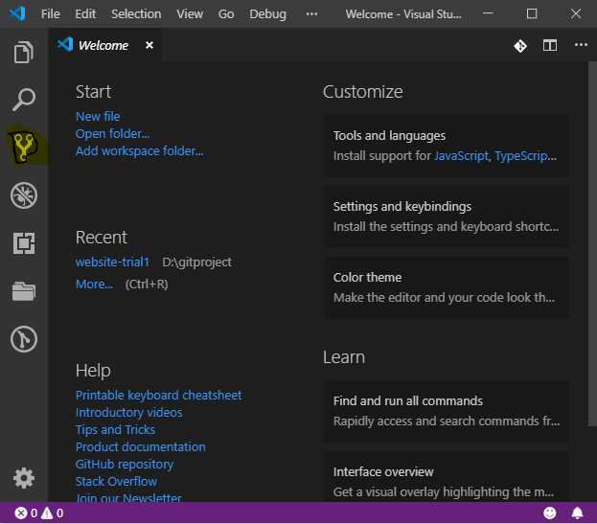

1. Do the changes required in the VS code.

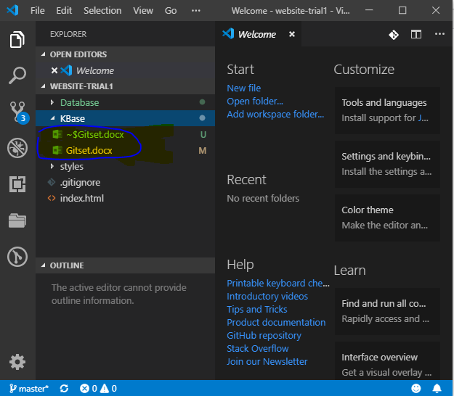

1. Go to git plugin and stage you changes and commit your changes.

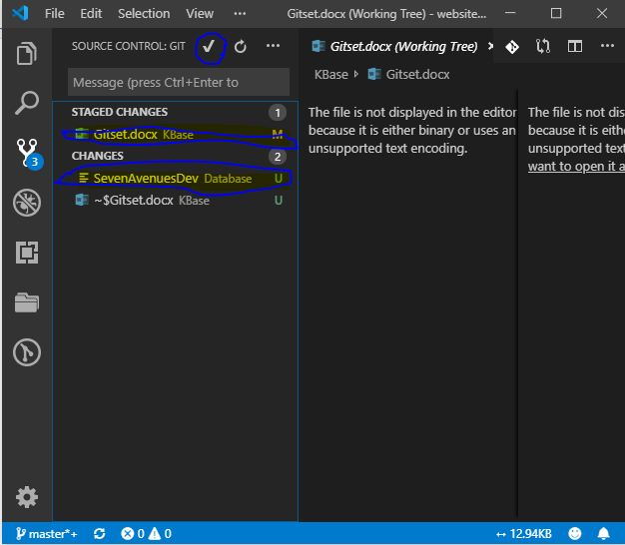

1. After commit push your changes to master workspace.

