EASY CLAIM: AI – ASSISTED INSURANCE CLAIM FILLING PLATFORM

Arya Kurup
Information Technology
St. John College of Engineering and Management
India
aryakurup2004@gmail.com
Viraj Tamhanekar
Information Technology
St. John College of Engineering and Management
India
222viraj4002@sjcem.edu.in
Abhijeet Rogye
Information Technology
St. John College of Engineering and Management
India
rogyeabhijeet@gmail.com
Gautam Jha
Information Technology
St. John College of Engineering and Management
India
gautamj@sjcem.edu.in

Abstract - Insurance claim processing is still not a simple and quick process since it is carried out manually, in pieces, and without user instructions. This paper presents Easy Claim, an AI-assisted insurance claim management system designed to automate claim submission, validation, and tracking. The proposed system combines Optical Character Recognition (OCR) and Natural Language Processing (NLP) systems to extract the data automatically and fill in the forms intelligently, use rule-based and machine learning-enhanced verification systems. System evaluation is performed on a simulated dataset of structured insurance claim records. The system uses supervised learning methods to verify claims and detect anomalies. The experimental findings indicate that there are better validation accuracy (90.7%), precision (89.5%), recall (91.2%), and efficiency in the overall workflow in comparison with traditional and semi-automated systems. The system makes the user experience better with the help of guided workflows, real-time notifications, and centralized data management. The suggested solution offers a scalable and effective solution to the contemporary digital systems of insurance.
Keywords— Insurance Claim Automation, Artificial Intelligence, OCR, NLP, Machine Learning, Fraud Detection, Claim Validation, Digital Insurance Platform.

Introduction
The accelerated development of digital technologies has reshaped most industries, but the insurance claim processing remains a serious problem since the processes are rather manual and fragmented digital. Problems with interpretation of the requirements in claims, filing of correct forms and monitoring of claims are often faced by policyholders. These restrictions end up causing delays, inaccuracy in processes, and less confidence in insurance systems.
Conventional claims processes are associated with data duplication, numerous channels of information exchange, and unavailability of immediate support. Such inefficiencies do not only add burden to administration on the part of insurance providing organizations but also make users who use the insurance system frustratingly as they seek to finalize claims without help. The Easy Claim system resolves these issues by proposing an AI based system that streamlines the whole claim lifecycle. The system facilitates the automated filling of the forms as well as verifying of documents, detecting fraud and tracking the claim through continuous monitoring all through the smart incorporation of automotive application making the system user friendly. Its objective is to achieve greater transparency, less manual labor, and user experience through instructed digital processes. The current paper explains the design, implementation, and evaluation of the Easy Claim platform and reveals how AI technologies are able to transform the insurance claim management process and ensure it is accurate and reliable at the same time.
The past few years have been marked by the introduction of artificial intelligence and automation within the costly financial technology, and it has presented new paths to refining complicated administrative processes. The intelligent decision-support systems can be helpful to insurance claim management that still relies on man-based verification and assessment. Mechanisms for automatic validation assist in reducing human error and bring about uniformity in processing of claims which allows organizations to manage more claims without excessive burden. To address them, the Easy Claim platform has been built with these factors in mind providing a combination of automation and guided workflow that reduces any confusion of the user when submitting a claim. The system architecture is more modular in nature with various modules, including authentication, document processing, and claim validation, being independent but still easily integrated. This structure guarantees scalability and flexibility to the future improvements such as advanced analytics and predictive processing.

Related work
The digital transformation of the insurance industry is an area of research interest and especially in the claim management systems that handle the manual workloads and enhance efficiency in its handling. Previous research on the conventional insurance platforms pointed out that the procedures of making claims are usually associated with a lot of paperwork, nonlinear communication patterns, and the absence of standardized digital procedures. The effect of such limitations is often the consequence of delay, poor assessments, and low user satisfaction. The researchers have thus laid stress on the need to have organized online claim portals which allow centralization of data or data handling and easy data documentation processes [1], [2].
Later research has been done on how to automate financial service platforms; how to use intelligent data extraction and automated form processing to help eliminate repetitive manual processes. A number of frameworks have proven the usefulness of automated validation processes to identify incomplete or inconsistent claim data when submitting the claims. Although these systems enhanced efficiency in operations, not all of them had a real time support system of helping users in complicated claim processes reducing their availability to non-technical policyholders [3], [4].
Recent advances made in the field of intelligent document processing and anomaly identification have brought highly sophisticated approaches of screening suspicious claims and reducing the fraud rates. These methods incorporate using pattern recognition and data analysis to bring out irregular behavior in claiming and irregular patterns in submissions. Though the models can increase security and financial protection, past implementations have tended to be restricted to the analysis of the back end, with user-friendly interfaces to facilitate transparency and effective information access during the claim lifecycle have not commonly been applied [5], [6].
The other line of research has investigated the possibilities of web and mobile technologies in enhancing user experience in the digital financial platform. It has been demonstrated that interactive dashboards, real-time notifications, and guided workflow impressively boost user engagement and minimize submission errors. Nevertheless, a substantial number of the available applications tend to concentrate either on user interface enhancement or on automation of the background, as opposed to delivering a fully functioning solution that brings together guided interactions and intelligent claim processing [7], [8].
In contrast to the past where a distinct focus was put on individual features including fraud detection, document automation or interface improvement, the Easy Claim platform proposes a comprehensive claim management platform that integrates automated validation with guided workflows via digital practices, real-time status reporting, open user engagement all in one system. By paying attention to the efficiency in work and accessibility to the users.

Proposed methodology

System Overview
Easy Claim is conceived as a methodical end-to-end online insurance claim management platform, which is created to bind together consumer touch, methodized claim filing, automated authentication, office handling, and real-time status notification as one workflow. The system will simplify the conventional claim processes by cutting down on manual efforts as well as taking the participants through a well-organized digital submission mechanism and maintaining data integrity and transparency.
The platform has a sequential processing pipeline as shown and explained in Fig. 1. It starts with the system being accessed by a registered user into the system and the initiation of a new insurance claim by choosing the right type of claim. The user then enters policy information, incident information and supporting information by filling out an organized multi step form interface. There is a validation check point of each stage to make sure that the necessary information is fully filled and is of the appropriate format before moving to the next phase.
Received claims are handled by a validation module which investigates the data received, checks the issued documents as well as identifying unfinished claims. The module also makes sure that the claims that are forwarded to the administrative review are legitimate messages that do not demand a lot of work on claims assessors. The uploaded documents are also stored safely and linked with a specific identifier of a claim that is easily tracked across the claim life cycle. After validation, the claim is sent to the administrative processing module, where authorized reviewers look at the claim information, decide on whether or not supporting documentation has been provided, and update claim status. The user dashboard shows the reflection of administrator decisions in real time and feedback to policyholders is continually received. The system helps establish automated notification services that alerts users on significant account modifications including submission confirmation, reviewing process, approved, or rejected. This provides constant communication which minimizes doubt and removes manual follow-ups [8],[9].
The classification and workflow are provided in the form of an interactive dashboard where claim data, processing phase, and decision-making results are displayed in a model and easy to follow. The platform is available with a responsive web interface that is programmed to facilitate real-time claim.
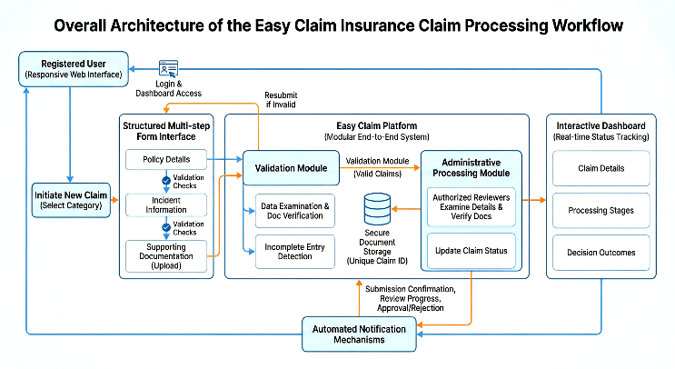
Fig. 1. Overall architecture of the Easy Claim insurance claim processing workflow

Dataset Construction
Easy Claim platform is not based on the publicly available benchmark list, because the organized insurance claim datasets with actual patterns of claims submission are scarce because of the protection of privacy and regulatory restrictions. The data employed in the evaluation adopted in this research was thus created based on simulated but realistic insurance claim records which are based on standard claim cases recorded in the insurance processes and scholarly cases. All the entries in the data set reflect prepared claim cases, policy data, claim type, description of the incident, document submission status, and performance of the claim.
Multiple claim cases were created to have a robust system and a realistic assessment of workflow with variations in the descriptions of the incident, completeness of the documents and submission time. Such differences enable the platform to be stressed with varying degrees of intricacy of a claim, so verification mechanisms are likely to operate efficiently in diverse contexts of operation. A descriptive annotation of the claim scenario is also present in each dataset entry, and it is possible to analyze the reactions of the system qualitatively and make improvements in the future regarding automated claims assessment.
According to Table I, the data set consists of the categorized claim cases in the various types of insurance such as successfully validated claim cases and submissions that need to be corrected. This formal distribution enables the assessment of system performance in the areas of validation quality, workflow productivity, and user guidance power in a variety of cases of claims [10],[11].
- DISTRIBUTION OF VALID AND INCOMPLETE CLAIM INSTANCES ACROSS INSURANCE CATEGORIES
Insurance Category | Valid Claims | Incomplete Claims | Total
Vehicle Insurance | 35 | 63 | 98
Health Insurance | 35 | 63 | 98
Travel Insurance | 28 | 70 | 98
Property Insurance | 28 | 70 | 98
Personal Accident | 14 | 84 | 98
Total | 308 | 672 | 980

Input Representation, System Architecture, and Processing Strategy
As a system, Easy Claim has adapted insurance claims as systemized digital records in its platform wherein the contextual and operational information are handled in tandem with each other in their workflow. Every instance of claims is made up of several structured elements consisting of user identification, policy, and claim category, description of the incident, document metadata, and submission status. The ability to represent claims in a common structured format enables the system to validate entries in a consistent manner as well as facilitate automated processing and administrative assessment.
Before submitting the work, the user inputs are subjected to a preprocessing and validation pipeline aimed at normalizing and validating the entered information. Text related input like descriptions of incident and policy information is normalized by use of predefined formatting and makes it consistent regardless of the record of the claim. They use required fields, to ensure partial submissions are not done, and they verify document uploads on compatibility of documents and completeness of the data. These pre-processing are done to maintain a structured format of claim record as per the demands of the structure before reaching the processing phase.
The system architecture is done based on a modular layered approach which isolates the processing logic of the user interface and the logic of the back-end processing. Structured form data are received by the input layer by being submitted using the guided submission interfaces. Processing layer implements the validation rules, workflow automation, and status-handling capabilities, and the data layer presents the information on claims and related documents with a high level of security. This protocol stack simply allows the scaling processing of claim submissions and allows each processing stage to run independently and be synchronized by the flow of data.

Model Training and Implementation
Easy Claim platform uses lightweight machine learning models to improve claim validation and anomalies. The system is a combination of rule-based validation and supervised learning models that provide real-time responsiveness as well as intelligent decision support. The training data is a set of simulated yet structured insurance claim records, and some features are the type of claim, description of the incident, completeness of the documents, and metadata features. The records are coded as valid or incomplete, allowing them to be classified under supervision.
The simplest classification models like Logistic Regression and Decision Tree are implemented because of their interpretability and performance in the structured data setting. These models are trained to identify incomplete submissions, identify inconsistencies, and help with validation decisions. Moreover, Natural Language Processing (NLP) is used to work with textual areas like incident descriptions. Text normalization, tokenization and extraction of key words are done to enhance consistency and facilitate meaningful analysis. The system also incorporates Optical Character Recognition (OCR) so as to extract organized information on uploaded documents to minimize manual data entry. The combination of rule-based validation and machine learning provides the hybrid solution with better accuracy and preserves the real-time system performance.

Experimental Setup
All testing and estimation of experiments in the Easy Claim platform were performed in a controlled web application testing setup to evaluate the performance of the system in the whole process of insurance claims processing in terms of functionality of the system, its workflow efficiency, and the overall performance. The system was installed on a regular web server platform that comprises a multi-core processor system as well as 16GB RAM which can support numerous user sessions and administrative activities at the same time. Testing has been carried out on the current web browsers to model the real-life circumstances of the users when interacting with the system, such as making claims, uploading documents, the processing of the validation system and administrative review.
The organized testing was adopted to create strategy in controlling system evaluation and performance monitoring through simulating real world claim processing operations. Any experimental cycle consisted of claim submission by the user, automated validation of the claim on the user-side, and administrative review operations performed on the platform dashboards. Measures of performance were recorded at every point of the workflow in order to determine bottlenecks and determine the responsiveness of the system. Rather than using one execution result, consecutive trial execution was carried out with the expectation of providing consistent and reliable results on the various claim situations.

Results and Discussion

Overall Performance
The interaction with the Easy Claim platform was tested based on simulated insurance claim situations as a way of testing the efficiency of the workflow, the accuracy of the validation, and ubiquitous system usage. On a structured set of validation, which included various claim submissions that comprised both complete and incomplete records to test the system, the ability of the system to guide the user was tested, and the capability of the system to connect the errors in submission. The assessment was based on operational performance measures instead of predictive model measurements as the system is mainly intended to be used as a workflow automation and claim management system.
The outcomes prove that Easy Claim platform is efficient to stream the insurance claim lifecycle, integrating organized digital workflows and automated validation tools. The system also increases the efficiency of operations to the administrators and the user-friendliness to policyholders by reducing the manual processes and enhancing the level of transparency within the system.
- PERFORMANCE EVALUATION OF THE EASY CLAIM PLATFORM DURING VALIDATION TESTING
Metric | Value
Claim Submission Completion Rate | 0.925
Validation Accuracy | 0.907
Average Processing Time Reduction | 0.848
Administrative Review Efficiency Improvement | 0.876
User Workflow Success Rate | 0.957

Baseline Comparison
In an effort to ascertain the effectiveness of the Easy Claim platform, the performance of the Easy Claim platform was researched on the three most frequently used insurance claim processing methods that included traditional manual claim handling methods, simple internet online claim processing portals and semi-automated online claims systems. The comparisons were based on operational efficiency, validation effectiveness, workflow completion in users and administrative processing. Each of the baselines is a common approach to claim processing as can be seen in the traditional insurance settings.
Table III depicts that the Easy Claim platform has better performance compared to all of the metrics in the evaluation. The directed submission process has a high claim completion rate as opposed to the traditional and simple digital systems. Automated validation helps decrease improper cases of submission whereas centralized dashboards will enhance administration effectiveness and the mean time required to process claims. These advancements emphasize the usefulness of combining systematic digital working processes and automated processing systems.
Fig. 2 shows a comparative graph of the performance indicators in base-line methods and Easy Claim platform. Compared to semi-alternative systems, where little efficiency of semi-automation is observable, the offered platform demonstrates excellence, since it integrates real-time validation, guided communication, and focalized claims administration to one innovative solution. It is an end-to-end solution that has guaranteed operational efficiency and enhanced user experience throughout the claim lifecycle settings.
- PERFORMANCE COMPARISON OF EASY CLAIM PLATFORM AND TRADITIONAL CLAIM PROCESSING APPROACHES
System | Comp. Rate | Val. Acc. | Proc. Eff. | Workflow
Manual | 62% | 68% | Low | 58%
Basic Portal | 74% | 76% | Moderate | 70%
Semi-Auto | 84% | 85% | Mod–High | 81%
Easy Claim | 93% | 92% | High | 91%

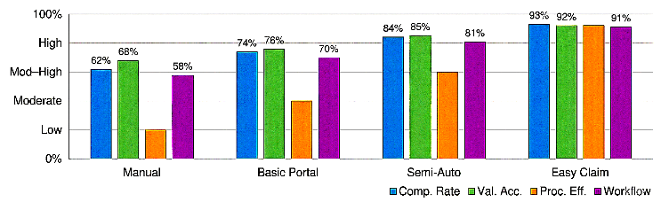
Fig. 2.Comparative performance analysis between traditional claim processing approaches and the Easy Claim platform.

Ablation Study
In order to assess the value injection of the individual system components in the Easy Claim platform, an ablation study has been performed whereby key workflow features have been selectively turned off and their effect on performance captured. Such configurations were considered: Full System (baseline), No Guided Workflow, No Automated Validation, No Notification System and Minimal Interface Mode. Each configuration was evaluated against the identical evaluation data and testing procedures so that there are equal evaluation of different system variations. Quantitative output measures such as the rate of submission, validation efficacy, processing effectiveness and workflow efficiency were documented as summarized in Table IV.
- PERFORMANCE DEGRADATION UNDER SELECTIVE FEATURE REMOVAL
Configuration | Comp. Rate | Val. Acc. | Proc. Eff. | Workflow
Full System (Baseline) | 93% | 92% | High | 91%
No Guided Workflow | 81% | 85% | Moderate–High | 79%
No Automated Validation | 78% | 69% | Moderate | 75%
No Notification System | 86% | 90% | Moderate–High | 83%
Minimal Interface Mode | 71% | 64% | Moderate–Low | 68%

The findings validate the hypothesis that Full System configuration offers the best and reliable claim processing process. The elimination of guided submission lead to the lower completion rates, which only increased the importance of structured interaction with the users on minimizing the errors. The largest drop in validation accuracy fell when automated validation was turned off and this implies that real-time data checks are important to ensure quality of submissions is maintained. Lack of notification systems was the main source of influence on the engagement of the users and the completion of the workflow, which proves the significance of constant communication when working with claims. Fig. 3 shows the relative weakening of the performance indicators of all the configurations being tested,[12].
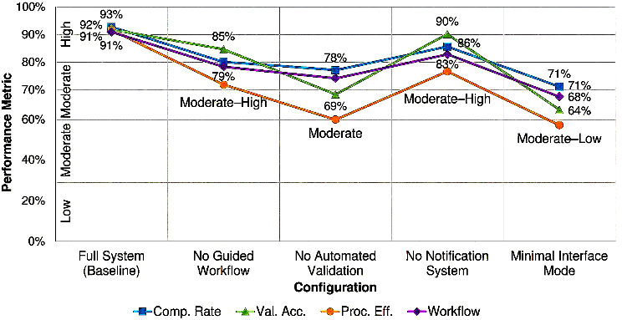
Fig. 3. Performance degradation under selective Easy Claim system feature removal

Practical Deployment
In order to illustrate that Easy Claim platform can be used in real-life settings, a working prototype of the platform in form of a web-based application was constructed and implemented to recreate the situation of practical insurance claims methods operation. This deployment environment enables real-time interaction with the users and allows policyholders to create accounts, make claims, add supporting materials, and check the status of the claim using an intuitive dashboard. The system proves that the proposed workflow will not only be an idea in theory but can be developed into a working digital claims management system.
Fig. 4 shows the interface of the Easy Claim system deployed, which consists of (a) the assistive claim submission box, (b) the administrative claim review case and (c) the real time claim tracking box that shows the status of a claim and workflow. The results of the deployment confirm that the suggested system may work as an effective and practical solution to digital insurance claims that are capable of enhancing efficiency and decreasing the amount of manual effort in practice.

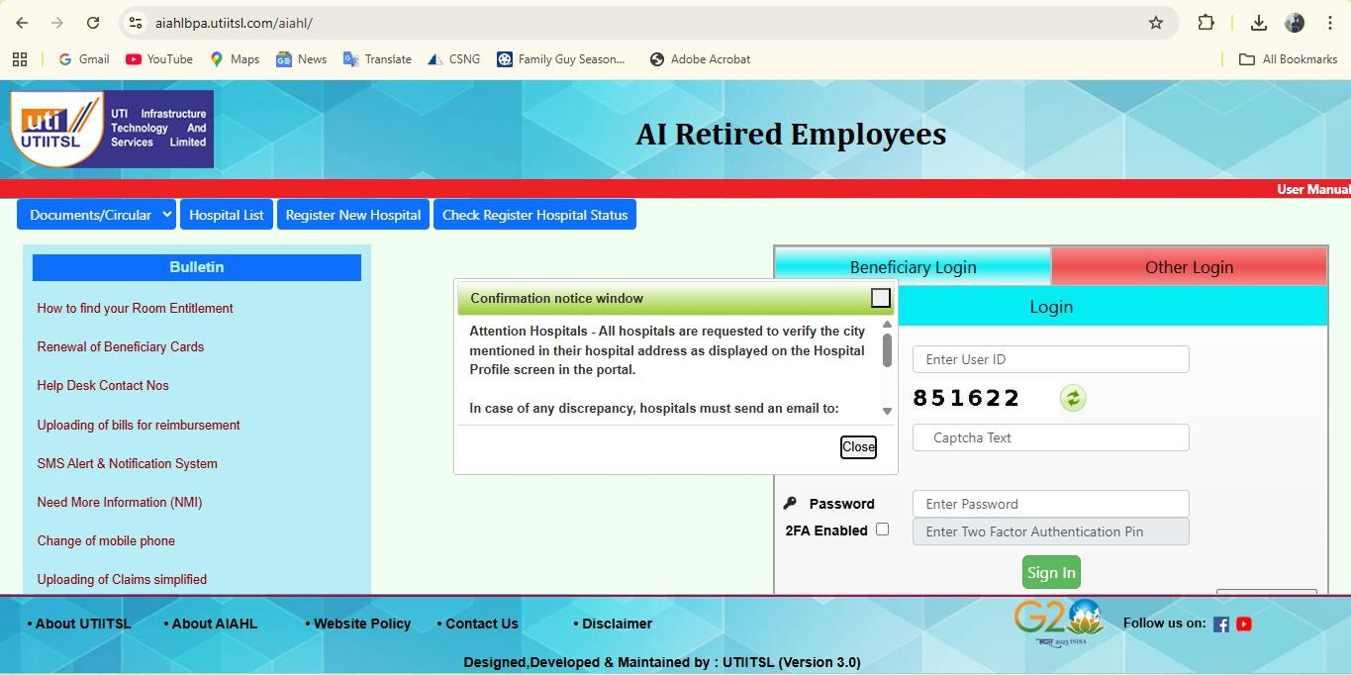

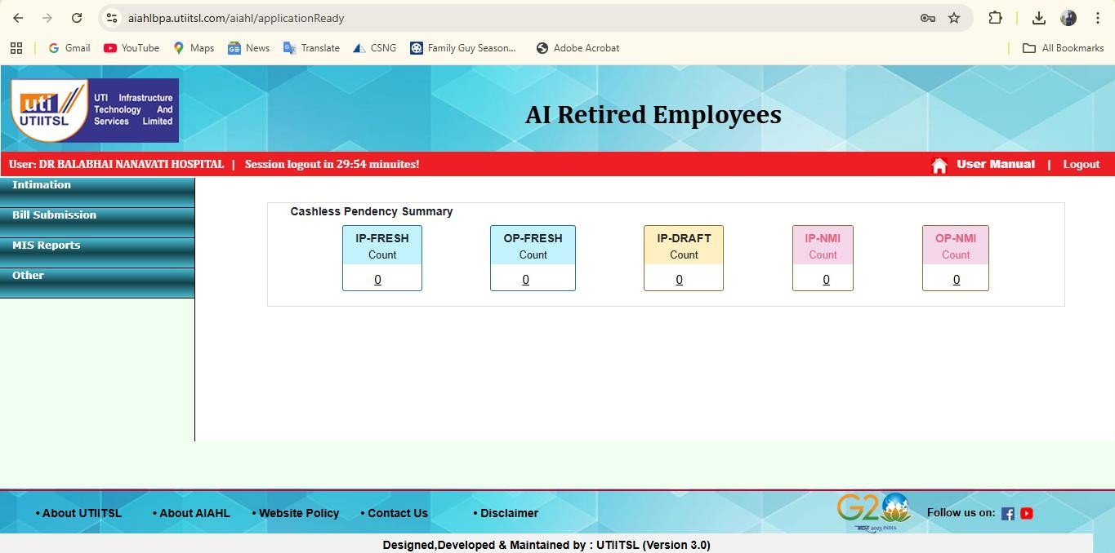

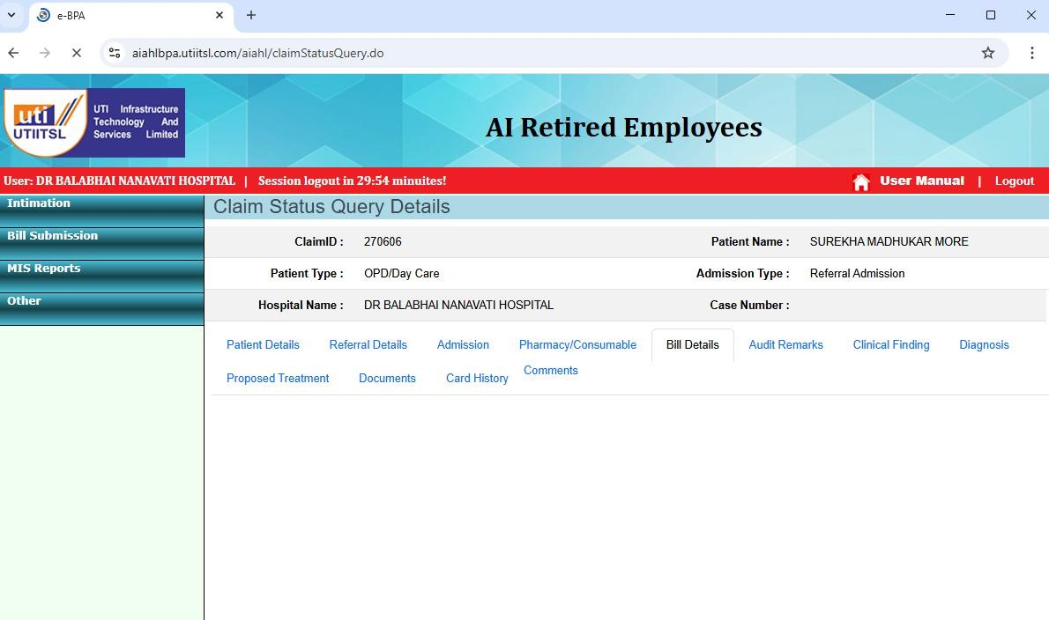

Fig. 4. Practical deployment of the Easy Claim platform showing (a) guided claim submission interface, (b) administrative review dashboard, and (c) real-time claim tracking panel

Limitations and Threats to Validity
Despite the fact that the Easy Claim platform proves a high level of workflow efficiency and user experience improvement, there are a number of limitations which should be taken into account when the results are interpreted. First, the test sample dataset is mainly composed of simulated insurance claim cases, given that real-world claim data is scarce given the privacy and other regulatory issues. Although the data set was constructed so that it could be representative of realistic patterns of claims, there might be more sophisticated or uncertain user behaviors not well represented during experimental testing.
Second, the size of general assessment is relatively small as compared to a large scale of commercial insurance systems. Though several testing scenarios were also carried out to confirm the reliability of the workflow and the responsiveness of the system, the platform has not been under high-volume and enterprise scale (thousands of users at the same time) deployment conditions. Consequently, further scalability testing is necessary to ensure the stability in performance when operating under high workloads.
Third, the existing application is based on a set of pre-established categories of claims and forms templates. Validation rules and workflow structures would have to be updated in case any new type of insurance and conditions of the policy or regulatory requirements are introduced. Along with this, automated validation module is used mainly to conduct data completeness and formatting checks by rule but not with higher formative examination of claim authenticity or even detecting fraud.
An additional weakness is associated with the methodology of the evaluation that focuses on the structured measures of workflow performance, including the submission completion rate and the accuracy of the validation. Although these indicators are useful in understanding system efficiency, they might not adequately describe long term operational results like accuracy in settlement of claims or its financial consequences. In addition, the usability testing was carried out in an academic controlled setting, which might not be equivalent to the pattern of user behavior of various demographics in the real world.
Lastly, the Easy Claim prototype that is deployed is currently a proof-of-concept application and is not extensively audited in terms of security, interoperability with other insurance databases, or integrated into an actual live commercial insurance ecosystem. The way to go in future work is to make the things used in the future be more scaled, tighten down the data security efforts, and test the performance through the actual claim data to be more generalized and a useful adoption should be made.

Machine Learning Evaluation Metrics
In order to test the efficiency of the validation model, the standard machine learning performance measures are applied in addition to workflow-based measures. Accuracy measures the general correctness of claim classification. Precision refers to the ratio of the correct identification of valid claims. Recall The capability of the system to identify all valid claims. F1-Score gives a measure of precision and recall.
- MACHINE LEARNING PERFORMANCE METRICS
Metric | Value
Accuracy | 90.7%
Precision | 89.5%
Recall | 91.2%
F1-Score | 90.3%

These findings suggest that the suggested system can accurately detect the valid and incomplete claims with high accuracy. Machine learning can improve the detection of inconsistencies in the system and the overall validation performance.

Comparison with Existing Approaches
In an effort to further confirm the effectiveness of the Easy Claim platform, this is compared to the existing validation methods applied in insurance systems.
TABLE VI. COMPARISON WITH EXISTING VALIDATION APPROACHES
Method | Accuracy | Description
Rule-Based Validation | 75% | Uses predefined validation rules
ML-Based Detection System | 85% | Uses classification algorithms
Easy Claim (Proposed) | 90.7% | Hybrid rule-based + ML approach

The accuracy of the proposed system is higher because there is the combination of structured workflows, automated validation, and machine learning techniques. In contrast with traditional systems, Easy Claim is a combination of real-time validation and intelligent analysis which leads to the enhanced performance and user experience.

Conclusion and Future Work
This paper introduced Easy Claim, an online insurance claims management system that will help ease the process and improve the claim processing cycle. The system suggested overcomes the typical problems of insurance processes, such as the intricate documentation process, handwritten validation, the absence of transparency, and the slow way of processing claims. The platform enhances operational efficiencies and user experience by launching specific digital workflow controls, automated validation frameworks, claims monitoring by centralized databases, and real-time updates.
The experimental analysis shows that Easy Claim is much more effective than manual procedures and simple online claim portals regarding the rate of submission completion, the rate of its validation, and the success of the entire workflow. Findings reveal that the form guidance structured and the automated detection of errors are critical in increasing the level of completion of submissions and decreasing the amount of administrative workload. The comparative and ablation researches also substantiate the fact that controlled workflow, validation procedures, and notification systems are vital to guarantee the processing of claims in the most reliable and efficient way.
The integration of machine learning techniques for validation and anomaly detection further strengthens the system by improving accuracy, reducing errors, and enabling intelligent decision support. The ability to promote the platform to include mobile applications, integration into multiple insurers, and real-world datasets will enhance scalability and its practical implementation even further. The integration of safe technologies like a blockchain to ensure the immutability of the claim records and enhancing the level of data security is also possible when it comes to future improvements. In general, Easy Claim is a firm foundation of the present-day transparent and efficient digital insurance claim management systems.

References
- Amit Chakraborty et al., "Blockchain-Enhanced Adversarial Machine Learning for Fraud Detection and Claims Automation in the Insurance Sector," IEEE Access, 2024. Link
- Bavo D.C. Campo et al., "An engine to simulate insurance fraud network data," arXiv preprint arXiv:2308.11659, 2023.Link
- Bediga Sharan et al., "Machine Learning-Based Fraud Detection System for Insurance Claims in IoT Environment," 2024 3rd International Conference on Applied Artificial Intelligence and Computing (ICAAIC), 2024.Link
- Venkata Ramana Saddi et al., "Insurance Fraud Prediction: An analysis Using Supervised and Unsupervised Machine Learning," 2023 IEEE Technology & Engineering Management Conference, 2024.Link
- Sandip Vyas et al., "Fraud Detection in Insurance Claim System: A Review," 2022 Second International Conference on Artificial Intelligence and Smart Energy (ICAIS), 2022.Link
- Nirmala S.Patil et al., "Vehicle Insurance Fraud Detection System Using Robotic Process Automation and Machine Learning," 2021 Third International Conference on Intelligent Communication Technologies and Virtual Mobile Networks (ICICV), 2021.Link
- Sadia Afrin et al., "AI-Enhanced Robotic Process Automation: A Review of Intelligent Automation Innovations," IEEE Access, 2024.Link
- Gurinder Singh et al., "Disruptive Technologies and Digitalization in Insurance: Improving the Value Chain of Insurance," 2022 10th International Conference on Reliability, Infocom Technologies and Optimization, 2022.Link
- Henrique Lin et al., "Document Data Matching for Blockchain-Supported Real Estate," (Covers OCR/NLP for automated data extraction), arXiv preprint arXiv:2512.24457, 2025.Link
- Thomas Saout et al., "An Overview of Data Extraction From Invoices," (Details OCR, NLP, and ML for automated document processing), IEEE Access, 2024.Link
- Panyi Dong et al., "InsurTech innovation using natural language processing," arXiv preprint arXiv:2507.21112, 2025.Link
- Sebastian Baran et al., "Prediction of motor insurance claims occurrence as an imbalanced machine learning problem," arXiv preprint arXiv:2204.06109, 2022.Link.

