1. For running the application, keep the application in your respective server folder like kept in inside in the wamp/www/ folder
2. A default user with credentials abh and password ‘pass’ are already created
3. Administrator can create separate users for admin purposes and separate users for non administrative purposes.
4. Users can easily be added , deleted and edited .

Main

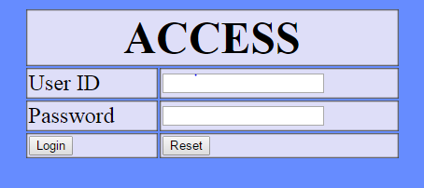

Admin menu

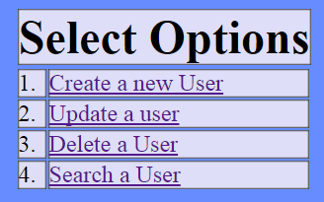

Sample adding data

