create database test5;

use test5;

**– 1)**

create table patients (

patient_id int PRIMARY KEY AUTO_INCREMENT,

name varchar(50),

age int,

gender varchar(1),

city varchar(50),

date_of_admission date,

status varchar(50),

doctor_id int,

Foreign Key (doctor_id) REFERENCES doctors(doctor_id)

);

**– 2)**

create table doctors (

doctor_id int PRIMARY KEY AUTO_INCREMENT,

name varchar(50),

age int,

gender varchar(1),

city varchar(50),

specialization varchar(50),

year_of_experience int,

salary int

);

**-- 3)**

ALTER TABLE doctors CHANGE specialization subject VARCHAR(50);



**-- 4)**

CREATE TABLE bkup_doctors AS SELECT * FROM doctors;



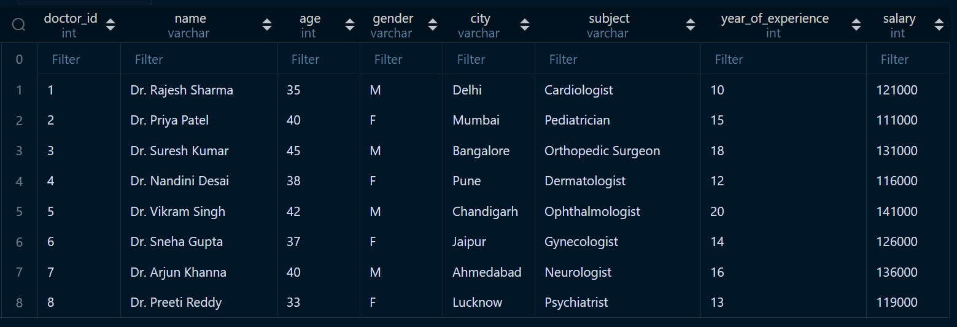

CREATE TABLE bkup_patients AS SELECT * FROM patients;



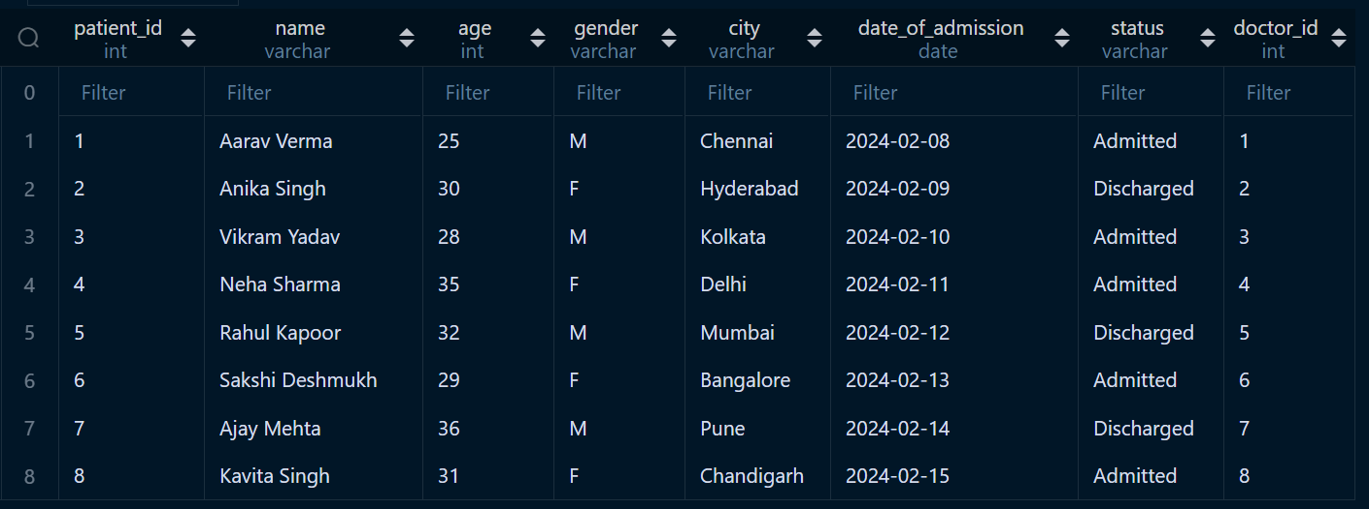

**-- 5)**

SELECT * FROM patients WHERE city = 'Pune' OR city = 'Mumbai';



**-- 6)**

SELECT * FROM doctors WHERE city = 'Ahmedabad' AND name LIKE('Dr. A%');



**-- 7)**

SELECT * FROM doctors WHERE year_of_experience >= 4;

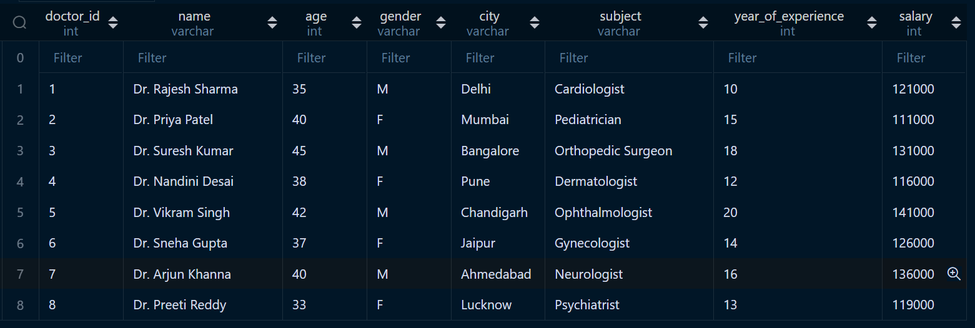

**-- 8)**

UPDATE doctors

SET salary = salary + 1000

WHERE year_of_experience > 5;



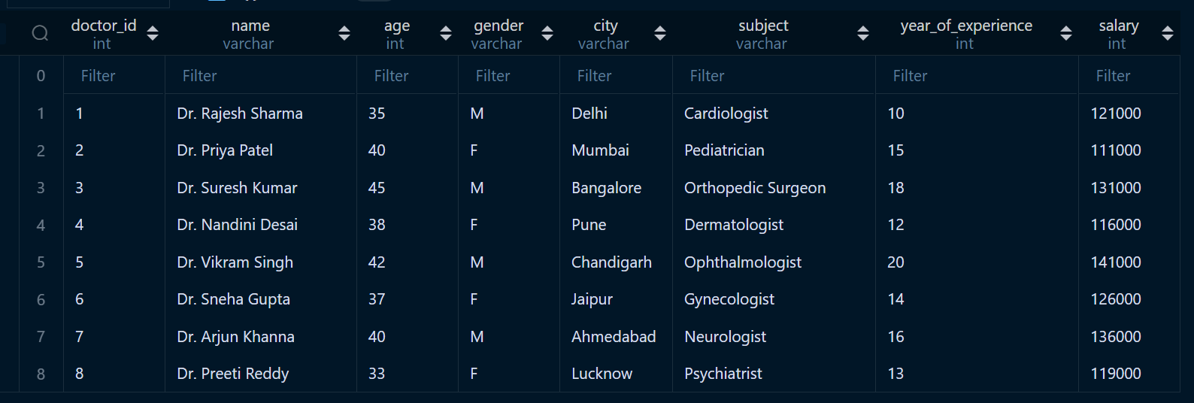

**-- 9)**

SELECT city, COUNT(city) as 'No. of Doctors' FROM patients

GROUP BY city;

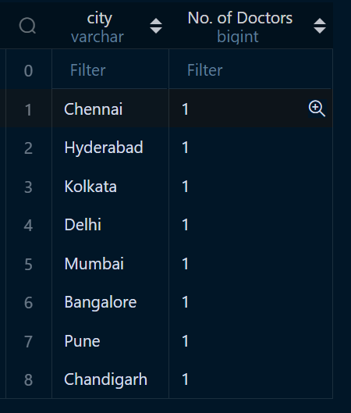

**-- 11)**

SELECT * FROM patients p

JOIN doctors d

ON p.doctor_id = d.doctor_id

WHERE p.status = 'Discharged' && d.year_of_experience > 3;

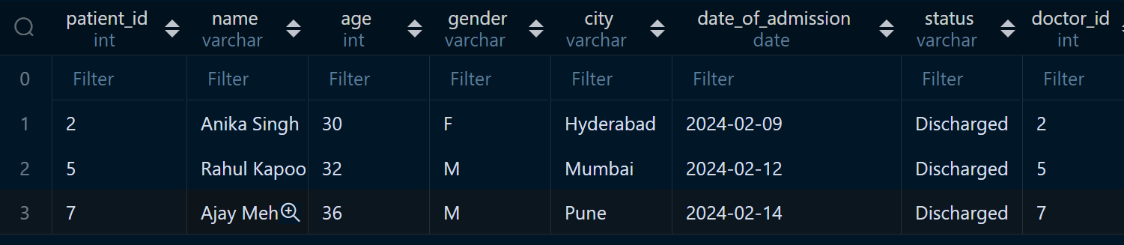



*Above table is contineous.*

**-- 12)**

CREATE TABLE bkup_doctors_structure AS SELECT * FROM doctors WHERE 0 = 1;





CREATE TABLE bkup_patients_structure AS SELECT * FROM patients WHERE 0 = 1;



