Insights and Visualization

This document contains insights and visualizations generated from the cleaned datasets which we acquired after the wrangling process. We posed some interesting questions on the dataset and generated insights on it. We also presented the answers in the form of visualizations.

We generated insights for the following intriguing questions:

1. How does tweet distribution look like year and month wise?
2. What is the repartition of the dog stages?
3. Which breed has got more likes and how retweet counts look like for those breeds?
4. Where do the tweets come from?
5. Is there any relationship between likes and retweets?

# How does tweet distribution look like year and month wise?

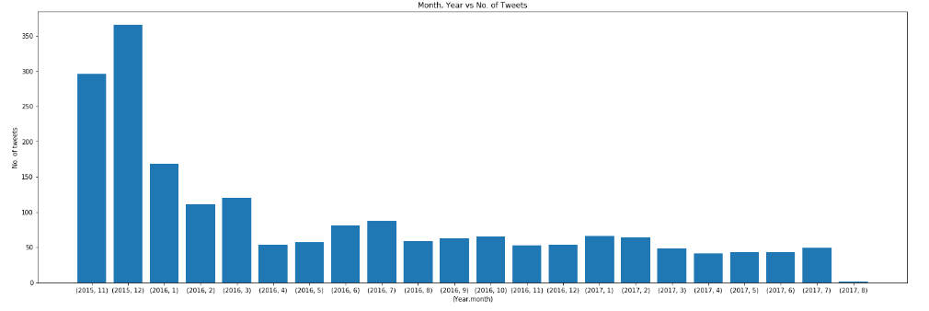We were interested in finding how the distribution of tweets looks like for user @dog_rates i.e. how many times he tweeted month and year wise. And we found this interesting graph.

This graph tells us that:

1. For the first two months, the number of tweets user @dog_rates posted were much more as compared to the following upcoming months. For the upcoming months, the count reduced, averaging between 50-80.
2. 366 is the count for the maximum number of tweets done in a month which came in the month of December and year 2015.
3. 2 is the count for the minimum number of tweets done in a month which came in the month of August and year 2017.

# Which breed has got more likes and how retweet counts looks like for those breeds?

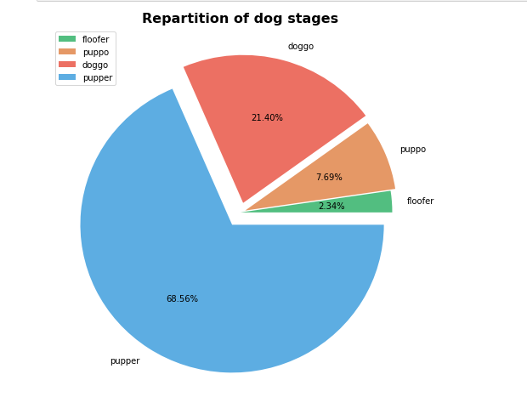We were interested in finding the stages in which dogs fall more. And here is what we found!

This pie chart depicts that the majority of dogs who appeared in tweets where in ‘Pupper’ stage (68.56%). Followed by Doggo (21.40%), Puppo (7.69%) and Floofer (2.34%) stages.

This brings us an interesting fact that the majority of dogs, featured in the tweets, were small and young. Almost 7 out of 10 times tweet had an image of a small dog. Old dogs were present in almost one out of five tweets. Dogs with excess fur were very less in the tweets. Almost 2 out of 100 times, dogs with excess fur featured.

# Which breed has got more likes and how retweet count looks like for those breeds?

We were interested in finding the breeds which received more likes than others and how retweet count for these breeds looks like. For it, we chose up to 8 top breeds who 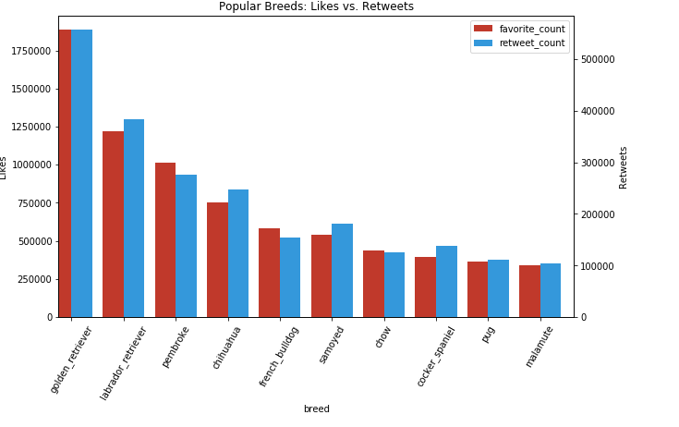gained more likes.

This graph shows us:

1. Golden Retriever has got the maximum number of likes. And this breed also got the maximum number of retweets among 8 breeds.
2. We can see that for these 8 most liked breeds when favorite count decreases, retweet count also decreases.

# Where do the tweets come froM?

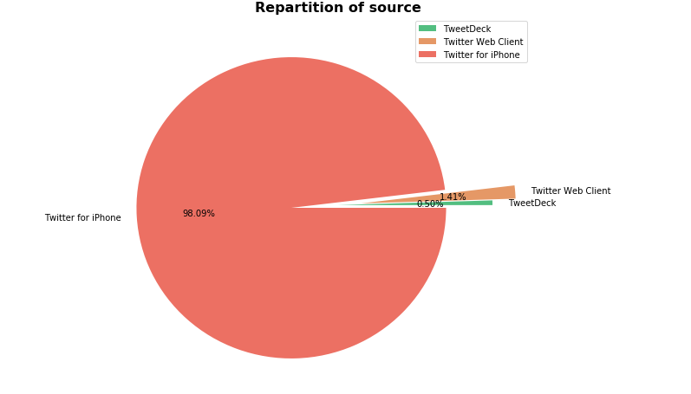The Maximum number of tweets came from ‘Twitter for iPhone’ (98.09%). Followed by ‘Twitter Web Client’ (1.4%) and ‘TweetDeck’ (0.5%)

# Is there any relationship between likes and retweets?

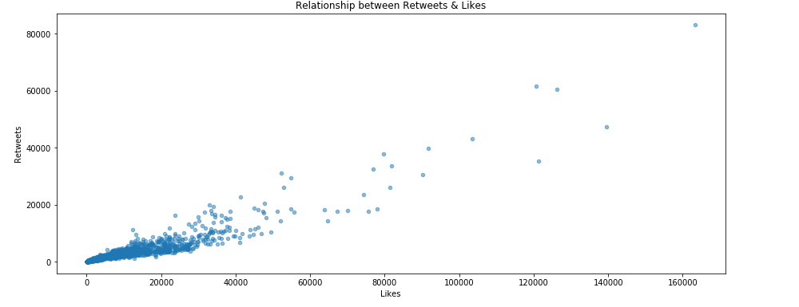We felt that there must be a relationship between like count and retweet count. And to see the relationship between these two attributes, we plotted a scatter plot between like count and retweet count. And here it is!

As we can see, there is a strong relationship between like count and retweet count. As one increases, another also increases. We got our belief checked. ☺