Introduction
Food Ordering Website is the core system of any online food delivery platform. It provides an easy-to-use interface for customers to browse various food items, place orders, and get their favorite meals delivered to their doorstep. It also allows the administrator to manage food items, categories, orders, and customer details efficiently.

OBJECTIVE:
- To view and manage Food Menu Details.
- To provide an online platform for Customers to order food easily.
- To manage Customer Orders and Delivery Details.
- To maintain Food Categories (Veg, Non-Veg, Beverages, etc.).
- Reports like Order Reports, Payment Reports, and Customer Feedback.

Theoretical Background
TOOL AND TECHNOLOGY:-
2.1 Microsoft.NET Framework:-

The .NET Framework is a new computing platform that simplifies application development in the highly distributed environment of the Internet. The .NET Framework is designed to fulfil the following objectives:
- To provide a consistent object-oriented programming environment whether object code is stored and executed locally, executed locally but Internet-distributed, or executed remotely.
- To provide a code-execution environment that minimizes software deployment and versioning conflicts.
- To provide a code-execution environment that guarantees safe execution of code, including code created by an unknown or semi-trusted third party.
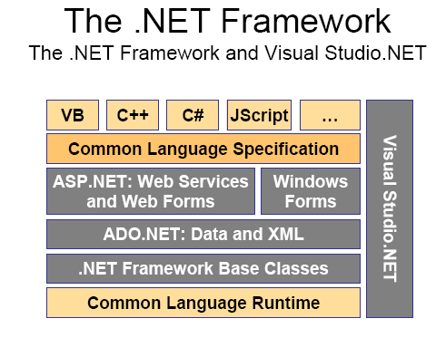
Fig 2.1 .Net framework

The .NET Framework has two main components:
- The common language runtime and
- The .NET Framework class library.

2.1.1 The common language runtime
Is the foundation of the .NET Framework. You can think of the runtime as an agent that manages code at execution time, providing core services such as memory management, thread management, and remoting, while also enforcing strict type safety and other forms of code accuracy that ensure security and robustness. In fact, the concept of code management is a fundamental principle of the runtime.
Features of the Common Language Runtime:-
The common language runtime manages memory, thread execution, code execution, code safety verification, compilation, and other system services. These features are intrinsic to the managed code that runs on the common language runtime.
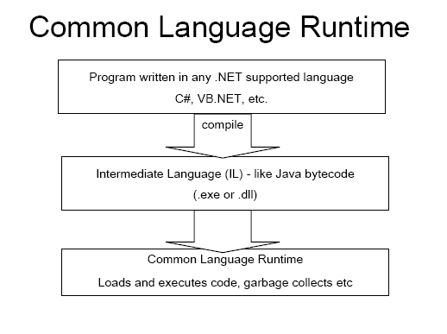
Fig 2.2 Common Language Runtime
With regards to security, managed components are awarded varying degrees of trust, depending on a number of factors that include their origin (such as the Internet, enterprise network, or local computer).
feature called just-in-time (JIT) compiling enables all managed code to run in the native machine languaFge of the system on which it is executing. Meanwhile, the memory manager removes the possibilities of fragmented memory and increases memory locality-of-reference to further increase performance.
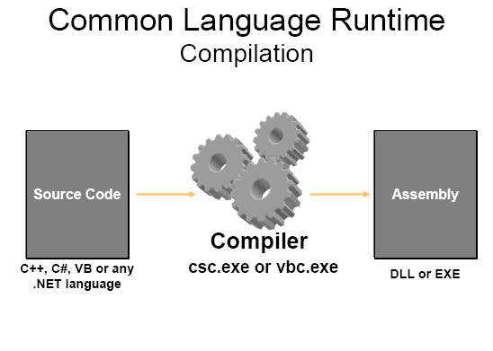
Fig 2.3 Common Language Runtime (Compilation)

2.1.2 .NET Framework Class Library

The .NET Framework class library is a collection of reusable types that tightly integrate with the common language runtime. The class library is object oriented, providing types from which your own managed code can derive functionality. This not only makes the .NET Framework types easy to use, but also reduces the time associated with learning new features of the .NET Framework. In addition, third-party components can integrate seamlessly with classes in the .NET Framework.
- Console applications.
- Scripted or hosted applications.
- Windows GUI applications (Windows Forms).
- ASP.NET applications.
- XML Web services.
- Windows services.
Client Application Development:-

Client applications are the closest to a traditional style of application in Windows-based programming. These are the types of applications that display windows or forms on the desktop, enabling a user to perform a task.

In the past, developers created such applications using C/C++ in conjunction with the Microsoft Foundation Classes (MFC) or with a rapid application development (RAD) environment such as Microsoft® Visual Basic®. The .NET Framework incorporates aspects of these existing products into a single, consistent development environment that drastically simplifies the development of client applications.

The Windows Forms classes contained in the .NET Framework are designed to be used for GUI development. You can easily create command windows, buttons, menus, toolbars, and other screen elements with the flexibility necessary to accommodate shifting business needs.

.NET Framework: High Level Architecture
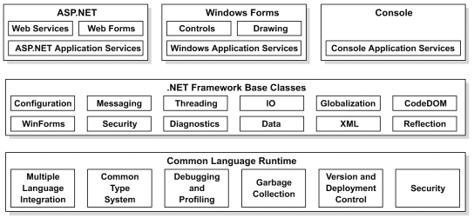
Fig-2.4 .Net framework: High Level Architecture
2.2 ACTIVEX DATA OBJECTS.NET (ADO.NET)

ADO.NET Overview:-
ADO.NET is an evolution of the ADO data access model that directly addresses user requirements for developing scalable applications. It was designed specifically for the web with scalability, statelessness, and XML in mind.
ADO.NET uses some ADO objects, such as the Connection and Command objects, and also introduces new objects. Key new ADO.NET objects include the DataSet, DataReader, and Data Adapter:-
The important distinction between this evolved stage of ADO.NET and previous data architectures is that there exists an object -- the Dataset -- that is separate and distinct from any data stores. Because of that, the Dataset functions as a standalone entity. You can think of the Dataset as an always disconnected record set that knows nothing about the source or destination of the data it contains. Inside a Dataset, much like in a database, there are tables, columns, relationships, constraints, views, and so forth.

A Data Adapter is the object that connects to the database to fill the Dataset. Then, it connects back to the database to update the data there, based on operations performed while the Dataset held the data. In the past, data processing has been primarily connection-based. It accomplishes this by means of requests to the appropriate SQL commands made against the data store.

While the Dataset has no knowledge of the source of its data, the managed provider has detailed and specific information. The role of the managed provider is to connect, fill, and persist the Dataset to and from data stores. The OLE DB and SQL Server .NET Data Providers (System.Data.OleDb and System.Data.SqlClient) that are part of the .Net Framework provide four basic objects: the Command, Connection, Data Reader and DataAdapter.

Connections. For connection to and managing transactions against a database.
When dealing with connections to a database, there are two different options: SQL Server .NET Data Provider (System.Data.SqlClient) and OLE DB .NET Data Provider (System.Data.OleDb). In these samples we will use the SQL Server .NET Data Provider. These are written to talk directly to Microsoft SQL Server. The OLE DB .NET Data Provider is used to talk to any OLE DB provider (as it uses OLE DB underneath).Connections

Connections are used to 'talk to' databases, and are represented by provider-specific classes such as SQLConnection. Commands travel over connections and result sets are returned in the form of streams which can be read by a DataReader object, or pushed into a DataSet object.

Commands:-
Commands contain the information that is submitted to a database, and are represented by provider-specific classes such as SQLCommand. A command can be a stored procedure call, an UPDATE statement, or a statement that returns results. You can also use input and output parameters, and return values as part of your command syntax. The example below shows how to issue an INSERT statement against the Northwind database.

DataReaders:-
The DataReader object is somewhat synonymous with a read-only/forward-only cursor over data. The DataReader API supports flat as well as hierarchical data. A DataReader object is returned after executing a command against a database. The format of the returned DataReader object is different from a recordset. For example, you might use the DataReader to show the results of a search list in a web page.
DataSets and DataAdapters:-
DataSets:-
The DataSet object is similar to the ADO Recordset object, but more powerful, and with one other important distinction: the DataSet is always disconnected. The DataSet object represents a cache of data, with database-like structures such as tables, columns, relationships, and constraints. However, though a DataSet can and does behave much like a database, it is important to remember that DataSet objects do not interact directly with databases, or other source data. This allows the developer to work with a programming model that is always consistent, regardless of where the source data resides.

DataAdapters (OLEDB/SQL):-
The DataAdapter object works as a bridge between the DataSet and the source data. Using the provider-specific SqlDataAdapter (along with its associated SqlCommand and SqlConnection) can increase overall performance when working with a Microsoft SQL Server databases. For other OLE DB-supported databases, you would use the OleDbDataAdapter object and its associated OleDbCommand and OleDbConnection objects.

The DataAdapter object uses commands to update the data source after changes have been made to the DataSet. Using the Fill method of the DataAdapter calls the SELECT command; using the Update method calls the INSERT, UPDATE or DELETE command for each changed row.
- ADO.NET is the next evolution of ADO for the .Net Framework.
- ADO.NET was created with n-Tier, statelessness and XML in the forefront. Two new objects, the DataSet and DataAdapter, are provided for these scenarios.
- ADO.NET can be used to get data from a stream, or to store data in a cache for updates.
- There is a lot more information about ADO.NET in the documentation.

2.3 C # .NET:-
This could be physical memory (Hard disk) or logical memory (RAM). Any cell of memory is represented with a unique address. This address is more than some combination of numbers or symbols.
C# language provides for practically all the data types. These types can be divided in three categories: value types, reference types and pointer types.
There are some more basic concepts to be learnt before the discussion of the data types. This is about variables and constants. A Variable is a named cell of memory used for data storage. A Variable value can be changed anytime.
- Static variables
- Variable of instance
- Array's elements
- Parameters given by reference
- Parameters given by value
- Returned values
- Local variables.
Static Variables will be alive throughout the life of a program. It can be declared using static modifier.
Constants in C#:-Constant type of data cannot be changed. To declare a constant the keyword const is used. An example for the constant declaration is: const double PI = 3.1415;
Values types in C#:-Value type stores real data. When the data are queried by different function a local copy of it these memory cells are created. It guarantees that changes made to our data in one function don't change them in some other function.
Common types in C#:-
Object in C# language is universal; it means that all supported types are derived from it. It contains only a couple of methods: Get Type () - returns a type of object, To String () returns string equivalent of type that called.
Interface is an abstract type. It is used only for declaring type with some abstract members. It means members without implementations. Please, have a look at piece of code with a declaration for a simple interface:
The members of interface can be methods, properties and indexers.
Next reference type to be dealt is delegate. The main goal of delegate usage is encapsulation of methods. It most like at pointers to function in C++.
String is common type that is used in almost all programming languages of high level. An example of string declaration and initialization:
string s = "declaration and init";
The last very used reference type is array. Array it is set of elements that have the same type. Array contains list of references on memory cells and it can contain any amount of members. In C# there are three types of arrays: one-dimensional, two-dimensional and jagged array.
System Analysis:-
3.1 IDENTIFICATION OF NEED:-
There are large numbers of commercial Bidding websites offering large number of products tailored to meet the bidding interests of large number of customers. These online marketplaces have thousands of products listed under various categories.
Problem:-
- The basic problems with the existing systems are the non-interactive environment they provide to the users and also not user friendly.
- The use of traditional user interfaces which make continuous post backs to theserver; each post back makes a call to the server, gets the response and then refreshes the entire web form to display the result. This scenario adds an extra trade off causing a delay in displaying the results
Solution:-
- The motive of this Online Bidding Web Application is to allow the user to play with the search tool and create different combinatorial search criterion to perform exhaustive search.
- Making the application AJAX enabled gets rid of these unnecessary delays lettingthe user to perform exhaustive search. The users of this application can easily feel the difference between the Ajax empowered user interfaces vs. Tradition all user interfaces.
3.2 PRELIMINARY INVESTIGATION:-
- The current system can be extended to allow the users to create accounts and save products in to with list.
- The users could subscribe for price alerts which would enable them to receivemessages when price for products fall below a particular level.
- The current system is confined only to the bidding cart process. It can be extended to have an ease to use check out process.
- Users can have multiple Bidding and View information through this application, Duringcheckout they can use the drag and drop feature to select Bidding and Pay pal information..

3.3 FEASIBILITY STUDY:-
A feasibility analysis is a test of the system proposal according to its workability, impact on organization, ability to meet user needs and effective use of resources. The objective of the feasibility analysis is not to solve the problem but to acquire sense of its scope.
Steps in feasibility analysis:
- Form a project team and appoint a project leader.
- Prepare system flowcharts.
- Enumerate potential proposed systems.
- Define and identify characteristics of proposed system.
- Determine and evaluate performance and cost effectiveness of each proposed system.
For approving the development of proposed system, three major aspects in the feasibility analyses are considered. These are:
  - Economic Feasibility
  - Technical Feasibility
  - Operational Feasibility
Economic Feasibility: -
To analyze the economic feasibility, the procedure known as Cost-Benefit analysis is used. This procedure helps to determine the benefits and saving that are expected from a proposed system and compare it with the cost.
Technical Feasibility:-
This feasibility centers on the existing computer system hardware and software and to what extent they support the proposed system. It includes:
- Feasibility to produce outputs in a given time.
- Response time under certain conditions.
- Ability to process a certain volume of transaction at a particular speed.
- Feasibility to communicate data to distant location.
For our project, hardware requirements were limited and for software we needed ASP.Net for front end and SQL Server-2005 for back end. Since the budget was not the serious constraint, the project was feasible.
Operational Feasibility: -
People are inherently resistant to change, and computers have been known to facilitate a change. As estimation is made to how strong a reaction, the fresher and IT people are likely to have, towards the development of knowledge base – educational application. So the proposed system is Operational Feasible too.

3.4 PROJECT PLANNING:-
Project planning is a discipline for stating how to complete a project within a certain timeframe, usually with defined stages, and with designated resources. One view of project planning divides the activity into:
- Setting objectives (these should be measurable)
- Identifying deliverables
- Planning the schedule
- Making supporting plans
Developing a written plan (and setting aside the necessary time for this) is essential to start involving partners and stakeholders in what you aim to do and to obtain funding. A clear plan will:
- provide relevant background to explain what the need or issue is that you want to address
- set out anticipated outcomes or changes that you expect to achieve
- map these into national and local policy contexts
Set out in a format that is easy to read at a glance:
- your specific objectives
- actions you propose to take or services you will provide to meet these
- how they will be delivered
- by when
- by whom
- how you will know whether you have been successful or not.
Involvement in the planning process
Identifying and making contact with key stakeholders is an important part of preparing your plan. Making contact at planning stage:

3.5 PROJECT SCHEDULING:-
Scheduling is an inexact process in that it tries to predict the future. While it is not possible to know with certainty how long a project will take, there are techniques that can increase your likelihood of being close. If you are close in your planning and estimating, you can manage the project to achieve the schedule by accelerating some efforts or modifying approaches to meet required deadlines.
1. Add people to the schedule. Additional staff must be added early in a project or they will slow it down while learning the ropes. If you add people, you may also need to add staff for supervision and coordination, so staffs are fully applied.
2. Improve productivity and work longer hours. A good team atmosphere with management support can help make this happen. Without positive nourishment of this process, you could lose your team to attrition.
3. Review schedule dependencies and look for opportunities to overlap tasks or make serial tasks concurrent or parallel activities. This requires greater coordination and sometimes involves increased risks which need to be managed carefully.
4. Review the project scope and remove or delay features or functionality from the project critical path.
3.6 SOFTWARE REQUIREMENTS SPECIFICATION (SRS)
INTRODUCTION to SRS Document:
The software, which is designed for give the better services for the college administration and the user. The college administration need all the information regarding hostel, magazine, admission need all the CMS base facilities.
Purpose: The main purpose for preparing this document is to give a general insight into the analysis and requirements of the existing system or situation and for determining the operating characteristics of the system.
Scope: This Document plays a vital role in the development life cycle (SDLC)
As it describes the complete requirement of the system. It is meant for use by the developers and will be the basic during testing phase. Any changes made to the requirements in the future will have to go through formal change approval process.
Developers Responsibilities Overview:
The developer is responsible for:
1) Developing the system, which meets the SRS and solving all the requirements of the system?
2) Demonstrating the system and installing the system at client's location after the acceptance testing is successful.
3) Submitting the required user manual describing the system interfaces to work on it and also the documents of the system.
Requirements gathering and Analysis:-
Requirements gathering and analysis for this system has been done by observation of existing system, studying existing procedures, discussion with customer and by the analysis of what needs to be added to the system.

3.7 SOFTWARE ENGINEERING APPLIED
Four paradigms have been widely discussed and are as follows:
- The Classical Life Cycle sometimes called “Waterfall Model”.
- Prototyping Model.
- Spiral Model.
- Evolutionary Model.
The ‘Web Portal’ applied the Classical Life Cycle paradigms. The life cycle paradigm encompasses the following activities:
- Software Requirement Analysis.
- Design.
- Coding.
- Testing.
- Maintenance.

Feasibility Study
Requirement analysis & Specification
Coding & Unit Testing
System Design
Integration & System Testing
Maintenance
[Figure 3.1: Water fall Model of Software Life Cycle]
3.7.1Software Requirement Analysis:
The requirement gathering process is intensified and focused specially on software. To understand the nature of the program to be built, the software engineering must understand the information domain for the software as well as required function, performance and interfacings requirements.
3.7.2 Design:-
Software design is actually a multi-step process that focuses on four distinct attributes of the program.
      - Data structure
      - Software architecture
      - Procedural details
      - Interface characterization
The design process translates requirements into representation of the software that can be accessed in quality before coding begins like requirements; the design is documented and becomes part of the software configurations.
3.7.3 Coding:-
The design must be translated into a machine readable form. The coding step performs this task. If design is performed in a detailed manner coding can be accomplished mechanistically.
3.7.4 Testing:-
Once code has been generated, program testing begins. The testing process focuses on the logical internals of the software, ensuring that all statements have been tested and on the functional externals, that is conducting test to uncover errors and ensure that defined input will be produced actual results that agree with the required results.
3.7.5 Maintenance:-
Software will undoubtedly undergo change after it is delivered to the customer. Change will occur because errors have been encountered, because the software must be adopted to accommodate, changes in its external environment.
System Requirements:-
  - SOFTWARE REQUIREMENTS
Using the following software this web portal was developed.

  - Operating system: WINDOWS 8 or above
  - Main technology: ASP.NET
  - Scripting Languages: Javascript
  - Web Server: IIS (Internet information server)
  - Front End: Asp.net, C#.net
  - Data Base: Sql Server-2012
  - Designing: Microsoft Development Environment(.Net)

  - HARDWARE REQUIREMENTS: -
Processor: Core I3 or above
RAM:4GB RAM
Hard Disk: 100MB Free Hard disk space
Mother board: 810E Intel
System Design:-
5.1 MODULE DESCRIPTION:-
It consists of following modules such as
- Login
- User
- Administrator
Login:
In this module the Employee or Administrator enters the system by using different user names.
User:
Under this we have seven sub titles
- New User Registration.
- Show Profile
- Add Cart Food
- Order Food
- Make Payment
- Check Order Details
Administrator:
Under this we have five sub titles
- Check Dashboard
- Add & Update Category
- Add & Update Product
- Check User’s Details
- Check query from users
5.2 Context Diagram (Level 0):
Online Food Ordering
ADMINISTRATOR

User

ssd

ssd
View Data

Edit and Change Profiles

ssd
Update Data

ssd
View Enquiry

ssd

Fig 5.1 Context Diagram ( Level 0)

Data Integration:-

In a database information from several files is co-ordinate, accessed and operated upon a as through it is single file.

Data Integrity:-
Data Integrity means storing all the data in a singly place and allow each application to access it. This approach results in more consistent, on update being sufficient to achieve a new record status for all the applications, which use it.

Data Independence:-
Data Independence is the insulation of application programs from changing aspects of physical data organization.

7.1 Normalization:-
Data structuring is refined through a process called normalization, is a formal process of developing data structures in a manner that eliminates redundancy and promotes integrity.
There are several normal forms to be followed in the normalization process .The most important and widely used are:
- First Normal Form
- Second Normal Form
- Third Normal Form

First Normal Form (1 NF):-
A table is said to be in the first normal form, if the intersection of any column and row contains only value. Identify a suitable identifier from the pool of UN normalized data.Remove any item that repeat within a single value of this key to another relation bringing with them .

Second Normal Form (2 NF):-
For a table to be in the second normal form it should be in the first normal form and the values in every column are functionally depend upon the primary key.

Third Normal Form (3 NF):-
For a table to be in the third normal form it should be in the second normal form and the values in every non-key column are not transitively depend upon on the primary key.

7.2 DATA STRUCTURE:-

TABLE-7.1: Users

Field Name | Data Type | Constraint
UserId | Int | PRIMARY KEY
Name | Varchar(50) | NULL
UserName | Varchar(50) | NULL
Mobile | Varchar(50) | NULL
Email | Varchar(50) | NULL
Address | Varchar(MAX) | NULL
PostCode | Varchar(50) | NULL
Password | Varchar(50) | NULL
ImageUrl | Varchar(MAX) | NULL
CreatedDate | Datetime | NULL

Description:
This table contains all the information about the Users (Customers) of the Food Ordering Website. It stores the personal details of the user such as Name, Username, Mobile Number, Email, Address, and PostCode.
It also stores the login credentials like Username and Password, the profile image of the user, and the date when the user was registered on the website.

TABLE-7.2: Carts

Field Name | Data Type | Constraint
CartId | int | PRIMARY KEY
ProductId | int | NULL
Quantity | int | NULL
UserId | int | NULL

DESCRIPTION:
This table contains all the information related to the items added to the cart by the user in the Food Ordering Website. It stores the details of the selected Product, Quantity of the product, and the User who added the product to the cart.

TABLE-7.3: Carts

Field Name | Data Type | Constraint
OrderDetailsId | int | PRIMARY KEY
OrderNo | varchar(MAX) | NULL
ProductId | int | NULL
Quantity | int | NULL
UserId | int | NULL
Status | varchar(50) | NULL
PaymentId | int | NULL
OrderDate | datetime | NULL

DESCRIPTION:
This table contains all the information related to the orders placed by the users in the Food Ordering Website. It stores details like Order Number, Product Id, Quantity ordered, User Id, Payment Id, Order Status (e.g., Pending, Delivered), and the Date of the Order.

TABLE-7.4: Contacts

Field Name | Data Type | Constraint
ContactId | int | PRIMARY KEY
Name | varchar(50) | NULL
Email | varchar(50) | NULL
Subject | varchar(200) | NULL
Message | varchar(MAX) | NULL
CreatedDate | datetime | NULL

DESCRIPTION:
This table contains all the information related to user inquiries or feedback submitted through the contact form of the Food Ordering Website. It stores the details like User Name, Email, Subject, Message, and the Date on which the user submitted the contact form.

TABLE-7.5: Admin

Field Name | Data Type | Constraint
AdminId | int | PRIMARY KEY
Name | varchar(50) | NOT NULL
UserName | varchar(50) | NOT NULL
Password | varchar(50) | NOT NULL
ImageUrl | varchar(MAX) | NOT NULL

DESCRIPTION:
This table contains all the information related to the Admin of the Food Ordering Website. It stores details like Admin Name, Username, Password for login authentication, and Profile Image. The Admin has full control over managing the website like adding food items, managing orders, and handling customer details.

TABLE-7.6: Category

Field Name | Data Type | Constraint
CategoryId | int | PRIMARY KEY
Name | varchar(50) | NULL
ImageUrl | varchar(MAX) | NULL
IsActive | bit | NULL
CreatedDate | datetime | NULL

DESCRIPTION:
This table contains all the information related to the Food Categories in the Food Ordering Website. It stores details like Category Name (e.g., Pizza, Burger, Drinks), Image for category display, IsActive status (to show or hide category), and the Date on which the category was created.

TABLE-7.6: Product

Field Name | Data Type | Constraint
ProductId | int | PRIMARY KEY
Name | varchar(50) | NULL
Description | varchar(MAX) | NULL
Price | decimal(18, 2) | NULL
Quantity | int | NULL
ImageUrl | varchar(MAX) | NULL
CategoryId | int | NULL
IsActive | bit | NULL
CreatedDate | datetime | NULL

DESCRIPTION:
This table contains all the information related to the Food Items (Products) available in the Food Ordering Website. It stores details like Product Name, Description, Price, Available Quantity, Product Image, Category (Foreign Key from Category Table), IsActive status (Available or Not), and the Date on which the product was added.
TABLE-7.6: Product
Field Name | Data Type | Constraint
PaymentId | int | PRIMARY KEY
Name | varchar(50) | NULL
CardNo | varchar(50) | NULL
ExpiryDate | varchar(50) | NULL
CvvNo | int | NULL
Address | varchar(MAX) | NULL
PaymentMode | varchar(50) | NULL

DESCRIPTION:
This table contains all the information related to the payment details of the customers in the Food Ordering Website. It stores details like Customer Name, Card Number, Card Expiry Date, CVV Number, Billing Address, and Payment Mode (e.g., Credit Card, Debit Card, UPI, Cash on Delivery).

Home Page :
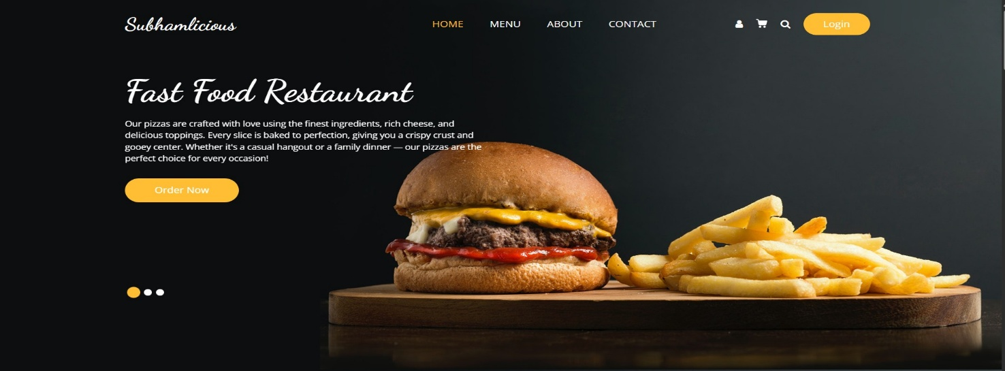

Home Page Footer :

Home Page Body :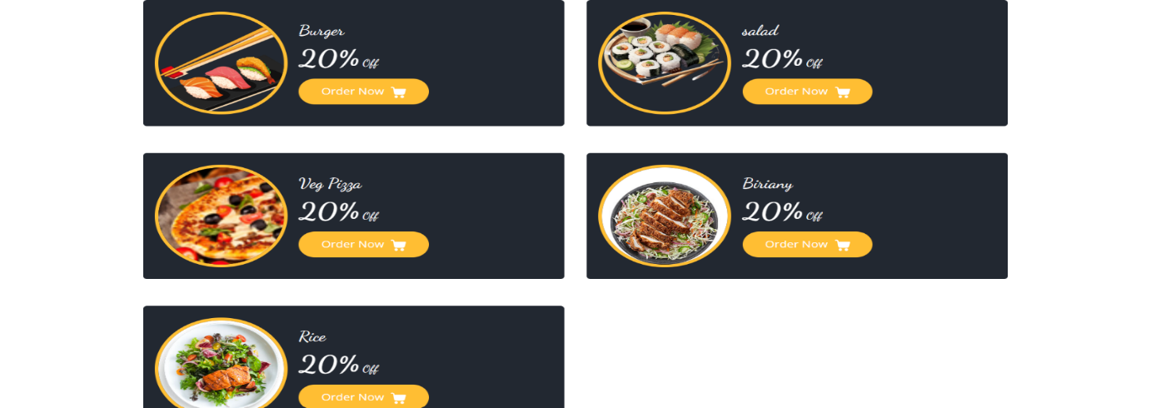


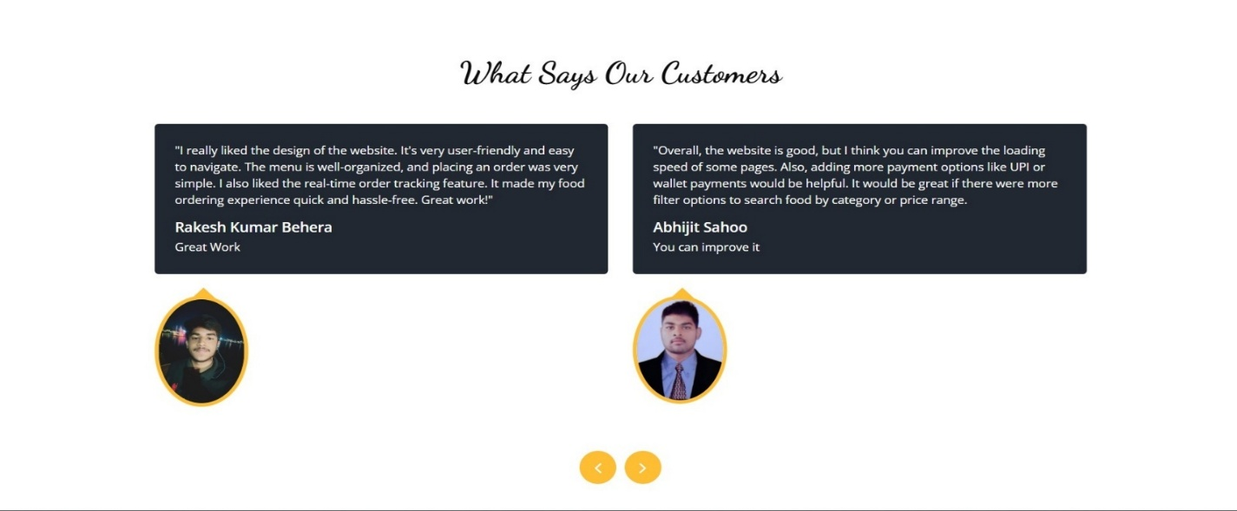
Home’s Menu Page:
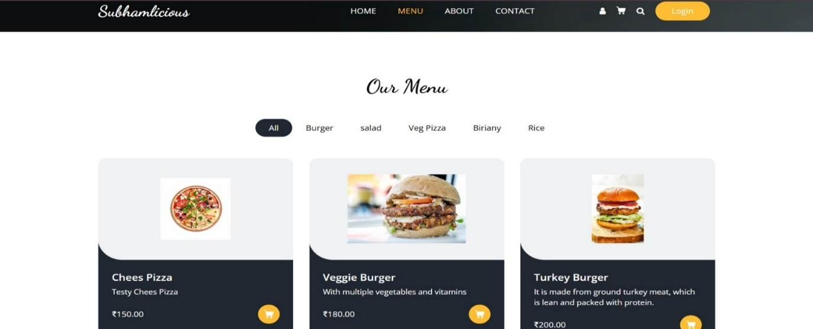

Home’s About Page :
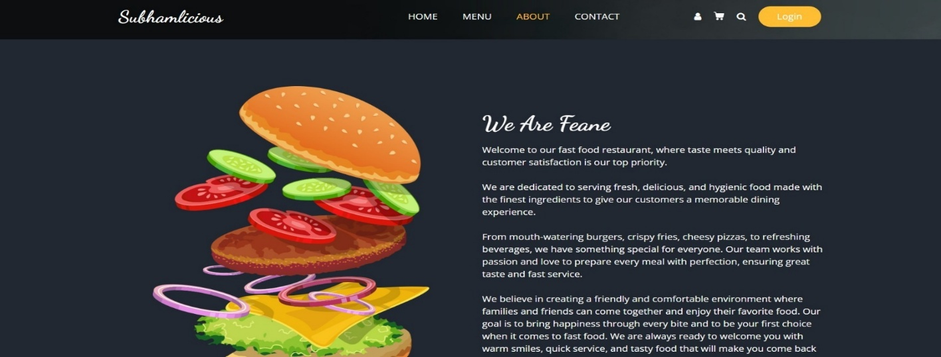

Home’s Contact Page :
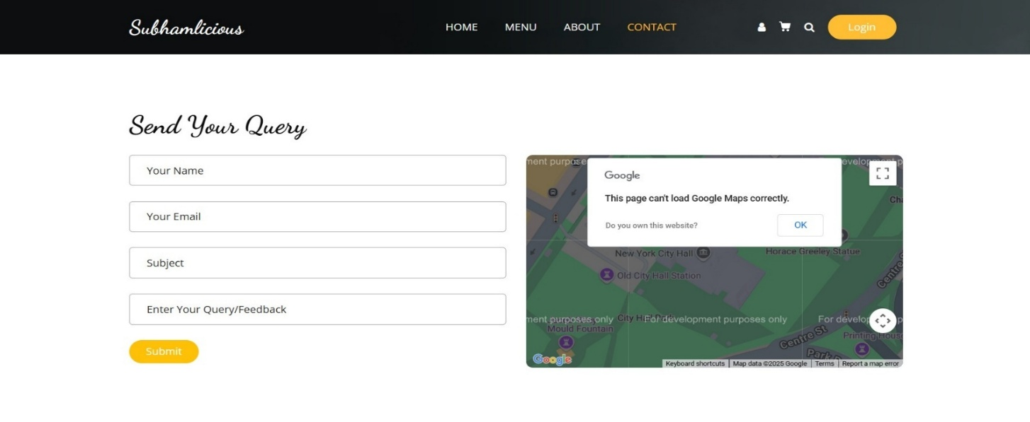

User’s Registration Page:
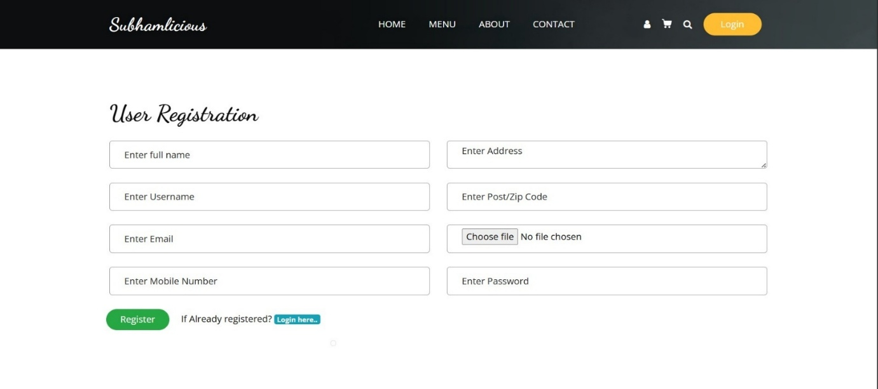

User’s Login Page:
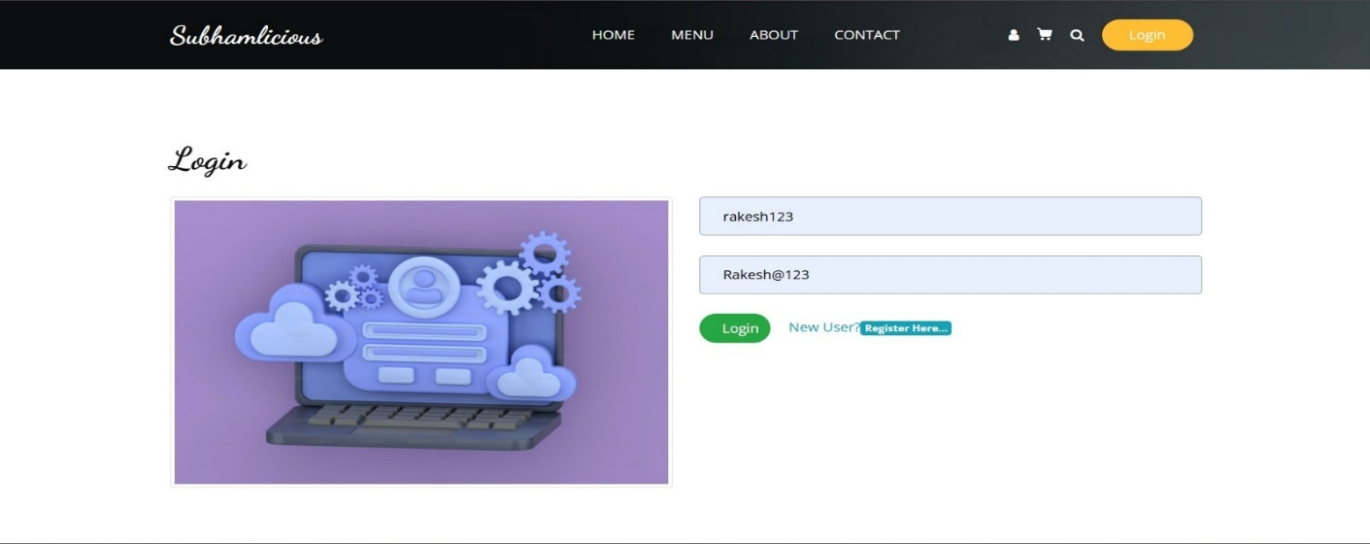

User’s Profile Page:
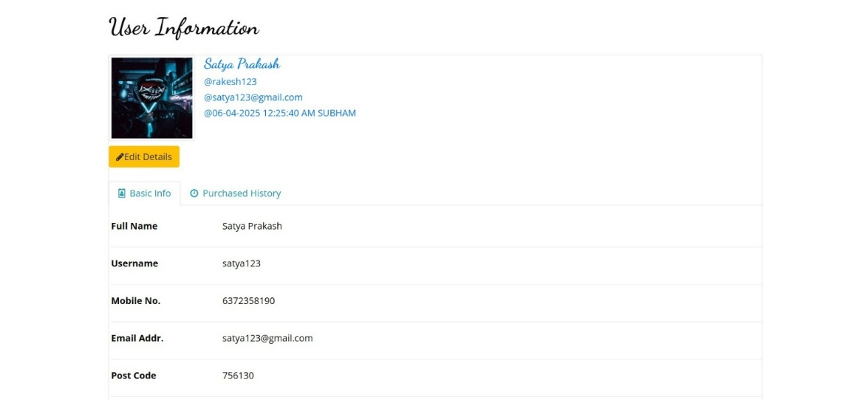

User’s Cart Page :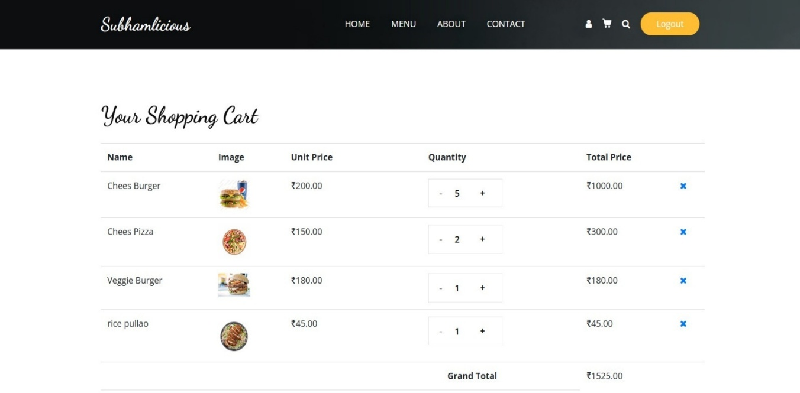

Admin’s Login Page :
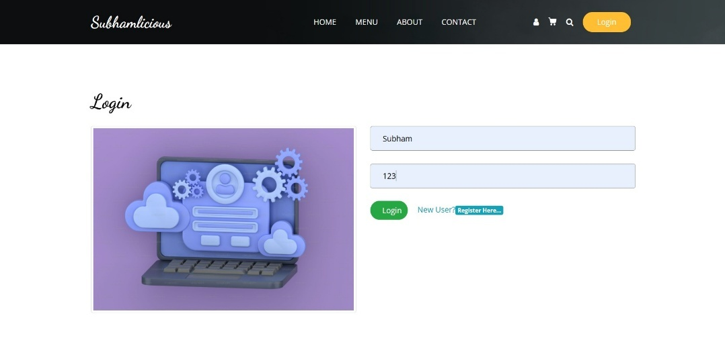

Admin’s Dashboard Page :
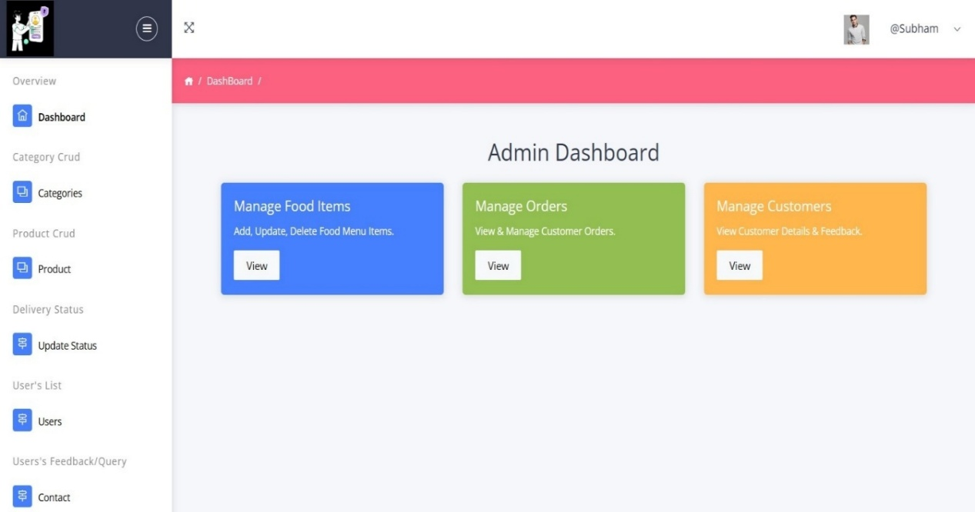
Admin’s Categories page :
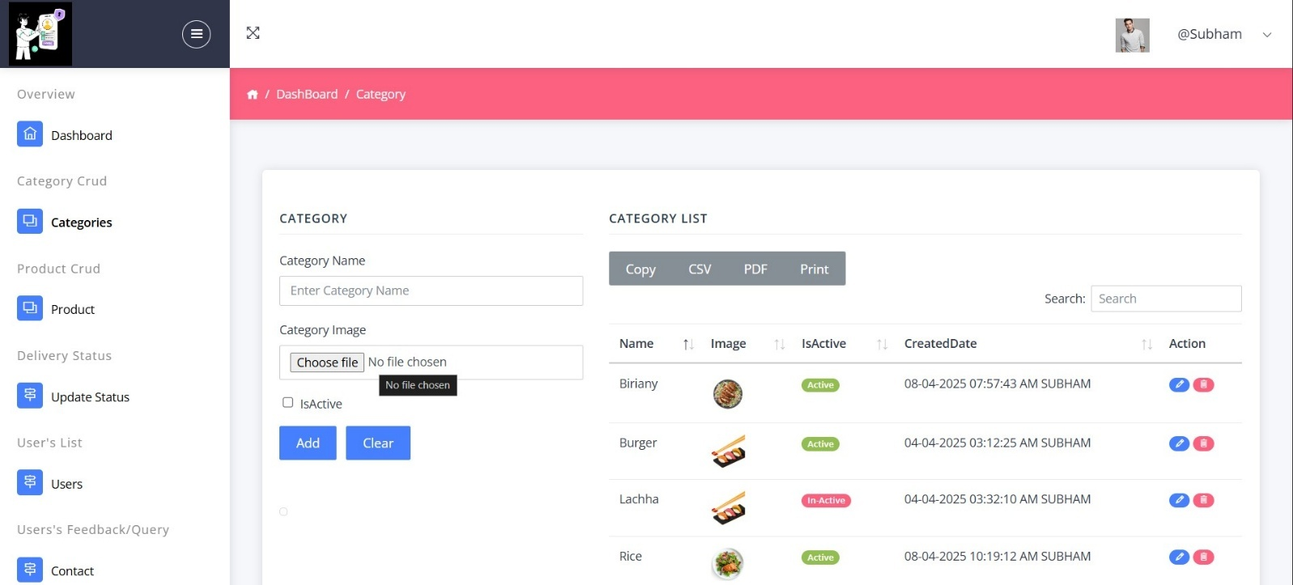

Admin’s Product Page :
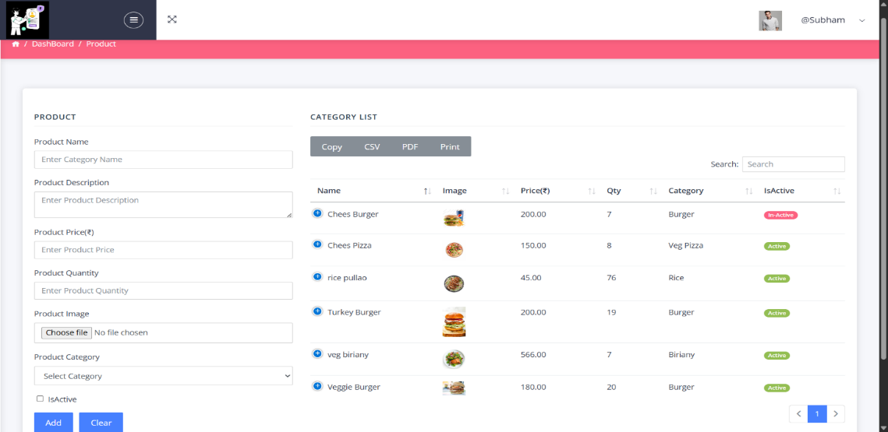

Admin’s Users Page:
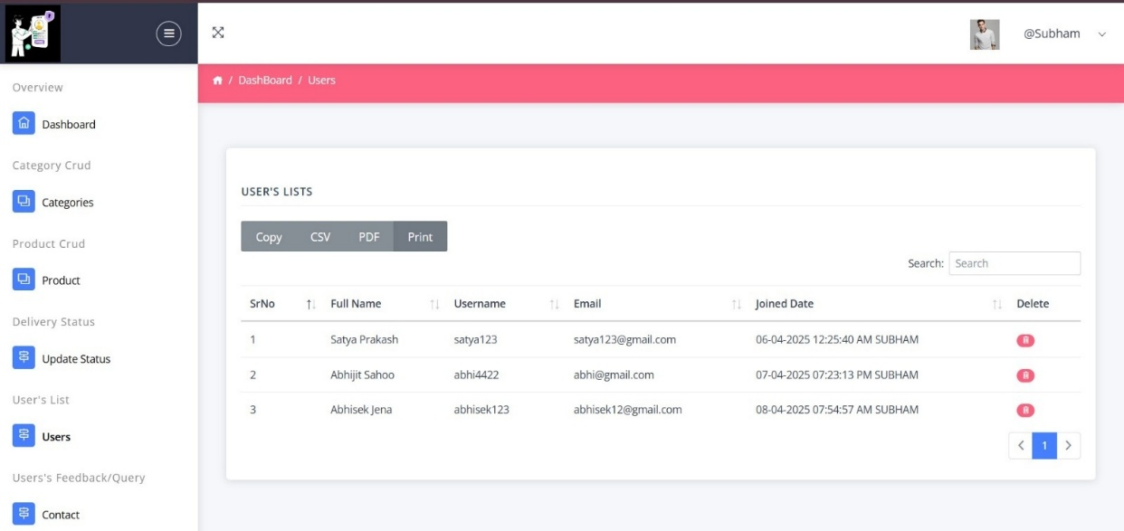

Admin’s Contact Page :
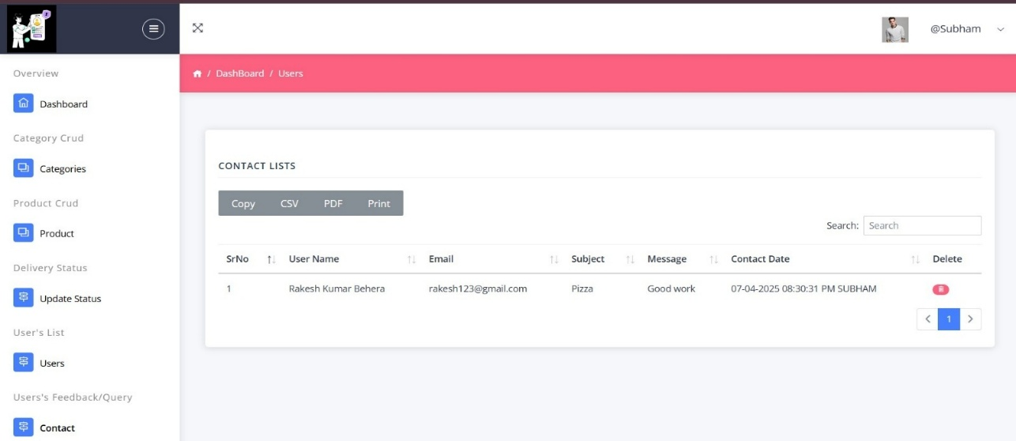

User Home Page Code :
using System;
using System.Collections.Generic;
using System.Linq;
using System.Web;
using System.Web.UI;
using System.Web.UI.WebControls;
namespace Foodie.User
{
public partial class User : System.Web.UI.MasterPage
{
protected void Page_Load(object sender, EventArgs e)
{
if(!Request.Url.AbsoluteUri.ToString().Contains("Default.aspx")) {
form1.Attributes.Add("class", "sub_page");
}
else {
form1.Attributes.Remove("class");
Control sliderUserControl = (Control)Page.LoadControl("SliderUserControl.ascx");
pnlSliderUC.Controls.Add(sliderUserControl);
}
if (Session["userId"] != null){
lbLoginOrLogout.Text = "Logout";
}
else{
lbLoginOrLogout.Text = "Login";
}
}

protected void lbLoginOrLogout_Click(object sender, EventArgs e)
{
if (Session["userId"] == null)
{
Response.Redirect("Login.aspx");
}
else
{
Session.Abandon();
Response.Redirect("Login.aspx");
}
}

protected void lbRegisterOrProfile_Click(object sender, EventArgs e)
{
if (Session["userId"] != null)
{
lbRegisterOrProfile.ToolTip = "User Profile";
Response.Redirect("Profile.aspx");
}
else
{
lbRegisterOrProfile.ToolTip = "User Registration";
Response.Redirect("Registration.aspx");
}
}
}
}

User’s Home’s Body Code :
using System;
using System.Collections.Generic;
using System.Data.SqlClient;
using System.Data;
using System.Linq;
using System.Web;
using System.Web.UI;
using System.Web.UI.WebControls;

namespace Foodie.User
{
public partial class Default : System.Web.UI.Page
{
SqlConnection con;
SqlCommand cmd;
SqlDataAdapter sda;
DataTable dt;
protected void Page_Load(object sender, EventArgs e)
{
if (!IsPostBack)
{

getCategories();
}
}
private void getCategories()
{
con = new SqlConnection(Connection.GetConnectionString());
cmd = new SqlCommand("Category_Crud", con);
cmd.Parameters.AddWithValue("@Action", "ACTIVECAT");
cmd.CommandType = CommandType.StoredProcedure;
sda = new SqlDataAdapter(cmd);
dt = new DataTable();
sda.Fill(dt);
rCategory.DataSource = dt;
rCategory.DataBind();
}
}
}

Menu Page Code :
using System;
using System.Collections.Generic;
using System.Data.SqlClient;
using System.Data;
using System.Linq;
using System.Web;
using System.Web.UI;
using System.Web.UI.WebControls;
using Foodie.Admin;

namespace Foodie.User
{
public partial class WebForm1 : System.Web.UI.Page
{
SqlConnection con;
SqlCommand cmd;
SqlDataAdapter sda;
DataTable dt;
protected void Page_Load(object sender, EventArgs e)
{
if(!IsPostBack)
{
getProducts();
getCategories();
}
}

private void getCategories()
{
con = new SqlConnection(Connection.GetConnectionString());
cmd = new SqlCommand("Category_Crud", con);
cmd.Parameters.AddWithValue("@Action", "ACTIVECAT");
cmd.CommandType = CommandType.StoredProcedure;
sda = new SqlDataAdapter(cmd);
dt = new DataTable();
sda.Fill(dt);
rCategory.DataSource = dt;
rCategory.DataBind();
}

private void getProducts()
{
con = new SqlConnection(Connection.GetConnectionString());
cmd = new SqlCommand("Product_Crud", con);
cmd.Parameters.AddWithValue("@Action", "ACTIVEPROD");
cmd.CommandType = CommandType.StoredProcedure;
sda = new SqlDataAdapter(cmd);
dt = new DataTable();
sda.Fill(dt);
rProducts.DataSource = dt;
rProducts.DataBind();

}

protected void rProducts_ItemCommand(object source, RepeaterCommandEventArgs e)
{
if (Session["userId"] != null)
{
bool isCartItemUpdated = false;
int i = isItemExistInCart( Convert.ToInt32(e.CommandArgument) );
if(i == 0)
{
//Adding new item in cart
con = new SqlConnection(Connection.GetConnectionString());
cmd = new SqlCommand("Cart_Crud", con);
cmd.Parameters.AddWithValue("@Action", "INSERT");
cmd.Parameters.AddWithValue("@ProductId", e.CommandArgument);
cmd.Parameters.AddWithValue("@Quantity", 1);
cmd.Parameters.AddWithValue("@UserId", Session["userId"]);
cmd.CommandType = CommandType.StoredProcedure;

try
{
con.Open();
cmd.ExecuteNonQuery();
}
catch(Exception ex)
{
Response.Write("<script>alert('Error --" + ex.Message + " ');</script>");
}
finally
{
con.Close();
}
}
else
{
//Adding existing item into cart
Utils utils = new Utils();
isCartItemUpdated=utils.updateCartQuantity(i+1, Convert.ToInt32(e.CommandArgument),
Convert.ToInt32(Session["userId"]));

}
lblMsg.Visible = true;
lblMsg.Text = "Item added successfully in your cart!";
lblMsg.CssClass = "alert alert-success";
Response.AddHeader("REFRESH", "1;URL=Cart.aspx");
}
else
{
Response.Redirect("Login.aspx");
}
}

int isItemExistInCart(int productId)
{
con = new SqlConnection(Connection.GetConnectionString());
cmd = new SqlCommand("Cart_Crud", con);
cmd.Parameters.AddWithValue("@Action", "GETBYID");
cmd.Parameters.AddWithValue("@ProductId", productId);
cmd.Parameters.AddWithValue("@UserId", Session["userId"]);
cmd.CommandType = CommandType.StoredProcedure;
sda = new SqlDataAdapter(cmd);
dt = new DataTable();
sda.Fill(dt);

int quantity = 0;
if(dt.Rows.Count > 0)
{
quantity = Convert.ToInt32(dt.Rows[0]["Quantity"]);
}
return quantity;
}

//public string lowerCase(object obj)
//{
// return obj.ToString().ToLower();
//}
}
}

Contact Page Code :

using System;
using System.Collections.Generic;
using System.Data;
using System.Data.SqlClient;
using System.Linq;
using System.Web;
using System.Web.UI;
using System.Web.UI.WebControls;

namespace Foodie.User
{
public partial class Contact : System.Web.UI.Page
{
SqlConnection con;
SqlCommand cmd;
protected void Page_Load(object sender, EventArgs e)
{

}

protected void btnSubmit_Click(object sender, EventArgs e)
{
try
{
con = new SqlConnection(Connection.GetConnectionString());
cmd = new SqlCommand("ContactSp", con);
cmd.Parameters.AddWithValue("@Action", "INSERT");
cmd.Parameters.AddWithValue("@Name", txtName.Text.Trim());
cmd.Parameters.AddWithValue("@Email", txtEmail.Text.Trim());
cmd.Parameters.AddWithValue("@Subject", txtSubject.Text.Trim());
cmd.Parameters.AddWithValue("@Message", txtMessage.Text.Trim());
cmd.CommandType = CommandType.StoredProcedure;
con.Open();
cmd.ExecuteNonQuery();
lblMsg.Visible= true;
lblMsg.Text = "Thanks for reaching out will look into your query";
lblMsg.CssClass = "alert alert-success";
clear();
}
catch (Exception ex)
{
Response.Write("<script>alert(' " + ex.Message + "');</script>");
}
finally
{
con.Close();
}
}

private void clear()
{
txtName.Text = string.Empty;
txtEmail.Text = string.Empty;
txtSubject.Text = string.Empty;
txtMessage.Text = string.Empty;
}
}
}

User’s Registration Code :

using System;
using System.Collections.Generic;
using System.Data.SqlClient;
using System.Data;
using System.Linq;
using System.Web;
using System.Web.UI;
using System.Web.UI.WebControls;
using System.IO;
using System.EnterpriseServices.CompensatingResourceManager;

namespace Foodie.User
{
public partial class Registration : System.Web.UI.Page
{

SqlConnection con;
SqlCommand cmd;
SqlDataAdapter sda;
DataTable dt;
protected void Page_Load(object sender, EventArgs e)
{
if(!IsPostBack)
{
if (Request.QueryString["id"] != null) /*&& Session["userId"] != null)*/
{
getUserDetails();
}
else if (Session["userId"] != null)
{
Response.Redirect("Default.aspx");
}
}
}

protected void btnRegister_Click(object sender, EventArgs e)
{
string actionName = string.Empty, imagePath = string.Empty, fileExtension = string.Empty;
bool isValidToExecute = false;
int userId = Convert.ToInt32(Request.QueryString["id"]);
con = new SqlConnection(Connection.GetConnectionString());
cmd = new SqlCommand("User_Crud", con);
cmd.Parameters.AddWithValue("@Action", userId == 0 ? "Insert" : "UPDATE");
cmd.Parameters.AddWithValue("@UserId", userId);
cmd.Parameters.AddWithValue("@Name", txtName.Text.Trim());
cmd.Parameters.AddWithValue("@Username", txtUsername.Text.Trim());
cmd.Parameters.AddWithValue("@Mobile", txtMobile.Text.Trim());
cmd.Parameters.AddWithValue("@Email", txtEmail.Text.Trim());
cmd.Parameters.AddWithValue("@Address", txtAddress.Text.Trim());
cmd.Parameters.AddWithValue("@PostCode", txtPostCode.Text.Trim());
cmd.Parameters.AddWithValue("@Password", txtPassword.Text.Trim());

if (fuUserImage.HasFile){
if (Utils.IsValidExtension(fuUserImage.FileName)){
Guid obj = Guid.NewGuid();
fileExtension = Path.GetExtension(fuUserImage.FileName);
imagePath = "Images/User/" + obj.ToString() + fileExtension;
fuUserImage.PostedFile.SaveAs(Server.MapPath("~/Images/User/") + obj.ToString() + fileExtension);
cmd.Parameters.AddWithValue("@ImageUrl", imagePath);
isValidToExecute = true;
}
else{
lblMsg.Visible = true;
lblMsg.Text = "Please select .jpg, .jpeg or .png image";
lblMsg.CssClass = "alert alert-danger";
isValidToExecute = true;
}
}
else{
isValidToExecute = true;
}

if (isValidToExecute){
cmd.CommandType = CommandType.StoredProcedure;
try{
con.Open();
cmd.ExecuteNonQuery();
actionName = userId == 0 ?
"registration is successful! <b> <a href='Login.aspx'>Click here</a></b> to do login" :
"detail updated successful! <b><a href='Profile.aspx'>Can check here</a></b>";
lblMsg.Visible = true;
lblMsg.Text = "<b>" + txtUsername.Text.Trim() + "</b>" + actionName;
lblMsg.CssClass = "alert alert-success";
if(userId != 0){
Response.AddHeader("REFRESH", "2;URL=Profile.aspx");
}
clear();
}
catch (SqlException ex){
if (ex.Message.Contains("Violation of UNIQUE KEY constraint")){
lblMsg.Visible = true;
lblMsg.Text = "<b>" + txtUsername.Text.Trim() + "</b> username already exist, try new one..!" ;
lblMsg.CssClass = "alert alert-danger";
} }
catch (Exception ex){
lblMsg.Visible = true;
lblMsg.Text="Error--"+ex.Message;
lblMsg.CssClass= "alert alert-danger";
}
finally {
con.Close();
}}}

void getUserDetails()
{
con = new SqlConnection(Connection.GetConnectionString());
cmd = new SqlCommand("User_Crud", con);
cmd.Parameters.AddWithValue("@Action", "SELECT4PROFILE");
cmd.Parameters.AddWithValue("@UserId", Request.QueryString["id"]);
cmd.CommandType = CommandType.StoredProcedure;
sda = new SqlDataAdapter(cmd);
dt = new DataTable();
sda.Fill(dt);
if(dt.Rows.Count == 1) {
txtName.Text = dt.Rows[0]["Name"].ToString();
txtUsername.Text = dt.Rows[0]["Username"].ToString();
txtMobile.Text = dt.Rows[0]["Mobile"].ToString();
txtEmail.Text = dt.Rows[0]["Email"].ToString();
txtAddress.Text = dt.Rows[0]["Address"].ToString();
txtPostCode.Text = dt.Rows[0]["PostCode"].ToString();
imgUser.ImageUrl = string.IsNullOrEmpty(dt.Rows[0]["ImageUrl"].ToString())
? "../Images/No_image.png" : "../" + dt.Rows[0]["ImageUrl"].ToString();
imgUser.Height = 200;
imgUser.Width = 200;
txtPassword.TextMode = TextBoxMode.SingleLine;
txtPassword.ReadOnly= true;
txtPassword.Text = dt.Rows[0]["Password"].ToString();
}
lblHeaderMsg.Text = "<h2>Edit Profile</h2>";
btnRegister.Text = "Update";
lblAlreadyUser.Text = "";
}
private void clear()
{
txtName.Text = string.Empty;
txtUsername.Text = string.Empty;
txtMobile.Text = string.Empty;
txtEmail.Text = string.Empty;
txtAddress.Text = string.Empty;
txtPostCode.Text = string.Empty;
txtPassword.Text = string.Empty;
}}}

User’s And Admin’s Login Code :
using System;
using System.Collections.Generic;
using System.Data.SqlClient;
using System.Data;
using System.Linq;
using System.Web;
using System.Web.UI;
using System.Web.UI.WebControls;
namespace Foodie.User
{
public partial class Login : System.Web.UI.Page
{
SqlConnection con;
SqlCommand cmd;
SqlDataAdapter sda;
DataTable dt;
protected void Page_Load(object sender, EventArgs e)
{
if (Session["userId"] != null){
Response.Redirect("Default.aspx");
}}

protected void btnLogin_Click(object sender, EventArgs e)
{
if(txtUsername.Text.Trim() == "Subham" && txtPassword.Text.Trim() == "123") {
Session["admin"] = txtUsername.Text.Trim();
Response.Redirect("../Admin/Dashboard.aspx");

}
else{
con = new SqlConnection(Connection.GetConnectionString());
cmd = new SqlCommand("User_Crud", con);
cmd.Parameters.AddWithValue("@Action", "SELECT4Login");
cmd.Parameters.AddWithValue("@Username", txtUsername.Text.Trim());
cmd.Parameters.AddWithValue("@Password", txtPassword.Text.Trim());
cmd.CommandType = CommandType.StoredProcedure;
sda = new SqlDataAdapter(cmd);
dt = new DataTable();
sda.Fill(dt);
if(dt.Rows.Count == 1){
Session["username"] = txtUsername.Text.Trim();
Session["userId"] = dt.Rows[0]["UserId"];
Response.Redirect("Default.aspx");
}
else{
lblMsg.Visible = true;
lblMsg.Text = "Invalid Credentials..!";
lblMsg.CssClass="alert alert-danger";
}}}}}

User’s Profile Code:
using System;
using System.Collections.Generic;
using System.Data.SqlClient;
using System.Data;
using System.Linq;
using System.Web;
using System.Web.UI;
using System.Web.UI.WebControls;
using System.Xml.Linq;
namespace Foodie.User
{
public partial class Profile : System.Web.UI.Page
{
SqlConnection con;
SqlCommand cmd;
SqlDataAdapter sda;
DataTable dt;
protected void Page_Load(object sender, EventArgs e)
{
if(!IsPostBack){
if (Session["userId"] == null){
Response.Redirect("Login.aspx");
}
else{
getUserDetails();
}}}
void getUserDetails()
{
con = new SqlConnection(Connection.GetConnectionString());
cmd = new SqlCommand("User_Crud", con);
cmd.Parameters.AddWithValue("@Action", "SELECT4PROFILE");
cmd.Parameters.AddWithValue("@UserId", Session["userId"]);
cmd.CommandType = CommandType.StoredProcedure;
sda = new SqlDataAdapter(cmd);
dt = new DataTable();
sda.Fill(dt);
rUserProfile.DataSource = dt;
rUserProfile.DataBind();
if (dt.Rows.Count == 1){
Session["name"] = dt.Rows[0]["Name"].ToString();
Session["email"] = dt.Rows[0]["Email"].ToString();
Session["imageUrl"] = dt.Rows[0]["ImageUrl"].ToString();
Session["createdDate"] = dt.Rows[0]["CreatedDate"].ToString();
}}}}

User’s Cart Code:
using Foodie.Admin;
using System;
using System.Collections.Generic;
using System.Data;
using System.Data.SqlClient;
using System.Linq;
using System.Web;
using System.Web.UI;
using System.Web.UI.WebControls;
namespace Foodie.User
{
public partial class Cart : System.Web.UI.Page
{
SqlConnection con;
SqlCommand cmd;
SqlDataAdapter sda;
DataTable dt;
decimal grandTotal = 0;
protected void Page_Load(object sender, EventArgs e)
{
if(!IsPostBack){
if (Session["userId"] == null){
Response.Redirect("Login.aspx");
}
else{
getCartItems();
}}}
void getCartItems()
{
con = new SqlConnection(Connection.GetConnectionString());
cmd = new SqlCommand("Cart_Crud", con);
cmd.Parameters.AddWithValue("@Action", "SELECT");
cmd.Parameters.AddWithValue("@UserId", Session["userId"]);
cmd.CommandType = CommandType.StoredProcedure;
sda = new SqlDataAdapter(cmd);
dt = new DataTable();
sda.Fill(dt);
rCartItem.DataSource = dt;
if (dt.Rows.Count == 0){
rCartItem.FooterTemplate = null;
rCartItem.FooterTemplate = new CustomTemplate(ListItemType.Footer);
}
rCartItem.DataBind();
}

protected void rCartItem_ItemCommand(object source, RepeaterCommandEventArgs e)
{
}
protected void rCartItem_ItemDataBound(object sender, RepeaterItemEventArgs e)
{
if (e.Item.ItemType == ListItemType.Item || e.Item.ItemType == ListItemType.AlternatingItem) {
Label totalPrice = e.Item.FindControl("lblTotalPrice") as Label;
Label productPrice = e.Item.FindControl("lblPrice") as Label;
TextBox quantity = e.Item.FindControl("txtQuantity") as TextBox;
decimal calTotalPrice = Convert.ToDecimal(productPrice.Text) * Convert.ToDecimal(quantity.Text);
totalPrice.Text = calTotalPrice.ToString();
grandTotal += calTotalPrice;
}
Session["grandTotalPrice"] = grandTotal;
}
private sealed class CustomTemplate : ITemplate
{
private ListItemType ListItemType { get; set; }

public CustomTemplate(ListItemType type)
{
ListItemType = type;
}
public void InstantiateIn(Control container)
{
if(ListItemType == ListItemType.Footer){
var footer = new LiteralControl("<tr><td colspan='5'><b>Your Cart is empty.</b><a href='Menu.aspx' class='badge badge-info ml-2'>Continue Shopping</a></td></tr></tbody></table>");
container.Controls.Add(footer);
}}}}}

Admin’s Home Page Code :
using System;
using System.Collections.Generic;
using System.Linq;
using System.Web;
using System.Web.UI;
using System.Web.UI.WebControls;
namespace Foodie.Admin
{
public partial class Admin : System.Web.UI.MasterPage
{
protected void Page_Load(object sender, EventArgs e)
{

}

protected void lblLogout_Click(object sender, EventArgs e)
{
Session.Abandon();
Response.Redirect("../User/Login.aspx");
}}}

Admin’s DashBoard Page :

using System;
using System.Collections.Generic;
using System.Linq;
using System.Web;
using System.Web.UI;
using System.Web.UI.WebControls;

namespace Foodie.Admin
{
public partial class Dashboard : System.Web.UI.Page
{
protected void Page_Load(object sender, EventArgs e)
{
if(!IsPostBack){
Session["breadCrum"] = "";
if (Session["admin"] == null){
Response.Redirect("../User/Login.aspx");
}}}}}

Admin’s Categories Page Code :
using System;
using System.Collections.Generic;
using System.ComponentModel;
using System.Data;
using System.Data.SqlClient;
using System.IO;
using System.Linq;
using System.Web;
using System.Web.UI;
using System.Web.UI.WebControls;
namespace Foodie.Admin
{
public partial class Category : System.Web.UI.Page
{
SqlConnection con;
SqlCommand cmd;
SqlDataAdapter sda;
DataTable dt;
protected void Page_Load(object sender, EventArgs e)
{
if (!IsPostBack){
Session["breadCrum"] = "Category";
if (Session["admin"] == null){
Response.Redirect("../User/Login.aspx");
}
else {
getCategories();
} }
lblMsg.Visible = false;
}
protected void btnAddOrUpdate_Click(object sender, EventArgs e)
{
string actionName = string.Empty, imagePath = string.Empty, fileExtension = string.Empty;
bool isValidToExecute = false;
int categoryId = Convert.ToInt32(hdnId.Value);
con = new SqlConnection(Connection.GetConnectionString());
cmd = new SqlCommand("Category_Crud", con);
cmd.Parameters.AddWithValue("@Action", categoryId == 0 ? "Insert" : "UPDATE");
cmd.Parameters.AddWithValue("@CategoryId", categoryId);
cmd.Parameters.AddWithValue("@Name", txtName.Text.Trim());
cmd.Parameters.AddWithValue("@IsActive", cbIsActive.Checked);

if (fuCategoryImage.HasFile) {
if (Utils.IsValidExtension(fuCategoryImage.FileName)) {
Guid obj = Guid.NewGuid();
fileExtension = Path.GetExtension(fuCategoryImage.FileName);
imagePath = "Images/Category/" + obj.ToString() + fileExtension;
fuCategoryImage.PostedFile.SaveAs(Server.MapPath("~/Images/Category/") + obj.ToString() + fileExtension);
cmd.Parameters.AddWithValue("@ImageUrl", imagePath);
isValidToExecute = true;
}
else{
lblMsg.Visible = true;
lblMsg.Text = "Please select .jpg, .jpeg or .png image";
lblMsg.CssClass = "alert alert-danger";
isValidToExecute = true;
} }
else{
isValidToExecute = true;
}
if (isValidToExecute){
cmd.CommandType = CommandType.StoredProcedure;
try{
con.Open();
cmd.ExecuteNonQuery();
actionName = categoryId == 0 ? "inserted" : "updated";
lblMsg.Visible = true;
lblMsg.Text = "Category" + actionName + "successfully";
lblMsg.CssClass = "alert alert-success";
getCategories();
clear();
}
catch (Exception ex){
lblMsg.Visible = true;
lblMsg.Text = "Error-" + ex.Message;
lblMsg.CssClass = "alert alert-danger";
}
finally{
con.Close();
} }}

private void getCategories()
{
con = new SqlConnection(Connection.GetConnectionString());
cmd = new SqlCommand("Category_Crud", con);
cmd.Parameters.AddWithValue("@Action", "SELECT");
cmd.CommandType = CommandType.StoredProcedure;
sda = new SqlDataAdapter(cmd);
dt = new DataTable();
sda.Fill(dt);
rCategory.DataSource = dt;
rCategory.DataBind();
}

private void clear()
{
txtName.Text = string.Empty;
cbIsActive.Checked = false;
hdnId.Value = "0";
btnAddOrUpdate.Text = "Add";
imgCategory.ImageUrl = string.Empty;
}

protected void btnClear_Click(object sender, EventArgs e)
{
clear();
}

protected void rCategory_ItemCommand(object source, RepeaterCommandEventArgs e)
{
lblMsg.Visible = true;
con = new SqlConnection(Connection.GetConnectionString());
cmd = new SqlCommand("Category_Crud", con);
if (e.CommandName == "edit") {
cmd.Parameters.AddWithValue("@Action", "GETBYID");
cmd.Parameters.AddWithValue("@CategoryId", e.CommandArgument);
cmd.CommandType = CommandType.StoredProcedure;
sda = new SqlDataAdapter(cmd);
dt = new DataTable();
sda.Fill(dt);
txtName.Text = dt.Rows[0]["Name"].ToString();
cbIsActive.Checked = Convert.ToBoolean(dt.Rows[0]["IsActive"]);
imgCategory.ImageUrl = string.IsNullOrEmpty(dt.Rows[0]["ImageUrl"].ToString()) ? "../Images/No_image.png" : "../" + dt.Rows[0]["ImageUrl"].ToString();
imgCategory.Height = 200;
imgCategory.Width = 200;
hdnId.Value = dt.Rows[0]["CategoryId"].ToString();
btnAddOrUpdate.Text = "Update";
LinkButton btn = e.Item.FindControl("lnkEdit") as LinkButton;
btn.CssClass = "badge badge-warning";
}
else if (e.CommandName == "delete"){
cmd.Parameters.AddWithValue("@Action", "DELETE");
cmd.Parameters.AddWithValue("@CategoryId", e.CommandArgument);
cmd.CommandType = CommandType.StoredProcedure;
try{
con.Open();
cmd.ExecuteNonQuery();
lblMsg.Visible = true;
lblMsg.Text = "Category deleted successfully";
lblMsg.CssClass = "alert alert-success";
getCategories();
}
catch (Exception ex){
lblMsg.Visible = true;
lblMsg.Text = "Error-" + ex.Message;
lblMsg.CssClass = "alert alert-danger";
}
finally{
con.Close();
}} }

protected void rCategory_ItemDataBound(object sender, RepeaterItemEventArgs e)
{
if (e.Item.ItemType == ListItemType.Item || e.Item.ItemType == ListItemType.AlternatingItem){
Label lbl = e.Item.FindControl("lblIsActive") as Label;
if (lbl.Text == "True"){
lbl.Text = "Active";
lbl.CssClass = "badge badge-success";
}
else{
lbl.Text = "In-Active";
lbl.CssClass = "badge badge-danger";
}}}}}

Admin’s Product Page Code :
using System;
using System.Collections.Generic;
using System.Data.SqlClient;
using System.Data;
using System.Linq;
using System.Web;
using System.Web.UI;
using System.Web.UI.WebControls;
using System.IO;
namespace Foodie.Admin
{
public partial class Product : System.Web.UI.Page
{
SqlConnection con;
SqlCommand cmd;
SqlDataAdapter sda;
DataTable dt;
protected void Page_Load(object sender, EventArgs e)
{
if (!IsPostBack){
Session["breadCrum"] = "Product";
if (Session["admin"] == null){
Response.Redirect("../User/Login.aspx");
}
else {
getProducts();
}}
lblMsg.Visible = false;
}
protected void btnAddOrUpdate_Click(object sender, EventArgs e)
{
string actionName = string.Empty, imagePath = string.Empty, fileExtension = string.Empty;
bool isValidToExecute = false;
int productId = Convert.ToInt32(hdnId.Value);
con = new SqlConnection(Connection.GetConnectionString());
cmd = new SqlCommand("Product_Crud", con);
cmd.Parameters.AddWithValue("@Action", productId == 0 ? "Insert" : "UPDATE");
cmd.Parameters.AddWithValue("@ProductId", productId);
cmd.Parameters.AddWithValue("@Name", txtName.Text.Trim());
cmd.Parameters.AddWithValue("@Description", txtDescription.Text.Trim());
cmd.Parameters.AddWithValue("@Price", txtPrice.Text.Trim());
cmd.Parameters.AddWithValue("@Quantity", txtQuantity.Text.Trim());
cmd.Parameters.AddWithValue("@CategoryId", ddlCategories.SelectedValue);
cmd.Parameters.AddWithValue("@IsActive", cbIsActive.Checked);
if (fuProductImage.HasFile)
{
if (Utils.IsValidExtension(fuProductImage.FileName)){
Guid obj = Guid.NewGuid();
fileExtension = Path.GetExtension(fuProductImage.FileName);
imagePath = "Images/Product/" + obj.ToString() + fileExtension;
fuProductImage.PostedFile.SaveAs(Server.MapPath("~/Images/Product/") + obj.ToString() + fileExtension);
cmd.Parameters.AddWithValue("@ImageUrl", imagePath);
isValidToExecute = true;
}
else{
lblMsg.Visible = true;
lblMsg.Text = "Please select .jpg, .jpeg or .png image";
lblMsg.CssClass = "alert alert-danger";
isValidToExecute = true;
}
}
else{
isValidToExecute = true;
}
if (isValidToExecute){
cmd.CommandType = CommandType.StoredProcedure;
try{
con.Open();
cmd.ExecuteNonQuery();
actionName = productId == 0 ? "inserted" : "updated";
lblMsg.Visible = true;
lblMsg.Text = "Product" + actionName + "successfull!";
lblMsg.CssClass = "alert alert-success";
getProducts();
clear();
}
catch (Exception ex){
lblMsg.Visible = true;
lblMsg.Text = "Error-" + ex.Message;
lblMsg.CssClass = "alert alert-danger";
}
finally{
con.Close();
}
}
}
private void getProducts()
{
con = new SqlConnection(Connection.GetConnectionString());
cmd = new SqlCommand("Product_Crud", con);
cmd.Parameters.AddWithValue("@Action", "SELECT");
cmd.CommandType = CommandType.StoredProcedure;
sda = new SqlDataAdapter(cmd);
dt = new DataTable();
sda.Fill(dt);
rProduct.DataSource = dt;
rProduct.DataBind();
}
private void clear()
{
txtName.Text = string.Empty;
txtDescription.Text = string.Empty;
txtQuantity.Text = string.Empty;
txtPrice.Text = string.Empty;
ddlCategories.ClearSelection();
cbIsActive.Checked = false;
hdnId.Value = "0";
btnAddOrUpdate.Text = "Add";
imgProduct.ImageUrl = string.Empty;
}
protected void btnClear_Click(object sender, EventArgs e)
{
clear();
}

protected void rProduct_ItemCommand(object source, RepeaterCommandEventArgs e)
{
lblMsg.Visible = true;
con = new SqlConnection(Connection.GetConnectionString());
cmd = new SqlCommand("Product_Crud", con);
if (e.CommandName == "edit") {
cmd.Parameters.AddWithValue("@Action", "GETBYID");
cmd.Parameters.AddWithValue("@ProductId", e.CommandArgument);
cmd.CommandType = CommandType.StoredProcedure;
sda = new SqlDataAdapter(cmd);
dt = new DataTable();
sda.Fill(dt);
txtName.Text = dt.Rows[0]["Name"].ToString();
txtDescription.Text = dt.Rows[0]["Description"].ToString();
txtPrice.Text = dt.Rows[0]["Price"].ToString();
txtQuantity.Text = dt.Rows[0]["Quantity"].ToString();
ddlCategories.SelectedValue = dt.Rows[0]["CategoryId"].ToString();
cbIsActive.Checked = Convert.ToBoolean(dt.Rows[0]["IsActive"]);
imgProduct.ImageUrl = string.IsNullOrEmpty(dt.Rows[0]["ImageUrl"].ToString()) ? "../Images/No_image.png" : "../" + dt.Rows[0]["ImageUrl"].ToString();
imgProduct.Height = 200;
imgProduct.Width = 200;
hdnId.Value = dt.Rows[0]["ProductId"].ToString();
btnAddOrUpdate.Text = "Update";
LinkButton btn = e.Item.FindControl("lnkEdit") as LinkButton;
btn.CssClass = "badge badge-warning";
}
else if (e.CommandName == "delete"){
cmd.Parameters.AddWithValue("@Action", "DELETE");
cmd.Parameters.AddWithValue("@ProductId", e.CommandArgument);
cmd.CommandType = CommandType.StoredProcedure;
try {
con.Open();
cmd.ExecuteNonQuery();
lblMsg.Visible = true;
lblMsg.Text = "Category deleted successfully";
lblMsg.CssClass = "alert alert-success";
getProducts();
}
catch (Exception ex) {
lblMsg.Visible = true;
lblMsg.Text = "Error-" + ex.Message;
lblMsg.CssClass = "alert alert-danger";
}
finally {
con.Close();
} }}
protected void rProduct_ItemDataBound(object sender, RepeaterItemEventArgs e)
{
if (e.Item.ItemType == ListItemType.Item || e.Item.ItemType == ListItemType.AlternatingItem){
Label lblIsActive = e.Item.FindControl("lblIsActive") as Label;
Label lblQuantity = e.Item.FindControl("lblQuantity") as Label;
if (lblIsActive.Text == "True") {
lblIsActive.Text = "Active";
lblIsActive.CssClass = "badge badge-success";
}
else {
lblIsActive.Text = "In-Active";
lblIsActive.CssClass = "badge badge-danger";
}
if(Convert.ToInt32(lblQuantity.Text) <= 5){
lblQuantity.CssClass = "badge badge-danger";
lblQuantity.ToolTip = "Item about to be 'Out of stock'!";
}}}}}
Admin’s Users Page Code :
using System;
using System.Collections.Generic;
using System.Data.SqlClient;
using System.Data;
using System.Drawing;
using System.Linq;
using System.Security.Cryptography;
using System.Web;
using System.Web.UI;
using System.Web.UI.WebControls;

namespace Foodie.Admin
{
public partial class Users : System.Web.UI.Page
{
SqlConnection con;
SqlCommand cmd;
SqlDataAdapter sda;
DataTable dt;
protected void Page_Load(object sender, EventArgs e)
{

if (!IsPostBack) {
Session["breadCrum"] = "Users";
if (Session["admin"] == null){
Response.Redirect("../User/Login.aspx");
}
else
{
getUsers();
}}}

private void getUsers()
{
con = new SqlConnection(Connection.GetConnectionString());
cmd = new SqlCommand("User_Crud", con);
cmd.Parameters.AddWithValue("@Action", "SELECT4ADMIN");
cmd.CommandType = CommandType.StoredProcedure;
sda = new SqlDataAdapter(cmd);
dt = new DataTable();
sda.Fill(dt);
rCategory.DataSource = dt;
rCategory.DataBind();
}
protected void rCategory_ItemCommand(object source, RepeaterCommandEventArgs e)
{
if (e.CommandName == "delete"){
con = new SqlConnection (Connection.GetConnectionString());
cmd=new SqlCommand("User_Crud", con);
cmd.Parameters.AddWithValue("@Action", "DELETE");
cmd.Parameters.AddWithValue("@UserId", e.CommandArgument);
cmd.CommandType = CommandType.StoredProcedure;
try{
con.Open();
cmd.ExecuteNonQuery();
lblMsg.Visible = true;
lblMsg.Text = "User deleted successfully";
lblMsg.CssClass = "alert alert-success";
getUsers();
}
catch (Exception ex) {
lblMsg.Visible = true;
lblMsg.Text = "Error-" + ex.Message;
lblMsg.CssClass = "alert alert-danger";
}
finally {
con.Close();
}}}}}
Admin’s Contact Page Code :
using System;
using System.Collections.Generic;
using System.Data.SqlClient;
using System.Data;
using System.Linq;
using System.Web;
using System.Web.UI;
using System.Web.UI.WebControls;
namespace Foodie.Admin
{
public partial class Contacts : System.Web.UI.Page
{
SqlConnection con;
SqlCommand cmd;
SqlDataAdapter sda;
DataTable dt;
protected void Page_Load(object sender, EventArgs e)
{
if (!IsPostBack) {
Session["breadCrum"] = "Users";
if (Session["admin"] == null) {
Response.Redirect("../User/Login.aspx");
}
else{
getContacts();

} } }

private void getContacts() {
con = new SqlConnection(Connection.GetConnectionString());
cmd = new SqlCommand("ContactSp", con);
cmd.Parameters.AddWithValue("@Action", "SELECT");
cmd.CommandType = CommandType.StoredProcedure;
sda = new SqlDataAdapter(cmd);
dt = new DataTable();
sda.Fill(dt);
rContacts.DataSource = dt;
rContacts.DataBind();
}
protected void rContacts_ItemCommand(object source, RepeaterCommandEventArgs e)
{
if (e.CommandName == "delete") {
con = new SqlConnection(Connection.GetConnectionString());
cmd = new SqlCommand("ContactSp", con);
cmd.Parameters.AddWithValue("@Action", "DELETE");
cmd.Parameters.AddWithValue("@ContactId", e.CommandArgument);
cmd.CommandType = CommandType.StoredProcedure;
try {
con.Open();
cmd.ExecuteNonQuery();
lblMsg.Visible = true;
lblMsg.Text = "Record deleted successfully";
lblMsg.CssClass = "alert alert-success";
getContacts();
}
catch (Exception ex){
lblMsg.Visible = true;
lblMsg.Text = "Error-" + ex.Message;
lblMsg.CssClass = "alert alert-danger";
}
finally
{ con.Close();
}}}}}

