Multi-Agent Data Analysis Tool - User Guide

1. Architecture Overview
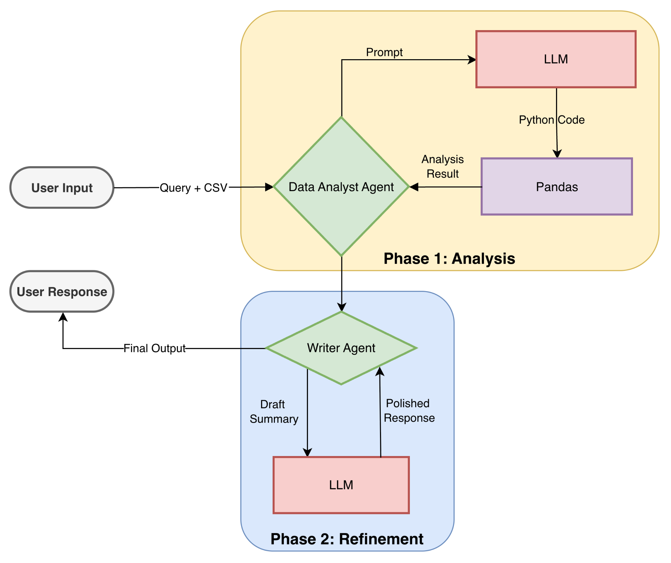
This application is built on a Multi-Agent System (MAS) architecture using LangChain and Google Gemini (Gemini 2.5 Flash). Instead of a single AI trying to do everything, the responsibilities are split into two specialized agents: one for logical execution and one for communication.

Key Technologies
- LangChain: Orchestrates the flow between agents and tools.
- Google Gemini 1.5 Flash: Provides the underlying intelligence for both code generation and text summarization.
- Pandas: The engine used by the Analyst agent to manipulate data in-memory.

2. Agent Structure

Agent 1: The Data Analyst ("The Brain")
- Type: Zero-shot ReAct (Reasoning + Acting) Agent.
- Capabilities:
  - Accesses a Python REPL (Read-Eval-Print Loop) environment.
  - Writes and executes valid Python/Pandas code on the fly.
  - Can handle data cleaning, complex filtering, aggregations, and math.
- Input: Raw CSV/Excel dataframes and the user's natural language query.
- Output: A raw, fact-based numeric or textual answer (often unpolished).

Agent 2: The Writer ("The Voice")
- Type: Instruction-tuned Summarization Chain.
- Capabilities:
  - Understands context and business tone.
  - Strips away technical jargon (e.g., "The dataframe index 0 shows...").
- Input: The raw output from the Data Analyst and the original user question.
- Output: A concise, executive-level summary sentence or bullet point.

3. Processing Workflow
When a user asks a question (e.g., "Which SKU sold the most?"), the system follows this linear pipeline:
- State Initialization: The system receives the file(s) and the question.
- Analyst Execution:
  - The Analyst inspects the dataframe columns.
  - It writes Python code to solve the query (e.g., df.groupby('SKU')['Qty'].sum()).
  - It executes the code and captures the result.
- Handoff: The raw result (e.g., "SKU-99, 500 units") is passed to the Writer.
- Refinement: The Writer formats this into a human-readable response (e.g., "The highest selling item is SKU-99 with 500 units sold.").
- Final Output: The result is displayed to the user.

4. Usage Steps

Prerequisites
- Python 3.9 or higher.
- A valid Google Cloud API Key with access to Gemini models stored in .env file
- Install Dependencies:

pip install -r requirements.txt

- Start the Application:

streamlit run app.py


5. Screenshots:
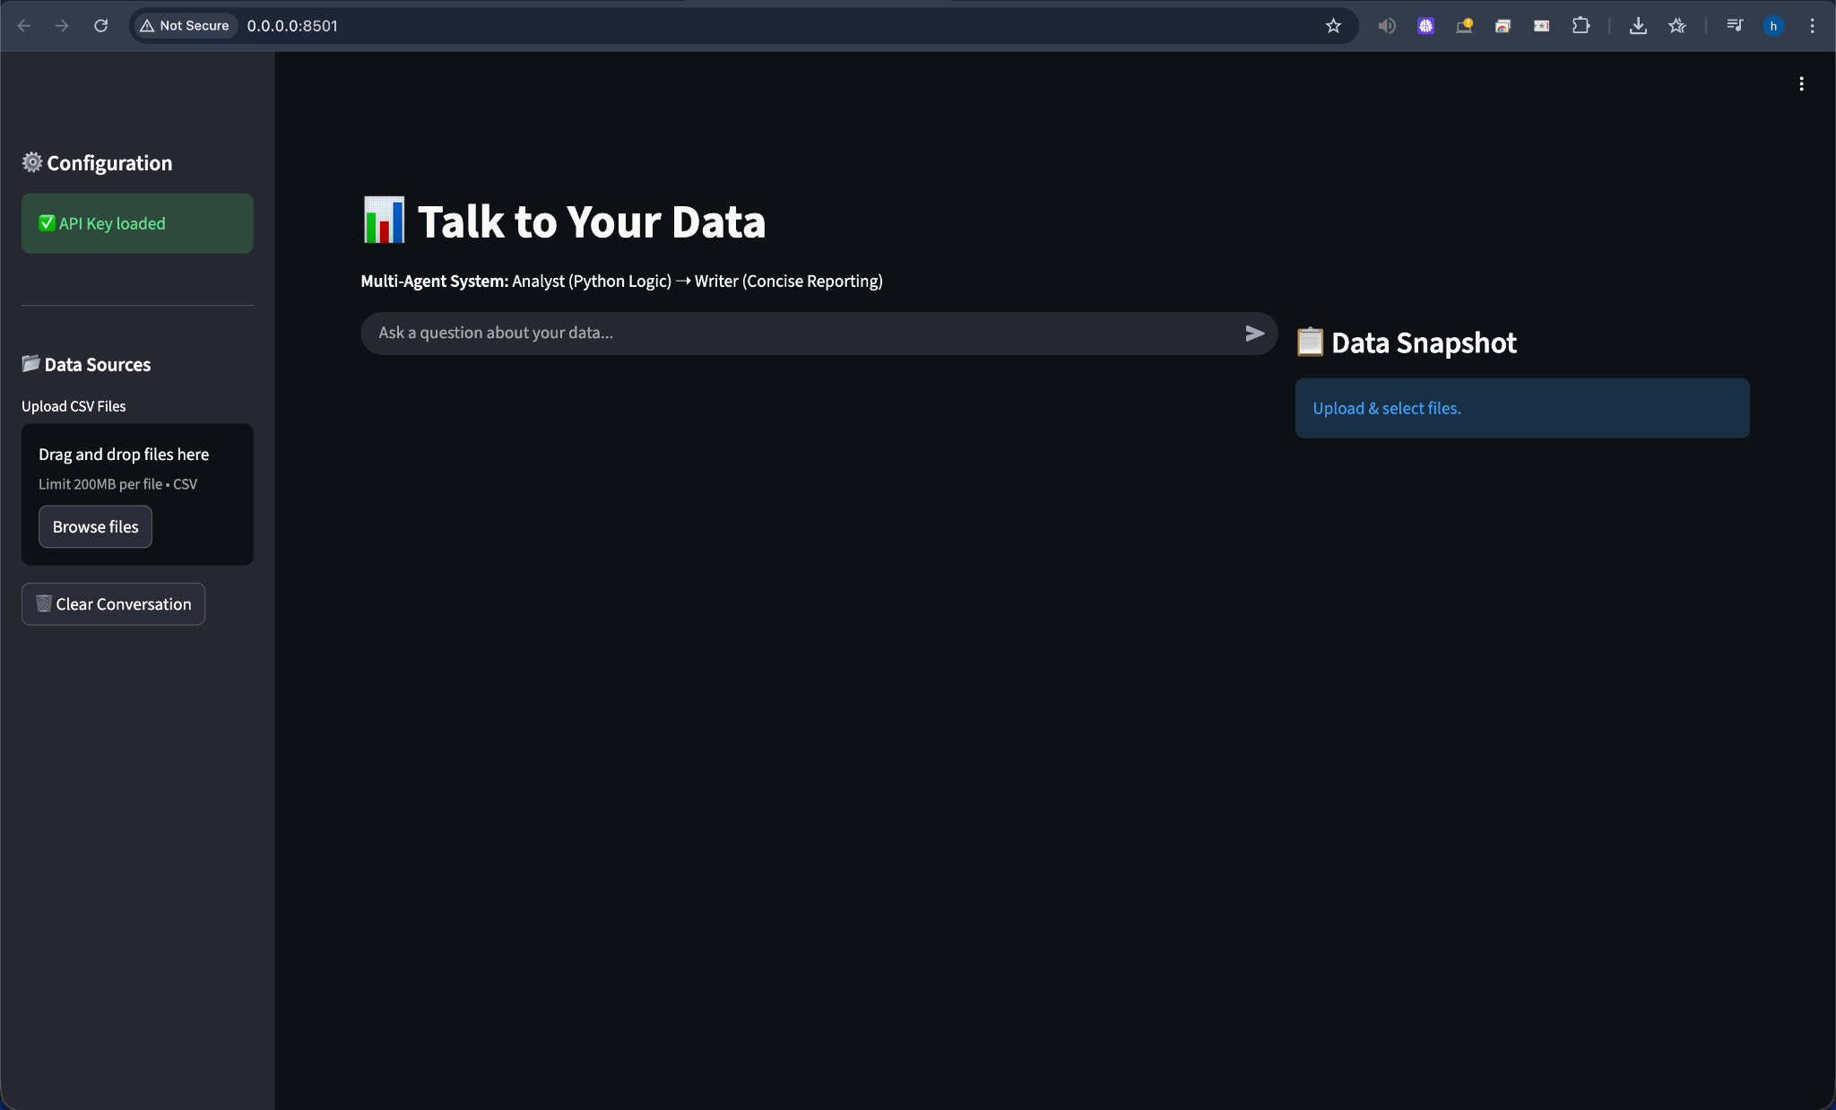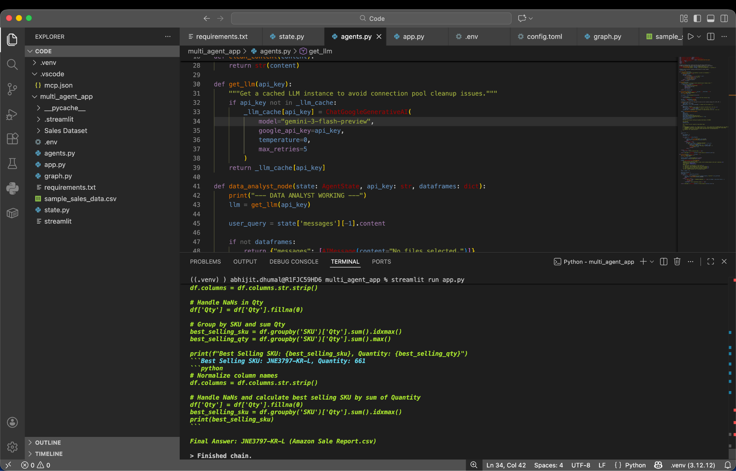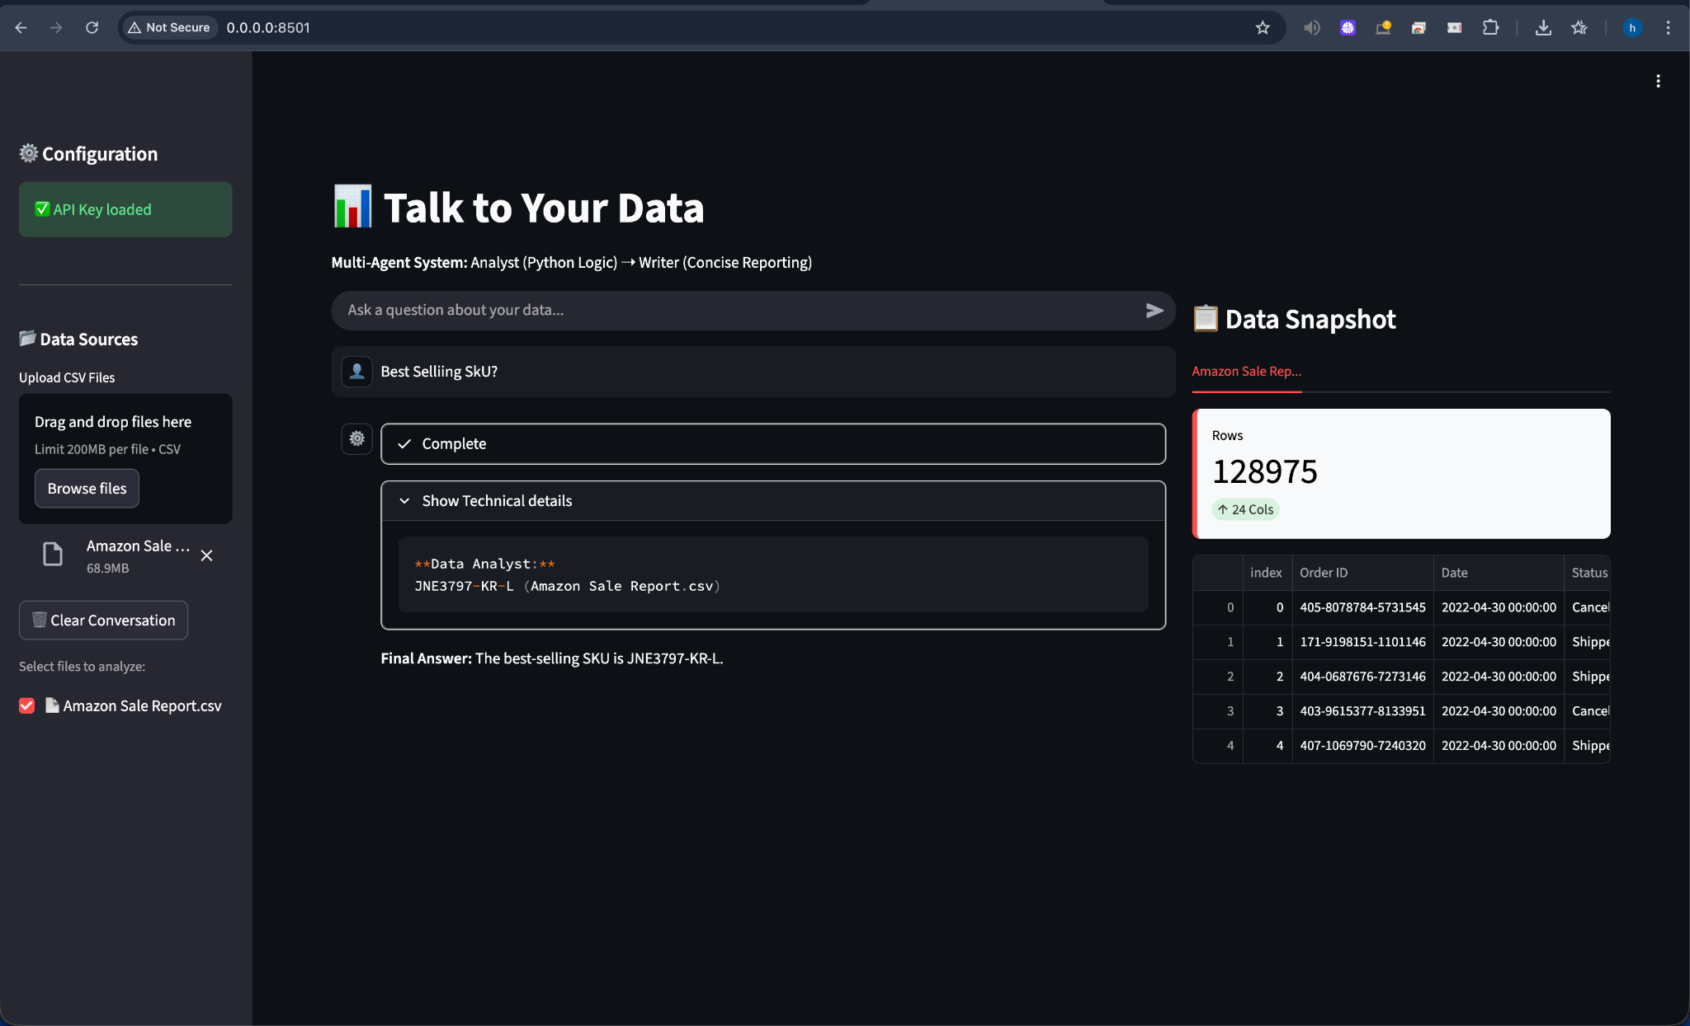

6. Production Readiness Roadmap
To transition this application from a prototype to a production environment, consider implementing the following enhancements:

Security & Sandboxing
- Sandboxed Execution: Currently, the agent executes Python code locally. In production, this poses a security risk. Use isolated environments like Docker containers or secure sandbox services (e.g., E2B) to execute generated code safely.
- PII Filtering: Implement a pre-processing layer to detect and redact Personally Identifiable Information (PII) from user queries or datasets before sending them to the LLM.

Observability & Monitoring
- Tracing: Integrate with tools like LangSmith to trace agent thought processes, latency, and token usage.
- Feedback Loops: Add a mechanism for users to rate answers (thumbs up/down). Use this data to fine-tune the Writer agent's prompts.

Reliability
- Validation Guardrails: Use libraries like Guardrails AI to validate the structure and content of the Analyst's output (e.g., ensuring no Hallucinated columns are used) before passing it to the Writer.
- State Persistence: Instead of in-memory state, use a persistent backend (e.g., Redis or PostgreSQL) to manage conversation history, allowing for long-running sessions and crash recovery.

Performance
- Semantic Caching: Implement caching (e.g., GPTCache) for common queries. If a user asks "Total Revenue" twice, serve the second answer from the cache to save costs and reduce latency.

