Submitting late (1 day) because of election week related stress.

1 point - A figure for each hyperparameter showing the cross validation accuracy on the y axis (with 50% 2-sided error bars) and the parameter value on x.

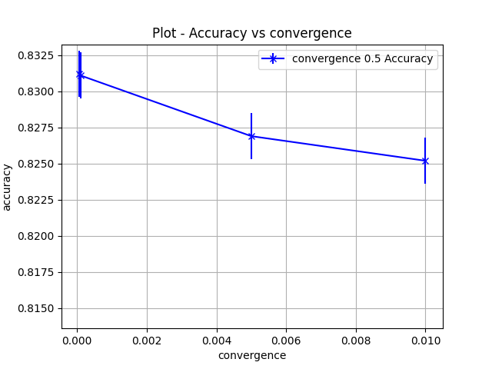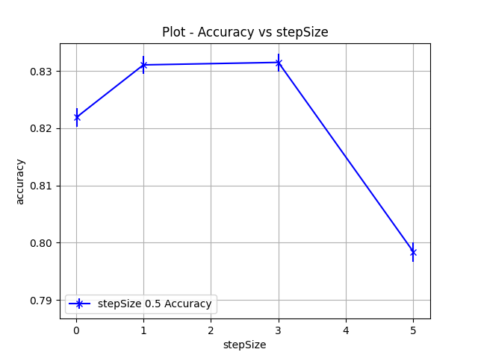

0.5 point - A few sentences describing the best hyperparameter setting you found and the estimated accuracy range. Is your model
better than predicting the most common class? How much? (be precise)
The best hyperparameter settings I found were a StepSize of 3 and a convergence 0.0001. These settings gave a 83.15% accuracy with a 50% 2 sided confidence interval (82.99% – 83.30%). This model is better than the most common class whose accuracy is 76.33% with 50% 2 sided confidence interval of (75.82% - 76.84%). We can say that logistic regression model is better than the most common model with atleast 75% confidence because their confidence intervals do not overlap.

