3 points - an ROC curve comparing a decision tree using the best hyperparameters you found in the previous assignment with a weighted
decision tree using the same hyperparameters, but a sample weight of: 10 when the age is < 45 (x[0] is the age feature) and 1 when age is >= 45..
Train both on the training set (no cross validation) and evaluate them on the validation data.

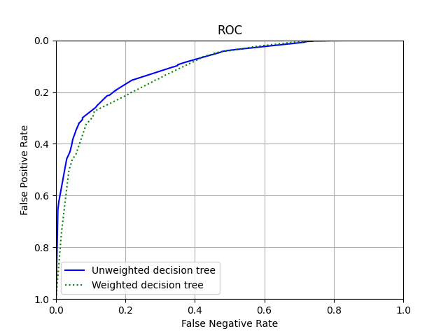

1 point - In 3-4 sentences, describe a condition when you might like to use this sample weighting with the Adult data set.

I would use model weighting if I knew that the data is heavily distributed towards one set of sample population. For example, if the adult data I have cannot be generalized well enough to cover global population because it simply has more data for people from one country. In that case, I will use sample weighting to reduce the weight of data for people belonging to that country so that the model does not overfit. By weighing the sample properly, we can avoid such overfitting of training data.

