2 points - your boosting code. Make sure it is clear and the TA can find the key componets:
* weight updating
* calculating beta
* predicting

See attached file

1 point - A plot showing test set accuracy (with bounds) on the synthetic concept provided in the framework.
On the x-axis show various values of 'rounds' from 1 through some number where there is diminishing return.
Include at least 5 values of 'rounds'. Make them interesting. Label everything correctly.
Use maxDepth = 1.

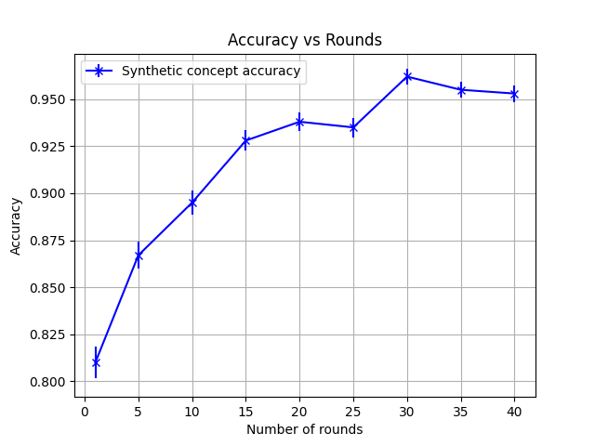

1 point - A visualization of the most accurate model you learned on the synthetic concept (the best value of rounds).

Generated Concept: Model:

