0.5 Point - A chart exploring maxDepth for decision trees (maxDepth on x-axis, train and validation accuracy on y-axis).

Decision Trees

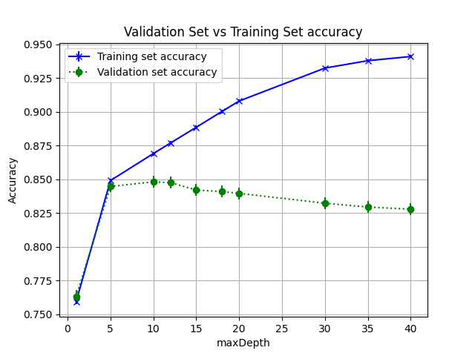

0.5 Point - A chart exploring the rounds hyperparamter in BoostedTrees with maxDepth set to 1.

Boosted Trees
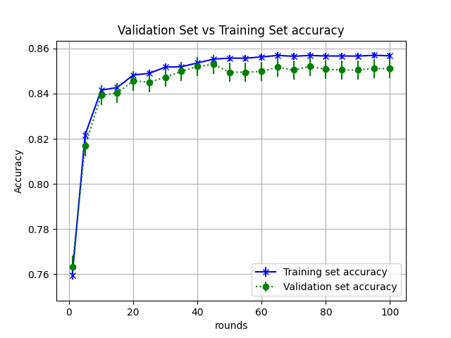
0.5 Point - A chart exploring the stepSize in logistic regression with convergence set to 0.0001.
Logistic Regression
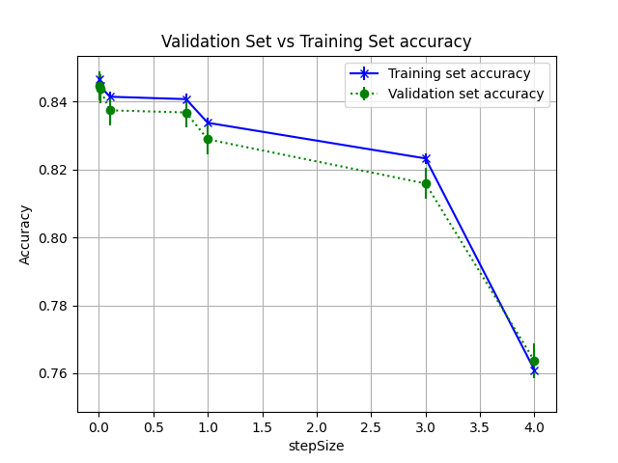

2 Points - A 3-5 senctence summary across the algorithms of the bias and variance issues you discovered with this experiment.

With this experiment I discovered that boosted trees show variance issues with increasing number of rounds parameter. We can see that after about 40 or so rounds, there accuracy does not change very much.
We can see that decision trees overfit the training data and that the accuracy on the validation set actually decreases after about 12 max depth. Variance issues are seen in decision trees between maxdepth = 5 to 12.

