2 point - your source code for neural network training. Make us it's easy for the TA to find the key components: forward propagaion, backward propagaion, weight updates, loss calculation.
See Attached File

1 point - A visualiztion of the weights you learn for the neurons in the hidden layer of your tuned single-hidden-layer network using the framework function 'VisualizeWeights'

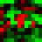

2 points - Tune the parameters until you have a single layer network with validation set accuracy greater than 85%. Report on the parameters you used. Include a chart
with training and validation set loss on the y-axis vs epoch nuber on the x-axis. In 1-2 sentences indicate the approach you took to finding hyperparameters that work.
Include a brief log of the Hyperparameters you tried.

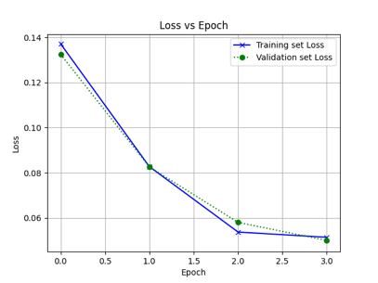

Best parameters for single layer network:
Step size : 1.0
Convergence: 0.005
Hidden layer structure : [6]
Validation set accuracy: 87.19%

My approach was to tune the hyperparameter hidden structure first to eliminate bias issues and then tune the hyperparameters convergence and stepsize to so that I could get the best accuracy. I did not consider the confidence intervals as part of this exercise.

Hyper Parameters tried:
- sweeps['hiddenStructure'] = [[5], [6], [7], [8], [9], [10], [11], [12]]
- sweeps['convergence'] = [ 0.1, 0.5, 0.01, 0.05, 0.001, 0.005, 0.0001, 0.0005]
- sweeps['stepSize'] = [4.0, 3.0, 2.0, 1.0, 0.5, 0.1, 0.05, 0.01]

2 points - Tune the parameters until you have a two layer network with validation set accuracy greater than 89%. Report on the parameters you used. Include a chart
with training and validation set loss on the y-axis vs epoch nuber on the x-axis. In 1-2 sentences indicate the approach you took to finding hyperparameters that work.
Include a brief log of the Hyperparameters you tried.
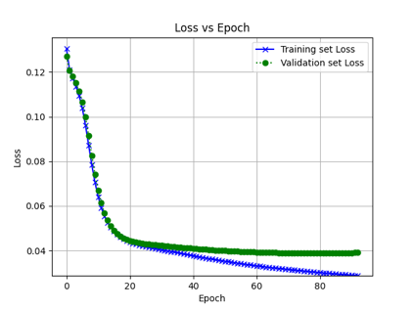

Best parameters for double layer network:
Step size : 0.01
Convergence: 0.0001
Hidden layer structure : [7, 2]
Validation set accuracy: 89.66%

My approach was to tune the hyperparameter hidden structure first to eliminate bias issues and then tune the hyperparameters convergence and stepsize to so that I could get the best accuracy. I did not consider the confidence intervals as part of this exercise.

Hyper Parameters tried:
- sweeps['hiddenStructure'] = [[2,2], [3,2], [4,2], [5,2], [6,2], [7,2], [8,2], [9,2]]
- sweeps['convergence'] = [ 0.5, 0.1, 0.05, 0.01, 0.005, 0.001, 0.0005, 0.0001]
- sweeps['stepSize'] = [4.0, 3.0, 2.0, 1.0, 0.5, 0.1, 0.05, 0.01]

