2 points -- Your implementation of QLearning.py. Make sure it's easy for the TA to follow.

See Attached File

5 points -- A writeup of your process for tuning the parameters. Include one chart per parameter with parameter value on the x-axis and policy quality on y-axis (average score on 20 runs).
For each step be sure to indicate the other parameter value you used (tuned or untuned). Include a final parameter setting and the average score it produced across 100 runs.

Step 1: Tune hyper parameter ‘binsPerDimension’:

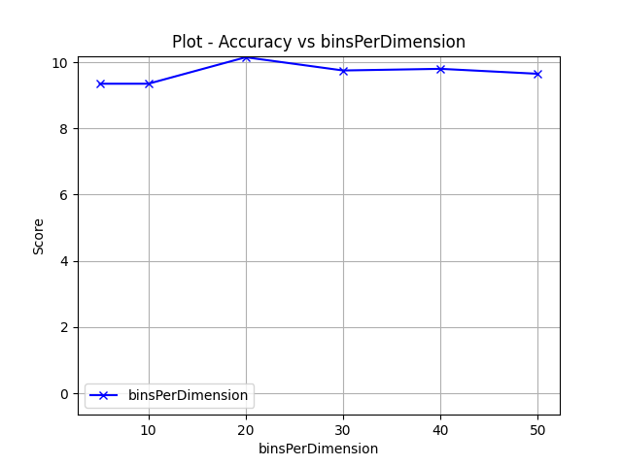

Other Hyper parameter values:

'discountRate': 1e-05,
'actionProbabilityBase': 2.718281828459045,
'randomActionRate': 0.5,
'learningRateScale': 1e-05

Best Parameters at step 1:
'discountRate': 1e-05,
'actionProbabilityBase': 2.718281828459045,
'randomActionRate': 0.5,
'learningRateScale': 1e-05,
'binsPerDimension': 20,

Step 2: Tune hyper parameter ‘randomActionRate’

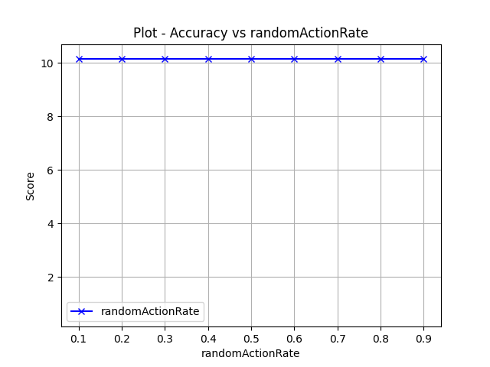

Other Hyper parameter values:

'discountRate': 1e-05,
'actionProbabilityBase': 2.718281828459045,
'learningRateScale': 1e-05
'binsPerDimension': 20

Best Parameters at step 2:
'discountRate': 1e-05,
'actionProbabilityBase': 2.718281828459045,
'randomActionRate': 0.5,
'learningRateScale': 1e-05,
'binsPerDimension': 20

Step 3: Tune hyper parameter ‘learningRateScale’

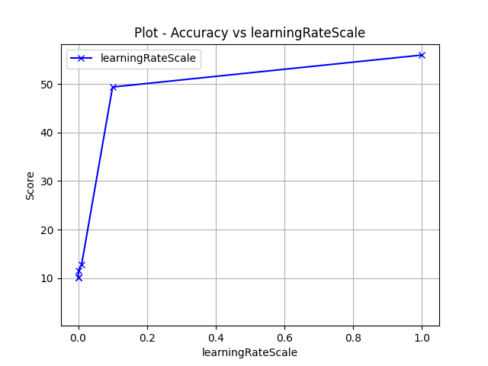

Other Hyper parameter values:

'discountRate': 1e-05,
'actionProbabilityBase': 2.718281828459045,
'binsPerDimension': 20
'randomActionRate': 0.5,

Best Parameters at step 3:
'discountRate': 1e-05,
'actionProbabilityBase': 2.718281828459045,
'randomActionRate': 0.5,
'learningRateScale': 1.0,
'binsPerDimension': 20

Step 4: Tune hyperparameter ‘actionProbabilityBase’
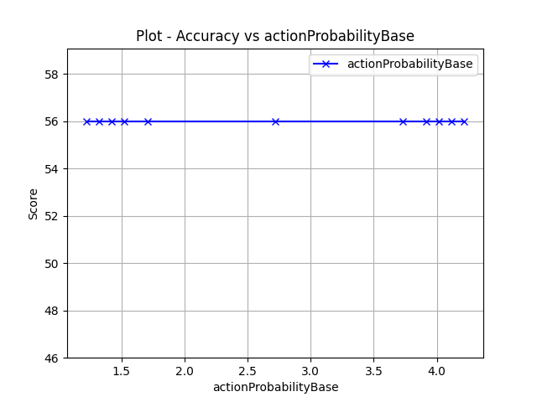

Other Hyper parameter values:

'discountRate': 1e-05,
'binsPerDimension': 20
'randomActionRate': 0.5,
'learningRateScale': 1.0,

Best Parameters at step 3:
'discountRate': 1e-05,
'actionProbabilityBase': 2.718281828459045,
'randomActionRate': 0.5,
'learningRateScale': 1.0,
'binsPerDimension': 20

Step 5: Tune hyperparameter ‘discountRate’

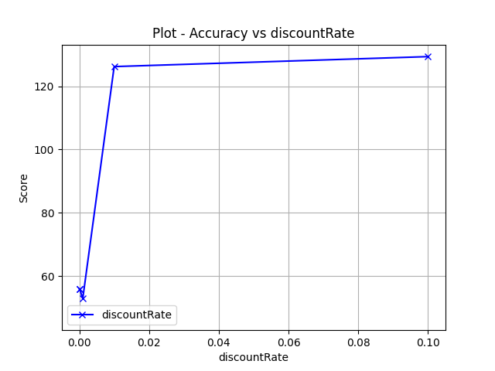

Other Hyper parameter values:

'binsPerDimension': 20
'randomActionRate': 0.5,
'learningRateScale': 1.0,
'actionProbabilityBase': 2.718281828459045,

Best Parameters at step 3:
'discountRate': 0.1,
'actionProbabilityBase': 2.718281828459045,
'randomActionRate': 0.5,
'learningRateScale': 1.0,
'binsPerDimension': 20

Evaluation score of 100 runs produced and average score of 124.6.

