Step-by-Step Build Guide: LinkedInScaler App in Google AI Studio

References-
- https://socialsonic.com/
- https://www.supergrow.ai/

Step 1: Open Google AI Studio
- Go to https://aistudio.google.com
- Sign in with your Google account.
- Click on “Create New Prompt” or “Create New App”.
- Choose “Structured Prompt / App Mode” (UI-based app, not chat-only).

Step 2: Set App Name and Purpose
- App Name: LinkedInScaler
- Description:
An AI-powered app to generate LinkedIn posts based on topic, writing style, post category, and preferred content length.

Step 3: Add Input Field – Main Topic
- Click Add Input → Text Input
- Configure:
  - Label: Enter Main Topic / Theme
  - Placeholder: e.g., AI in Marketing, Career Growth, Personal Branding
  - Required: Yes
- Save the field as:
  - Variable Name: topic

Step 4: Add Dropdown – Writing Style
- Click Add Input → Dropdown
- Configure:
  - Label: Select Writing Style
  - Required: Yes
- Add these options:
  - Professional
  - Inspirational
  - Educational
  - Storytelling
  - Conversational
  - Promotional
- Save as:
  - Variable Name: writing_style

Step 5: Add Dropdown – Post Category
- Click Add Input → Dropdown
- Configure:
  - Label: Select Post Category
  - Required: Yes
- Add these options:
  - Thought Leadership
  - Personal Story
  - Industry Insight
  - Case Study
  - Announcement
  - How-To / Tips
  - Career Advice
- Save as:
  - Variable Name: post_category

Step 6: Add Slider – Post Length
- Click Add Input → Slider
- Configure:
  - Label: Select Post Length
  - Required: Yes
- Set values:
  - Min: Short
  - Mid: Medium
  - Max: Large
- Save as:
  - Variable Name: post_length

Once user clicks ‘Generate Post’ Button- send all the above parameters as POST request on this webhook URL- <Paste your webhook URL>

AI Agent Prompt in n8n
Prompt- Persona:
You are an expert LinkedIn Ghostwriter who has written 2,000+ viral posts for CEOs, founders, creators, and tech professionals. You deeply understand LinkedIn algorithms, storytelling, hooks, audience psychology, and content formats that drive millions of views. You specialise in creating scroll-stopping hooks, emotional storytelling, authority-building insights, and CTAs that spark engagement.

Task:
Create a viral-style LinkedIn post based on:
Use user messsage to get the details on Topic, style, length etc for the post.

Don't use "# and *"" for headers and in the post. Don't use em-dashes

Your job is to craft a LinkedIn post that maximizes reach, engagement, and shares through strong hooks, relatable narratives, crisp formatting, and powerful CTAs.

Context:
The post should feel like it was written by a top LinkedIn creator. It must capture attention in the first 2–3 seconds, use pattern-interrupt techniques, create emotional resonance, and deliver real value. Add insights, examples, frameworks, or micro-stories depending on the post type. The goal is to trigger comments, saves, and reposts.

Format:
Follow this exact structure:

Don't use "# and *"" for headers and in the post. Don't use em-dashes

Hook (1–2 lines, punchy, curiosity-building, scroll-stopping)

Body (story, insight, or breakdown depending on the post type)

Value Section (actionable takeaways, lessons, or frameworks)

CTA (ask a question that encourages comments, or invite people to share their thoughts)

Keep paragraphs short (1–2 lines max).

Use simple English, no jargon.

Add spacing for readability.

Don't use # and * for headers.

Add few hashtags related to that topic maximum 4 or 5

Tone:
Conversational, bold, authoritative, and engaging—like top LinkedIn creators. No fluff. Every line should deliver value, emotion, or curiosity.

Output:
A polished viral-style LinkedIn post ready to publish.

Second Iteration Prompt on your Google AI studio -
Once the user clicks on create or generate button you will receive a Text response back from n8n. Create a ediatable textbox to display the text and user can edit the text inside that.
Don't generate any post from your own

Second Webhook URL Instructions for posting on Linkedin on Google AI Studio
Create a new button "Publish Now" below the preview textbox and send this edited text back to my n8n webhook URL as a POST request. URL-
"Paste your URL ”

Attach Screenshot for reference-
- 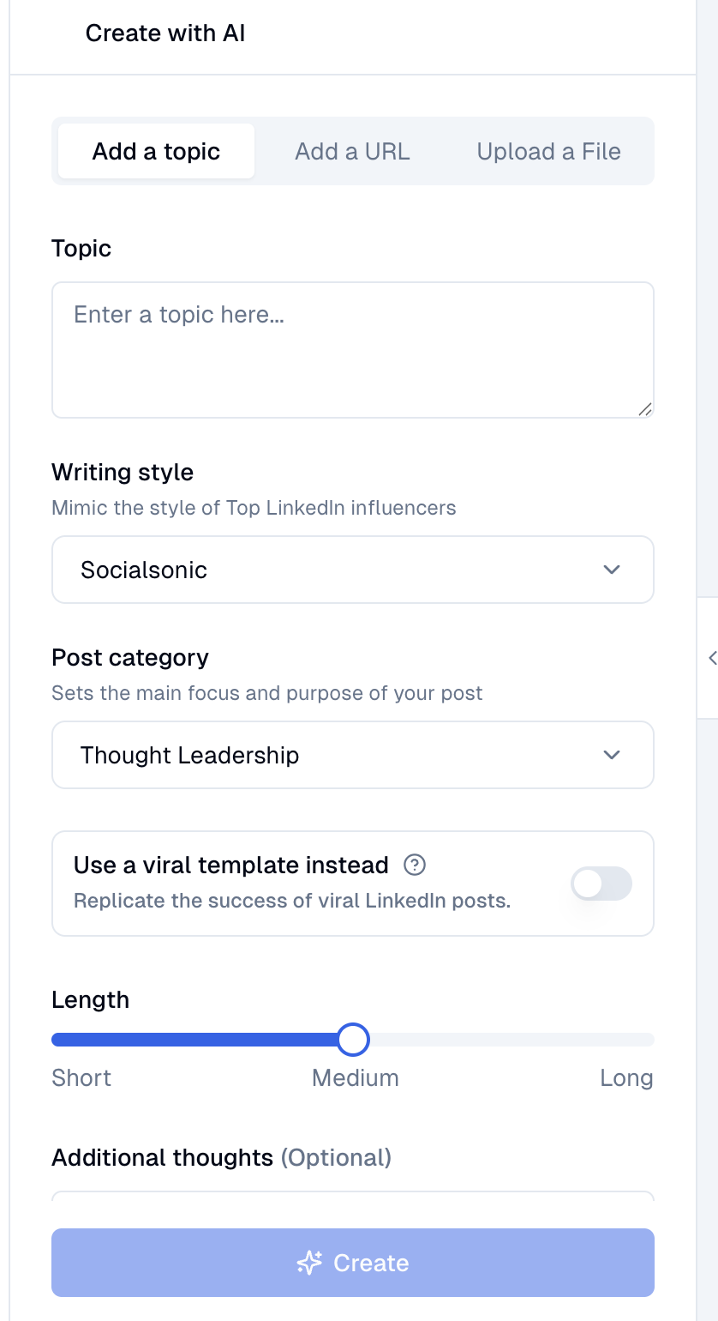
- 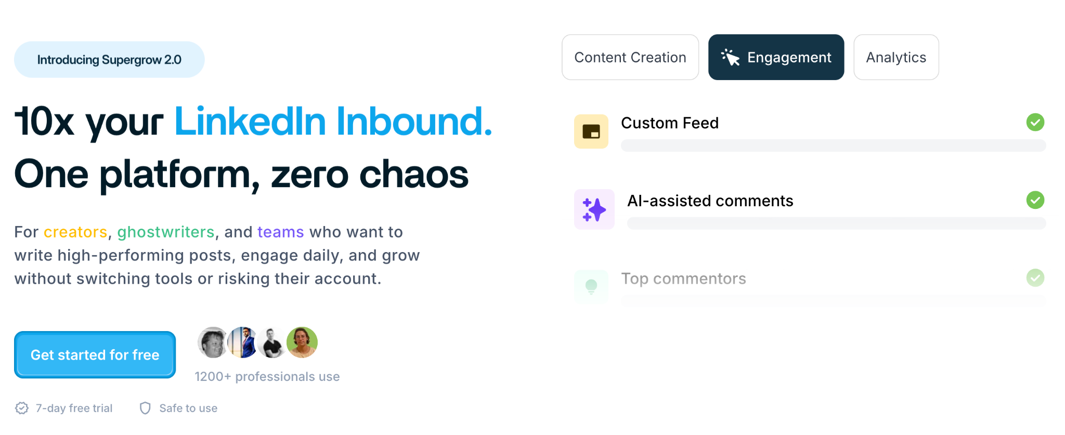

Create a landing page for our web app similar to the attached screenshot. It should be Linkedin based theme with Blue and white colours. Give option to user to switch between Dark and Light model

Step 7: Configure System Prompt (Core AI Instruction)
Paste this into the System Prompt / App Instruction section:
You are a professional LinkedIn content writer and personal branding expert.
Generate a high-quality LinkedIn post based on the following inputs:

Topic: {{topic}}
Writing Style: {{writing_style}}
Post Category: {{post_category}}
Post

Change to Production URL and make n8n Active

Update my both button webhook URL to production ones.

Once user clicks on create send this as POST request to production URL- <>

And secondly once user clicks on "Publish Now"button send the text back as POST request to this updated production URL- <>

