**NAME:- ABHIJIT SHEET**

**CU ROLL NO:- 203513-21-0099**

**CU REG NO:-513-1112-0402-20**

**SUB:-HTML LAB ASSIGNMENT**

1)Create a webpage that­

i)• prints your name to the screen.

ii)• prints the numbers 1 ­ 10 to the screen.

iii)• Prints  current date.

Now set its title to "This is a webpage".

ANS:-i) <html> **output:-**

<body>

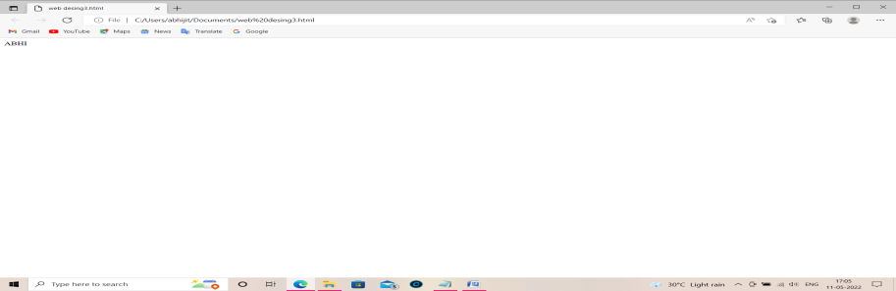 <!-- print name to the screen -->

ABHI

</body>

</html>

ii) <html>

<body>

<!-- print the numbers 1 to 10 to the screen -->

1 2 3 4 5 6 7 8 9 10

</body>

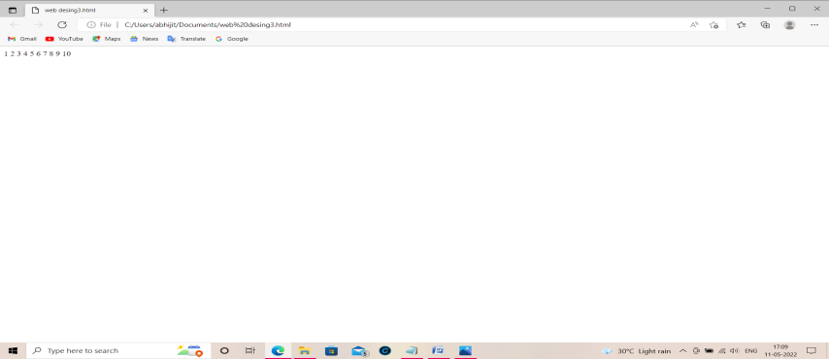 </html> **output:**-

iii) <html>

<head> **output:-**

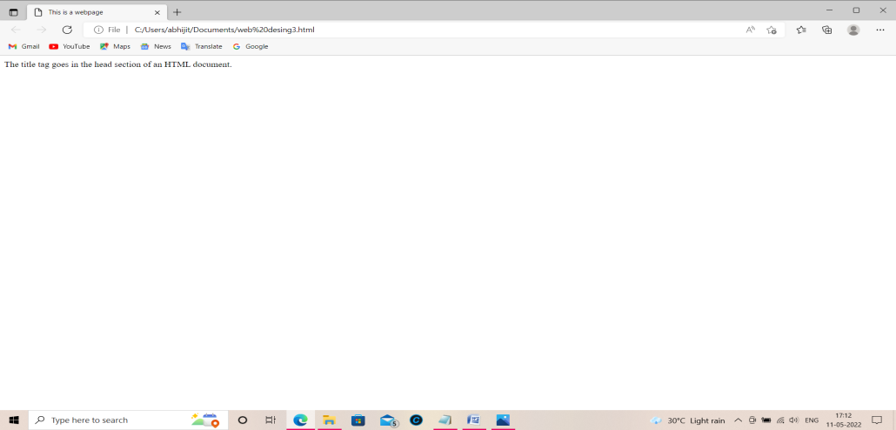<!--set the title of the page-->

<title>This is a webpage</title>

</head>

<body>

<p class="note">

The title tag goes in the head section of an HTML document.

</p>

</body>

</html>

2**) Create a webpage that prints a paragraph with 4 ­ 5 sentences to the screen, excluding/including a head section in the code. Each sentence should have a different font and different colour.**

**ANS:-** **<html>**

**<body>**

**<p>**

**<font face="Courier New">**

**HTML stands for Hyper Text Markup Language.**

**</font>**

**<font face="Times New Roman">It is the core**

**language of the world wide web and is used to define**

**the structure and layout of web documents by using**

**various tags and attributes.**

**</font>**

**<font face="Helvetica">**

**Although a fundamental language of the web, HTML is a**

**static language - content created with it does not change.**

**</font>**

**<font face="Georgia">**

**HTML is used to specify the way webpages look, not how they**

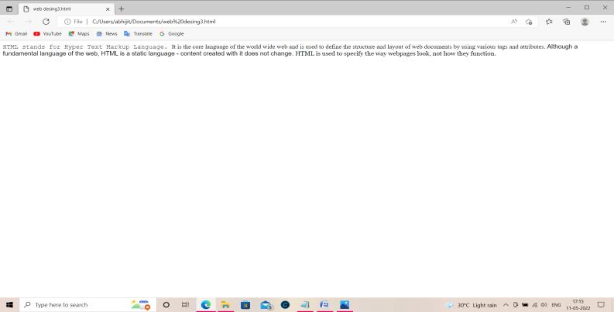**function.**

**</font> output:-**

**</p>**

**</body>**

**</html>**

**3)** **Print a paragraph that is a description of a book, include the title of the book as well as its author. Names and titles should be underlined, adjectives should be italicized and bolded.**

**ANS:-** **<html>**

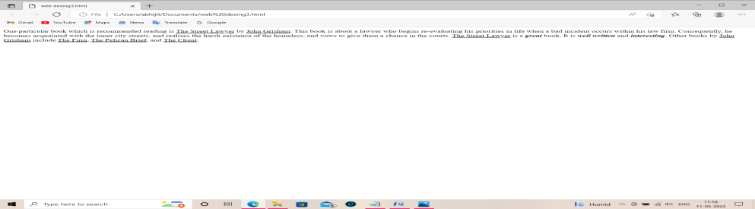**<body> output:-**

**<p>**

**One particular book which is recommended reading is <u>The Street Lawyer</u> by <u>John Grisham</u>. This book is about a lawyer who begins re-evaluating his priorities in life when a bad**

**incident occurs within his law firm. Consequently, he becomes acquainted with the inner city streets, and realizes the harsh existence of the homeless, and vows to give them a chance in the courts. <u>The Street Lawyer</u> is a <b><i>great</i></b>**

**book. It is <b><i>well written</i></b> and <b><i>interesting</i></b>. Other books by <u>John Grisham</u> include <u>The Firm</u>, <u>The Pelican Brief</u>, and <u>The Client</u>.**

**</p>**

**</body>**

**</html>**

4)Print the squares of the numbers 1 ­ 20. Each number should be on a separate line, next to it the number 2 superscripted, an equal sign and the result. (Example: 102  = 100)

ANS:- <html>

<body>

1<sup>2</sup> = 1

<br />

2<sup>2</sup> = 4

<br />

3<sup>2</sup> = 9

<br />

4<sup>2</sup> = 16

<br />

5<sup>2</sup> = 25

<br />

6<sup>2</sup> = 36

<br />

7<sup>2</sup> = 49

<br />

8<sup>2</sup> = 64

<br />

9<sup>2</sup> = 81

<br />

10<sup>2</sup> = 100

<br />

11<sup>2</sup> = 121

<br />

12<sup>2</sup> = 144

<br />

13<sup>2</sup> = 169

<br />

14<sup>2</sup> = 196

<br />

15<sup>2</sup> = 225

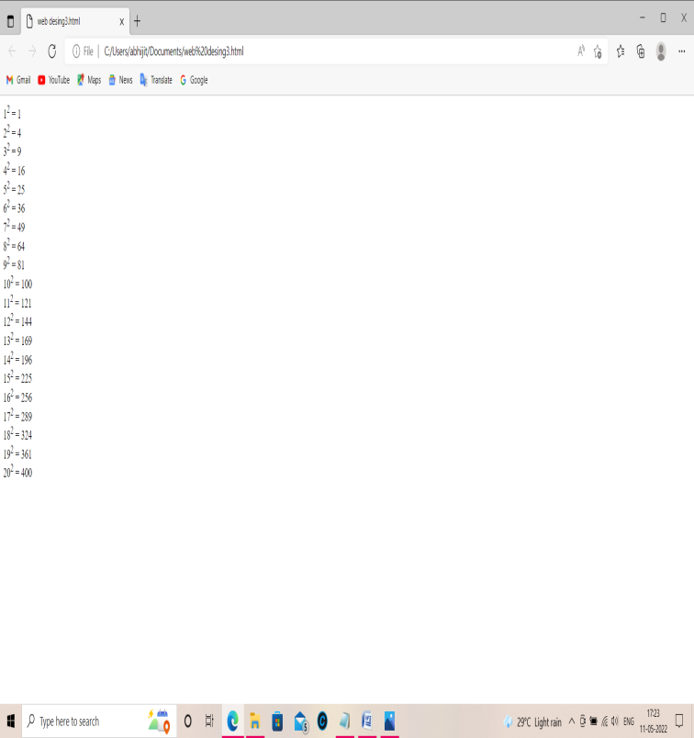<br /> output:-

16<sup>2</sup> = 256

<br />

17<sup>2</sup> = 289

<br />

18<sup>2</sup> = 324

<br />

19<sup>2</sup> = 361

<br />

20<sup>2</sup> = 400

</body>

</html>

5)Print 10 names with a line break between each name. The list should be alphabetized, and to do this place a subscripted number next to each name based on where it will go in the alphabetized list. (Example: Alan1). Print first, the unalphabetized list with a subscript number next to each name, then the alphabetized list. Both lists should have an

 level heading.

ANS:- <html>

<body>

<h1>Unalphabetized list</h1>

Bill<sub>3</sub>

<br />

Roger<sub>5</sub>

<br />

Sandra<sub>6</sub>

<br />

Stacy<sub>7</sub> output:-

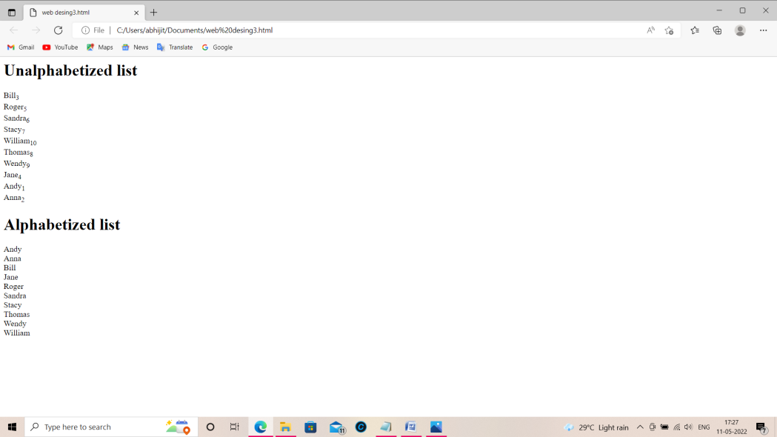<br />

William<sub>10</sub>

<br />

Thomas<sub>8</sub>

<br />

Wendy<sub>9</sub>

<br />

Jane<sub>4</sub>

<br />

Andy<sub>1</sub>

<br />

Anna<sub>2</sub>

<h1>Alphabetized list</h1>

Andy

<br />

Anna

<br />

Bill

<br />

Jane

<br />

Roger

<br />

Sandra

<br />

Stacy

<br />

Thomas

<br />

Wendy

<br />

William

</body>

</html>

6)Print two paragraphs that are both indented using the   command.

ANS:- <html>

<body>

<p>

&nbsp;&nbsp;&nbsp;&nbsp;&nbsp;&nbsp;Computer programming is defined as telling a computer what to

do through a special set of instructions which are then

interpreted by the computer to perform some task(s). These

instructions can be specified in one or more programming

languages including (but not limited to) Java, PHP, C, and

C++. A computer goes through a series of steps whose purpose

is to achieve something - a series of steps that are

instructed to it in great detail by computer programs.

Essentialy, computer programming is the process by which these

programs are designed and implemented.

</p>

<p>

&nbsp;&nbsp;&nbsp;&nbsp;&nbsp;&nbsp;While computer programming can be a great tool used to achieve

many things, there are a few misconceptions when it comes to

the subject, a few misconceptions that should be cleared up.

One misconception about computer programming is that you would

need to have some kind of special software to write programs -

this is hardly the case.

</p>

</body>

</html>

7)Print two lists with any information you want. One list should be an ordered list, the other list should be an unordered list.

ANS:- <html>

<body>

<b>Hardware devices</b>

<ol type="I">

<li>CD-ROM drive</li>

<li>DVD drive</li>

<li>Hard disk</li>

<li>Modem</li>

</ol>

<b>Web languages</b>

<ul type="square">

<li>HTML</li>

<li>Javascript</li>

<li>PHP</li>

<li>Java</li>

</ul>

</body>

</html>

8)Prints an h1 level heading followed by a horizontal line whose width is 100%. Below the horizontal line print a paragraph relating to the text in the heading.

ANS:- <html>

<body>

<h1>Cookie</h1>

<hr width="100%" />

<p>

A delicious confection that is quite popular when it comes to

sweets. Cookies come in various varieties including chocolate

chip, raisin, and macademia nut. A very different type of

cookie is a small text file stored on a user's computer by

a web server.

</p>

</body>

</html>

9)Print some preformatted text of your choosing. (hint: use the

 tag).

ANS:- <html>

<body>

<b>A sample Java program:</b>

<pre>

class DataClass{

public static void main(String[] args){

System.out.println("Here is some text.");

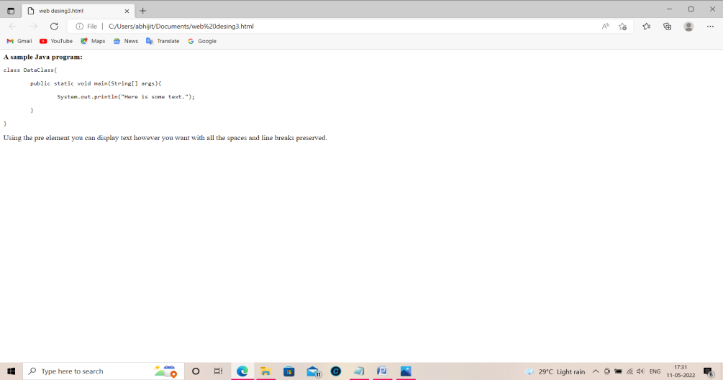

} **output:-**

}

</pre>

<p>

Using the pre element you can display text however you want with all the spaces and line breaks preserved.

</p>

</body>

</html>

10)Print a long quote and a short quote. Cite the author of each quote.

ANS:- <html>

<body>

<blockquote>

"Anyone who has lost track of time when using a

computer knows the propensity to dream, the urge

to make dreams come true and the tendency to miss

lunch." - Tim Berners-Lee

</blockquote>

<br />

<q>"Hi, Super Nintendo Chalmers!"</q> - Ralph Wiggum

</body>

</html>

11)Print some deleted and inserted text of your choosing. Also print a definition list with 5 items.

ANS:- <html>

<body>

<dl>

<dt>HTML</dt>

<dd>A markup language</dd>

<dt>Pen</dt>

<dd>A writing tool</dd>

<dt>Lettuce</dt>

<dd>A vegetable</dd>

<dt>Technology</dt>

<dd>The development of tools which serve as a means to

certain objectives</dd>

<dt>Megabyte</dt>

<dd>A unit of data consisting of 1024 kilobytes</dd>

</dl>

</body>

</html>

12)Print two addresses in the same format used on the front of envelopes (senders address in top left corner, receivers address in the center).

ANS:- <html>

<body>

<address>

Dilbert H.<br />

1234 Anim Street<br />

P.O. Box 22222

</address>

<br /><br />

<center>

<address>

Someone A. Person<br />

5555 Street Avenue<br />

Metrpolitan, Metropolis 11111

</address>

</center>

</body>

</html>

13)Print ten acronyms and abbreviations of your choosing, each separated by two lines. Specify the data that the abbreviations and acronyms represent.

ANS:- <html>

<body>

<abbr title="Abstract">Abstr.</abbr>

<br /><br />

<abbr title="Biochemistry">Biochem.</abbr>

<br /><br />

<abbr title="Example">Ex.</abbr>

<br /><br />

<abbr title="Literature">Lit.</abbr>

<br /><br />

<abbr title="Mathematics">Math.</abbr>

<br /><br />

<acronym title="World Wide Web Consortium">W3C</acronym>

<br /><br />

<acronym title="Institute of Electrical

and Electronic Engineers">IEEE</acronym>

<br /><br />

<acronym title="International Standards Organization">

ISO

</acronym>

<br /><br />

<acronym title="Hyper Text Markup Language">HTML</acronym>

<br /><br />

<acronym title="Beginners All Purpose

Symbolic Instruction Code">BASIC

</acronym>

<p>

Move your mouse over an abbreviation or acronym to get more data.

</p>

</body>

</html>

14)Create some links to various search engines (google, yahoo, altavista, lycos, etc). Now create links  to  five  different   pages  on  five   different  websites  that   should   all  open  in  a new window.

ANS:- <html>

<body>

<a href="http://www.google.com">

Search the web with Google!

</a>

<br /><br />

<a href="http://www.yahoo.com">

Search the web with Yahoo!

</a>

<br /><br />

<a href="http://www.bing.com">

Search the web with Bing!

</a>

<br /><br />

<a href="http://www.altavista.com">

Search the web with Altavista!

</a>

<br /><br />

<a href="http://www.lycos.com">

Search the web with Lycos!

</a>

</body>

</html>

15)Create a page with a link at the top of it that when clicked will jump all the way to the bottom of the page. At the bottom of the page there should be a link to jump back to the top of the page.

ANS:- <html>

<body>

<a name="top">The top of the page</a>

<p>Some text</p>

<p>Some text</p>

<p>Some text</p>

<p>Some text</p>

<p>Some text</p>

<p>Some text</p>

<p>Some text</p>

<p>Some text</p>

<p>Some text</p>

<p>Some text</p>

<p>Some text</p>

<p>Some text</p>

<p>Some text</p>

<p>Some text</p>

<p>Some text</p>

<p>Some text</p>

<p>Some text</p>

<p>Some text</p>

<p>Some text</p>

<p>Some text</p>

<a href="#top">Jump to the top of the page</a>

</body>

</html>

16)Display five different images. Skip two lines between each image. Each image should have a title. There must be one image having a border of size 2, a width of 200, and a height of 200.

ANS:- <html>

<head>

<title>Five images</title>

</head>

<body>

<img src="/images/apple.jpg" alt="Apple" title="Apple" />

<br /><br />

<img src="/images/sky.jpg" alt="Sky" title="Sky" />

<br /><br />

<img src="/images/swan.jpg" alt="Swan" title="Swan" />

<br /><br />

<img src="/images/tree.jpg" alt="Tree" title="Tree" />

<br /><br />

<img src="/images/waterfall.jpg" src="Waterfall" title="Waterfall" />

</body>

</html>

*<html>

<body>

<img src="/images/tree.jpg" width="200" height="200" alt="Tree" border="2" />

</body>

</html>

17)Display an image that when clicked will link to a search engine of your choice (should be opened in a new window).

ANS:- <html>

<body>

<a href="http://www.yahoo.com" target="_blank">

<img src="/images/swan.jpg" alt="Swan" />

</a>

</body>

<p>

Click on the image to be taken to the Yahoo search engine.

</p>

</html>

18)Create employee registration webpage using HTML form objects.

ANS:-

DAY1:

The syntax used is i) <h1></h1>, ii) <h2></h2>, iii) <h3></h3>,

iv) <h4></h4>, v) <h5></h5>, vi) <h6></h6>,

vii) <hr>, viii) <marquee></marquee, ix) <p></p>,

x) <font></font>

Code:- <html>

<head>

<title>New Web</title>

</head>

<body bgcolor="skyblue">

<h1>I am the larger one</h1>

<h2>I am the second largest</h2>

<h3>I am H3 text</h3>

<h4>I am H4 text</h4>

<h5>I am the second smallest text</h5>

<h6>I am the smallest one</h6>

<hr>

<marquee>Hi, I am marquee</marquee>

<hr>

<p style="font-size: 20px">

<font color="red">

I am Abhijit, a student of Sammilani Mahavidyalaya College.

You all must know the story of my coming here.

I am a student in the computer Science Department of this college.

</font>

</p>

</body>

</html>

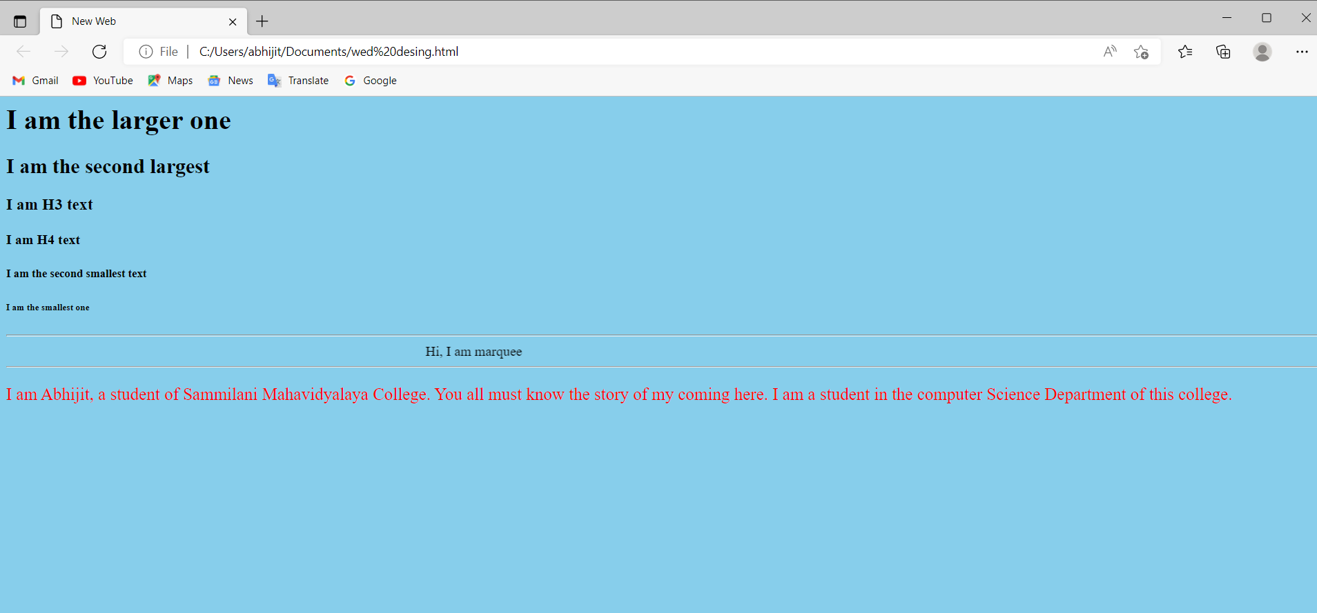

DAY2

Description **:** The syntax used is i) <ol></ol>, ii) <ul></ul>, iii) <li></li>,

Code:- <html>

<head>

<title>html list</title>

</head>

<body bgcolor="yellow">

<ol>

<li>I am the 1st line of Order list</li>

<li>I am the 2nd line of Order list</li>

<li>I am the 3rd line of Order list</li>

<li>I am the 4th line of Order list</li>

</ol>

<hr><hr>

<ul>

<li>I am the 1st line of Unordered list</li>

<li>I am the 2nd line of Unordered list</li>

<li>I am the 3rd line of Unordered list</li>

<li>I am the 4th line of Unordered list</li>

</ul>

<hr><hr>

<ol>

<li>I am the 1st line of Order list</li>

<ul>

<font color="red">

<li>I am the 1st line of nested Unordered list</li>

<li>I am the 2nd line of nested Unordered list</li>

</font>

</ul>

<li>I am the 2nd line of Order list</li>

<li>I am the 3rd line of Order list</li>

</ol>

<hr><hr>

<ul>

<li>I am the 1st line of Unordered list</li>

<ol>

<font color="red">

<li>I am the 1st line of nested Order list</li>

<li>I am the 2nd line of nested Order list</li>

</font>

</ol>

<li>I am the 2nd line of Unordered list</li>

<li>I am the 3rd line of Unordered list</li>

</ul>

</body>

</html>

Output:- 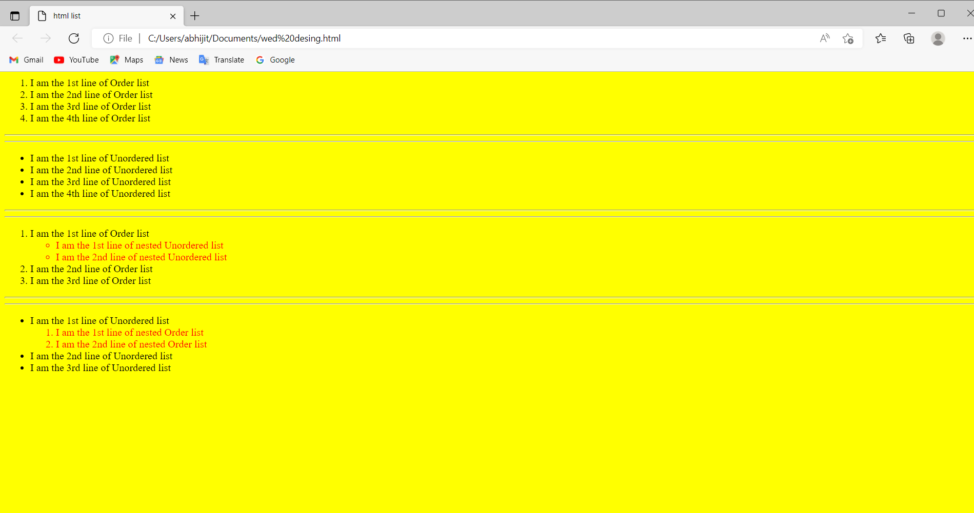

DAY3

Description :The syntax used is i) <table></table>, ii) <tr></tr>, iii) <th></th>,

iv) <td></td>

code:- <html>

<head>

<title>4th sem routine</title>

</head>

<body bgcolor="gray">

<table border="1" bordercolor="RED">

<caption><h1 id="caption1">My Collage Routine [4th Sem]</h1></caption>

<tr id="title">

<th>Day</th>

<th>10-11a.m.</th>

<th>11-12a.m.</th>

<th>12-1p.m.</th>

<th>1-2p.m.</th>

<th>2.00-2.30p.m.</th>

<th>2.30-3.30p.m.</th>

<th>3.30-4.30p.m.</th>

<th>4.30-5.30p.m.</th>

</tr>

<tr>

<td id="day">MonDay</td>

<td bgcolor="teal">PHSG</td>

<td bgcolor="pink">Algorithm Theory(SSS)</td>

<td colspan="2" bgcolor="skyblue">CN and WebDesign Lab(BS)</td>

<td></td>

<td bgcolor="red" colspan="2">E-Commerce(DK)</td>

<td></td>

</tr>

<tr>

<td id="day">TuesDay</td>

<td></td>

<td bgcolor="pink">Algorithm Theory(SSS)</td>

<td colspan="2" bgcolor="cornflowerblue">Microprocessor Lab(SD)</td>

<td></td>

<td colspan="2" bgcolor="skyblue">CN and WebDesign Lab(BS)</td>

<td></td>

</tr>

<tr>

<td id="day">WednesDay</td>

<td></td>

<td bgcolor="teal">PHSG</td>

<td bgcolor="cornflowerblue" colspan="2">Algorithm Lab(SD)</td>

<td></td>

<td bgcolor="chartreuse" colspan="2">DCN Theory(BM)</td>

<td></td>

</tr>

<tr>

<td id="day">ThursDay</td>

<td bgcolor="teal" colspan="2">PHSG Lab</td>

<td bgcolor="darksalmon" colspan="2">Microprocessor Theory(AS)</td>

<td></td>

<td bgcolor="darksalmon" colspan="2">Microprocessor Lab(AS)</td>

<td></td>

</tr>

<tr>

<td id="day">FriDay</td>

<td bgcolor="teal" colspan="2">PHSG Lab</td>

<td bgcolor="chartreuse" colspan="2">DCH Theory(BM)</td>

<td></td>

<td bgcolor="pink" colspan="2">Algorithm Lab(SSS)</td>

<td></td>

</tr>

<tr>

<td id="day">SaturDay</td>

<td bgcolor="cornflowerblue" colspan="2">Algorithm Lab(SD)</td>

<td bgcolor="cornflowerblue" colspan="2">Microprocessor Theory(SD)</td>

<td></td>

<td bgcolor="teal">PHSG</td>

<td></td>

<td></td>

</tr>

</table>

</body>

</html>

Output:-

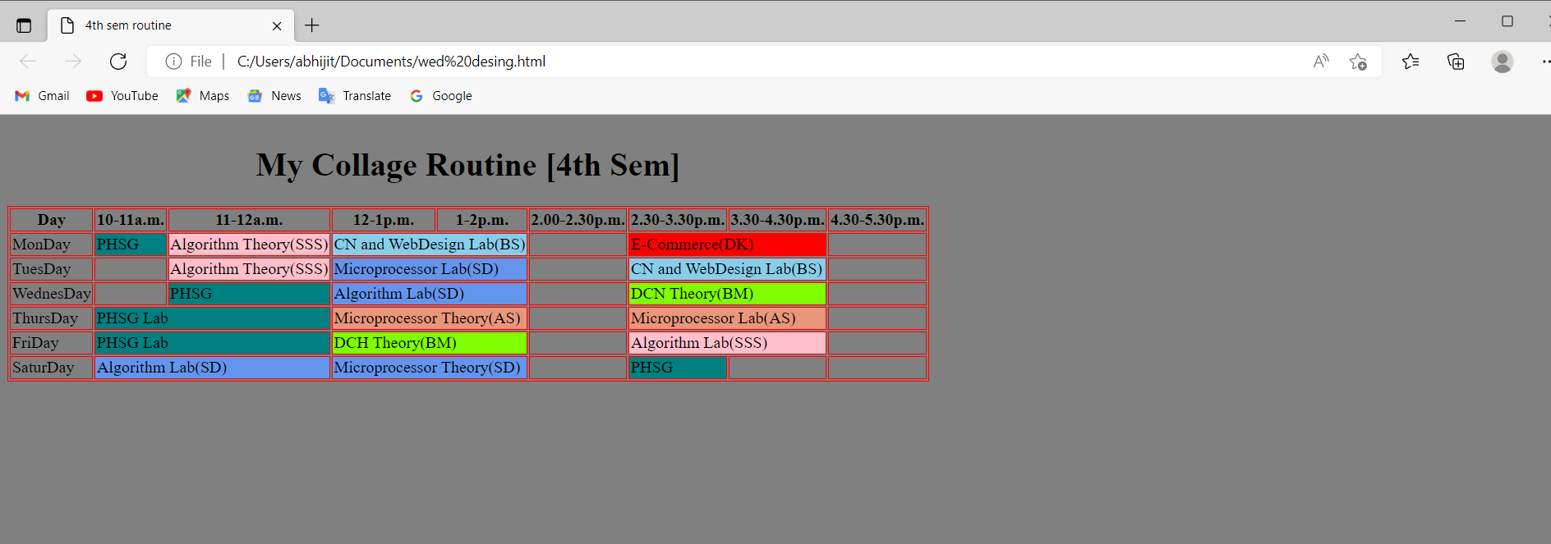

DAY4

Description :The syntax used is i) <div></div>, ii) <from></from>, iii) <br><br>,

iv) <input>, v) <textarea></textarea,

vi) <select></select, vii) <option></option>,

viii) <button></button?

Code:- <html>

<head>

<title>Input Controls</title>

</head>

<body bgcolor="skyblue">

<div>

<form method="get" style="margin-left: 40%;">

First name: <input type="text" name="first_name" value="xyz">

<br><br>

Last name: <input type="text" name="last_name" maxlength="6">

<br><br>

Password: <input type="password" name="password" required>

<br><br> Description: <br>

<textarea rows="5" cols="50" name="description">Enter description here </textarea>

<br><br>

<div required>

<input type="checkbox" name="maths" value="on"> Maths

<input type="checkbox" name="Physics" value="on"> Physics

</div>

<br><br>

<input type="ratio" name="subject" value="maths"> Maths

<input type="ratio" name="subject" value="physics"> Physics

<br><br>

<select name="subject" size="2" multiple>

<option value="Maths">Maths</option>

<option value="Physics" selected>Physics</option>

<option value="Computer Science">Computer Science</option>

<option value="English" selected>English</option>

<option value="Bengali">Bengali</option>

</select>

<br><br>

<input type="file" name="myfile">

<br><br>

<input type="submit" name="submit" value="Send"><br><br>

<input type="reset" name="reset" value="Restore Defaults"><br><br>

<input type="button" name="logout" value="Logout">

<button>Click Me!</button>

</form>

</div>

</body>

</html>

Output:- 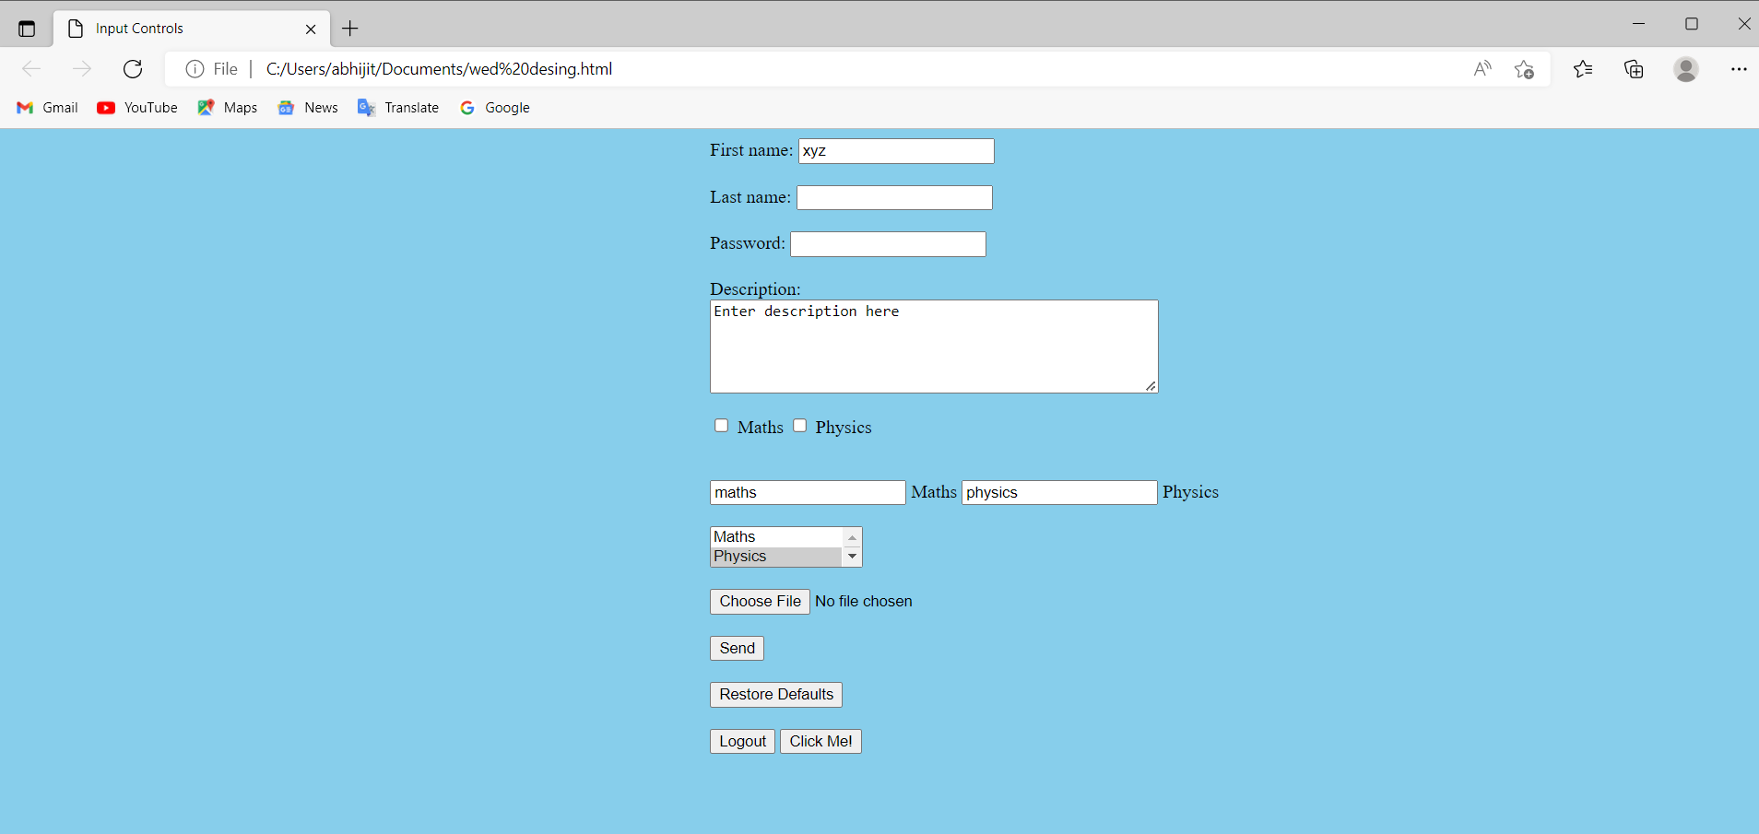

DAY5

Description **:** This html code shows that how to connect two html page internally The syntax used is i) <a></a>, ii) <img>

### Code:- 1st File name - test.html

<html>

<head>

<title>first page</title>

</head>

<body bgcolor="skyblue">

<h1>First html page</h1>

<img height="200px" width="400px" src="https://www.openaccessgovernment.org/wp- content/uploads/2021/03/dreamstime_xxl_56200615-1068x601.jpg">

<h3>Go to second page</h3>

<a href="test2.html">click here</a>

</body>

</html>

2nd File name - test2.html

<html>

<head>

<title>second page</title>

</head>

<body bgcolor="skyblue">

<h1>Second html page</h1>

<img height="200px" width="400px" src="https://cdn.downtoearth.org.in/ library/large/2021-10-26/0.31737700_1635249252_climate-change23.jpg">

<h3>Go to first page</h3>

<a href="test.html">click here</a>

</body>

</html>

Output:1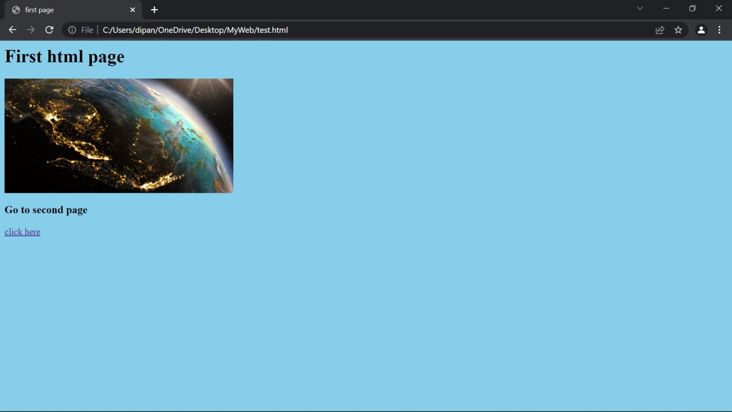

Output:2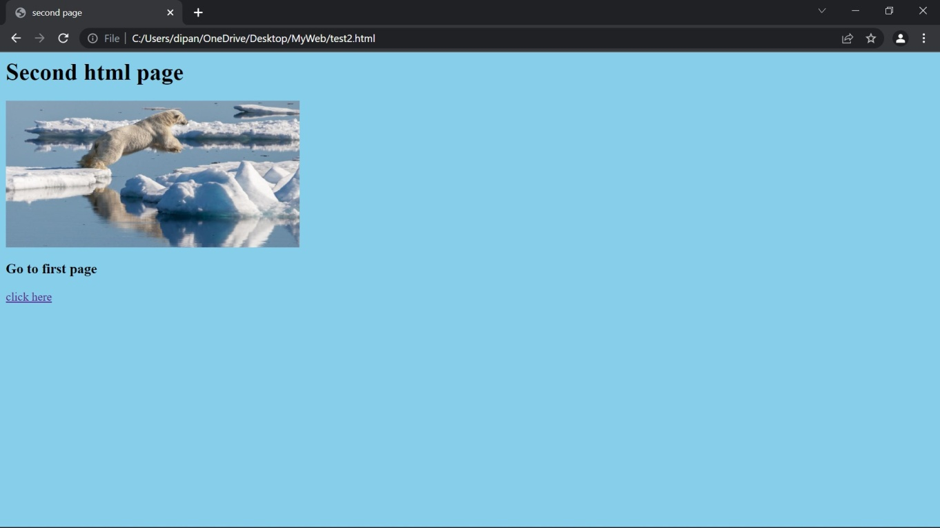

DAY6

Description :This html code shows that ow to connect two html page internally The syntax used is i) <script></script>, ii) document.write(“”),

iii) document.alert(“”),

code:- <html>

<head>

<title>javascript</title>

</head>

<body bgcolor="aquamarine">

<script>

document.write("Hello World") window.alert("I am java script into the html") document.write(5+6)

</script>

</body>

</html>

Output:-

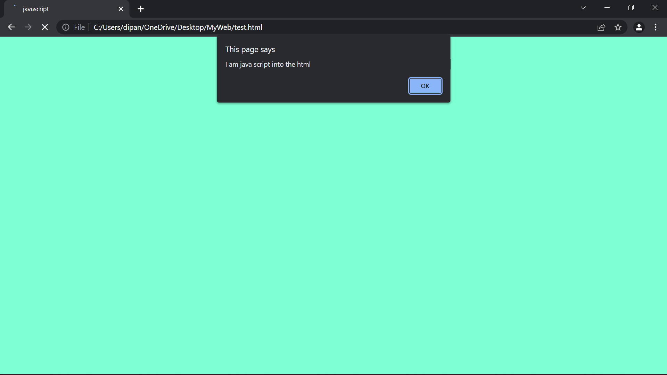

DAY-7

Description :This html code shows that ow to connect two html page internally The syntax used is i) <script></script>, ii) document.write(“”),

Code:- <html>

<head>

<title>javascript</title>

</head>

<body bgcolor="aquamarine">

<script>

document.write("Hello World") document.write(5+6)

</script>

</body>

</html>

Output:-

