**TeacherById & Get all teachers**

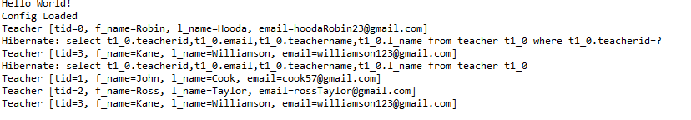

**Insert into teacher**

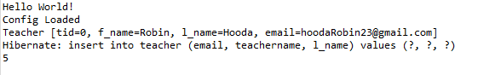

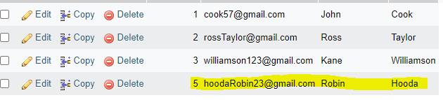

**Update Teacher name**



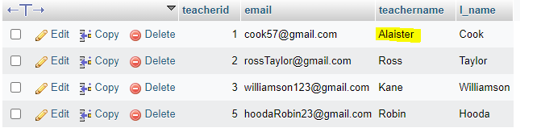

**Delete operation**

