What is Ansible?
Ansible is an open-source automation tool used for:
- Configuration management (installing software, editing config files),
- Application deployment,
- Server provisioning, and
- IT orchestration (coordinating multiple systems).
It helps automate repetitive tasks across many servers using simple YAML scripts (called playbooks).
Ansible doesn’t require installing agents on target systems—it uses SSH to communicate.

Real-Time Example Use Case
Example Scenario: Deploy Apache Web Server to Multiple Servers
Imagine you are a DevOps Engineer managing 100 Linux servers.
You want to install and start the Apache2 web server on all of them.
Instead of connecting to each server manually and running:

sudo apt update
sudo apt install apache2 -y
sudo systemctl start apache2
You just write one Ansible playbook, and Ansible will run all commands automatically on all servers.

Step 1: Update System Packages
sudo apt update
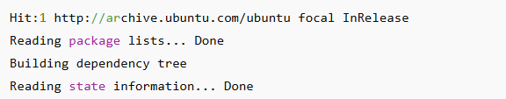

Step 2: Install Software Properties Common
sudo apt install software-properties-common -y

Step 3: Add Ansible PPA Repository
sudo add-apt-repository --yes --update ppa:ansible/ansible
Step 4:
Install Ansible
sudo apt install ansible -y
Verify Installation
ansible –version


Create a Playbook to Install Apache2
Step 1: Create a folder for the project
mkdir apache2
cd apache2

Step 2: Create a Playbook File
nano apache2-install.yml

Then paste the content

---
- name: Install and Start Apache2 on Localhost
hosts: localhost
become: true
connection: local

tasks:
- name: Update APT package index
apt:
update_cache: yes

- name: Install Apache2 web server
apt:
name: apache2
state: present

- name: Ensure Apache2 service is running and enabled
service:
name: apache2
state: started
enabled: yes

- name: Display Apache service status
command: systemctl status apache2
register: apache_status
ignore_errors: yes

Create Inventory File
nano hosts

Add this line
[local]
localhost ansible_connection=local

Verify inventory:
ansible all -i hosts -m ping

Output


Run the Playbook
Check syntax before running:
ansible-playbook -i hosts apache2-install.yml --syntax-check
Output


Run the playbook:
ansible-playbook -i hosts apache2-install.yml

Expected Output
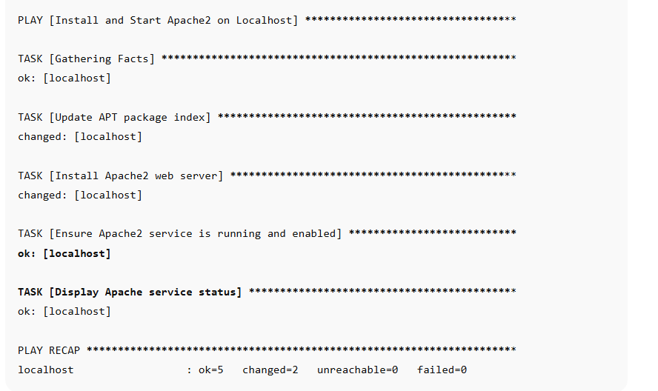

Verify Apache Installation
sudo systemctl status apache2
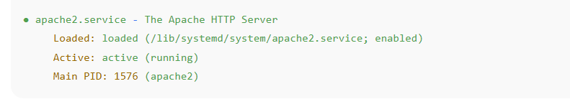

Now go to browser
http://localhost
You’ll see the Apache2 Ubuntu Default Page — proof that Ansible successfully installed and started it.

