- Install Docker on Ubuntu
Update APT & install prerequisites

sudo apt update
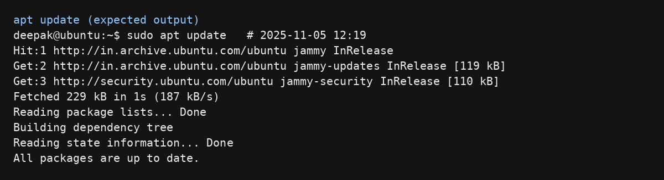

Few Dependencies are needed for installation
sudo apt install curl apt-transport-https ca-certificates software-properties-common

Install Docker from Ubuntu repo
sudo apt install docker.io -y
You can verify with docker --version.
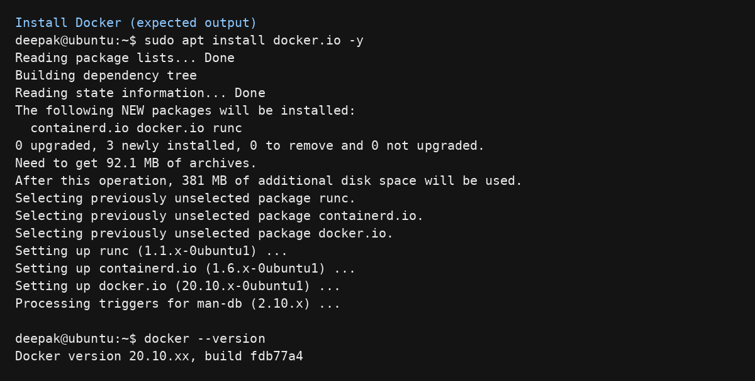

Step 4: Docker GPG key using the curl command
curl -fsSL https://download.docker.com/linux/ubuntu/gpg | sudo gpg --dearmor -o /usr/share/keyrings/docker-archive-keyring.gpg
Step 5: add the Docker APT repository to your system
echo "deb [arch=$(dpkg --print-architecture) signed-by=/usr/share/keyrings/docker-archive-keyring.gpg] https://download.docker.com/linux/ubuntu $(lsb_release -cs) stable" | sudo tee /etc/apt/sources.list.d/docker.list > /dev/null
Step 6: update the local package
sudo apt update
Step 7: install Docker Community Edition
sudo apt install docker-ce -y
Step 8: Docker service starts automatically upon installation
sudo systemctl start docker
sudo systemctl enable docker

2) Create project files
mkdir mydockerapp
cd mydockerapp

Create index.html
Hello from Docker!

Create Dockerfile:
nano Dockerfile

FROM nginx:latest
COPY index.html /usr/share/nginx/html/index.html
EXPOSE 80
After typing, you:
- Press Ctrl + O → to save the file
- Press Enter → to confirm the file name
- Press Ctrl + X → to exit Nano editor

3) Build & run
Build the image
docker build -t mydockerapp .

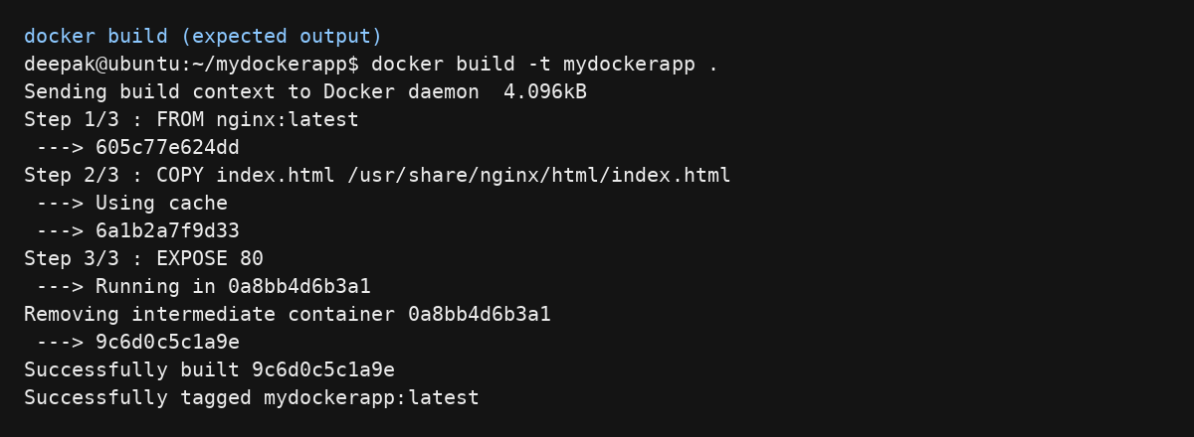

Run the container (named, and mapped to 8080)

docker run -d --name mydockerapp -p 8080:80 mydockerapp

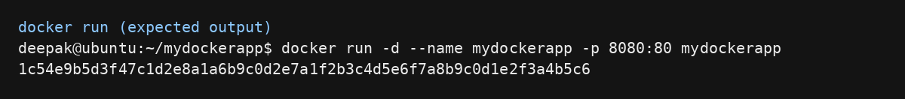

Visit http://localhost:8080 — you should see “Hello from Docker!”.

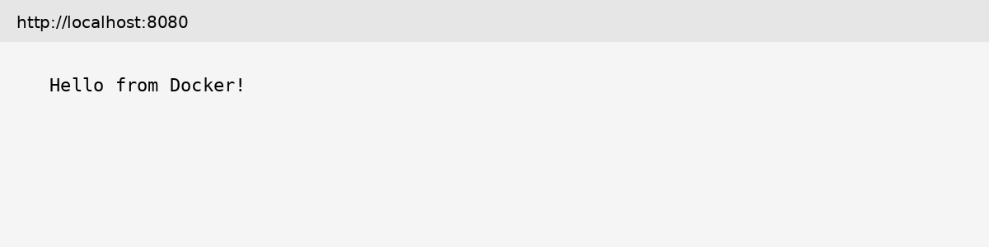

4) Verify & observe

docker ps

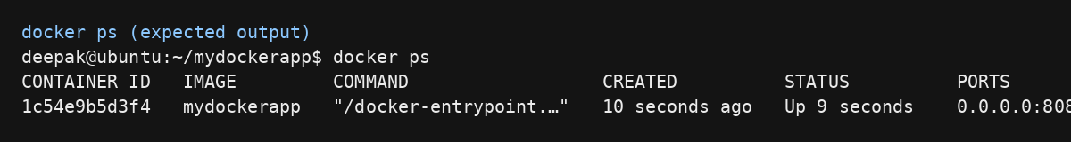

Check logs
docker logs mydockerapp

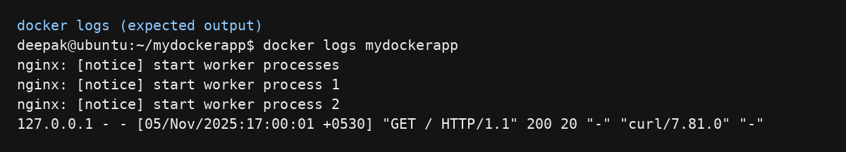

Stop when its done
docker stop mydockerapp

