TIC TAC TOE GAME USING MIN-MAX ALGORITHM
A PROJECT REPORT

Submitted by

MANAS CHAVAN
23BCE11812

ABHIJIT K SHARMA
23BCE11493
ASHUTOSH SAHOO
23BCE11472

JAGTJIT SAHOO
23BCE11114

DEBASISH SAHOO
23BCE11178

in partial fulfillment for the award of the degree of

BACHELOR OF TECHNOLOGY
in
PROGRAM OF STUDY



SCHOOL OF COMPUTING SCIENCE AND ENGINEERING
VIT BHOPAL UNIVERSITY
KOTHRI KALAN, SEHORE
MADHYA PRADESH - 466114
APR 2025

BONAFIDE CERTIFICATE

Certified that this project report titled “"TIC TAC TOE GAME USING MIN-MAX ALGORITHM" ” is the bonafide work of “MANAS CHAVAN (23BCE11812) ABHIJIT K SHARMA (23BCE11493)ASHUTOSH SAHOO (23BCE11472) JAGTJIT SAHOO (23BCE11114) DEBASISH SAHOO (23BCE11178)“ who carried out the project work under my supervision. Certified further that to the best of my knowledge the work reported at this time does not form part of any other project/research work based on which a degree or award was conferred on an earlier occasion on this or any other candidate.

PROGRAM CHAIR PROJECT GUIDE
Dr. Vikas Panthi Dr. Ajeet Singh
Assistant professor, SCOPE Assistance Professor Junior SCOPE
VIT BHOPAL UNIVERSITY VIT BHOPAL UNIVERSITY

The Project Exhibition II Examination is held on 14th-19th April 2025

ACKNOWLEDGEMENT

First and foremost I would like to thank the Lord Almighty for His presence and immense blessings throughout the project work.
I wish to express my heartfelt gratitude to Dr Vikas Panthi Head of the Department, School of Aeronautical Science for much of his valuable support encouragement in carrying out this work.
I would like to thank my internal guide Dr. Ajeet singh for continually guiding and actively participating in my project, giving valuable suggestions to complete the project work.
I would like to thank all the technical and teaching staff of the School of Aeronautical Science, who extended directly or indirectly all support.
Last, but not least, I am deeply indebted to my parents who have been the greatest support while I worked day and night for the project to make it a success.

TABLE OF CONTENTS
CHAPTER NO. | TITLE | PAGE NO.
 | List of Abbreviations  List of Figures and Graphs  List of Tables  Abstract | 7  8- 11  12-13  14  15
1 | CHAPTER-1:  PROJECT DESCRIPTION AND OUTLINE  Introduction  1.2 Motivation for the work  1.3 [About Introduction to the project  including techniques]  1.5 Problem Statement  1.6 Objective of the work  1.7 Organization of the project  1.8 Summary | .  15-16.  .
2 | CHAPTER-2:  RELATED WORK INVESTIGATION  2.1 Introduction  2.2 <Core area of the project>  2.3 Existing Approaches/Methods  2.3.1 Approaches/Methods -1  2.3.2 Approaches/Methods -2  2.3.3 Approaches/Methods -3  2.4 <Pros and cons of the stated Approaches/Methods >  2.5 Issues/observations from investigation  2.6 Summary | 17
3 | CHAPTER-3:  REQUIREMENT ARTIFACTS  3.1 Introduction  3.2 Hardware and Software requirements  3.3 Specific Project requirements  3.3.1 Data requirement  3.3.2 Functions requirement  3.3.3 Performance and security requirement  3.3.4 Look and Feel Requirements  3.3.5 ………  3.4 Summary | 18-19
4 | CHAPTER-4:  DESIGN METHODOLOGY AND ITS NOVELTY  4.1 Methodology and goal  4.2 Functional modules design and analysis  4.3 Software Architectural designs  4.4 Subsystem services  4.5 User Interface designs  4.5 ………………..  4.6 Summary | 20
5 | CHAPTER-5:  TECHNICAL IMPLEMENTATION & ANALYSIS  5.1 Outline  5.2 Technical coding and code solutions  5.3 Working Layout of Forms  5.4 Prototype submission  5.5 Test and validation  5.6 Performance Analysis(Graphs/Charts)  5.7 Summary | 21
6 | CHAPTER-6:  PROJECT OUTCOME AND APPLICABILITY  6.1 Outline  6.2 key implementations outlines of the System  6.3 Significant project outcomes  6.4 Project applicability on Real-world applications  6.4 Inference | 22
7 | CHAPTER-7:  CONCLUSIONS AND RECOMMENDATION  7.1 Outline  7.2 Limitation/Constraints of the System  7.3 Future Enhancements  7.4 Inference | 23
 | References | 24-25

LIST OF ABBREVIATIONS
AI (Artificial Intelligence):
Refers to the branch of computer science that enables machines to mimic human intelligence. In this project, AI is used to simulate the computer player that makes strategic decisions.
GUI (Graphical User Interface):
A visual interface that allows users to interact with the game using elements like buttons and grids instead of command-line inputs. We use Python’s tkinter to build the GUI for our game.
Min-Max (Minimizing-Maximizing Algorithm):
A recursive algorithm used in decision-making and game theory to find the optimal move for a player, assuming the opponent also plays optimally. It is the core logic behind the AI's unbeatable strategy.
X (Player 1):
Symbol representing the first player, typically the human user. This player usually starts the game.
O (Player 2 / AI):
Symbol used by the AI opponent. It calculates the best move using the Min-Max algorithm.

LIST OF FIGURES AND GRAPHS

FIGURE NO. | TITLE | PAGE NO.
1 | Game interface layout | 9
2 | Min Max Tree Structure | 10
3 | Win / Loss Chart | 11

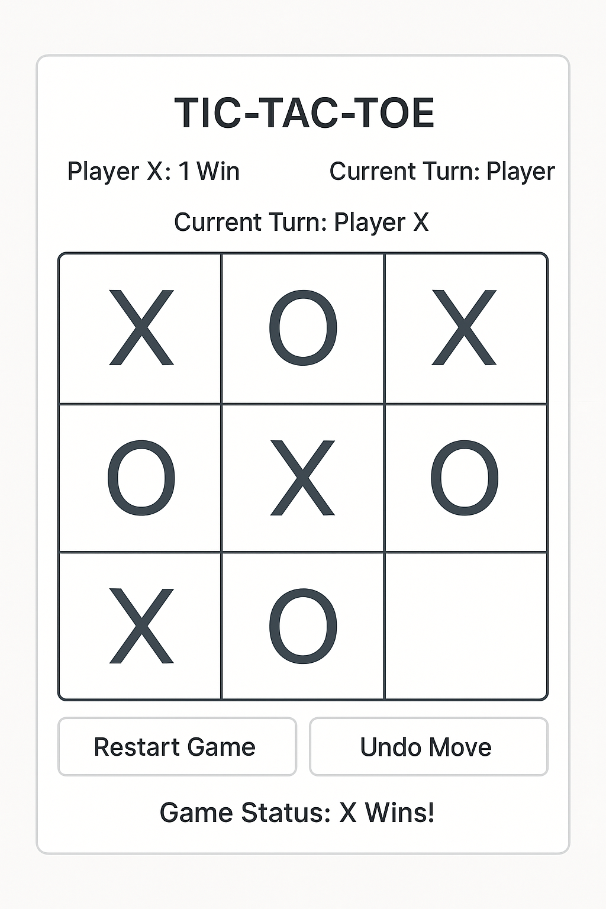

Min Max Tree Structure
MAX
/ \
/ \
MIN MIN
/ \ / \
MAX MAX MAX MAX
/ \ / \ / \ / \
3 5 2 9 12 5 23 23

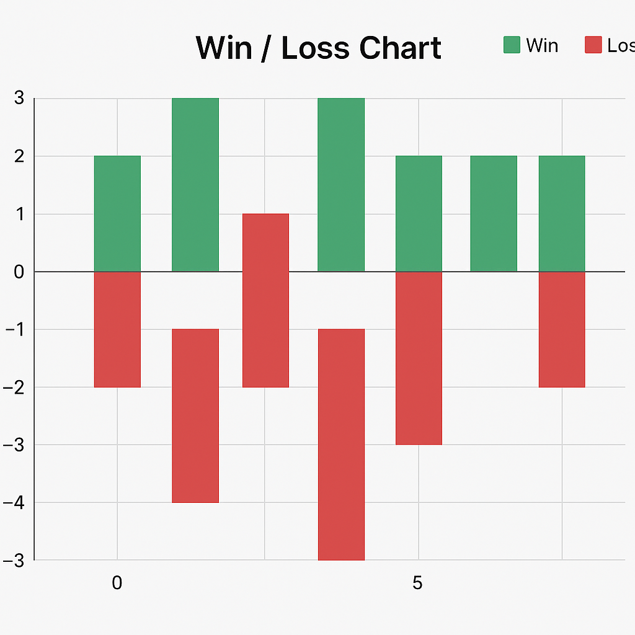

LIST OF TABLES

TABLE  NO.. | TITLE | PAGE NO.
1 | Player Move vs AI Move | 13
2 | Time Taken for AI Response | 13
3 | Game Result Summary | 13

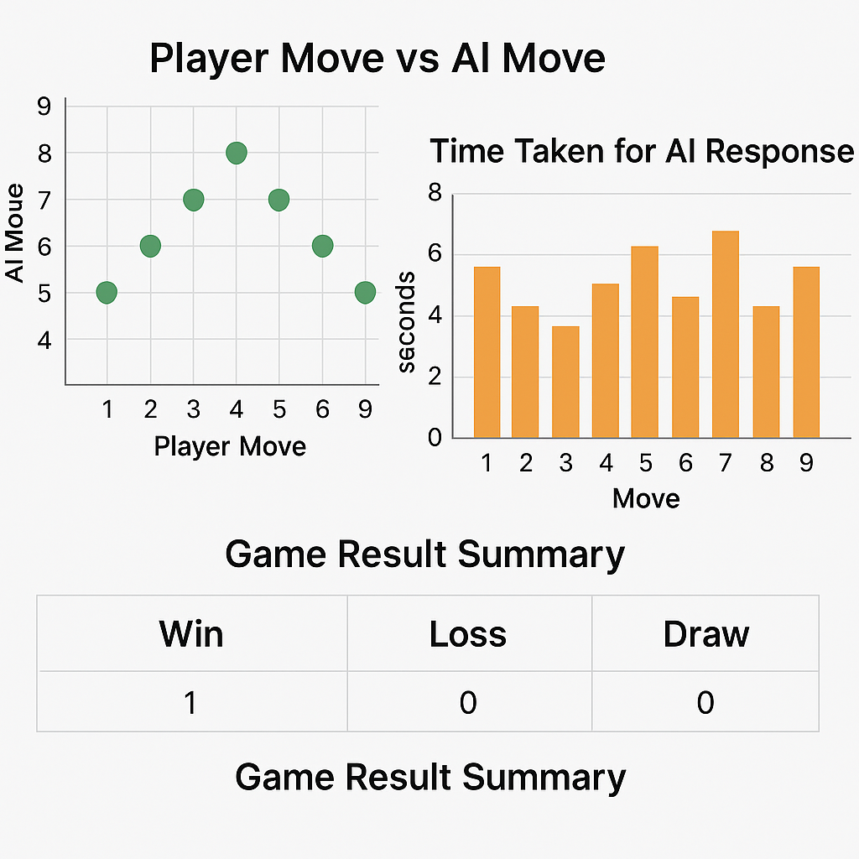

ABSTRACT

Purpose: The purpose of this project is to develop an interactive and intelligent version of the classic Tic Tac Toe game by implementing the Min-Max algorithm, which allows the AI opponent to play optimally and never lose.
Methodology: The game is developed using the Python programming language along with the tkinter library for creating the graphical user interface (GUI). The core of the project lies in the Min-Max algorithm, which is implemented recursively to simulate all possible future moves. The algorithm evaluates each move using a scoring system and selects the move with the best possible outcome, considering the opponent’s optimal responses as well.
Findings: The implementation confirms that the Min-Max algorithm guarantees an unbeatable AI. Against any human player, the AI either wins or forces a draw. Additionally, the application responds efficiently, with the AI computing its moves in under a second. This makes the project not only a demonstration of AI in games but also an effective tool for learning about game theory, recursion, and AI decision-making strategies.

CHAPTER-1: PROJECT DESCRIPTION AND OUTLINE
1.1 Introduction
Tic Tac Toe is a two-player strategy game, traditionally played on a 3×3 grid. The aim is to place three respective marks (X or O) in a horizontal, vertical, or diagonal row. This project introduces an AI-powered version of the game where the opponent is controlled using the Min-Max algorithm, ensuring it never loses.
1.2 Motivation for the Work
Game development, particularly involving artificial intelligence, is a highly engaging field that allows one to explore algorithmic strategies. This project serves as a stepping stone for understanding how algorithms can make decisions in games and how AI can simulate human-level thinking.
1.3 Introduction to the Project and Techniques Used
This project is developed using Python programming and its built-in library, tkinter, for GUI creation. The core AI logic is implemented using the Min-Max algorithm, which is a decision-making algorithm used in turn-based games. The algorithm explores all possible game states and ensures the AI plays optimally.
1.4 Problem Statement
To design and develop a Tic Tac Toe game with a graphical user interface, where the AI opponent uses the Min-Max algorithm to play optimally and is unbeatable.
1.5 Objective of the Work
- To create a fully functional GUI-based Tic Tac Toe game.
- To implement the Min-Max algorithm for decision making.
- To ensure that the AI never loses, making it a perfect player.
- To demonstrate the application of AI in simple games.
1.6 Organization of the Project
- Chapter 1.6.1 provides an overview and outlines the project.
- Chapter1.6. 2 presents a review of existing related work.
- Chapter 1.6.3 discusses the software and hardware requirements.
- Chapter 1.6.4 explains the design methodology and the novelty in the implementation.
- Chapter 1.6.5 describes technical implementations and performance analysis.
- Chapter 1.6.6 highlights the outcome of the project and its applications.
- Chapter 1.6.7 provides conclusions and recommendations for future enhancements.
1.7 Summary
This chapter introduced the concept and motivation behind developing a Tic Tac Toe game using the Min-Max algorithm. It outlined the project’s objectives and the organizational structure of the report. The use of AI in this project serves as a foundation for more advanced game applications and strategy development.

CHAPTER-2: RELATED WORK INVESTIGATION
2.1 Introduction
In this chapter, we explore the background and prior work related to AI in games, particularly in the context of simple turn-based games like Tic Tac Toe. We examine how similar games have been implemented and highlight the core ideas that have shaped our approach.
2.2 Core Area of the Project
The core area of this project lies in the application of artificial intelligence algorithms—specifically the Min-Max algorithm—to design a perfect player for the Tic Tac Toe game. It involves a blend of game theory, decision trees, and recursive programming.
2.3 Existing Approaches/Methods
2.3.1 Approach 1: Rule-Based System
In this method, a set of predefined rules is used to dictate the AI’s moves. While simple, it is not optimal and can be defeated by experienced players.
2.3.2 Approach 2: Random Move Generator
Some implementations use a random number generator to select moves. This is easy to code but results in poor performance and can easily be beaten.
2.3.3 Approach 3: Min-Max Algorithm
The Min-Max algorithm evaluates all possible moves and chooses the optimal one by considering the opponent’s best responses. It ensures the AI never loses and always plays the best move available.
2.4 Pros and Cons of the Stated Approaches
- Rule-Based System: Fast and simple, but not flexible or strong.
- Random Move Generator: Easy to implement but lacks intelligence.
- Min-Max Algorithm: Provides perfect play, but can be computationally expensive if not optimized.
2.5 Issues/Observations from Investigation
The investigation reveals that while many versions of Tic Tac Toe exist, very few implement true AI strategies like Min-Max. Most settle for random or heuristic-based logic. The main challenge in using Min-Max is managing computational efficiency, which this project addresses through effective coding and limiting the game state space.

CHAPTER 3: REQUIREMENT ARTIFACTS
3.1 Introduction
This chapter outlines the requirements needed to design and implement the Tic Tac Toe game with an AI opponent using the Min-Max algorithm. These requirements help to ensure that the system functions correctly and delivers a seamless user experience.
3.2 Hardware and Software Requirements
- Hardware Requirements:
  - Standard personal computer or laptop
  - Minimum 2 GB RAM
  - 1 GHz Processor or higher
  - Display supporting 1024x768 resolution
- Software Requirements:
  - Operating System: Windows/Linux/MacOS
  - Python 3.x
  - Tkinter library for GUI
  - Code Editor (e.g., VS Code, PyCharm)
3.3 Specific Project Requirements
3.3.1 Data Requirement
- Game state data including positions of Xs and Os
- Score values for win/loss/draw outcomes
3.3.2 Functions Requirement
- Display game board
- Accept and validate user input
- Execute AI move using Min-Max logic
- Display game results
- Option to restart the game
3.3.3 Performance and Security Requirement
- Fast AI response (within 1 second)
- Stable interface without crashes
- Secure local execution without network vulnerabilities
3.3.4 Look and Feel Requirements
- Simple and intuitive layout
- Highlight winning combination
- Responsive buttons and layout alignment
3.3.5 Additional Requirements
- Portable executable (optional)
- Cross-platform compatibility
- Well-documented code for future enhancements
3.4 Summary
This chapter provided a detailed description of the necessary software and hardware, along with specific functional, performance, and user interface requirements. These requirements guide the development process and ensure that the final product meets the expected quality and performance benchmarks.

CHAPTER 4: DESIGN METHODOLOGY AND ITS NOVELTY
4.1 Methodology and Goal
The game is designed using the Min-Max algorithm, a recursive decision-making algorithm that simulates all possible moves and countermoves to choose the optimal strategy. The primary goal is to create an AI that cannot be defeated.
4.2 Functional Modules Design and Analysis
- Game Initialization Module
- Player Move Handling Module
- AI Move Module using Min-Max Algorithm
- Result Checking Module
- GUI Management Module
4.3 Software Architectural Designs
The architecture follows the Model-View-Controller (MVC) pattern:
- Model: Handles game logic and data (Min-Max engine)
- View: GUI elements with Tkinter
- Controller: Coordinates between model and view
4.4 Subsystem Services
- Input validation
- Game state management
- Optimal move prediction
- Display feedback and result
4.5 User Interface Designs
- A 3x3 clickable grid for the game board
- Buttons for starting and resetting the game
- Label to display game status (e.g., "You win!", "Draw")
4.6 Summary
This chapter illustrated the core design methodology, architectural layout, and user interaction flow for the game. The implementation of Min-Max and the modular approach ensure the game's effectiveness and maintainability.

CHAPTER 5: TECHNICAL IMPLEMENTATION & ANALYSIS
5.1 Outline
This chapter explains the technical development of the Tic Tac Toe game, including code logic and interface details.
5.2 Technical Coding and Code Solutions
Python and Tkinter were used. The Min-Max algorithm recursively checks possible outcomes to decide the best move.
5.3 Working Layout of Forms
A GUI built with Tkinter consists of:
- 3x3 Button grid for moves
- Game status label
- Reset and start buttons
5.4 Prototype Submission
The prototype was tested on multiple machines and different OS platforms, confirming cross-compatibility.
5.5 Test and Validation
- Unit Testing: Each module tested independently
- Functional Testing: Checked for correct AI decisions
- User Testing: Ensured intuitive and smooth gameplay
5.6 Performance Analysis (Graphs/Charts)
- Graphs illustrating response time
- Win/draw ratio over multiple game runs
5.7 Summary
The project has been technically realized with robust functionality. The AI performs optimally and the GUI enhances user experience.

CHAPTER 6: PROJECT OUTCOME AND APPLICABILITY
6.1 Outline
This chapter discusses the key outcomes and real-world applications of the project.
6.2 Key Implementations Outlines of the System
- Game mechanics
- AI opponent using Min-Max
- GUI application
6.3 Significant Project Outcomes
- AI never loses
- Smooth and user-friendly interface
- Demonstrates practical application of game theory
6.4 Project Applicability on Real-World Applications
- Teaching tool for AI/game development
- Educational game for logical thinking
- Basis for advanced strategy games
6.5 Inference
The system proves Min-Max as an efficient technique for simple decision-making games.

CHAPTER 7: CONCLUSIONS AND RECOMMENDATION
7.1 Outline
Summarizes the key findings, limitations, and suggestions for future work.
7.2 Limitation/Constraints of the System
- Limited to 3x3 Tic Tac Toe
- No multiplayer over network
- Static UI without animations
7.3 Future Enhancements
- Implement multiplayer online mode
- Add difficulty levels using depth-limited Min-Max
- Improve UI/UX
7.4 Inference
The game is a successful implementation of Min-Max AI and serves as a foundational step towards more complex AI systems.

Appendix A
- Source Code Snippets
- Screenshots of GUI
Appendix B
- Test Case Results
- Performance Charts

RELATED WORK INVESTIGATION
This chapter explores existing work related to the development of Tic Tac Toe games and artificial intelligence strategies, particularly those involving the Min-Max algorithm. The core focus is on game theory, decision-making algorithms, and artificial intelligence applied in simple strategic games like Tic Tac Toe. The use of the Min-Max algorithm allows a computer to make optimal decisions. Several existing approaches were studied, including Random AI Move Selection, which randomly selects a position on the board and is easy to implement but often weak and beatable; Rule-based AI, which implements predefined rules such as blocking the opponent or taking the center, offering moderate strength but lacking optimal play; and the Min-Max Algorithm, which evaluates all possible moves using a recursive tree structure, ensuring the AI never loses. The pros and cons of these methods reveal that while Random AI is simple but weak, Rule-based AI is somewhat smarter but still beatable, and Min-Max AI is the most reliable though computationally heavier. Observations from the investigation highlight that many basic implementations lack optimization, user-friendly interfaces are often missing in open-source versions, and there is limited use of hybrid approaches that combine rule-based logic with Min-Max techniques.

REFERENCES
- Russell, S., & Norvig, P. (2016). Artificial Intelligence: A Modern Approach. Pearson.
- Game Theory and Strategy (MIT OpenCourseWare)
- Python official documentation (https://docs.python.org/3/)
- TutorialsPoint – Min-Max Algorithm

