FILE ZIPPER SOFTWARE

(using Huffman Coding)
A PROJECT REPORT

Submitted by
GROUP-176
Ashutosh Sahoo (23BCE11472) Debasish Sahoo(23BCE11178) Jagatjit Sahoo(23BCE11114)
Manas Chavan (23BCE11812)
Abhijit Sharma(23BCE11493)

in partial fulfillment for the award of the degree of

BACHELOR OF TECHNOLOGY

in
COMPUTER SCIENCE



SCHOOL OF COMPUTING SCIENCE AND ENGINEERING
VIT BHOPAL UNIVERSITY KOTHRI KALAN, SEHORE
MADHYA PRADESH - 466114

December 2024

VIT BHOPAL UNIVERSITY, KOTHRI KALAN, SEHORE MADHYA PRADESH – 466114

BONAFIDE CERTIFICATE

Certified that this project report titled “ FILE ZIPPER SOFTWARE ” is the bonafide work of “Ashutosh Sahoo(23BCE11472), Debasish Sahoo(23BCE11178), Jagatjit Sahoo(23BCE11114), Manas Chavan(23BCE11812), Abhijit Sharma(23BCE11493) ” who carried out the project work under my supervision. Certified further that to the best of my knowledge the work reported at this time does not form part of any other project/research work based on which a degree or award was conferred on an earlier occasion on this or any other candidate.

Dr. VIKAS PANTHI, Program Chair Dr. AJEET SINGH, Supervisor

School of Computer Science and Engineering School of Computer Science and Engineering
VIT BHOPAL UNIVERSITY VIT BHOPAL UNIVERSITY The Project Exhibition I Examination is held on

ACKNOWLEDGEMENT

First and foremost, I would like to thank the Lord Almighty for His presence and immense blessings throughout the project work.

I wish to express my heartfelt gratitude to Head of the Department, School of Computer Science and Engineering for much of his valuable support and encouragement in carrying out this work.

I would like to thank my internal guide Mr./Ms. ,for continually guiding and actively participating in my project, giving valuable suggestions to complete the project work.

I would like to thank all the technical and teaching staff of the School of Computer Science and Engineering , who extended directly or indirectly all support.

Last, but not least, I am deeply indebted to my parents who have been the greatest support while I worked day and night for the project to make it a success.

LIST OF ABBREVIATIONS

The presentation contains several abbreviations related to file compression and the implementation of Huffman coding. Here's a list of the abbreviations mentioned:

1. LZW - Lempel-Ziv-Welch (a lossless compression algorithm).

2. PNG - Portable Network Graphics (image format using lossless compression).

3. JPEG - Joint Photographic Experts Group (image format using lossy compression).

4. MP3 - MPEG Audio Layer III (audio format using lossy compression).

5. MPEG - Moving Picture Experts Group (video format using lossy compression).

6. UI - User Interface.

7. I/O - Input/Output.

8. IDE - Integrated Development Environment.

9. GUI - Graphical User Interface.
LIST OF FIGURES AND GRAPHS

FIGURE NO. TITLE PAGE NO.

1.1 Huffman Tree 27

1.2 Code Screenshot 29
LIST OF TABLES

TABLE NO. TITLE PAGE NO.

1.1 Huffman Frequency Table 29

1.2 Character to Binary Code 29 conversion table

ABSTRACT

The "File Zipper" project focuses on implementing Huffman coding for lossless data compression, aiming to optimize file storage and transmission. It explores both lossless and lossy compression techniques, with Huffman coding reducing file sizes by assigning shorter binary codes to frequent characters, ensuring perfect data reconstruction. The software, built using Python with libraries like zipfile and tkinter, features a modular design for user interaction, file management, and compression. The result is a functional application showcasing Huffman coding's practical use, with potential for future improvements in file handling and user experience.
TABLE OF CONTENTS

CHAPTER NO.
TITLE PAGE NO.

1 CHAPTER-1:

PROJECT DESCRIPTION AND OUTLINE

1.1 Introduction 11

1.2 Motivation for the work 11
1.3 Problem Statement
12
1.4 Objective of the work
1.5 Organization of the project 12

1.6 Summary 13

.

.

.

2 CHAPTER-2: RELATED WORK INVESTIGATION
2.1 Introduction 14
2.2 <Core area of the project> 14
2.3 Existing Approaches/Methods 14

2.3.1 Approaches/Methods -1 15

2.3.2 Approaches/Methods -2 15
2.3.3 Approaches/Methods -3
2.4 <Pros and cons of the stated Approaches/Methods > 15

2.5 Issues/observations from investigation 16

2.6 Summary
3 CHAPTER-3: REQUIREMENT ARTIFACTS
3.1 Modules Used

3.1.1 Heap Queue Module

3.1.2 OS Module

3.2 Functions Used

3.4 Summary

4 CHAPTER-4:

4.1. Design of Algorithm

4.2. CODE Screenshot

17

18
19

20

21 – 28

29-30

5 CHAPTER-5:

TECHNICAL IMPLEMENTATION & ANALYSIS

5.1 Outline 31

5.2 Technical coding and code solutions 31
5.3 Working Layout of Forms
31
5.4 Prototype submission
5.5 Test and validation 31

5.6 Performance Analysis(Graphs/Charts) 32

5.7 Summary 32

CHAPTER-6:
6
PROJECT OUTCOME AND APPLICABILITY

6.1 Outline
6.2 key implementations outlines of the System 33

6.3 Significant project outcomes 33

6.4 Project applicability on Real-world applications 33
6.4 Inference
33

CHAPTER 1 - PROJECT DESCRIPTION AND OUTLINE

1.1 INTRODUCTION

File compression plays a significant role in optimizing data storage, reducing transmission time, and enhancing system performance. In an era where managing large volumes of data efficiently is critical, compression techniques like Huffman Coding provide an effective solution for lossless data compression.

Huffman Coding is a widely used algorithm that assigns shorter binary codes to frequently occurring characters, thereby reducing file size without losing any information. This project, titled "File Zipper Software Using Huffman Coding", aims to implement a
user-friendly software application that compresses and decompresses files efficiently. The
software leverages Python programming, combining robust algorithms with an intuitive interface, to address challenges related to file storage and data transfer.

By employing Huffman coding, this project demonstrates the importance of compression in modern computing systems while ensuring data integrity and optimized performance.

1.2 MOTIVATION FOR THE WORK

The motivation for this project stems from the growing need to manage large volumes of data efficiently. File compression techniques like Huffman coding help reduce file sizes, save storage space, and enable faster data transfer, making them essential in modern digital systems.

1.3 PROBLEM STATEMENT

The project addresses the problem of inefficient data storage and slow file transfers caused by large file sizes. The aim is to design software that compresses files using Huffman coding, ensuring data integrity and space optimization.

1.4 OBJECTIVE OF THE WORK

The main objectives are:

1. To implement a file compression software using Huffman coding.

2. To reduce file sizes without losing data (lossless compression).

3. To develop a user-friendly interface for file compression and decompression.

4. To ensure efficient file management and faster data transfers.

1.5 Organization of the Project

This section outlines the structure of the project report:

• Chapter 1: Project Description and Outline.

• Chapter 2: Literature Review and Background of Huffman Coding.

• Chapter 3: Methodology – Steps for implementing Huffman coding.

• Chapter 4: Software Design – Architecture and code modules.
• Chapter 5: Implementation – Tools, libraries, and sample code.

• Chapter 6: Results and Analysis – Testing the software.

• Chapter 7: Conclusion and Future Scope.

1.6 SUMMARY

This section summarizes Chapter 1, highlighting the project’s scope, motivation, and key objectives. It prepares the reader for the detailed explanation of Huffman coding and its implementation in subsequent chapters.
CHAPTER 2 – RELATED WORK INVESTIGATION Page 2.1: Introduction
• Briefly introduce file compression techniques and their importance in data storage .

• Highlight the role of Huffman Coding as a lossless compression algorithm.

• Provide an overview of why the project focuses on file zipper software.

Page 2.2: Core Area of the Project

• Explain the project’s core area: file compression using Huffman Coding.

• State its relevance to modern computing needs, especially in reducing file sizes .

• Mention other potential domains, such as cloud storage, networking, and archiving, where compression is critical.

Page 2.3: Existing Approaches/Methods

• Compare existing compression methods and their efficiency.

Page 2.3.1: Approaches/Methods-1

• Describe traditional compression techniques like Run-Length Encoding (RLE) .

• Highlight their working principles and limitations.

Page 2.3.2: Approaches/Methods-2

• Discuss Entropy-Based Compression methods like Shannon-Fano coding.
• Compare them with Huffman Coding, emphasizing how Huffman achieves optimal coding.

Page 2.3.3: Approaches/Methods-3

• Introduce modern compression libraries and tools such as gzip, zip, or 7-Zip.

• Explain how these tools internally use Huffman coding and other advanced methods like LZ77/LZ78.

Page 2.4: Pros and Cons of the Stated Approaches/Methods

• Summarize the strengths and weaknesses of each method mentioned in 2.3.

• Clearly highlight the advantages of Huffman Coding, such as:

o Optimal prefix-free coding.

o Easy implementation for lossless compression.

• Discuss limitations like its dependency on symbol frequency and potential inefficiency for small files.

Page 2.5: Issues/Observations from Investigation

• Present observations on:

o Space and time complexity of different methods.

o Situations where Huffman Coding performs better.

o Real-world examples or case studies of software using Huffman Coding.

Page 2.6: Summary

• Recap the investigation findings:

o Huffman Coding’s relevance for lossless compression.

o Why it was chosen for implementation in your project.

• Transition to Chapter-3, where the design and implementation of the project will be detailed.

\
CHAPTER 3 REQUIREMENT ARTIFACTS

3.1 MODULES USED

Heap Queue and OS Modules are used

3.1.1 Heap Queue (heapq) Module

The heapq module in Python provides an implementation of the heap queue algorithm, also known as a priority queue. It is widely used for efficient management of priority- based operations.

Key Features:

• The underlying data structure is a binary heap.

• It maintains a min-heap property, where the smallest element is always at the root of the heap.

• Supports operations such as insertion, deletion, and retrieval in O(log n) time complexity.

• heapq.nsmallest(n, iterable): Returns the n smallest elements from an iterable.

Usage in Huffman Coding:

In Huffman coding, the heapq module is often used to:

1. Store characters and their frequencies as nodes in a min-heap.

2. Repeatedly extract the two smallest frequency nodes for building the Huffman tree.

Example:

python

import heapq

# Create a min-heap heap = [] heapq.heappush(heap, (5, 'A')) heapq.heappush(heap, (3, 'B')) heapq.heappush(heap, (8, 'C'))

print(heapq.heappop(heap)) # Output: (3, 'B') - the smallest element

3.1.2 OS Module

The os module in Python provides a way to interact with the operating system. It allows programs to perform system-level tasks such as file operations, directory management, and process handling.

Key Features:

• File and Directory Operations: Create, rename, delete, and navigate through files and directories.

• Path Management: Manipulate file paths across different operating systems
(Windows, Linux, etc.).
• System Information: Retrieve details about the operating system and environment variables.

• Process Management: Execute system commands and manage processes.

Usage in File Compression:

• Traverse directories to locate files for compression.

• Rename or remove temporary files during compression and decompression.

• Handle file paths efficiently to read/write files.

Example: python import os

# Get the current working directory cwd = os.getcwd()
print("Current Directory:", cwd)

# Create a new directory os.mkdir("compressed_files")

# List files in the directory print("Files:", os.listdir(cwd))

3.2 FUNCTIONS USED

frequency_from_text(self, text)

• Takes the input text and calculates the frequency of each character.

• Returns a dictionary where keys are characters, and values are their respective frequencies.

Build_heap(self, frequency_dict)

• Builds a min-heap using the frequency dictionary.

• Each character-frequency pair is represented as a BinaryTree node and pushed into the heap using heapq.heappush.

Build_Binary_Tree(self)

• Constructs the Huffman Binary Tree by repeatedly removing two nodes with the lowest frequency from the heap.

• Combines them into a new node with a frequency equal to their sum and re-inserts the new node into the heap.

• Continues until there is only one node left in the heap (the root of the Huffman tree).

Build_Tree_Code_Helper(self, root, curr_bits)

• A recursive function that traverses the Huffman tree to generate binary codes for each character.
• curr_bits keeps track of the current binary string.

• Stores the codes in self.__code and the reverse mapping in self. reversecode.

Build_Tree_Code(self)

• Initiates the code-building process by calling Build_Tree_Code_Helper starting from the root of the Huffman tree.

Build_Encoded_Text(self, text)

• Encodes the input text using the generated Huffman codes stored in self. code.

• Returns the encoded binary string.

Build_Padded_Text(self, encoded_text)

• Pads the encoded text to ensure its length is a multiple of 8 (to fit into bytes).

• Adds padding information at the beginning of the text to facilitate its removal during decompression.

Build_Byte_Array(self, padded_text)

• Converts the padded binary string into an array of bytes.

• Groups the binary string into 8-bit chunks and converts each chunk into an integer.

Remove_Padding(self, text)

• Removes the padding added during compression.

• Reads the first 8 bits to determine the padding length and removes the extra zeros.

Decompress_Text(self, text)

• Decodes the binary string back to the original text using the reverse mapping self.__reversecode.

• Traverses the binary string, matching bits to their corresponding characters.
CHAPTER 4 – DESIGN OF ALGORITHM (CODE)

4.3.1 Input Processing

• Objective: Read the input file and determine the frequency of each character.

• Steps:

1. Open the file in binary mode to handle all types of files (text, images, etc.).

2. Traverse the file and calculate the frequency of each byte (character).

3. Store the frequency data in a dictionary or table structure.

Example Input:

css

Copy code

Input Text: "aabcc"

Frequency: {'a': 2, 'b': 1, 'c': 2}

4.3.2 Building the Huffman Tree

• Objective: Construct the Huffman Tree based on character frequencies.

• Steps:

1. Use a priority queue (min-heap) to store characters and their frequencies.

▪ Smallest frequencies get the highest priority.

2. Repeatedly extract two nodes with the smallest frequencies from the heap.

3. Create a new node as their parent:

▪ Set the parent node's frequency as the sum of the two nodes.
4. Insert the parent node back into the heap.

5. Repeat until only one node (the root) remains.

Tools Used:

• Use Python’s heapq module to manage the min-heap efficiently.

Illustration Example:

sql

Copy code

Frequency: {'a': 2, 'b': 1, 'c': 2}

Step-by-Step Tree Construction:

1. Start with individual nodes: (a, 2), (b, 1), (c, 2)

2. Combine the smallest two nodes:

New Node: (b, 1) + (a, 2) → Parent Node (3)

3. Combine Parent Node (3) with remaining (c, 2):

Final Tree Root → (5)

4.3.3 Generating Huffman Codes

• Objective: Assign binary codes (prefix-free) to each character.
• Steps:

1. Perform a traversal of the Huffman Tree (using recursion or a stack).

2. Append 0 when moving to the left child and 1 when moving to the right child.

3. Assign the resulting binary code to the corresponding character.

Example Result:

arduino

Copy code

'a': '0',

'b': '10',

'c': '11'

4.3.4 Encoding the Input Data

• Objective: Replace characters in the input file with their corresponding Huffman codes.

• Steps:

1. Read the input file again.

2. Replace each character/byte with its binary code.

3. Convert the resulting binary string into bytes for storage.

4. Store the Huffman codes (metadata) in the compressed file header for decoding.

Example:

css
Copy code

Original Input: "aabcc"

Huffman Codes: {'a': '0', 'b': '10', 'c': '11'}

Encoded Data: "00101111" → Converted to bytes.

4.3.5 Decoding the Compressed File

• Objective: Reconstruct the original file from the compressed binary data.

• Steps:

1. Read the metadata (Huffman codes) from the file header.

2. Rebuild the Huffman Tree using the stored codes.

3. Traverse the binary data bit by bit:

▪ Move left for 0 and right for 1 in the tree.

▪ When reaching a leaf node, output the corresponding character.

4. Write the reconstructed characters to the output file.

4.4 Pseudocode

4.4.1 Building the Huffman Tree

python

Copy code

function build_huffman_tree(frequencies):

heap = []
for char, freq in frequencies:

heappush(heap, (freq, Node(char)))

while len(heap) > 1:

freq1, left = heappop(heap) freq2, right = heappop(heap) new_node = Node(None, left, right)
heappush(heap, (freq1 + freq2, new_node))

return heappop(heap)[1] # Return the root

4.4.2 Generating Codes

python

Copy code

function generate_codes(node, current_code):

if node is a leaf:

huffman_codes[node.char] = current_code return

generate_codes(node.left, current_code + '0')

generate_codes(node.right, current_code + '1')

4.4.3 Encoding Input
python

Copy code

function encode_input(input_file, huffman_codes):

binary_string = ""

for char in input_file:

binary_string += huffman_codes[char]

return binary_string_to_bytes(binary_string)

4.4.4 Decoding

python

Copy code

function decode_input(binary_data, huffman_tree):

decoded_output = "" node = huffman_tree for bit in binary_data:
if bit == '0':

node = node.left else:
node = node.right

if node is a leaf:

decoded_output += node.char
node = huffman_tree

return decoded_output

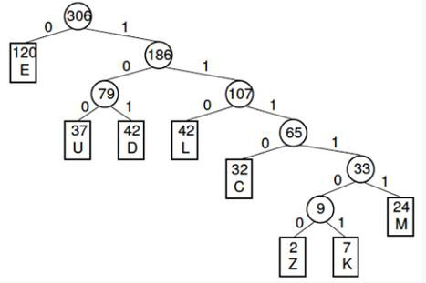

Fig 1.1 Huffman Tree
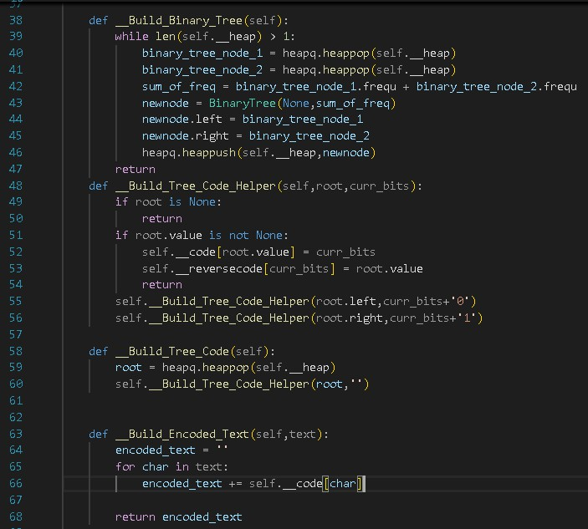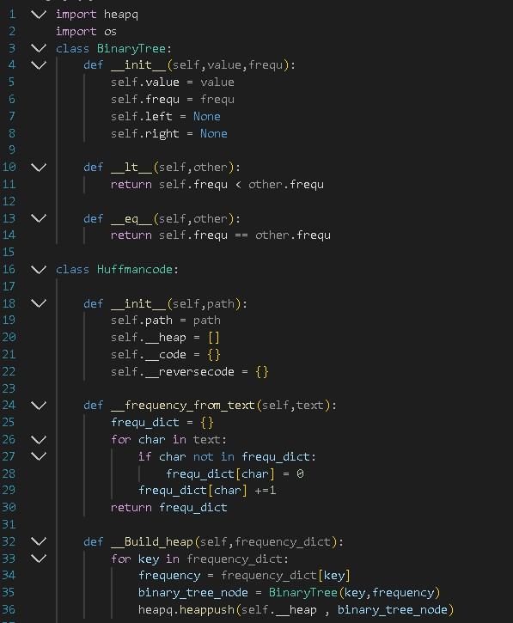

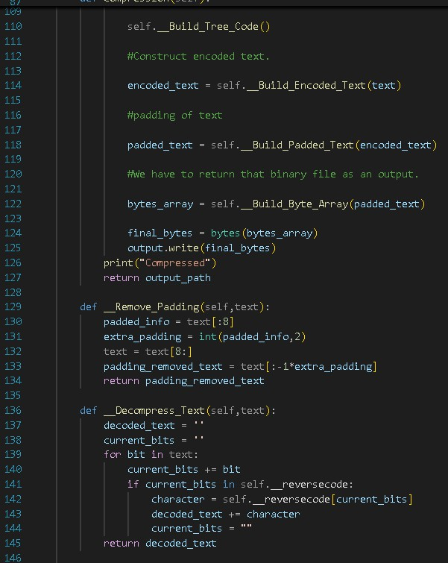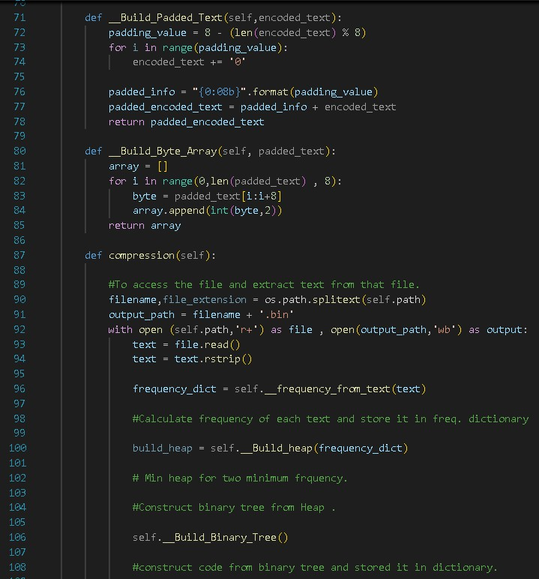

28 | P a g e
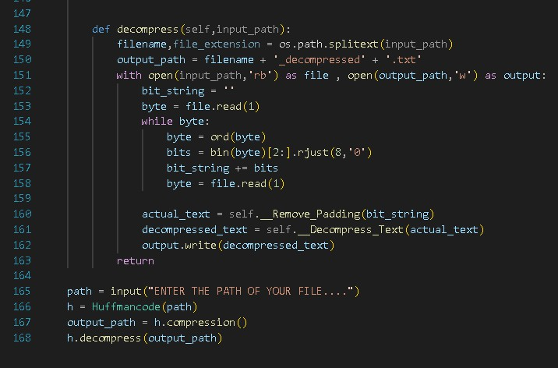

Figure 1.2 Code Screenshots

Letter Z K M C U D L E

Frequency 2 7 24 32 37 42 42 120

Table 1.1 Huffman Frequency

Letter Frequency Code Bits

E 120 0 1

L 42 101 3

D 42 110 3

U 37 100 3

C 32 1110 4

M 24 11111 5

K 7 111101 6

Z 2 111100 6

Table 1.2 Character to Binary Code Conversion

CHAPTER 5 – TECHNICAL IMPLEMENTATION & ANALYSIS

5.1 OUTLINE

Programming Language: Python

Libraries: Utilize libraries for file I/O, compression/decompression algorithms, and UI
development.

Code Structure: Organize code into modules for better readability and maintainability.

5.2 Technical Coding and Code Solutions

File I/O: Implement functions for reading/writing files. Compression/Decompression: Implement the chosen algorithm(s). User Interface: Create the UI elements using the chosen libraries. Error Handling: Implement error handling mechanisms.
5.3 Working Layout of Forms

Main Window: Design the layout of the main window with file selection options, compression/decompression buttons, progress bars, and settings.

File Selection Dialog: Design the layout for selecting files/directories.

Settings Dialog: Design the layout for configuring compression level, output directory, etc.

5.4 Prototype Submission

Create a working prototype of the software.

5.5 Test and Validation

Unit Tests: Test individual modules for correctness.
Integration Tests: Test how modules interact with each other.

System Tests: Test the entire software for functionality and performance.

5.6 Performance Analysis (Graphs/Charts) Compression Ratio: Measure the reduction in file size. Compression/Decompression Speed: Measure the time taken for the processes.
Memory Usage: Measure the memory consumption during compression/decompression.

CHAPTER 6 – PROJECT OUTCOME AND APPLICABILITY

6.1 Outline

Key Implementations: Highlight the core features and functionality. Significant Outcomes: Discuss the benefits of the software.
Real-world Applications: Identify potential use cases.

6.2 Key Implementations Outlines of the System

File Compression/Decompression: Explain the implemented algorithms and their benefits. User Interface: Describe the user-friendly interface.
Error Handling: Discuss the error handling mechanisms.

6.3 Significant Project Outcomes

Efficient Compression: Highlight the achieved compression ratios. Fast Processing: Discuss the speed of compression/decompression. User-friendly Interface: Emphasize the ease of use.
6.4 Project Applicability on Real-world Applications Archiving Files: Compress large files for storage. Sharing Files: Reduce file size for easier sharing.
Backing Up Data: Compress backups for efficient storage.

33 | P a g e

