**Vapor - Liquid Equilibria from ideal vapor and non - ideal liquid phase**

**OBJECTIVE**

1. Construct a T-x-y diagram for a binary system of THF and water at a total pressure of 1 atm using Wilson model for a given T vs x data of water (water_data.txt file has been given) Consider the liquid to be non-ideal and vapor to behave ideally.
2. Construct the x vs y graph for THF (your simulated data) with the literature value x vs y (given in THF_literature.txt file) on the same plot at a total pressure of 1 atm.
3. Construct a P-x-y and x-y diagram for THF at a temperature of 50 °C.

**METHODOLOGY**

1. **To construct T-x-y diagram for the binary system using Wilson model:**

The temperature - mole fraction (xj) of water data is extracted from the text file using readmatrix( ) function in MATLAB.

The activity coefficients $γ_{i}$ and $γ_{j}$ of THF and water respectively are found out using the Wilson equation. The Wilson equation is given by,

$$lnγ_{i}= −ln(x_{i}+Λ_{ij}x_{j})+x_{j}\left[\frac{Λ_{ij}}{x_{i}+Λ_{ij}x_{j}}−\frac{Λ_{ji}}{x_{j}+Λ_{ji}x_{i}}\right]$$

$$lnγ_{j}= −ln(x_{j}+Λ_{ji}x_{i})−x_{i}\left[\frac{Λ_{ij}}{x_{i}+Λ_{ij}x_{j}}−\frac{Λ_{ji}}{x_{j}+Λ_{ji}x_{i}}\right]$$

where Wilson parameters $Λ_{ij}$ and $Λ_{ji}$ at corresponding temperatures can be found using,

$Λ_{ij}$ = $\frac{V_{j}}{V_{i}}exp\left[−\frac{(λ_{ij}−λ_{ii})}{RT}\right]$

$Λ_{ji}$ = $\frac{V_{i}}{V_{j}}exp\left[−\frac{(λ_{ji}−λ_{jj})}{RT}\right]$

where Vi and Vj is the molar volume, $λ_{ij}−λ_{ii}$ and $λ_{ji}−λ_{jj}$ are binary interaction parameters available from literature for a binary pair, R is universal gas constant and T is temperature in Kelvin.

Considering “i” to be THF and “j” to be water,

|  |  |
| --- | --- |
| **Wilson Parameters** | **Values from literature** |
| $$λ_{ij}−λ_{ii}$$ | 1475.26 (cal/mol) |
| $$λ_{ji}−λ_{jj}$$ | 1844.79 (cal/mol) |
| Vi | 81.55 (cm3/mol) |
| Vj | 18.07 (cm3/mol) |

The vapor pressure of a pure component is found out using the Antoine’s Equation, which is given by,

$$\log_{10}P_{i}^{VP} = (A − \frac{B}{C + T})$$

where A, B and C are Antoine parameters, T is the temperature in °C and PiVP is the vapor pressure of pure component in mm of Hg.

|  |  |  |  |
| --- | --- | --- | --- |
| **Component** | **A** | **B** | **C** |
| THF | 7.1057 | 1256.68 | 232.621 |
| Water | 8.07131 | 1730.63 | 233.426 |

Also, 1 mm of Hg = $\frac{{10}^{5}}{760}$ Pa.

Taking into account the ideal vapor and non - ideal liquid conditions, the total pressure of the binary mixture at a given xi  or xj can be determined using the relation,

$$P = x_{i}{ γ}_{i}{ P}_{i}^{VP} + x_{j}{ γ}_{j}{ P}_{j}^{VP}$$

The mole fraction of any component i in the vapor phase can be obtained using the relation,

$$y_{i} = \frac{x_{i}{ γ}_{i}{ P}_{i}^{VP}}{P}$$

Boiling Point of THF and water are 65 °C and 100 °C respectively. This is the range of temperature for which T in T-x-y curve will vary whereas x, y will vary from 0 to 1.

1. **To compare the x vs y graph for THF with the literature value x vs y graph at a total pressure of 1 atm:**

The literature x vs y data for THF is extracted from the given text file using readmatrix( ) in MATLAB. The x vs y (simulated) graph for THF is then made using plot( ) in MATLAB, with xi (mole fraction of THF in liquid phase) as the x - input and yi (mole fraction of THF in vapor phase) as the y - input. Then, using hold on, the literature value x vs y graph for THF is made using plot( ) on the same plot, with xliterature (literature value mole fraction of THF in liquid phase) as the x - input and yliterature (literature value mole fraction of THF in vapor phase) as the y - input.

1. **To construct P-x-y and x-y diagram for THF at a temperature of 50 °C:**

The pure component vapor pressures of THF and water at a temperature of 50 °C is calculated using the Antoine’s Equation which is given by,

$$\log_{10}P_{i}^{VP} = (A − \frac{B}{C + T})$$

where A, B and C are Antoine parameters, T is the temperature in °C and PiVP is the vapor pressure of pure component in mm of Hg.

The value of mole fraction of THF (xi) in liquid phase is taken ranging (0, 1), taking number of datapoints to be 101.

For corresponding value of xi, xj can be given by,

$$x_{j} = 1 − x_{i}$$

The Wilson parameters $Λ_{ij}$ and $Λ_{ji}$ at a temperature of 50 °C are then obatined using the given relation.

The activity coefficients $γ_{i}$ and $γ_{j}$ of THF and water respectively at corresponding mole fractions in liquid phase are found out using the Wilson equation.

The total pressure (P) of the binary mixture at 50 °C is determined using the relation, given by,

$$P = x_{i}{ γ}_{i}{ P}_{i}^{VP} + x_{j}{ γ}_{j}{ P}_{j}^{VP}$$

where xi and xj are mole fractions of THF and water in liquid phase respectively, PiVP and PjVP are pure component vapor pressures of THF and water at 50 °C respectively.

The mole fraction of each component in the vapor phase at corresponding total pressure P is calculated using the relation,

$$y_{i} = \frac{x_{i}{ γ}_{i}{ P}_{i}^{VP}(50 °C)}{P}$$

$$y_{j} = 1 − y_{i}$$

The P-x-y diagram and x-y diagram for THF at the temperature of 50 °C are made using plot( ) in MATLAB.

**RESULTS AND DISCUSSIONS**

1. **T-x-y diagram for THF and water using Wilson model:**

**T-x-y diagram for THF:**

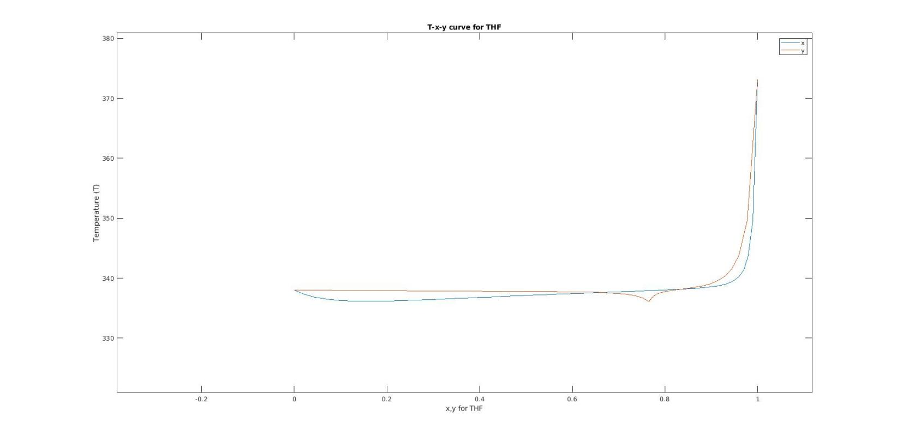

**T-x-y diagram for water:**

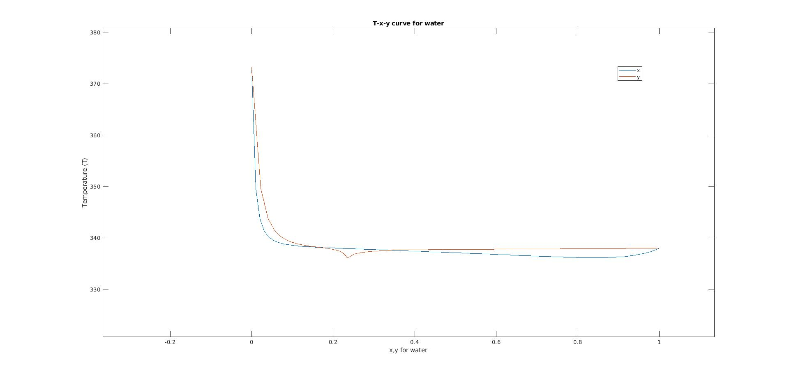

1. **Comparison of x vs y graph for THF (simulated data) with the literature value x vs y graph at a total pressure of 1 atm:**

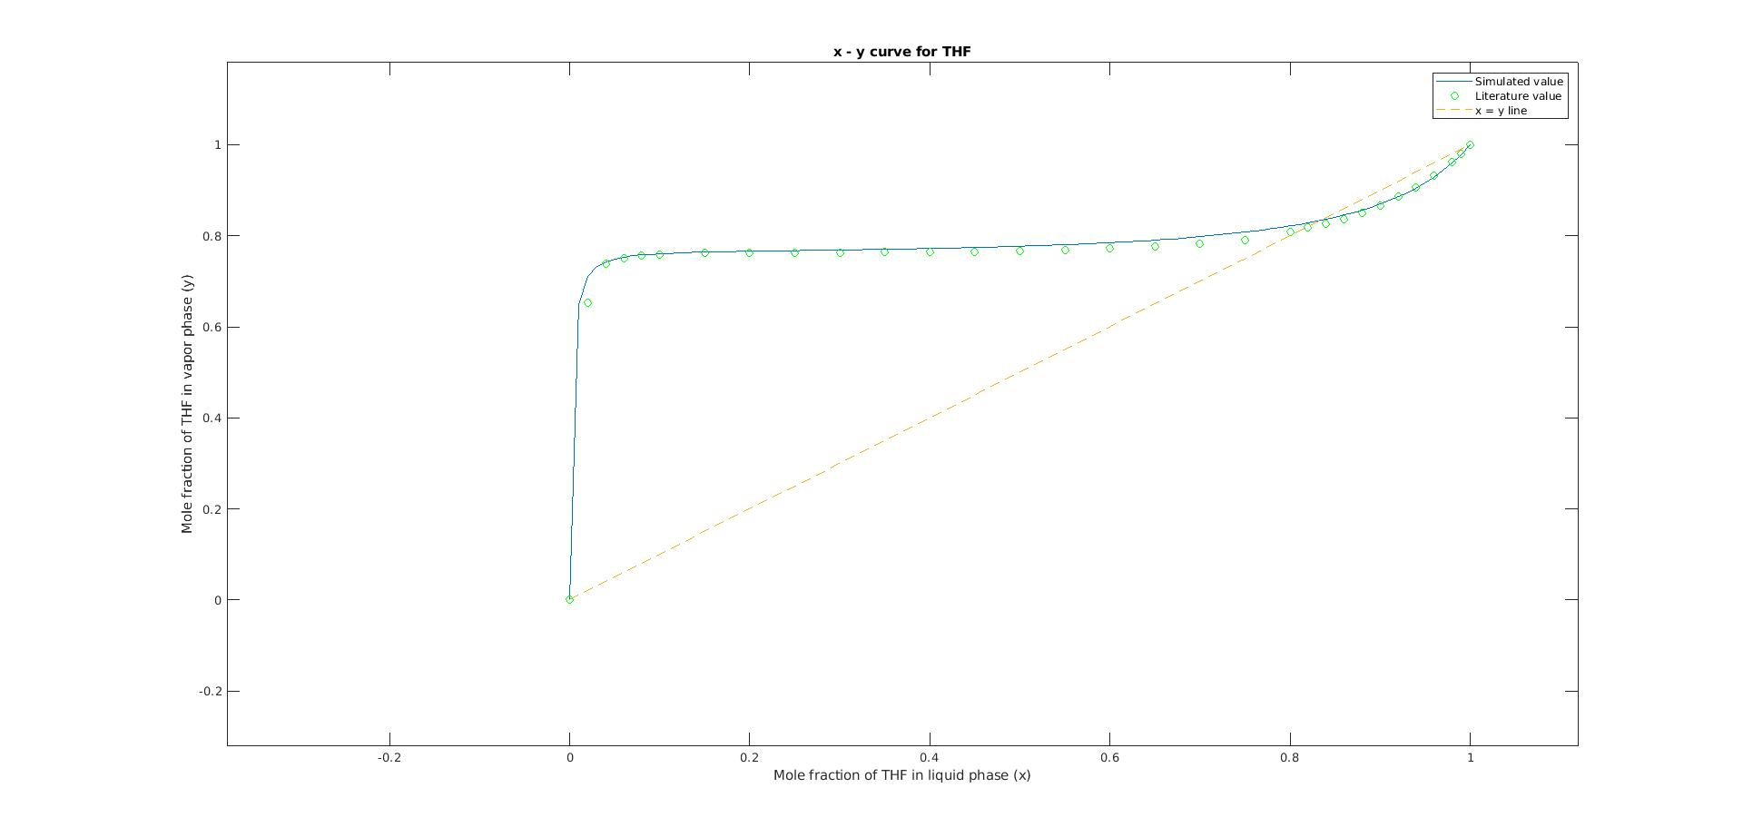

1. **P-x-y diagram and x-y diagram for THF at a temperature of 50 °C:**

**P-x-y diagram for THF:**

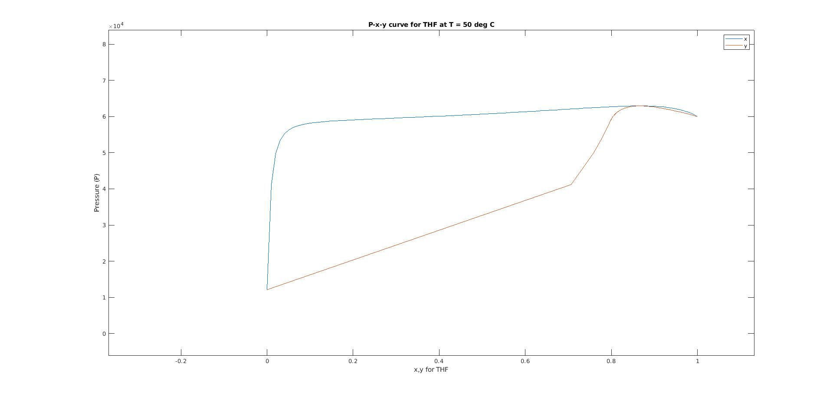

**x-y diagram for THF:**

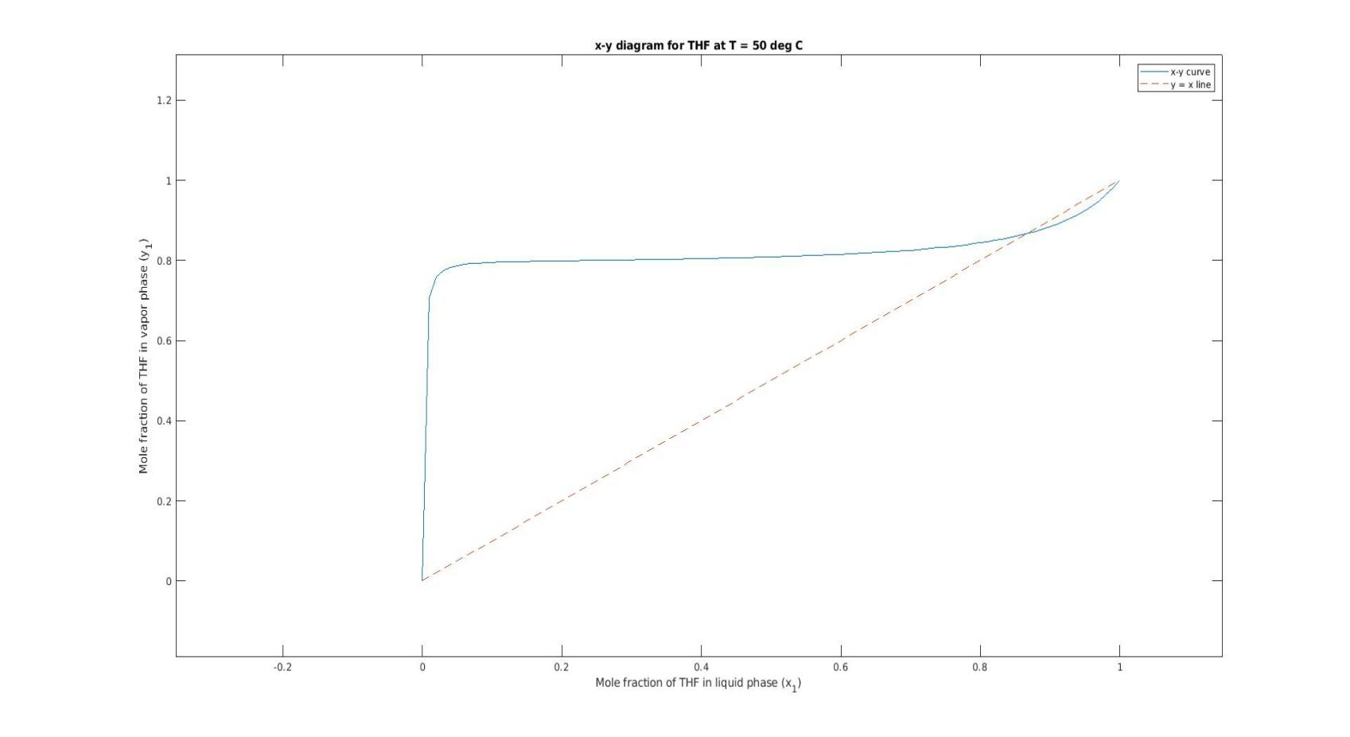

**CONCLUSION**

For both THF and water, the **T-x-y diagrams** illustrate the behavior of the binary system at different temperatures. As temperature increases, the mole fraction of THF in the vapor phase also increases, indicating higher volatility, while on the other hand, as temperature increases, the mole fraction of water in the vapor phase decreases, indicating it is less volatitle. Overall, the observation highlights the significance of temperature in governing the vapor-liquid equilibrium behaviour of binary mixtures. Understanding these trends is crucial for various industrial applications, particularly in separation processes like distillation, where precise control over temperature and composition is essential for achieving desired product purities.

When comparing the simulated **x vs y graph** for THF with the literature values, a reasonable agreement is observed, suggesting that the simulation captures the expected behavior of the system. Deviations between simulated and literature values could be due to variations in experimental conditions or assumptions made in the simulation (ideal vapor and non - ideal liquid phase).

The generated **P-x-y diagram** provides a detailed portrayal of the phase equilibrium behavior of THF at 50°C. It is observed that pressure (P) increases drastically with increase in xTHF to a certain value of x and then the increase is linear. In case of P vs y, increase in pressure is linear with increase in y to a certain value of yTHF, and then it increases drastically until some yTHF and then it traces the P vs x graph.

The **x-y diagram for THF** **at a temperature of 50 °C** is almost similar to that at a total pressure of 1 atm with varying temperature. The diagram shows that there is rapid increase in yTHF initially with slight increase in xTHF, indicating THF vaporises more initially. After a small considerable increase in xTHF, the increase in yTHF with the increase in xTHF is gradual and close to linear.

**APPENDIX**

clc;

clear all;

%%

water_data = readmatrix('water_data.txt');

T = water_data(:,1); % in K

x_j = water_data(:,2); % mole fraction of water

x_i = 1 - x_j; % mole fraction of THF

lambda_ij_ii = 1475.26*4.2; % J/mol

lambda_ji_jj = 1844.79*4.2; % J/mol

V_i = 81.55*10^(-6); % m^3/mol

V_j = 18.07*10^(-6); % m^3/mol

R = 8.314; % J/mol.K

x_set = linspace(0,1,100);

for i = 1:size(T,1)

WilsonParameter_ij(i,1) = (V_j/V_i)*exp(-lambda_ij_ii/(R*T(i)));

WilsonParameter_ji(i,1) = (V_i/V_j)*exp(-lambda_ji_jj/(R*T(i)));

end

for i = 1:size(T,1)

gamma_i(i,1) = exp(-log(x_i(i) + WilsonParameter_ij(i)*x_j(i)) + x_j(i)*(WilsonParameter_ij(i)/(x_i(i)+WilsonParameter_ij(i)*x_j(i)) - WilsonParameter_ji(i)/(x_j(i)+WilsonParameter_ji(i)*x_i(i))));

gamma_j(i,1) = exp(-log(x_j(i) + WilsonParameter_ji(i)*x_i(i)) - x_i(i)*(WilsonParameter_ij(i)/(x_i(i)+WilsonParameter_ij(i)*x_j(i)) - WilsonParameter_ji(i)/(x_j(i)+WilsonParameter_ji(i)*x_i(i))));

end

% Antoine Equation

A_i = 7.1057;

B_i = 1256.68;

C_i = 232.621;

A_j = 8.07131;

B_j = 1730.63;

C_j = 233.426;

T_new = T - 273; % in deg C

for i = 1:size(T,1)

Pvp_i(i,1) = (10^(A_i - B_i/(C_i + T_new(i))))*10^5/760; % in Pa

Pvp_j(i,1) = (10^(A_j - B_j/(C_j + T_new(i))))*10^5/760; % in Pa

end

for i = 1:size(T,1)

P(i,1) = x_i(i)*gamma_i(i)*Pvp_i(i) + x_j(i)*gamma_j(i)*Pvp_j(i);

end

for i = 1:size(T,1)

y_i(i,1) = (gamma_i(i)*x_i(i)*Pvp_i(i))/P(i);

y_j(i,1) = (gamma_j(i)*x_j(i)*Pvp_j(i))/P(i);

end

set_x = [0,0];

set_y = [1,1];

figure(1);

plot(x_i, T);

hold on;

plot(y_i, T);

xlabel('x,y for THF');

ylabel('Temperature (T)');

title('T-x-y curve for THF');

legend('x', 'y');

hold off;

figure(2);

plot(x_j, T);

hold on;

plot(y_j, T);

xlabel('x,y for water');

ylabel('Temperature (T)');

title('T-x-y curve for water');

legend('x', 'y');

hold off;

%% Part 2.

THF_literature_data = readmatrix('THF_literature.txt');

x_THF_lit = THF_literature_data(:,1);

y_THF_lit = THF_literature_data(:,2);

figure(3);

plot(x_i, y_i, '-');

hold on;

plot(x_THF_lit, y_THF_lit, 'og');

plot(x_set, x_set, '--');

xlabel('Mole fraction of THF in liquid phase (x)');

ylabel('Mole fraction of THF in vapor phase (y)');

title('x - y curve for THF');

legend('Simulated value', 'Literature value', 'x = y line');

hold off;

%% Part 3.

T_3 = 50; % in deg C

Pvp_i_50 = (10^(A_i - B_i/(C_i + T_3)))*10^5/760; % in Pa

PVp_j_50 = (10^(A_j - B_j/(C_j + T_3)))*10^5/760; % in Pa

x_i_3 = linspace(0,1,101)';

x_j_3 = 1 - x_i_3;

WilsonParameter_ij_3 = (V_j/V_i)*exp(-lambda_ij_ii/(R*(T_3+273)));

WilsonParameter_ji_3 = (V_i/V_j)*exp(-lambda_ji_jj/(R*(T_3+273)));

for i = 1:size(x_i_3,1)

gamma_i_3(i,1) = exp(-log(x_i_3(i) + WilsonParameter_ij_3*x_j_3(i)) + x_j_3(i)*(WilsonParameter_ij_3/(x_i_3(i)+WilsonParameter_ij_3*x_j_3(i)) - WilsonParameter_ji_3/(x_j_3(i)+WilsonParameter_ji_3*x_i_3(i))));

gamma_j_3(i,1) = exp(-log(x_j_3(i) + WilsonParameter_ji_3*x_i_3(i)) - x_i_3(i)*(WilsonParameter_ij_3/(x_i_3(i)+WilsonParameter_ij_3*x_j_3(i)) - WilsonParameter_ji_3/(x_j_3(i)+WilsonParameter_ji_3*x_i_3(i))));

end

for i = 1:size(gamma_i,1)

P_3(i,1) = x_i_3(i)*gamma_i_3(i)*Pvp_i_50 + x_j_3(i)*gamma_j_3(i)*PVp_j_50;

end

for i = 1:size(x_i_3,1)

y_i_3(i,1) = gamma_i_3(i)*x_i_3(i)*Pvp_i_50/P_3(i);

y_j_3(i,1) = 1 - y_i_3(i,1);

end

figure(4);

plot(x_i_3, P_3);

hold on;

plot(y_i_3, P_3);

xlabel('x,y for THF');

ylabel('Pressure (P)');

title('P-x-y curve for THF at T = 50 deg C');

legend('x', 'y');

hold off;

figure(5);

plot(x_i_3, y_i_3);

hold on;

plot(x_set, x_set, '--');

xlabel('Mole fraction of THF in liquid phase (x_1)');

ylabel('Mole fraction of THF in vapor phase (y_1)');

title('x-y diagram for THF at T = 50 deg C');

legend('x-y curve', 'y = x line');

hold off;