**1. Literature Review**

The proliferation of e-commerce has transformed the consumer landscape, enabling users to make informed decisions through online reviews. However, the authenticity of these reviews is increasingly compromised by the prevalence of fake reviews. This literature review aims to explore existing research on the identification of fake reviews on e-commerce platforms, focusing on the application of linguistic and sentiment analysis to enhance customer experience, covering the techniques and methods used for natural language processing and machine learning. This review gives us the necessary insight into the variables for this research and the current knowledge regarding the usage of linguistic and sentiment analysis features in fake review detection.

The detection of fake reviews has grown in importance as a research topic, inspiring the creation of numerous techniques and methods. These methods include machine learning based Linguistic Feature analysis approaches, which utilize different features. Additionally, sentiment analysis, which involves analyzing the textual information within reviews to determine the writer's sentiment, has proven effective in detecting fake reviews (Abri et al., 2020). One approach, in particular, can potentially improve current classification techniques, lexicons (Patel et al., 2018). This technique allows researchers to calculate sentiment without the use of any pre-classified dataset and analyze review-based features (Berger et al., 2019).

**1.1. Detection and Usage of Linguistic Pattern Features**

Linguistic pattern features in a text refer to the observable elements and patterns that contribute to its structure, meaning, and communication (Crossley, S., 2020). Therefore, text-related features are essential in fake review classifications (Birim et al., 2022). Furthermore, a review writer must write the reviews convincingly and consistently in order to capture readers' attention and affect a consumer's purchasing decisions. As a result, it is expected that manipulators' writing styles will differ from those of true consumers (Hu et al., 2010).

Recent developments in natural language processing (NLP) have made it possible to more accurately compute linguistic features in big datasets of reviews, which has allowed researchers to gain insight into a variety of cognitive processes, such as how people judge the quality of texts and the styles of writing (Crossley, 2020). Abri et al. (2020) applied NLP to extract different linguistic features as input for machine learning fake review detection algorithm. Their research analyzed linguistic features in the category's quantity, complexity, non-immediacy, expressiveness, diversity, informality, and specificity. In addition, they identified the number of adjectives, redundancy, lexical diversity, and pausality as the most important features to classify whether a review was fake or trustworthy.

Vanta and Aono (2019) used 24 linguistic and sentiment analysis features, including the rating. They combined the extracted features with a Bag-of-Words approach, where they vectorized all the words to calculate the importance of each word based on the number of times it occurs in the dataset. They concluded that word count, the extremity of rating, and the ratio of numerals were the most important variables in detecting fake reviews combined with using Bag-of-Words.

Dewang and Singh (2015) used Lexical features to study fake reviews. These features represent characters and different words used by the writer of a review. Using 17 different features resulted in promising results to classify reviews as fake or real. Finally, Alsubari et al. (2020) researched the identification methods of fake reviews based on linguistic features. They used features like POS count, polarity score, and authenticity score to train their model, and with success.

Several studies focused on only specific linguistic features, like Ghose and Ipeirotis (2011). They used readability as a predictor for fake review detection. Many metrics have been effective for measuring a text's readability. Based on research on readability, the Flesch Reading Ease is a helpful metric for assessing how simple it is for an individual to read a review (Ghose & Ipeirotis, 2011). A formula produces a score for readability. It was created based on a mathematical model that evaluated how easy it was for subjects to read various text samples. Also, Hu et al., 2011, found that readability is a significant predictor for manipulations of online reviews.

Concluding, Natural Language Processing opened the doors to research linguistic features by extracting them from the text. Previous research has exposed several linguistic features promising to detect fake reviews, but there is always room for improvement.

**1.2. Detection and Usage of Sentiment Analysis Feature**

The sentiment of word-of-mouth (WOM) is critical for consumers to share their experiences and evaluate products, as WOM communication can be positive or negative. Positive WOM (PWOM) is believed to stem from satisfactory experiences. In contrast, negative WOM (NWOM) is often driven by motives and needs associated with a negativity bias, as negative information is easier for consumers to perceive (Vázquez-Casielles et al., 2013). These emotions are presented as sentiment analysis features in text analysis (Bandhakavi et al., 2016).

Business owners and (potential) consumers post fake reviews for different purposes. Business owners often create fake consumer identities to post positive reviews to promote their products/services or negative reviews to demote competitors' products/services (Luca & Zervas., 2016). Meanwhile, individual (potential) consumers post positive and negative fake reviews for economic or personal reasons. Deviant consumers may create fake identities and post negative fake reviews when they are unsatisfied with a company's products/services or positive fake reviews to support the business of their friends or family or receive gifts (Hunt, 2015). Regardless of the source, fake reviews can reduce the credibility and value of online reviews (Hunt, 2015). According to the theory of negativity effects, negative information is more straightforward for consumers to perceive than positive information; therefore, negative information can substantially influence purchase decisions. For this reason, stakeholders need to know the sentiment of reviews (Gavilan et al., 2018).

Knowing the sentiment in a review gives us insight into a writer's intention. However, it has also been identified as a reliable predictor of whether a review is fake or not (Wang et al., 2020). General emotional features that can be extracted from a text are contextual features, sentiment features, polarity shifters, modifiers, and negations. These features help dissect the text in numerical information that is perfect for feeding a machine learning algorithm and has had promising results in detecting fake reviews (Bandhakavi et al., 2023). Besides, there are previous papers investigating the relationship between fake reviews and sentiment analysis features; the way these features are harvested and combined with other features needs to be more enlightened.

**1.3. Relationship of Linguistic Pattern and Sentiment Analysis Features**

Jung et al. (2020) established a significant impact of quantitative and non-quantitative characteristics of customer reviews on a consumer's decision-making process. Because of evidence of significant impact, they confirmed that product-related quantitative and textual information affects e-commerce and emphasized the significance of taking consumer text reviews seriously. (Choi et al., 2022). Various features, like linguistic features, readability, and redundancy, have been proposed for detecting reviews spam. Azimi et al. (2022) also concluded that redundancy and readability are important features in detecting fake reviews. In addition, researchers have recently included sentiment analysis features to strengthen the detection methods' accuracy (Alsubari et al., 2020).

Ghose et al. (2011) used text analysis to identify the crucial aspects of the review. To find linguistic features with strong predictive power in determining a review's usefulness and economic impact, they conducted an analysis at the lexical, grammatical, semantic, and stylistic levels. Subsequently, Hu et al. (2012) were the first researchers to believe that using certain linguistic features in combination with sentiment would be an important step in figuring out the effects of fake reviews.

Besides, Jindal and Liu (2008) noted that fake reviews are repetitive most of the time because their authors had neither bought nor used the products they were reviewing. Therefore, to explain some of the product's features or point out some of its disadvantages, they needed help. So, in order to determine whether a review is fake, it is crucial to compare how the reviews are written (Wang et al., 2022). This assessment will be easier to conclude by applying a feature set of linguistic and sentiment analysis features.

**1.4. Development of Machine Learning Algorithms**

Detecting fake reviews is now a critical field of research for academics and practitioners, as it is imperative to strengthen the reliability and validity of website posts (Alsubari et al., 2021). In this context, developing effective algorithms using machine learning techniques has gained prominence to enable the automated detection of fake reviews. Algorithm detection involves building a machine-learning classification model and using similarities to detect fake online reviews (Shukla et al., 2019). To detect fake reviews, machine learning approaches, such as supervised and unsupervised, have been extensively used (Crawford et al., 2015). In addition, various machine learning classifiers, such as Support Vector Machines (SVM) or Support Vector Classifier (SVC), Decision trees, Naive-Bayes (NB), Random Forest, Logistic regression, and Multiple Layer Perceptron (MLP), have been used (Abri et al., 2020).

The machine learning algorithms each offer different approaches. Decision Tree (DTC) constructs a tree-like model using feature thresholds, providing an easily interpretable solution. Random Forest (RF) combines multiple decision trees to improve accuracy and prevent overfitting. Support Vector Machine (SVM) and Support Vector Classifier (SVC) have been proven helpful in binary classification, seeking to separate different classes. Naive Bayes (NB) is a probabilistic classifier assuming feature independence. Logistic Regression (LR) is a way to determine the likelihood of a feature belonging to a particular group using a math formula called a logistic function (Elmogy et al., 2021). Finally, the Multiple Layer Perceptron (MLP) is a multi-layer neural network that excels at capturing complex relationships, using multiple layers to find important features and identify patterns in data (Abri et al., 2020). In Table 1, the result of numerous fake review detection papers are listed:

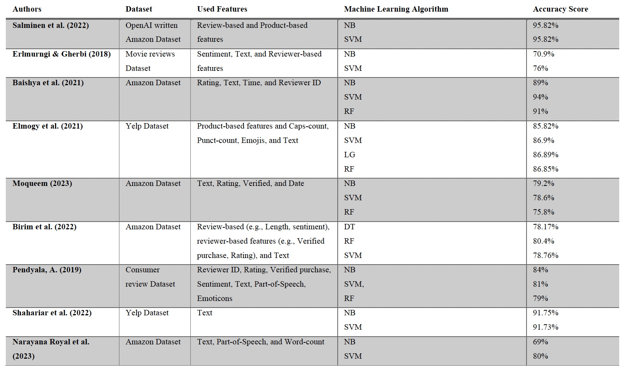

**Table 1: Prior Research on Fake Review Detection Machine Learning Algortithms**

Table 1 shows that the Support Vector Machine (SVM) and Naïve Bayes (NB) are among the most common methods. They show excellent performance and are useful in detecting fake reviews. The accuracy of correct predictions variates from 69% to 96%. SVM 16 is great at drawing a clear line between genuine and fake reviews. SVMs work by finding the best possible separation between the two classes, making them highly effective for detecting fake and real reviews. On the other hand, NB is an effective algorithm, especially for tasks involving text, like detecting fake reviews. It assumes that the features are independent (Hossain, F. 2019).

Narayana Royal et al. (2023) used NB and SVM to detect fake reviews on an Amazon dataset. They chose these machine learning algorithms due to their success in previous studies in identifying fake reviews due to their classification technique. Their research achieved an accuracy of 80.1% with SVM and 68.7% using NB.

In summary, various techniques have been employed to detect fake reviews, each with its strengths and limitations. In most cases, SVM was the most successful machine learning algorithm, next to NB. For this reason, our research will implement these methods to detect fake reviews. The following two sections will clarify the method to extract the features to feed the algorithms.

**1.5. Main Limitations of Existing Work:**

Despite significant progress, existing research faces several limitations, below are the main areas where the more development work required in future

* Temporal Dynamics: A notable research gap exists in understanding the temporal evolution of linguistic and sentiment patterns in fake reviews. Addressing this gap would enhance the adaptability of detection models to emerging deceptive strategies.
* Cross-Category Generalization: There is a need for research that investigates the generalizability of linguistic and sentiment analysis models across diverse product categories. This would contribute to the development of more robust and versatile detection techniques.
* User Perception: Limited research explores how users perceive and respond to the presence of fake reviews. Understanding user behavior and the factors influencing trust can provide insights into the broader implications of fake reviews on customer experience.

**Reference:**

Abri, F., Gutiérrez, L. F., Namin, A. S., Jones, K. S., & Sears, D. R. (2020, December). Linguistic features for detecting fake reviews. In *2020 19th IEEE International Conference on Machine Learning and Applications (ICMLA)* (pp. 352-359). IEEE.

Patel, D., Kapoor, A., & Sonawane, S. (2018). Fake review detection using opinion mining. *International Research Journal of Engineering and Technology (IRJET)*, *5*.

Berger, J., Humphreys, A., Ludwig, S., Moe, W. W., Netzer, O., & Schweidel, D. A. (2020). Uniting the tribes: Using text for marketing insight. *Journal of marketing*, *84*(1), 1-25.

Crossley, S. A. (2020). Linguistic features in writing quality and development: An overview. *Journal of Writing Research*, *11*(3), 415-443.

Hu, N., Bose, I., Koh, N. S., & Liu, L. (2012). Manipulation of online reviews: An analysis of ratings, readability, and sentiments. *Decision support systems*, *52*(3), 674-684.

Vanta and Aono, T. V. M. (2019). Fake review detection focusing on emotional expressions and extreme rating. *The association for natural language processing*.

Alsubari, S. N., Shelke, M. B., & Deshmukh, S. N. (2020). Fake reviews identification based on deep computational linguistic. *International Journal of Advanced Science and Technology*, *29*(8s), 3846-3856.

Ghose, A., & Ipeirotis, P. G. (2010). Estimating the helpfulness and economic impact of product reviews: Mining text and reviewer characteristics. *IEEE transactions on knowledge and data engineering*, *23*(10), 1498-1512

Bandhakavi, A., Wiratunga, N., Padmanabhan, D., & Massie, S. (2017). Lexicon based feature extraction for emotion text classification. *Pattern recognition letters*, *93*, 133-142

Luca, M., & Zervas, G. (2016). Fake it till you make it: Reputation, competition, and Yelp review fraud. *Management Science*, *62*(12), 3412-3427

Gavilan, D., Avello, M., & Martinez-Navarro, G. (2018). The influence of online ratings and reviews on hotel booking consideration. *Tourism Management*, *66*, 53-61

Wang, J., Kan, H., Meng, F., Mu, Q., Shi, G., & Xiao, X. (2020). Fake review detection based on multiple feature fusion and rolling collaborative training. *IEEE Access*, *8*, 182625-182639

Salminen, J., Kandpal, C., Kamel, A. M., Jung, S. G., & Jansen, B. J. (2022). Creating and detecting fake reviews of online products. *Journal of Retailing and Consumer Services*, *64*, 102771

Choi, W., Nam, K., Park, M., Yang, S., Hwang, S., & Oh, H. (2022). Fake review identification and utility evaluation model using machine learning. *Frontiers in artificial intelligence*, *5*

Azimi, S., Chan, K., & Krasnikov, A. (2022). How fakes make it through: the role of review features versus consumer characteristics. *Journal of Consumer Marketing*, (ahead-of-print)

Elmogy, A. M., Tariq, U., Ammar, M., & Ibrahim, A. (2021). Fake reviews detection using supervised machine learning. *International Journal of Advanced Computer Science and Applications*, *12*(1)

Hossain, M. F. (2019). Fake review detection using data mining.

Narayana Royal, M., Reddy, R. P. K., Sangathya, G. S., Sai Madesh Pretam, B., Kaliappan, J., & Suganthan, C. (2023). Detection of Fake Reviews on Products Using Machine Learning. In *Information and Communication Technology for Competitive Strategies (ICTCS 2022)* (pp. 601-611). Springer, Singapore.

Elmurngi & Gherbi (2018) Elmurngi EI, Gherbi A. Unfair reviews detection on amazon reviews using sentiment analysis with supervised learning techniques. *Journal of Computer Science.*2018;14(5):714–726. doi: 10.3844/jcssp.2018.714.726

Baishya, D., Deka, J. J., Dey, G., & Singh, P. K. (2021). SAFER: sentiment analysis-based fake review detection in e-commerce using deep learning. SN Computer Science, 2, 1-12

Moqueem, A., Moqueem, F., Reddy, C. V., Jayanth, D., & Brahma, B. (2023, January). Online Shopping Fake Reviews Detection Using Machine Learning. In Cognition

and Recognition: 8th International Conference, ICCR 2021, Mandya, India, December 30–

31, 2021, Revised Selected Papers (pp. 305-318). Cham: Springer Nature Switzerland.

Birim, Ş. Ö., Kazancoglu, I., Mangla, S. K., Kahraman, A., Kumar, S., & Kazancoglu, Y. (2022). Detecting fake reviews through topic modelling. Journal of Business Research, 149, 884-900. <https://doi.org/10.1016/j.jbusres.2022.05.081>

Pendyala, A. (2019). Fake consumer review detection (Doctoral dissertation,

California State University, Sacramento).

Shahariar, G. M., Biswas, S., Omar, F., Shah, F. M., & Hassan, S. B. (2019, October). Spam review detection using deep learning. In 2019 IEEE 10th Annual Information Technology, Electronics and Mobile Communication Conference (IEMCON) (pp. 0027-0033). IEEE.

Dewang, Rupesh Kumar and Anil Kumar Singh. “Identification of Fake Reviews Using New Set of Lexical and Syntactic Features.” *International Conference on Computing and Convergence Technology* (2015).

Vázquez-Casielles, R., Suárez-Álvarez, L. and del Río-Lanza, A.-B. (2013). The Word of Mouth Dynamic: How Positive (and Negative) WOM Drives Purchase Probability. *Journal of Advertising Research*, 53(1), pp.43–60. doi:https://doi.org/10.2501/jar-53-1-043-060

Hunt, K. (2015). Gaming the system: Fake online reviews v. consumer law. *Computer Law & Security Review*, 31(1), pp.3–25. doi:https://doi.org/10.1016/j.clsr.2014.11.003

Shukla, A., Wang, W., Gao, G. (Gordon) and Agarwal, R. (2019). Catch Me If You Can — Detecting Fraudulent Online Reviews of Doctors Using Deep Learning. *SSRN Electronic Journal*. doi:https://doi.org/10.2139/ssrn.3320258

Crawford, M., Khoshgoftaar, T.M., Prusa, J.D., Richter, A.N. and Al Najada, H. (2015). Survey of review spam detection using machine learning techniques. *Journal of Big Data*, 2(1). doi:https://doi.org/10.1186/s40537-015-0029-9