Database:  # →comment  →case insensitive  “/’→used for string mentioning  Create database database_name;  Use database_name;  CREATE TABLE table_name  (  Column1 datatype,  Column2 datatype,  Column3 datatype  ) ;  Catagories of datatypes:  - String  - Numeric  - Data & Time | 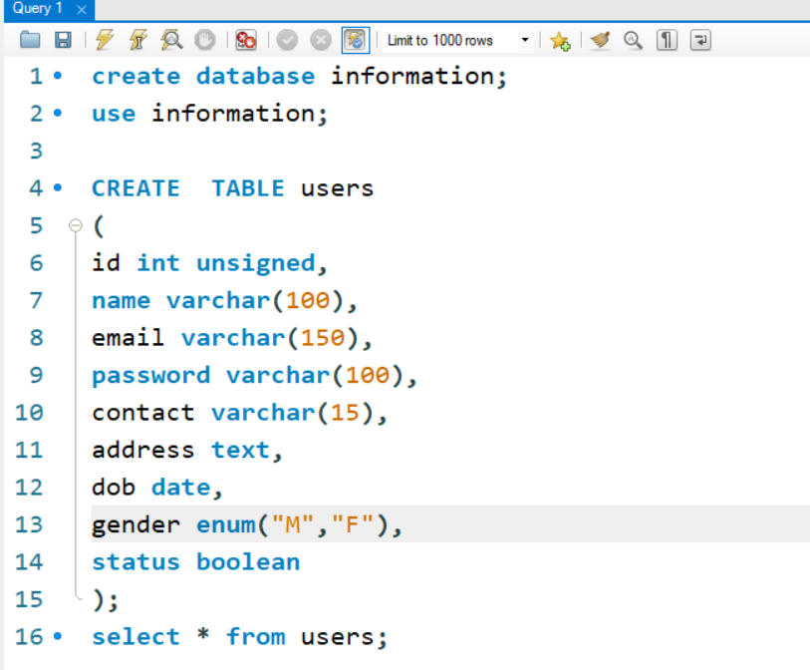

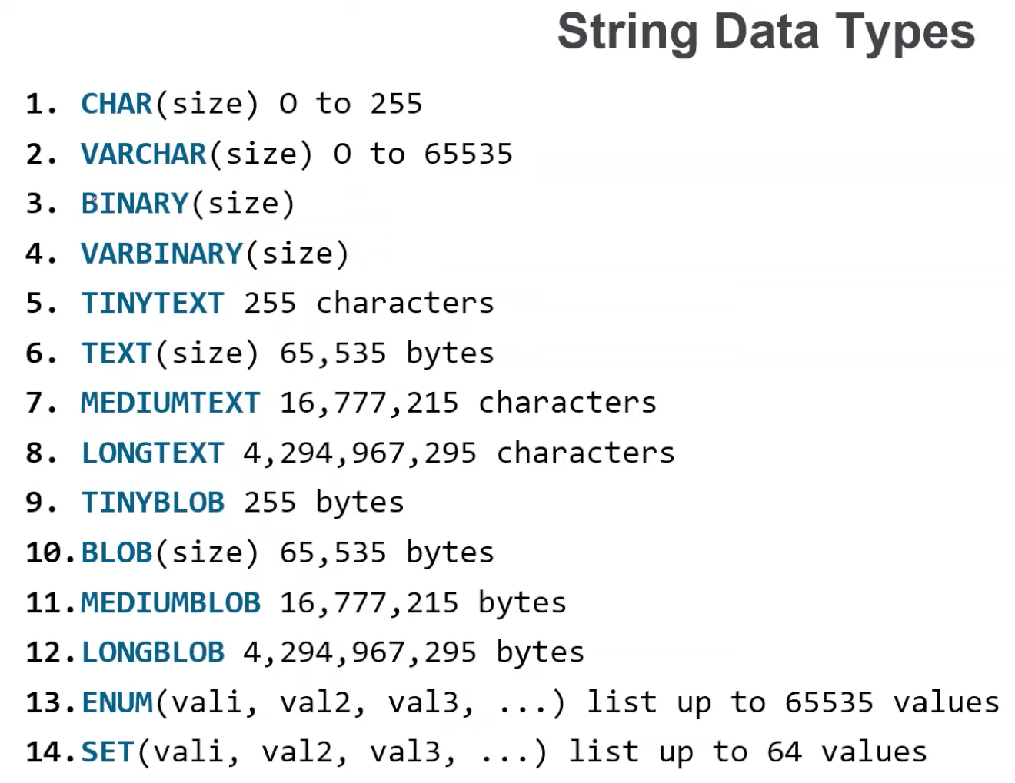 | 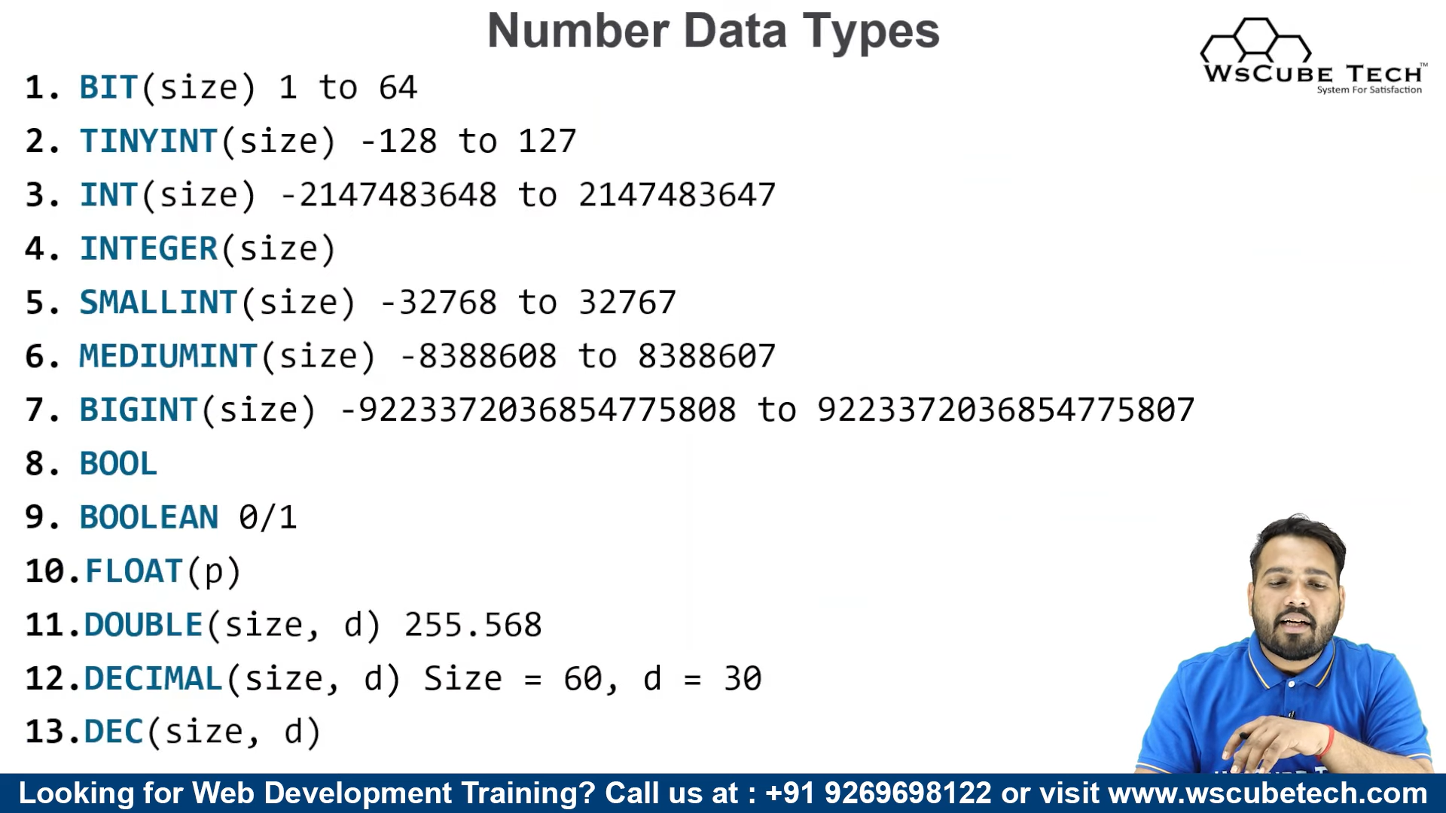
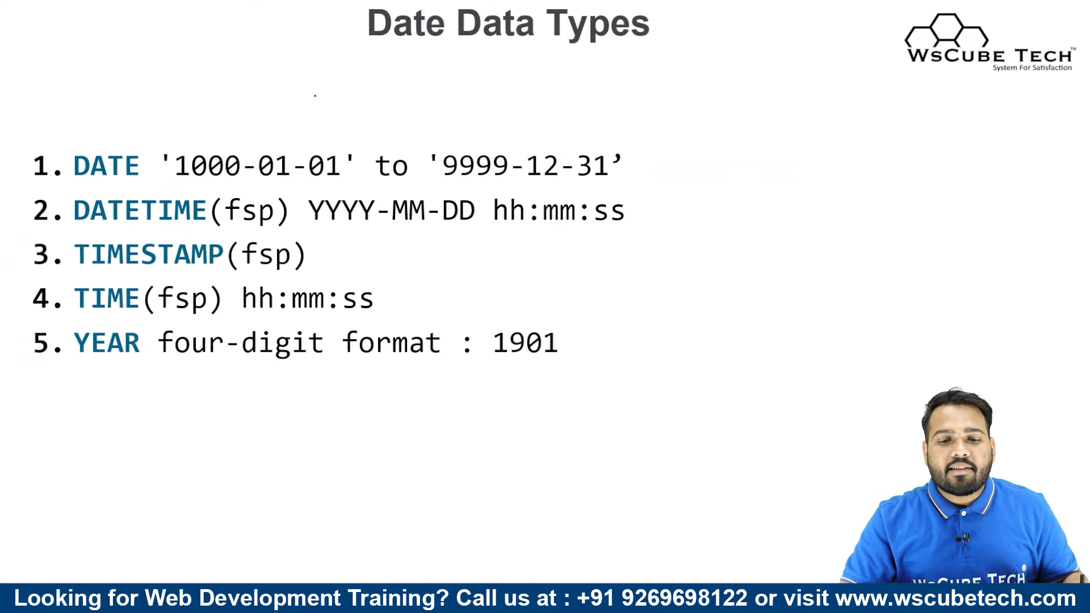

CREATE:

create table s_table(  id int,  name verchar(30),  age int  ); | create table students  (  id int not null unique,  name varchar(100) not null,  email varchar(100) not null unique,  age int check(age>=18),  status Boolean default 1  );
  id | name | age

INSERT: (For single value:)

insert into table_name values(1,”ABHIJITE”,23);
id | name | age
1 | ABHIJITE | 23

id | name | age
1 | ABHIJITE | 23
2 |  | 24
insert into table_name (id,age)
values(2,24);

select * from table_name(show all columns of the table)
select column_name , column_name table_name(show column1,column2)
→to change column name in output we may use as keyword after the column name and
set a name if more than one syllable use double quote()

INSERT: For multiple value:

insert into students values
(1,'abhijite1',25),
(2,'abhijite2',26),
(3, 'abhijite3',27);

id | name | age
1 | abhijite1 | 25
2 | abhijite2 | 26
3 | abhijite3 | 27

WHERE:
→is used to filter records.
→it is used to extraxt only those records that fulfill a specified condition.
SELECT column_name1,column_name2,…. FROM table_name WHERE condition;
SELECT * from s_table where age>=23;
Condition:
> | < | = | != | >= | <=

OPERATOR:
AND: if all are true then true otherwise false; Select * from students wehere condition1 and condition2 and …..;
OR: if one is true then true otherwise false; Select * from students wehere condition1 or condition2 or ….;
NOT: true→false….false→true. Select * from students wehere not condition1 or not condition2
Ex…..
select *from students where id >10 and stutus=1 or age>18

IN Operator:
Shorthand of multiple or condition.
SELECT * from table_name where column_name IN (val1,val2,val3…);
SELECT * from students where id =1 or id=2 or id=3;
SELECT * from students where id in (1,2,3);

ORDER BY:
Used to arrange a table ascending or descending order by column
select *from table_name order by column_name asc; (ascending )
select *from table_name order by column_name desc; (descending)
  1 | John | 25
  2 | Sarah | 32
  3 | Michael | 18
  4 | Emily | 29
  5 | David | 42
  6 | Jessica | 35
  7 | Kevin | 21
  8 | Amanda | 27
  9 | Jacob | 19
  10 | Olivia | 24
  8 | Amanda | 27
  5 | David | 42
  4 | Emily | 29
  9 | Jacob | 19
  6 | Jessica | 35
  1 | John | 25
  7 | Kevin | 21
  3 | Michael | 18
  10 | Olivia | 24
  2 | Sarah | 32
  2 | Sarah | 32
  10 | Olivia | 24
  3 | Michael | 18
  7 | Kevin | 21
  1 | John | 25
  6 | Jessica | 35
  9 | Jacob | 19
  4 | Emily | 29
  5 | David | 42
  8 | Amanda | 27

DIST:
select distinct column_name from table_name;
→will give a column that contains unique records of that column
12  13  14  12  12  13  16 | 12  13  14  16

MySQL Constraints:
1 NOT NULL → we can not leave it null.ex name varchar(100) not null.
2 UNIQUE →must be unique.ex email varchar(100) not null unique;
3 DEFAULT →we can set default value for the cell. ex status Boolean default 1;
4 CHECK →we can add condition for this column ex. age int check(age>=18);
5 PRIMARY KEY
6 FOREGIN KEY

NULL:
Syntax: SELECT * FROM table_name where column_name is null;
Ex….select * from table where age is null;
  18 | Amanda | 27
  19 | David | 19
  20 | Olivia | 24
  21 | abhijite
  22 | deb
  23 |  | 22
  21 | abhijite
  22 | deb

LIMIT:
select * from table_name limit n;
→ it gives first n records from database
→ it starts from index 0 to n-1;
select * from table limit 5;
  1 | John | 25
  2 | Sarah | 32
  3 | Michael | 18
  4 | Emily | 29
  5 | David | 42
  6 | Jessica | 35
  7 | Kevin | 21
  8 | Amanda | 27
  9 | Jacob | 19
  1 | John | 25
  2 | Sarah | 32
  3 | Michael | 18
  4 | Emily | 29
  5 | David | 42

OFFSET:
SELECT * FROM table_name limit n offset p;
→it gives n records from pth index.(0 based index).
→it will just give pth index to n index data which are available.
SELECT * FROM cheeck1 limit 5 offset 0;
SELECT * FROM cheeck1 limit 5 offset 1;
 | 0 to 4 | 1 to 5
  1 | John | 25
  2 | Sarah | 32
  3 | Michael | 18
  4 | Emily | 29
  5 | David | 42
  6 | Jessica | 35
  7 | Kevin | 21
  8 | Amanda | 27
  9 | Jacob | 19
  1 | John | 25
  2 | Sarah | 32
  3 | Michael | 18
  4 | Emily | 29
  5 | David | 42
  2 | Sarah | 32
  3 | Michael | 18
  4 | Emily | 29
  5 | David | 42
  6 | Jessica | 35
Function:
count()→returns the number of rows in database table;
sum()→returns the total sum of numeric column.
avg()→calculates the average value of a set of values.
min()→returns minimum value in a set.
max()→returns maximum value in a set.
select sum(column_name) from table_name;
→→returns sum of this column
select avg(column_name) from table_name;
→→returns average of this column(float)
UPDATE:
→ use to update a cell or column
update table_name set column_name="new_value" where condition;
update s_table set name="Abhijite deb Barman" where id=1;
→→id must be primary key.

DELETE:

→→for row:

delete from table_name where condition;
delete from s_table where id IN(3,5,6);
delete from s_table where id=2;

→→for column

alter table table_name drop column column_name;
alter table students drop column email;

