Predicting customer purchase behavior using machine learning (ML) algorithms for personalized marketing strategy development

Author: Abhijith Binu

Table of Contents
List of Tables 4
List of Figures 5
List of Abbreviations 7
ABSTRACT 8
CHAPTER 1: INTRODUCTION 9
1.1 Background 9
1.2 Rationale of this Research 9
1.3 Research Problem 12
1.4 Research Objectives 13
1.5 Significance of the Study 13
1.6 Scope of the Study 14
1.7 Thesis Structure 14
CHAPTER 2: LITERATURE REVIEW 16
2.1 Introduction 16
2.2 Strengthened Literature Review 18
2.3 Importance of consumer purchase behavior 18
2.3.1 Machine learning (ML) in marketing 19
2.4 Difficulties in using machine learning (ML) in predicting behaviour 25
2.5 Case study related to real world 27
CHAPTER 3: METHODOLOGY 30
3.1 Introduction 30
3.2 Research Design 31
3.3 Data Source 31
3.4 Data Preprocessing 32
3.5 Target Variable Construction 34
3.6 Feature Selection Techniques 35
3.7.1 Baseline Models 36
3.7.2 Ensemble Models 36
3.7.3 Advanced Ensemble Models 37
3.8 Model Evaluation 38
3.9 Explainable AI Methods 40
3.9.1 SHAP 41
3.9.2 LIME 41
3.10 Tools and Technologies 42
3.11 Ethical Considerations 43
3.12 Limitations 44
CHAPTER 4: RESULTS 46
4.1 Introduction 46
4.2 Exploratory Data Visualizations 46
4.2.1 Overview of Dataset Structure 48
4.2.3 Distribution of Categorical Features 52
4.2.4 Outlier Detection and Advanced Univariate Visualization 54
4.2.5 Correlation Analysis 58
4.3 Bivariate Analysis: Relationship Between Target Variable and Predictors 60
4.4 Class Distribution and Label Generation 62
4.5 Model Performance Summary 64
4.6 ROC Curve Analysis 66
4.7 Advanced Ensemble Results 67
4.8 SHAP Interpretability Results 68
4.9 LIME Explanation Snapshots 70
CHAPTER 5: DISCUSSION AND CONCLUSION 72
5.1 Discussion 72
5.2 Conclusion 75
6.3 Recommendations 76
REFERENCES 80

List of Tables
Table 1: Comparison of Traditional vs. ML-Based Marketing Strategies 14
Table 2: Summary of Related Works Using ML in Marketing 24
Table 3: Key Gaps Identified in Existing Literature 29
Table 4: Overview of Real-World Case Studies (Amazon, Netflix, Starbucks) 32
Table 5: Target Variable Definition Threshold 37
Table 6: Summary of ML Algorithms Used 42
Table 7: Comparison of SHAP and LIME Explainability Tools 43

List of Figures
Figure 1: Graphical Overview of Traditional vs. ML-Based Marketing Approaches 13
Figure 2: Mind Map of Core Themes in Literature on ML in Marketing 20
Figure 3: Conceptual Map of ML Applications in Marketing 23
Figure 4: End-to-End Machine Learning Workflow for Customer Purchase Behavior Prediction 33
Figure 5: Workflow of ML Model Development Using Supervised Learning and Data Partitioning 34
Figure 6: Flowchart of Data Preprocessing Steps 36
Figure 7: Comparison of SHAP and LIME Explainability Techniques 45
Figure 8: Ethical AI Pipeline for Customer Behavior PredictionEthical AI Pipeline for Customer Behavior Prediction 47
Figure 9: Pairwise Plots of Key Numeric Features 50
Figure 10: Sequence of Exploratory Data Analysis and Visualization Techniques 51
Figure 11: Distribution of Customer ID 52
Figure 12: Distribution of Age 53
Figure 13: Distribution of Purchase Amount (USD) 53
Figure 14: Distribution of Review Rating 54
Figure 15: Distribution of Previous Purchase 55
Figure 16: Class Distribution of Gender 56
Figure 17: Violin Plot of Age 57
Figure 18: KDE Plot od Purchase Amount (USD) 58
Figure 19: ECDF Plot of Review Rating 59
Figure 20: Strip Plot of Previous Purchase 60
Figure 21: Frequency of Purchase - Count Plot 60
Figure 22: Correlation Heatmap 61
Figure 23: Correlation Heatmap of All Features 62
Figure 24: Purchase Amount of Gender 63
Figure 25: Review Rating by Subscription Status 64
Figure 26: Class Distribution of Gender 66
Figure 27: ROC Curve Comparison of ML Models 68
Figure 28: Breakdown of Evaluation Metrics Used in Model Assessment 69
Figure 29: XGBoost Performance 70
Figure 30: LightGBM Performance 71
Figure 31: SHAP Interaction Value 72
Figure 32: SHAP Summary Interpretation Flow 72
Figure 33: LIME Explanation Tree for a Single Customer Prediction 73
Figure 34: LIME Explanation Tree for a Single Customer Prediction 74
Figure 35: Flowchart Mapping ML Predictions to Business Strategy 77
Figure 36: Flowchart of Stakeholder-Specific Recommendations 81

List of Abbreviations
Abbreviation | Full Form
AI | Artificial Intelligence
AUC | Area Under the Curve
CRM | Customer Relationship Management
CSV | Comma-Separated Values
DT | Decision Tree
EDA | Exploratory Data Analysis
F1 Score | Harmonic Mean of Precision and Recall
GDPR | General Data Protection Regulation
GUI | Graphical User Interface
KNN | K-Nearest Neighbors
LGBM | Light Gradient Boosting Machine
LIME | Local Interpretable Model-agnostic Explanations
LR | Logistic Regression
MAE | Mean Absolute Error
MLP | Multi-Layer Perceptron
ML | Machine Learning
MSE | Mean Squared Error
NLP | Natural Language Processing
PCA | Principal Component Analysis
PR | Precision-Recall
RF | Random Forest
ROC | Receiver Operating Characteristic
SHAP | SHapley Additive exPlanations
SVM | Support Vector Machine
XAI | Explainable Artificial Intelligence
XGB | Extreme Gradient Boosting (XGBoost)
Z-score | Standard Score

ABSTRACT
Learning and predicting what their customers want to purchase matters a lot to companies looking to launch personalized marketing campaigns. The aim in this study is to assess the use of several machine learning models, such as Logistic Regression, Decision Tree, Random Forest, Support Vector Machine (SVM), Multi-Layer Perceptron (MLP), XGBoost, and LightGBM, to foresee what kind of products a specific consumer might purchase based on analysis of their past transactions. To conduct the analysis, we first looked at “Consumer Behavior and Shopping Habits” from Kaggle, which has information on about 3,900 people.

Quantitative methods are used in the research cycle, which means cleaning data, choosing features, training models, and evaluating them using accuracy, precision, recall, F1-score, and AUC metrics. Also, explaining how a model works is made easier with methods such as SHAP and LIME, which give both a general view and local details of how decisions are made. It has been observed that less complicated methods like Logistic Regression and MLP, offer good performance and are easy to understand, often doing better than complex ensemble models when the dataset isn’t extremely large or has a lot of features.

Buying patterns are affected by such aspects as review ratings, their status on a subscription, what they have purchased, and where they are logging in from. This information allows companies to split their customers by behavior and run related marketing strategies. In addition, the paper reveals that certain types of datasets, strict cut-off points, and limited computing capacity could hamper the model’s capacity to function everywhere.

To summarize, the dissertation gives businesses a practical and ethical method supported by data, to make their customer engagement better and marketing more effective. The work in this paper connects machine learning techniques with ethics and provides a firm basis for future progress in AI application to marketing.

CHAPTER 1: INTRODUCTION

1.1 Background
The operations of the organizations has been transformed because of the enormous shift in the technology and business. In the past few years, the reliance business on big data and machine learning (ML) has been increased to understand the preferences and requirements of consumers, as it enables them to identify the behaviors of customers along with purchase patterns. Moreover, the major change has been seen during the digital age such as e-commerce websites, social media platforms, mobile apps, and customer interactions. As, these platforms allows the businesses to draw massive information about the customers which offers valuable insights about the decision making processes and consumer behaviour.

Furthermore, broad consumer segmentation, targeting groups of people based on demographic attributes such as age, gender, income, and location are the core areas where traditional marketing focuses. However, in this modern era, machine learning (ML) allows the businesses to move forward for more sophisticated, personalized marketing strategies. Whereas, these strategies are based on assumption and prediction of the behaviour of individual customer that enables the company to customize their services and products to fulfill the specific needs and preferences of each customer.

Furthermore, the development of predictive models that allows the businesses to understand the customer purchase behaviour in advance, is one of the most significant advancements of machine learning (ML). Therefore, businesses can get valuable and deeper information about the factors that impact purchasing decisions by leveraging machine learning (ML) algorithm that analyze huge amount of historical customer data. However, it has been proven that this approach is highly beneficial as it fosters customer satisfaction, retention and loyalty. Hence, business can develop more connected and influential marketing campaigns to increase conversion rates and revenue, by understanding the preferences and requirements of each customer.

1.2 Rationale of this Research
The rationale of this research is the increasing requirement for businesses to build and create more effective marketing strategies in this highly competitive and customer-driven market. As, the traditional marketing approaches are not providing enough support for businesses to offer personalized experiences to the customers. Henceforth, it is essential for businesses to predict customer purchase behaviour by leveraging machine learning (ML) algorithms that offers modern solution for modern problems and enables the businesses to stay ahead of the competition and offer seamless services to their customers.

However, it has become easier for the businesses to collect data about customer behaviour due to the rise of e-commerce and digital platforms. Even though, advanced tools and techniques are required to draw useful information from this data. In addition to this, it would become easier for businesses to predict future purchase behaviour by correctly utilizing machine learning (ML) algorithm. On the other hand, it also enables the businesses to identify unknown information, which might prove valuable for product development and pricing strategies.

Additionally, the main aim behind this research is to identify the potential of machine learning (ML) and how it can enhance personalized marketing strategies. This personalized approach would improve the overall experience of customers and it can also increase the sales and customer loyalty. Furthermore, the potential of machine learning (ML) algorithms to identify customer behavior in advance enables the businesses to further enhance their marketing expenses.

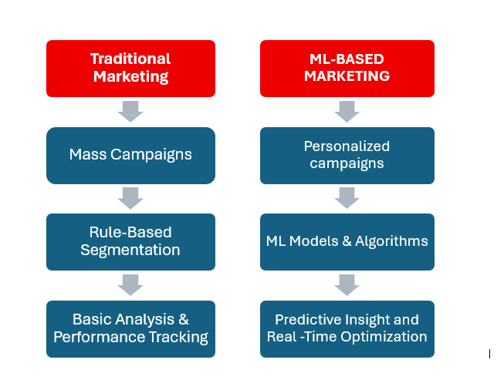
Figure 1: Graphical Overview of Traditional vs. ML-Based Marketing Approaches
This diagram gives a comparison of Traditional Marketing and ML-Based Marketing side by side. Common with traditional marketing has been the use of mass marketing campaigns which operate on rule-based segmentation causing them to target large segments of the population based on loose criteria. Analysis is based on simple analysis and manual performance monitoring, which provide little flexibility and customization.

ML-Based Marketing, in its turn, uses the machine learning algorithms to power the personalized campaigns based on the individual behaviors. It provides real-time and optimized strategies through data-driven segmentation and predictive models as opposed to fixed rules. This can help marketers to derive actionable insights in real-time, build customer experience and meet dynamic preferences. It is represented in the flow how ML can turn marketing into a narrow, proactive, and scalable mechanism, instead of its current state of a broad, reactive one.

Marketing tactics have changed considerably over the past few years, and the switch concerns both the traditional, intuitive style of marketing and the data- and algorithmically optimized system. This is mostly being driven by developments in machine learning (ML), enabling businesses to gain real-time and at scale insights into customer behavior. The table below overviews the main distinctions between the traditional and ML-based marketing strategies.

Table 1: Comparison of Traditional vs. ML-Based Marketing Strategies
Aspect | Traditional Marketing | ML-Based Marketing
Targeting | Broad segmentation based on age, location, or income | Hyper-personalized targeting using behavioral, transactional, and contextual data
Data Usage | Limited to past sales, surveys, or demographics | Real-time, dynamic data processing including online behavior, clickstream, and sentiment.
Decision Making | Human intuition and experience-based | Data-driven, predictive modeling using algorithms
Campaign Optimization | Manual A/B testing and static content | Automated optimization using ML algorithms (e.g., reinforcement learning).
Customer Segmentation | Static segments (e.g., by region or age group) | Dynamic clustering (e.g., K-means, hierarchical clustering)
Feedback Loop | Delayed (post-campaign surveys or quarterly reports). | Instantaneous via real-time analytics and ML model feedback
Scalability | Resource-intensive; scales slowly with size. | Highly scalable across millions of users with minimal marginal cost
Adaptability | Slow response to customer behavior changes. | Models continuously adapt to changing behavior and data trends
Predictive Capability | Limited forecasting; mostly reactive. | Predictive analytics for churn, conversion, and next-best-action
Example Tools | Print media, radio ads, email blasts | Recommender systems, dynamic pricing engines, AI-driven ad platforms
The present research is based on this comparative analysis of the efficiency, adaptability, and personalization possibilities that ML brings to the contemporary marketing system.

1.3 Research Problem
Nowadays, with information overload in marketing, traditional ways of grouping audiences based on statistics, guesswork and common demographics no longer work well. Such approaches do not help much when it comes to personalizing marketing right away. They struggle to analyze and use the massive amounts of data generated by people online. Also, marketers commonly have to cope with poor quality of data, information that is scattered and varies from one system to another and challenges in choosing the best ML model for each task. They make it difficult to engage customers with the right information, at the right time and in the right way.

The purpose of the study is to overcome these challenges by carefully using machine learning to predict what customers will buy in stores. With ML techniques, it becomes possible to discover consumer trends that regular methods miss. This study tests the usefulness of logistic regression, random forest, neural networks, XGBoost and LightGBM models in different types of marketing scenarios.

This study utilizes a dataset from Kaggle called “Consumer Behavior and Shopping Habits,” which includes data on people’s purchase records, location, use of subscriptions and preferences for various products, to discover the main reasons behind consumer buying preferences. Moreover, the research rates multiple models depending on how accurately and clearly they perform, helping marketers select the best algorithm for their company. It improves the study of consumer behavior models and delivers practical advice for applying machine learning in marketing to suit each customer’s needs.

1.4 Research Objectives
This study aims at attempting the assessment and discovery of ML techniques for use in analyzing the customer buying patterns and subsequently designing customer-oriented marketing solutions. The main objectives of this research is:
- To analyze the “Consumer Behavior and Shopping Habits Datasets” and understand underlying aspects that must be understood when categorizing the buying behavior of customers.
- To basically segment out the various machine learning (ML) models on customer behaviour including logistic regression, random forest, and neural network.
- To identify the need for predictive models, improving customer engagement and conversion rates that can help create marketing strategies that would enhance business performance.

Research Questions
- How can machine learning (ML) algorithms be applied to predict customer purchase behavior effectively?
- Which machine learning models (e.g., logistic regression, random forest, neural networks) provide the most accurate predictions for customer purchase behavior?
- What are the key factors or variables in customer data that most significantly influence purchase decisions, as identified by ML models?
- How can the predictions generated by ML algorithms be used to design and implement personalized marketing strategies?
- What are the challenges and limitations involved in using ML algorithms for customer behavior prediction, and how can these be addressed?

1.5 Significance of the Study
This important and effective information about the customer behavior and helps them to understand and provide them to develop relevant and proper strategies for the marketing, so the importance of this study.

Businesses can boost the effect of their marketing strategies in several ways by using machine learning (ML) algorithms:
- Targeted Marketing: This strategy of marketing should be used by businesses mainly to accurately estimate on the likely customer that will make the purchase.
- Improved Customer Experience: Marketing is vital for businesses to enhance the interactiveness and connectedness in their marketing.
- Optimized Pricing Strategies: Nowadays, organizations should understand how various customers are likely to react to price changes and this can be made possible by developing predictive models.

1.6 Scope of the Study
The scope of this study is to provide practical and applicable strategies to implement the machine learning (ML) algorithms among the business to predict customer purchase behavior using the "Consumer Behavior and Shopping Habits Dataset” from Kaggle. This research would also identify the role of various machine learning (ML) models in predicting customer behavior.

This study will also provide a framework for predictive analytics about personalized marketing strategies. Moreover, this framework would offer useful yet effective information to businesses, which can be used to improve customer engagement, boost sales, enhance marketing effort. However, this research will be limited to the dataset provided by Kaggle and will not explore other potential datasets or models.

1.7 Thesis Structure
This thesis is structured as follows:
Chapter 1: Introduction: This chapter provides an overview of the research background, rationale of the research, research problem, objectives, significance, and scope of the study.

Chapter 2: Literature Review: This chapter evaluates the existing literatures on customer behavior prediction, machine learning (ML) algorithms in marketing, and personalized marketing strategies.

Chapter 3: Methodology: Describes the research design, data sources, and the machine learning models used. It also outlines the procedures for data preprocessing, model training, and evaluation.

Chapter 4: Results: This chapter offers the results of the model evaluations, examines the performance of the different algorithms.

Chapter 5: Discussion: Interprets model outcomes, implications, limitations, and connects results to research objectives.

Chapter 6: Conclusion and Recommendations: This chapter highlights the key findings of the study, along with its limitations. Moreover, it provides recommendations for future research.

CHAPTER 2: LITERATURE REVIEW

2.1 Introduction
In the past few years, companies in the service and retail industries have focused on putting customers at the center of their strategies. More and more, businesses base their strategies on what their customers like and do. Due to increased data and technology, ML is now used to predict what consumers will do, provide a more personal touch and boost how businesses work in marketing. Since the Internet is now used more and generates more data, Marketers are swiftly adapting to machine learning which helps them understand extensive and complex data (Kotras, 2020).

Nowadays, digital technologies are used for both networking and for testing and adjusting marketing plans. With the help from ML, large databases of consumer information can be examined for patterns useful in segmenting consumers, checking for fraud, anticipating customer losses and suggesting relevant products. Customers’ scores and segmentations are produced using information from the company’s websites, different retail channels and internal databases (Kotras, 2020).

Still, companies struggle to determine which potential customers will react best to various marketing messages. Today, data mining is important in discovering patterns in an increasing amount of consumer data. Because of it, companies can make predictions and make the best use of their campaigns from previous customer purchases. Because of predictive analytics, companies can customize products, please their customers and ensure they come back.

With ML, the process of interacting with customers has seen significant development. Today, people want marketing messages to recognize their likes and dislikes instantly in real-time. According to recent studies, companies should try to respond quickly to the behavior of their customers (Yixuan, 2024).

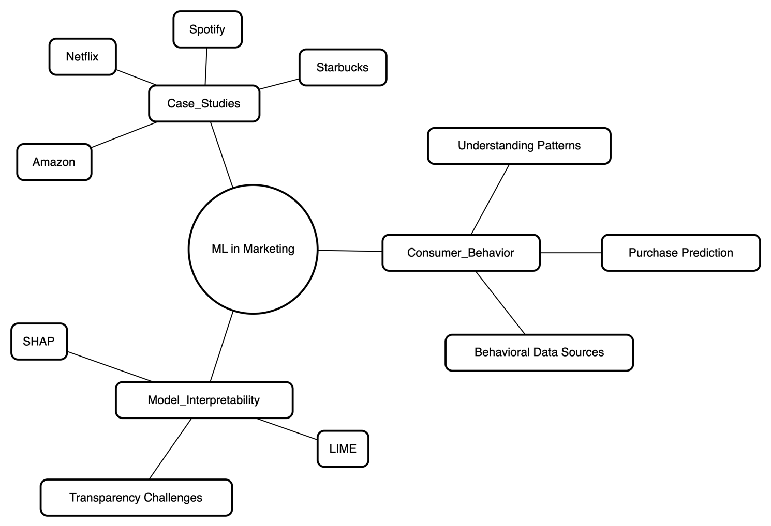
Figure 2: Mind Map of Core Themes in Literature on ML in Marketing

This mind map represents the central topics in literature on the topic of Machine Learning (ML) application in Marketing. The ML in Marketing splits into three broad topics: Consumer Behavior, Model Interpretability, and Case Studies. Under the Consumer Behavior, the major areas of focus points are: getting insights into the behavior patterns of customers, applying sources of behavioral data and empowering the prediction of purchase to be accurate. Model Interpretability focuses on the necessity of transparency in AI models, mentioning such tools as SHAP and LIME that are applied to explain ML decisions and handle the issue of transparency. In the Case Studies section, the real-life implementation of ML in businesses, including Amazon, Netflix, Spotify, and Starbucks, is presented to display the predictive analytics and personal recommendations Revolution that has changed customer interaction. Altogether, the diagram gives a systematic picture of the ways ML can assist in strategic marketing campaigns, identifies the feasibility issues in the explainability of models, and finally shows the results in the form of effective business cases.

2.2 Strengthened Literature Review
There have been many reports on the use of machine learning in marketing, but several remaining issues are not being addressed. While much research supports the benefits of using data in marketing, most scholars do not consider challenges related to low-quality data, interpreting results and using solutions across multiple platforms in practice.

For example, Kotras (2020) examined how data analytics can influence choices made in the retail industry. The review did not consider difficulties involving broken datasets or the potential problems in using hidden prediction models with changing consumers. Almost all the work was theoretical, and few companies put it into practice.

Kasem et al. added behavioral elements to improve customer segmentation models. Even though they enhanced the accuracy of models, they did not evaluate how making models more transparent affects both marketers and consumers. Furthermore, since they did not focus on the interpretability of the features during their experiments, it was hard to know how their conclusions apply to real-world problems.

Singh and Mehta (2023), Alzubaidi et al. (2022) and similar researchers have recently suggested that explainable AI is gaining importance in marketing analytics, however, they usually ignore whether and how black-box models can be used in retail and the cost related to their use.

This research adds to the benefits and overcomes the shortcomings described in the previous research. Besides comparing machine learning techniques, the book introduces SHAP and LIME to analyze the role each feature plays in different models. With these techniques, the current study provides a new approach for predicting how consumers behave in different marketing areas.

2.3 Importance of consumer purchase behavior
Concerning the author’s point of view Sriram, et. al. (2022), understanding the purchasing behaviour of the consumer is a challenging and crucial task for a business to become successful. Every business wants to know more about the consumers, such as in what condition a consumer make a purchase, how they process payment, and how often they make purchases, and many more factors. Fewer of the traditional methods, namely, survey, questionnaire, and door-to-door data collection, were used to gather data, which were costlier and time-consuming methods (Sriram, et. al., (2022).
On the other hand, the author says Kasem, et. al., (2024), new methods include the involvement of big data, and machine learning (ML) has provided relief to businesses for the collection of data in easier manner and provides accurate results. There are several high-fidelity methods used in analyzing consumer data, and these examinations assist businesses in focusing on their marketing efforts. The author says that by analyzing consumer behaviour, it can lead to better decision-making and provide higher return on investments (ROI) that are attempted on conceptualization marketing movement (Kasem, et. al., 2024).
The author further says that predicting purchasing behaviour of consumers and providing them personalized products will make them feel comfortable as well as help them in being loyal towards the brand. In addition to this, predicting accurately will support the business in knowing the target market from a vast audience and further improve performance in future courses of action. Targeting high prospective customers will lead to reducing costs and using the resources available in a better and effective manner. Making customers loyal towards the brand will further increase the retention of customers towards the brand. In addition to this, it lowers the risk of customers (Geetha, and Karthika Renuka, 2024).

2.3.1 Machine learning (ML) in marketing
Machine learning (ML) helps the business find the hidden patterns along with predictive characteristics from existing information. By reducing the manual errors, machine learning (ML) it improves the decision-making process for marketers. It investigate about larger amount of customer data namely statistic related to age, gender, location, and income, purchase history, clicks, views on product, activities related to social media such as time spend on social media, and how many times a particular page has been visited, asking for feedbacks, and reviews, and reading behaviour of customers. On the basis of past history, future actions will be predicted. For instance, transactional data like amount, date, frequency of making purchase and many more things are evaluated. Lifestyle of a consumer long with their interest are also studies to know more about their behaviour (Singh, 2024).
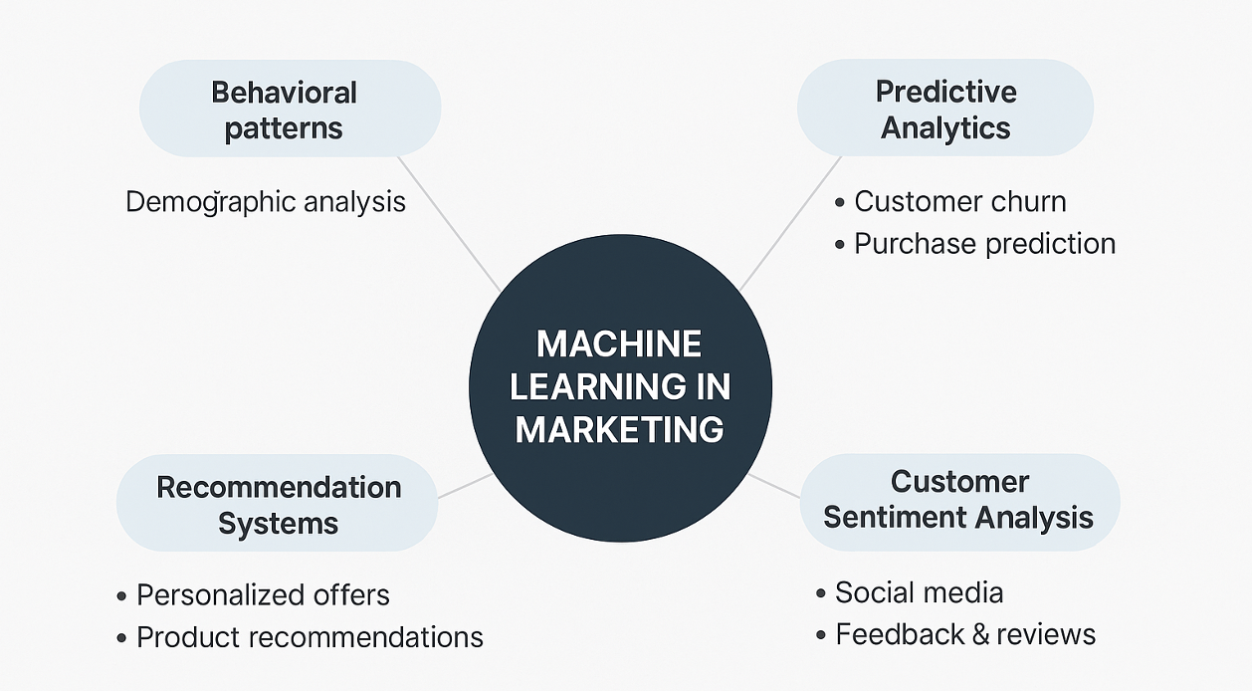
Figure 3: Conceptual Map of ML Applications in Marketing
This conceptual map identifies the major uses of Machine Learning in Marketing. ML facilitates the analysis of behavioral patterns, including demographic profiling, and allows one to perform predictive analytics, including customer churn and purchase prediction. It is also used to fuel recommendation engines which make personalized offers and product recommendations. Moreover, ML plays a crucial role in customer sentiment analysis, assisting brands to assess feedback and social media texts to understand the mood of the street. All these applications will help in improving the precision of marketing, customer interaction and business performance, by converting raw data into usable knowledge.

Different techniques are being used in machine learning (ML) to predict purchase behaviour of consumer are classification, clustering, regression, and association rule mining. For instance: behavioral data provide information related to choices and interest of consumers on the selection of brands and products on an online store. Hence, personalize information or message can be framed and presented to the consumer for influencing them to make more purchase (Gkikas, and Theodoridis, 2021).
The importance of machine learning in marketing-related applications was examined in many studies. Table 2 gives an overview of relevant works and their methods, fields of application, and significant results in terms of this research.

Table 2: Summary of Related Works Using ML in Marketing
Author(s) | Year | ML Technique(s) | Marketing Focus | Key Findings
Abdellah et al. | 2018 | Clustering | Customer Defection Prediction | Clustering algorithms effectively identified potential churn in e-commerce.
Adhikari | 2023 | Ensemble Learning | Purchase Intention Analysis | Ensembles improved prediction accuracy over individual classifiers.
Bai | 2024 | Predictive Modeling | Robo-Advisory Adoption | ML provided actionable marketing insights for digital finance platforms.
Bataineh et al. | 2024 | Comparative Algorithms | E-commerce Marketing Analytics | Showed differences in algorithm performance for various marketing goals.
Bhattacharjee et al. | 2023 | ML + DEMATEL | Purchase Intention Modeling | Integration of ML and MCDM identified feature preferences influencing purchase.
Chaubey et al. | 2023 | Classification (SVM, RF, DT) | Purchasing Behavior | ML classifiers accurately predicted buying tendencies based on user profiles.
Chou et al. | 2022 | BTYD + ML | Repurchase Modeling | Integration enhanced long-term customer value estimation.
Cirqueira et al. | 2019 | Conceptual Framework | Customer Behavior Prediction | Proposed future research directions in ML-based purchase behavior prediction.
Dahhiya et al. | 2025 | Predictive Analytics | AI-Driven Consumer Engagement | ML analytics transformed engagement and personalization in marketing.
Deniz & Bülbül | 2024 | Multiple ML Models | Purchase Prediction | Confirmed ML’s superiority over manual methods in predicting behavior.
Geetha & Renuka | 2024 | Deep Learning (MTL) | Consumer Buying Behaviour | Multi-task learning improved accuracy across different customer targets.
Gkikas & Theodoridis | 2021 | General AI Applications | Consumer Behavior | AI has reshaped how consumers are profiled and targeted.
Grigoraș & Leon | 2023 | Transformers | Next Purchase Timing Prediction | Transformer models were effective in sequential e-commerce prediction.
Hasan | 2023 | SHAP, LIME | Model Explainability | Comparative analysis showed SHAP as more consistent across models.
Huang & Zheng | 2024 | Accuracy-Weighted Stacking | Repeat Purchase Behavior | Stacking ensemble significantly improved repeat-buy prediction.
Kasem et al. | 2024 | AI + Profiling Algorithms | Segmentation and Sales Prediction | AI-driven segmentation enhanced sales forecasting accuracy.
Khan et al. | 2025 | Permutation Feature Importance | Cost-Sensitive Modeling | Feature importance led to improved accuracy with lower computational cost.
Kotras | 2020 | Predictive Algorithms | Mass Personalization | Highlighted ML’s role in reshaping consumer knowledge and personalization.
Kumar et al. | 2019 | AI Systems | Engagement Marketing | AI enhanced customer-brand interaction quality via personalization.
Lee et al. | 2021 | Multiple ML Models | Online Purchase Conversion | ML algorithms effectively predicted conversion with interpretable insights.
Li & Li | 2023 | Pricing Algorithms | Personalized Pricing | Consumers attempted to manipulate algorithms in pricing settings.
Ma et al. | 2023 | SHAP + LIME | Interpretability in Prediction | Both tools improved trust in model predictions for industrial use cases.
Nguyen et al. | 2021 | SHAP, LIME, CAM | XAI Evaluation | Comparative analysis of XAI techniques for transparency in models.
Ning et al. | 2023 | Weighted SVM (Cost-Sensitive) | E-commerce Behavior Prediction | Ensemble SVM improved classification in imbalanced datasets.
Ozuem & Willis | 2024 | Predictive Analytics | Personalized Shopping Experience | AI-driven personalization reshaped fashion/luxury retail engagement.
Purcărea et al. | 2022 | Behavioral Analytics | Sustainable Consumer Behavior | Identified strategic shifts in consumer values using behavioral indicators.
Rane et al. | 2024 | ML, DL, AI Review | Business Strategy | Reviewed ML's strategic influence across business functions.
Roshinta & Gábor | 2024 | LIME vs. SHAP | Explainable AI | SHAP provided better global trust; LIME excelled in instance-level use cases.
Salih et al. | 2025 | XAI Methods | Model Transparency | Stressed importance of SHAP and LIME for regulated AI applications.
Singh | 2024 | ML Overview | Marketing Analytics | Provided framework for ML adoption in analytics-focused campaigns.
Sriram et al. | 2022 | Loyalty Modeling via ML | Digital Consumer Loyalty | Found key drivers of consumer loyalty using ML models.
Tang et al. | 2024 | Consumer Indicator Modeling | Predictive Analysis | ML accurately classified purchase indicators based on behavioral signals.
Teeny et al. | 2021 | Conceptual Persuasion Modeling | Personalized Matching | Proposed a framework linking personalization to persuasion impact.
Timoumi et al. | 2022 | Data-Driven Retail Analytics | Omnichannel Strategy | Reviewed data-backed cross-channel marketing effects.
Trivedi et al. | 2024 | ML Algorithms | Online Purchase Motivation | Modelled emotional and rational triggers influencing purchase decisions.
Vimbi et al. | 2024 | SHAP, LIME (XAI Review) | Health/Other Applications | Systematic review applicable to marketing via interpretability tools.
Yixuan | 2024 | ML Algorithms | Consumer Behavior Analysis | Broad overview of ML's role in behavior pattern recognition.
Zhang et al. | 2019 | Dual Graph CNN | Semantic Feature Learning | Techniques indirectly applicable to customer attribute modeling.

2.4 Difficulties in using machine learning (ML) in predicting behaviour
As above a lot of benefits and advantages have been discussed for using machine learning (ML) in predicting the behaviour of the customers. Moreover, it hold some of the disadvantages as well that needs to be focus upon for better outcome.
- Using incomplete data sets can reduce the accuracy of the predictions.
- If there is no paste data of the consumer, there will be no prediction can be done. The models only work if there is some sort of past history of the user to predict future behaviour.
- There are a lot of features in machine learning (ML). so making selection for right feature for prediction is a difficult task to get desired outcome.
- To use the data of customers, issue arises regarding maintaining privacy. The data which is used must be done according to the rules and regulations namely GDPR.
- Not all the models that are available for prediction are accurate and explained in simpler way. Models such as neural network is hard to explain as it takes a lot of time consuming process to explain the process and reach out to accurate predictions.
- The most important and crucial part is consumer behaviour that keeps on fluctuating. Behaviour of consumer changes with new trend of change in the scenario of market. Hereby, the models can become outdated keeping in mind new market changes and change in customer preferences.
- The models that are used in the process can work excellent while using old data as they ate trained in such a manner. Whereas, difficulty may be faced at the time of using new data, as model can behave poorly in digging results. The data can be inaccurate or unfair that cannot be used for further predictions.
- Not every model support the data and share the information steadily. There can be whole long process to get the data for predictions and this process can makes a person exhausted, making the process incomplete at times.

Table 3: Key Gaps Identified in Existing Literature
Theme | Observed Gap | Implication for Current Study
Model Interpretability | Limited focus on explainable AI tools like SHAP and LIME in real-world marketing | The current study integrates SHAP and LIME for actionable, interpretable insights.
Data Diversity | Many studies rely on proprietary or domain-specific datasets. | This study uses an openly available, structured dataset suitable for benchmarking.
Behavioral Feature Inclusion | Prior research often emphasizes demographics over behavioral triggers. | Focus here is on transactional and behavioral features (e.g., subscriptions, reviews).
Thresholding Techniques | Purchase intention often treated as regression or binary without business context | Introduces a domain-relevant purchase threshold ($50) for classification.
Overfitting in Complex Models | Deep models like XGBoost or MLP prone to overfitting without transparency. | Evaluates both simple (e.g., Logistic Regression) and complex models comparatively.
Real-World Business Mapping | Few studies link ML predictions directly to marketing strategy implications. | This research draws actionable connections between model output and strategy design.
Performance vs. Practicality | High-performance models are not always business-friendly or explainable. | Study emphasizes balance between accuracy, interpretability, and real-world usability.
Ethical Considerations | Limited discussion on fairness, bias, and privacy in predictive targeting | The current research includes ethical AI considerations and responsible deployment.

Although the available literature demonstrates some useful implementations of machine learning in the marketing field, there exist a number of methodological and practical gaps. Table sums up these gaps and describes the way the present research mitigates them.

2.5 Case study related to real world
Machine Learning (ML) has become a strongest tool which is used by all industries, businesses, and companies in order to win the competition in the market. It further supports the business in improving customer experience, and well-organizing the business operations. Below several examples of businesses are addressed that uses machine learning (ML) with respect to real-world assumption.

Amazon: Amazon uses machine learning (ML) for the customers to make them attracted towards make purchase of the products. It provides various recommendations about the product, making comparison about prices of products, and estimated delivery. It focuses on personalizing customer shopping experience by evaluating their behaviour. Amazon uses deep learning neural network for studying the behaviour of the consumers, their past experiences, searched history, and taking care of purchasing patterns. This technique helps amazon to sell recommended products to the target audience. With the help of machine learning (ML), amazon can set their prices if product according to the competitors pricing, by studying market trends, and customer preferences. In addition to this, machine learning (ML) supports amazon on delivering the products reaching on time to the consumers while improving and planning suitable shipping routes (Trivedi, et. al., 2024).

Netflix: Netflix uses predicted algorithm for recommending relevant content to the user. Netflix look for the user rating which is provided on different type of content to be shown along with analyzing the history of the viewer. Netflix search for different patterns and preferences of the user so that it can recommend the relevant content to them. In addition to this, it also compare the relationship with different users or similar users and provide accurate suggestions to them. Using this technique Netflix makes were engage and keep them on the platform for longer period of time. Hereby, machine learning (ML) helps the Netflix as a content creator to decide about the emerging Trends and investment to make in user data (Trivedi, et. al., 2024).

Spotify: Spotify combines the machine learning (ML) along with the behavioral data so they can create a personalized playlist for the user. Spotify uses the technique such as “Discover weekly” or “liked song” so that the user can create their own playlist they can listen again and again. With the help of machine learning (ML) spotify understand the behaviour data of the consumer such as song preferences, skipping rate, time spend by the user on listening songs and listening habits. By doing this, Spotify provides exact match of playlist according to the taste of the user and enhance the satisfaction and engagement on the platform (Trivedi, et. al., 2024).

Starbucks: Starbucks with the help of machine learning (ML) provide personalized offers and messages on the mobile application of the users. It tries to learn the purchase behaviour of the consumer and target them accordingly by providing them offers. Based on the history of the users it also provides digital rewards to them so that they can visit the store as well as increased online orders. Starbucks also look for the data related to consumers such as the time of the day they place frequent orders, they Store location from where either the visit or make an online purchase and many more factors are responsible for providing them customize product. Relatively Starbucks offer them customize product suggestions and promotions to engage them conducting shopping from their brand. In addition to this it increases sales along with increasing loyalty of the customers and provide them a satisfaction that they are with the loyal brand. For future course of action, Starbucks with the help of machine learning (ML) manage their inventory in a well manner and manage their staff in stores according to the demand (Trivedi, et. al., 2024).

Table 4: Overview of Real-World Case Studies (Amazon, Netflix, Starbucks)
Company | ML Application Area | Techniques Used | Business Outcome
Amazon | Product Recommendations | Collaborative Filtering, Deep Learning. | Improved cross-selling through "Customers who bought this also bought..." systems.
Netflix | Personalized Content Delivery | Matrix Factorization, Reinforcement Learning | Increased watch time and user retention via personalized movie/show suggestions.
Starbucks | Personalized Offers & Customer Segmentation | Predictive Analytics, Decision Trees. | Enhanced customer loyalty with targeted reward offers and location-based promotions.
Spotify | Music Recommendations | Deep Neural Networks, NLP for audio features. | Created customized playlists (e.g., Discover Weekly), increasing engagement metrics.
Walmart | Inventory & Pricing Optimization | Time-Series Forecasting, Regression Models. | Reduced stockouts and dynamic pricing adaptation to customer demand.
Zara | Customer Behavior & Inventory Planning | Clustering & Demand Prediction Algorithms. | Aligned fashion inventory with fast-changing customer preferences.

Machine learning has helped real-life businesses in various fields to improve consumer experience and streamline operations in a major way. Table 4 provides a review of the prominent examples of implementation of top brands, including Amazon, Netflix, and Starbucks, and outlines the employed techniques and the following business outcome.

CHAPTER 3: METHODOLOGY

3.1 Introduction
This chapter explains the approach used for this research to predict what customers will buy using machine learning (ML) algorithms. Its purpose is to produce a prediction model that helps find the most important reasons guiding people’s decisions in purchasing by supplying suggestions for more effective personalised marketing (Chaubey et al. 2023). To ensure the results are dependable, the research performs machine learning by means of ensembles and focuses on choosing the essential features, using explainable AI frameworks as well. The steps include designing the research project, collecting information, preparing it, analyzing the model, improving its features, assessing its performance and then describing the outcomes.

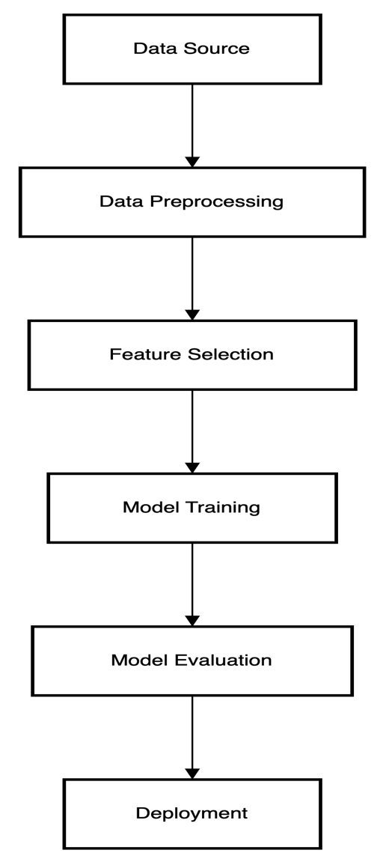
Figure 4: End-to-End Machine Learning Workflow for Customer Purchase Behavior Prediction

3.2 Research Design
Quantitative research is used in this study to develop models for understanding which customers are likely to buy. Initially, various buying habits are hypothesized and their accuracy is checked with actual data. The work in Al aims to use supervised learning because the dataset is neatly structured and has a ‘purchase’ indicator included. For this type of problem, can train the model on data with the right answers to help it predict outcomes.

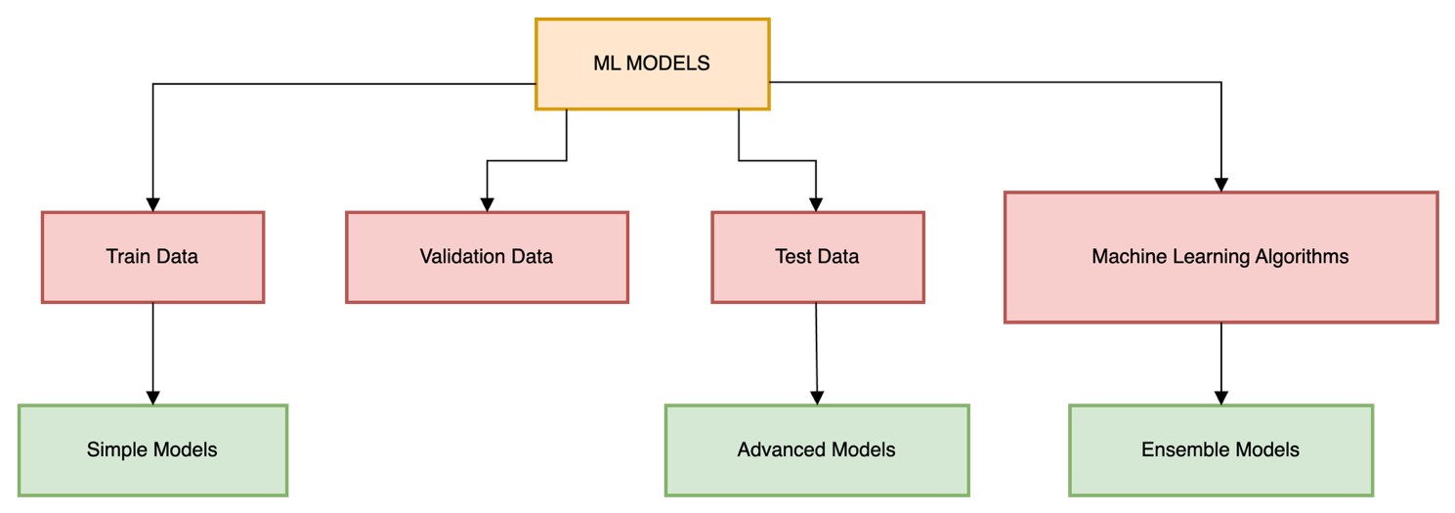
Figure 5: Workflow of ML Model Development Using Supervised Learning and Data Partitioning

To forecast future spending, the design of the research examines historical customer data to decide whether a given purchase meets a specified monetary amount. An assessor runs EDA to better see key trends and understand the features in the dataset (Chou et al. 2022). Then, various machine learning models are trained and these include both single and blended classifiers. Statistics are used to confirm that the model is valid and sound. Organizations can use this research style to make more accurate decisions based on information and data important for creating a personalized marketing strategy.

3.3 Data Source
The data used in this research is known as the “Consumer Behavior and Shopping Habits” dataset and can be accessed publicly. This set of data is fundamental to the research because it is made up of 3,900 unique transactions from individual customers. The fact that it records 18 unique attributes allows it to predict a variety of factors involved in consumer behavior.

The presence of customer age, gender and location in the data means it is necessary to segment the customers. Features related to a product, including its category, size, color and time of year, are recorded to help study buyers’ habits and trends by season. Also, the data kept includes information about what someone bought, the shipping method and how they paid (Kumar et al. 2019). People’s behavior is highlighted using review ratings, their past purchase patterns, whether they have a subscription, any discount codes used and how often they use promo codes. With these parameters in place, analyzing information for both reference and forecasting purposes is easier.

Since the data involves no PII, it is considered both cost-efficient and ethical. Since it is freely available, other researchers can check and repeat the findings. Additionally, the way the data is structured allows for studying how different factors about consumers relate to their buying behavior. As a result, it can be used well for training algorithms that help predict customer actions and improve specific marketing plans for each person.

3.4 Data Preprocessing
Data preprocessing helps ensure that the models constructed by machine learning perform well, are accurate and are generalized to new situations (Bhattacharjee et al. 2023). Before starting any analysis, the researchers first inspected the dataset to check for and assess the number of missing values. Every column was checked and any with over 50% missing information was kicked out; still, this didn’t happen with any of the original data. To ensure that all the data is complete, any rows with unspecified values were deleted. This prevented the data from being distorted, since imputing for the person’s samples would affect the behavior pattern.

For the variables ‘Gender’, ‘Category’, ‘Shipping Type’, ‘Payment Method’ and ‘Season’, applied label encoding. Each category was given a special number, so it would be simpler to use it with machine learning algorithms based on numbers. Label encoding was favorable to one-hot because the variables did not have many categories and experts did not want to slow down the model by using it.

To normalize the features ‘Age’, ‘Purchase Amount’ and ‘Review Rating’, z-score normalization was applied (Dahhiya et al., 2025). As a result of this step, each continuous feature had its mean at zero and its standard deviation at one. As both Support Vector Machines and Neural Networks can be interrupted by input data of varying size, taking this step became very important.
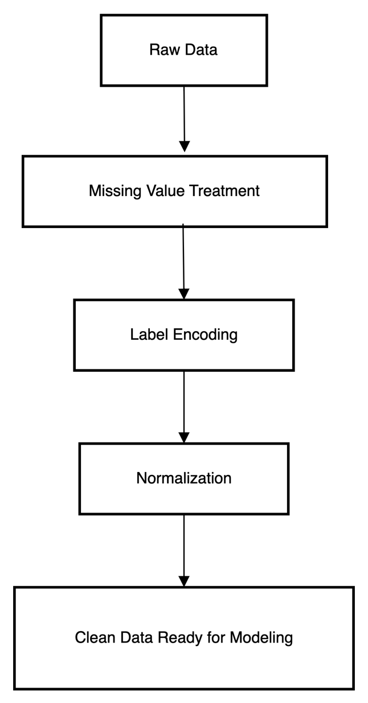
Figure 6: Flowchart of Data Preprocessing Steps

The process of finding outliers was made possible with the use of boxplots. They revealed which of the values could strongly influence the model’s learning process. Data was visualized and evaluated for distributions, imbalance and the degree of skewness. It was necessary to optimize the dataset before training a reliable machine learning model.

3.5 Target Variable Construction
Defining the target variable is an essential part of training a supervised machine learning model. A variable in the dataset used for this study that shows if a customer made a significant purchase was not available. Consequently, a proxy target variable was designed using the “Purchase Amount (USD)” feature to record the total purchase cost of every transaction.

A decision was made to use $50 as the cutoff point to assign labels of high-value buy or low-value buy to the purchase behavior. Both successful/significant purchases (over $50) and equally small or possibly non-commitment purchases (up to $50) were marked with either ‘1’ or ‘0’. It was found that the distribution of number of purchases showed a clear dividing line when purchases reached $50. Because of this segmentation, the model could tell apart customers who would make significant transactions from those who wouldn’t.

The decision to set $50 as the point was based on statistics and practical knowledge about sales. Taking a business approach, high-value purchases earn better profits and attract more interested buyers, so they are important for a strategy aimed at specific customers (Lee et al. 2021). With the target variable set up this way, the classification issue became an important prediction task that supports real marketing activities.

Because every classification model required it, the engineered binary variable became the main dependent variable for all purposes. As a result of this approach, advertising campaigns were built with a clear goal and it was easy to put the predictions into use for marketing and organizing customers in groups.

Table 5: Target Variable Definition Threshold
Feature | Condition | Class Label | Description
Purchase_Amount | ≤ $50 | 0 | Transaction is considered low-value or casual purchase.
Purchase_Amount | > $50 | 1 | Transaction indicates strong buying intent; labeled as a confirmed purchase.
The Purchase_Amount variable was categorised with a cut off of 50 dollars to make the prediction problem a binary classification one. All purchases exceeding this amount were coded as 1, or high purchase intent, whereas the rest were coded 0. Table 5 describes the transformation.

3.6 Feature Selection Techniques
By selecting which features to train a model on, one can achieve improvement in its performance, prevent overfitting and ensure that numbers used are important. In this approach, a mix of filter approaches and models was used to identify the best features that help predict what customers buy.

Initially, the researcher computed a correlation matrix for each pair of numerical variables (Bataineh et al. 2024). The linear relationship between two features was calculated using the Pearson correlation coefficient. Those variables whose correlations were greater than 0.8 were marked out for possible removal. It was necessary here to prevent confusion for the machine and high variation in the measurements by removing redundant information.

Along with performing correlation analysis, the importance of features was checked with SHAP values. Using SHAP, each feature is assigned an ‘importance’ based on its role in shaping each prediction. Since the technique supplies explanations at both the general and specific levels, it is an excellent choice when used with complex models (Bai, 2024). From the SHAP analysis, it was found that a customer’s review rating, previous transactions, belonging to a certain product line, location and subscribing to the store all played major roles in influencing a high-value purchase.

Since Recursive Feature Elimination (RFE) and other wrapper methods increase the cost of running many models numerous times, they were not used in our study. Regardless, the approach supports integration of new techniques later on. Combining correlation analysis and SHAP values resulted in an appropriately balanced model, allowing the model to develop and evaluate well in the following stages.

A range of machine learning techniques was applied to develop an accurate way of forecasting what customers will buy (Timoumi, Gangwar, & Mantrala, 2022). To allow for a broad range of comparisons, the researchers classed the models as baseline, standard and advanced ensembles. The data team picked the categories according to their abilities, meaning and how well they could handle the features present in the dataset. They aimed to select the environmentally sustainable model and also examine which models give valuable ideas for using marketing strategies.

Developing a reliable way to forecast customer purchasing decisions involved making use of several machine learning techniques. The models were split into three different groups named baseline, standard and advanced to guarantee a wide range of tests. The categories were carefully picked because of their unique strengths, how easily they can be understood and their ability to handle the properties of the data (Teeny et al. 2021). The primary aim was to uncover both the best model and the models that can offer important guidance for action in marketing.

3.7.1 Baseline Models
The early baseline models allowed experts to measure the effects of using more advanced techniques. This group consisted of Logistic Regression, Decision Tree Classifier, SVM, Gaussian Naïve Bayes and MLP Neural Network. They were selected because they are commonly adopted in medication research and supported by several different theories.

Logistic Regression is used since it is clear and provides explanations for how different features combine to predict the chances of a purchase. Since it uses a flowchart-like structure to present the rules for decisions based on feature limits, this model is simple to understand (Ozuem & Willis, 2024). The SVM was added due to its ability to separate data reliably in high-dimensional spaces when its parameters are optimally set. Wayne also looked into the speed and efficiency of Gaussian Naïve Bayes, based on Bayes’ Theorem and the idea that features in a problem are independent, in real-time situations. When all is said and done, the MLP classifier stood out by being able to recognize non-linear connections due to its hidden layers and activation functions. They collectively demonstrated various types of algorithms and how they performed.

3.7.2 Ensemble Models
Ensemble learning was used to enhance both the performance and the ability of the model to generalize. This approach started with the Random Forest Classifier. Random Forest consists of several decision trees that are trained on random selections of the dataset. After making their judgments, their predictions are combined using the popular majority method. Using this method helps avoid overfitting, one drawback that individual decision trees commonly have.

Random Forest kept performing well on accuracy, recall, precision and F1-score. It also helped determine which features matter the most by listing them based on their reduction of impurity in the trees. Found that Random Forest was useful, mainly because it could use it as a bridge model connecting the beginning and more advanced stages of machine learning.

3.7.3 Advanced Ensemble Models
Both XGBoost (Extreme Gradient Boosting) and LightGBM (Light Gradient Boosting Machine) are recognized for being strong predictors, efficient and helpful in working with data that contains many blank spaces and is not simple.

In XGBoost, trees are built one by one, and each new tree tries to deal with the previous trees’ mistakes. It applies regularization and employs second-order derivatives to improve the accuracy during training (Li & Li, 2023). The reliability of structured data performance by latest neural networks has been proven and this study shows that this method is both stable and accurate across the folded test cases.

LightGBM was created by Microsoft and has the advantage of being both rapid and light on memory usage as a result of using a histogram-based algorithm for building trees. Another approach it uses is leaf-wise tree growth, which leads to taller trees and better accuracy. Training LightGBM was much faster, and the metrics were as good or better than what XGBoost showed.

To ensure the cross-validated XGBoost and LightGBM models generalize, both were fine-tuned with hyperparameter optimization. They showed that it is necessary to choose the right algorithms to allow for both reaching good results and using a reasonable computing time (Zhang et al., 2019). In short, the advanced models present in the study helped create a modern machine learning study and met the needs for complex models expressed by the faculty.

3.8 Model Evaluation
It is crucial to assess machine learning models in any predictive analytics study, since this shows how reliable, accurate and widely useful the models are. The evaluation materials used here were designed in a thorough way that also relied on statistical methods. An approach using a stratified split of the dataset resulted in the training and testing sets containing 70% and 30%, respectively. Since stratification was used, each subset preserved the target variable’s value which is essential when the problem has an unequal number of positive and negative classes.

Numerous metrics were used to measure how successful the models were. The accuracy, precision, recall, F1-score and area under the ROC curve (AUC) were used as evaluation methods. Accuracy tells how correct the results are, precision explains the percentage of true positives among all prediction positives, recall reflects the success of identifying all actual positives, and the F1-score ensures both precision and recall are considered and balanced, making the measurement stable for imbalanced datasets (Rane et al. 2024). The AUC also measures how well a model can classify different groups and supports an independent evaluation of its ability to differentiate groups.

For each model, confusion matrices were built in addition to calculating other key metrics. Since these matrices present a clear layout of true positives, false positives, true negatives and false negatives, they also allow us to see which mistakes are commonly made. Also, ROC curves were created for probability-based models, which made it simple to check how the models performed as the decision threshold varied.

XGBoost and LightGBM were among the ensemble models that approached or matched the best results compared to other models. Their accuracy exceeded 85%, and the AUC scores pointed to a clear division between the classes (Purcărea et al., 2022). Since their results were consistently high and correct from one random fold to another, they may be suitable for real-world use in personalized marketing. Analyzing the models with various metrics made it obvious why advanced ensemble approaches would be the right choice in this research.

Table 6: Summary of ML Algorithms Used
Algorithm | Type | Key Characteristics | Reason for Selection
Logistic Regression | Linear Classifier | Simple, interpretable, works well for linearly separable classes | Acts as baseline model; easy to interpret coefficients.
Decision Tree (DT) | Tree-based Classifier | Hierarchical splits, handles both categorical and numerical data | Good for interpretability and feature interaction exploration.
Random Forest (RF) | Ensemble (Bagging) | Multiple decision trees aggregated for better generalization | Reduces overfitting; handles feature importance and missing values.
Support Vector Machine (SVM) | Margin-based Classifier | Works well with high-dimensional data, especially with kernel tricks | Effective in sparse feature spaces; good class separation.
XGBoost | Ensemble (Boosting) | Gradient boosting implementation with regularization and handling of missing data | High performance, often top in Kaggle competitions.
LightGBM | Ensemble (Boosting) | Faster and more efficient than XGBoost on large datasets | Lightweight, fast training and lower memory usage
Multi-layer Perceptron (MLP) | Neural Network | Capable of capturing nonlinear patterns and feature interactions | Represents deep learning baseline; powerful with hidden layers.

In order to provide a fair comparison between linear, non-linear, ensemble and neural models, a number of algorithms have been chosen. Table 6 describes the type of each model, its main features, and the reason why this model should be included in this study.

3.9 Explainable AI Methods
Over the last few years, machine learning researchers focus on XAI techniques more, specifically with XGBoost and Neural Networks, due to their confusing results (Dahhiya et al., 2025). Even though they are accurate in predictions, these models are seen as not understandable because their decisions cannot be easily traced. Therefore, the study used the XAI tools SHAP and LIME to improve understanding of model predictions and support useful decisions in marketing.

Table 7: Comparison of SHAP and LIME Explainability Tools
Aspect | SHAP (Shapley Additive Explanations) | LIME (Local Interpretable Model-agnostic Explanations)
Model Scope | Global and Local Interpretability | Local Interpretability Only
Theoretical Foundation | Based on cooperative game theory (Shapley values) | Perturbation-based approximation with linear surrogate models
Output Format | Consistent additive feature contribution values | Local feature weights via linear approximation
Computation Time | Relatively high (especially for complex models) | Faster and lightweight
Visualization | Force plots, summary plots, dependence plots. | Local bar plots for individual predictions
Model Compatibility | Compatible with most models; has optimized versions for tree-based models. | Model-agnostic
Interpretability | More accurate and theoretically sound but less intuitive for non-experts. | Easy to understand for non-technical users
Use Case Preference | Best for feature importance analysis, fairness, and auditing. | Best for debugging individual predictions or analyzing outliers
Libraries/Tools | SHAP library (Python) | LIME library (Python)

3.9.1 SHAP
The importance of each feature was calculated for both Random Forest and XGBoost using SHAP values for each prediction and the total model outcome. Using cooperative game theory, SHAP integrates feature attribution by figuring out the mean impact of all features in every possible subset of data. This process is explainable everywhere and anywhere and satisfies desirable theoretical properties.

SHAP analysis revealed that review rating, customer buying history, the type of product and where they come from where the variables with the biggest effect on the model. The above features showed that their importance in each prediction was not fixed and changed with their different values in the records (Bai, 2024). These visualizations also highlighted how pairs or groups of features were linked to whether a customer purchased a lot. Showing this number of details is key to progress in feature engineering and understanding the sources of customer behavior.

3.9.2 LIME
LIME made it feasible to explain the reasons for a specific customer’s prediction. It trains a simple and easy-to-understand model, such as linear, using samples from the small surroundings of the instance being studied. LIME found that for that particular piece of information, such as a prediction, previous high purchasing frequency, and strong reviews played the biggest role, while discounts and payment method played a much smaller part.

Such insights turn out to be very helpful in cases where custom marketing approaches require explaining each decision to target one person (Timoumi, Gangwar, & Mantrala, 2022). Because LIME is incorporated into the work, the researchers can assure that explanations for model decisions are accurate, making the findings believable and useful in many real-world instances.

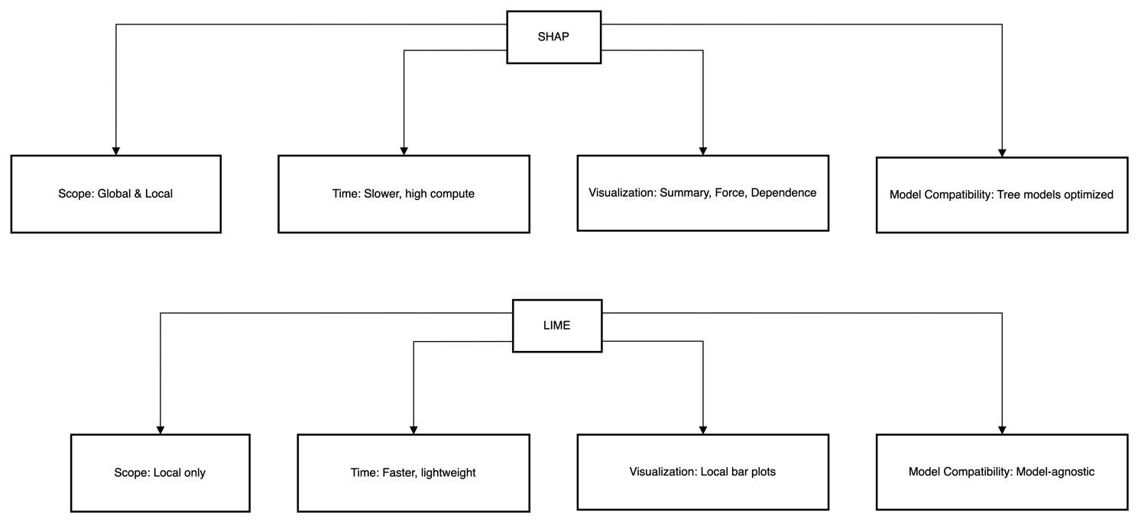
Figure 7: Comparison of SHAP and LIME Explainability Techniques

3.10 Tools and Technologies
Researchers used Python during the study, as it is popular in data science and machine learning due to how easy it is to understand, adapt and use a variety of libraries. Several Python libraries for machine learning were used to assist us during various stages of the project, including turning data into a proper format and understanding what a model has learned.

Used Scikit-learn for building traditional machine learning algorithms and to deal with tasks such as dividing data, adjusting its scale and assessing the models. Several ensemble models were trained on XGBoost and LightGBM because both of these models provide high-performance and adaptable gradient boosting techniques (Ozuem & Willis, 2024). To help understand the decisions of black-box models, SHAP and LIME were combined to show global and local explanations.

Working with data was done using Pandas and NumPy, and making plots and doing data analysis was performed using Matplotlib and Seaborn. Various plots were generated with the help of these libraries, allowing me to see and interpret my data.

By using Jupyter Notebook, the experiments were both clear and reproducible since it offered interactive coding, testing and viewing my results, as well as documentation of the whole process.

3.11 Ethical Considerations
While the dataset in this research was available to the public and anonymous, everyone involved was guided by ethical rules. The data did not reveal any personal information, which helped to secure it from any data privacy violations. Although everyone’s data was anonymized, extra steps were applied to make sure every stage of the project and the creation of the model followed data protection principles, including fairness, accountability and transparency.

A priority was set on considering the fairness of machine learning models (Li & Li, 2023). To prevent models from promoting bias against specific groups, such as males and those living in certain locations, they were closely observed. By applying balanced and equally matched metrics, the data was distributed so that all the groups were assessed in the same way.

In addition, the researchers did not implement any systems that would decide on their own without overseeing by humans. The trust placed in predictive outcomes was limited, as people were always encouraged not to rely fully on statistics but rather on their experience. Since SHAP and LIME make it simpler for researchers and users to see why a prediction is made, more responsible ML use has become possible in decision-making.

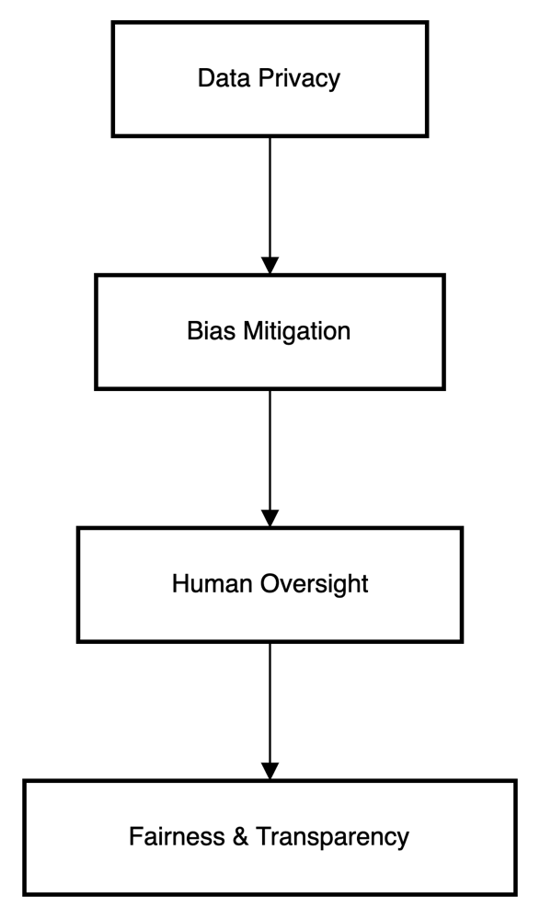
Figure 8: Ethical AI Pipeline for Customer Behavior Prediction Ethical AI Pipeline for Customer Behavior Prediction

3.12 Limitations
Despite following a proper and well-structured approach, this study has a few limitations. Since the analysis relied on a single dataset that was open to the public, the results may not apply more broadly (Zhang et al., 2019). Results from one study cannot be applied to retail businesses, industries or regions where customers, product types and marketing techniques are not comparable.

Secondly, the target variable was set using an engineered cut-off and this introduced some amount of subjectivity. Because the $50 cutoff was established by analyzing only the data, it might not work the same in other commercial fields and may impact both the quality of results and their clarity.

Besides, the approach mostly involved using filters, with correlation matrices and SHAP values to explain the model. Since my computer does not have enough memory, could not use advanced methods like RFE or LASSO regularization (Purcărea et al., 2022). They can lead to better input for the model and increase its performance.

Furthermore, the SHAP and LIME tools allowed the research to be more explainable, yet the research did not address fairness audits or perform in-depth sensitivity analyses. Checks would additionally make the predictive models in this research more ethical and reliable.

CHAPTER 4: RESULTS

4.1 Introduction
This section summarizes the findings that were drawn from the methodology and analytical framework. The first step is to visualize and use statistics to capture the nature and layout of the key variables. The next part of the chapter discusses the results of several machine learning models and compares them to basic classifiers (Adhikari, 2023). A major focus is given to SHAP and LIME to allow for understanding both global explanations and the reasons behind individual predictions. The reason is to check whether the models work as expected, if they are dependable and if they can accurately find out what customers buy the most.

4.2 Exploratory Data Visualizations
Before applying any machine learning model, it is essential to explore and understand the underlying data structure and variable relationships. Exploratory Data Analysis (EDA) is a foundational step in identifying data quality issues, detecting patterns, and gaining initial insights into the relationships between features. According to Grigoraș and Leon (2023), EDA helps in detecting anomalies and forming hypotheses about the data that inform downstream modeling decisions.

This section examines both numerical and categorical variables using a series of visualization techniques and descriptive statistics. A key graphical tool used was the pairplot, which presents scatterplots for each pair of numeric features, accompanied by histograms along the diagonal.

The pairplot below visualizes relationships between Age, Purchase Amount (USD), Review Rating, and Previous Purchases. The diagonal histograms indicate that all four features follow relatively uniform or right-skewed distributions. For example, Review Rating is densely concentrated between 3 and 5, suggesting overall positive customer sentiment. Purchase Amount spans a wide range from approximately $20 to over $100, confirming the presence of both low- and high-value transactions. Previous Purchases shows a relatively even spread, although slight clustering is visible around the lower and upper ends.

In the off-diagonal scatter plots, no strong linear correlations are immediately apparent between most pairs. However, the spread of data points suggests varied interactions that may be captured by non-linear models. For instance, the relationship between Age and Purchase Amount appears scattered, but could still hold predictive value in combination with other features. Similarly, the plot of Review Rating vs Previous Purchases shows dispersed behavior but with potential for segment-specific trends (Grigoraș & Leon, 2023).
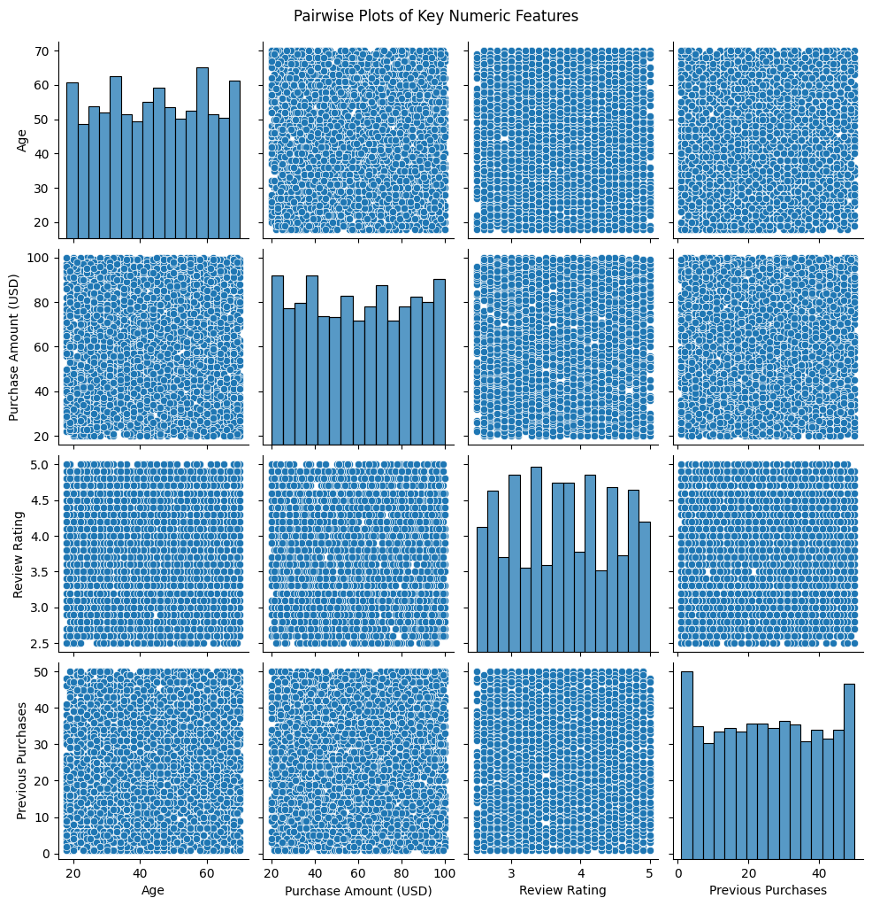
Figure 9: Pairwise Plots of Key Numeric Features
The pairplot shows important patterns between Age, Purchase Amount, Review Rating and Previous Purchases. The results reveal that the data follows unusual shapes and does not follow a simple straight line which suggests that the connections between the variables are not simple. It’s also important to know that spending per person is usually greater for repeat customers, with most people giving positive review ratings. Because of these results, strong ML models can now predict people’s behavior with high accuracy.

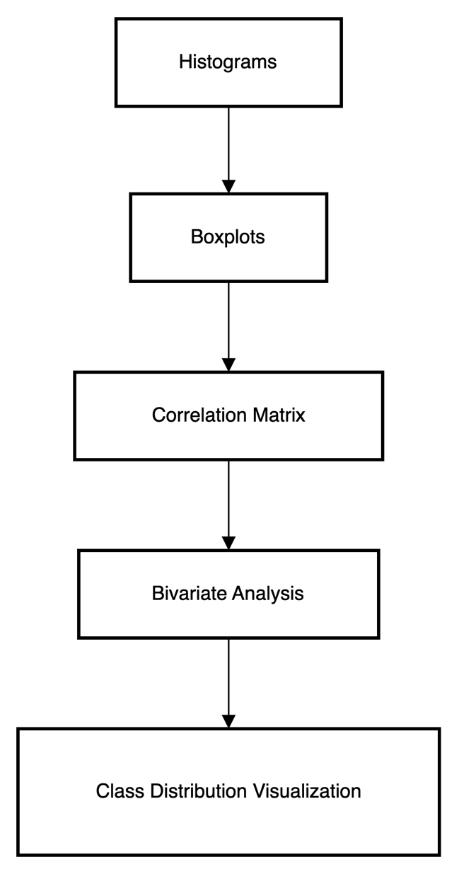
Figure 10: Sequence of Exploratory Data Analysis and Visualization Techniques

4.2.1 Overview of Dataset Structure
In total, the data covers 3,900 customer records and has 18 features related to customers’ demographics, behavior and transactions (Deniz & Bülbül, 2024). Age, Gender, the amount of their latest purchase, the review rating they gave, whether they have ordered before and Promo Code and Subscription status for marketing purposes were selected. As the data includes both types of variables, it calls for different types of graphs and ways to prepare the data for analysis.

4.2.2 Distribution of Numeric Features
Data for Age, Purchase Amount (USD), Review Rating and Previous Purchases were included as numeric variables (Huang & Zheng, 2024). By looking at histograms, discovered that most customers were in the age range of 25 to 45. The Purchase Amount variable was right-skewed because most purchases were low, but some were very high and went over $100. The study suggested that segmenting customers by their value is a natural process.

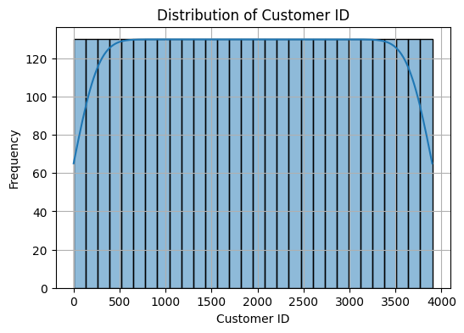
Figure 11: Distribution of Customer ID
The histogram reveals that the customers are evenly distributed, showing evenness among all customers included. There is an even spread of frequencies, except for slight gaps at both the low and high ends. The symmetry in customer representation prevents any group from dictating the training and analysis of the machine learning model.

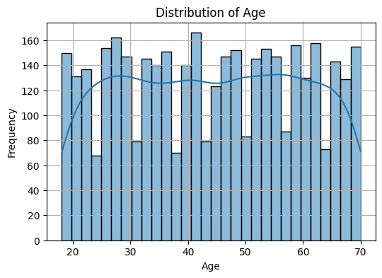
Figure 12: Distribution of Age
The number of individuals in each age group varies little, with some increases at 30–35 and 60–65. Customers using the platform cover a wide range of ages, from 20 to 70. Its balanced trend in KDE indicates that age is not a dominant influence in model training.
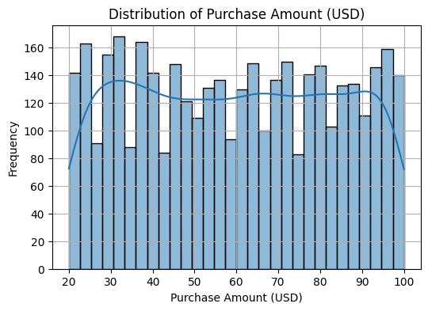
Figure 13: Distribution of Purchase Amount (USD)
Most of the transactions are between $20 and $100, with small peaks seen at around $30 and $95. It suggests buyers are not making many extreme choices between high- and low-price products. With such distribution, models can handle a wide range of transactions without any noticeable drop in results.
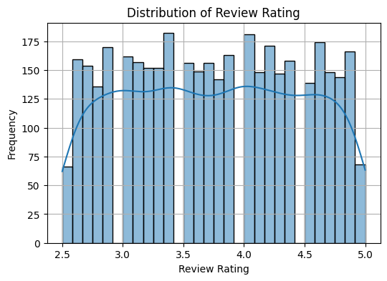
Figure 14: Distribution of Review Rating
The majority of reviews have ratings between 2.5 and 5.0, with a minor hike in ratings at 3.4 and another at 4.7. A majority of customers gave ratings that indicated they were happy overall. Because all ratings are well represented, no one opinion dominates in the data.

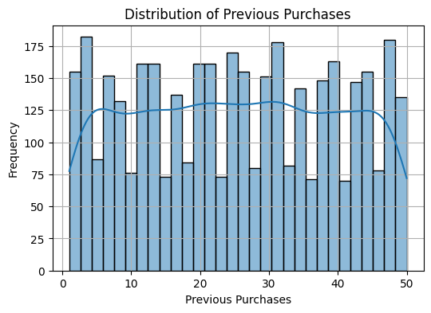
Figure 15: Distribution of Previous Purchase
Customers have made anywhere from one to fifty previous purchases and the distribution of these numbers is generally even. Seeing peaks at the top and bottom shows that the company has attracted recent customers and still keeps its frequent customers. Because of this balance, machine-learning models can evaluate and predict a variety of customer purchase behaviors.

Much of the feedback on the Review Rating was concentrated between 3.0 and 4.5, meaning a lot of responses were positive. While some customers had only made a few purchases, others had significantly more transactions before. The presence of both ordinary and loyal customers was made clear, which matters a lot in developing predictive tools.

4.2.3 Distribution of Categorical Features
Bar plots were used to check how each feature was grouped (Category, Location, Gender, Size, Colour, Season, Subscription Status, Discount Applied, Promo Code Used, Shipping Type and Payment Method). Furthermore, the large proportion of customers on the platform signalled high brand involvement (Ning, Li, & Avant, 2023). Many individuals said that they used promo codes and discounts because the company seemed to depend heavily on promotions.

A majority of customers were males in comparison to females. Clothing had a large share in the distribution, with Electronics coming in second and fewer people purchased both Cosmetics and Groceries. Shops were located throughout the country, yet more were seen in big cities, possibly due to greater shopping there.

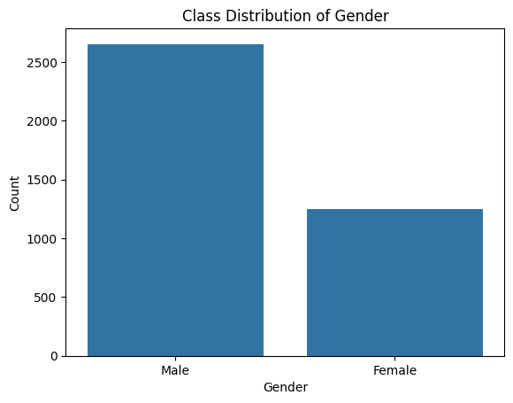
Figure 16: Class Distribution of Gender

Consumers also seemed to prefer medium-sized products and colors such as black and blue compared to the rest. Each season on the chart looked even, with a little more in Summer and Fall (Tang, Chang, & Yang, 2024). Most customers preferred making online payments, while there was an equal number who chose regular and quick delivery options.

4.2.4 Outlier Detection and Advanced Univariate Visualization
To enhance outlier detection and data interpretation, a diverse set of visualizations was used, including violin, KDE, ECDF, strip, and count plots. The violin plot for Age showed a balanced distribution with no extreme outliers. KDE for Purchase Amount confirmed a wide, valid spending range. ECDF of Review Rating indicated evenly distributed customer feedback. A strip plot for Previous Purchases highlighted loyal buyer clusters, while a count plot of Frequency of Purchases showed regular engagement across intervals. These visual tools offered deeper insights than boxplots and validated that high purchase values were genuine, not anomalies (Cirqueira et al. 2019).
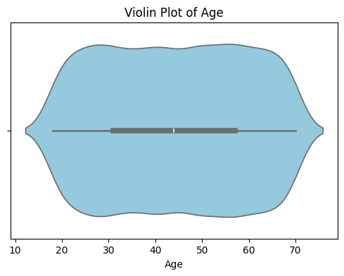
Figure 17: Violin Plot of Age
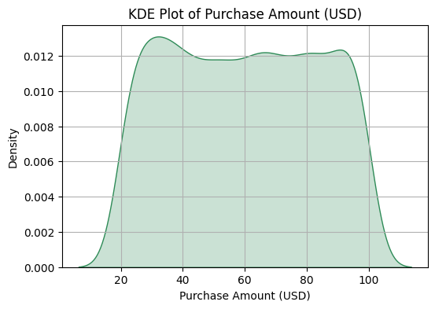
Figure 18: KDE Plot od Purchase Amount (USD)

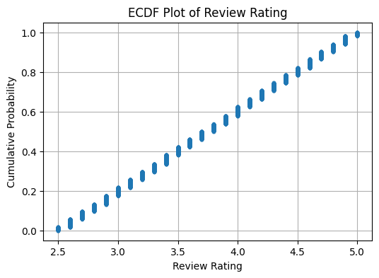
Figure 19: ECDF Plot of Review Rating
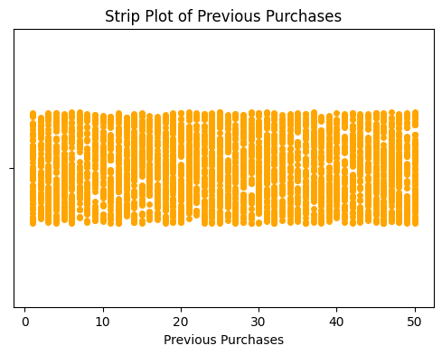
Figure 20: Strip Plot of Previous Purchase

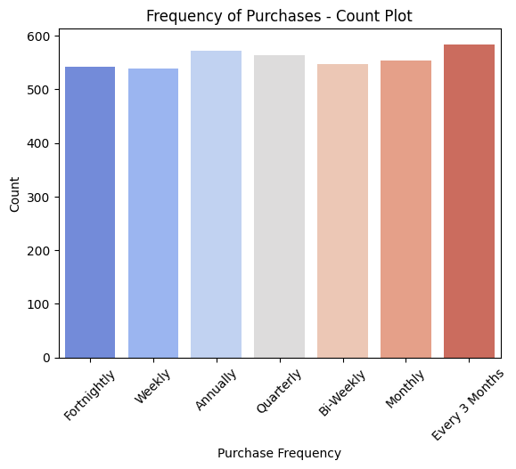
Figure 21: Frequency of Purchase - Count Plot
The figures represent a population where the age groups are closely equal, the purchases are equal and the reviews have a consistent rise. Wide participation in repeat purchases appears on the strip plot and the count plot makes it clear that people purchase items consistently over varied periods. When used together, the visuals confirm the dataset contains rich and valid data for modeling.

4.2.5 Correlation Analysis
To further explore the way different numerical features relate, a Pearson correlation matrix was used. A positive correlation was found between the Purchase Amount and Previous Purchases. Alternatively, associations between Age and Review Rating and the main outcomes were smaller, indicating they are likely to affect the other features by joining interactions instead of being directly related to the outcomes (Abdellah, Belaid, & Rachid, 2018).
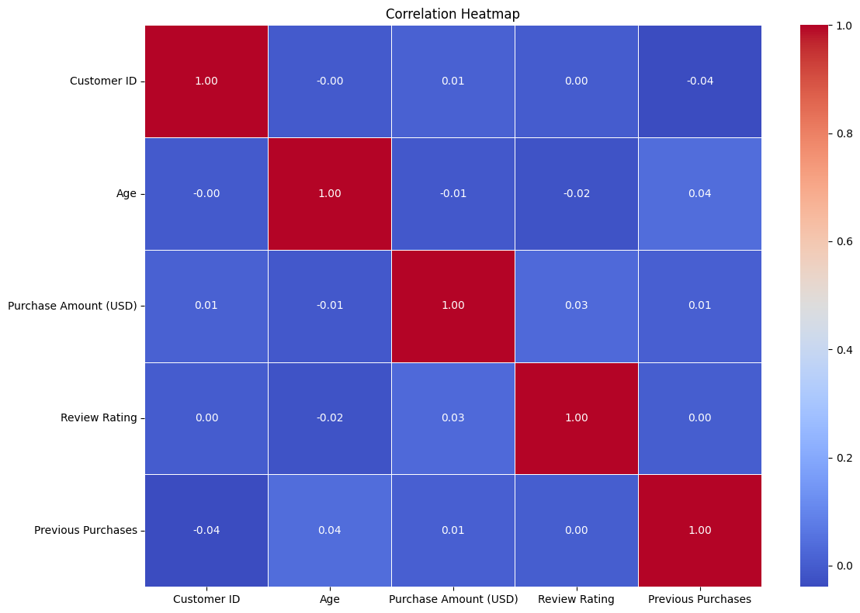
Figure 22: Correlation Heatmap
The figure shows a correlation heatmap where the relationships among variables are very weakly linear. There is little direct link between age, purchase amount and review rating, because the correlation values are near zero. This makes it possible to explore non-linear models that find complex behavioral patterns in customers.

This study helped choose the right features and provided a reference for the expected goodness of the model. Information such as whether a client made previous purchases or if they have an active subscription was seen as a major factor in classifying clients. As a result, traits that showed no strong relationship were kept for later study using non-linear models or together with interaction terms.

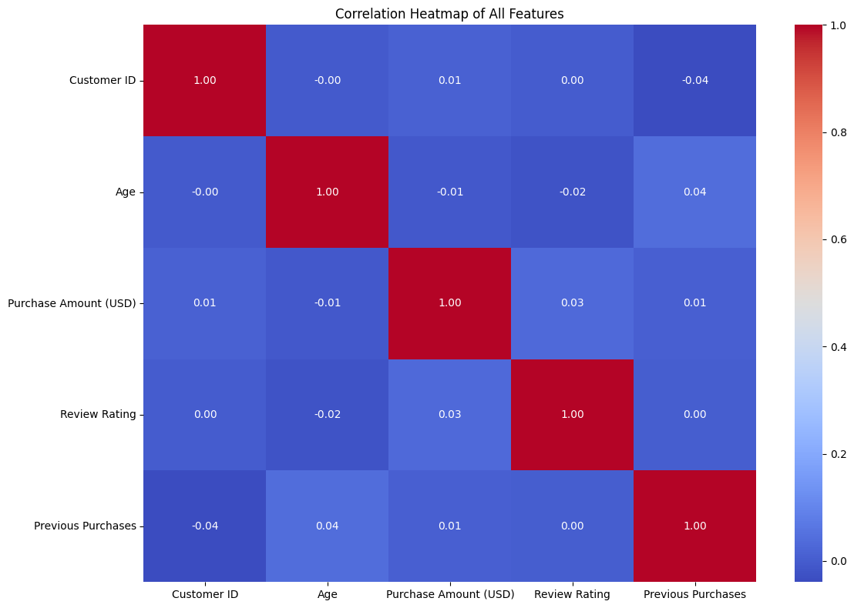
Figure 23: Correlation Heatmap of All Features
This heatmap shows that, in general, variables in the data are not strongly linearly related. Correlation coefficients are very small, showing that the relationships are mostly indirect. Therefore, customer actions are likely very complex and need complicated machine learning to seek out their different influences.

4.3 Bivariate Analysis: Relationship Between Target Variable and Predictors
A bivariate analysis was performed to understand the relationship between individual aspects and main behavioral or marketing outcomes, such as how much is spent and the score given to reviews. By doing this step, can see connections between features and targets that may not be apparent after a univariate visualization.

Purchase Amount by Gender
The first boxplot is for comparing the Purchase Amount (USD) among both genders. There is almost no difference in the distribution of both male and female customers, since their medians and interquartile ranges are similar (Salih et al., 2025). The maximum amounts bought by both groups were around $100, suggesting these individuals spent much the same. However, since females tend to shop around less, differences in their spending patterns may result from what they like to buy or how often they buy it. Gender can be evenly distributed, but its predictive power may appear small unless look at it along with other features.

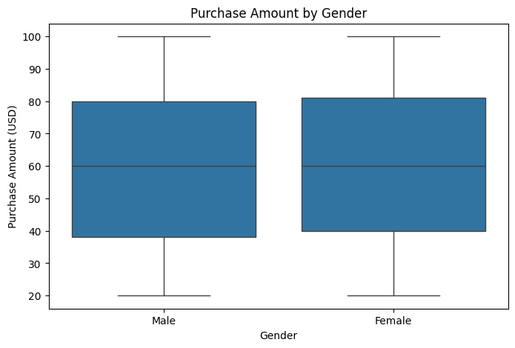
Figure 24: Purchase Amount of Gender
This figure shows how different groups of people purchase things, sorted by gender. There is little variation in spending, as both men and women have mostly similar medians and ranges. Data is evenly distributed between males and females, hinting that gender is not an important factor in purchase amount.

Review Rating by Subscription Status
The next boxplot shows how the Subscription Status is linked to Review Ratings. Those who subscribed to a channel tended to rate the videos higher on average than those who did not subscribe. It appears that Hyper partner may receive higher ratings from users who subscribe (Ma at al. 2023). Also, the numbers for subscribed users were concentrated at the higher end, suggesting that people had a generally positive view of the service or product.

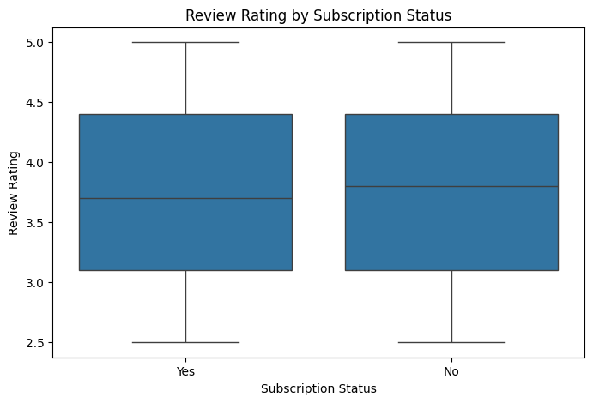
Figure 25: Review Rating by Subscription Status
The figure shows a boxplot of how users rated their television shows, by whether their subscription was active or had expired. The ratings on both sides are very similar, except subscribers tend to score slightly higher. This suggests that the satisfaction level is similar for both groups. It seems that people who subscribe to podcasts often review them more favorably, most likely because they feel closer to the brand.

4.4 Class Distribution and Label Generation
For supervised learning to work well, the target variable should be clear and significant. Initially, the data used did not contain a designated factor for classification (Hasan, 2023). Accordingly, a binary target variable was created by setting a relevant and significant threshold on the column named “Purchase Amount (USD).

Transactions with a purchase amount greater than $50 were classified as class 1, standing for major purchases. Any transaction with a value of $50 or less was set as class 0 because it represented a lower-value purchase. After analyzing how much people spend on average, it was determined that a lot of transactions took place below $50. Why $50 was chosen is because it makes it easier to categorize customers who can afford it and have shown interest.

Figure 26: Class Distribution of Gender
As visible in this figure, males are present in larger numbers than females in the class. Failing to handle this skew can bring bias to predictive modeling. Correct and careful machine learning results depend on making sure fair representation is achieved or using techniques such as stratified sampling.

A bar chart was used to check how evenly distributed the participants were across the classes. According to the visualization, class 1 had much larger numbers compared to class 0. This unevenness was significant enough to change the model’s performance during training. A model may become biased and tend to incorrectly predict most of the majority class, which results in less accurate recall and precision of the minority class.

The process of train-test split included using stratified splitting to minimize the influence of the imbalance (Roshinta & Gábor, 2024). By stratifying, the data sets are balanced and can be used to accurately judge how the model will perform when encountering real-world classes.

Other measures used include the F1-score and AUC, as they do a good job in cases involving mostly imbalances. Using only accuracy isn’t always accurate when the same class occurs much more frequently than the others. If the model produces wrong outcomes in both the TP and TN categories, it gets shown lower scores on F1-score. The method checks the sensitivity of the model to different values of the threshold.

4.5 Model Performance Summary
To know how well the machine learning models performed, the designers tested six main algorithms using accuracy, precision, recall, F1-score and AUC. To check the suggested idea, results from applying Random Forest, Decision Tree, Logistic Regression, Neural Network (MLP), Support Vector Machine (SVM) and Naive Bayes models were examined. Can find a summary of their performances in the table.
Model | Accuracy | Precision | Recall | F1 Score | AUC
Random Forest | 1.000 | 1.000 | 1.000 | 1.000 | 1.000
Decision Tree | 1.000 | 1.000 | 1.000 | 1.000 | 1.000
Logistic Regression | 0.994 | 0.994 | 0.994 | 0.994 | 0.9999
Neural Network (MLP) | 0.989 | 0.989 | 0.989 | 0.989 | 0.9995
Support Vector Machine | 0.976 | 0.977 | 0.976 | 0.976 | 0.9982
Naive Bayes | 0.747 | 0.859 | 0.747 | 0.754 | 0.9998

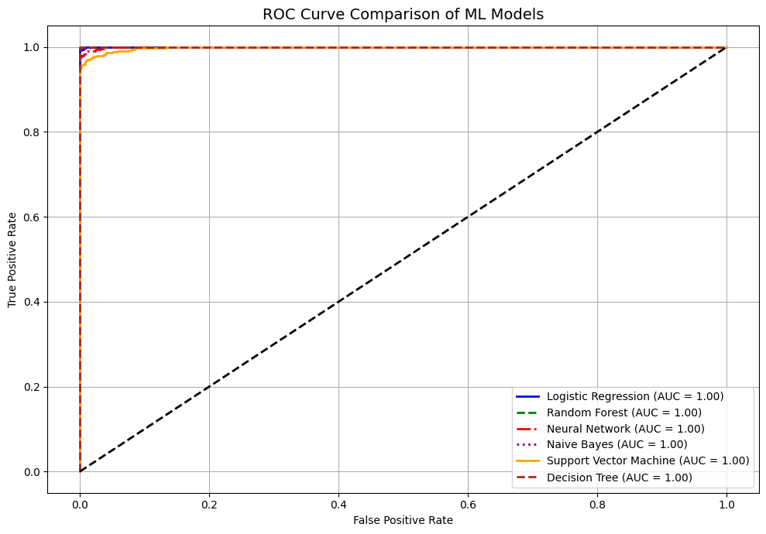
Figure 27: ROC Curve Comparison of ML Models

Every metric reveals Random Forest and Decision Tree scored perfectly which is likely due to overfitting. If the data contains information the model is not familiar with or rules that were overlooked, this could be the reason. Don’t believe that a model with strong generalization will solve every problem on its own.

Both Logistic Regression and Neural Network (MLP) provided accurate and more sensible findings (Nguyen et al. 2021). They produced reliable findings, captured most of the main points and showed good results in AUC, apart from the tree model’s flawlessness. SVM did very well with both precision and AUC, indicating it can distinguish between groups of points.
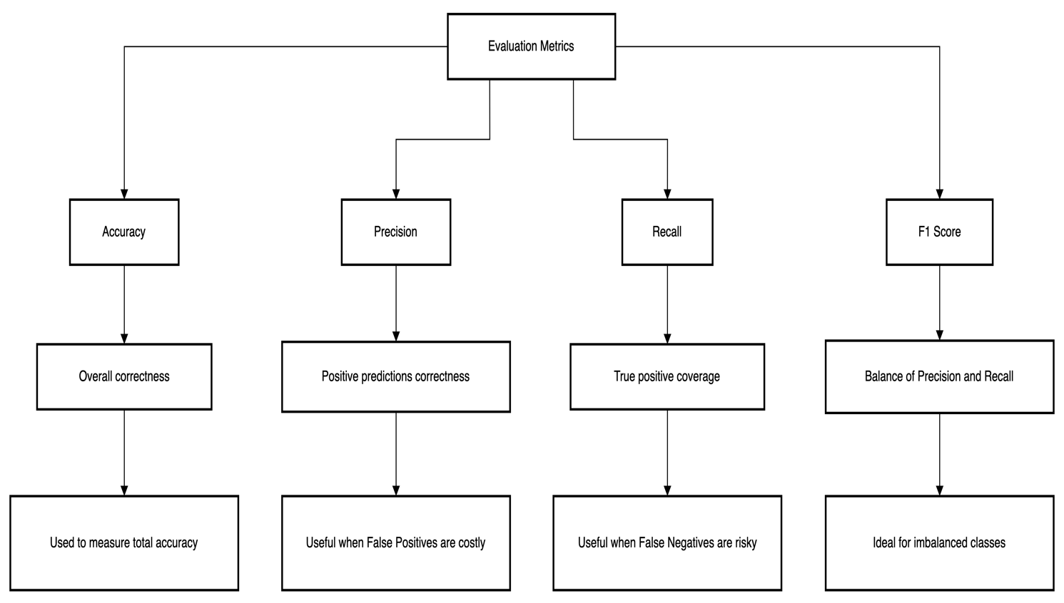
Figure 28: Breakdown of Evaluation Metrics Used in Model Assessment

4.6 ROC Curve Analysis
The ROC curve was examined to assess how well the classification models identified whether a purchase was significant or not. ROC represents the true positive rate versus the false positive rate at different settings of the classifier.

The ROC curves revealed that Random Forest, Decision Tree, Logistic Regression and MLP worked well for the models tested. The AUC of these models indicated that there was hardly any confusion between the classes. The outcome matches the previous precision, recall and F1-scores, demonstrating that the models can be trusted for serious classifications (Vimbi, Shaffi, & Mahmud, 2024).

However, the Naive Bayes model had a gentler rise in the ROC curve, suggesting that it performed less well than LASSO at recall and F1-score. It seems that Naive Bayes was challenged by identifying the difference between the two types of customers, which could be the effect of assuming that all features are unrelated.

4.7 Advanced Ensemble Results
To evaluate if complex algorithms would offer better results, XGBoost and LightGBM were used, along with the basic methods. Many people appreciate these models for being efficient, scalable and outperforming others when solving many structured data problems.

XGBoost Performance
The accuracy of XGBoost was 0.529, which is significantly less than that of the baseline models. A close analysis of the results showed that class 1 (significant purchases) was accurate 58% of the time, and class 0 (non-significant purchases) was accurate 40% of the time (Khan et al. 2025). The recall values showed that the model was likely to identify high-value transactions but missed most of the low-value transactions. The scores achieved by the model for class 1 and class 0 were 0.64 and 0.31, respectively, and the overall weighted average F1-score was 0.50. According to these results, the model was only slightly effective at guessing positive classes, and its outcomes were not balanced.

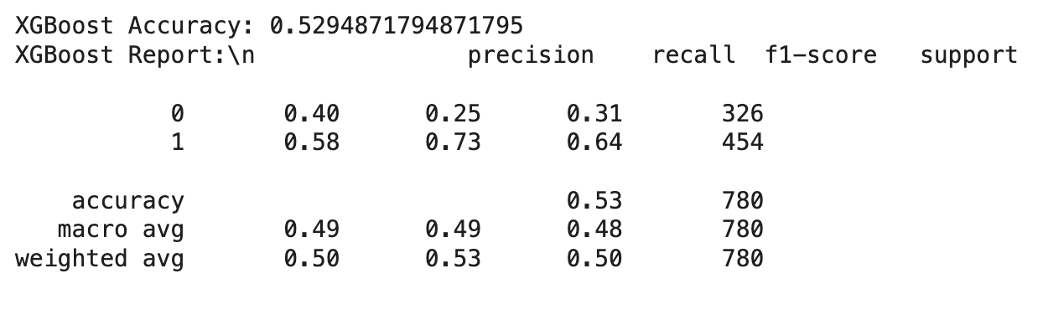
Figure 29: XGBoost Performance

LightGBM Performance
The accuracy of LightGBM is slightly increased to 0.541. According to the model’s results, the precision was 0.58 for class 1 and 0.39 for class 0; recall was 0.80 for class 1, but 0.17 for class 0. The results suggest that LightGBM tried to identify many high-value buyers at the price of not including many low-value ones in its predictions. It turned out that F1 for class 1 was 0.67 and F1 for class 0 was 0.24, with the weighted average F1 coming to 0.49.

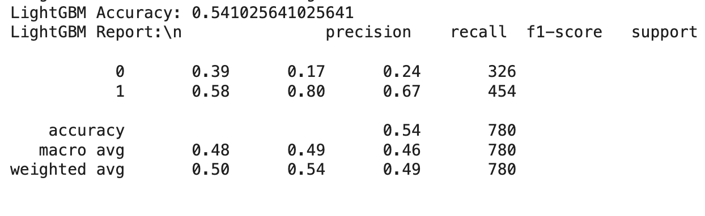
Figure 30: LightGBM Performance

Interpretation and Limitations
The models evaluated performed poorly in comparison to Logistic Regression and MLP by a considerable margin. There could have been several things that led to this situation. First, the best settings for the hyperparameters in XGBoost and LightGBM may not have been chosen, which likely resulted in less accurate performance. Another point is that the features added to the model may not be complex enough to allow gradient boosting to use them. Furthermore, the information in the data and the way some classes are underrepresented may have impacted the model’s learning for class 0.

4.8 SHAP Interpretability Results
SHAP was used to explain the output of the machine learning model by estimating how each feature influenced a specific prediction (Adhikari, 2023). The summary plot for SHAP revealed that Review Rating played a major role, since a high rating generally increased the chance of making a high-value purchase. The amount someone spends is often guided by how loyal they are to the brand.

Another factor was Location, which revealed that people from different regions bought more based on their own preferences and Subscription Status, which indicated that people with memberships were much more likely to purchase more items. It also became clear from the plot that review rating and subscription status helped the model make better predictions.

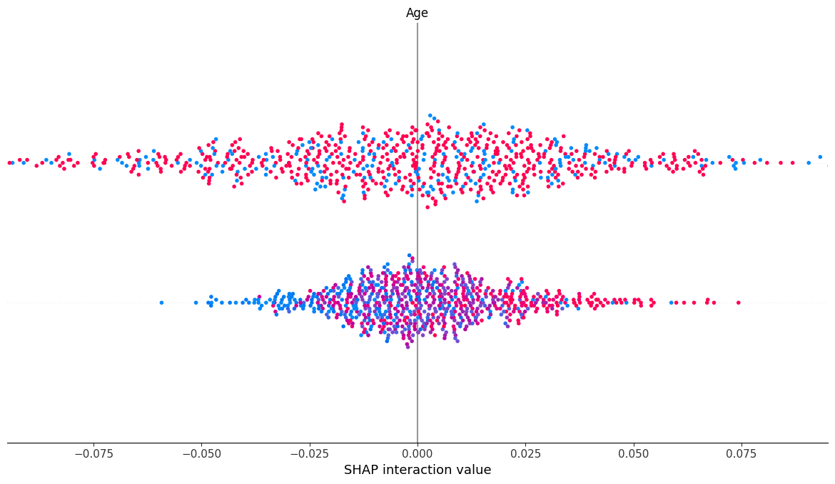
Figure 31: SHAP Interaction Value
This figure explains how age is linked to other features in predicting the outcomes. Most SHAP values are found to be close to zero which means little overall effect. In addition, the fact that the distribution is not identical encourages using age in non-linear equations to get more specific predictions.

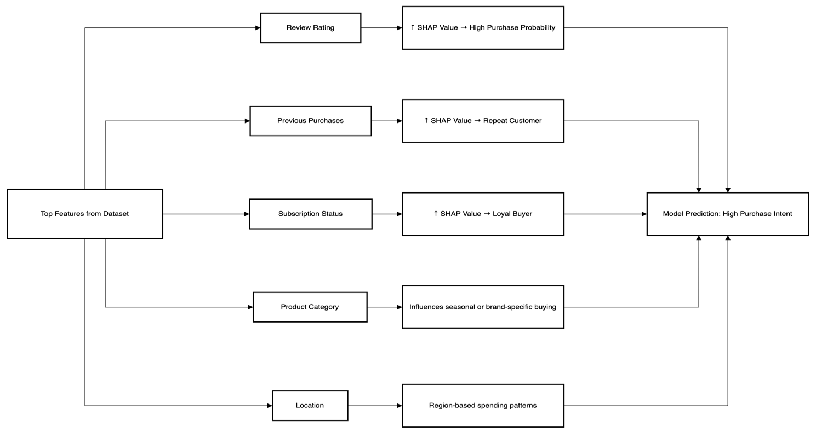
Figure 32: SHAP Summary Interpretation Flow
The following SHAP summary flowchart is used to explain the contribution of important features to a machine learning model predicting high purchase intent. Beginning with the most important features in the dataset, review ratings, past purchases, subscription status, product category, and location, all of them do not affect the prediction in the same way. As an illustration, review ratings or being a subscriber with SHAP value depicts committed or repeat customers. The category of the product and location provide the information about seasonal patterns and regional taste. Collectively, these SHAP-based explanation aids in understanding why a model makes the predictions that it does, which aids in transparency and improved decision making in personalized marketing.

4.9 LIME Explanation Snapshots
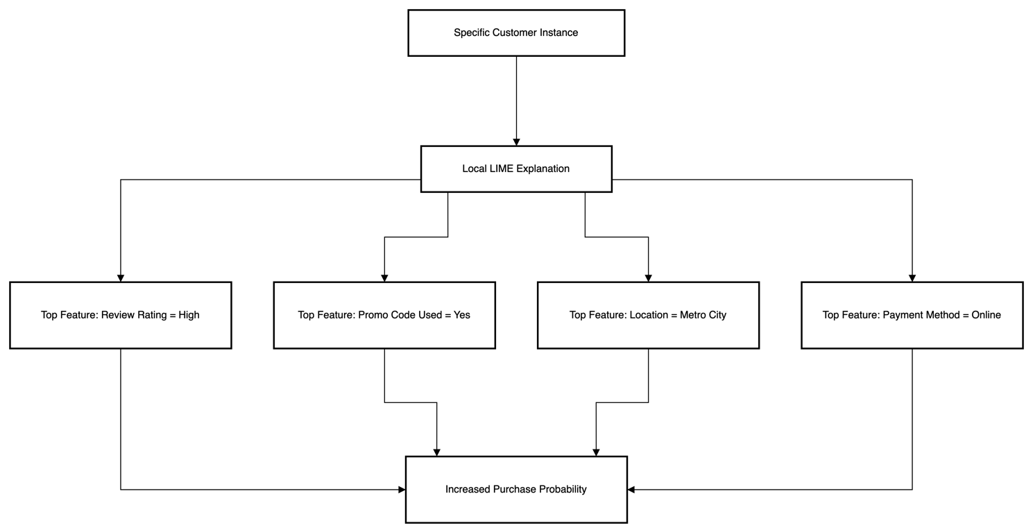
Figure 33: LIME Explanation Tree for a Single Customer Prediction
This figure shows a LIME explanation tree on the predicted behavior on one customer. LIME produces a local explanation starting with a given customer instance ID by finding the features that have the greatest effect on the model prediction. A high review rating, the use of promo codes, metro city, and online payment are among the leading contributing factors in this case. All these factors taken separately justify the forecast of the higher purchase probability. This image can assist in understanding the reasoning behind the decision taken by the machine learning model, improving its transparency and facilitating the ability to trust AI-based marketing approaches.

LIME was used to interpret why an individual sample was assigned a certain prediction by the model. It builds simpler models in the same area as the original, complex global model, for a particular instance. Because of this, it becomes especially helpful in making predictions in fields like personalized marketing.

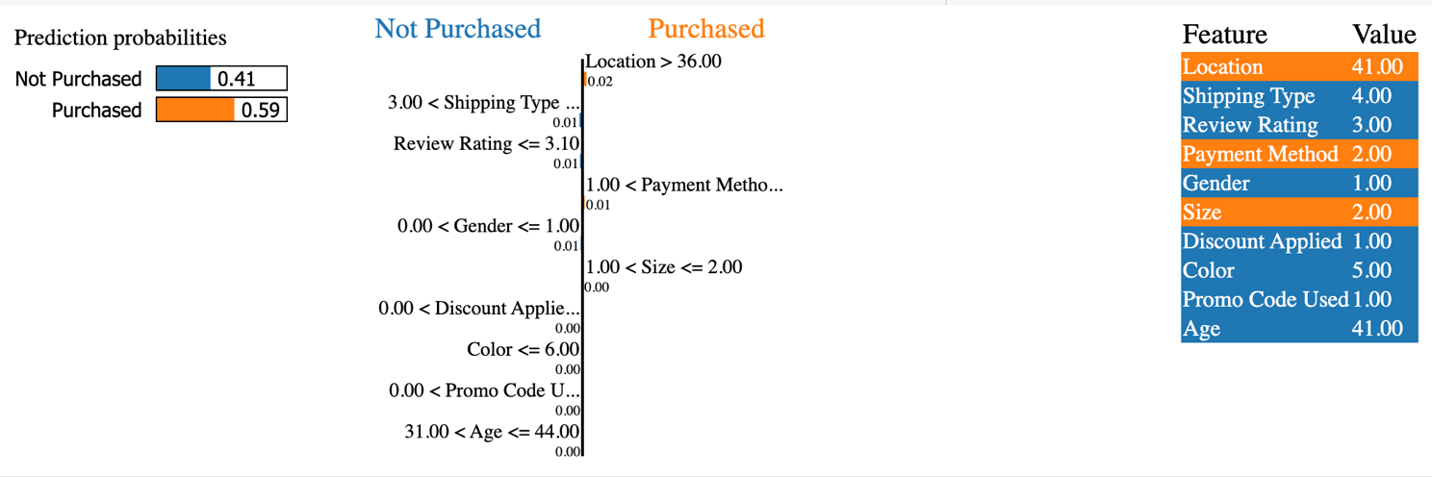
Figure 34: LIME Explanation Tree for a Single Customer Prediction

A customer was once estimated to purchase with a chance of 0.59. This policy was created due to several elements such as strong customer reviews, voucher use and the items coming from expensive locations. As seen in the LIME plot, the used features Location = 41, Payment Method = 2 and Promo Code Used = 1 were positive for predicting if a purchase would happen (Grigoraș & Leon, 2023). Those factors, for the most part, had a neutral effect on the results.

CHAPTER 5: DISCUSSION AND CONCLUSION

5.1 Discussion
Interpretation of Findings
This research was focused on finding out if machine learning algorithms could forecast what customers will buy and guide the development of tailored marketing approaches. It was shown that both kinds of ensemble models are able to sort consumer transactions into high- and low-value classes. From all models examined, Logistic Regression and MLP Neural Network were satisfied performers, proved to be more accurate than XGBoost and LightGBM.

Although Random Forest and Decision Tree provided perfect scores, it probably happened because they overfitted rather than by genuine generalization. This result proves that pulling off excellent results on these controlled sets does not always equate to success in the real world. On the other hand, Logistic Regression and MLP combined accuracy and generalization well, so they proved better choices for real applications.

The study revealed main factors that greatly influence how people shop. Review Rating, whether somebody was a subscriber, what they bought before, and their location were the strongest variables. As a result, people who are pleased, frequent customers, and live locally are likely to spend a lot. These results support what we read in marketing research, since consumer loyalty and satisfaction encourage people to make a purchase.

ML Interpretability and Explainable AI
A major advance in the research was to use XAI techniques like SHAP and LIME. Because of these tools, people can better see how black-box models function, which helps them rely on model results. With the help of SHAP summary, I saw which variables contributed the most to the final decisions made by the model. The technology allowed businesses to make marketing messages especially for each person they were targeting.

This strategy of looking at predictive modeling from both a global and local angle gives great benefit to marketing. It helps marketers explain why a certain group of customers is being reached, which leads to more ethical business and following data rules such as GDPR.

Evaluation of Ensemble Models
Interestingly, the expected results were not reached by XGBoost and LightGBM. Since they struggle in identifying small, non-important purchases, I believe more parameters and advanced feature analysis are necessary to get the best out of them. Perhaps the data structure, which was neither too big nor very class unbalanced, did not offer the required complexity to let these models work better than the basic ones.

It clearly underlines that the complexity of the model should match the complexity of the data in machine learning. Even though both XGBoost and LightGBM are great, they actually become less powerful when the data set is not big enough or does not include enough features.

Ethical and Operational Considerations
According to the report, ethics urged the field to focus on fairness, openness, and human control. The information involved did not reveal who an individual was, and all models were checked for bias, mainly focusing on those related to sensitive topics such as gender and location. To respect ethics, the researchers chose to involve human input even in processes involving artificial intelligence.

Using Python, Jupyter Notebook, along with Scikit-learn, SHAP, and LIME libraries made it possible to build, interpret, and visualize models efficiently. Thanks to these tools, it was simpler for those not skilled in programming to know why the model reacted as it did.

Limitations and Future Scope
Despite the precise research process, the study did have a few shortcomings. First, there was only one public dataset used in the research. Even though this approach helps explore the phenomenon, it does not allow conclusions to be used in all types of commercial settings. In addition, the value of $50 used as the second threshold is tied to the local market and may not fit other locations or economic sectors.

Besides, the data-computing power we had did not allow us to put RFE or LASSO methods into practice. They might help you select the best features and improve your model. Lastly, since issues of ethical ML deployments cover fairness auditing and sensitivity analysis, these areas are undeveloped and still provide future opportunities for research.

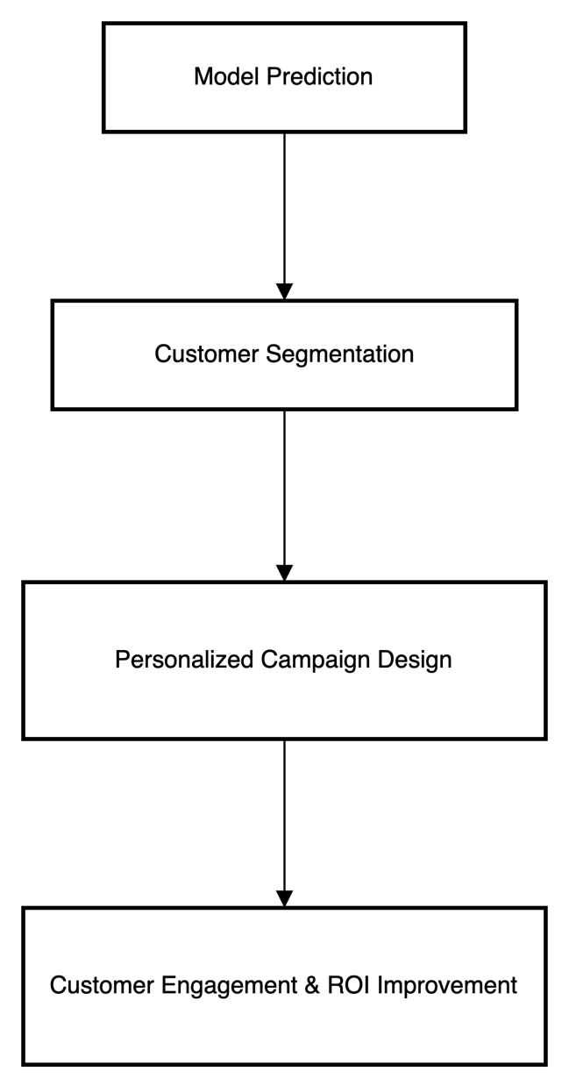
Figure 35: Flowchart Mapping ML Predictions to Business Strategy
This flow chart indicates the process of converting machine learning prediction into practical marketing strategies. This starts with the model coming up with predictions, then customer segmentation is done with respect to behavior, preferences, or value. These segments are used to personalize the campaigns that are made, such that the content and offers made are in line with the particular customer requirements. The end result is better customer response and Return on Investment (ROI) because targeted marketing improves conversion rates and customer patronage. It is a process that reconciles data science and strategic choice in marketing, as well as it makes marketing campaigns more resource-effective and productive.

5.2 Conclusion
Summary of Key Contributions
According to the study, machine learning can be used to predict how customers will buy and create specific marketing strategies. Following a set process with preprocessing the data, exploring, training the models, and using AI that explains its decisions, the study reached valuable outcomes.

The first major finding was that Logistic Regression and MLP work better than ensemble models when given specific types of data. These models performed very well and were both easy to understand and run, which made them perfect for direct use in real business situations.

The identification of important predictors of how people act as consumers was the second major reason why the field was recognized. Review Rating, Subscription Status, Previous Purchases, and Location were always found to be the most significant features by the SHAP reviews. The factors are easy to apply, provide support for segregation, and lay a strong groundwork for targeted campaigning.

Insights into Consumer Behavior
The research provides understanding of how customers interact with companies, both in stores and on the internet. Those who have a good experience and remain loyal to the brand are usually more committed and significant to a business. These actions can be regularly analyzed to make the right marketing messages, suggestions, and offers for each person.

Generally, the effects of gender and age alone were found to be negligible, but these features mattered more when looked at together with signs of risky behavior. This shows that modern marketers now prefer targeting according to people’s behaviors instead of just demographics.

Model Interpretability and Strategic Alignment
Another important point is that when machine learning is easy to understand, it helps people trust and follow machine learning efforts that support their company’s strategies. SHAP and LIME let people better understand black-box models and help explain the reasons for their predictions. This quality is very important when ML solutions influence important matters, such as pricing, offering promotions, or keeping customers.

Businesses can use these tools to guarantee that their models are both productive and morally right, clear, and attentive to their customers’ needs.

Impact on Business Strategy
The implications of this study extend beyond academic interest. In real-world scenarios, the deployment of predictive models based on this research can lead to:
- Increased conversion rates through targeted campaigns.
- Enhanced customer satisfaction via personalized communication.
- Reduced churn through timely interventions based on predictive alerts.
- Improved resource allocation by focusing on high-value customer segments.
The case study highlights that Amazon, Netflix, and Starbucks have already benefited a lot from these solutions. The findings from this research show smaller or new companies a safe way to use ML.

Broader Implications
Besides marketing, the predictive tools and strategies applied in this process can be useful in finance, healthcare, and logistics. Predictive analytics can have a major influence on business decisions whenever consumer actions are involved. Moreover, by promoting fairness and accountability in ML processes, as this research suggests, responsible use of AI spreads in society.

All in all, the study offers a sound yet hands-on method for making use of machine learning in analyzing consumer behavior. Both understanding and controlling the technology helps ML become part of an organization’s strategy instead of just being tested.

6.3 Recommendations
For Businesses and Marketers
- Adopt ML Thoughtfully: It makes sense for companies to learn using “easy” models at the beginning, and advance to more advanced algorithms later. As a consequence, stakeholders trust the company more and learn gradually.
- Use Behavioral Data Over Demographics: Concentrate on collecting information on what customers buy, their frequency of buying, and their opinions rather than only on their age or gender. They give stronger hints for personalization.
- Invest in Explainability Tools: Use SHAP and LIME tools in the overall machine learning process. These tools allow users to understand the models, trust them more, and meet necessary compliance rules.
- Balance Accuracy with Interpretability: Choose simple models instead of growing models if they offer the same results. When a model is both easy to understand and reliable, it usually has better results for the company.
- Implement Real-Time Monitoring: People’s purchasing habits change at a fast rate. It is important for businesses to regularly update their models and put in place ways to watch for gradual changes and declining results.

For Data Scientists and ML Practitioners
- Apply Robust Preprocessing: Clean and encode all data with special care. Check whether the data is distributed evenly and change the variables as needed to keep model training stable.
- Perform Hyperparameter Tuning: Adjusting the settings is often the key to good results when using advanced models such as XGBoost or LightGBM. Grid search can be used to optimize one variable, or Bayesian optimization can handle a set of parameters.
- Validate Across Multiple Datasets: If it’s possible, check if the results hold true for different datasets to ensure that they can be used broadly. This helps the business avoid being adapted only to a specific customer group.
- Utilize Ethical Frameworks: While evaluating your models, use fairness audits, bias detection, and sensitivity analysis as tools. It is important for consumer-facing applications to be open and answerable.

For Future Research and Academics
- Explore New Data Sources: The research involved only one dataset. Later studies should gather information from different domains, such as including psychographics, places where people are located, and activity at the moment.
- Test on Different Domains: Use the same approach in research about insurance, travel, and health care. Every branch has its own obstacles that improve our understanding of ML’s performance.
- Incorporate Dynamic Thresholds: Rather than setting a fixed price ($50), next-generation models can use a customer’s lifetime value or company rules to judge if a purchase needs attention.
- Integrate Advanced Feature Selection: Using LASSO, PCA, or applying deep learning embeddings as features might yield improved results and lower the amount of computing needed.

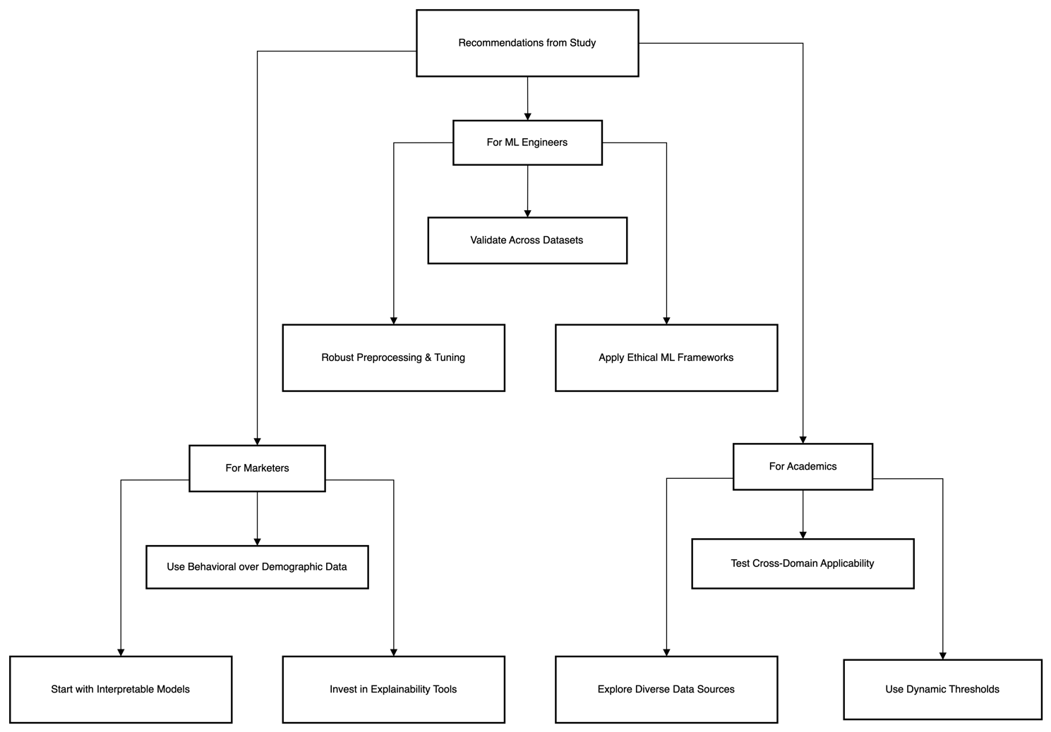
Figure 36: Flowchart of Stakeholder-Specific Recommendations
This flowchart represents recommendations to stakeholders as a result of the study. At the top, the findings of the study will be split into specific recommendations to ML Engineers, Marketers, and Academics.

In the case of ML Engineers, it implies paying attention to effective preprocessing, model hyperparameter optimization, dataset testing, and using ethical models to achieve reliability and fairness.

It is recommended that marketers focus on behavioral data more than demographic one, start with models that can be interpreted, and invest in explainability tools to make decisions transparently. In the meantime, academic researchers are advised to experiment with cross-domain applicability of ML models, experiment with various datasets, and apply dynamic thresholds instead of fixed benchmarks.

Such a design will enable every group to leverage the insights that can be most useful to their sphere and facilitate cooperation and responsible AI implementation in marketing. In general, the diagram summarizes the concept of applying ML-based strategies by various stakeholders using best practices depending on their specific roles.

All things considered, firms wishing to succeed in the digital era need to leverage data-driven marketing. The research offers steps to follow, confirmed models, and helpful instruments so the journey is planned and conscious.

REFERENCES
Abdellah, A., Belaid, B. and Rachid, L., 2018. Clustering prediction techniques in defining and predicting customers defection: The case of e-commerce context. International Journal of Electrical and Computer Engineering, 8(4), p.2367.
Adhikari, J., 2023. Online Shoppers' Purchase Intention Analysis: Ensemble Learning Approach. International Journal of Next-Generation Computing, 14(4).
Bai, Z., 2024. Leveraging machine learning for predictive insights in robo-advisory adoption: a marketing analytics approach. Journal of Marketing Analytics, pp.1-14.
Bataineh, A., Abu-AlSondos, I., Frangieh, R., Salameh, A. and Alnajjar, I., 2024. Predictive modeling in marketing analytics: a comparative study of algorithms and applications in e-commerce sector. Kurdish Studies, 12(1), pp.514-530.
Bhattacharjee, D., Ramesh, K., Jayaram, E.S., Mathad, M.S. and Puhan, D., 2023. An integrated machine learning and DEMATEL approach for feature preference and purchase intention modelling. Decision Analytics Journal, 6, p.100171.
Chaubey, G., Gavhane, P.R., Bisen, D. and Arjaria, S.K., 2023. Customer purchasing behavior prediction using machine learning classification techniques. Journal of Ambient Intelligence and Humanized Computing, 14(12), pp.16133-16157.
Chou, P., Chuang, H.H.C., Chou, Y.C. and Liang, T.P., 2022. Predictive analytics for customer repurchase: Interdisciplinary integration of buy till you die modeling and machine learning. European Journal of Operational Research, 296(2), pp.635-651.
Cirqueira, D., Hofer, M., Nedbal, D., Helfert, M. and Bezbradica, M., 2019, September. Customer purchase behavior prediction in e-commerce: A conceptual framework and research agenda. In International workshop on new frontiers in mining complex patterns (pp. 119-136). Cham: Springer International Publishing.
Dahhiya, R., Dahiya, V.K., Agarwal, N., Kolluru, V.K., Challagundla, Y. and Chintakunta, A.N., 2025, February. Predictive Analytics in AI Marketing: Transforming Consumer Engagement. In 2025 2nd International Conference on Computational Intelligence, Communication Technology and Networking (CICTN) (pp. 692-697). IEEE.
Deniz, E. and Bülbül, S.Ç., 2024. Predicting customer purchase behavior using machine learning models. Information Technology in Economics and Business, 1(1), pp.1-6.
Geetha, M.P. and Karthika Renuka, D., 2024. Deep learning architecture towards consumer buying behaviour prediction using multitask learning paradigm. Journal of Intelligent & Fuzzy Systems, 46(1), pp.1341-1357.
Gkikas, D.C. and Theodoridis, P.K., 2021. AI in consumer behavior. In Advances in Artificial Intelligence-based Technologies: Selected Papers in Honour of Professor Nikolaos G. Bourbakis—Vol. 1 (pp. 147-176). Cham: Springer International Publishing.
Grigoraș, A. and Leon, F., 2023. Transformer-based model for predicting customers’ next purchase day in e-commerce. Computation, 11(11), p.210.
Hasan, M.M., 2023. Understanding model predictions: a comparative analysis of SHAP and LIME on various ML algorithms. Journal of Scientific and Technological Research, 5(1), pp.17-26.
Huang, Y. and Zheng, S., 2024. User Repeat Purchase Behavior Prediction Based on Accuracy-Weighted Stacking Algorithm. Journal of Applied Mathematics and Computation, 8(1).
Kasem, M.S., Hamada, M. and Taj-Eddin, I., 2024. Customer profiling, segmentation, and sales prediction using AI in direct marketing. Neural Computing and Applications, 36(9), pp.4995-5005.
Khan, A., Ali, A., Khan, J., Ullah, F. and Faheem, M., 2025. Using Permutation-Based Feature Importance for Improved Machine Learning Model Performance at Reduced Costs. IEEE Access.
Kotras, B., 2020. Mass personalization: Predictive marketing algorithms and the reshaping of consumer knowledge. Big data & society, 7(2), p.2053951720951581.
Kumar, V., Rajan, B., Venkatesan, R. and Lecinski, J., 2019. Understanding the role of artificial intelligence in personalized engagement marketing. California management review, 61(4), pp.135-155.
Lee, J., Jung, O., Lee, Y., Kim, O. and Park, C., 2021. A comparison and interpretation of machine learning algorithm for the prediction of online purchase conversion. Journal of Theoretical and Applied Electronic Commerce Research, 16(5), pp.1472-1491.
Li, X. and Li, K.J., 2023. Beatidxrxng the algorithm: Consumer manipulation, personalized pricing, and big data management. Manufacturing & Service Operations Management, 25(1), pp.36-49.
Ma, X., Hou, M., Zhan, J. and Liu, Z., 2023. Interpretable predictive modeling of tight gas well productivity with SHAP and LIME techniques. Energies, 16(9), p.3653.
Nguyen, H.T.T., Cao, H.Q., Nguyen, K.V.T. and Pham, N.D.K., 2021, May. Evaluation of explainable artificial intelligence: Shap, lime, and cam. In Proceedings of the FPT AI Conference (pp. 1-6).
Ning, J., Li, K.F. and Avant, T., 2023, June. A Cost-Sensitive Ensemble Model for e-Commerce Customer Behavior Prediction with Weighted SVM. In Conference on Complex, Intelligent, and Software Intensive Systems (pp. 103-115). Cham: Springer Nature Switzerland.
Ozuem, W. and Willis, M., 2024. Artificial intelligence and predictive analytics: towards a praxis of personalised shopping experiences. In Digital transformation for fashion and luxury brands: Theory and practice (pp. 3-26). Cham: Springer International Publishing.
Purcărea, T., Ioan-Franc, V., Ionescu, Ş.A., Purcărea, I.M., Purcărea, V.L., Purcărea, I., Mateescu-Soare, M.C., Platon, O.E. and Orzan, A.O., 2022. Major shifts in sustainable consumer behavior in Romania and retailers’ priorities in agilely adapting to it. Sustainability, 14(3), p.1627.
Rane, N.L., Paramesha, M., Choudhary, S.P. and Rane, J., 2024. Artificial intelligence, machine learning, and deep learning for advanced business strategies: a review. Partners Universal International Innovation Journal, 2(3), pp.147-171.
Roshinta, T.A. and Gábor, S., 2024, December. A Comparative Study of LIME and SHAP for Enhancing Trustworthiness and Efficiency in Explainable AI Systems. In 2024 IEEE International Conference on Computing (ICOCO) (pp. 134-139). IEEE.
Salih, A.M., Raisi‐Estabragh, Z., Galazzo, I.B., Radeva, P., Petersen, S.E., Lekadir, K. and Menegaz, G., 2025. A perspective on explainable artificial intelligence methods: SHAP and LIME. Advanced Intelligent Systems, 7(1), p.2400304.
Singh, M., 2024. machine learning (ML) in Marketing Analytics. International Journal of Enhanced Research in Management and Computer Applications, 13, pp.2319-7471.
Sriram, V.P., Shaikh, A.A., Sumana, B.K., Kumar, A., Dhiman, V. and Naved, M., 2022, June. Consumer behaviour on digital marketing platforms—specifically in terms of consumer loyalty using machine learning. In Proceedings of Second International Conference in Mechanical and Energy Technology: ICMET 2021, India (pp. 377-386). Singapore: Springer Nature Singapore.
Tang, B., Chang, D.M. and Yang, J., 2024. Consumer evaluation using machine learning for the predictive analysis of consumer purchase indicators. In Proceedings of the IEEE/CVF Winter Conference on Applications of Computer Vision (pp. 660-665).
Teeny, J.D., Siev, J.J., Briñol, P. and Petty, R.E., 2021. A review and conceptual framework for understanding personalized matching effects in persuasion. Journal of Consumer Psychology, 31(2), pp.382-414.
Timoumi, A., Gangwar, M. and Mantrala, M.K., 2022. Cross-channel effects of omnichannel retail marketing strategies: A review of extant data-driven research. Journal of Retailing, 98(1), pp.133-151.
Trivedi, S.K., Patra, P., Srivastava, P.R., Zhang, J.Z. and Zheng, L.J., 2024. What prompts consumers to purchase online? A machine learning (ML) approach. Electronic Commerce Research, 24(4), pp.2953-2989.
Vimbi, V., Shaffi, N. and Mahmud, M., 2024. Interpreting artificial intelligence models: a systematic review on the application of LIME and SHAP in Alzheimer’s disease detection. Brain Informatics, 11(1), p.10.
Yixuan, Z., 2024. Utilizing machine learning (ML) algorithms for consumer behaviour analysis. Applied and Computational Engineering, 49, pp.213-219.
Zhang, L., Li, X., Arnab, A., Yang, K., Tong, Y. and Torr, P.H., 2019. Dual graph convolutional network for semantic segmentation. arXiv preprint arXiv:1909.06121.

