# SECTION – 1 : Instructions for Standalone installation.

# SECTION – 2 : Instructions for Group Policy based remote installation.

Dependencies: Epson Firmware Update

# SECTION -1

# Instructions for Standalone Installation.

Pre-Installation Process:

Download the Nexxo.Wrapper.Epson.msi in a folder.

Create a text file with the name NexxoConfig.txt files, having the following parameters

ClientID 33

InstallLogFolder G:\LOG\

InstallErrorFolder G:\LOG\

ServiceURL <https://172.18.100.222/Nexxo.Channel.DMS.NpsInstallerServer.Svc_HttpsTest/NpsInstallerWSImpl.svc>

ClientId will be used only during the NPS Installation. The configuration file is common for both installs. Log folder can be a shared location also.

Run Nexxo.Wrapper.Epson.msi.

Wait for 2 to 3 minutes till the Epson Drivers are completely installed.

Once the silent installation of Nexxo Wrapper is completed go to the control panel Add/Remove program files, where you can see the EPSON TM-S9000 Driver, EPSON PDS along with Nexxo wrapper for Epson.

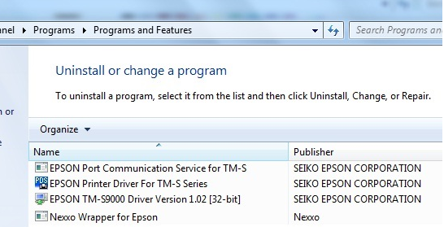

Once the printer is installed check inside printer & Device Manger for Epson TM-S9000 Roll Paper.

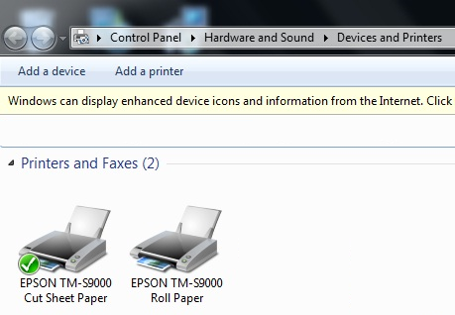

For Uninstall Click on Nexxo.Wrapper.Epson from Add/Remove program files which will also uninstall EPSON PDS as well as EPSON SDK.

# SECTION – 2

# Group Policy Creation for Remote Installation.

Pre-Installation Process:

Remove any existing Epson drivers from the remote systems.

**Shared Location**

To deploy through a group policy management, the server should have a shared read/write folder which can be accessed by all the remote systems.

Create a folder NexxoDeploy and share it across all Users.

Copy the Epson Driver and Nexxo Peripheral Service MSI Packages to this location.

**Nexxo Config**

Create a text file NexxoConfig.txt and add the following entries

Note: All the entries are mandatory and ClientId would be ignored during Epson Driver Installation

ClientID 33

InstallLogFolder G:\LOG\

InstallErrorFolder G:\LOG\

ServiceURL <https://172.18.100.222/Nexxo.Channel.DMS.NpsInstallerServer.Svc_HttpsTest/NpsInstallerWSImpl.svc>

Install and Error Log Folders

Create shared folder for storing the Log Files generated during the Epson Driver and NPS Installation.

Create a folder Logs under NexxoDeploy

**Policy Creation**

**Logon Script**

Nexxo Configuration file has to be copied from server to all the remote systems and a batch script has to be created for the same as follows:

Create a file CopyConfig.bat with the following statements

@echo off

if not exist "%windir%\Temp\NexxoConfig.txt" copy "\\172.18.100.127\\NexxoDeploy\\NexxoConfig.txt" "%windir%\Temp"

Change the IP address in the above line to reflect the server’s IP address. Copy this file to NexxoDeploy.

Open “Group Policy Management”, Right Click on Group Policy Object and Select “New”

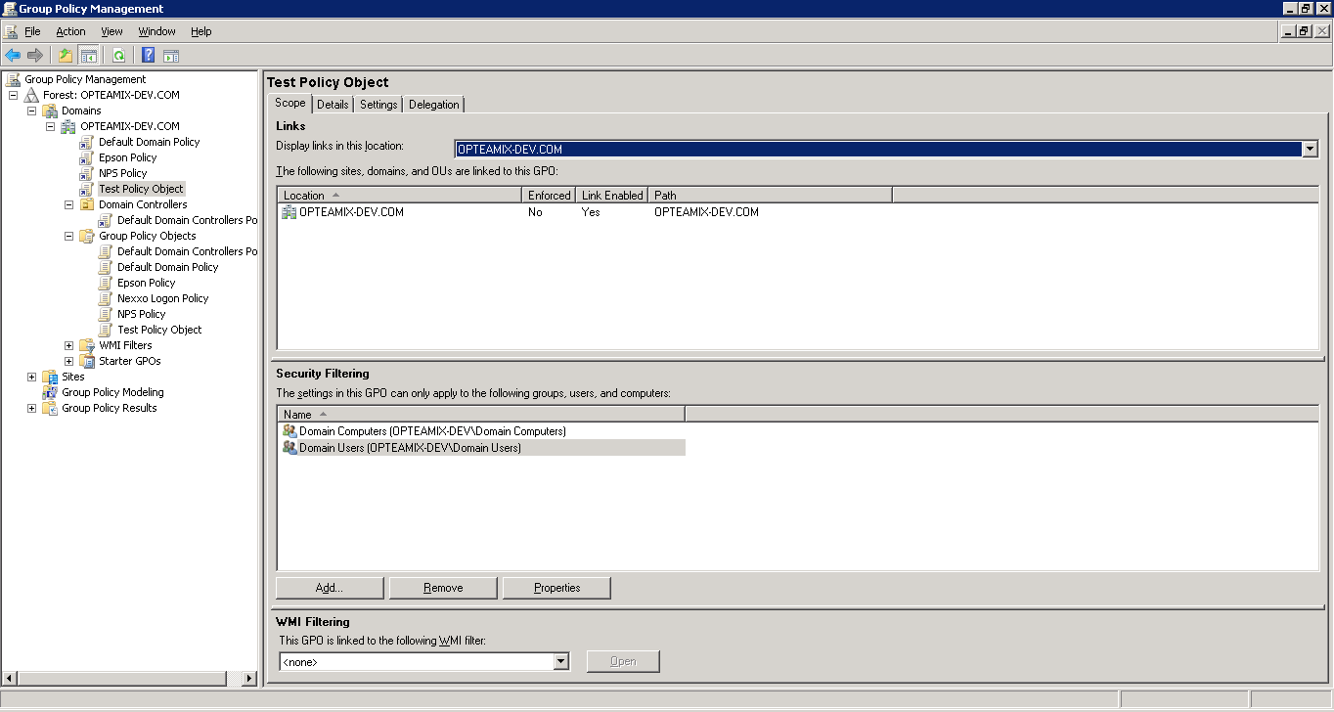

Make the following entry and Click OK

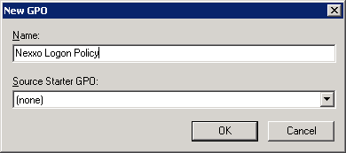

Select the “Nexxo Logon Policy” and check to see in the right pane, Security Filtering to add the remote systems are included. Easy way is to add “Authenticated Users” or “Domain Users” or “Domain Computers”.

Right Click on Nexxo Logon Policy to open the Group Policy Management Editor.

Navigate to Scripts/Startup as shown below

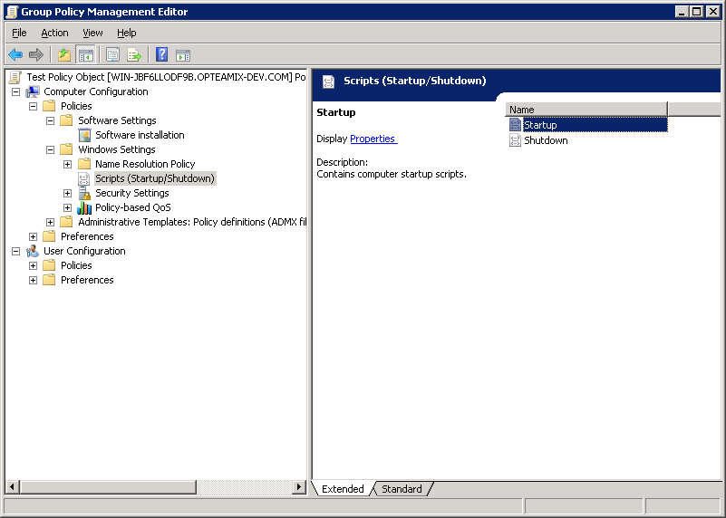

Right Click on Startup and Select properties.

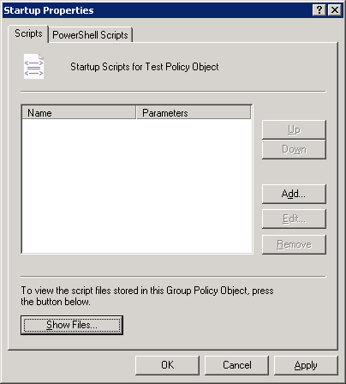

Click on Show Files, which will Open a Folder, where the CopyConfig.bat needs to be copied.

Copy the CopyConfig.bat to above opened folder.

Click on “Add” to open the following window

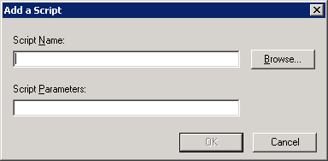

Browse and select the CopyConfig.bat from Scripts/Startup Folder. Click OK to complete the process.

Close the Group Management editor and Go back to Group Policy Management Window.

Select the entry under Domain and right click to select “Link and existing GPO”

Select the Policy that was created earlier (Nexxo Logon Policy)

**Epson Policy**

Similar to above, Create a new Policy Object for Epson, “Epson Policy”

Edit to open Policy Management Editor.

Navigate to Software Installation, Right Click on right Pane to add the “Nexxo.Wrapper.Epson.msi”

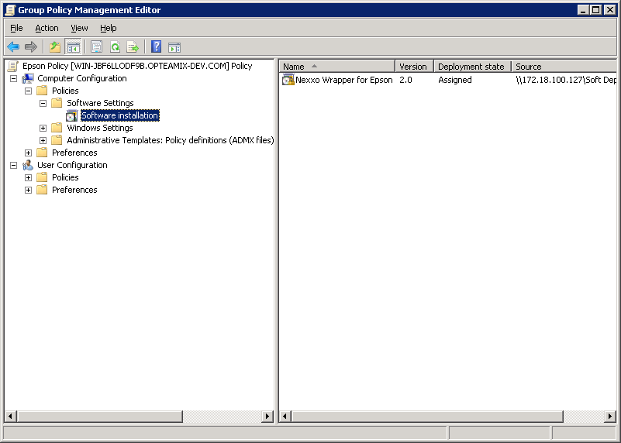

Close the editor window and Link the GPO in Group Policy Management.

Reboot, remote systems.

Note: It will take 2/3 reboots for the group update to happen on remote machines. It can manually done as follows:

On remote systems, command prompt type the following and reboot the system.

Gpupdate /force