# SECTION – 1 : Instructions for Standalone installation.

# SECTION – 2 : Instructions for Group Policy based remote installation.

Dependencies :

**Epson Drivers**

1. Epson SDK Driver
2. Epson PDS Driver

OR

1. Nexxo Wrapper for Epson (which auto installs the above drivers)

The Nexxo Peripheral Service will upgrade any previous versions.

# SECTION - 1

**NPS Silent Installation**

**Step -1**

1. Create a text file with the name NexxoConfig.txt ,which should have the following contents refer below screen shot

ClientID 33

InstallLogFolder G:\LOG

InstallErrorFolder G:\LOG

ServiceURL https://10.111.109.16/Nexxo.Channel.DMS.NpsInstallerServer.Svc.2.4.5-DIT-4/NpsInstallerWSImpl.svc

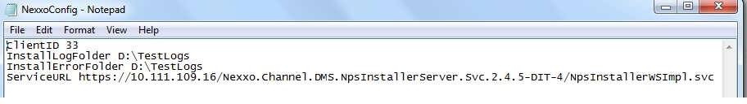

Step - 2

NexxoCofig.txt can be placed either in the following locations:-

1. Inside the same folder of Peripheral.Service.Installer.msi (ex: D:\NPS\)
2. Inside the System root temp directory (ex:- C:\Windows\Temp\)
3. Inside current user temp directory (ex:- C:\Users\ nxo-Test \AppData\Local\Temp\)

Step – 3

1. Then go to the folder where Peripheral Service Installer is place and click on Peripheral.Service.Installer.msi.

Step-4

1. Once the silent installation of Peripheral Service Installer is completed go to the control panel Add/Remove program files, where you can see the Nexxo Peripheral Service Installer.
2. Open Services.msc and check whether Nexxo Peripheral Service is available.
3. Now connect the printer
4. Then re-start the machine.
5. After machine got restarted (if printer is connected) will print the diagnostics.

Note : Logs of the installation will be available inside the LogFolder which is mentioned inside NexxoConfig.txt.

1. Nexxo Peripheral Service Installer will update if any previous versions is already available in the same machine. So no need to uninstall already existing NPS installer.

(Older Version of NPS)

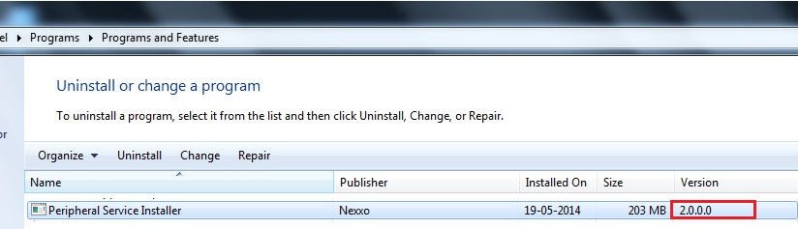

(Newer version of NPS without uninstalling the old version i.e 2.0.0.0)

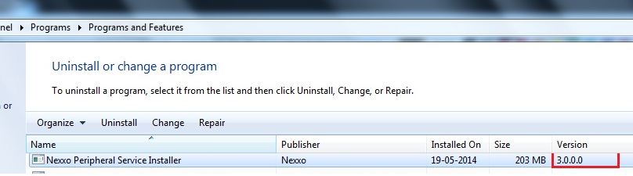

# SECTION – 2

**NPS Policy**

Similar to above, Create a new Policy Object for Epson, “NPS Policy”

Edit to open Policy Management Editor.

Navigate to Software Installation, Right Click on right Pane to add the “Peripheral.Service.Installer_Win7.msi”

Close the editor window and Link the GPO in Group Policy Management.

Reboot, remote systems.

Note: It will take 2/3 reboots for the group update to happen on remote machines. It can manually done as follows:

On remote systems, command prompt type the following and reboot the system.

Gpupdate /force

Screenshots for doing the exact process is available as part of Epson Driver Installation Procedure.