**New ZEO Platform Functionality**

Now we can get the Retail Banking Support (RBS) details easily from the ZEO application by selecting the “Contacts” option from the “Help?” menu.

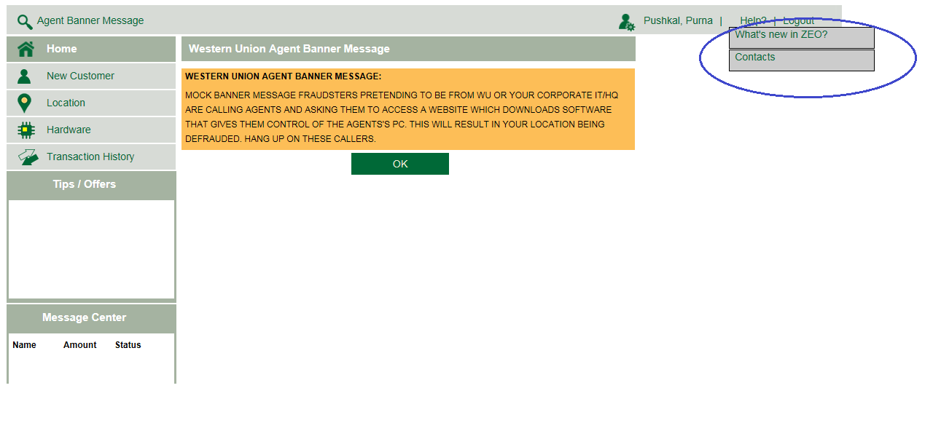

With this we will be able to see the RBS details of the branch based on the region with the provider contact details also which will be same for all the regions. This contacts section is accessible across the application and can be viewed at any time. For example, if the location belongs to the Minnesota region we will display the RBS details related to that region. Below are the screen shots of contact help details for all the regions.

**Minnesota Region:**

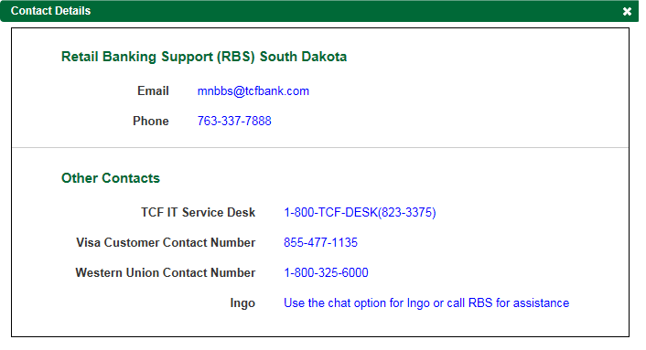

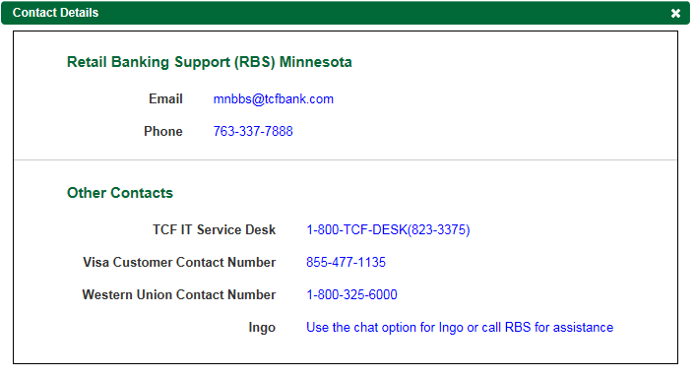

**Michigan Region:**

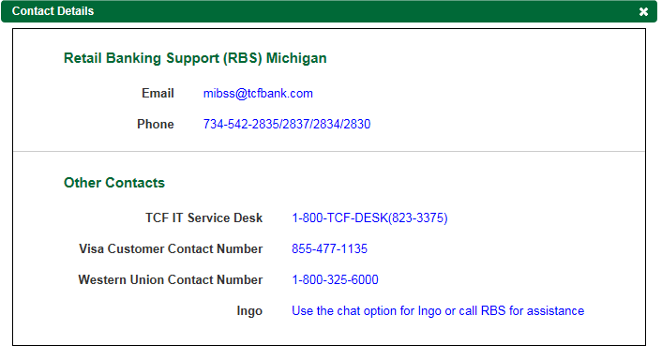

**Lakeshore Region:**

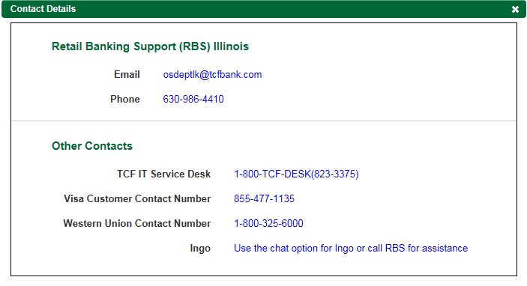

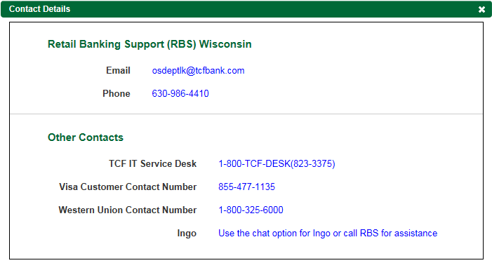

**Mountain West Region:**

