***“BLUETOOTH CONTROLLED FLOOR CLEANING ROBOT”***

**DESIGN PROJECT**

***Submitted by***

***ABHIJITH P D LIDK17EC058***

***SANGEERTHANA RAJ IDK17EC047***

***MUHAMMED MUFEED M IDK17EC032***

***SALMANUL FARIS P K IDK17EC045***

***In partial fulfillment for the award of the degree of***

***Bachelor of Technology***

**in**

***ELECTRONICS***

***AND COMMUNICATION***

**of**

**APJ ABDUL KALAM TECHNOLOGICAL UVIVERSITY**

**KERALA**



**GOVERNMENT ENGINEERING COLLEGE IDUKKI**

**PAINAVU 685 603**

**September 2017**

**GOVERNMENT ENGINEERING COLLEGE IDUKKI**

**PAINAVU 685 603**



**CERTIFICATE**

This is to certify that the project design document entitled ***" BLUETOOTH CONTROLLED FLOOR CLEANING ROBOT "*** is a bonafied record of the Design Project presented by ***ABHIJITH P D (LIDK17EC058),SANGEERTHANA RAJ( IDK17EC047),MUHAMMED MUFEED M (IDK17EC032),SALMANUL FARIS P K (IDK17EC045)*** in partial fulfillment of the requirements for the award of the Degree of Bachelor of Technology in Electronics and communication of APJ Abdul Kalam Technological University, Kerala.

**DECLARATION**

I hereby declare that the design of the project titled ***“BLUETOOTH CONTROLLED FLOOR CLEANING ROBOT”*** being submitted in partial fulfillment for the award of B.Tech degree is the original work carried out by us. It has not formed the part of any other thesis submitted for award of any degree or diploma, either in this or any other University.

***ABHIJITH P D LIDK17EC058***

***SANGEERTHANA RAJ IDK17EC047***

***MUHAMMED MUFEED M IDK17EC032***

***SALMANUL FARIS P K IDK17EC045***

**ACKNOWLEDGEMENTS**

It is our privilege to express our sincere gratitude and deep indebtedness to the people who helped me to complete the thesis successfully.All glory and honours to Almighty God,who showered his grace upon me to make this endeavour a success.

I express my gratitude to Dr.HARIS P A, Head of Departmen of Electronics and Communication Engineering, Government Engineering College for his valuable suggestions , advice and encourage ment through out this project.

This project would have not been completed without the proper guidance and constant encouragement provided by our project supervisor Dr.ALEX RAJ S M Department of Electronics and Communucation Engineering , Government Engineering College, Idukki.

I express my gratitude to our project advisor Professor Salih Sulaiman, Department of Electronics and Communication Engineering, Government Engineering College for his valuable suggestions, advice and encouragement throughout this project.

I also wish to express my gratitude to all our teaching and nonteaching staff of Electronics and Communication Engineering, Government Engineering College, Idukki for their valuable support and help. I also thank my friends for their support and valuable suggestions. Lastly, I express my sincere thanks to all those who directly or indirectly have supported me in all the stages for the completion of this thesis.

**ABHIJITH P D**

**SANGEERTHANA RAJ**

**MUHAMMED MUFEED M**

**SALMANUL FARIS P K**

**ABSTRACT**

Robot is an electromechanical machine and used for various purposes in industrial and domestic applications. Robot appliances are entering in the consumer market, since the introduction of iRobots. Many related appliances from various companies have been followed. Initially the main focus was on having a cleaning device. As the time pass on many improvements were made and more efficient appliances were developed. In early, 2010 a new automatic floor cleaner robot “Mint” was developed by Jen Steffen. Detachable clothes were attached for sweeping and mopping purposes. For tracking mint used the GPS-like indoor localization system.

**INTRODUCTION**

Robot is an electromechanical machine and used for various purposes in industrial and domestic applications. Robot appliances are entering in the consumer market, since the introduction of iRobots. Many related appliances from various companies have been followed. Initially the main focus was on having a cleaning device. As the time pass on many improvements were made and more efficient appliances were developed.

In early, 2010 a new automatic floor cleaner robot “Mint” was developed by Jen Steffen. Detachable clothes were attached for sweeping and mopping purposes. For tracking mint used the GPS-like indoor localization system.

A floor cleaner robot based on Arduino UNO have been developed. Atachable mop is used for mopping. Unlike other floor cleaner robots this is not a vacuum cleaner robot,it performs sweeping and mopping operation. It works on 12V supply.The cleaning action is controlled by bluetooth module.

In the manual mode, user itself operates the robot.

Bluetooth module have been used to transmit and receive the signal for controlling the robot through the phone by the user itself.Therefore user can move the robot in the desired direction.

**MATERIAL REQUIRED**

**\* ARDUINO UNO**

**\* DOUBLE SHAFT MOTORS**

**\* MOTOR DRIVER**

**\* SERVO MOTOR**

**\* BLUETOOTH MODULE**

**\* MOTOR SHIELD**

**1.BLUETOOTH MODULE**

Bluetooth wireless technology is a 2.4GHz ISM-band open industry standard for short range wireless communication, which is capable of voice and data transfer .In this document, the SEMCO-Bluetooth Modules are presented, which consists of RF, base band and link manager protocol together with Host Controller Interface(HCI) / HCI-UART functionality implemented according to the Bluetooth specification version 1.1.SEMCO-Bluetoth Modules are designed for use as an universal Bluetooth module compliant for the Bluetooth specification version 1.1, which can be applied to hand-held phones, PDAs, headsets, PCs and PCperipherals, et cetera for wireless voice and data communication. Bluetooth essentially aims to fix this problem. This is considered a cable-replacement technology.

**2.SERVO MOTER**

**A** servo motor is an electrical device which can push or rotate an object with great precision. If you want to rotate and object at some specific angles or distance, then you use servo motor. It is just made up of simple motor which run through servo mechanism. If motor is used is DC powered then it is called DC servo motor, and if it is AC powered motor then it is called AC servo motor. We can get a very high torque servo motor in a small and light weight packages. Doe to these features they are being used in many applications like toy car, RC helicopters and planes, Robotics, Machine etc

**3.MOTOR DRIVER**

Motor drives are circuits used to run a motor. In other words, they are commonly used for motor interfacing. These drive circuits can be easily interfaced with the motor and their selection depends upon the type of motor being used and their ratings (current, voltage).

**4.DOUBLE SHAFT MOTOR**

An electic motor is an electrical machin that converts electrical energy into mechanical energy. Most electric motors operate through the interaction between the motor’s magnetic field andelectric current in a wirw winding to generate force in theform of rotation of a shaft. Electric motors can be poweed by direct current sources, such as from batterier, motor vechicle or rectifiers, or by alternating current (AC) sources, such as power grid, inverters or electrical generators. An electric generator is mechanically identical to an electric motor, but operates in the reverse direction, coverting mechanical energy into electical energy.

**5.MOTOR SHIELD**

**L293D Motor Driver Shield**

The Arduino Motor Shield is based on the L293D, which is a Half-bridge driver designed to drive inductive loads such as relays, solenoids, DC and stepping motors. Drive the two DC motors with Robomart Arduino board, controlling the speed and direction of each one independently. Also measure the motor current absorption of each motor, among other features.

**Specification of L293D Motor Driver Shield:**

* Operating Voltage :5V to 12V.
* Motor controller: L293D, Drives 2 DC motors or 1 stepper motor.
* Max current: 600mA per channel.
* Peak Output Current :1.2 Amp.

**CIRCUT DIAGRAM:**

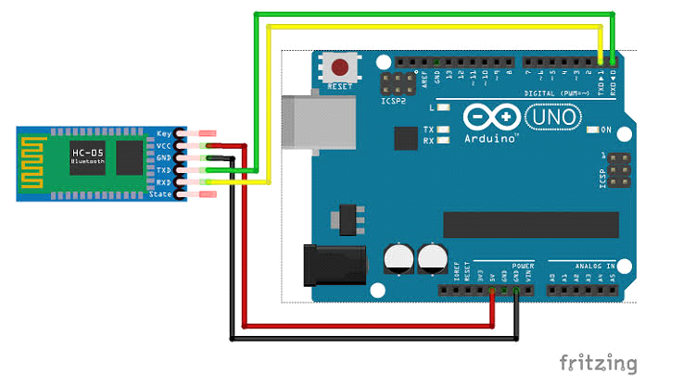

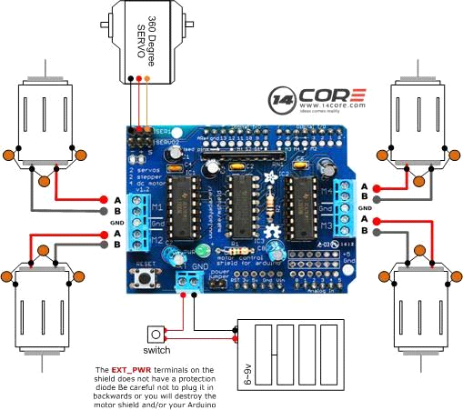

**CODE SECTION:**

#include <AFMotor.h>

#include <Servo.h>

Servo myservo;

int pos=0;

int pump=A0;

AF_DCMotor motor1(1);

AF_DCMotor motor2(2);

AF_DCMotor motor3(3);

char bt='S';

void setup()

{

  Serial.begin(38400);

 my servo.attach(9);

pinMode(Pump,OUTPUT);

  motor1.setSpeed(255);

  motor2.setSpeed(255);

  motor3.setSpeed(255);

  Stop();

}

void loop() {

bt=Serial.read();

if(bt=='F')

{

 forward();

}

if(bt=='B')

{

 backward();

}

if(bt=='L')

{

 left();

}

if(bt=='R')

{

 right();

}

if(bt=='S')

{

 Stop();

}

if(bt=='W')

{

 UP();

}

if(bt=='D')

{

 Down();

}

if(bt=='M')

{

 Sweep();

}

if(bt=='F')

{

 Water();

}

void forward()

{

     motor1.run(FORWARD);

  motor2.run(FORWARD);

}

void backward()

{

     motor1.run(BACKWARD);

  motor2.run(BACKWARD);

}

void left()

{

  motor1.run(FORWARD);

  motor2.run(BACKWARD);

}

void right()

{

  motor1.run(BACKWARD);

  motor2.run(FORWARD);

}

void Stop()

{

  motor1.run(RELEASE);

  motor2.run(RELEASE);

  motor3.run(RELEASE);

  digitalWrite(Pump,LOW);

}

void seep()

{

   motor3.run(FORWARD);

}

void UP()

{

for (pos=180;pos>=0;pos+=1)

{

myservo.write(pos);

}}

Void Down()

{

for (pos=180;pos>=0;pos+=1)

{

myservo.write(pos);

}}

{

void water()

{

digitalwrite(pump,HIGH);

**}**

**CONCLUSION:**

A cheaper and user friendly floor Cleaner robot can be developed by controlling manualy using an Arduino Board with more electronics functionality. Households of today are becoming smarter and more automated. Home automation delivers convenience and creates more time for people. Several robotic vacuum cleaners are available on the market but only few ones implement wet cleaning of floors.