To discover probable G-protein coupled receptor (GPCR) sequences, a systematic study of entire proteomes from diverse animal species was done. Phobius was used for the identification, which allowed for the accurate discovery of sequences having precisely 7 transmembrane domains, as is typical of GPCRs. The GPCR sequences were then clustered into orthogroups using OrthoFinder, which groups related sequences based on evolutionary ties. Thus, the evolutionary distribution and conservation of GPCRs across many animal species could be studied. By labelling the list of probable GPCR sequences with its orthogroup

Aedes

We carried out a comprehensive study on the single-cell RNA sequencing (scRNA-seq) data that we got from Aedes aegypti. The information on male and female species was gathered independently for this study. It was comprised of roughly between 3,000 to 4,000 cells derived from male and female individuals. To get rid of the cells that were of poor quality the data set was filtered. Only the specimens having a feature count of between 200 and 500 were chosen from the male Aedes aegypti data. In the female data set, the individuals that met the selection criteria of having a feature count between 400 and 2800 and an RNA count of more than 400 were chosen.
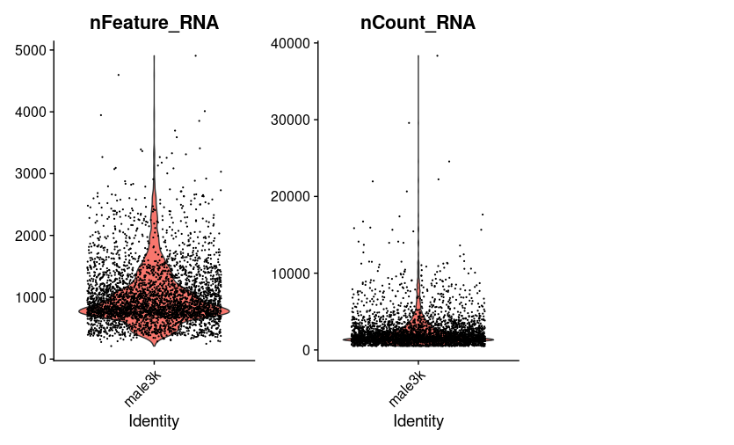

Viloin plot of the male Aedes aegypti dataset

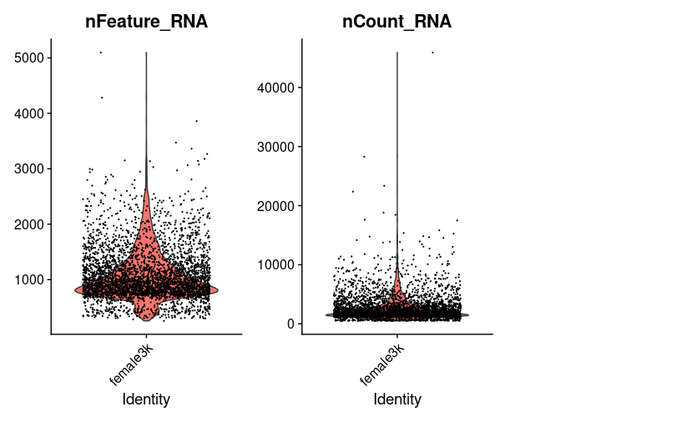

Violin plot of the female Aedes aegypti dataset
The male and female datset were combined after being normalized so that undesirable variance could be eliminated. 7 450 cells were a part of the combined data set. After that, a principal component analysis is carried out in order to determine which aspect of the data set is the most significant. It was decided to construct a heat map of the principal component (PC).
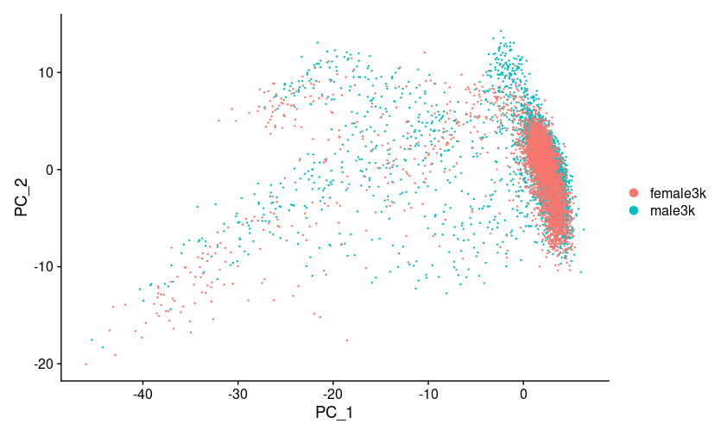
Principal component analysis based on their origin dataset(male and female)

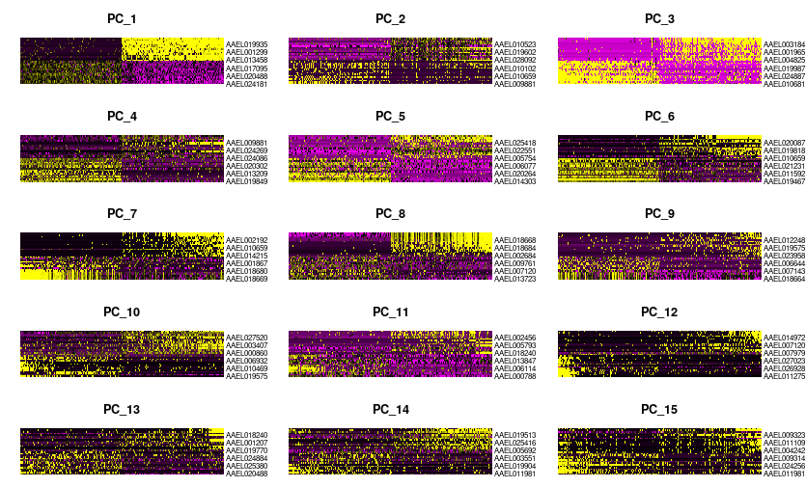

Heat map of the principal component present in the merged data.

For identifying the important PC It was decided to create a Jackstraw plot. 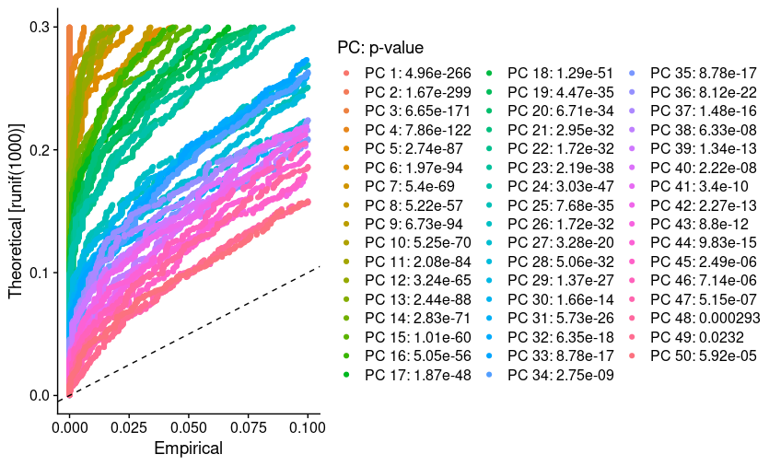

Jackstraw plot to find the significant principle component

Based on the information provided by the jack straw plot of the PC, we determined that the appropriate dimension for the clustering of the complete data set would be 1:50, and this was accomplished with a resolution of 0.5. Approximately 31 clusters were included in the Aedes data set. From among these clusters, the Custer 0 and 1 cluster seems to be significantly large cluster comparatively. 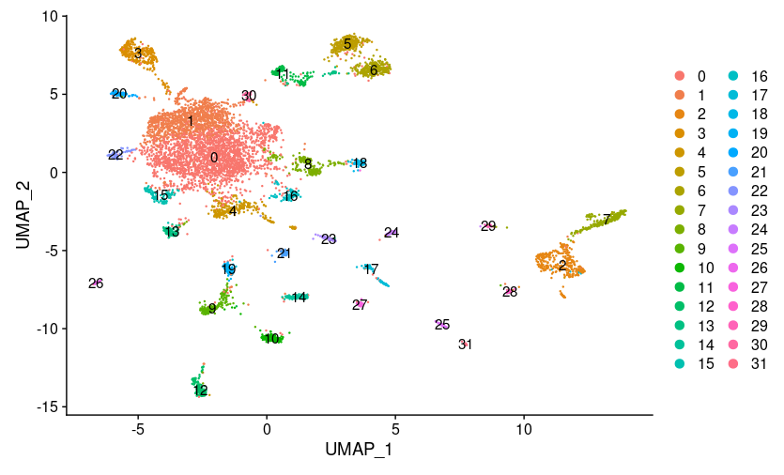
The cluster of the Aedes aegypti mosquito.
We then decided to compile a list of marker genes specific to each cluster. There were a large number of marker genes for each cluster, and from this list of marker genes, the ones that had an average log2FC greater than 1 were selected. Using this list of maker genes, we tried to determine the cell type that corresponds to each cluster. In order to get information on the marker genes, we looked at past research. After that, we annotated the cluster using the marker genes that were significant in each individual cluster. We located the maker genes, used a dot plot to examine the presence of the selected marker genes in the cluster, and then determined which of the possible matches was the most appropriate. We have annotated the cluster based on marker genes for the cell type.
Naming the clusters
We able to annotate 13 clusters to cell types based on the markers on Drosophila
*** explain more about the cell types and markers
Cluster 29 was initially annotated as astrocytes, which is a type of glia cells due to the presence of markers reversed polarity (repo) , wunen-2(wun2) and sprouty(sty) .But on the later stage of our analysis this cluster was named as glia cells so that we could compare them with the clusters of other species.
`

Cell type | Markers in Ae. aegypti | Markers in Drosophila
astrocyte | AAEL027131, AAEL007322, AAEL014510 | repo, wun2, sty
glia 1 | AAEL027131, AAEL010145 | repo, nrv2
KC 1 | AAEL002321, AAEL005834, AAEL019691 | eyeless, DopR2, sNPF
Mi1 | AAEL011643, AAEL007221 | hth, bsh
monoaminergic neuron | AAEL026276, AAEL024732, AAEL005581 | Vmat, DAT, SerT
Pm | AAEL011643, AAEL007120
PN 1 | AAEL019970, AAEL005507 | ct, acj6
vPN 1 | AAEL019970, AAEL005507, AAEL019457 | ct, acj6, Lim 1

CLUSTER | Cell Type | Annoatation
6 | vPN 2 | PN
5 | vPN 1 | PN
11 | PN 1 | PN
22 | Pm | Pm
16 | monoaminergic neuron | monoaminergic
10 | Mi1 | Mi1
18 | KC 3 | KC
13 | KC 2 | KC
3 | KC 1 | KC
28 | glia 3 | glia
7 | glia 2 | glia
2 | glia 1 | glia
29 | astrocyte | glia

We next compared the list of complete genes included in all clusters to the 7 transmembrane list we created to filter out those having 7 transmembrane structure.From the list of ortho groups of genes, we attempted to locate the ortho group of the filtered list of seven transmembrane structures in our database. Only those in ortho group 6 were chosen from this list since GPCRs are present in this ortho group. Because serotonin and dopamine were of special interest to us, we looked for the drosophila homologues of serotonin and dopamine receptors in drosophila. Since we already knew h serotonin and dopamine receptors in drosophila, we searched for the serotonin and dopamine homologue.We compiled a list of the serotonin receptor as well as the dopamine receptor in Aedes aegypti

DROSOPHILIA​ | AEDES AEGYPTI​
5-HT1 A​ | AAEL08360​
5-HT1 B​ | AAEL017272​
5-HT7​ | AAEL025125​
 | AAEL027242​
5-HT2 A​ | AAEL019804​

DROSOPHILIA​ | AEDES AEGYPTI​
DOP 1R1​ | AAEL019437​
DOP 1R2​ | AAEL005834​
DOP EcR​ | AAEL00266​
DOP 2R​ | AAEL019766​
Dot plots were used in order to ascertain whether or not clusters contained serotonin or dopamine.In addition, both their precantage as well as their average expression was observed.. To focus on the most relevant information, we applied a filtering step, retaining only the data points with a percentage expression above 25 percentage and avg.exp.scaled greater than 0.5. This ensured that we were examining the more significant expression levels in our analysis.

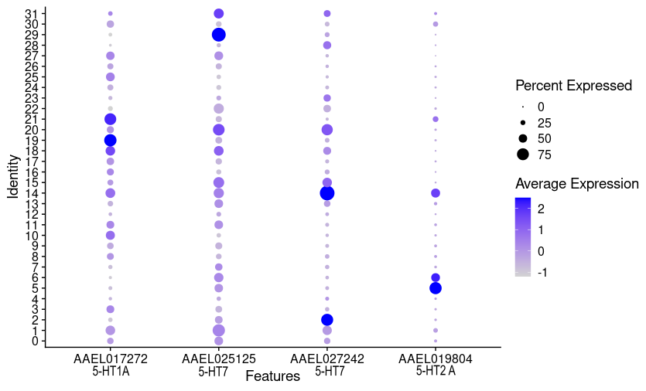
Serotonin receptors presence in cluster of Aedes aegypti

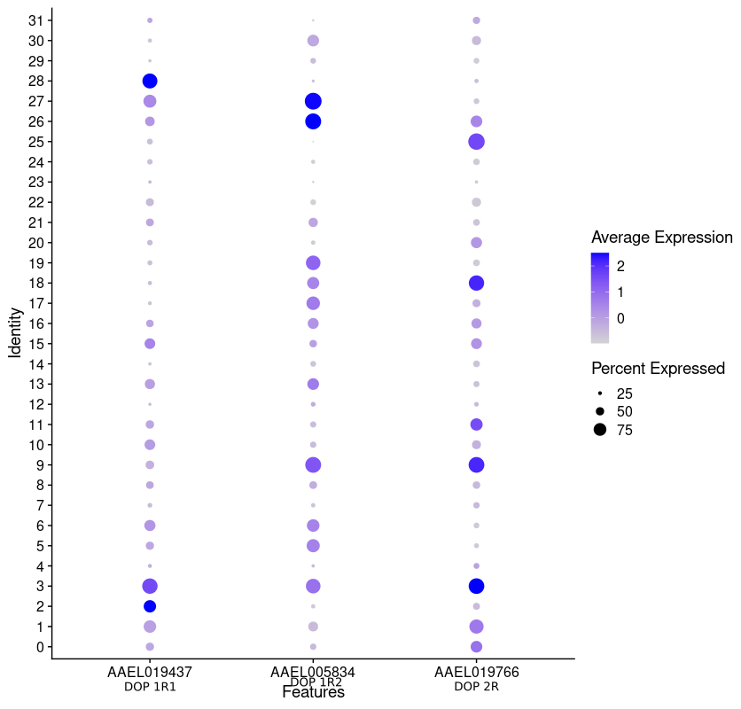
Dopamine receptors presence in cluster of Aedes aegypti
In order to independently understand the percentage expression in each cluster, we used the filtered dataset to generate a bar graph. The y-axis showed the percentage of receptor expression in each group, while the x-axis showed the different clusters. We were able to quickly and readily examine the distribution and patterns of expression for both neurotransmitters across different clusters using this visualisation.

By examining serotonin and dopamine expression levels in relation to the investigated experimental and biological parameters, we aimed to gain a deeper understanding of the role that each neurotransmitter plays in its own cluster. It was easy to interpret the data and see how the percentages of serotonin and dopamine expression related to our study.
On the other hand, a feature plot was created to verify if the filtered receptors were actually present in the particular clusters or if they were just left out due to the percentage cutoff. To visually confirm the expression patterns of the filtered receptors in each cluster, the feature plot is an essential visual tool. The expression levels of the receptors are shown as coloured data points or intensity values, and each cluster is displayed on the plot.

DROSOPHILA
Approximately 40,000 cells made up the first part of the dataset obtained from Drosophila.A filtering procedure was carried out in order to concentrate more on the genes that are active and important.Only those individuals with expression levels ranging from 200 to 2500 were chosen for analysis.Following the application of filters, the data set included 38000 cells.The Jackstraw plot indicated that there were one hundred significantly important principal components.The dataset was clustered using a resolution of 0.5, which resulted in 67 groups indicating groupings of cells with similar patterns of gene expression. The clustered sample indicated that out of the total of 67 clusters, Clusters 0 and 1 were the biggest, followed by Cluster 2. This demonstrates that the number of cells in these three clusters is much larger than the number of cells in the other clusters.

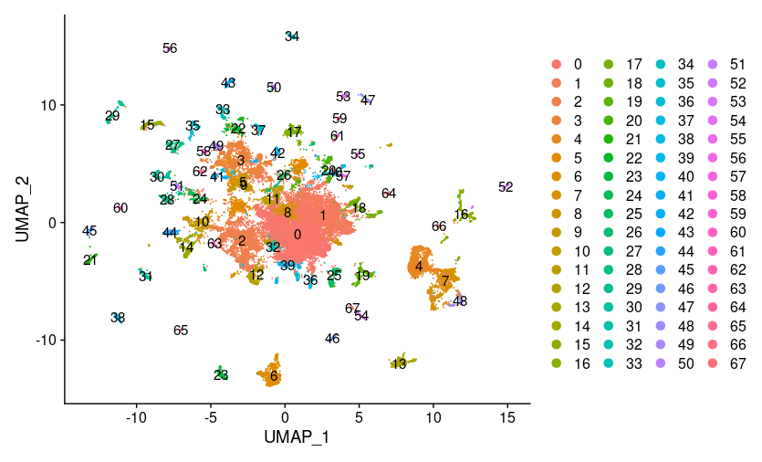
Drosophila Clusters with a resolution of 0.5

After collecting the markers from these clusters, we narrowed our choices down to those that had an avg_log2FC value that was more than one and tried annotating the clusters based on the marker genes present in each clusters.After determining the cell type that each cluster corresponds to based on the marker genes, we labeled them appropriately. Additionally, we searched for the Drosophila markers that were used to identify Aedes and utilized that data as well for the annotation process. Instead of labeling the clusters separately as surface glia, cortical glia, and astrocytes, we simply referred to all of these clusters together as glia since they are composed entirely of glia cells.In order to verify this, we decided to utilize the glia drosophila markers that were used to annotate the Aedes data set.
And in the same way, we did the same thing with Kenyon cells; instead of separating the alpha, beta, and gamma KC cells into their own groups, we simply referred to all of them together as KC cells. This made it much simpler to compare the clusters between different species.
***EXPLLAIN IN DETAIL OF THE MARKERS AND CELL TYPE

Cell Type | MARKERS IN DROSOPHILIA | Markers used for Aedes | Cluster Name
Surafce glia | Indy | repo,nrv2 | glia
CTX (Cortex glia) | wrapper | repo,nrv2 | glia
AST(glia) | alrm | repo,nrv2 | glia
Gamma KC | sNPF,trio | ey,trio,sNPF,DopR2 | KC
alpha/beta KC | sNPF | ey,trio,sNPF,DopR2 | KC
alpha'/beta' KC | trio | ey,trio,sNPF,DopR2 | KC
Monoaminergic | Vmat,DAT | ddc | Monoaminergic
Olfactory Projectial Neuron | tup,otp,c15,hth |  | OPN
DAL | dally |  | DAL
PEP | pdf,dimm |  | PEP
Mi1 | hth,bsh |  | Mi1
Mip | Mip |  | Mip
T1 | Eaat1 |  | T1
Hemocytes | Hml |  | Hemocytes
OCTY | Tdc2 |  | OCTY
Pm | Lim3 |  | Pm
Photoreceptors | ort |  | Photoreceptors
Pm3 | Vsx1 |  | Pm3

A dot plot was created for the purpose of identifying the cluster in which the markers are present, and the clusters were then annotated accrdingly.
CLUSTER ID | Cell type | Annoatation
7 | dally | Dally
16 | SURFACE GLIA | glia
48 | CTX CORTEX GLIA (glia) | glia
66 | AST (glia) | glia
52 | Hemocytes | Hemocytes
6 | Gamma KC | KC
13 | alpha/beta KC | KC
23 | alpha’/beta’ KC | KC
20 | Mi1 | Mi1
25 | Mip | Mip
19 | Monoaminergic | monoaminergic
54 | OCTY | OCTY
32 | OPN | OPN
18 | PEP | PEP
61 | Photoreceptors | Photoreceptors
59 | Pm | Pm
65 | Pm3 | Pm3
45 | T1 | T1

Then, we compiled a list of all the cells that were included in the data set, compared it to the seven transmembrane lists that we previously had, and filtered the results based on the criteria "avg_log2FC > 1”.Moreover, the ortho group of the seven transmembrane cells that are included in our dataset was discovered.Only the items in ortho group 6 were selected from this list for further study.The serotonin and dopamine (HT1A,HT1B,HT 2, HT 7,DOP 1R1, DOP1R2, DOPEcR, DOP 2R ) in which we are interested were the focal point of our attention, and a dot plot was utilised to identify the cluster in which these receptors were expressed. The expression percentage of these receptors was also recorded. Only the cluster with a pct.exp more than 25 and an avg.exp.scaled greater than 0.5 caught our attention.
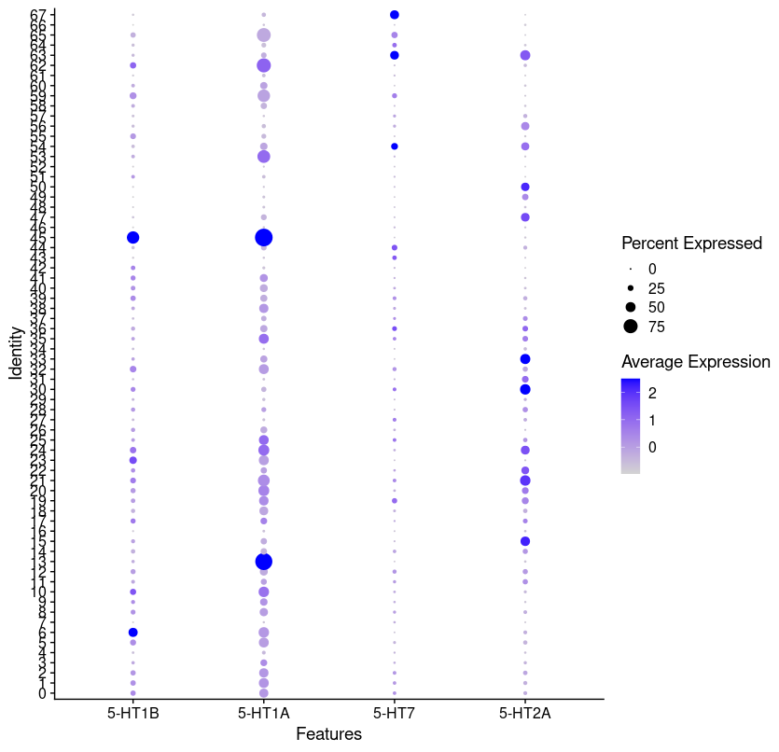
Dot plot of the Serotonin Receptor in Drosophila

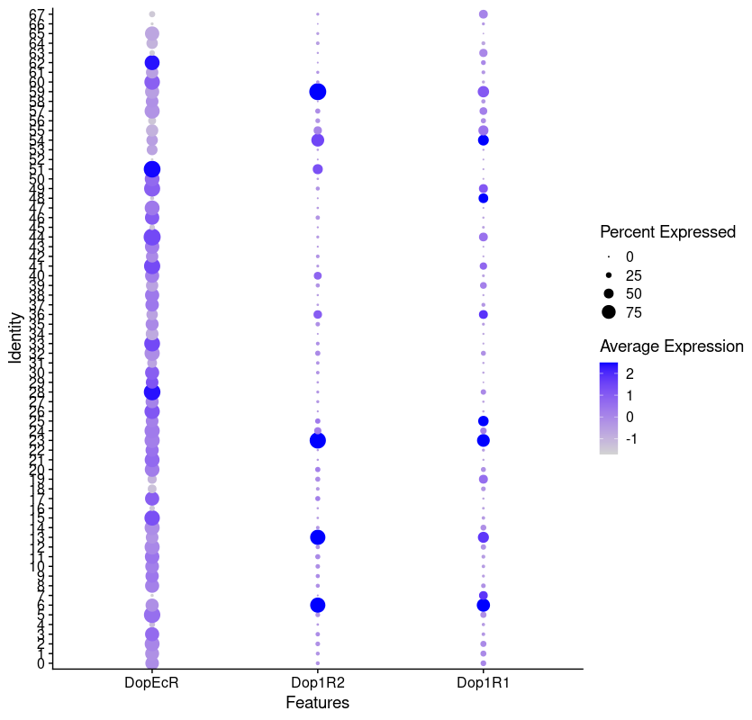
Dot plot of the Dopamine receptor in Drosophila

ANT
About 25,000 cells were included in the data obtained from the herphathous monomorium ant dataset.In the first phase of data preparation, we restricted our analysis to genes with modest expression levels (between 200 and 1000 reads per gene). This filtering was performed with the intention of boosting the quality of subsequent studies by concentrating on physiologically significant genes and decreasing background noise. After filtering, the data was normalised to guarantee that detected variations in gene expression were biologically significant.

We used dimensionality reduction with the jackstraw plot to look further into the cellular heterogeneity seen in Herpanthos monomorium. Dimensions 1-45 were picked from the plot because they represented the most important sources of variance in the data. This improved the efficiency of subsequent studies and the visualisation of the cellular landscape by decreasing their size.

To further separate cells with comparable gene expression patterns, a clustering analysis was performed at a resolution of 0.5. Serotonergic and dopaminergic cells are well-known for their functions in neurotransmission and behaviour, yet at this resolution, no substantial clusters associated with these cells were seen. This indicated that a higher resolution was required to provide a better and more complete view of the various cell types in the ant dataset.

Increasing the resolution to 2.5 allowed us to see more detail inside individual cells, with a total of 47 clusters visible in comparison to the original 37 clusters seen at the lesser resolution. By dividing larger clusters into smaller, unique subpopulations, made possible by the improved resolution, we were able to discover finer cellular diversity within Herpanthos monomorium.
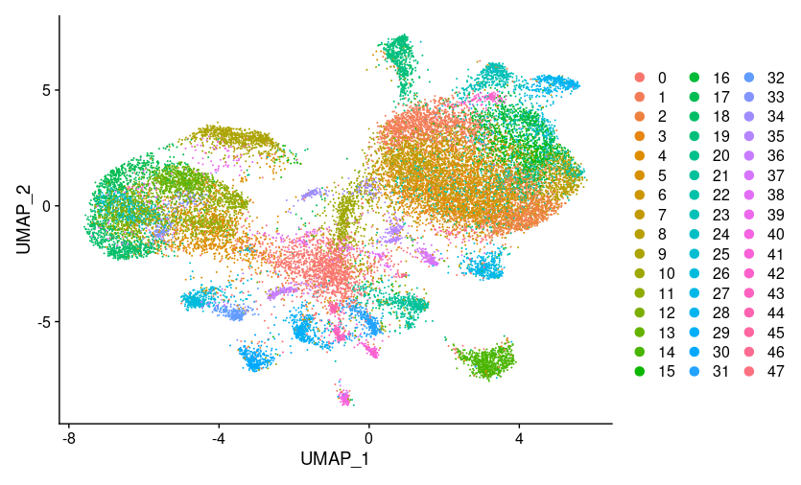
Cluster of the ant dataset with a resolution of 2.5
Later we generated a list of marker genes for each cluster. We selected only the marker genes that showed substantial differential expression across clusters based on an average log2 value larger than 1.
To solve this problem, we looked to previous research for insight on these marker genes. Research on Herpanthos monomorium was used to determine the Drosophila analogues of these genes, a model organism with a large body of research behind it.

After comparing the marker genes to those of the fruit fly, we checked to see if they were present in each cluster of Herpanthos monomorium. This allowed us to annotate the clusters according to the unique markers they contained.

Using this method, we were able to gain a deeper understanding of the marker genes' meaning and the potential identities of the many cell clusters found in Herpanthos monomorium. We were able to better comprehend the cellular heterogeneity found in the ant species by linking certain markers with distinct cell types or subpopulations.

Marker in Drosophila | GENE Name in ANT | Cell Type | Cluster annotation
Pka-C1 | Pharaoh-ant-17936 | Kenyon cells | Kenyon cells
CaMK|| | Pharaoh-ant-13966 | Kenyon cells | Kenyon cells
trio | Pharaoh-ant-01234 | Kenyon cells | Kenyon cells
zyd | Pharaoh-ant-06337 | Cotex glia | glia
wrapper | Pharaoh-ant-07329 | Cotex glia | glia
Indy | Pharaoh-ant-04520 | Ensheathing glia | glia
vKg | Pharaoh-ant-04838 | Ensheathing glia | glia
Mdr49 | Pharaoh-ant-00624 | Ensheathing glia | glia
Idgf4 | Pharaoh-ant-17376 | Surface glia | glia
CG8745 | Pharaoh-ant-13676 | Surface glia | glia
Tsf1 | Pharaoh-ant-07850 | Surface glia | glia
Gat | Pharaoh-ant-11362 | Astrocytes | glia
GS1 | Pharaoh-ant-17185 | Astrocytes | Astrocytes
Ddc | Pharaoh-ant-04831 | Monoaminergic neurons | Monoaminergic neurons
DAT | Pharaoh-ant-17489 | Monoaminergic neurons | Monoaminergic neurons
Vmat | Pharaoh-ant-11830 | Monoaminergic neurons | Monoaminergic neurons
acj6 | Pharaoh-ant-10873 | Olfactory projectional neuron | Olfactory projectional neuron
trp | Pharaoh-ant-06879 |  | Photoreceptors
ninaC | Pharaoh-ant-11119 |  | Photoreceptors
ninaB | Pharaoh-ant-13171 |  | Photoreceptors
Drgx | Pharaoh-ant-13626 | Optic lobe T4/T5 | Optic lobe T4/T5

CLUSTER | Cell Type | Annotation
29 | Surface glia | glia
30 | Ensheathing glia | glia
40 | Cotex glia | glia
21 | Astrocytes | glia
4 | Kenyon cells | KC
11 | Kenyon cells | KC
12 | Kenyon cells | KC
13 | Kenyon cells | KC
18 | Kenyon cells | KC
24 | Kenyon cells | KC
33 | Kenyon cells | KC
27 | Monoaminergic neurons | Monoaminergic
14 | Olfactory projectional neuron | OPN
19 | Optic lobe T4/T5 | Optic lobe T4/T5

The scRNA-seq data from Herpanthos monomorium was subjected to further screening. For this purpose, cells expressing genes encoding seven-transmembrane proteins were prioritised, as GPCR are themselves seven-transmembrane receptors.Following this initial culling, the surviving genes were cross-referenced against an existing set of orthologous sets. The sixth orthogroup was chosen in particular for this investigation.
After the initial round of culling, the gene list underwent still another round of scrutiny. To choose which genes to keep, we looked at their expression levels and only kept those with pct.exp > 25% and avg.exp.scaled > 0.5. Only genes with high average expression levels across cells and stable expression patterns were kept for further study according to these criteria.
Following that, the purpose of the study was to evaluate whether or not the dataset contained any serotonin or dopamine receptor homologs. In order to accomplish this, a software called FigTree, which is used for visualising and analysing phylogenetic trees, was utilised to investigate the phylogenetic tree of these receptors. The homologous receptors for serotonin and dopamine were located throughout the tree, demonstrating that Herpanthos monomorium contains both of these neurotransmitters.

DROSOPHILIA​ | ANT​
5-HT1 A​ | Pharaoh-ant-03257​
5-HT1 B​
5-HT7​ | Pharaoh-ant-03226​
5-HT2 A​ | Pharaoh-ant-04214​

DROSOPHILIA​ | ANT​
DOP 1R1​ | Pharaoh-ant-07697​
DOP 1R2​ | Pharaoh-ant-03879​
DOP EcR​ | Pharaoh-ant-17390​
DOP 2R​ | Pharaoh-ant-00663​

Later, a dot plot analysis was carried out in order to investigate the expression patterns of serotonin and dopamine receptors throughout the various cell clusters that had been discovered. We are able to identify certain cell types or subpopulations that express these receptors

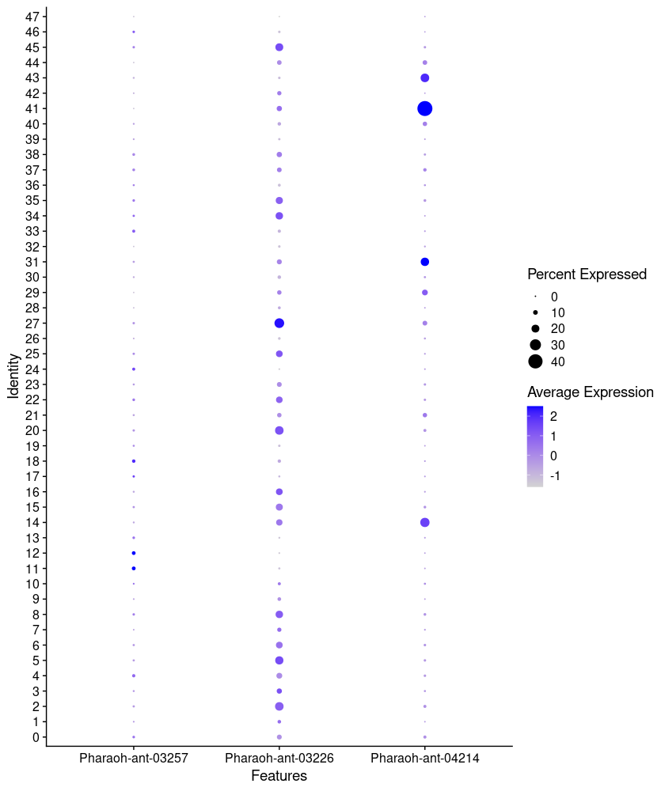
Dot Plot of serotonin homologue in cluster of ant data set

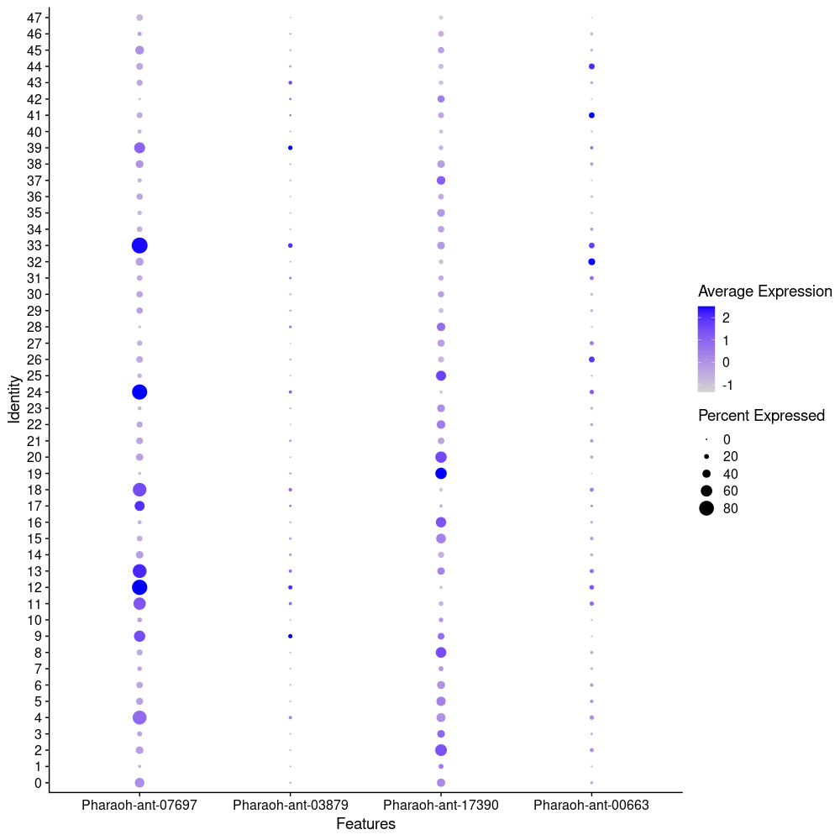
Dot plot of Dopamine homologue in Ant dataset.

The cluster common in all three of the species were selcted and the presence or absence of the serotonina and dopmine genes were marked.This gives better understanding of the presence or absence of the serotonin and dopamine in the cell types all the 3 species.

RECEPTOR | DROSOPHILIA |  |  |  | AEDES |  |  |  | ANT
 | Monoaminergic | KC | glia | OPN | Monoaminergic neuron | KC | glia | PN | Monoaminergic neurons | Kenyon cells | glia | Olfactory projectional neuron
5HT1A | ❌ | ❌ | ❌ | ❌ | ❌ | ✅ | ❌ | ❌ | ❌ | ❌ | ❌ | ❌
5HT1B | ❌ | ✅ | ❌ | ✅ | ❌ | ❌ | ❌ | ❌ | ❌ | ❌ | ❌ | ❌
5HT7 | ❌ | ❌ | ❌ | ❌ | ❌ | ❌ | ✅ | ❌ | ✅ | ❌ | ❌ | ❌
5HT2 | ❌ | ❌ | ❌ | ❌ | ❌ | ❌ | ❌ | ✅ | ❌ | ❌ | ❌ | ❌
DOP1R1 | ✅ | ✅ | ✅ | ❌ | ❌ | ✅ | ✅ | ❌ | ❌ | ✅ | ❌ | ❌
DOP1R2 | ❌ | ✅ | ❌ | ❌ | ❌ | ✅ | ❌ | ✅ | ❌ | ❌ | ❌ | ❌
DOPEcR | ❌ | ❌ | ❌ | ❌ | ❌ | ✅ | ❌ | ✅ | ❌ | ❌ | ❌ | ❌
DOP2R | ✅ | ❌ | ❌ | ✅ | ❌ | ✅ | ❌ | ✅ | ❌ | ❌ | ❌ | ❌

According to the previous study, 5-HT1A and 5HT1B were selected as receptors for investigatation upon exposure to serotonin hormone in Drosophila. We then conducted a phylogenetic analysis to understand the relationship between these two receptors. The result as shown below revealed a very close relationship between the two receptors indicating homology to some extent.

After conducting scRNA sequencing to generate different clusters that represent different cell types we went on to examine the expression level of 5HT1A specifically in all these clusters in Drosophila. The figure below illustrates the percentage expression result of receptor 5-HT1A in Drosophila after exposure to serotonin hormone in different clusters (x-axis) that represent different cell types.

It was observed that cluster 45 showed the highest gene expression for 5HT-1A receptor followed by cluster 13. Furthermore, from the cell annotation we know that cluster 45 represents the cell type T1 and the cluster 13 represents the alpha/beta KC cells thus giving us insight into what type of cells the receptor gets activated when exposed to serotonin. In Aedes aegypti (yellow fever mosquito), AAEL008360 receptor that was homologous to 5 HTA in Drosophila, was instead shown to have lower expression level in clusters 3 and 25 comparatively as shown in the figure above at the right. Cell annotation showed cluster 3 belonged to KC cells.
In case of 5HT1-B, Drosophila showed highest gene expression upon serotonin exposure again in cluster 45 followed by cluster 6, which was annotated as cell type Gamma KC cells. Surprisingly, where the gene expression for 5HT1A was found to be lower in Aedes compared to Drosophila, the the receptor homolog to 5HT1B was as highly expressed in Aedes aegypti as Drosophila, with the highest expression seen in cluster 19 followed by cluster 21 and cluster 18, which belonged to KC3 cell type.

