TOURIST MANAGEMENT APPLICATION

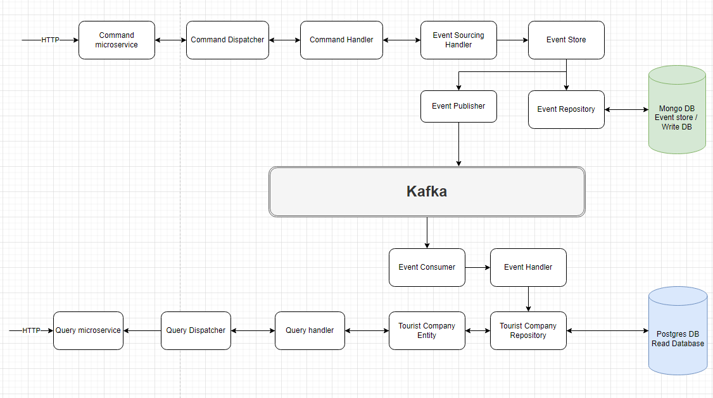
This application is developed using spring boot microservices design pattern. This implements Command and Query responsiblity segregation pattern. It also uses Kafka for sending messages from command API to Query API as soon as Create or Update event occurs.

Below are the list of microservices developed:

- Command microservice
- Query microservice
- User management microservice
- Spring cloud config server microservice
- Eureka discovery microservice
- Spring cloud API gateway

Other technoloy used are:

- Postgres as write database
- MongoDB as read database
- Kafka
- ELK stack
- Gradle

Below is the swagger documment screenshots showing list of endpoints exposed:

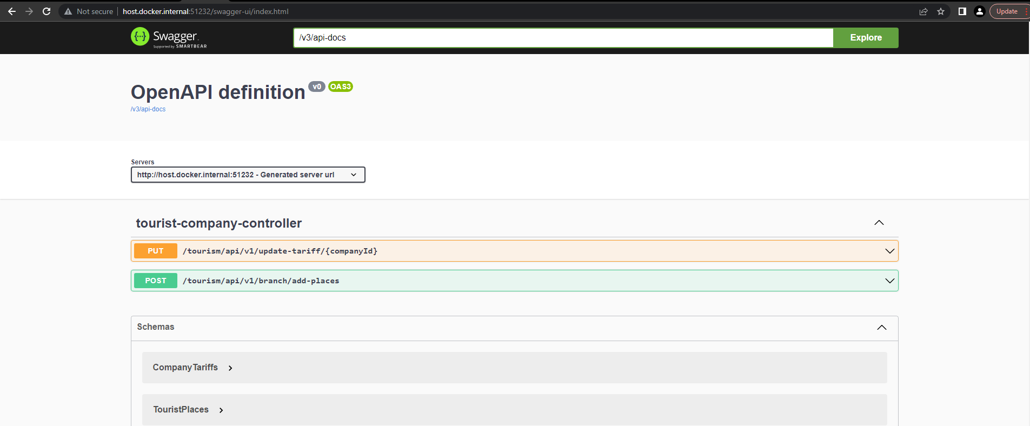

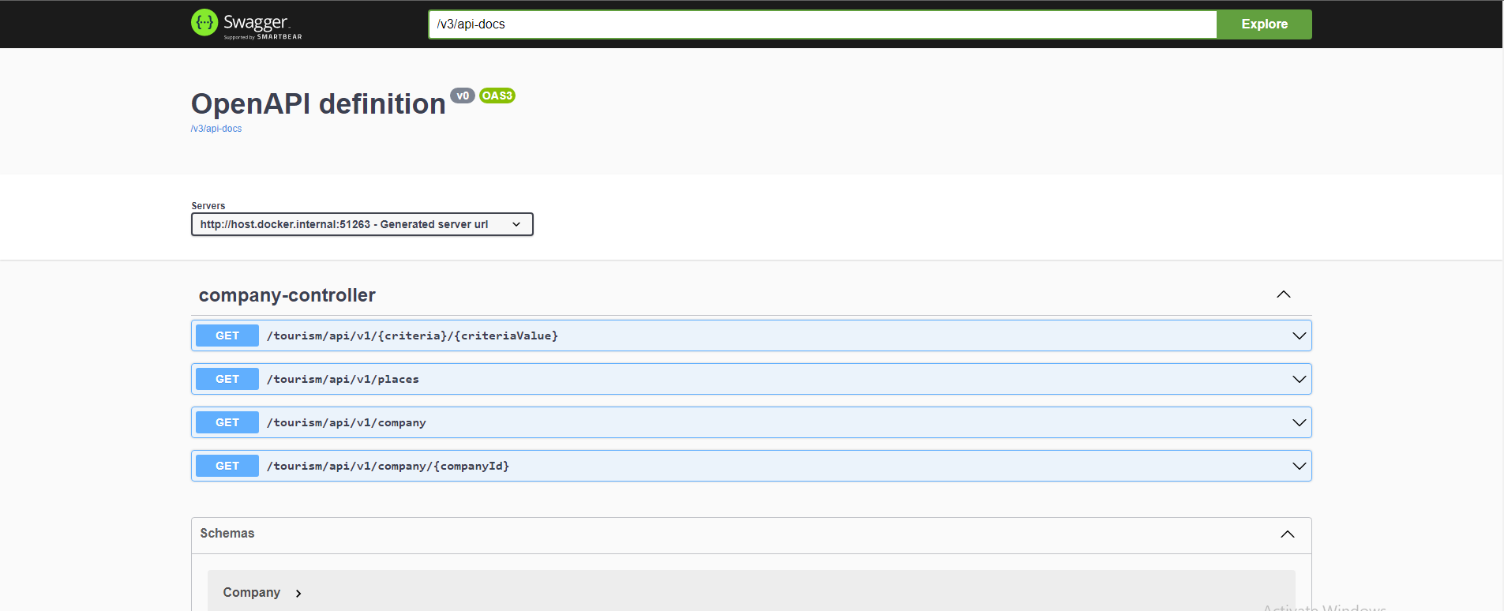

Below process to run and test microserices:

First start below services one by one:
- Start discovery service
- Start config server
- Start API gateway
- Start User management

Once above 4 service are started hit the eureka dashboard URL to confirm all 4 are runing and registered with discovery service. http://localhost:8010/

Once above services are up start remaning 2 services
- Command microservice
- Quey microservice

Finally Eureka dashboard should look like below:

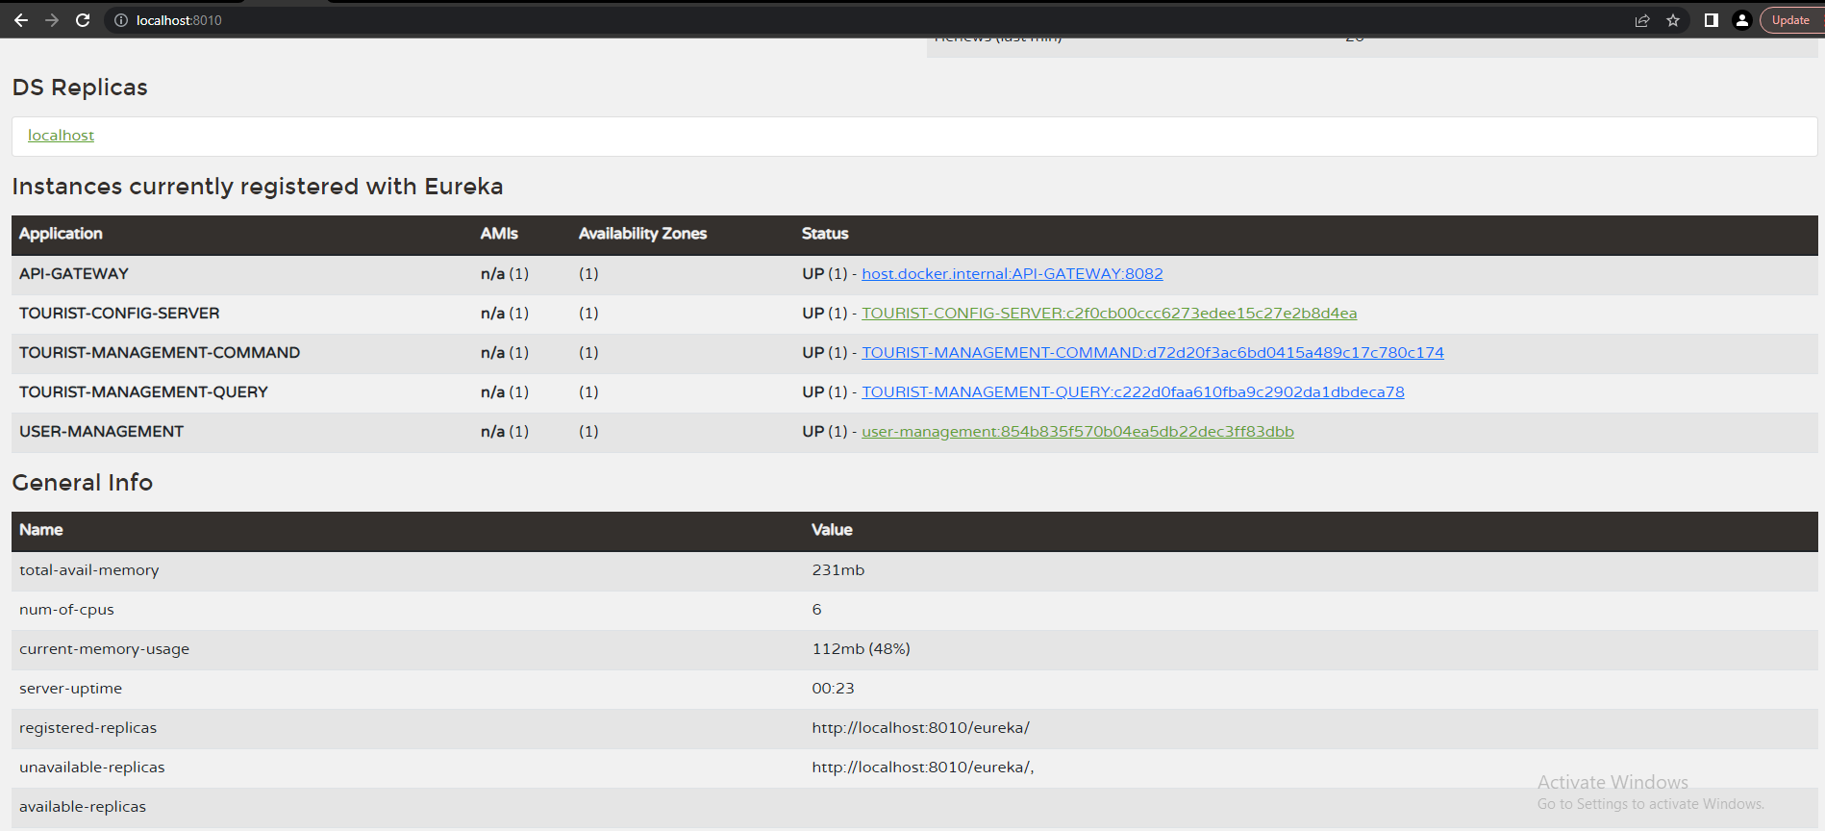
- Register user
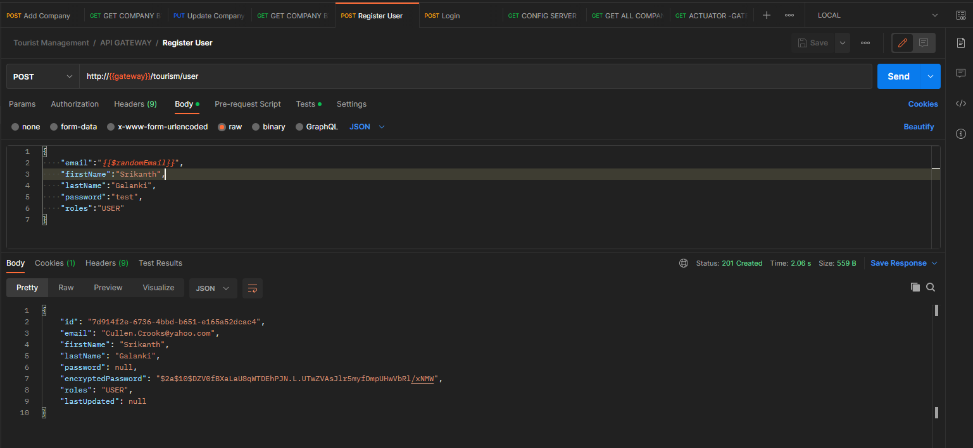

- Login user

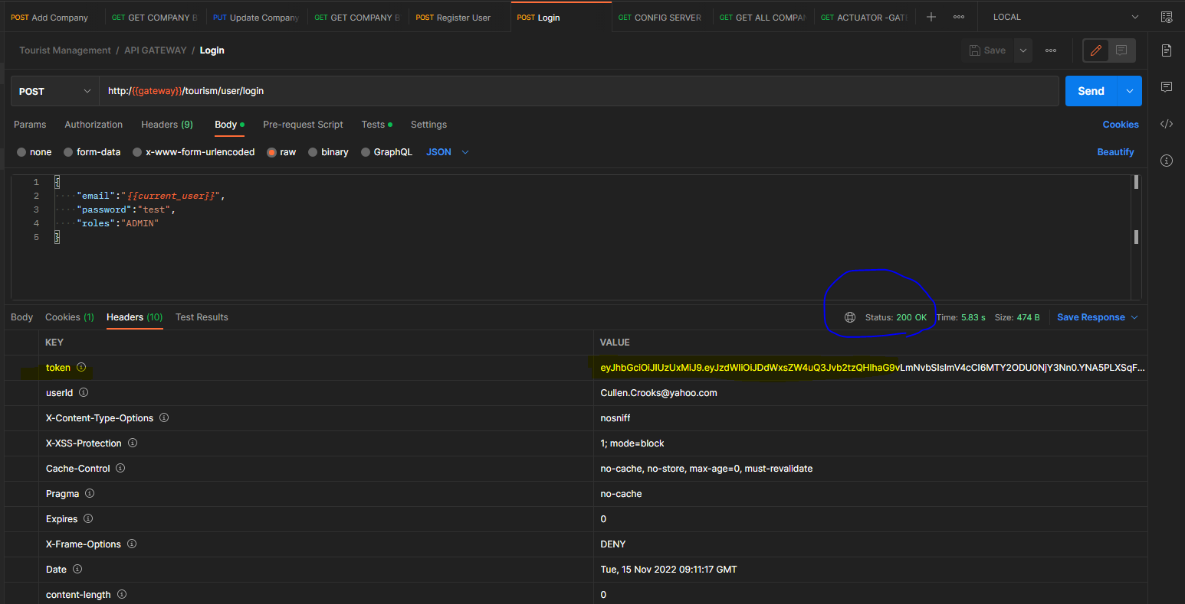
3. Add/Register company API

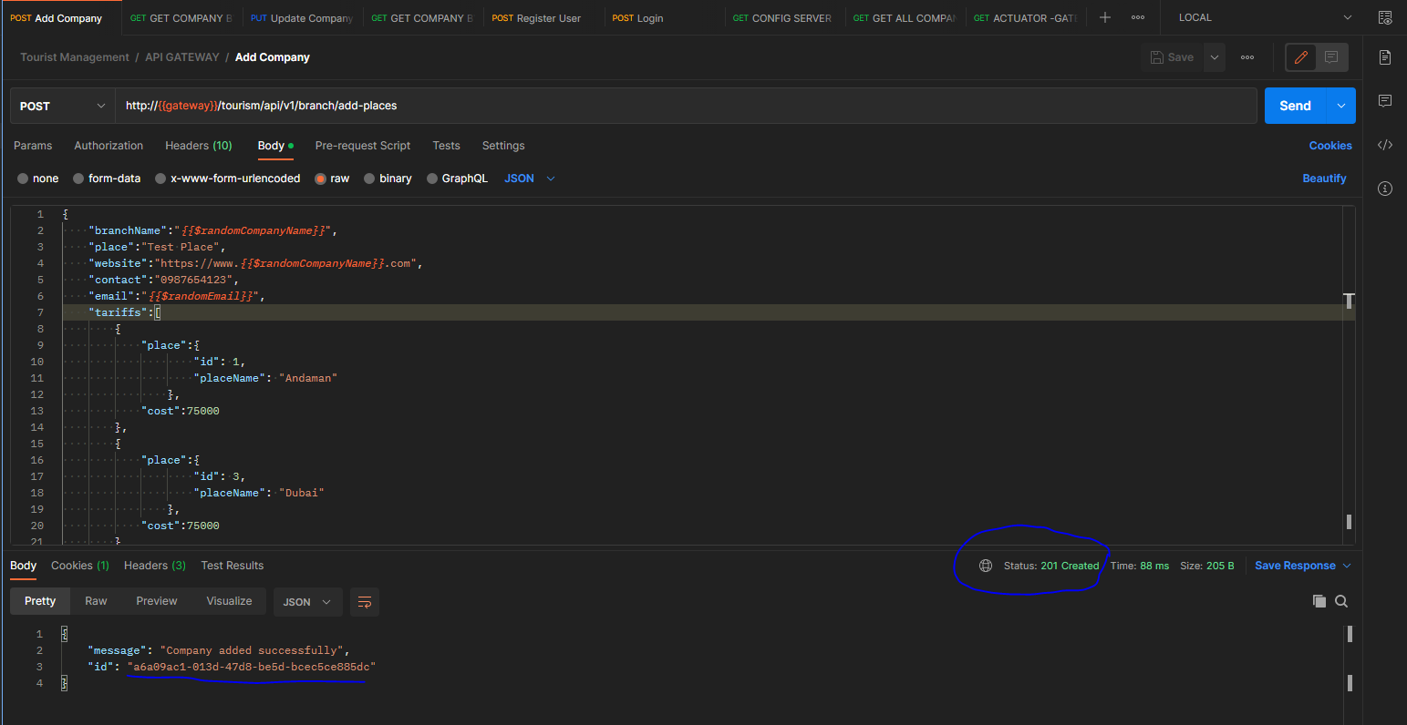

- Mongo DB event store after adding company

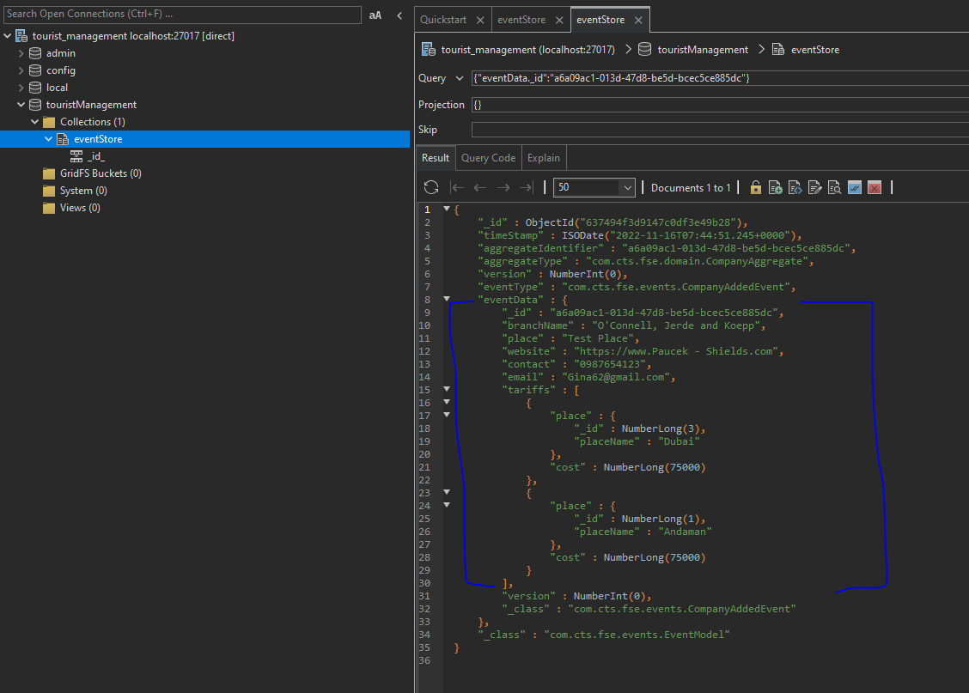
5. Read database state after adding company

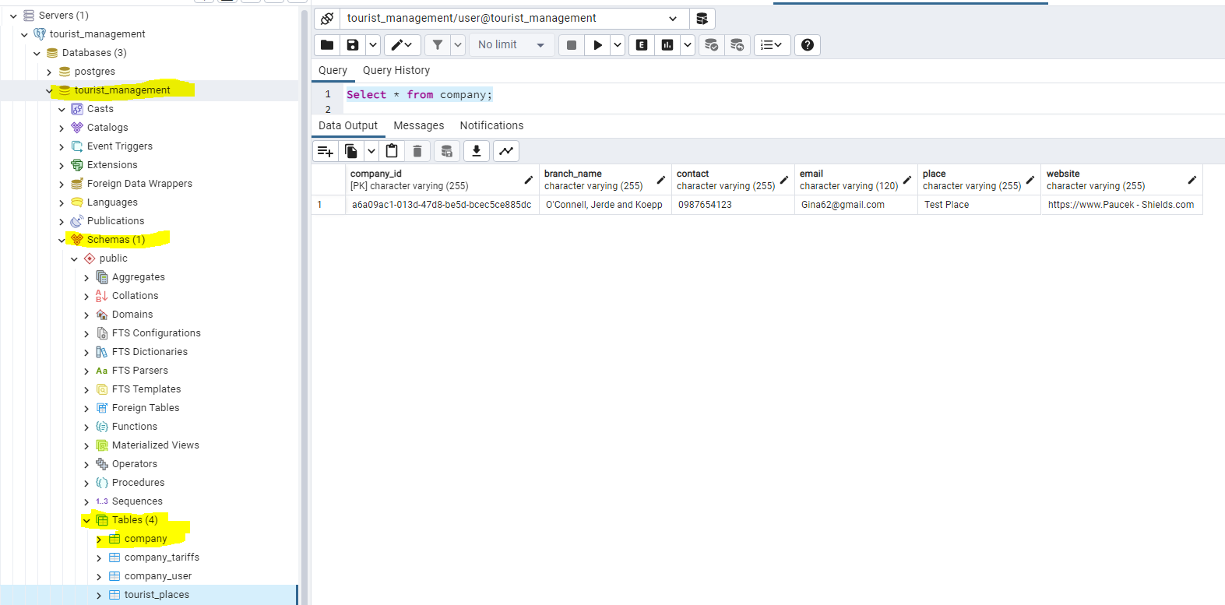

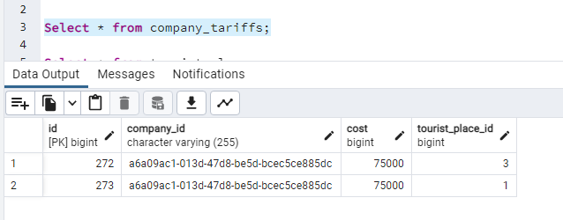

- Searh company by id

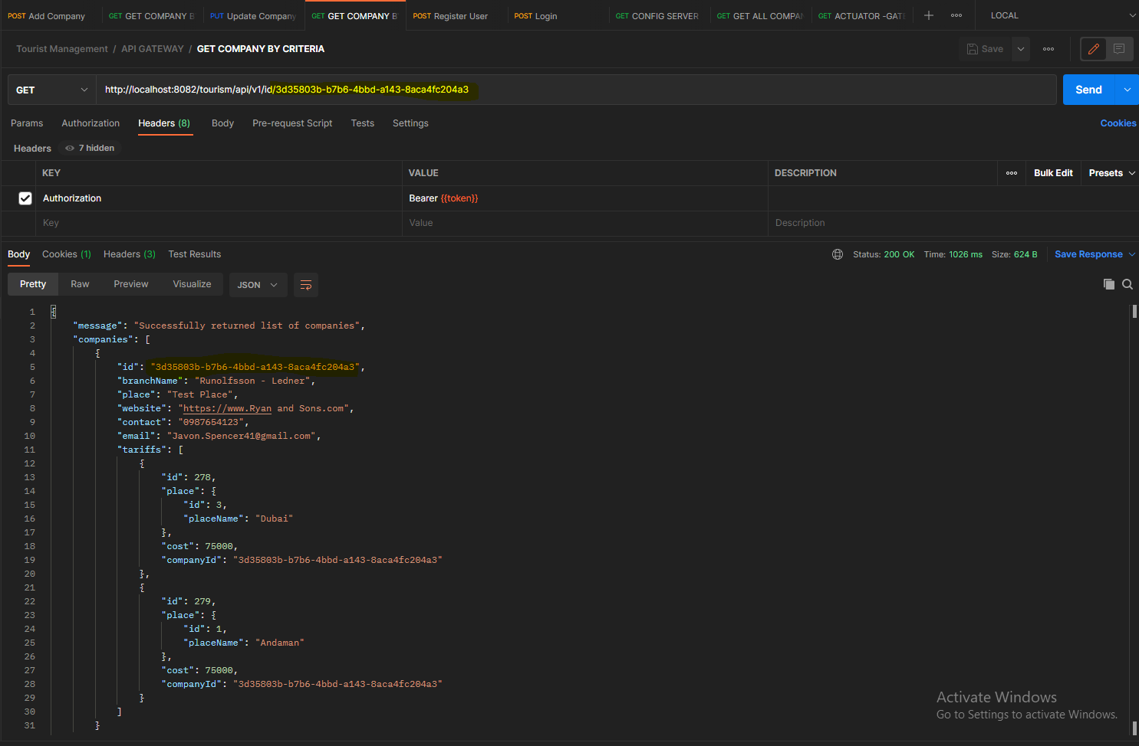
- Update company tarriff details

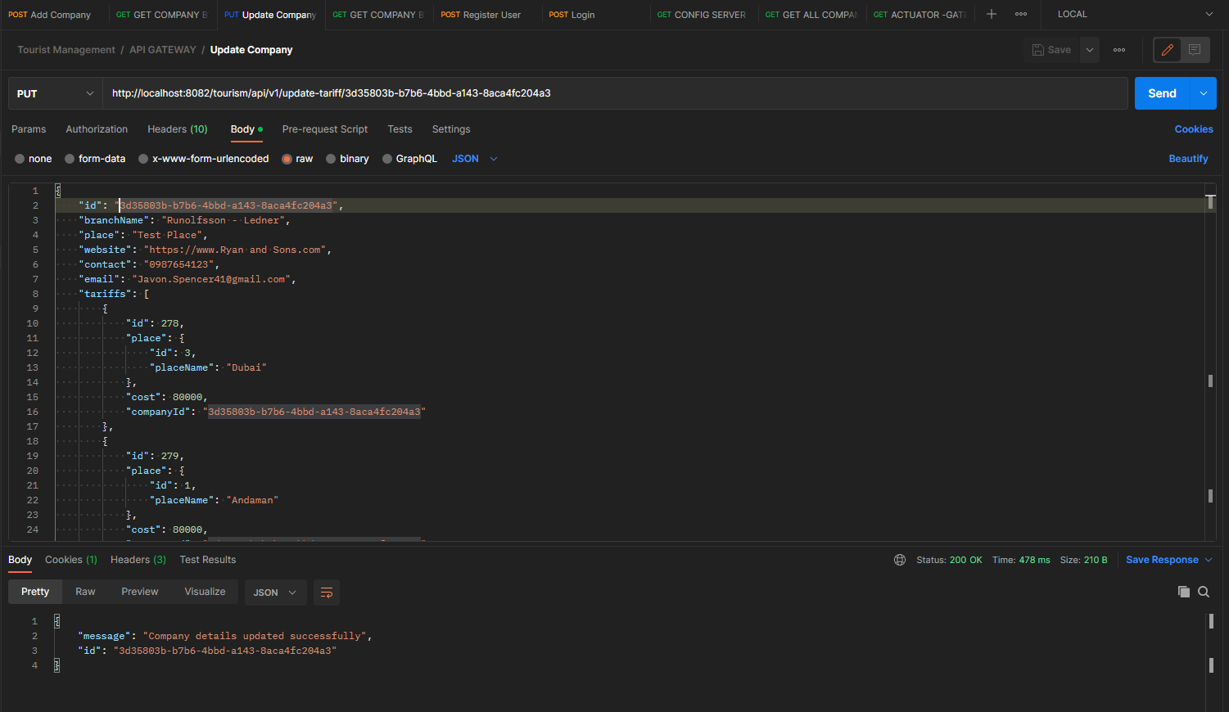

- List of Tourist places
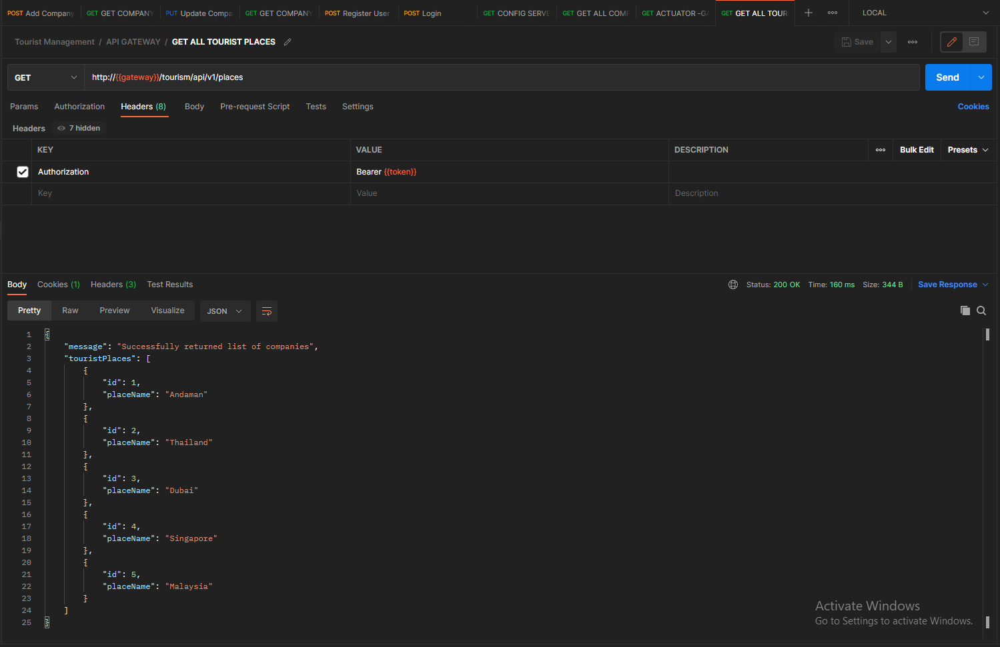

- Config server details

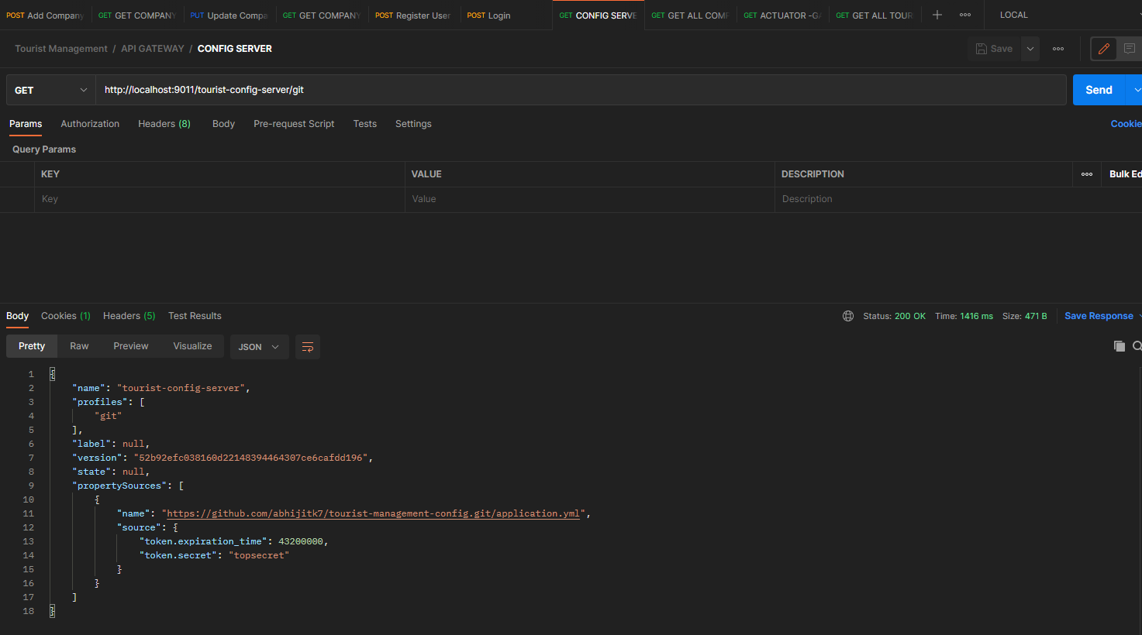
Below is the GIT HUB repo for above services

