End-to-End CI/CD Pipeline

mern-auth Application — DevOps Competency Submission

PRCICD-001: Software Release Workflows PRCICD-002: Build and Test Code
Prepared: 03 April 2026 · Architecture: Jenkins Master/Slave · Runtime: Kubernetes · Monitoring: Prometheus

1. Overview
This document describes the end-to-end CI/CD pipeline designed for the mern-auth application (MERN stack). It maps each pipeline stage to the two DevOps competency controls under review, demonstrating how the implementation satisfies both release governance (PRCICD-001) and build quality (PRCICD-002) requirements.
The pipeline runs on a Jenkins Master/Slave architecture deployed within a Kubernetes cluster. The Master coordinates the workflow while ephemeral slave agents handle compute-intensive tasks. Prometheus provides real-time production monitoring and triggers automatic rollback when error thresholds are exceeded.
2. Architecture Diagram
The diagram below shows the three-lane pipeline structure: Jenkins Master (orchestrator), Jenkins Slaves (workers), and External Systems.
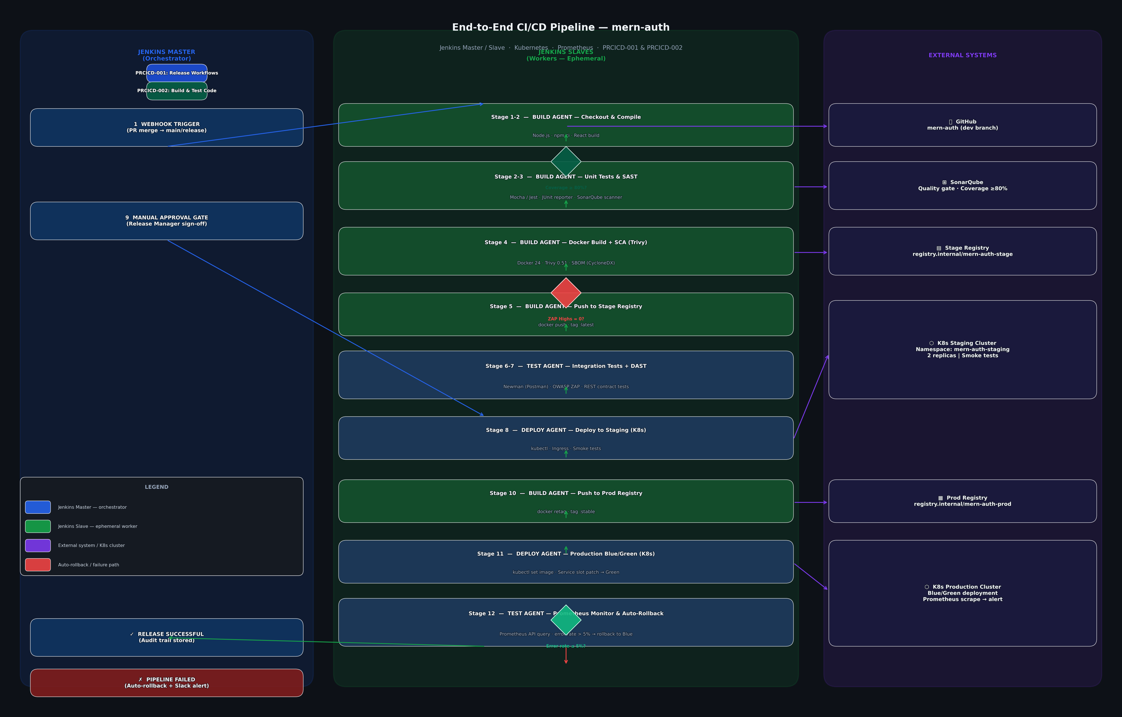
3. Master / Slave Design
Component | Location | Responsibility
Jenkins Master | Permanent EC2/K8s pod in the cicd namespace | Receives webhook on PR merge, schedules agent pods, holds the Manual Approval Gate, sends Slack notifications, stores the audit trail. Never runs build or test work itself.
Build Agent (Slave) | Ephemeral K8s pod — label: build-agent | Runs compile, unit tests, SonarQube SAST, Docker image build, Trivy SCA scan, and registry push. Terminated after each job to eliminate state bleed between runs.
Test Agent (Slave) | Ephemeral K8s pod — label: test-agent | Runs integration tests via Newman (Postman collections) and OWASP ZAP DAST against a live container. Also queries Prometheus for the post-production health check.
Deploy Agent (Slave) | Ephemeral K8s pod — label: deploy-agent | Executes kubectl commands to update Kubernetes Deployments in staging and production namespaces. Handles Blue/Green traffic switching by patching the Service selector.

4. Pipeline Stages
Each stage is mapped to the control it satisfies, the tools used, and the evidence artefact produced.
Stage 1
Checkout & Compile
Agent / Control | Build Agent · PRCICD-002
Tools | Git · npm ci · React build
What happens | Pipeline triggers on PR merge to main. Build agent clones the repo and compiles both backend (Node.js) and frontend (React), confirming the codebase builds cleanly.
Evidence artefact | Build log with exit code 0 and npm install manifest

Stage 2–3
Unit Tests & SAST
Agent / Control | Build Agent · PRCICD-002
Tools | Mocha · Jest · SonarQube
What happens | Unit tests run across backend and frontend suites; JUnit XML reports are published. SonarQube scanner analyses code for injection flaws, insecure patterns, and anti-patterns. A quality gate check enforces ≥ 80% line coverage and blocks the pipeline on failure.
Evidence artefact | JUnit test report · SonarQube dashboard · coverage %

Stage 4
Docker Build & SCA
Agent / Control | Build Agent · PRCICD-002
Tools | Docker 24 · Trivy 0.51
What happens | Source is containerised. Trivy scans the image for known CVEs in OS packages and application dependencies. A SBOM in CycloneDX format is generated. Zero critical CVEs are permitted; any finding halts the pipeline immediately.
Evidence artefact | trivy-report.json · sbom.json · Docker image digest

Stage 5
Push Stage Registry
Agent / Control | Build Agent · PRCICD-002
Tools | Docker registry
What happens | Verified image is pushed to the stage registry tagged with the short commit SHA (immutable) and :latest. This is the exact binary that will travel through every downstream environment — no rebuilds between stages.
Evidence artefact | Registry push log · image tag = commit SHA

Stage 6–7
Integration Tests & DAST
Agent / Control | Test Agent · PRCICD-002
Tools | Newman · OWASP ZAP
What happens | A live container is started on the test agent. Newman executes Postman API collections verifying auth endpoints, token flows, and error codes. OWASP ZAP then runs a baseline DAST scan, simulating real-world attacks against the running application. Zero high-severity findings are required to proceed.
Evidence artefact | integration-results.xml · zap-report.html · zap-report.xml

Stage 8
Deploy to Staging (K8s)
Agent / Control | Deploy Agent · PRCICD-001
Tools | kubectl · Kubernetes
What happens | Deploy agent runs kubectl set image against the mern-auth-staging namespace. Kubernetes performs a rolling update; rollout status is polled until complete. A curl smoke test confirms the /health endpoint returns HTTP 200 before the gate opens.
Evidence artefact | kubectl rollout output · smoke test log

Stage 9
Manual Approval Gate
Agent / Control | Master (no agent) · PRCICD-001
Tools | Jenkins Input Step · Slack
What happens | Pipeline pauses. An SNS/Slack notification is sent to the release manager with links to the SonarQube report, Trivy CVE report, ZAP DAST report, and test coverage. The approver reviews all evidence and clicks Approve or Reject. The approver identity and timestamp are captured in the Jenkins build record.
Evidence artefact | Approval record: approver name + timestamp in build history

Stage 10
Push Prod Registry
Agent / Control | Build Agent · PRCICD-001
Tools | Docker registry
What happens | Staging-validated image is retagged and pushed to the separate prod registry (registry.internal/mern-auth-prod) with the commit SHA tag and :stable. Separate registries provide an audit boundary between non-production and production images.
Evidence artefact | Prod registry push log · :stable tag

Stage 11
Prod Deploy — Blue/Green
Agent / Control | Deploy Agent · PRCICD-001
Tools | kubectl · Blue/Green strategy
What happens | The new image is deployed to the Green Deployment in the mern-auth-production namespace. Once all Green pods pass readiness probes, the mern-auth-prod Service selector is patched to slot=green, shifting 100% of traffic with zero downtime. Blue remains live and idle for instant rollback.
Evidence artefact | kubectl patch output · Service selector change log

Stage 12
Prometheus Monitor & Rollback
Agent / Control | Test Agent · PRCICD-001
Tools | Prometheus API
What happens | For five minutes after traffic switch, the test agent polls Prometheus every 30 seconds for the production HTTP 5xx error rate. If the rate exceeds 5%, the pipeline automatically patches the Service selector back to slot=blue, reverting to the previous stable version with no human intervention required.
Evidence artefact | Prometheus query results · rollback log (if triggered)

5. Evidence Summary
The following artefacts should be attached to the APN competency case study submission:
Control | Artefact | Source
PRCICD-001 | Multibranch Pipeline definition + branching strategy | Jenkins → Configure → Pipeline script
PRCICD-001 | Manual approval record (approver + timestamp) | Jenkins Build #N → Input step log
PRCICD-001 | Blue/Green deployment log + traffic switch | kubectl output archived in Jenkins
PRCICD-001 | Prometheus rollback log (or "no rollback" confirmation) | Pipeline Stage 12 console log
PRCICD-002 | buildspec / Jenkinsfile showing compile + test commands | Jenkinsfile in repo root
PRCICD-002 | JUnit test report (unit + integration) | Jenkins Test Results page
PRCICD-002 | SonarQube quality gate result (≥ 80% coverage) | SonarQube dashboard export
PRCICD-002 | Trivy CVE scan report (trivy-report.json) | Jenkins Artifacts tab
PRCICD-002 | SBOM — CycloneDX format (sbom.json) | Jenkins Artifacts tab
PRCICD-002 | OWASP ZAP DAST report (zap-report.html) | Jenkins Artifacts tab
PRCICD-002 | ECR/Registry image push log with commit SHA tag | Jenkins Stage 5 / Stage 10 log

6. Tool Selection Rationale
Tool | Why Used
Jenkins Master/Slave | Industry-standard orchestrator with Kubernetes cloud plugin. Master/Slave separation ensures the controller is never a build bottleneck; ephemeral slaves eliminate state contamination between pipeline runs.
Kubernetes (K8s) | Provides declarative, version-controlled infrastructure for agent pods, staging, and production environments. Blue/Green deployments are implemented natively via Deployment slot labels and a single Service selector patch.
SonarQube | SAST tool with built-in quality gate API consumed by the Jenkins "waitForQualityGate" step. Provides coverage thresholds and vulnerability rules that directly meet the PRCICD-002 code quality criterion.
Trivy | Fast, lightweight SCA/CVE scanner with SBOM generation (CycloneDX). Supports image scanning, exit-code enforcement, and JSON output for pipeline integration.
OWASP ZAP | DAST scanner that tests the running application for OWASP Top 10 vulnerabilities, complementing Trivy's static analysis. Baseline scan mode is CI-friendly with a defined exit code.
Newman | CLI runner for Postman collections. Provides repeatable, version-controlled API integration tests with JUnit-format output natively supported by Jenkins.
Prometheus | Pull-based metrics collection from both the Jenkins cluster and application pods. Alert rules enforce a 5% error rate SLA; the test agent queries the Prometheus API to implement automated rollback logic without external dependencies.

AWS DevOps Competency Submission · mern-auth CI/CD · PRCICD-001 / PRCICD-002

