**Why we need DOCKER:**

Let’s suppose we are creating an End-to-End stack where,

Web Server = NodeJS

DB= MongoDB

Messaging= Radius

Orchestration tool=Ansible

1st: Compatibility with underlying OS

2nd: Libraries and dependency requirements are different

3rd: Architecture of the proj changes over time.so that point we need to update the entire structure as well.

4th: A new Developer comes it’s a whole long process for him to set up everything as well.

5th: Environment issue for codes in stg vs devp env.

6th: It is the leading s/w container platform.

7th: s/w(UI, backend, db, servers etc..) need to run in every possible platforms.

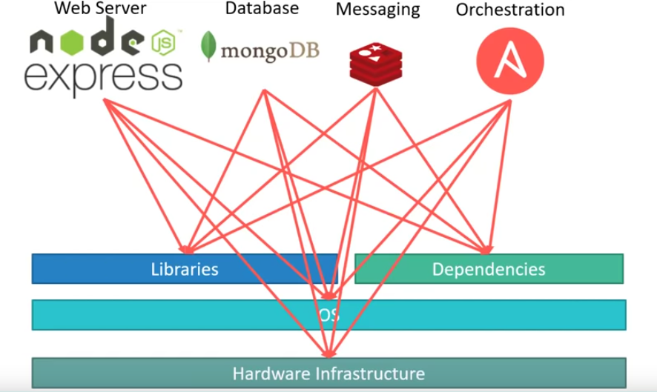

**With Docker, we** are able to run each component with a separate container. With its own libraries and dependencies.

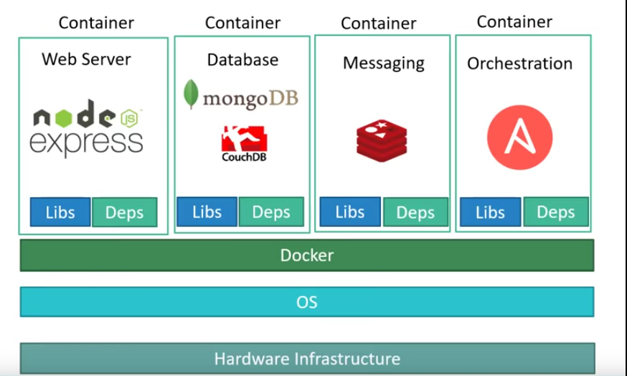

**Containers:**

Containers are completely isolated environment with its own processes, services, mounts etc.. Like a VM other than they **share the same OS kernel**. **Docker uses LXc Containers**.

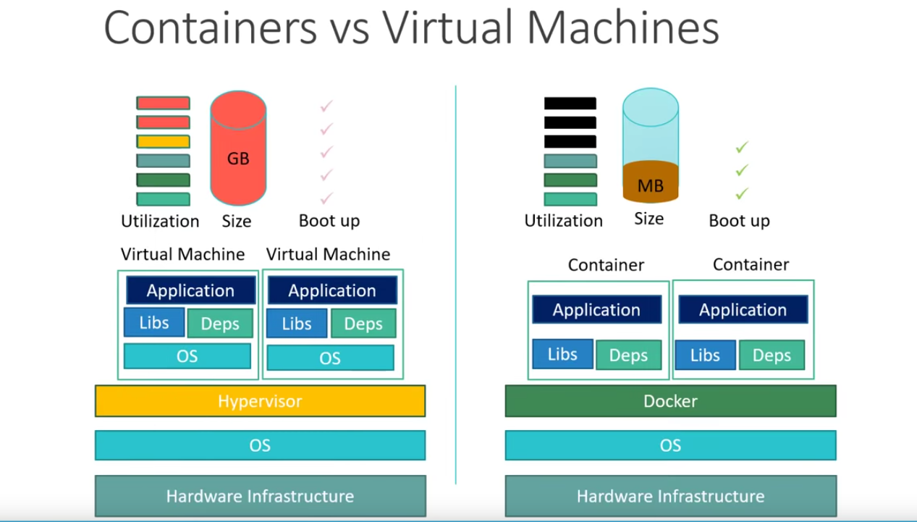

1st: Higher utilization of resources coz every VM has its own OS attached to it.

2nd: Hence takes a large disk space in GB’s. Compared to containers in MB’s.

3rd: Boot up time is also high coz the entire VM/OS has to be up.

4th: No overhead of Fixed memory so light weight and fast.

**5th: VM can have diff OS on them like Linux or Windows where we can’t do the same in Docker.**

**How DOCKER works**

1. Devp will create a dockerFile( image details :application , dependencies, requirements etc..)

2. dockerFile helps to create docker image.

3. docker image will give us **docker container(instance of docker image)** . Which will be placed in the centralized dockerHub.

# Benefits of DOCKER

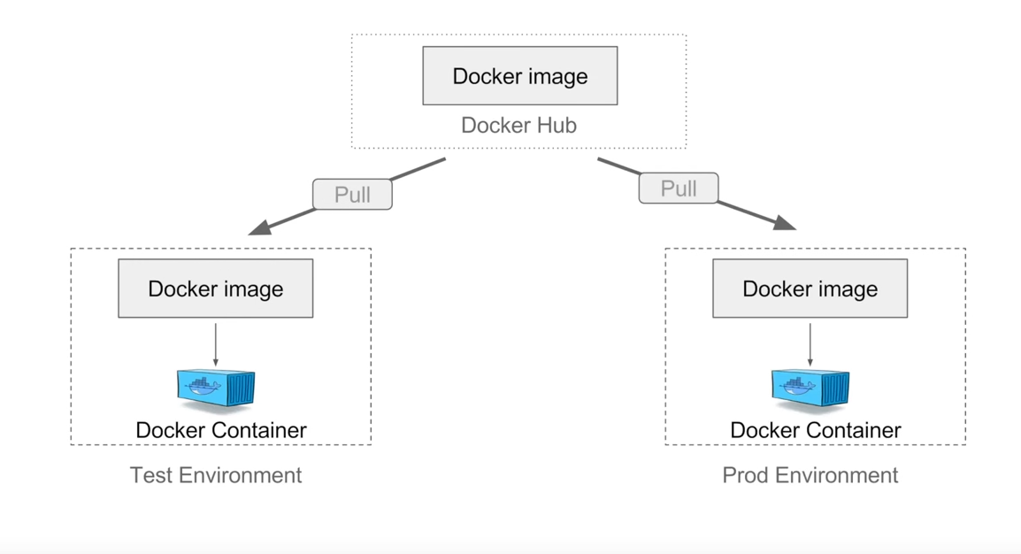

No need to build for different env. Just upload the image to docker HUB/Repo. download to the appliance u want and create the container there and now will be able to use. Both satge and prd will have same container so no point of being scared of not working there.

**Its Portable as well**.

**Its easy version controlling as well.**

# Install DOCKER on WINDOWS:

# Docker Commands:

# 

# Docker Images:

**Docker pull Ubuntu**

# Docker Containers:

# Docker Architecture:

# 

# Client here is cmd/shell that runs the command.

# Docker pull Hello-world

# Docker run hello-world

# Both will help u test ur box…

# How to create and build Dockerfile:

# It is a text file with instruction to build a image. Ex,

# 

# To build ur dockerFile,

# 

# adding a tag to ur image,

# 

# Steps to follow,

# 

# Docker Compose:

# 

# Install docker compose(already present if on Windows or MAC).

# Create the .yml file.

# Modify it with ur details.

# Run the file,

# Docker Volume:

# Docker Swarm:

# Kubernetes: