/proc/sys/fs

The /proc/sys/fs directory consists of the information regarding the virtual filesystem and its tuning.
The directory mostly consists of the default and max sizes for the various parametes of the virtual filesystems.

The contents of the /proc/sys/fs directory are:

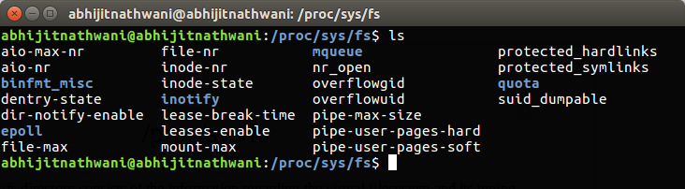
Talking about each file of the /pric/sys/fs directory:

aio-max-nr & aio-nr

aio-nr is the running total of the number of events specified on the io_setup system call for all currently active aio contexts. If aio-nr reaches aio-max-nr then io_setup will fail with EAGAIN. Note that raising aio-max-nr does not result in the pre-allocation or re-sizing of any kernel data structures.

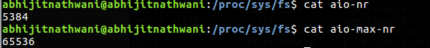

binfmt_misc

binfmt_misc allows you to configure the system to execute miscellaneous binary formats. For instance it enables you to make the system execute .exe files using wine and java files using the java interpreter, just by typing a file name.

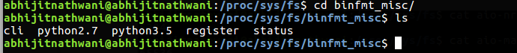

Dentry-state

Provides the status of the directory cache. The first number reveals the total number of directory cache entries, while the second number displays the number of unused entries. The third number tells the number of seconds between when a directory has been freed and when it can be reclaimed, and the fourth measures the pages currently requested by the system. The last two numbers are not used and display only zeros.

Dir-notify-enable

enable/disable dnotify interface, dnotify is a signal used to notify a process about file/directory changes. This is mainly interesting to programmers

File max and file-nr:

The value in file-max denotes the maximum number of file-handles that the Linux kernel will allocate. When you get lots of error messages about running out of file handles, you might want to increase this limit.

Historically,the kernel was able to allocate file handles dynamically, but not to free them again. The three values in file-nr denote the number of allocated file handles, the number of allocated but unused file handles, and the maximum number of file handles. Linux 2.6 always reports 0 as the number of free file handles -- this is not an error, it just means that the number of allocated file handles exactly matches the number of used file handles.

Attempts to allocate more file descriptors than file-max are reported with printk, look for "VFS: file-max limit <number> reached".

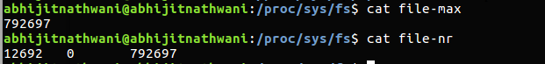

inode-nr & inode-state:

As with file handles, the kernel allocates the inode structures dynamically, but can't free them yet.

The value in inode-max denotes the maximum number of inode handlers. This value should be 3-4 times larger than the value in file-max, since stdin, stdout and network sockets also need an inode struct to handle them. When you regularly run out of inodes, you need to increase this value.

The file inode-nr contains the first two items from inode-state.

Inode-state contains three actual numbers and four dummies. The actual numbers are, in order of appearance, nr_inodes, nr_free_inodes and preshrink.

Nr_inodes stands for the number of inodes the system has allocated, this can be slightly more than inode-max because Linux allocates them one pageful at a time.

Nr_free_inodes represents the number of free inodes (?) and preshrink is nonzero when the nr_inodes > inode-max and the system needs to prune the inode list instead of allocating
more.
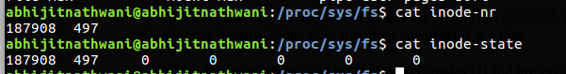

Lease-break-time & leases-enable

This file specifies the grace period that the kernel grants to a process holding a file lease after it has sent a signal to that process notifying it that another process is waiting to open the file.

Leases-enable file can be used to enable or disable file leases on a system-wide basis.

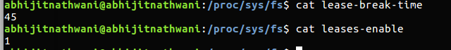
nr_open:

This denotes the maximum number of file-handles a process can allocate. Default value is 1024*1024 (1048576) which should be enough for most machines. Actual limit depends on RLIMIT_NOFILE resource limit.

overflowgid & overflowuid:

Some filesystems only support 16-bit UIDs and GIDs, although in Linux UIDs and GIDs are 32 bits. When one of these filesystems is mounted with writes enabled, any UID or GID that would exceed 65535 is translated to a fixed value before being written to disk.

These sysctls allow you to change the value of the fixed UID and GID. The default is 65534.

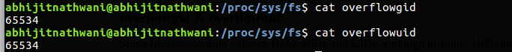

pipe-max-size:

Max size of the pipe IPC in the kernel.

pipe-user-pages-hard:

Maximum total number of pages a non-privileged user may allocate for pipes. Once this limit is reached, no new pipes may be allocated until usage goes below the limit again. When set to 0, no limit is applied, which is the default setting.

pipe-user-pages-soft:

Maximum total number of pages a non-privileged user may allocate for pipes before the pipe size gets limited to a single page. Once this limit is reached, new pipes will be limited to a single page in size for this user in order to limit total memory usage, and trying to increase them using fcntl() will be denied until usage goes below the limit again. The default value allows to allocate up to 1024 pipes at their default size. When set to 0, no limit is applied.

protected_hardlinks:

A long-standing class of security issues is the hardlink-based time-of-check-time-of-use race, most commonly seen in world-writable directories like /tmp. The common method of exploitation of this flaw is to cross privilege boundaries when following a given hardlink (i.e. a root process follows a hardlink created by another user). Additionally, on systems without separated partitions, this stops unauthorized users from "pinning" vulnerable setuid/setgid files against being upgraded by the administrator, or linking to special files.

When set to "0", hardlink creation behavior is unrestricted.

When set to "1" hardlinks cannot be created by users if they do not already own the source file, or do not have read/write access to it.

protected_symlinks:

A long-standing class of security issues is the symlink-based time-of-check-time-of-use race, most commonly seen in world-writable directories like /tmp. The common method of exploitation of this flaw is to cross privilege boundaries when following a given symlink (i.e. a root process follows a symlink belonging to another user).

When set to "0", symlink following behavior is unrestricted.

When set to "1" symlinks are permitted to be followed only when outside a sticky world-writable directory, or when the uid of the symlink and follower match, or when the directory owner matches the symlink's owner.

suid_dumpable:

This value can be used to query and set the core dump mode for setuid or otherwise protected/tainted binaries. The modes are

0 - (default) - traditional behaviour. Any process which has changed privilege levels or is execute only will not be dumped.
1 - (debug) - all processes dump core when possible. The core dump is owned by the current user and no security is applied. This is intended for system debugging situations only. Ptrace is unchecked. This is insecure as it allows regular users to examine the memory contents of privileged processes.
2 - (suidsafe) - any binary which normally would not be dumped is dumped anyway, but only if the "core_pattern" kernel sysctl is set to either a pipe handler or a fully qualified path. This mode is appropriate when administrators are attempting to debug problems in a normal environment, and either have a core dump pipe handler that knows to treat privileged core dumps with care, or specific directory defined for catching core dumps. If a core dump happens without a pipe handler or fully qualifid path, a message will be emitted to syslog warning about the lack of a correct setting.

/proc/sys/fs/mqueue:
This directory contains files controlling the resources used by POSIX message queues.

/proc/sys/fs/mqueue/queues_max is a read/write file for setting/getting the maximum number of message queues allowed on the system.

/proc/sys/fs/mqueue/msg_max is a read/write file for setting/getting the maximum number of messages in a queue value. In fact it is the limiting value for another (user) limit which is set in mq_open invocation. This attribute of a queue must be less or equal then msg_max.

/proc/sys/fs/mqueue/msgsize_max is a read/write file for setting/getting the maximum message size value (it is every message queue's attribute set during its creation).

/proc/sys/fs/mqueue/msg_default is a read/write file for setting/getting the default number of messages in a queue value if attr parameter of mq_open(2) is NULL. If it exceed msg_max, the default value is initialized msg_max.

/proc/sys/fs/mqueue/msgsize_default is a read/write file for setting/getting the default message size value if attr parameter of mq_open(2) is NULL. If it exceed msgsize_max, the default value is initialized msgsize_max.

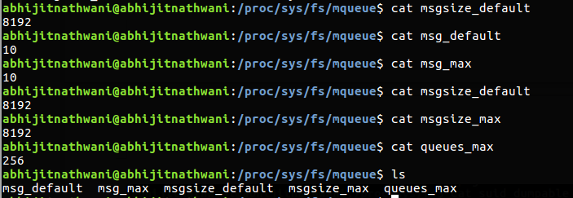
/proc/sys/fs/epoll

This directory contains configuration options for the epoll(7) interface.

max_user_watches
----------------

Every epoll file descriptor can store a number of files to be monitored
for event readiness. Each one of these monitored files constitutes a "watch".
This configuration option sets the maximum number of "watches" that are
allowed for each user.
Each "watch" costs roughly 90 bytes on a 32bit kernel, and roughly 160 bytes
on a 64bit one.
The current default value for max_user_watches is the 1/32 of the available
low memory, divided for the "watch" cost in bytes.

