# Linear Classifiers

# Break-up

## **Data**

Do we assume IID or something else ? )

## **Problem Class**

Classification problem

## **Solution Class(Hypothesis)**

We assume the solution is Linear i.e.

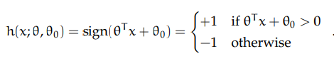

Think of a line ( similar to Y = mx + c )

Now since x(i) is in RD hence

y(i) = θ x + θ0

Here , θ is a D dimension column vector similar to x(i) , 1 x D

θT is the transpose of θ hence it is D x 1

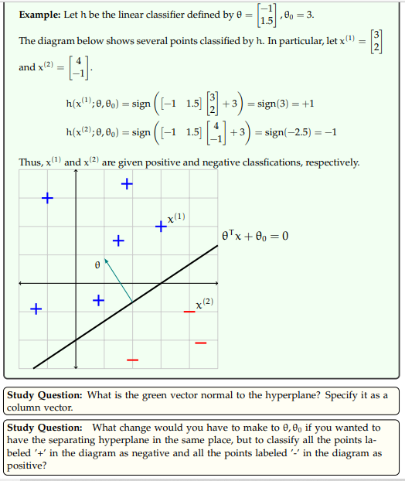

Normal vector to the plane :

<https://youtu.be/gw-4wltP5tY>

<https://www.youtube.com/watch?v=0iNrGpwZwog>

<https://www.youtube.com/watch?v=-2wXhCbdDLY>

<https://www.youtube.com/watch?v=kAwdhLFdqvc&list=PL20lyKVUaxng7M18-Y6LBRJMA6nR58r3g&index=22>

# Input Data

In supervised learning we are given a training data set of the form

Dn = { (x (1) , y (1)) , . . . , (x (n) , y (n))}  
We will assume that each x (i) is a **d × 1 column vector**.

# Problem statement

x(i) ∈ R(d)

x(i) ---> y(i) ==> R(d) --> y(i) , wherey(i) ∈ {0,1}  
The mapping is done by a parameterized function called the hypothesis ***h***



# Error

## Training error

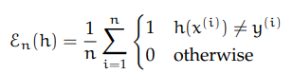

## Testing error

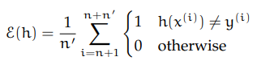

# Possible Solution (Hypothesis) - Linear classifiers

To predict x(i) -> {0,1}

Lets use a hypothesis given by the function y = h(x; θ)

h(x;θ,θ0) = θT x + θ0

A linear classifier in d dimensions is defined by a vector of parameters θ ∈ R d and scalar θ0 ∈ R.

