Catalog

Objective Function 1

# Linear Logistic Classifier

# Model

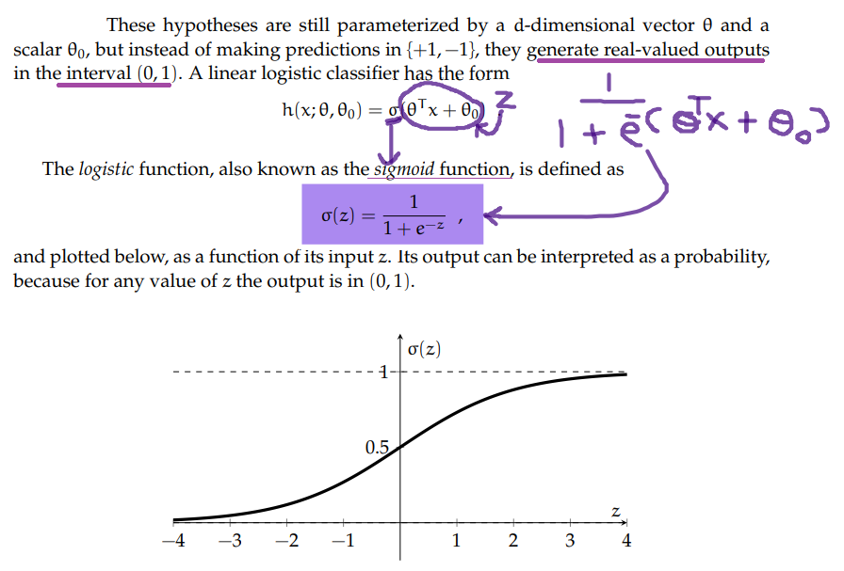

## Loss Function

## Objective Function

